Supplementary Material
Intrinsic Piezoelectric Anisotropy of Tetragonal ABO₃ Perovskites: A High-Throughput Study
Fanhao Jia,^{1,2} Shaowen Xu,³ Shunbo Hu,^{4,5,1*} Jianguo Chen¹, Yongchen Wang,¹ Yuan Li, ² Wei Ren,^{1*} and Jinrong Cheng^{1*}
¹School of Materials Science and Engineering; Department of Physics, International Centre of Quantum and Molecular Structures, Shanghai University, Shanghai 200444, China
²Department of Physics, School of Sciences, Hangzhou Dianzi University, Hangzhou 310018, China
³School of Physics and Optoelectronic Engineering, Hangzhou Institute for Advanced Study, University of Chinese Academy of Sciences, Hangzhou 310024, China
⁴Institute for the Conservation of Cultural Heritage, School of Cultural Heritage and Information Management, Shanghai University, Shanghai 200444, China
⁵Key Laboratory of Silicate Cultural Relics Conservation (Shanghai University), Ministry of Education, China
*E-mail: shunbohu@shu.edu.cn; renwei@shu.edu.cn; jrcheng@shu.edu.cn
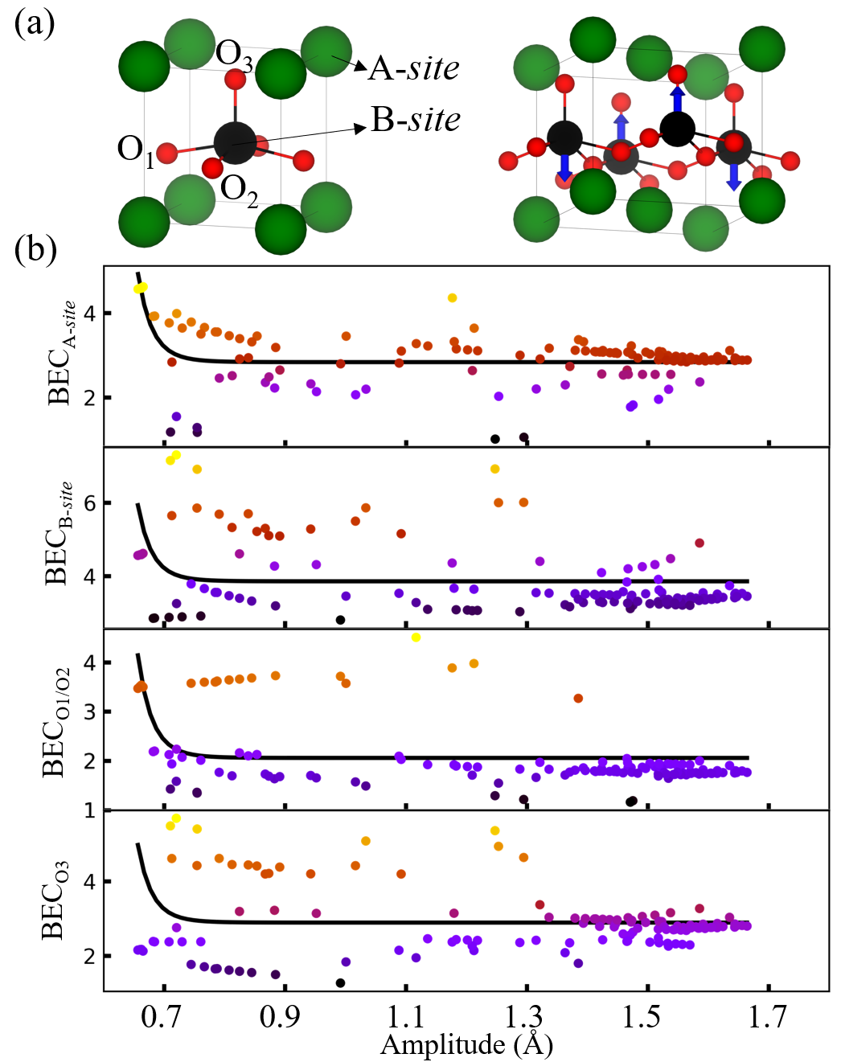
Figure S1. (a) Schematic of tetragonal ABO₃ perovskite, where the arrows in the right panel are spin directions of the antiferromagnetic configuration used in this study. (b) The born effective charge Z₃₃ of A-site, B-site, O₁/O₂ and O₃ as a function of interatomic displacement amplitude.
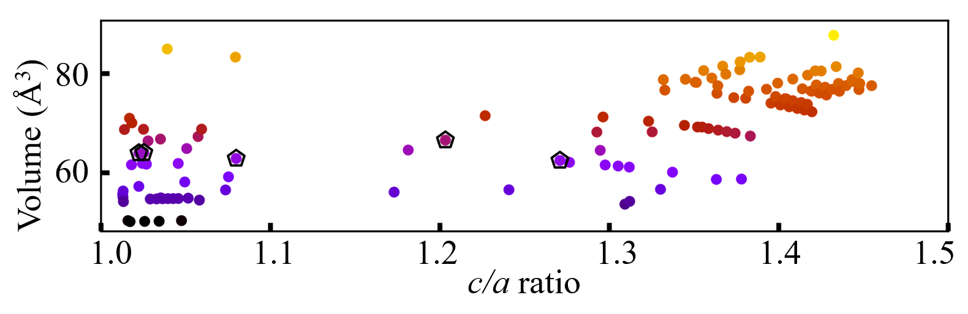
Figure S2. Lattice volume as a function of c/a ratio.
Elasticity
In view of P4mm symmetry relations, the 4th-rank elastic stiffness tensor (in Voigt notation) of tetragonal perovskite can be given by:
$$\begin{aligned}C=\left[\begin{matrix}c_{11} & c_{12} & c_{13} & 0 & 0 & 0 \\ c_{12} & c_{11} & c_{13} & 0 & 0 & 0 \\ c_{13} & c_{13} & c_{33} & 0 & 0 & 0 \\ 0 & 0 & 0 & c_{44} & 0 & 0 \\ 0 & 0 & 0 & 0 & c_{44} & 0 \\ 0 & 0 & 0 & 0 & 0 & c_{66}\end{matrix}\right],\#\left(1\right)\end{aligned}$$
which is consistent by six independent elastic constants, namely c₁₁, c₃₃, c₄₄, c₆₆, c₁₂, and c₁₃. The tension can produce not only normal strains but also shear strains, and it will be convenient to describe the directional elastic properties in the spherical coordinates with basis set [1],
$$\begin{aligned}a=\left(\begin{aligned}\sin\left(θ\right)\cos\left(φ\right) \\ \sin\left(θ\right)\sin\left(φ\right) \\ \cos\left(θ\right)\end{aligned}\right), 0≤θ≤π,0≤φ≤2π\#\left(2\right)\end{aligned}$$
$$\begin{aligned}b=\left(\begin{aligned}\cos\left(θ\right)\cos\left(φ\right)\cos\left(γ\right)-\sin\left(φ\right)\sin\left(γ\right) \\ \cos\left(θ\right)\sin\left(φ\right)\cos\left(γ\right)-\cos\left(φ\right)\sin\left(γ\right) \\ -\sin\left(θ\right)\cos\left(γ\right)\end{aligned}\right),0≤γ≤2π\#\left(3\right)\end{aligned}$$
Then, the fourth order elastic compliance tensor S transforms in a new basis set following the rule:
$$\begin{aligned}S_{αβγδ}^{'}=r_{αi}r_{αi}r_{αi}r_{αi}S_{ijkl},\#\left(4\right)\end{aligned}$$
where Einstein’s summation rule (i.e., when an index occurs twice in the same term, summation with respect to that index is applied) is adopted and the r_{αi} are the components of the rotation matrix (or direction cosines). Once the S' is determined, the Young’s modulus E(a), linear compressibility β(a) (or multiplicative inverse of bulk modulus B(a) of the normal stress along a can be easily written by
$$\begin{aligned}E\left(a\right)=E\left(θ,φ\right)=\frac{1}{S_{11}^{'}\left(θ,φ\right)}=\frac{1}{a_{i}a_{j}a_{k}a_{l}S_{ijkl}},\#\left(5\right)\end{aligned}$$
$$\begin{aligned}β\left(a\right)=\frac{1}{B\left(a\right)}=a_{i}a_{j}a_{k}a_{k}S_{ijkk}=a_{i}a_{j}S_{ijkk}.\#\left(6\right)\end{aligned}$$
Shear modulus G and Poisson’s ratio ν are not as straightforward to represent and depend on two directions (a and b) at the same time, with
$$\begin{aligned}G\left(a,b\right)=G\left(θ,φ, γ\right)=\frac{1}{4}\frac{1}{a_{i}b_{j}a_{k}b_{l}S_{ijkl}},\#\left(7\right)\end{aligned}$$
$$\begin{aligned}ν\left(a,b\right)=ν\left(θ,φ, γ\right)=-\frac{a_{i}a_{j}b_{k}b_{l}S_{ijkl}}{a_{i}a_{j}a_{k}a_{l}S_{ijkl}}.\#\left(8\right)\end{aligned}$$

Table SI. The calculated elastic constants c_{ij} (in GPa) of tetragonal ABO₃ systems.
System | c₁₁ | c₃₃ | c₄₄ | c₆₆ | c₁₂ | c₁₃
BaTiO₃ | 299  211ª | 136  160 | 116  56 | 125  127 | 113  107 | 90  114
KNbO₃ | 380 | 163 | 88 | 93 | 83 | 82
PbTiO₃ | 252  237^{b} | 55  60 | 56  69 | 100  104 | 105  90 | 76  70
PbVO₃ | 231 | 33 | 53 | 43 | 48 | 51
BiCoO₃ | 204 | 89 | 23 | 53 | 40 | 38
ªRef [2]; ^{b}Ref [3];
Table SⅡ. The calculated elastic moduli (in GPa) along crystal axes of tetragonal ABO₃ systems. G and ν are shear modulus and Poisson's ratio represented by Marmier manner. An overall anisotropy index of property X (Young’s modulus E and linear compressibility β) can be defined by A_{X}= max(X(θ, φ, $γ$))/min(E(θ, φ, $γ$)).
System | BaTiO₃ | KNbO₃ | PbTiO₃ | PbVO₃ | BiCoO₃
E_{a} | 228 | 334 | 145 | 148 | 185
E_{c} | 97 | 134 | 23 | 15 | 78
E_{a}/E_{c} | 2.4 | 2.5 | 6.3 | 9.9 | 2.4
A_{E} | 3.1 | 2.5 | 9.8 | 12.0 | 2.8
β_{a} | 1.1 | 1.3 | 3.3 | 4.2 | 2.9
β_{c} | 6.1 | 4.9 | 28.6 | 42.9 | 9.4
β_{a}/β_{c} | 5.5 | 3.8 | 8.6 | 10.2 | 3.2
A_{β} | 5.4 | 3.8 | 8.6 | 10.2 | 3.2
$$G_{a}^{max}$$ | 126 | 94 | 100 | 53 | 53
$$G_{a}^{min}$$ | 116 | 88 | 56 | 43 | 23
$$G_{c}^{max}$$ | 116 | 88 | 56 | 53 | 23
$$G_{c}^{min}$$ | 116 | 88 | 56 | 53 | 23
$$ν_{a}^{max}$$ | 0.52 | 0.44 | 1.42 | 1.81 | 0.37
$$ν_{a}^{min}$$ | 0.22 | 0.12 | -0.01 | -0.19 | 0.13
$$ν_{c}^{max}$$ | 0.22 | 0.18 | 0.21 | 0.19 | 0.15
$$v_{c}^{min}$$ | 0.22 | 0.18 | 0.21 | 0.19 | 0.15

Piezoelectricity

“Piezoelectric stress constant” is written as:
$$\begin{aligned}e_{αj}={\left.\frac{∂P_{α}}{∂η_{j}}\right|}_{ε}={\left.\frac{∂σ_{j}}{∂ε_{α}}\right|}_{η}.\#\left(9\right)\end{aligned}$$

“Piezoelectric strain constant” is written as:
$$\begin{aligned}d_{αj}={\left.\frac{∂P_{α}}{∂σ_{j}}\right|}_{ε}={\left.\frac{∂η_{j}}{∂ε_{α}}\right|}_{σ}.\#\left(10\right)\end{aligned}$$

They can be converted by the thermodynamic relations:
$$\begin{aligned}d_{αj}=S_{jk}e_{αk},\#\left(11\right)\end{aligned}$$

$$\begin{aligned}e_{αj}=C_{jk}d_{αk}.\#\left(12\right)\end{aligned}$$

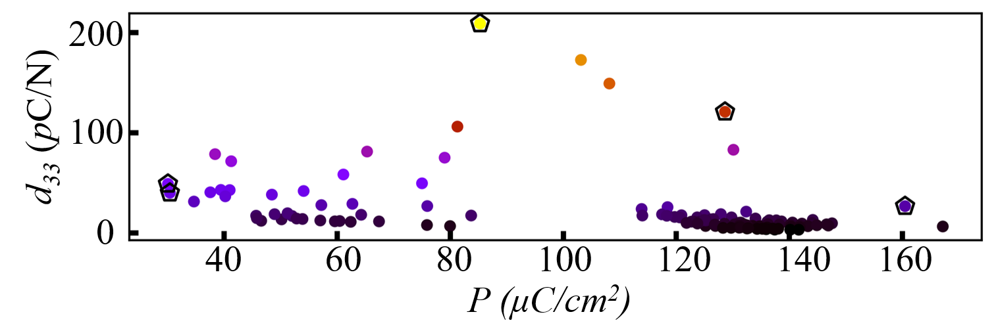
Figure S3. Piezoelectric constant d₃₃ as a function of polarization.
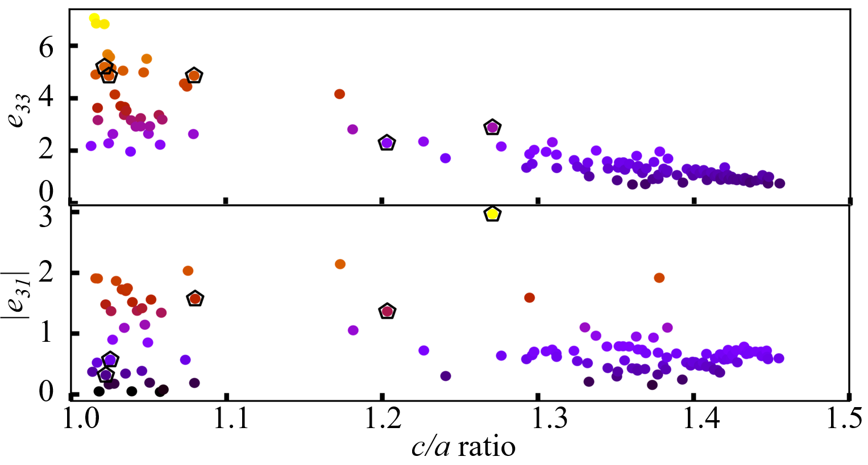
Figure S4. Piezoelectric constants e₃₃ and e₃₁ as a function of c/a ratio.
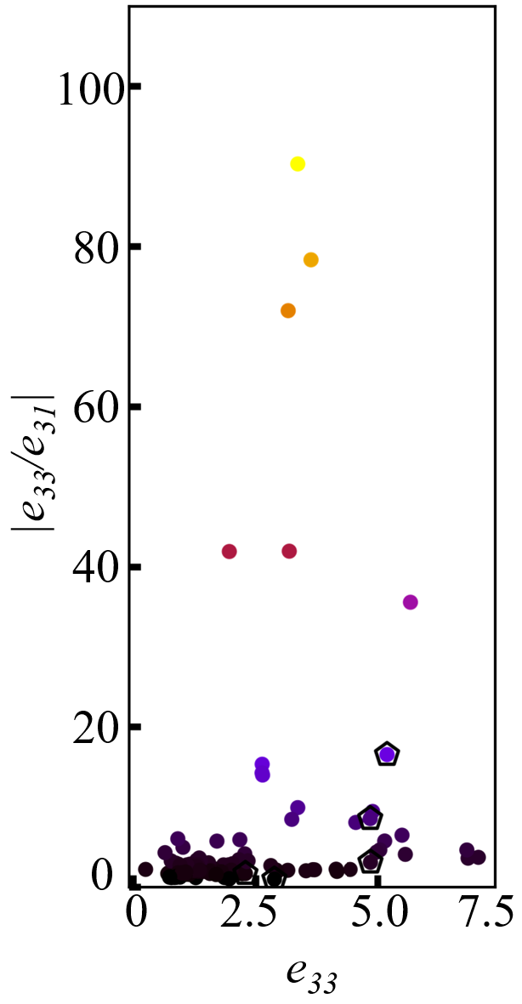
Figure S5. |e₃₃/e₃₁| ratio as a function of c/a ratio.

Table SⅢ. The calculated piezoelectricity (e_{αj} in C/m², d_{αj} in pC/N,) of tetragonal ABO₃ systems.
System | Phase | e₃₃ | e₃₁ | |e₃₃/e₃₁| | d₃₃ | d₃₁ | |d₃₃/d₃₁|
BaTiO₃ | P4mm | 4.85  5.48ª | 0.57  -3.88ª | 8.5  1.4 | 49.0 | -9.2 | 5.3
KNbO₃ | P4mm | 5.20 | -0.31 | 16.5 | 40.1 | -7.7 | 5.2
PbTiO₃ | P4mm | 4.86  5.0^{b} | 1.57  2.1 | 3.1  2.5 | 209.0 | -40.3 | 5.2
PbVO₃ | P4mm | 1.36 | 2.29 | 1.7 | 120.9 | -17.1 | 7.1
BiCoO₃ | P4mm | 2.97 | 2.88 | 1.0 | 26.7 | 8.7 | 3.1
ªRef [2]; ^{b}Ref [3]

REFERENCE
[1] A. Marmier, Z. A. D. Lethbridge, R. I. Walton, C. W. Smith, S. C. Parker, and K. E. Evans, Computer Physics Communications 181, 2102 (2010).
[2] Z. Li, S. K. Chan, M. Grimsditch, and E. Zouboulis, Journal of Applied Physics 70, 7327 (1991).
[3] A. Kalinichev, J. Bass, B. Sun, and D. Payne, Journal of materials research 12, 2623 (1997).

