Supplementary files for “Untangling lineage introductions, persistence, and temporal heterogeneity of HP-PRRSV (sublineage 8.7)”

Supplementary figure 1 Maximum likelihood phylogeny of all sublineage 8.7 sequences. Maximum likelihood phylogeny including 4 HP-PRRSV MLV vaccines, with 1000 replicates. The clusters relevant to MLV vaccines were shaded with corresponding color, and MLVs were annotated in the right panel.
Supplementary figure 2 Shared amino acid mutation in MLV TJM cluster. These candidates’ amino acid are selected in the criteria: the amino acid of field strains should remain constant compared with MLV sequence (vac_TJM) whereas changed compared with parental sequence (EU860248.1_TJ_complete_genome)

Supplementary figure 3 Shared amino acid mutation in MLV HUN4 cluster. These candidates' amino acid are selected in the criteria: the amino acid of field strains should keep constant compared with MLV sequence (vac_HuN4) whereas changed compared with parental sequence (EF635006.1_HUN4_complete_genome)
Supplementary figure 4 Shared amino acid mutation in MLV JXA1 cluster. These candidate amino acids are selected in the criteria: the amino acid of field strains should keep constant compared with MLV sequence (vac_JXA1_P80) whereas changed compared with parental sequence (EF112445.1_JXA1).

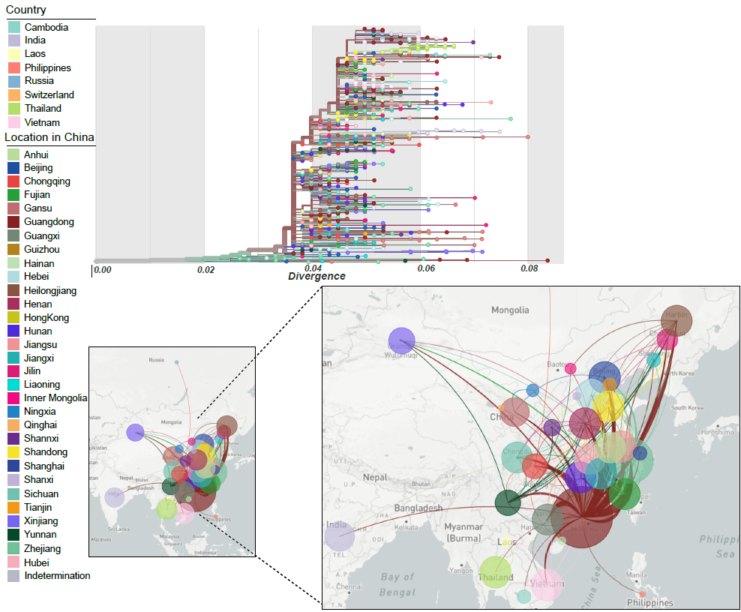
Supplementary figure 5 PRRSV sublineage 8.7 subsampled phylogeographic reconstruction. Detailed description can be referred to the legend of Figure 3.
Supplementary figure 6 PRRSV sublineage 8.7 phylogeographic reconstruction within China accommodating sampling size. A. Maximum clade credibility tree with ancestral nodes and branches colored according to estimated (province) location, depicting the spread of PRRSV within China. B. Spatiotemporal dissemination of PRRSV in China, determined by Bayesian phylogeography inference. Curves show the among-province virus lineage transitions statistically supported with Bayes factor >3. Curve widths represent transition rate values; curve colors represent corresponding statistical support (Bayes factor value) for each province. C. Sankey plots summarizing Markov jump estimates for the transition between provinces.
Supplementary figure 7 The support and contribution of PRRSV diffusion predictors among 30 Chinese provinces when considering sample size as a potential predictor between Chinese provinces. Support for each predictor is represented by an inclusion probability that is estimated as the posterior expectation for the indicator variable associated with each predictor. Indicator expectations corresponding to Bayes factor support values of 3, 20, and 150 are represented by a dotted vertical in this bar plot. The contribution of each predictor is represented by the mean and credible intervals of the GLM coefficients (b) on a log scale conditional on the predictor being included in the model.
Supplementary figure 8 Heatmap showing the pairwise distance between provinces.

