Additional file 4: The results of sensitivity analysis
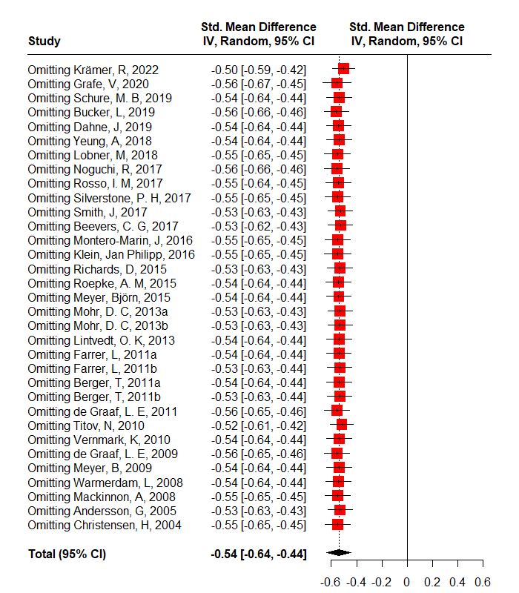
The sensitivity analysis of primary outcome 1
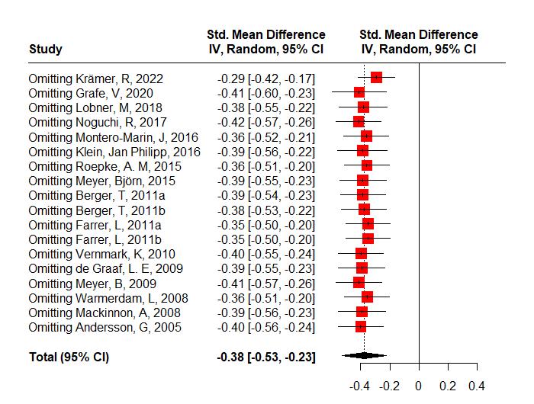
The sensitivity analysis of primary outcome 2

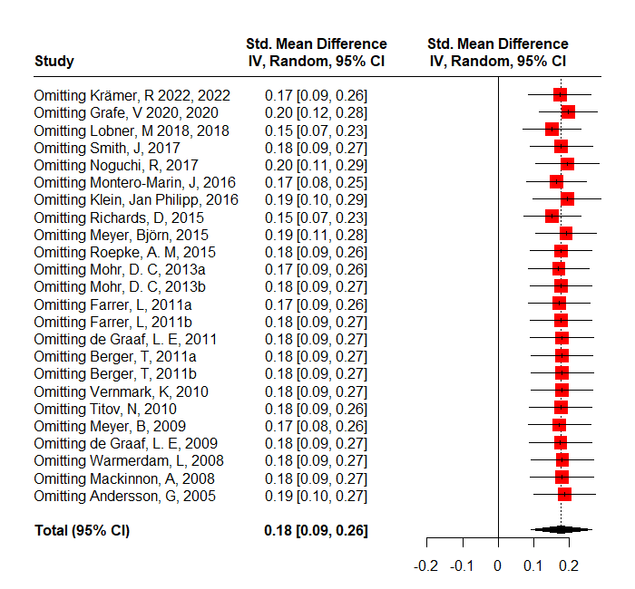
The sensitivity analysis of primary outcome 3
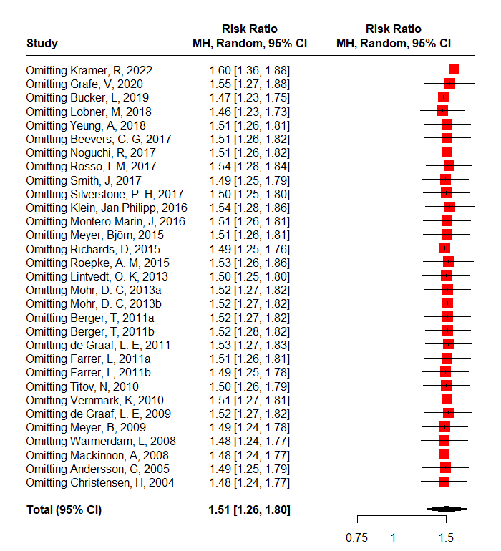
The sensitivity analysis of primary outcome 4

