Supplementary figures and tables
Table S1. Primer sequences used in this study.
Gene | Primer sequences (5'-3')
IGFBP1 | Forward, TTGGGACGCCATCAGTACCTA
IGFBP1 | Reverse, TTGGCTAAACTCTCTACGACTCT
IGFBP2 | Forward, GACAATGGCGATGACCACTCA
IGFBP2 | Reverse, CAGCTCCTTCATACCCGACTT
IGFBP3 | Forward, AGACACACTGAATCACCTGAAGT
IGFBP3 | Reverse, AGGGCGACACTGCTTTTTCTT
IGFBP4 | Forward, ACTCACTCACTCATTCCTTCAC
IGFBP4 | Reverse, GACCATTACTCCATCTGCTACC
IGFBP5 | Forward, ACCTGAGATGAGACAGGAGTC
IGFBP5 | Reverse, GTAGAATCCTTTGCGGTCACAA
IGFBP6 | Forward, TGTGAACCGCAGAGACCAAC
IGFBP6 | Reverse, GCCCATCTCAGTGTCTTGGA
IGFBP7 | Forward, CATCACCCAGGTCAGCAAG
IGFBP7 | Reverse, TCACAGCTCAAGTACACCTG
β-actin | Forward, CATGTACGTTGCTATCCAGGC
β-actin | Reverse, CTCCTTAATGTCACGCACGAT
Abbreviations: IGFBP, insulin-like growth factor-binding proteins.

Table S2. The product information and dilution of primary antibodies.
Antibody | Catalog No. | Company | Dilution for IHC
IGFBP1 | 13981-1-AP | Proteintech,China | 1/100
IGFBP2 | 11065-3-AP | Proteintech,China | 1/100
IGFBP3 | 10189-2-AP | Proteintech,China | 1/100
IGFBP4 | 18500-1-AP | Proteintech,China | 1/100
IGFBP5 | 55205-1-AP | Proteintech,China | 1/100
IGFBP6 | ER65554 | Huabio,China | 1/100
IGFBP7 | 19961-1-AP | Proteintech,China | 1/100

Table S3. Assessment of staining densities in endometrial cancer (EC) tissues and adjacent normal tissues (X ± SD, %).
 | Tumor tissues (n = 20) | Paracancer tissues (n = 20)
IGFBP1 | 0.781 ± 0.303* | 6.712 ± 0.771
IGFBP2 | 14.952 ± 1.267* | 2.168 ± 0.826
IGFBP3 | 1.469 ± 0.634* | 5.025 ± 0.898
IGFBP4 | 1.144 ± 0.337* | 7.621 ± 0.929
IGFBP5 | 1.575 ± 0.362* | 11.152 ± 1.753
IGFBP6 | 1.473 ± 0.431* | 9.818 ± 1.150
IGFBP7 | 2.049 ± 0.649* | 18.487 ± 0.835
*P＜0.05, compared with paracancer tissues.

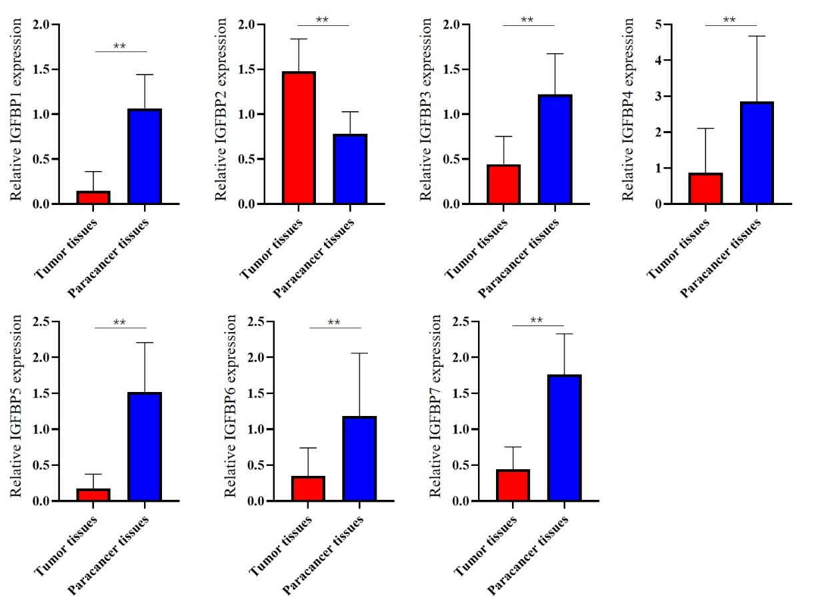
Figure S1. qRT‒PCR analysis of the expression levels of IGFBP1-7 in EC tissues and adjacent normal tissues (n = 30). ** P <0.01

