Supplementary information:
Single cell RNA-seq reveals that the Vibrio cholerae MakA toxin is required for killing Tetrahymena pyriformis and for survival inside of protozoan expelled food vacuoles.
Gustavo Espinoza-Vergara^{1*}, M. Mozammel Hoque¹, Parisa Noorian¹, Joyce To¹, Jonah Moon¹, Scott A. Rice², Diane McDougald¹.
¹ The Australian Institute for Microbiology & Infection, University of Technology Sydney, Sydney, Ultimo NSW 2007, Australia.
² Agriculture and Food, Microbiomes for One Systems Health, Commonwealth Scientific and Industrial Research Organization, Sydney, Australia.
*Correspondence to: Gustavo.EspinozaVergara@uts.edu.au
Contents:
Supplementary Table 1
Supplementary Figure 1
Supplementary File Legends
Supplementary Video Legends

Supplementary Table 1 - List of bacterial and protozoan strains and plasmids
Strain and plasmids | Properties | Origin
V. cholerae A1552 S | Wild type, O1, El Tor, Inaba, Smooth, Rif^{r} | Laboratory collection
V. cholerae A1552 S ΔlacZ | O1, El Tor, Inaba, Smooth, Rif^{r} ΔlacZ | Laboratory collection
V. cholerae A1552 S  ΔmakA | O1, El Tor, Inaba, Smooth, Rif^{r} ΔmakA | This study
V. cholerae ΔmakA  pBAD::makA | V. cholerae A1552 S ΔmakA with  makA complemented in trans in pBAD24. | This study
Escherichia coli BW20767 | RP42tet::Mu1kan::Tn7integrant uidA(ΔMlu1)::pir+ recA1 creB510 leu63 hsdR17 endA1 zbf5 thi | ATCC 47084
pBAD24 | Cloning vector with arabinose inducible promoter, Amp^{r} | Laboratory collection
Protozoan strains

T. pyriformis | Wild type | ATCC 205063

Supplementary Figure 1

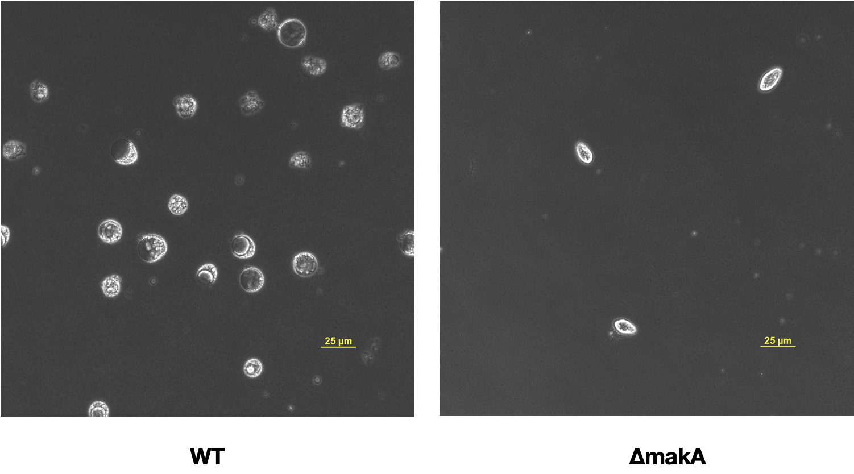
Supplementary Figure 1. Killing effect of V. cholerae against T. pyriformis. The left side shows many dead T. pyriformis cells concentrated at the bottom of the well. On the right side, the co-incubation of V. cholerae makA mutant with T. pyriformis shows no dead Tetrahymena cells. Scale bar, 25 µm. Images are representative of three independent experiments.

Supplementary Figure 2
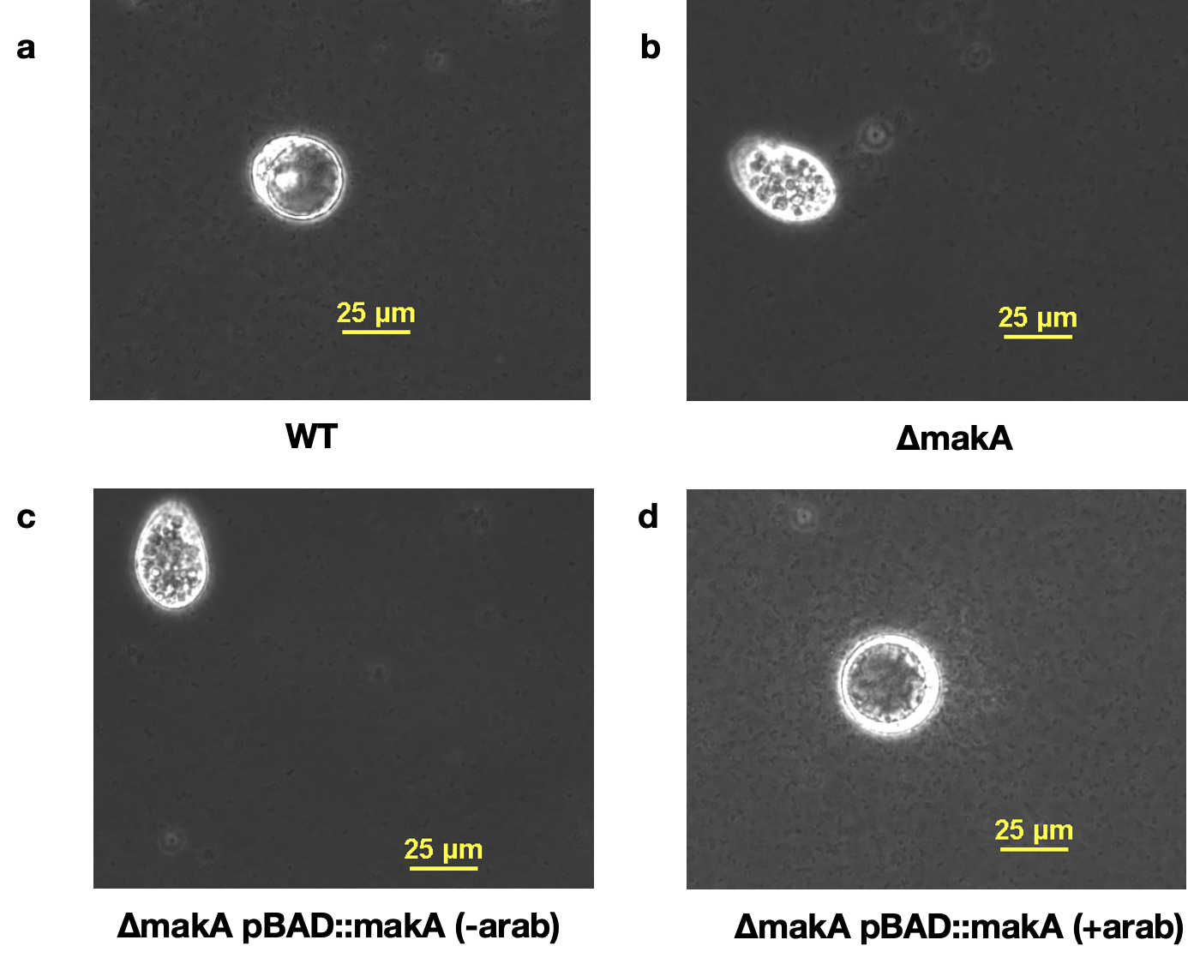
Supplementary Figure 2. Complementation of the makA gene in trans in the V. cholerae ΔmakA restores the killing effect against T. pyriformis. a. WT strain killing T. pyriformis, an enlarged intracellular vesicle is observed. b, c. The killing effect against T. pyriformis is not observed in either the ΔmakA strain (b) or in the ΔmakA pBAD::makA with no addition of arabinose (c). d. The killing effect of T. pyriformis is restored in the ΔmakA pBAD::makA in the presence of arabinose. Scale bar, 25 µm. Images are representative of three independent experiments.

Supplementary Files
Supplementary File 1. Gene list showing significant differential gene expression (log₂FC) per cluster.
Supplementary Videos
Supplementary Video 1. Co-incubation of V. cholerae WT with T. pyriformis after 5 h in ASW. Real time video (phase contrast, transmitted light) showing the killing of T. pyriformis by V. cholerae. Video is representative of three independent experiments.
Supplementary Video 2. Co-incubation of V. cholerae ΔmakA with T. pyriformis after 5 h in ASW. Real time video (phase contrast, transmitted light) showing no killing of T. pyriformis by V. cholerae ΔmakA. Video is representative of three independent experiments.
Supplementary Video 3. Co-incubation of V. cholerae ΔmakA pBAD::makA with T. pyriformis after 5 h in ASW. Real time video (phase contrast, transmitted light) showing that makA complementation in trans restores the killing of T. pyriformis by V. cholerae. Video is representative of three independent experiments.

