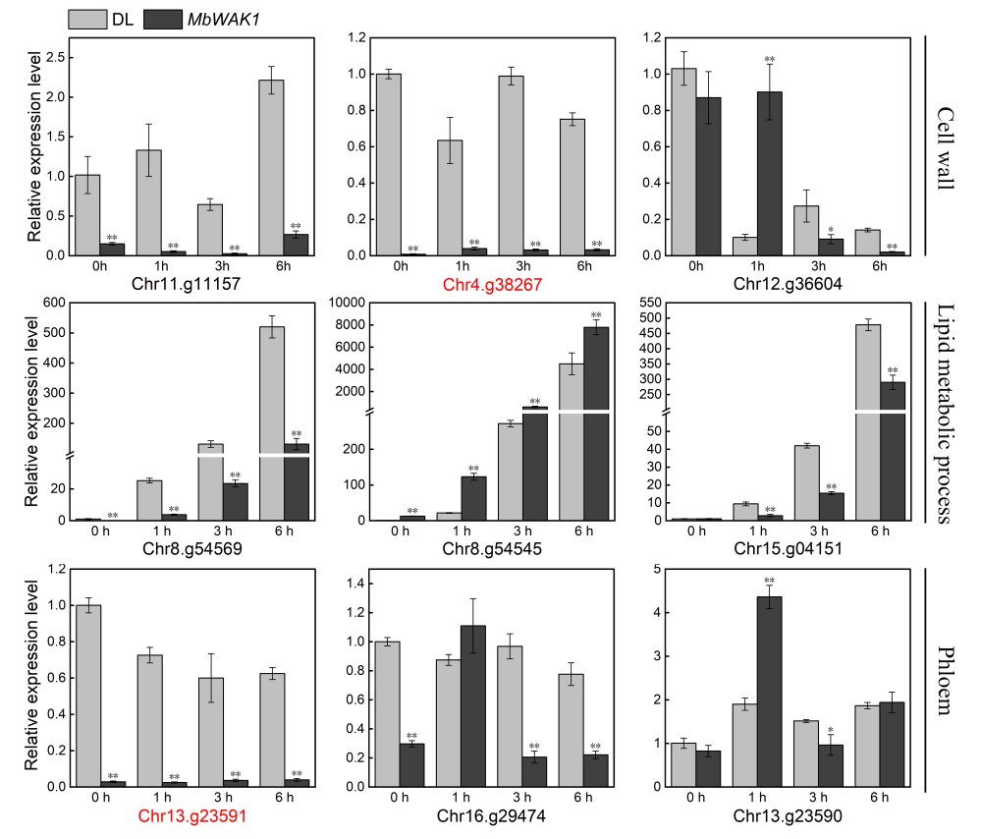
Supplementary Fig S1: Expression of 9 candidate genes in MbWAK1 over-expressing cell lines with 20% VpM treatment. Data are means (±SD), n=3. Significant differences compared with the control were determined using Student’s t-test: *p<0.05, **p<0.01.

