SUPP. MATERIALS AND METHODS

Detection of ZFP-362 by western blot: Cells were pelleted and then lysed in M-PER lysis buffer (Thermo Fisher Scientific, MA, USA) according to manufacturer’s protocol. The lysate was loaded on BioRad mini Protean TGX 7.5% gel and run in TGS running buffer (Bio-rad, CA, USA). Protein was transferred to nitrocellulose membranes using BioRad TransBlot Turbo Transfer system (Bio-rad, CA, USA). The membranes were blocked for 1 hr in 1xTBST with 5% milk. Membranes were washed briefly then incubated overnight at 4 °C with Cell Signaling Myc-Tag (9B11) Mouse mAb (Cell Signaling technologies, MA, USA, Cat#2276) diluted 1:1000 in blocking buffer. Membranes were washed three times for 2 min each, before incubating for 1 hr at room temperature with BioRad Goat anti-Mouse HPR (Bio-rad, CA, USA, Cat#1721011) diluted 1:5000 in blocking buffer. Membranes were washed again then incubated briefly Pierce™ ECL Plus Western Blotting Substrate (Thermo Fisher Scientific, MA, USA) before imaging on BioRad Chemidoc™ Touch Gel-imaging system. Images were analyzed on Bio-rad Image Lab™ Software V6.0.0.

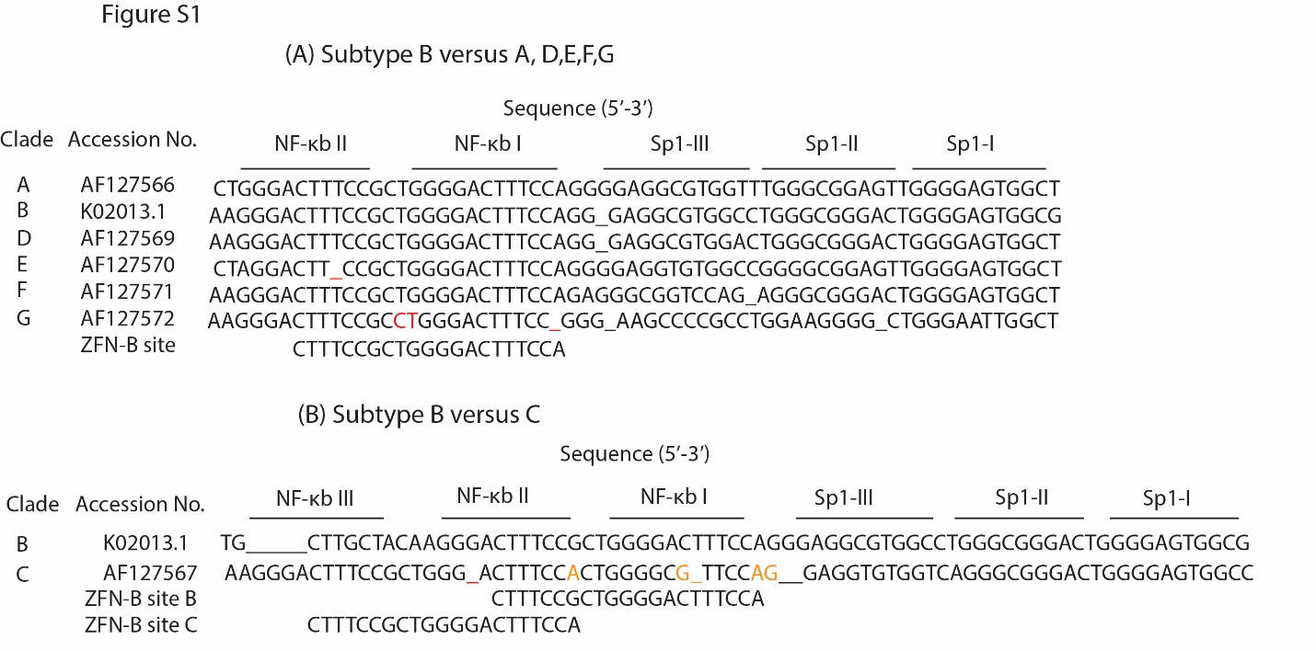

Figure S1: Homology alignments at the ZFP-362 site: Various HIV subtypes were assessed relative to subtype B for sequence homology at the ZFP-362 target site. For subtypes A, D, E, F, G (A) mismatches are highlighted in red. For Subtype C (B) the ZFP-362 has two possible binding site but is more complementary to the upstream NF-κB III site. Mismatches for the two possible binding sites are highlighted in orange and red, respectively.

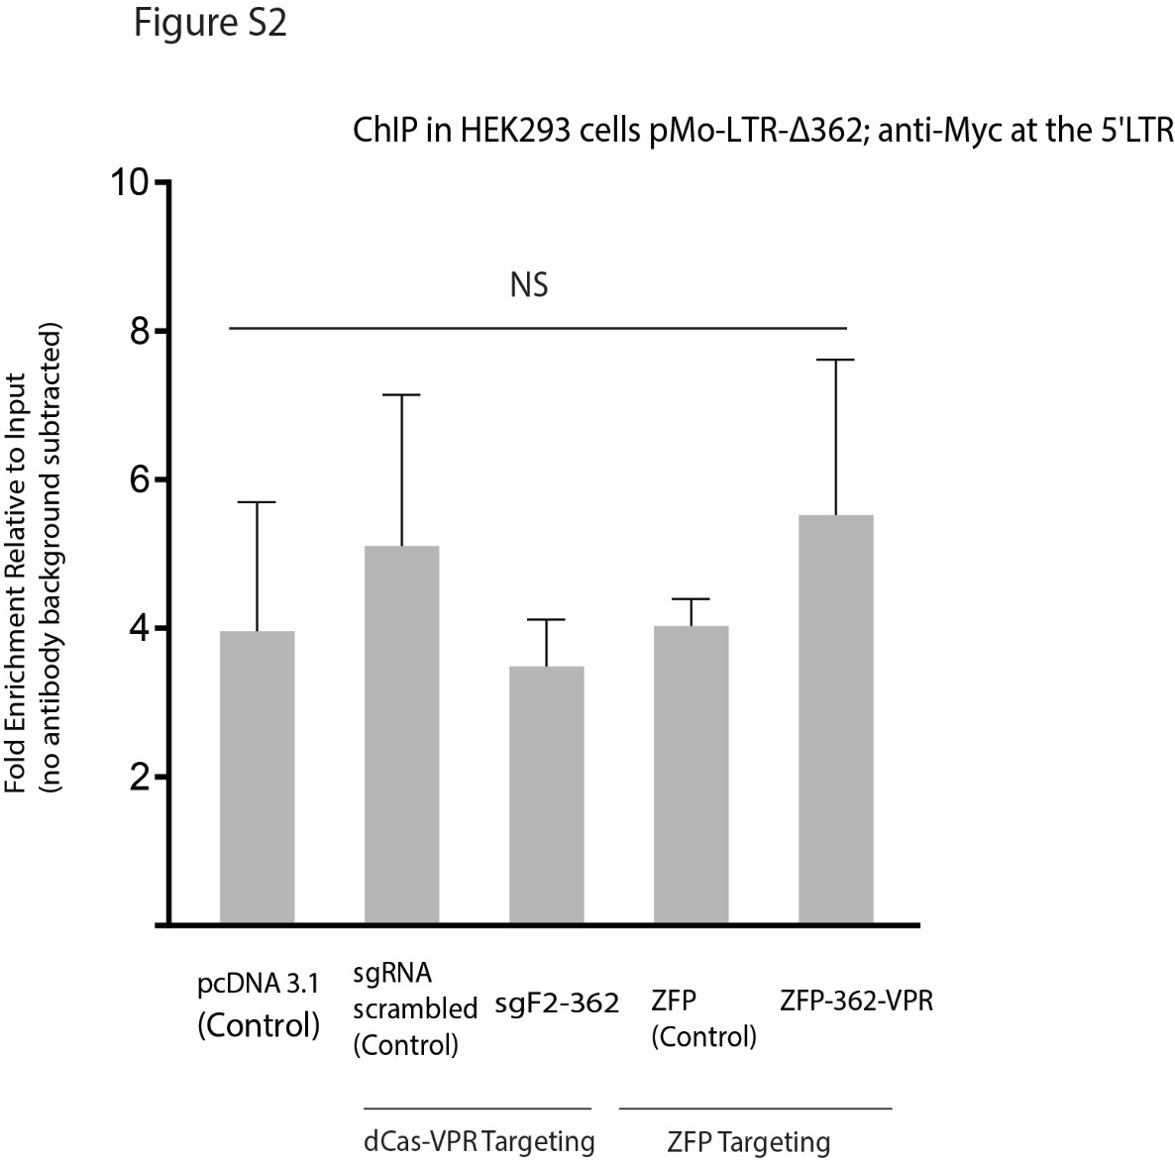

Figure S2: ZFP-362 does not bind to a LTR lacking the NF-κB site: CHIP analysis of ZFP-362-VPR and dCas-VPR binding to the HIV LTR. HEK293 cells were transfected with pcDNA-ZFP-362-VPR, pcDNA-VEGF-VPR, or dCas9-VPR with a control gRNA or sgF2-362. pcDNA was included as a mock control. A ChIP was performed 72 hrs post-transfection to determine binding to the LTR-362 site. The average of triplicate treated cells is shown with the standard deviations. Significance was determined a unpaired student t-test.

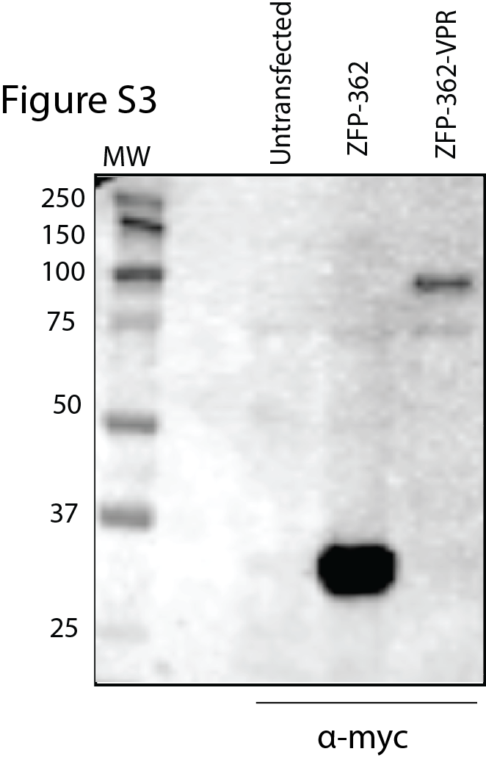

Figure S3: Detection of ZFP-362-VPR fusion protein. HEK293 cells were transfected with ZFP-362 or ZFP-362-VPR and anti-Myc antibody was used to detect the expressed proteins in total protein extract by a western blot assay. The size of the ZFP-362 and ZFP-362-VPR are ~28 kDa or ~84kDa, respectively.

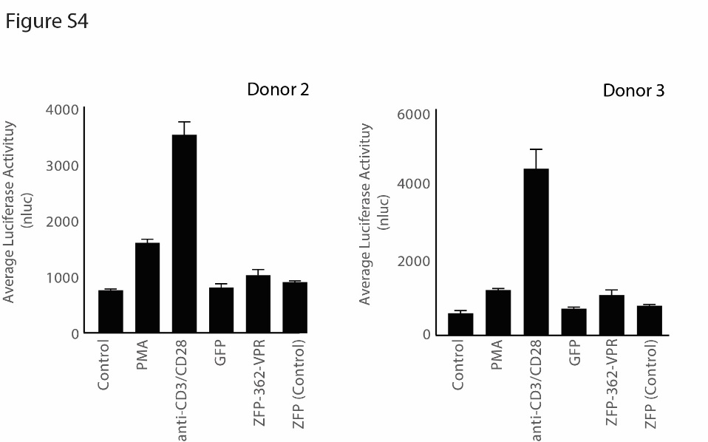

Figure S4: ZFP-362-VPR activation of HIV’s LTR in CD4⁺ T cells. CD4⁺ T-cells (pseudotyped viruses pNL4.3-Env-nLuc-VSVG uninfected cells and latently infected cells) were transfected with ZFP-362-VPR and control vectors (GFP and ZFP-control), and 72 hrs later the levels of luciferase were measured. CD4⁺ T-cells were also treated with PMA (10 ng/ml) and anti-CD3/CD28 beads as positive controls. The average of triplicate treated cells is shown with the standard deviations.
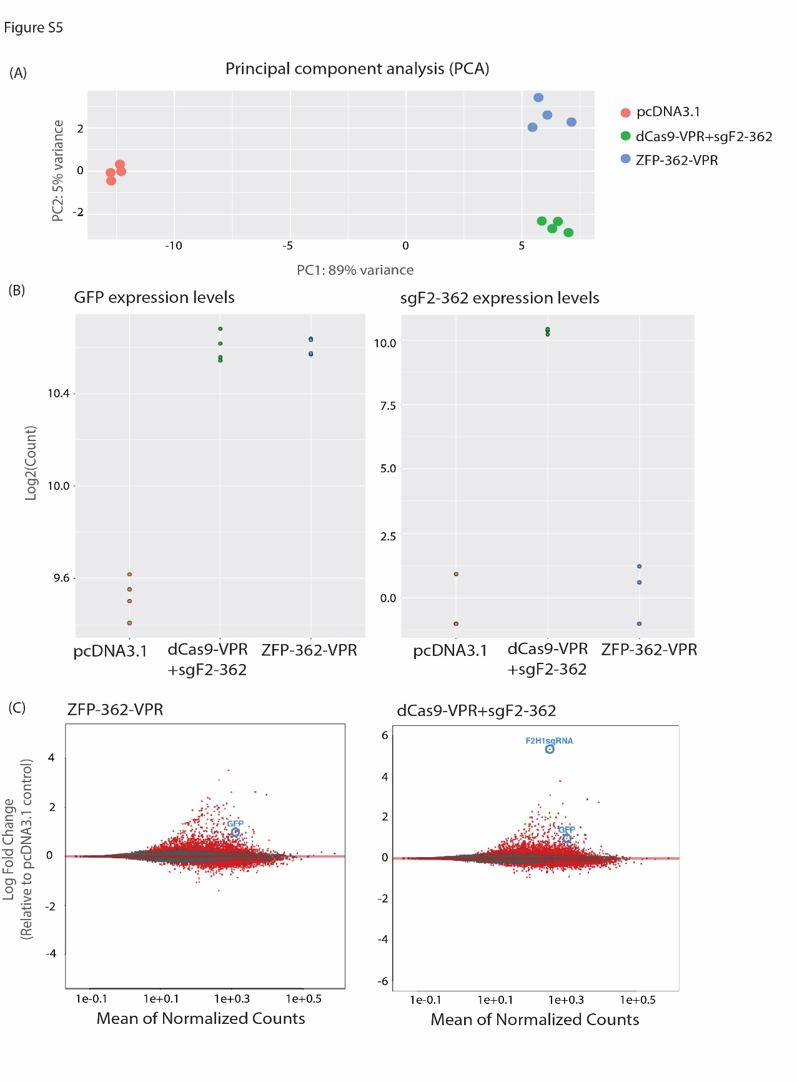
Figure S5: RNA sequencing analysis in cells treated with ZFP-362-VPR. pMo-HEK cells were transfected with the pcDNA3.1, dCas9-VPR+sgF2-362 or ZFP-362-VPR expression vectors and total RNA was extract 72 hrs post-transfection and subjected to RNA sequencing analysis. (A) Principal component analyses showing that controls cluster closely and separately from the treated samples, which each cluster separately, indicating that the treatment is the major source of variation between samples. (B) Expression of GFP and sgF2-362 was measured as the log2 of mapped reads in the pcDNA3.1, ZFP-362-VPR and dCas9-VPR+sgF2-362 samples. (C) MA plots of samples treated with pcDNA3.1, dCas9-VPR+sgF2-362 and ZFP-362-VPR; differentially expressed genes are shown in red (|log2FC| ≥ 2, FDR 0.05).

