Supplemental table 2. Table of time spent on various activities
Childcare/homeschooling
MS: 0: 88.4%, >0: 11.6%
GS: 0: 88.5%, >0: 11.5%
RFJF: 0: 43.2%, >0: 56.8%

Administrative duties
MS: <=45: 81%, >45: 19%
GS: <=45: 99%, >45: 1%
RFJF: <=45: 96%, >45: 4%

Clinical duties
MS: <=45: 57%, >45: 43%
GS: <=45: 97%, >45: 3%
RFJF: <=45: 51.2%, >45: 48.8%

Research/Scholarly Activities
MS: <=45: 57%, >45: 43%
GS: <=45: 18.1% , >45: 81.9%
RFJF: <=45: 64.6%, >45: 35.4%

Personal Time
MS: <=45: 91%, >45: 9%
GS: <=45: 97%, >45: 3%
RFJF: <=45: 99%, >45: 1%

Volunteer Activities
MS: <=45: 91.6%, >45: 8.4%
GS: <=45: 100%, >45: 0%
RFJF: <=45: 100%, >45: 0%

Supplemental figure
MS
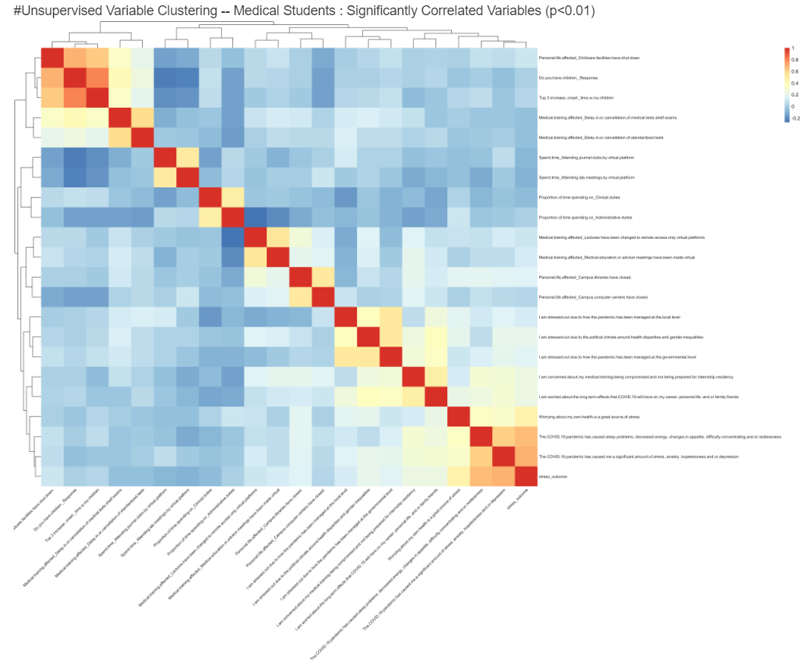

GS
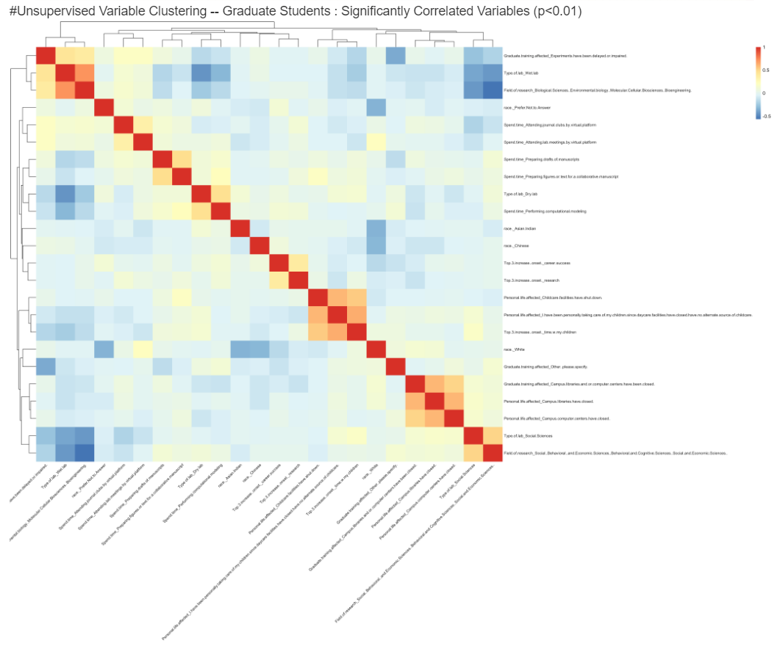

RFJF
