Supplemental Table 1. Accuracy of machine learning algorithms to predict α-diversity from 259 cats (195 for training and 64 for testing) who provided stool samples using health factors of cats. Recursive feature elimination was used to eliminate features that increase root mean square error, thus features included in final models ranged from 1 feature to 30 features. Model performance is assessed by comparing to the RMSE of the null (non-informative model) which does not use predictors.
Model (α-diversity index) | Cross Validation Median RMSE [Q1,Q3] | Test Data RMSE | # of Features Included | Top features
Null Model  Shannon Diversity  Richness  Evenness | 0.5161  124.22  0.0694 | 0.52867  138.742  0.07057 | —  —  — | —  —  —
GLM  Shannon Diversity  Richness  Evenness | 0.504 [0.464,0.557]**  117.2 [111.9,135.2]**  0.0690 [ 0.062, 0.076]** | 0.53532  140.493  0.07150 | 1  1  1 | med_dexdomitor_buprenorphine_ketamine  pregnant_or_lactating  med_dexdomitor_buprenorphine_ketamine
** Best performing model for α-diversity index

Supplemental Table 2. Accuracy of machine learning algorithms to predict β-diversity (as measured by PCoA axes generated using Bray-Curtis dissimilarity matrix) from 259 cats (195 for training and 64 for testing) using health factors of cats. Recursive feature elimination was used to eliminate features that increase root mean square error, thus features included in final models ranged from 1 feature to 30 features. Model performance is assessed by comparing to the RMSE of the null (non-informative model) which does not use predictors.
Model (β-diversity) | Cross Validation Median RMSE [Q1,Q3] | Test Data RMSE | # of Features Included | Top features
Null Model  PCoA1  PCoA2 | 0.0974  0.0712 | 0.10170  0.06466 | —  — | —  —
GLM  PCoA1  PCoA2 | 0.0935 [0.0885, 0.1007]**  0.0623 [0.0602, 0.0710]** | 0.09870  0.06425 | 1  3 | Kitten  Quarantine_room, isolation_room, med_terramycin
** Best performing model for β-diversity index

Supplementary Table 3. Subject characteristics of 174 cats and their comparisons by age. Continuous data are expressed as median [IQR] and categorical data are expressed as count (%).
Variable | Total  (n=174) | Kitten  (<1 y, n=31) | Young adult  (≥1&<6 y, n=118) | Mature adult  (≥6&<10 y, n=25) | p value*
Room  Adoption  Feral  Isolation  Quarantine | 86 (49%)  67 (39%)  3 (2%)  18 (10%) | 22 (71%)ª  4 (13%)  0 (0%)  5 (16%) | 50 (42%)^{b}  55 (47%)  3 (3%)  10 (8%) | 14 (56%)^{a,b}  8 (32%)  0 (0%)  3 (12%) | 0.011
Sex  Female  Male | 90 (52%)  84 (48%) | 20 (65%)  11 (35%) | 61 (52%)  57 (48%) | 9 (36%)  16 (64%) | 0.112
Altered status  True  False  No data | 44 (26%)  128 (74%)  2 | 1 (3%)ª  30 (97%)  0 | 31 (27%)^{b}  85 (73%)  2 | 12 (48%)^{b}  13 (52%)  0 | 2.25e-04
BCS | 4.0 [3.0-4.0] | 4.0 [4.0-4.0] | 4.0 [3.0-4.0] | 4.0 [3.5-4.0] | 0.055
Body weight, in lbs | 8.0 [6.4-10.0] | 3.5 [2.7-4.9]ª | 8.5 [7.0-10.0]^{b} | 10.0 [8.0-11.8]^{c} | <2.2e-16
Breed  DLH  DMH  DSH  Other | 12 (7%)  5 (3%)  156 (90%)  1 (1%) | 1 (3%)  1 (3%)  29 (94%)  0 | 9 (8%)  2 (2%)  106 (90%)  1 (1%) | 2 (8%)  2 (8%)  21 (84%)  0 (0%) | 0.550
Bristol stool scale | 2.0 [2.0-3.8] | 4.0 [2.3-5.0]ª | 2.0 [2.0-3.0]^{b} | 2.0 [1.5-3.0]^{b} | 3.33e-04
Diarrhea recency  <24 hr  >24 hr | 16 (9%)  158 (91%) | 6 (19%)  25 (81%) | 9 (8%)  109 (92%) | 1 (4%)  24 (96%) | 0.132
Medication  DBK  Meloxicam  Gabapentin  Antisedan  Pyrantel  Revolution | 104 (60%)  106 (61%)  7 (4%)  44 (25%)  132 (76%)  154 (89%) | 23 (74%)ª  23 (74%)ª  0 (0%)  20 (65%)ª  23 (74%)^{a,b}  25 (81%) | 73 (62%)ª  75 (64%)ª  5 (4%)  22 (19%)^{b}  85 (72%)ª  108 (92%) | 8 (32%)^{b}  8 (32%)^{b}  2 (8%)  2 (8%)^{b}  24 (96%)^{b}  24 (96%) | 0.004  0.004  0.275  4.39e-07  0.024  0.148
Vaccine  Rabies  FVRCP | 152 (87%)  157 (90%) | 20 (65%)ª  25 (81%) | 108 (92%)^{b}  108 (92%) | 24 (96%)^{b}  24 (96%) | 5.05e-04  0.148
Health issue  Skin/flea/mite  Eye  Thyroid  Dental | 11 (6%)  2 (1%)  1 (1%)  3 (2%) | 0 (0%)ª  0 (0%)  0 (0%)  0 (0%) | 6 (5%)ª  2 (2%)  1 (1%)  1 (1%) | 5 (20%)^{b}  0 (0%)  0 (0%)  2 (8%) | 0.012  1  1  0.073
* For continuous variables, the Kruskal-Wallis test was used when one or more groups were compared. Fisher’s exact test was performed to assess the association between two categorical variables. Pairwise comparison with Benjamini-Hochberg correction of the p-value was performed when the null hypothesis of the Kruskal-Wallis test or the Fisher’s exact test was rejected. Data not sharing a common superscript are significantly different in the post-hoc comparison.

Supplementary Table 4. Species with differential abundances between kittens (< 1 y, n=31) and young adults (≥1&<6 y, n=118). Fold changes (FC) were calculated using young adults as the reference group.
Phylum | Class | Order | Family | Genus | Species | log2FC±SE | adj p
Kittens more abundant than young adults (36 species)
Proteobacteria | Gammaproteobacteria | Burkholderiales | Burkholderiaceae | Burkholderia | unknown | 8.19±1.19 | 4.29E-10
Bacteroidota | Bacteroidia | Bacteroidales | Bacteroidaceae | Phocaeicola | sartorii | 5.17±1.16 | 2.15E-04
Fusobacteriota | Fusobacteriia | Fusobacteriales | Fusobacteriaceae | Fusobacterium_A | sp900543175 | 5.05±0.47 | 1.76E-24
Bacteroidota | Bacteroidia | Bacteroidales | Bacteroidaceae | Phocaeicola | ilei | 4.76±0.61 | 9.12E-13
Proteobacteria | Gammaproteobacteria | Burkholderiales | Burkholderiaceae | Ralstonia | unknown | 4.63±0.64 | 5.07E-11
Firmicutes | Bacilli | Staphylococcales | Staphylococcaceae | Staphylococcus | pettenkoferi | 4.49±0.57 | 3.45E-13
Proteobacteria | Alphaproteobacteria | Rhizobiales | Beijerinckiaceae | Bosea | sp002220095 | 4.40±0.52 | 4.72E-15
Proteobacteria | Alphaproteobacteria | Rhizobiales | Xanthobacteraceae | Afipia | broomeae | 4.33±1.21 | 3.69E-03
Proteobacteria | Gammaproteobacteria | Burkholderiales | Burkholderiaceae | Burkholderia | cenocepacia | 4.27±0.40 | 1.07E-23
Bacteroidota | Bacteroidia | Bacteroidales | Bacteroidaceae | Bacteroides | fluxus | 4.15±1.15 | 3.55E-03
Firmicutes_A | Clostridia | Clostridiales | Clostridiaceae | Clostridium_P | sp001403635 | 4.06±1.17 | 4.95E-03
Actinobacteriota | Actinomycetia | Propionibacteriales | Propionibacteriaceae | Cutibacterium | acnes | 3.93±0.61 | 1.04E-08
Proteobacteria | Gammaproteobacteria | Enterobacterales | Enterobacteriaceae | Escherichia | coli | 3.80±0.84 | 1.83E-04
Firmicutes | Bacilli | Lactobacillales | Streptococcaceae | Streptococcus | suis | 3.80±1.06 | 3.60E-03
Firmicutes | Bacilli | Lactobacillales | Lactobacillaceae | Lactobacillus | taiwanensis | 3.78±1.12 | 6.91E-03
Bacteroidota | Bacteroidia | Bacteroidales | Rikenellaceae | Alistipes | onderdonkii | 3.77±0.79 | 5.97E-05
Actinobacteriota | Actinomycetia | Actinomycetales | Bifidobacteriaceae | Bifidobacterium | bifidum | 3.68±0.92 | 9.58E-04
Firmicutes | Bacilli | Lactobacillales | Enterococcaceae | Enterococcus_E | cecorum | 3.64±0.96 | 1.85E-03
Firmicutes_A | Clostridia | Clostridiales | Clostridiaceae | Clostridium | tertium | 3.63±0.69 | 7.88E-06
Firmicutes | Bacilli | Lactobacillales | Enterococcaceae | Enterococcus_E | unknown | 3.55±0.46 | 9.04E-13
Bacteroidota | Bacteroidia | Bacteroidales | Bacteroidaceae | Bacteroides | fragilis_A | 3.33±1.04 | 1.16E-02
Proteobacteria | Gammaproteobacteria | Enterobacterales | Enterobacteriaceae | Citrobacter | freundii | 3.26±1.22 | 4.42E-02
Bacteroidota | Bacteroidia | Bacteroidales | Rikenellaceae | Alistipes | putredinis | 2.98±0.60 | 2.19E-05
Firmicutes | Bacilli | Lactobacillales | Enterococcaceae | Enterococcus_E | columbae | 2.90±0.75 | 1.55E-03
Firmicutes_A | Clostridia | Eubacteriales | Eubacteriaceae | Eubacterium | unknown | 2.86±0.67 | 3.68E-04
Bacteroidota | Bacteroidia | Bacteroidales | Rikenellaceae | Alistipes | obesi | 2.62±0.76 | 5.37E-03
Bacteroidota | Bacteroidia | Bacteroidales | Rikenellaceae | Alistipes | unknown | 2.52±0.64 | 1.28E-03
Firmicutes_A | Clostridia | Lachnospirales | Lachnospiraceae | Anaerostipes | caccae | 2.47±0.42 | 1.56E-07
Proteobacteria | Gammaproteobacteria | Enterobacterales | Enterobacteriaceae | Klebsiella_B | aerogenes | 2.23±0.50 | 2.35E-04
Firmicutes_A | Clostridia | Lachnospirales | Lachnospiraceae | Enterocloster | aldenensis | 2.20±0.64 | 6.22E-03
Bacteroidota | Bacteroidia | Bacteroidales | Bacteroidaceae | Bacteroides | caccae | 2.18±0.80 | 3.95E-02
Firmicutes | Bacilli | Lactobacillales | Streptococcaceae | Streptococcus | hyovaginalis | 2.17±0.52 | 4.93E-04
Bacteroidota | Bacteroidia | Bacteroidales | Bacteroidaceae | Bacteroides | fragilis | 2.16±0.52 | 5.66E-04
Firmicutes_A | Clostridia | Lachnospirales | Lachnospiraceae | Sellimonas | intestinalis | 2.15±0.61 | 4.16E-03
Firmicutes | Bacilli | Lactobacillales | Lactobacillaceae | Limosilactobacillus | antri | 2.06±0.72 | 2.76E-02
Desulfobacterota | Desulfovibrionia | Desulfovibrionales | Desulfovibrionaceae | Bilophila | wadsworthia | 2.05±0.49 | 5.66E-04
Kittens less abundant than young adults (43 species)
Firmicutes | Bacilli | Lactobacillales | Streptococcaceae | Streptococcus | pasteurianus | -5.98±0.69 | 8.21E-16
Firmicutes_A | Clostridia | Clostridiales | Clostridiaceae | Clostridium | baratii | -5.80±1.05 | 1.50E-06
Firmicutes | c__Bacilli | Lactobacillales | Lactobacillaceae | Ligilactobacillus | saerimneri | -5.19±1.67 | 1.48E-02
Firmicutes | Bacilli | Erysipelotrichales | Erysipelotrichaceae | Allobaculum | stercoricanis | -5.08±0.99 | 1.29E-05
Firmicutes | Bacilli | Lactobacillales | Enterococcaceae | Enterococcus_B | hirae | -5.07±0.77 | 4.43E-09
Firmicutes | Bacilli | Lactobacillales | Enterococcaceae | Enterococcus_B | villorum | -4.95±1.31 | 1.91E-03
Firmicutes_A | Clostridia | Clostridiales | Clostridiaceae | Clostridium | sp000753455 | -4.85±1.48 | 9.32E-03
Firmicutes | Bacilli | Lactobacillales | Streptococcaceae | Streptococcus | gallolyticus | -4.07±1.04 | 1.37E-03
Firmicutes | Bacilli | Haloplasmatales | Turicibacteraceae | Turicibacter | sp001543345 | -3.91±0.95 | 6.43E-04
Firmicutes_A | Clostridia | Peptostreptococcales | Peptostreptococcaceae | Paeniclostridium | sordellii | -3.88±0.63 | 4.31E-08
Proteobacteria | Gammaproteobacteria | Enterobacterales | Succinivibrionaceae | Succinivibrio | unknown | -3.87±0.94 | 6.43E-04
Actinobacteriota | Actinomycetia | Mycobacteriales | Mycobacteriaceae | Mycobacterium | mucogenicum_B | -3.82±0.89 | 4.09E-04
Firmicutes | Bacilli | Lactobacillales | Lactobacillaceae | Limosilactobacillus | mucosae | -3.66±0.93 | 1.16E-03
Campylobacterota | Campylobacteria | Campylobacterales | Helicobacteraceae | Helicobacter_B | canis_A | -3.64±0.81 | 1.83E-04
Firmicutes | Bacilli | Lactobacillales | Enterococcaceae | Enterococcus_C | massiliensis | -3.53±1.29 | 3.78E-02
Firmicutes | Bacilli | Lactobacillales | Enterococcaceae | Enterococcus_B | pernyi | -3.43±1.21 | 3.13E-02
Firmicutes | Bacilli | Lactobacillales | Streptococcaceae | Lactococcus | garvieae | -3.30±0.79 | 5.66E-04
Firmicutes_A | Clostridia | Peptostreptococcales | Peptostreptococcaceae | Paraclostridium | unknown | -3.29±0.74 | 2.35E-04
Firmicutes_A | Clostridia | Clostridiales | Clostridiaceae | Clostridium_P | ventriculi | -3.11±1.07 | 2.50E-02
Firmicutes | Bacilli | Lactobacillales | Enterococcaceae | Enterococcus_B | unknown | -3.05±0.68 | 2.05E-04
Firmicutes_A | Clostridia | Clostridiales | Clostridiaceae | Clostridium | saudiense | -3.02±0.84 | 3.68E-03
Campylobacterota | Campylobacteria | Campylobacterales | Helicobacteraceae | Helicobacter_B | unknown | -3.01±0.94 | 1.14E-02
Firmicutes | Bacilli | Lactobacillales | Lactobacillaceae | Ligilactobacillus | animalis | -2.98±0.96 | 1.50E-02
Firmicutes | Bacilli | Lactobacillales | Streptococcaceae | Streptococcus | macedonicus | -2.90±0.91 | 1.25E-02
Campylobacterota | Campylobacteria | Campylobacterales | Helicobacteraceae | unknown | unknown | -2.88±0.77 | 2.11E-03
Actinobacteriota | Actinomycetia | Mycobacteriales | Mycobacteriaceae | Mycobacterium | immunogenum | -2.84±0.96 | 2.16E-02
Firmicutes | Bacilli | Lactobacillales | Enterococcaceae | unknown | unknown | -2.79±0.61 | 1.37E-04
Firmicutes | Bacilli | Lactobacillales | Enterococcaceae | Enterococcus_B | durans | -2.77±0.92 | 1.87E-02
Firmicutes | Bacilli | Lactobacillales | Streptococcaceae | Lactococcus | petauri | -2.77±0.95 | 2.50E-02
Campylobacterota | Campylobacteria | Campylobacterales | Campylobacteraceae | Campylobacter_D | upsaliensis | -2.75±0.68 | 7.89E-04
Firmicutes_A | Clostridia | Oscillospirales | Ruminococcaceae | D5 | sp900113995 | -2.71±0.66 | 6.43E-04
Firmicutes_C | Negativicutes | Acidaminococcales | Acidaminococcaceae | Phascolarctobacterium_A | sp900544885 | -2.60±0.59 | 2.50E-04
Firmicutes_C | Negativicutes | Selenomonadales | Selenomonadaceae | Mitsuokella | jalaludinii | -2.58±0.81 | 1.25E-02
Firmicutes | Bacilli | Lactobacillales | Enterococcaceae | Enterococcus_B | faecium | -2.49±0.53 | 9.24E-05
Campylobacterota | Campylobacteria | Campylobacterales | Campylobacteraceae | Campylobacter | sp002139915 | -2.39±0.70 | 6.23E-03
Firmicutes_C | Negativicutes | Veillonellales | Megasphaeraceae | Megasphaera_B | hexanoica | -2.38±0.61 | 1.37E-03
Firmicutes | Bacilli | Lactobacillales | Lactobacillaceae | Limosilactobacillus | secaliphilus | -2.36±0.65 | 3.18E-03
Firmicutes_A | Clostridia | Lachnospirales | Lachnospiraceae | Mediterraneibacter | faecis | -2.35±0.47 | 2.19E-05
Firmicutes | Bacilli | Lactobacillales | Streptococcaceae | Lactococcus | unknown | -2.16±0.74 | 2.50E-02
Actinobacteriota | Actinomycetia | Actinomycetales | Actinomycetaceae | Pauljensenia | odontolytica_B | -2.13±0.69 | 1.49E-02
Firmicutes_C | Negativicutes | Veillonellales | unknown | unknown | unknown | -2.09±0.69 | 1.95E-02
Firmicutes_C | Negativicutes | Veillonellales | Megasphaeraceae | Megasphaera | stantonii | -2.06±0.74 | 3.40E-02
Actinobacteriota | Actinomycetia | Actinomycetales | Bifidobacteriaceae | Bifidobacterium | pseudocatenulatum | -2.00±0.56 | 3.68E-03

Supplementary Table 5. Species with differential abundances between kittens (< 1 y, n=31) and mature adults (≥6 y, n=25). Fold changes (FC) were calculated using mature adults as the reference group.
Phylum | Class | Order | Family | Genus | Species | log2FC±SE | adj p
Kittens more abundant than mature adults (87 species)
Firmicutes | Bacilli | Lactobacillales | Lactobacillaceae | Limosilactobacillus | antri | 9.95±1.59 | 6.48E-08
Desulfobacterota | Desulfovibrionia | Desulfovibrionales | Desulfovibrionaceae | Bilophila | wadsworthia | 8.32±1.61 | 1.08E-05
Firmicutes | Bacilli | Lactobacillales | Streptococcaceae | Streptococcus | equinus | 7.72±1.92 | 9.16E-04
Firmicutes_A | Clostridia | Clostridiales | Clostridiaceae | Clostridium | tertium | 7.10±1.69 | 5.47E-04
Firmicutes | Bacilli | Lactobacillales | Lactobacillaceae | Lactobacillus | taiwanensis | 7.01±1.46 | 5.58E-05
Firmicutes | Bacilli | Lactobacillales | Lactobacillaceae | Lactobacillus | paragasseri | 6.82±1.47 | 8.75E-05
Bacteroidota | Bacteroidia | Bacteroidales | Rikenellaceae | Alistipes | shahii | 6.78±1.65 | 7.43E-04
Firmicutes | Bacilli | Lactobacillales | Lactobacillaceae | Levilactobacillus | brevis | 6.73±1.51 | 1.89E-04
Firmicutes | Bacilli | Lactobacillales | Streptococcaceae | Streptococcus | unknown | 6.66±0.82 | 2.16E-13
Firmicutes | Bacilli | Lactobacillales | Lactobacillaceae | Ligilactobacillus | animalis | 6.63±1.25 | 6.18E-06
Firmicutes | Bacilli | Lactobacillales | Streptococcaceae | Streptococcus | lutetiensis | 6.60±0.80 | 9.16E-14
Firmicutes | Bacilli | Lactobacillales | Lactobacillaceae | Lactobacillus | johnsonii | 6.57±1.28 | 1.12E-05
Firmicutes | Bacilli | Lactobacillales | Streptococcaceae | Streptococcus | equinus_B | 6.19±1.59 | 1.45E-03
Proteobacteria | Gammaproteobacteria | Enterobacterales | Enterobacteriaceae | Escherichia | coli_D | 5.56±1.05 | 6.18E-06
Firmicutes | Bacilli | Lactobacillales | Streptococcaceae | Streptococcus | infantarius | 5.53±1.44 | 1.67E-03
Proteobacteria | Gammaproteobacteria | Enterobacterales | Enterobacteriaceae | Yersinia | pestis | 5.26±1.58 | 7.97E-03
Proteobacteria | Gammaproteobacteria | Enterobacterales | Enterobacteriaceae | Klebsiella_B | aerogenes | 5.25±1.79 | 2.29E-02
Proteobacteria | Gammaproteobacteria | Enterobacterales | Enterobacteriaceae | Escherichia | fergusonii | 5.22±1.38 | 1.99E-03
Bacteroidota | Bacteroidia | Bacteroidales | Bacteroidaceae | Bacteroides | fragilis | 5.18±0.80 | 1.90E-08
Firmicutes | Bacilli | Lactobacillales | Lactobacillaceae | Limosilactobacillus | frumenti | 5.15±1.54 | 7.95E-03
Firmicutes | Bacilli | Lactobacillales | Streptococcaceae | Streptococcus | hyovaginalis | 5.09±0.93 | 3.35E-06
Bacteroidota | Bacteroidia | Bacteroidales | Rikenellaceae | Alistipes | unknown | 4.97±1.44 | 5.68E-03
Proteobacteria | Gammaproteobacteria | Enterobacterales | Enterobacteriaceae | Escherichia | flexneri | 4.94±0.96 | 1.08E-05
Firmicutes | Bacilli | Lactobacillales | Lactobacillaceae | Lactobacillus | gasseri | 4.94±1.55 | 1.24E-02
Firmicutes | Bacilli | Lactobacillales | Lactobacillaceae | Lacticaseibacillus | paracasei | 4.91±1.80 | 3.68E-02
Firmicutes_A | Clostridia | Lachnospirales | Lachnospiraceae | Enterocloster | aldenensis | 4.85±0.99 | 3.77E-05
Firmicutes | Bacilli | Lactobacillales | Streptococcaceae | Streptococcus | suis | 4.83±0.86 | 2.01E-06
Proteobacteria | Gammaproteobacteria | Enterobacterales | Enterobacteriaceae | Escherichia | sp000208585 | 4.77±1.41 | 7.28E-03
Proteobacteria | Gammaproteobacteria | Enterobacterales | Enterobacteriaceae | Citrobacter_A | amalonaticus | 4.68±1.28 | 3.06E-03
Proteobacteria | Gammaproteobacteria | Enterobacterales | Enterobacteriaceae | Citrobacter | portucalensis | 4.68±1.36 | 6.12E-03
Proteobacteria | Gammaproteobacteria | Enterobacterales | Enterobacteriaceae | unknown | unknown | 4.67±0.85 | 3.35E-06
Bacteroidota | Bacteroidia | Bacteroidales | Bacteroidaceae | Bacteroides | caccae | 4.64±0.85 | 3.35E-06
Firmicutes | Bacilli | Lactobacillales | Lactobacillaceae | Limosilactobacillus | vaginalis | 4.63±1.37 | 7.28E-03
Proteobacteria | Gammaproteobacteria | Enterobacterales | Enterobacteriaceae | Escherichia | unknown | 4.57±0.99 | 9.73E-05
Proteobacteria | Gammaproteobacteria | Enterobacterales | Enterobacteriaceae | Escherichia | albertii | 4.54±1.25 | 3.19E-03
Proteobacteria | Gammaproteobacteria | Enterobacterales | Enterobacteriaceae | Escherichia | marmotae | 4.54±1.45 | 1.40E-02
Proteobacteria | Gammaproteobacteria | Enterobacterales | Enterobacteriaceae | Escherichia | dysenteriae | 4.43±1.36 | 1.01E-02
Firmicutes_A | Clostridia | Clostridiales | Clostridiaceae | Clostridium_P | sp001403635 | 4.41±1.10 | 9.16E-04
Firmicutes_A | Clostridia | Lachnospirales | Lachnospiraceae | Anaerostipes | caccae | 4.40±0.65 | 3.54E-09
Firmicutes_A | Clostridia | Lachnospirales | Lachnospiraceae | Sellimonas | intestinalis | 4.35±0.72 | 1.75E-07
Firmicutes | Bacilli | Lactobacillales | Streptococcaceae | Streptococcus | gallolyticus | 4.11±1.02 | 9.16E-04
Proteobacteria | Gammaproteobacteria | Enterobacterales | Enterobacteriaceae | Escherichia | coli | 4.01±1.07 | 2.15E-03
Proteobacteria | Gammaproteobacteria | Enterobacterales | unknown | unknown | unknown | 3.82±1.29 | 2.17E-02
Proteobacteria | Gammaproteobacteria | Enterobacterales | Enterobacteriaceae | Citrobacter_A | rodentium | 3.76±1.33 | 2.85E-02
Firmicutes | Bacilli | Lactobacillales | Streptococcaceae | Lactococcus | lactis_E | 3.72±1.02 | 3.13E-03
Firmicutes | Bacilli | Lactobacillales | Streptococcaceae | unknown | unknown | 3.68±0.84 | 2.29E-04
Bacteroidota | Bacteroidia | Bacteroidales | Bacteroidaceae | Bacteroides | fragilis_A | 3.62±0.90 | 9.16E-04
Firmicutes | Bacilli | Lactobacillales | Enterococcaceae | Enterococcus_E | unknown | 3.47±1.04 | 7.95E-03
Firmicutes | Bacilli | Lactobacillales | Lactobacillaceae | Pediococcus | acidilactici | 3.40±1.13 | 1.96E-02
Bacteroidota | Bacteroidia | Bacteroidales | Rikenellaceae | Alistipes | finegoldii | 3.39±1.12 | 1.81E-02
Firmicutes | Bacilli | Lactobacillales | Enterococcaceae | Enterococcus_E | cecorum | 3.38±0.86 | 1.32E-03
Bacteroidota | Bacteroidia | Bacteroidales | Rikenellaceae | Alistipes | senegalensis | 3.23±1.10 | 2.24E-02
Proteobacteria | Gammaproteobacteria | Burkholderiales | Burkholderiaceae | Burkholderia | cenocepacia | 3.19±0.62 | 1.08E-05
Actinobacteriota | Actinomycetia | Mycobacteriales | Mycobacteriaceae | Corynebacterium | aurimucosum_E | 3.16±0.82 | 1.71E-03
Actinobacteriota | Actinomycetia | Actinomycetales | Bifidobacteriaceae | Bifidobacterium | minimum | 3.15±1.13 | 3.06E-02
Firmicutes | Bacilli | Lactobacillales | Lactobacillaceae | Lactobacillus | unknown | 3.14±0.89 | 4.09E-03
Bacteroidota | Bacteroidia | Bacteroidales | Bacteroidaceae | Phocaeicola | massiliensis | 3.14±0.61 | 1.08E-05
Proteobacteria | Alphaproteobacteria | Rhizobiales | Beijerinckiaceae | Bosea | sp002220095 | 3.09±0.77 | 1.04E-03
Actinobacteriota | Actinomycetia | Actinomycetales | Bifidobacteriaceae | Bifidobacterium | tsurumiense | 3.07±1.03 | 2.10E-02
Firmicutes | Bacilli | Lactobacillales | Enterococcaceae | Enterococcus_E | columbae | 3.07±1.08 | 2.79E-02
Proteobacteria | Alphaproteobacteria | Rhizobiales | Xanthobacteraceae | Afipia | broomeae | 3.06±0.65 | 6.62E-05
Proteobacteria | Gammaproteobacteria | Burkholderiales | Burkholderiaceae | Ralstonia | unknown | 3.01±0.68 | 2.29E-04
Bacteroidota | Bacteroidia | Bacteroidales | Bacteroidaceae | Bacteroides | eggerthii | 3.00±0.79 | 2.11E-03
Proteobacteria | Gammaproteobacteria | Burkholderiales | Burkholderiaceae | Burkholderia | unknown | 2.96±0.62 | 5.94E-05
Firmicutes | Bacilli | Lactobacillales | Lactobacillaceae | Lactobacillus | kitasatonis | 2.94±0.88 | 7.97E-03
Bacteroidota | Bacteroidia | Bacteroidales | Bacteroidaceae | Bacteroides | xylanisolvens | 2.93±0.82 | 3.66E-03
Firmicutes | Bacilli | Lactobacillales | Lactobacillaceae | Leuconostoc | gelidum | 2.91±0.94 | 1.53E-02
Bacteroidota | Bacteroidia | Bacteroidales | Bacteroidaceae | Bacteroides | uniformis | 2.89±0.53 | 3.35E-06
Firmicutes_C | Negativicutes | Selenomonadales | Selenomonadaceae | Megamonas | funiformis | 2.88±0.76 | 1.95E-03
Firmicutes_A | Clostridia | Clostridiales | Clostridiaceae | Clostridium_P | unknown | 2.78±0.59 | 5.94E-05
Actinobacteriota | Actinomycetia | Propionibacteriales | Propionibacteriaceae | Cutibacterium | acnes | 2.75±0.94 | 2.29E-02
Proteobacteria | Gammaproteobacteria | Burkholderiales | Burkholderiaceae | Ralstonia | sp001078575 | 2.73±0.72 | 2.00E-03
Firmicutes | Bacilli | Lactobacillales | Streptococcaceae | Streptococcus | minor | 2.56±0.80 | 1.14E-02
Bacteroidota | Bacteroidia | Bacteroidales | Bacteroidaceae | Phocaeicola | coprocola | 2.55±0.69 | 2.79E-03
Bacteroidota | Bacteroidia | Bacteroidales | Bacteroidaceae | Bacteroides | sp900066265 | 2.54±0.84 | 1.95E-02
Bacteroidota | Bacteroidia | Bacteroidales | Bacteroidaceae | Bacteroides | fluxus | 2.51±0.80 | 1.28E-02
Bacteroidota | Bacteroidia | Bacteroidales | Bacteroidaceae | Phocaeicola | unknown | 2.43±0.58 | 5.47E-04
Bacteroidota | Bacteroidia | Bacteroidales | unknown | unknown | unknown | 2.43±0.51 | 5.94E-05
Firmicutes_A | Clostridia | Eubacteriales | Eubacteriaceae | Eubacterium | unknown | 2.39±0.75 | 1.25E-02
Firmicutes | Bacilli | Lactobacillales | Lactobacillaceae | unknown | unknown | 2.37±0.90 | 4.77E-02
Firmicutes | Bacilli | Lactobacillales | Streptococcaceae | Lactococcus | lactis | 2.33±0.85 | 3.58E-02
Bacteroidota | Bacteroidia | Bacteroidales | Bacteroidaceae | Phocaeicola | dorei | 2.29±0.56 | 8.23E-04
Firmicutes | Bacilli | Lactobacillales | Lactobacillaceae | Lactobacillus | amylovorus | 2.27±0.80 | 2.81E-02
Bacteroidota | Bacteroidia | Bacteroidales | Bacteroidaceae | Phocaeicola | ilei | 2.27±0.79 | 2.72E-02
Firmicutes | Bacilli | Erysipelotrichales | Erysipelotrichaceae | Longicatena | dolichum | 2.26±0.55 | 6.47E-04
Bacteroidota | Bacteroidia | Bacteroidales | Bacteroidaceae | Bacteroides | unknown | 2.24±0.56 | 9.16E-04
Firmicutes_A | Clostridia | Oscillospirales | Oscillospiraceae | Intestinimonas | butyriciproducens | 2.22±0.57 | 1.45E-03
Kittens less abundant than mature adults (13 species)
Proteobacteria | Gammaproteobacteria | Enterobacterales | Succinivibrionaceae | Succinivibrio | unknown | -5.35±1.08 | 2.73E-05
Firmicutes | Bacilli | Lactobacillales | Enterococcaceae | Enterococcus_B | hirae | -4.52±0.99 | 1.18E-04
Actinobacteriota | Actinomycetia | Mycobacteriales | Mycobacteriaceae | Mycobacterium | mucogenicum_B | -3.73±1.15 | 1.08E-02
Firmicutes | Bacilli | Lactobacillales | Enterococcaceae | Enterococcus_B | unknown | -3.66±0.83 | 2.15E-04
Firmicutes | Bacilli | Lactobacillales | Enterococcaceae | Enterococcus_B | faecium_B | -3.65±0.79 | 9.73E-05
Firmicutes | Bacilli | Erysipelotrichales | Erysipelotrichaceae | Allobaculum | stercoricanis | -3.32±1.13 | 2.29E-02
Firmicutes | Bacilli | Lactobacillales | Enterococcaceae | unknown | unknown | -3.09±0.76 | 8.69E-04
Actinobacteriota | Coriobacteriia | Coriobacteriales | Eggerthellaceae | Enteroscipio | sp000270285 | -2.98±0.61 | 4.20E-05
Firmicutes_A | Clostridia | Lachnospirales | Lachnospiraceae | Anaerobutyricum | unknown | -2.83±0.89 | 1.27E-02
Firmicutes_C | Negativicutes | Veillonellales | Megasphaeraceae | Megasphaera_B | hexanoica | -2.69±0.75 | 3.66E-03
Actinobacteriota | Actinomycetia | Actinomycetales | Bifidobacteriaceae | Bifidobacterium | pseudocatenulatum | -2.61±0.72 | 3.34E-03
Firmicutes_A | Clostridia | Lachnospirales | Lachnospiraceae | Anaerobutyricum | hallii_A | -2.42±0.80 | 1.88E-02
Firmicutes_A | Clostridia | Oscillospirales | Ruminococcaceae | D5 | sp900113995 | -2.09±0.72 | 2.47E-02

Supplementary Table 6. Species with differential abundances between young adults (≥1&<6 y, n=118) and mature adults (≥6 y, n=25). Fold changes (FC) were calculated using mature adults as the reference group.
Phylum | Class | Order | Family | Genus | Species | log2FC±SE | adj p
Young adults more abundant than mature adults (48 species)
Firmicutes | Bacilli | Lactobacillales | Streptococcaceae | Streptococcus | gallolyticus | 8.46±1.15 | 4.07E-11
Firmicutes | Bacilli | Lactobacillales | Streptococcaceae | Streptococcus | unknown | 7.28±0.78 | 5.56E-18
Firmicutes | Bacilli | Lactobacillales | Streptococcaceae | Streptococcus | pasteurianus | 7.12±0.76 | 3.71E-18
Firmicutes | Bacilli | Lactobacillales | Lactobacillaceae | Ligilactobacillus | saerimneri | 6.98±1.77 | 2.00E-03
Firmicutes | Bacilli | Lactobacillales | Streptococcaceae | Streptococcus | equinus | 6.95±1.42 | 4.80E-05
Firmicutes | Bacilli | Lactobacillales | Lactobacillaceae | Ligilactobacillus | animalis | 6.89±1.05 | 5.43E-09
Firmicutes | Bacilli | Lactobacillales | Streptococcaceae | Streptococcus | equinus_B | 6.20±1.36 | 1.97E-04
Proteobacteria | Gammaproteobacteria | Enterobacterales | Enterobacteriaceae | Escherichia | albertii | 5.58±0.92 | 1.06E-07
Firmicutes | Bacilli | Lactobacillales | Streptococcaceae | Streptococcus | lutetiensis | 5.43±0.67 | 1.31E-13
Proteobacteria | Gammaproteobacteria | Enterobacterales | Enterobacteriaceae | Escherichia | coli_D | 5.16±0.86 | 1.46E-07
Firmicutes | Bacilli | Lactobacillales | Streptococcaceae | Streptococcus | macedonicus | 5.02±1.06 | 9.74E-05
Firmicutes | Bacilli | Lactobacillales | Enterococcaceae | Enterococcus_A | hermanniensis | 4.95±1.52 | 1.62E-02
Proteobacteria | Gammaproteobacteria | Enterobacterales | Enterobacteriaceae | Escherichia | coli | 4.80±0.73 | 5.43E-09
Firmicutes_A | Clostridia | Clostridiales | Clostridiaceae | Clostridium | baratii | 4.62±1.09 | 7.53E-04
Firmicutes | Bacilli | Lactobacillales | Streptococcaceae | Streptococcus | infantarius | 4.56±1.12 | 1.33E-03
Proteobacteria | Gammaproteobacteria | Enterobacterales | Enterobacteriaceae | unknown | unknown | 4.54±0.66 | 6.63E-10
Firmicutes | Bacilli | Lactobacillales | Streptococcaceae | Lactococcus | garvieae | 4.30±0.92 | 1.24E-04
Firmicutes_C | Negativicutes | Acidaminococcales | Acidaminococcaceae | Phascolarctobacterium_A | sp900544885 | 4.21±0.66 | 2.05E-08
Firmicutes | Bacilli | Lactobacillales | Lactobacillaceae | Lactobacillus | crispatus | 4.13±0.98 | 7.70E-04
Firmicutes | Bacilli | Lactobacillales | Lactobacillaceae | Limosilactobacillus | mucosae | 3.95±1.09 | 6.26E-03
Firmicutes | Bacilli | Lactobacillales | Enterococcaceae | Enterococcus_B | sp002140175 | 3.87±1.21 | 1.98E-02
Firmicutes | Bacilli | Lactobacillales | Lactobacillaceae | Lactobacillus | johnsonii | 3.86±1.14 | 1.18E-02
Campylobacterota | Campylobacteria | Campylobacterales | Helicobacteraceae | Helicobacter_B | canis_A | 3.77±0.86 | 4.35E-04
Firmicutes | Bacilli | Lactobacillales | Lactobacillaceae | Ligilactobacillus | murinus | 3.66±1.09 | 1.23E-02
Firmicutes_A | Clostridia | Clostridiales | Clostridiaceae | Clostridium | tertium | 3.54±1.01 | 9.26E-03
Proteobacteria | Gammaproteobacteria | Enterobacterales | Enterobacteriaceae | Escherichia | unknown | 3.45±0.75 | 1.71E-04
Proteobacteria | Gammaproteobacteria | Enterobacterales | Enterobacteriaceae | Escherichia | flexneri | 3.44±0.70 | 4.79E-05
Firmicutes | Bacilli | Lactobacillales | Lactobacillaceae | Lactobacillus | acidophilus | 3.43±0.97 | 8.68E-03
Firmicutes | Bacilli | Lactobacillales | Enterococcaceae | Enterococcus_B | faecium | 3.21±0.58 | 1.55E-06
Firmicutes | Bacilli | Lactobacillales | Streptococcaceae | Lactococcus | petauri | 3.16±1.12 | 4.82E-02
Firmicutes | Bacilli | Haloplasmatales | Turicibacteraceae | Turicibacter | sp001543345 | 3.02±0.99 | 2.86E-02
Firmicutes_C | Negativicutes | Selenomonadales | Selenomonadaceae | Megamonas | funiformis | 2.99±0.61 | 4.79E-05
Proteobacteria | Gammaproteobacteria | Enterobacterales | Enterobacteriaceae | Escherichia | fergusonii | 2.99±0.96 | 2.49E-02
Firmicutes | Bacilli | Lactobacillales | Streptococcaceae | Streptococcus | canis | 2.91±0.85 | 1.05E-02
Firmicutes | Bacilli | Lactobacillales | Streptococcaceae | Lactococcus | unknown | 2.88±0.86 | 1.23E-02
Firmicutes_C | Negativicutes | Selenomonadales | Selenomonadaceae | Megamonas | hypermegale | 2.86±0.99 | 4.49E-02
Firmicutes | Bacilli | Lactobacillales | Lactobacillaceae | unknown | unknown | 2.84±0.71 | 1.79E-03
Campylobacterota | Campylobacteria | Campylobacterales | Helicobacteraceae | Helicobacter_B | canis_B | 2.78±0.72 | 2.46E-03
Campylobacterota | Campylobacteria | Campylobacterales | unknown | unknown | unknown | 2.74±0.91 | 3.32E-02
Firmicutes | Bacilli | Lactobacillales | Streptococcaceae | unknown | unknown | 2.70±0.78 | 1.05E-02
Firmicutes | Bacilli | Lactobacillales | Lactobacillaceae | Ligilactobacillus | salivarius | 2.65±0.90 | 3.61E-02
Firmicutes | Bacilli | Lactobacillales | Lactobacillaceae | Lactobacillus | unknown | 2.57±0.77 | 1.31E-02
Firmicutes | Bacilli | Lactobacillales | Lactobacillaceae | Ligilactobacillus | unknown | 2.53±0.67 | 3.32E-03
Bacteroidota | Bacteroidia | Bacteroidales | Bacteroidaceae | Bacteroides | fragilis | 2.41±0.59 | 1.18E-03
Firmicutes_A | Clostridia | Peptostreptococcales | Peptostreptococcaceae | Paraclostridium | unknown | 2.33±0.77 | 3.20E-02
Firmicutes | Bacilli | Lactobacillales | Enterococcaceae | Enterococcus_E | cecorum | 2.28±0.67 | 1.11E-02
Bacteroidota | Bacteroidia | Bacteroidales | Bacteroidaceae | Phocaeicola | massiliensis | 2.20±0.52 | 7.70E-04
Firmicutes | Bacilli | Lactobacillales | Lactobacillaceae | Lactobacillus | amylovorus | 2.01±0.66 | 2.86E-02
Young adults less abundant than mature adults
Actinobacteriota | Actinomycetia | Mycobacteriales | Mycobacteriaceae | Corynebacterium | mastitidis | -3.63±0.79 | 1.61E-04
Firmicutes | Bacilli | Lactobacillales | Enterococcaceae | Enterococcus_B | faecium_B | -2.24±0.56 | 1.82E-03
Firmicutes_A | Clostridia | Lachnospirales | Lachnospiraceae | Anaerobutyricum | hallii_A | -2.08±0.61 | 1.10E-02

Supplementary Table 7. Subject characteristics of 174 cats and their comparisons by body condition score (BCS). Continuous data are expressed as median [IQR] and categorical data are expressed as count (%).
Variable | Total  (n=174) | Underweight  (BCS 1-3.5, n=61) | Normal weight  (BCS 4-5, n=113) | p value
Room  Adoption  Feral  Isolation  Quarantine | 86 (49%)  67 (39%)  3 (2%)  18 (10%) | 25 (41%)  29 (48%)  1 (2%)  6 (10%) | 61 (54%)  38 (34%)  2 (2%)  12 (11%) | 0.305
Age, in years | 3.0 [1.0-4.2] | 2.4 [1.4-4.0] | 3.0 [0.8-4.2] | 0.264
Sex  Female  Male | 90 (52%)  84 (48%) | 31 (51%)  30 (49%) | 59 (52%)  54 (48%) | 0.875
Altered status  True  False  No data | 44 (26%)  128 (74%)  2 | 13 (21%)  48 (79%)  0 | 31 (28%)  80 (72%)  2 | 0.368
Body weight, in lbs | 8.0 [6.4-10.0] | 7.5 [6.5-8.3] | 9.0 [5.9-11.0] | 0.001
Breed  DLH  DMH  DSH  Other | 12 (7%)  5 (3%)  156 (90%)  1 (1%) | 3 (5%)  2 (3%)  56 (92%)  0 (0%) | 9 (8%)  3 (3%)  100 (88%)  1 (1%) | 0.849
Bristol stool scale | 2.0 [2.0-3.8] | 2.0 [2.0-4.0] | 2.0 [2.0-3.0] | 0.508
Diarrhea recency  <24 hr  >24 hr | 16 (9%)  158 (91%) | 6 (10%)  55 (90%) | 10 (9%)  103 (91%) | 0.791
Medication  DBK  Meloxicam  Gabapentin  Antisedan  Pyrantel  Revolution | 104 (60%)  106 (61%)  7 (4%)  44 (25%)  132 (76%)  157 (90%) | 39 (64%)  40 (66%)  4 (7%)  11 (18%)  51 (84%)  58 (95%) | 65 (58%)  66 (58%)  3 (3%)  33 (29%)  81 (72%)  99 (88%) | 0.424  0.417  0.242  0.143  0.096  0.179
Vaccine  Rabies  FVRCP | 152 (87%)  157 (90%) | 58 (95%)  58 (95%) | 94 (83%)  99 (88%) | 0.030  0.179
Health issue  Skin/flea/mite  Eye  Thyroid  Dental | 11 (6%)  2 (1%)  1 (1%)  3 (2%) | 4 (7%)  2 (3%)  1 (2%)  1 (2%) | 7 (6%)  0 (0%)  0 (0%)  2 (2%) | 1  0.122  0.351  1
* For continuous variables, the Kruskal-Wallis test was used when one or more groups were compared. Fisher’s exact test was performed to assess the association between two categorical variables. Pairwise comparison with Benjamini-Hochberg correction of the p-value was performed when the null hypothesis of the Kruskal-Wallis test or the Fisher’s exact test was rejected. Data not sharing a common superscript are significantly different in the post-hoc comparison.

Supplementary Table 8. Species with differential abundances between underweight (BCS 1-3.5, n=61) and normal weight cats (BCS 4-5, n=113). Fold changes (FC) were calculated using normal weight cats as the reference group.
Phylum | Class | Order | Family | Genus | Species | log2FC±SE | adj p
Underweight more abundant than normal weight cats (8 species)
Firmicutes | Bacilli | Lactobacillales | Lactobacillaceae | Lactobacillus | jensenii | 3.97±1.24 | 2.45E-02
Firmicutes_A | Clostridia | Clostridiales | Clostridiaceae | Clostridium | sp000753455 | 3.81±1.19 | 2.45E-02
Firmicutes | Bacilli | Lactobacillales | Streptococcaceae | Streptococcus | pasteurianus | 3.35±0.50 | 5.44E-09
Firmicutes_A | Clostridia | Clostridiales | Clostridiaceae | Clostridium | tertium | 3.19±0.79 | 3.58E-03
Firmicutes | Bacilli | Lactobacillales | Streptococcaceae | Streptococcus | anginosus_C | 3.03±0.80 | 5.43E-03
Actinobacteriota | Actinomycetia | Mycobacteriales | Mycobacteriaceae | Mycobacterium | immunogenum | 2.89±0.70 | 3.22E-03
Actinobacteriota | Actinomycetia | Mycobacteriales | Mycobacteriaceae | Corynebacterium | mastitidis | 2.43±0.60 | 3.36E-03
Firmicutes | Bacilli | Lactobacillales | Streptococcaceae | Streptococcus | suis | 2.35±0.48 | 9.95E-05
Underweight less abundant than normal weight cats (10 species)
Desulfobacterota | Desulfovibrionia | Desulfovibrionales | Desulfovibrionaceae | Bilophila | wadsworthia | -8.16±1.08 | 3.86E-11
Bacteroidota | Bacteroidia | Bacteroidales | Rikenellaceae | Alistipes | putredinis | -4.63±0.88 | 2.17E-05
Bacteroidota | Bacteroidia | Bacteroidales | Rikenellaceae | Alistipes | obesi | -3.44±0.87 | 4.06E-03
Bacteroidota | Bacteroidia | Bacteroidales | Rikenellaceae | Alistipes | shahii | -3.19±0.96 | 1.94E-02
Firmicutes | Bacilli | Lactobacillales | Enterococcaceae | Enterococcus_C | massiliensis | -3.16±0.97 | 2.06E-02
Bacteroidota | Bacteroidia | Bacteroidales | Bacteroidaceae | Bacteroides | fragilis | -3.02±0.46 | 1.49E-08
Firmicutes_A | Clostridia | Clostridiales | Clostridiaceae | Clostridium_P | ventriculi | -2.80±0.79 | 1.14E-02
Bacteroidota | Bacteroidia | Bacteroidales | Rikenellaceae | Alistipes | onderdonkii | -2.25±0.76 | 4.14E-02
Firmicutes | Bacilli | Lactobacillales | Streptococcaceae | Lactococcus | garvieae | -2.25±0.56 | 3.80E-03
Firmicutes_A | Clostridia | Lachnospirales | Lachnospiraceae | Blautia_A | hydrogenotrophica | -2.01±0.37 | 1.01E-05

Supplementary Table 9. Subject characteristics of 174 cats and their comparisons by Bristol stool scale. Continuous data are expressed as median [IQR] and categorical data are expressed as count (%). Younger age was associated with looser stool consistency.
Variable | Total  (n=174) | Dense  (Bristol 1-2, n=93) | Normal stool  (Bristol 2.5-4.5, n=44) | Loose  (Bristol 5-7, n=37) | p value
Room  Adoption  Feral  Isolation  Quarantine | 86 (49%)  67 (39%)  3 (2%)  18 (10%) | 43 (46%)ª  42 (45%)  2 (2%)  6 (6%) | 22 (50%)^{a,b}  18 (41%)  0 (0%)  4 (9%) | 21 (57%)^{b}  7 (19%)  1 (3%)  8 (22%) | 0.035
Age, in years | 3.0 [1.0-4.2] | 3.0 [1.4-5.0]ª | 3.0 [1.0-4.3]^{a,b} | 1.1 [0.6-3.2]^{b} | 0.035
Sex  Female  Male | 90 (52%)  84 (48%) | 48 (52%)  45 (48%) | 21 (48%)  23 (52%) | 21 (57%)  16 (43%) | 0.727
Altered status  True  False  No data | 44 (26%)  128 (74%)  2 | 25 (27%)  67 (73%)  1 | 14 (32%)  29 (66%)  1 (2%) | 5 (14%)  32 (86%)  0 | 0.114
BCS | 4.0 [3.0-4.0] | 4.0 [3.5-4.0] | 4.0 [3.0-4.0] | 4.0 [3.0-4.0] | 0.563
Body weight, in lbs | 8.0 [6.4-10.0] | 8.5 [7.0-10.0]a | 8.0 [6.0-10.3]a,b | 6.3 [4.3-9.0]b | 0.010
Breed  DLH  DMH  DSH  Other | 12 (7%)  5 (3%)  156 (90%)  1 (1%) | 9 (10%)  4 (4%)  80 (86%)  0 (0%) | 2 (5%)  1 (2%)  40 (91%)  1 (2%) | 1 (3%)  0 (0%)  36 (97%)  0 (0%) | 0.366
Diarrhea recency  <24 hr  >24 hr | 16 (9%)  158 (91%) | 1 (1%)ª  92 (99%) | 0 (0%)ª  44 (100%) | 15 (41%)^{b}  22 (59%) | 1.03e-10
Medication  DBK  Meloxicam  Gabapentin  Antisedan  Pyrantel  Revolution | 104 (60%)  106 (61%)  7 (4%)  44 (25%)  132 (76%)  157 (90%) | 53 (57%)  54 (58%)  4 (4%)  19 (20%)  70 (75%)  83 (89%) | 26 (59%)  26 (59%)  2 (5%)  12 (27%)  33 (75%)  40 (91%) | 25 (68%)  26 (70%)  1 (3%)  13 (35%)  29 (78%)  34 (92%) | 0.538  0.455  1  0.203  0.944  0.944
Vaccine  Rabies  FVRCP | 152 (87%)  157 (90%) | 81 (87%)  83 (89%) | 38 (86%)  40 (91%) | 33 (89%)  34 (92%) | 0.955  0.944
Health issue  Skin/flea/mite  Eye  Thyroid  Dental | 11 (6%)  2 (1%)  1 (1%)  3 (2%) | 5 (5%)  1 (1%)  1 (1%)  3 (3%) | 4 (9%)  1 (2%)  0 (0%)  0 (0%) | 2 (5%)  0 (0%)  0 (0%)  0 (0%) | 0.706  0.716  1  0.423
* For continuous variables, the Kruskal-Wallis test was used when one or more groups were compared. Fisher’s exact test was performed to assess the association between two categorical variables. Pairwise comparison with Benjamini-Hochberg correction of the p-value was performed when the null hypothesis of the Kruskal-Wallis test or the Fisher’s exact test was rejected. Data not sharing a common superscript are significantly different in the post-hoc comparison.

Supplementary Table 10. Subject characteristics of 143 cats (after excluding 31 kitten samples) and their comparisons by Bristol stool scale. Continuous data are expressed as median [IQR] and categorical data are expressed as count (%).
Variable | Total  (n=143) | Dense  (Bristol 1-2, n=85) | Normal stool  (Bristol 2.5-4.5, n=34) | Loose  (Bristol 5-7, n=24) | p value
Room  Adoption  Feral  Isolation  Quarantine | 64 (45%)  63 (44%)  3 (2%)  13 (9%) | 38 (45%)  40 (47%)  2 (2%)  5 (6%) | 13 (38%)  17 (50%)  0 (0%)  4 (12%) | 13 (54%)  6 (25%)  1 (4%)  4 (17%) | 0.214
Age, in years | 3.0 [2.0-5.0] | 3.0 [2.0-5.0] | 3.3 [2.6-5.0] | 3.0 [1.8-5.0] | 0.308
Sex  Female  Male | 70 (49%)  73 (51%) | 43 (51%)  42 (49%) | 15 (44%)  19 (56%) | 12 (50%)  12 (50%) | 0.797
Altered status  True  False  No data | 43 (30%)  98 (70%)  2 | 25 (30%)  59 (70%)  1 | 13 (39%)  20 (61%)  1 | 5 (21%)  19 (79%)  0 | 0.323
BCS | 4.0 [3.0-4.0] | 4.0 [3.0-4.0] | 4.0 [3.0-4.0] | 3.5 [3.0-4.0] | 0.266
Body weight, in lbs | 9.0 [7.5-10.2] | 9.0 [7.5-10.3] | 9.0 [7.0-12.0] | 8.7 [6.8-10.0] | 0.578
Breed  DLH  DMH  DSH  Other | 11 (8%)  4 (3%)  127 (89%)  1 (1%) | 8 (9%)  4 (5%)  73 (86%)  0 (0%) | 2 (6%)  0 (0%)  31 (91%)  1 (3%) | 1 (4%)  0 (0%)  23 (96%)  0 (0%) | 0.506
Diarrhea recency  <24 hr  >24 hr | 10 (7%)  133 (93%) | 1 (1%)ª  84 (99%) | 0 (0%)ª  34 (100%) | 9 (37%)^{b}  15 (63%) | 2.21e-07
Medication  DBK  Meloxicam  Gabapentin  Antisedan  Pyrantel  Revolution | 81 (57%)  83 (58%)  7 (5%)  24 (17%)  109 (76%)  132 (92%) | 49 (58%)  50 (59%)  4 (5%)  16 (19%)  65 (76%)  77 (91%) | 17 (50%)  17 (50%)  2 (6%)  4 (12%)  25 (74%)  31 (91%) | 15 (63%)  16 (67%)  1 (4%)  4 (17%)  19 (79%)  24 (100%) | 0.647  0.480  1  0.667  0.890  0.332
Vaccine  Rabies  FVRCP | 132 (92%)  132 (92%) | 77 (91%)  77 (91%) | 31 (91%)  31 (91%) | 24 (100%)  24 (100%) | 0.332  0.332
Health issue  Skin/flea/mite  Eye  Thyroid  Dental | 11 (8%)  2 (1%)  1 (1%)  3 (2%) | 5 (6%)  1 (1%)  1 (1%)  3 (4%) | 4 (12%)  1 (3%)  0 (0%)  0 (0%) | 2 (8%)  0 (0%)  0 (0%)  0 (0%) | 0.505  0.648  1  0.746

Supplementary Table 11. Species with differential abundances between dense stool (Bristol 1-2, n=85) and normal stool consistency (Bristol 2.5-4.5, n=34). Fold changes (FC) were calculated using normal stool consistency as the reference group.
Phylum | Class | Order | Family | Genus | Species | log2FC±SE | adj p
Dense stool more abundant than normal consistency (12 species)
Bacteroidota | Bacteroidia | Bacteroidales | Rikenellaceae | Alistipes | putredinis | 4.97±1.11 | 7.36E-04
Desulfobacterota | Desulfovibrionia | Desulfovibrionales | Desulfovibrionaceae | Desulfovibrio | piger | 3.93±1.01 | 5.07E-03
Bacteroidota | Bacteroidia | Bacteroidales | Rikenellaceae | Alistipes | shahii | 3.86±1.14 | 1.84E-02
Desulfobacterota | Desulfovibrionia | Desulfovibrionales | Desulfovibrionaceae | Desulfovibrio | piger_A | 3.48±0.91 | 5.37E-03
Desulfobacterota | Desulfovibrionia | Desulfovibrionales | Desulfovibrionaceae | Desulfovibrio | unknown | 3.20±1.02 | 3.07E-02
Firmicutes | Bacilli | Lactobacillales | Enterococcaceae | Enterococcus | faecalis | 3.19±0.85 | 6.01E-03
Firmicutes | Bacilli | Erysipelotrichales | Erysipelatoclostridiaceae | Massiliomicrobiota | sp002160865 | 2.95±0.78 | 6.01E-03
Firmicutes_A | Clostridia | Monoglobales | Monoglobaceae | Monoglobus | pectinilyticus | 2.77±0.75 | 7.55E-03
Bacteroidota | Bacteroidia | Bacteroidales | Bacteroidaceae | Phocaeicola | coprocola | 2.57±0.52 | 2.12E-04
Firmicutes_A | Clostridia | Lachnospirales | Lachnospiraceae | Blautia_A | hydrogenotrophica | 2.38±0.47 | 1.39E-04
Firmicutes_A | Clostridia | Oscillospirales | Oscillospiraceae | Intestinimonas | butyriciproducens | 2.07±0.46 | 7.36E-04
Firmicutes | Bacilli | Erysipelotrichales | Erysipelatoclostridiaceae | Erysipelatoclostridium | spiroforme | 2.03±0.64 | 2.92E-02
Dense stool less abundant than normal consistency (13 species)
Firmicutes | Bacilli | Lactobacillales | Lactobacillaceae | Ligilactobacillus | saerimneri | -5.82±1.49 | 4.68E-03
Firmicutes | Bacilli | Lactobacillales | Lactobacillaceae | Ligilactobacillus | salivarius | -5.10±0.83 | 6.02E-07
Firmicutes | Bacilli | Haloplasmatales | Turicibacteraceae | Turicibacter | sanguinis | -4.93±1.41 | 1.34E-02
Firmicutes | Bacilli | Lactobacillales | Lactobacillaceae | Limosilactobacillus | ingluviei | -4.74±0.98 | 2.12E-04
Firmicutes | Bacilli | Lactobacillales | Lactobacillaceae | Lactobacillus | johnsonii | -3.61±0.96 | 6.01E-03
Firmicutes | Bacilli | Lactobacillales | Lactobacillaceae | Lactobacillus | taiwanensis | -3.47±1.09 | 2.92E-02
Firmicutes_A | Clostridia | Clostridiales | Clostridiaceae | Clostridium | saudiense | -3.28±0.82 | 3.95E-03
Firmicutes_A | Clostridia | Clostridiales | Clostridiaceae | Clostridium | tertium | -3.20±0.76 | 2.01E-03
Firmicutes | Bacilli | Lactobacillales | unknown | unknown | unknown | -2.64±0.55 | 2.12E-04
Firmicutes | Bacilli | Lactobacillales | Enterococcaceae | Enterococcus_D | casseliflavus | -2.51±0.83 | 4.20E-02
Firmicutes | Bacilli | Lactobacillales | Lactobacillaceae | Ligilactobacillus | agilis | -2.50±0.76 | 2.09E-02
Actinobacteriota | Actinomycetia | Mycobacteriales | Mycobacteriaceae | Corynebacterium | aurimucosum_E | -2.04±0.62 | 2.09E-02
Firmicutes | Bacilli | Lactobacillales | Lactobacillaceae | unknown | unknown | -2.02±0.67 | 4.18E-02

Supplementary Table 12. Species with differential abundances between loose/watery stool (BCS 5-7, n=24) and normal stool consistency (BCS 4-5, n=34). Fold changes (FC) were calculated using normal stool consistency as the reference group.
Phylum | Class | Order | Family | Genus | Species | log2FC±SE | adj p
Loose stool more abundant than normal consistency (9 species)
Firmicutes_A | Clostridia | Lachnospirales | Lachnospiraceae | Bariatricus | comes | 2.09±0.47 | 1.03E-03
Firmicutes_A | Clostridia | Lachnospirales | Lachnospiraceae | Anaerostipes | hadrus | 2.54±0.47 | 2.51E-05
Firmicutes_A | Clostridia | Lachnospirales | Lachnospiraceae | Mediterraneibacter | faecis | 3.00±0.73 | 3.52E-03
Firmicutes | Bacilli | Lactobacillales | Streptococcaceae | Streptococcus | gallolyticus | 3.87±1.16 | 3.53E-02
Firmicutes_A | Clostridia | Lachnospirales | Lachnospiraceae | Lachnobacterium | bovis_A | 4.21±1.11 | 8.61E-03
Firmicutes_A | Clostridia | Lachnospirales | Lachnospiraceae | Lachnobacterium | sp900113385 | 4.45±1.18 | 8.61E-03
Firmicutes_A | Clostridia | Lachnospirales | Lachnospiraceae | Lachnobacterium | bovis | 4.90±1.08 | 9.67E-04
Actinobacteriota | Actinomycetia | Actinomycetales | Bifidobacteriaceae | Bifidobacterium | gallicum | 4.91±1.09 | 9.67E-04
Firmicutes | Bacilli | Lactobacillales | Streptococcaceae | Streptococcus | pasteurianus | 6.29±0.81 | 3.44E-12
Loose stool less abundant than normal consistency (2 species)
Firmicutes | Bacilli | Lactobacillales | Enterococcaceae | Enterococcus_B | faecium | -3.01±0.75 | 4.78E-03
Firmicutes_A | Clostridia | Peptostreptococcales | Peptostreptococcaceae | Romboutsia | lituseburensis | -2.79±0.68 | 3.52E-03

Supplementary Table 13. KO terms with differential abundances between kittens (n=31) and young adults (n=118). Fold changes (FC) were calculated using young adults as the reference group.
KO term | log2FC±SE | adj p
Kittens more abundant than young adults (1 KO term)
K12252 arginine:pyruvate transaminase [EC:2.6.1.84] | 3.70±0.82 | 6.48E-06
Kittens less abundant than young adults (11 KO terms)
K22980 capsule synthesis positive regulator AcpB | -4.48±0.89 | 4.61E-07
K22977 capsule synthesis positive regulator AcpA | -4.21±1.09 | 1.18E-04
K21839 2-haloacrylate reductase [EC:1.3.1.103] | -4.20±0.88 | 1.75E-06
K21712 N-acetylglucosamine-binding protein A | -3.79±0.97 | 8.80E-05
K08680 2-succinyl-6-hydroxy-2,4-cyclohexadiene-1-carboxylate synthase [EC:4.2.99.20] | -3.19±0.73 | 1.19E-05
K06999 phospholipase/carboxylesterase | -3.01±0.77 | 1.01E-04
K13797 DNA-directed RNA polymerase subunit beta-beta' [EC:2.7.7.6] | -2.92±0.77 | 1.42E-04
K10209 4,4'-diapophytoene desaturase [EC:1.3.8.2] | -2.87±0.76 | 1.52E-04
K06436 spore coat assembly protein | -2.83±0.68 | 3.24E-05
K00367 ferredoxin-nitrate reductase [EC:1.7.7.2] | -2.52±0.65 | 1.12E-04
K04076 ATP-dependent Lon protease [EC:3.4.21.53] | -2.22±0.50 | 8.11E-06

Supplementary Table 14. KO terms with differential abundances between young adults (n=118) and mature adults (n=25). Fold changes (FC) were calculated using mature adults as the reference group.
KO term | log2FC±SE | adj p
Young adults more abundant than mature adults (61 KO terms)
K14195 surface protein G | 5.30±1.23 | 6.85E-03
K11746 glutathione-regulated potassium-efflux system ancillary protein KefF | 5.25±1.03 | 1.24E-03
K05597 glutamin-(asparagin-)ase [EC:3.5.1.38] | 5.02±1.47 | 3.82E-02
K15984 16S rRNA (guanine1516-N2)-methyltransferase [EC:2.1.1.242] | 3.78±0.94 | 1.31E-02
K16956 L-cystine transport system substrate-binding protein | 3.76±1.09 | 3.63E-02
K03417 methylisocitrate lyase [EC:4.1.3.30] | 3.66±1.05 | 3.42E-02
K13895 microcin C transport system permease protein | 3.53±1.01 | 3.42E-02
K13821 RHH-type transcriptional regulator, proline utilization regulon repressor / proline dehydrogenase / delta 1-pyrroline-5-carboxylate dehydrogenase [EC:1.5.5.2 1.2.1.88] | 3.48±0.71 | 1.47E-03
K02456 general secretion pathway protein G | 3.45±0.81 | 8.02E-03
K07347 outer membrane usher protein | 3.38±0.91 | 2.39E-02
K01433 formyltetrahydrofolate deformylase [EC:3.5.1.10] | 3.30±0.94 | 3.42E-02
K01666 4-hydroxy 2-oxovalerate aldolase [EC:4.1.3.39] | 3.25±0.83 | 1.54E-02
K12940 aminobenzoyl-glutamate utilization protein A | 3.22±0.89 | 3.17E-02
K07248 lactaldehyde dehydrogenase / glycolaldehyde dehydrogenase [EC:1.2.1.22 1.2.1.21] | 3.12±0.86 | 2.87E-02
K03566 LysR family transcriptional regulator, glycine cleavage system transcriptional activator | 3.11±0.85 | 2.87E-02
K16692 tyrosine-protein kinase Etk/Wzc [EC:2.7.10.3] | 3.08±0.67 | 2.61E-03
K00116 malate dehydrogenase (quinone) [EC:1.1.5.4] | 3.07±0.85 | 3.22E-02
K12975 KDO II ethanolaminephosphotransferase [EC:2.7.8.42] | 3.05±0.87 | 3.42E-02
K01737 6-pyruvoyltetrahydropterin/6-carboxytetrahydropterin synthase [EC:4.2.3.12 4.1.2.50] | 3.04±0.74 | 1.05E-02
K19804 lipopolysaccharide assembly protein B | 3.03±0.85 | 3.29E-02
K04744 LPS-assembly protein | 2.90±0.72 | 1.31E-02
K06894 alpha-2-macroglobulin | 2.85±0.65 | 5.11E-03
K05875 methyl-accepting chemotaxis protein II, aspartate sensor receptor | 2.84±0.83 | 3.66E-02
K01256 aminopeptidase N [EC:3.4.11.2] | 2.76±0.80 | 3.66E-02
K03274 ADP-L-glycero-D-manno-heptose 6-epimerase [EC:5.1.3.20] | 2.74±0.76 | 3.15E-02
K07796 outer membrane protein, copper/silver efflux system | 2.73±0.69 | 1.46E-02
K11904 type VI secretion system secreted protein VgrG | 2.73±0.79 | 3.66E-02
K19230 cationic peptide transport system ATP-binding protein | 2.73±0.76 | 3.22E-02
K01667 tryptophanase [EC:4.1.99.1] | 2.72±0.72 | 2.11E-02
K00697 trehalose 6-phosphate synthase [EC:2.4.1.15 2.4.1.347] | 2.69±0.78 | 3.63E-02
K03820 apolipoprotein N-acyltransferase [EC:2.3.1.269] | 2.66±0.73 | 2.87E-02
K07048 phosphotriesterase-related protein | 2.65±0.70 | 2.11E-02
K15461 tRNA 5-methylaminomethyl-2-thiouridine biosynthesis bifunctional protein [EC:2.1.1.61 1.5.-.-] | 2.63±0.77 | 3.82E-02
K12679 outer membrane protein IcsA | 2.63±0.70 | 2.11E-02
K21085 diguanylate cyclase [EC:2.7.7.65] | 2.62±0.55 | 1.47E-03
K04030 ethanolamine utilization protein EutQ | 2.61±0.78 | 4.57E-02
K02446 fructose-1,6-bisphosphatase II [EC:3.1.3.11] | 2.59±0.61 | 8.57E-03
K00113 glycerol-3-phosphate dehydrogenase subunit C | 2.58±0.70 | 2.58E-02
K15586 nickel transport system permease protein | 2.57±0.77 | 4.66E-02
K01599 uroporphyrinogen decarboxylase [EC:4.1.1.37] | 2.57±0.68 | 2.11E-02
K00135 succinate-semialdehyde dehydrogenase / glutarate-semialdehyde dehydrogenase [EC:1.2.1.16 1.2.1.79 1.2.1.20] | 2.52±0.55 | 3.35E-03
K17948 N-acetylneuraminate epimerase [EC:5.1.3.24] | 2.49±0.72 | 3.66E-02
K03272 D-beta-D-heptose 7-phosphate kinase / D-beta-D-heptose 1-phosphate adenosyltransferase [EC:2.7.1.167 2.7.7.70] | 2.48±0.61 | 1.31E-02
K16326 CRP/FNR family transcriptional regulator, putaive post-exponential-phase nitrogen-starvation regulator | 2.43±0.69 | 3.42E-02
K19611 ferric enterobactin receptor | 2.38±0.69 | 3.63E-02
K00111 glycerol-3-phosphate dehydrogenase [EC:1.1.5.3] | 2.26±0.66 | 3.81E-02
K07791 anaerobic C4-dicarboxylate transporter DcuA | 2.22±0.67 | 4.93E-02
K02666 type IV pilus assembly protein PilQ | 2.20±0.63 | 3.42E-02
K18142 multidrug efflux pump | 2.17±0.65 | 4.80E-02
K07715 two-component system, NtrC family, response regulator GlrR | 2.12±0.64 | 4.77E-02
K01665 para-aminobenzoate synthetase component I [EC:2.6.1.85] | 2.11±0.44 | 1.47E-03
K01847 methylmalonyl-CoA mutase [EC:5.4.99.2] | 2.10±0.62 | 3.82E-02
K07264 4-amino-4-deoxy-L-arabinose transferase [EC:2.4.2.43] | 2.09±0.50 | 1.05E-02
K00381 sulfite reductase (NADPH) hemoprotein beta-component [EC:1.8.1.2] | 2.06±0.59 | 3.45E-02
K07701 two-component system, CitB family, sensor histidine kinase DcuS [EC:2.7.13.3] | 2.05±0.54 | 2.11E-02
K02395 peptidoglycan hydrolase FlgJ | 2.04±0.53 | 2.06E-02
K05830 LysW-gamma-L-lysine/LysW-L-ornithine aminotransferase [EC:2.6.1.118 2.6.1.-] | 2.03±0.62 | 4.93E-02
K02567 nitrate reductase (cytochrome) [EC:1.9.6.1] | 2.03±0.57 | 3.42E-02
K01581 ornithine decarboxylase [EC:4.1.1.17] | 2.02±0.57 | 3.42E-02
K08223 MFS transporter, FSR family, fosmidomycin resistance protein | 2.02±0.60 | 4.49E-02
K21084 diguanylate cyclase [EC:2.7.7.65] | 2.01±0.49 | 1.07E-02

Supplementary Table 15. KO terms with differential abundances between kittens (n=25) and mature adults (n=31). Fold changes (FC) were calculated using mature adults as the reference group.
KO term | log2FC±SE | adj p
Increased in kittens (8 KO terms)
K11746 glutathione-regulated potassium-efflux system ancillary protein KefF | 4.93±1.03 | 2.93E-03
K02456 general secretion pathway protein G | 3.35±0.85 | 3.12E-02
K00370 nitrate reductase / nitrite oxidoreductase, alpha subunit [EC:1.7.5.1 1.7.99.-] | 3.34±0.83 | 3.12E-02
K11599 proteasome maturation protein | 3.12±0.68 | 4.18E-03
K05939 acyl-[acyl-carrier-protein]-phospholipid O-acyltransferase / long-chain-fatty-acid--[acyl-carrier-protein] ligase [EC:2.3.1.40 6.2.1.20] | 2.80±0.71 | 3.12E-02
K07048 phosphotriesterase-related protein | 2.77±0.68 | 3.12E-02
K01847 methylmalonyl-CoA mutase [EC:5.4.99.2] | 2.74±0.69 | 3.12E-02
K21085 diguanylate cyclase [EC:2.7.7.65] | 2.42±0.49 | 2.83E-03

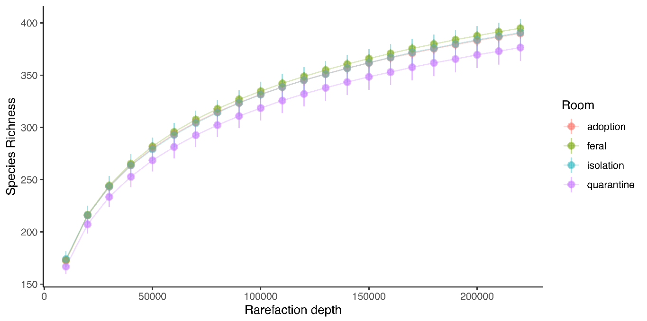
Supplementary Figure 1. Rarefaction curve that demonstrates sequencing coverage used to calculate α-diversity metrics. Each point represents a mean and each error bar represents a standard error of the mean at each rarefaction depth.

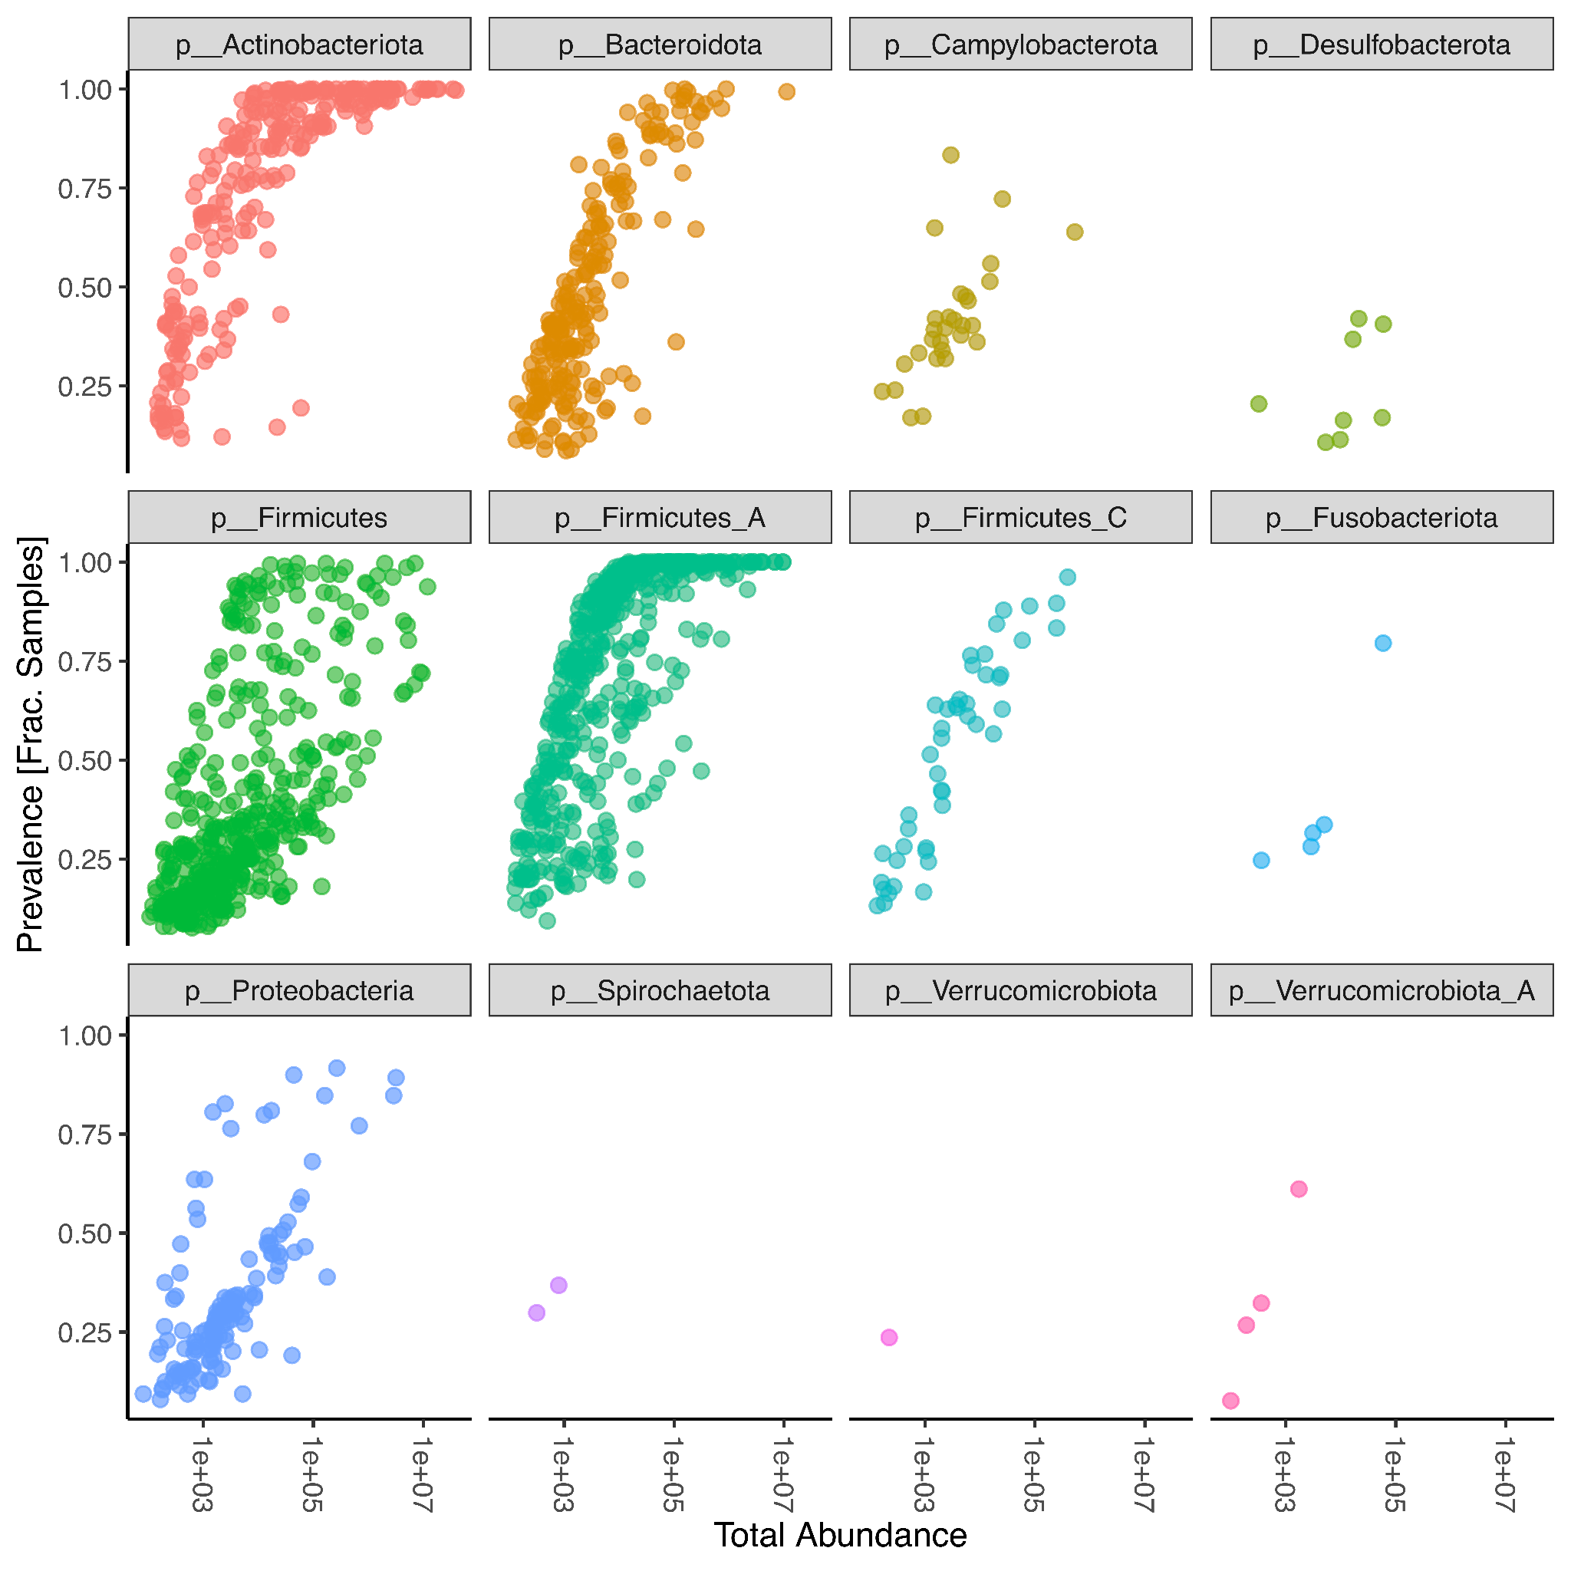

Supplementary Figure 2. Abundance and prevalence of 1,701 taxa detected in feces from n=288 cats sampled at the Wake County Animal Shelter in Raleigh, North Carolina, USA between February and July 2021. Each data point represents a taxon.

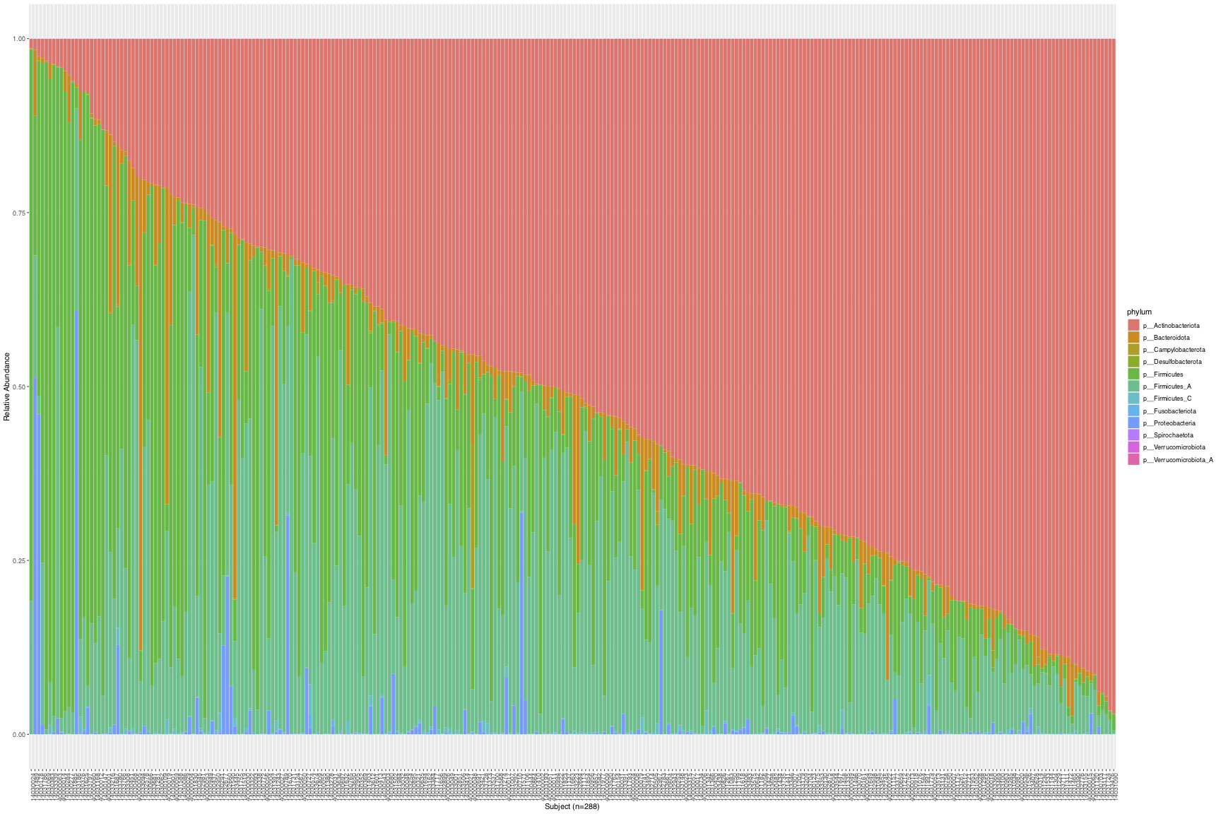
Supplementary Figure 3. Relative abundance of 12 phyla from gut microbial communities in n=288 cats sampled at the Wake County Animal Shelter in Raleigh, North Carolina, USA between February and July 2021. Bars are ordered by Actinobacteriota abundance.

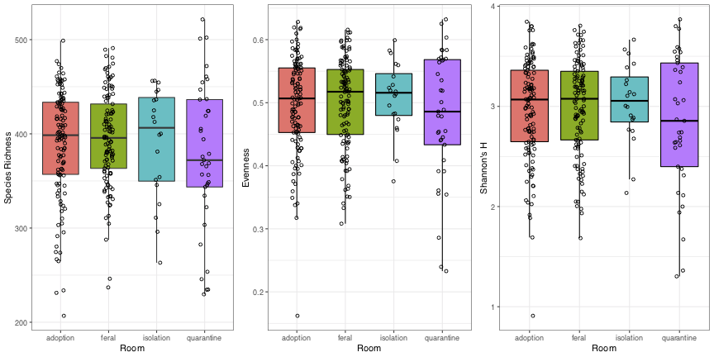
Supplementary Figure 4. α-Diversity metrics at read depth 220,000 among the samples collected from the four rooms (adoption n=117, feral n=113, isolation n=20, quarantine n=37).

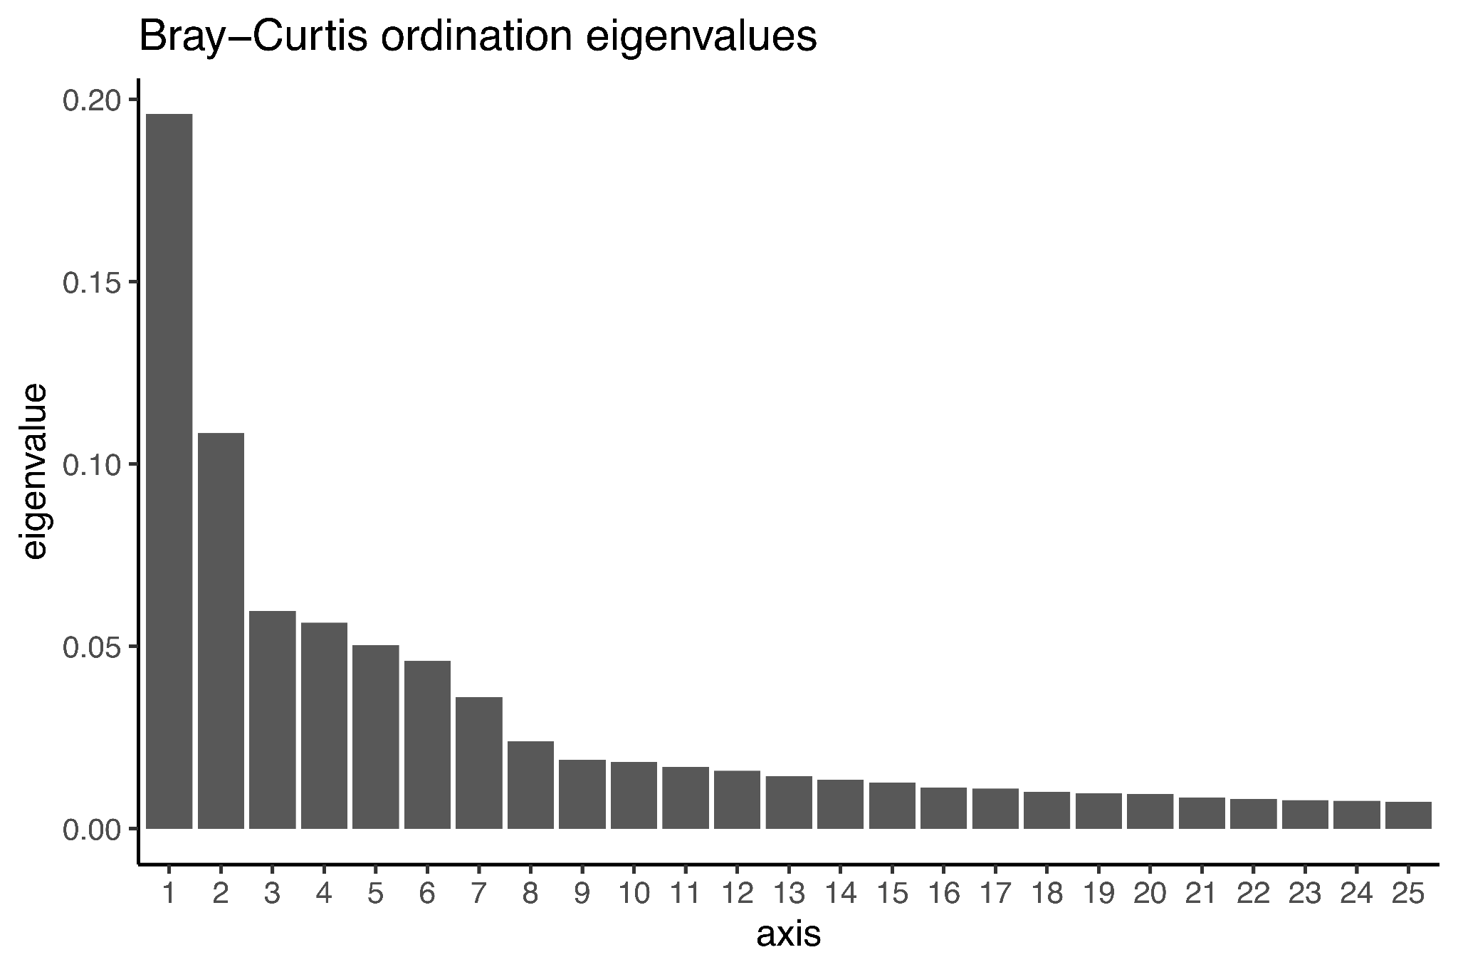
Supplementary Figure 5. Scree plot of the species data showing the first 25 PCoA axes with the highest variances (n=288).

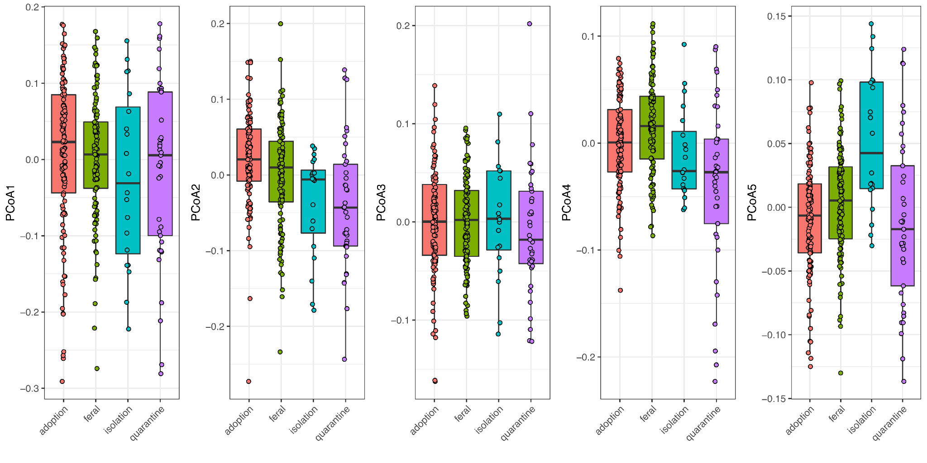

Supplementary Figure 6. Scores of the first five PCoA axes (species) in the four rooms at the shelter (adoption n=117, feral n=113, isolation n=20, quarantine n=37).

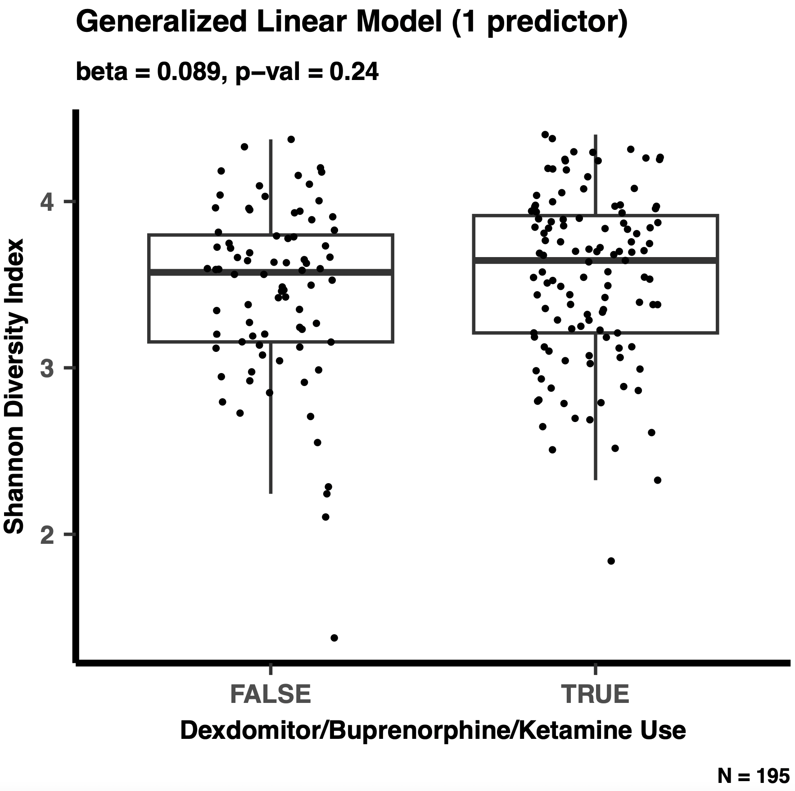
Supplementary Figure 7. The best performing generalized linear model that predicts Shannon Diversity uses “dexdomitor/buprenorphine/ketamine use” as a predictor. The association between Shannon Diversity and dexdomitor/buprenorphine/ketamine use is shown in the figure.

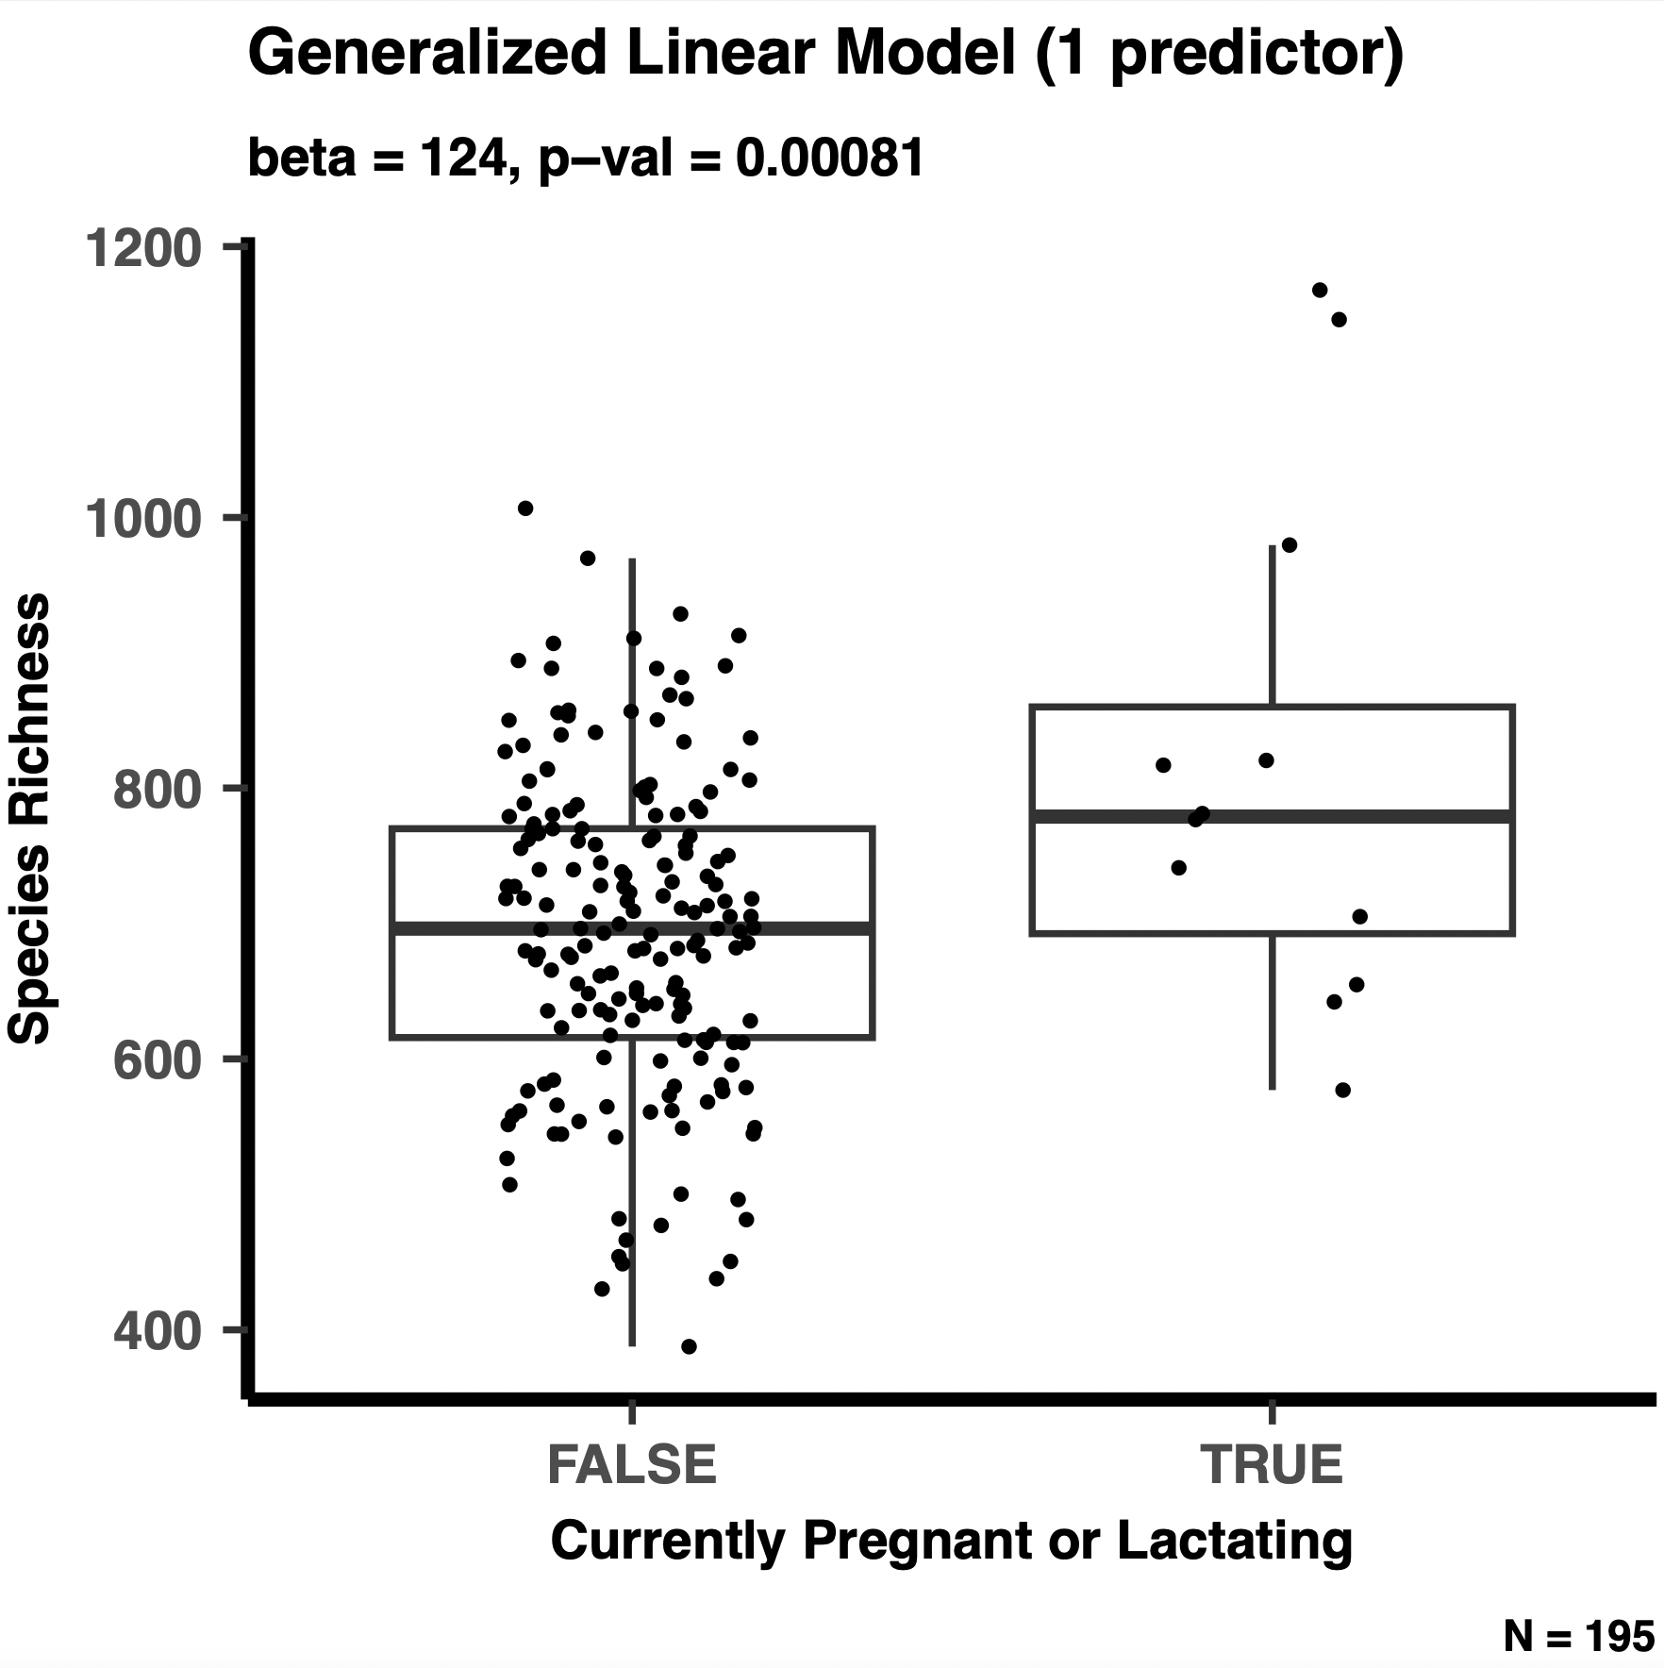
Supplementary Figure 8. The best performing generalized linear model that predicts species richness uses only “currently pregnant or lactating” as a predictor. The association between species richness and whether the cat is currently pregnant or lactating is shown in the figure.

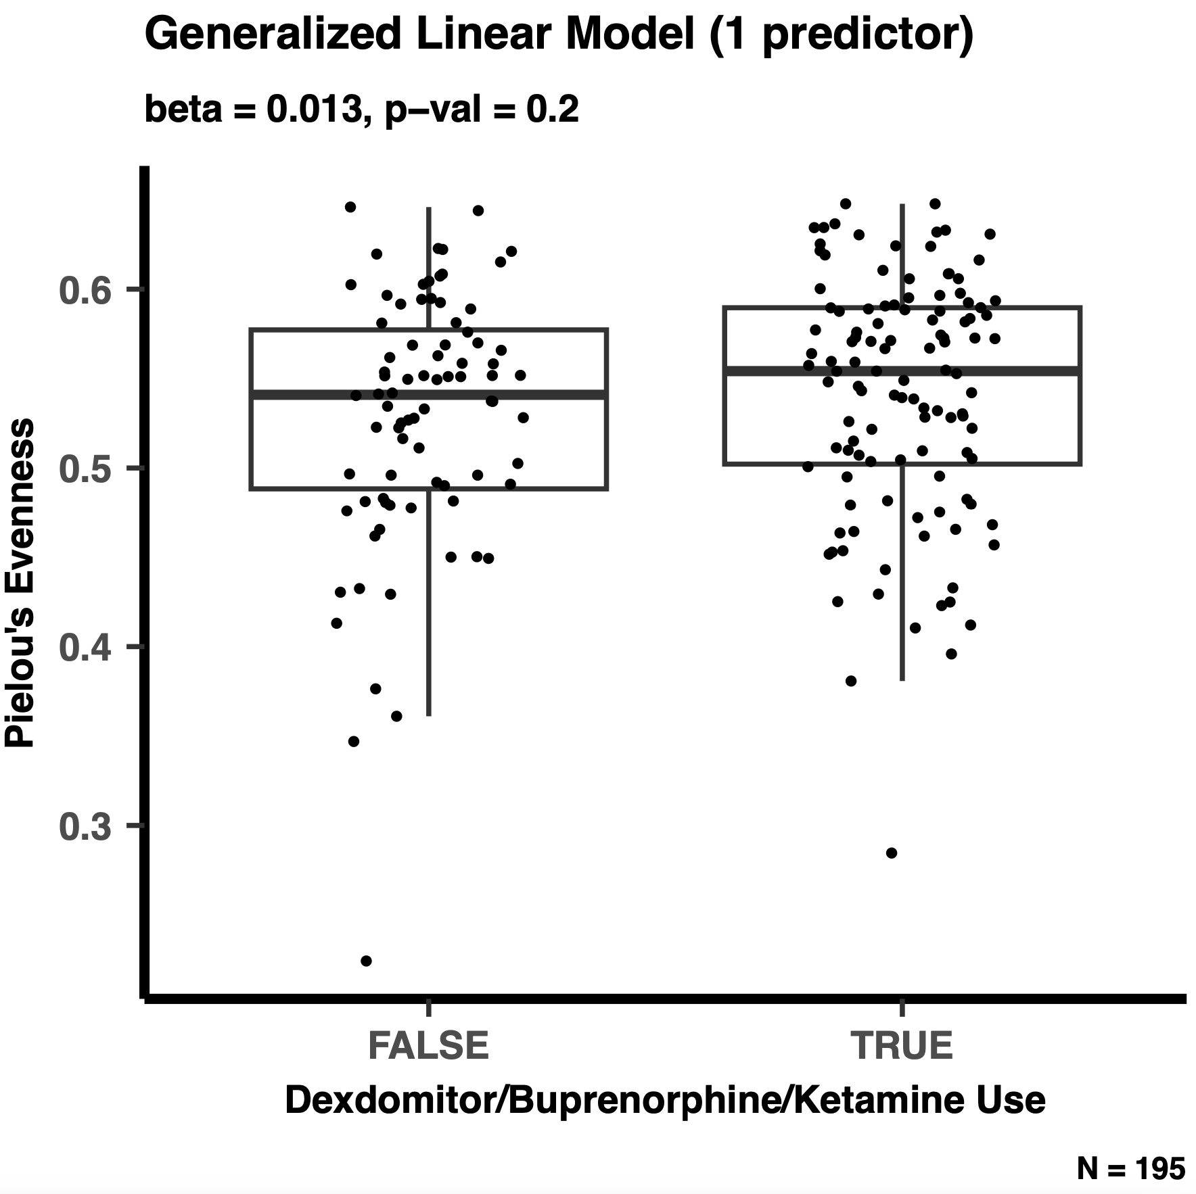

Supplementary Figure 9. The best performing generalized linear model that predicts Pielou’s evenness uses “dexdomitor/buprenorphine/ketamine use” as a predictor. The association between evenness and dexdomitor/buprenorphine/ketamine use is shown in the figure.

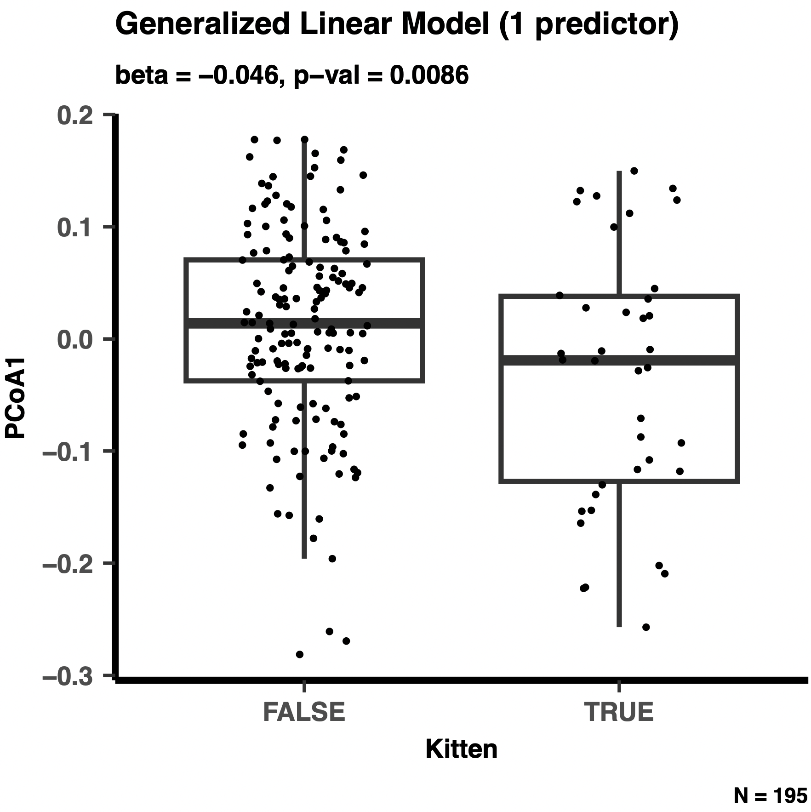
Supplementary Figure 10. The best performing generalized linear model that predicts PCoA Axis 1 position uses whether the cat is a kitten or not as the sole predictor. The association between PCoA Axis 1 position and kitten status is shown in the figure.

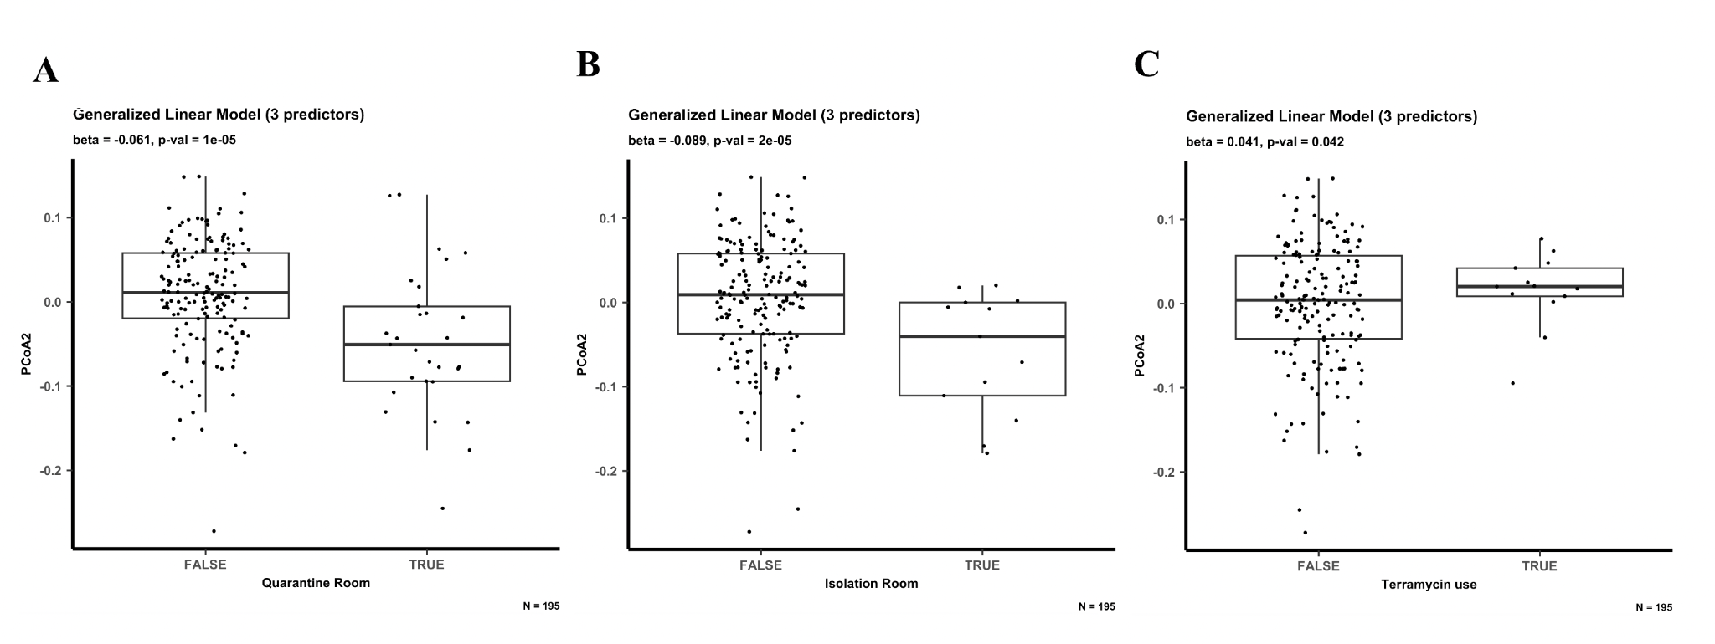

Supplementary Figure 11. The best performing generalized linear model that predicts PCoA Axis 2 position uses 3 predictors: housing in quarantine room, housing in isolation room and terramycin use. (A) Association between PCoA Axis 2 position and whether the cat was housed in the quarantine room. (B) Association between PCoA Axis 2 position and whether the cat was housed in the isolation room. (C) Association between PCoA Axis 2 position and terramycin use.

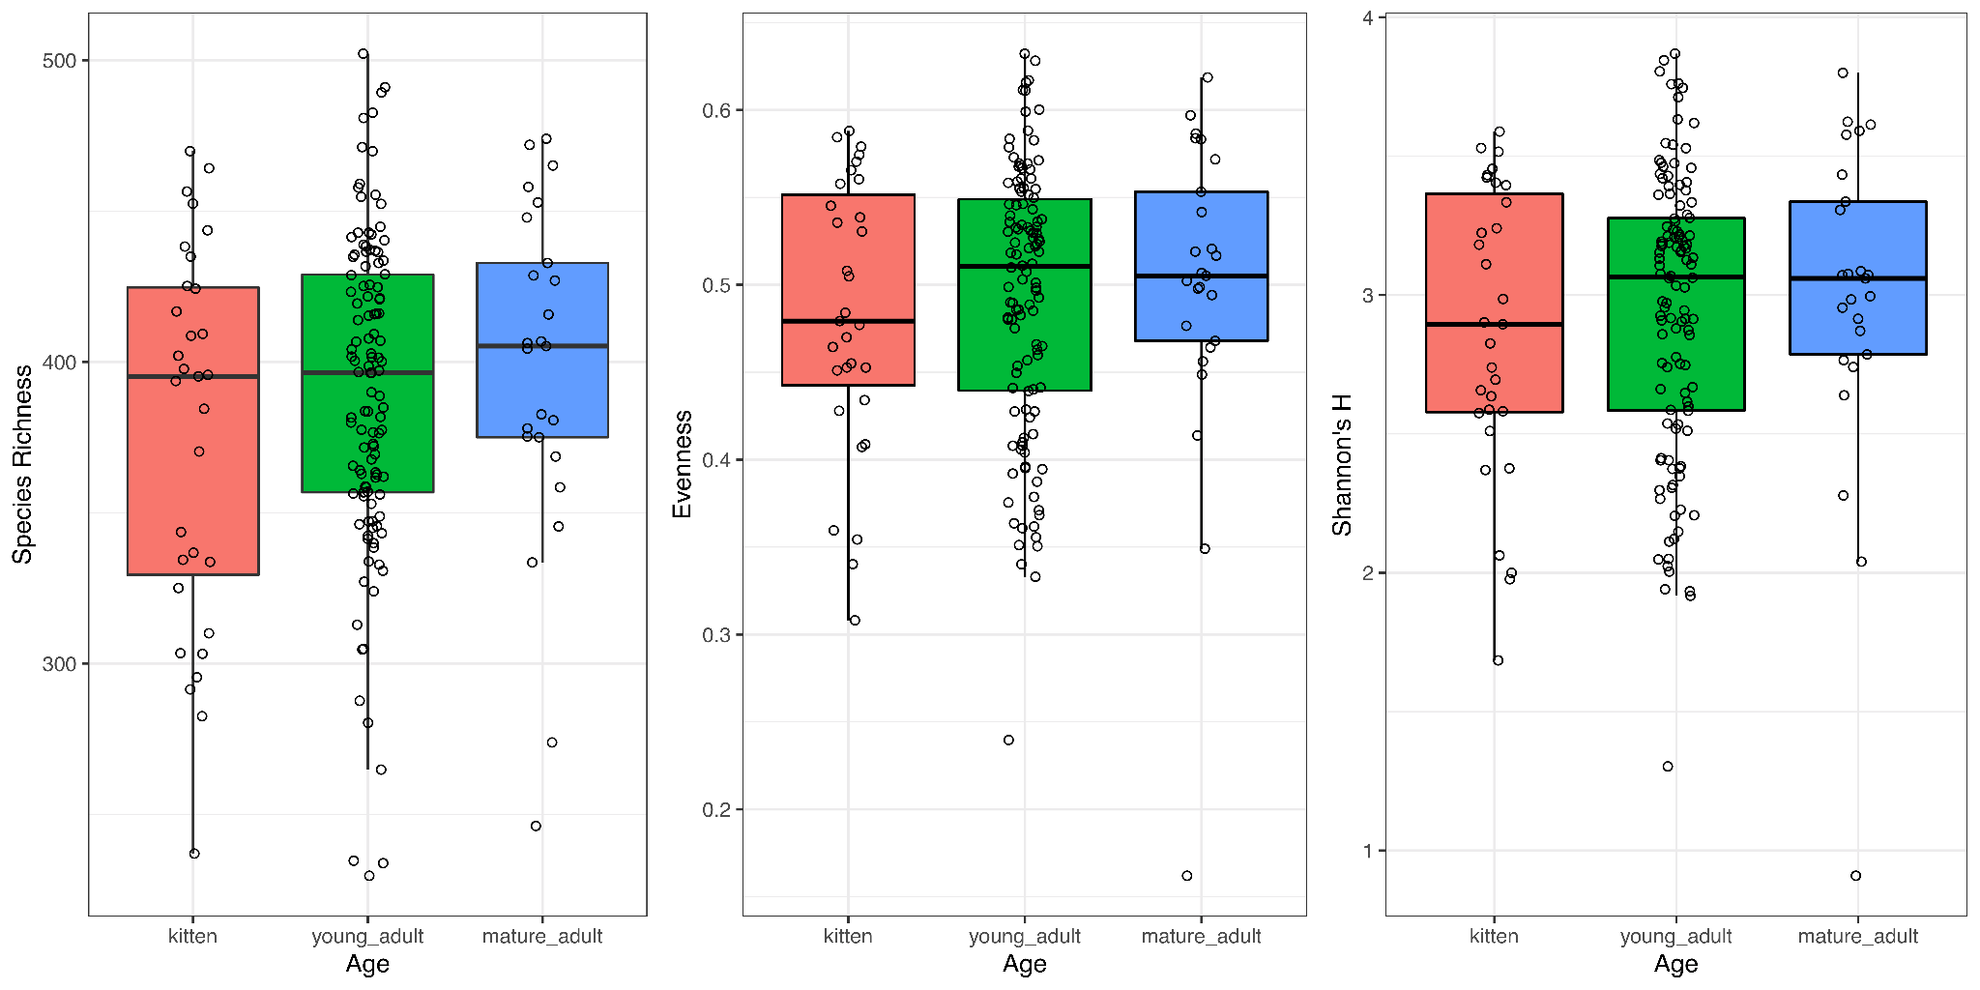

Supplementary Figure 12. α-Diversity metrics at read depth 220K in the three age groups (kitten n=31, young adult n=118, mature adult n=25).

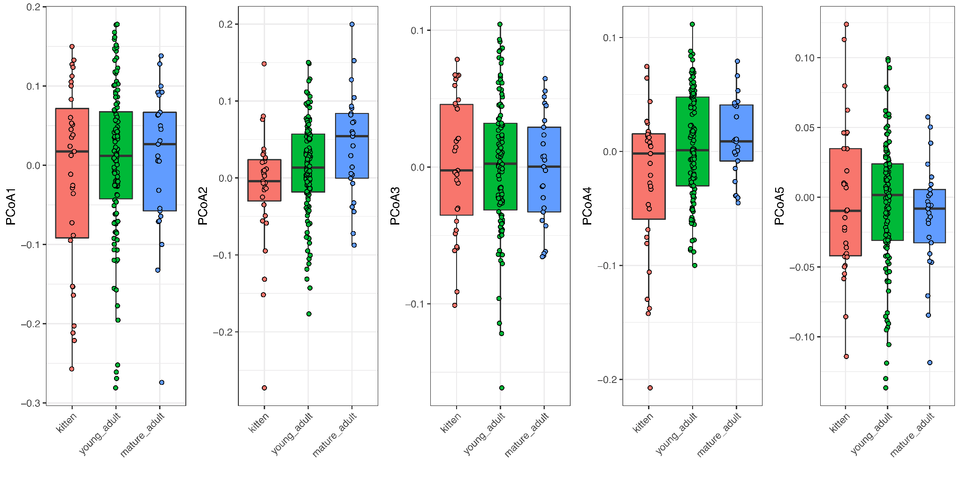
Supplementary Figure 13. Scores of the first five PCoA axes (species) in the three age groups (kitten n=31, young adult n=118, mature adult n=25).

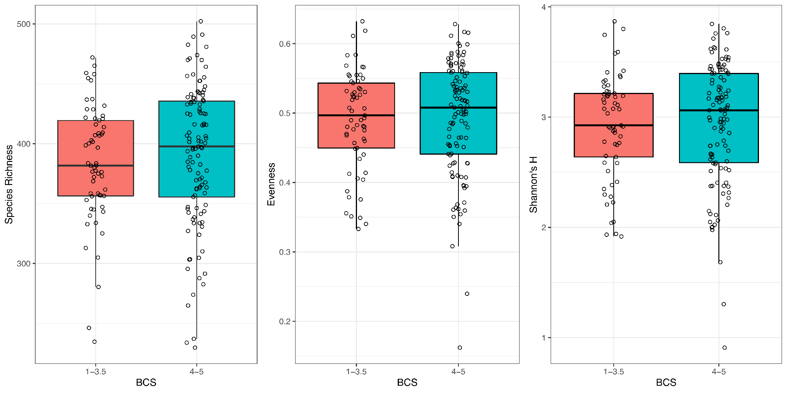
Supplementary Figure 14. α-Diversity metrics at read depth 220,000 in the two body condition score (BCS) groups (BCS 1-3.5 n=61, BCS 4-5 n=113).

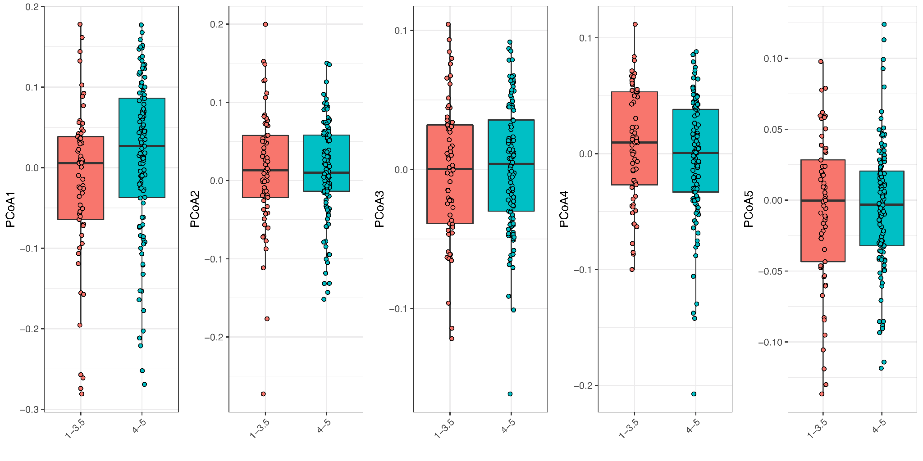
Supplementary Figure 15. Scores of the first five PCoA axes (species) in the two body condition score (BCS) groups (BCS 1-3.5 n=61, BCS 4-5 n=113)

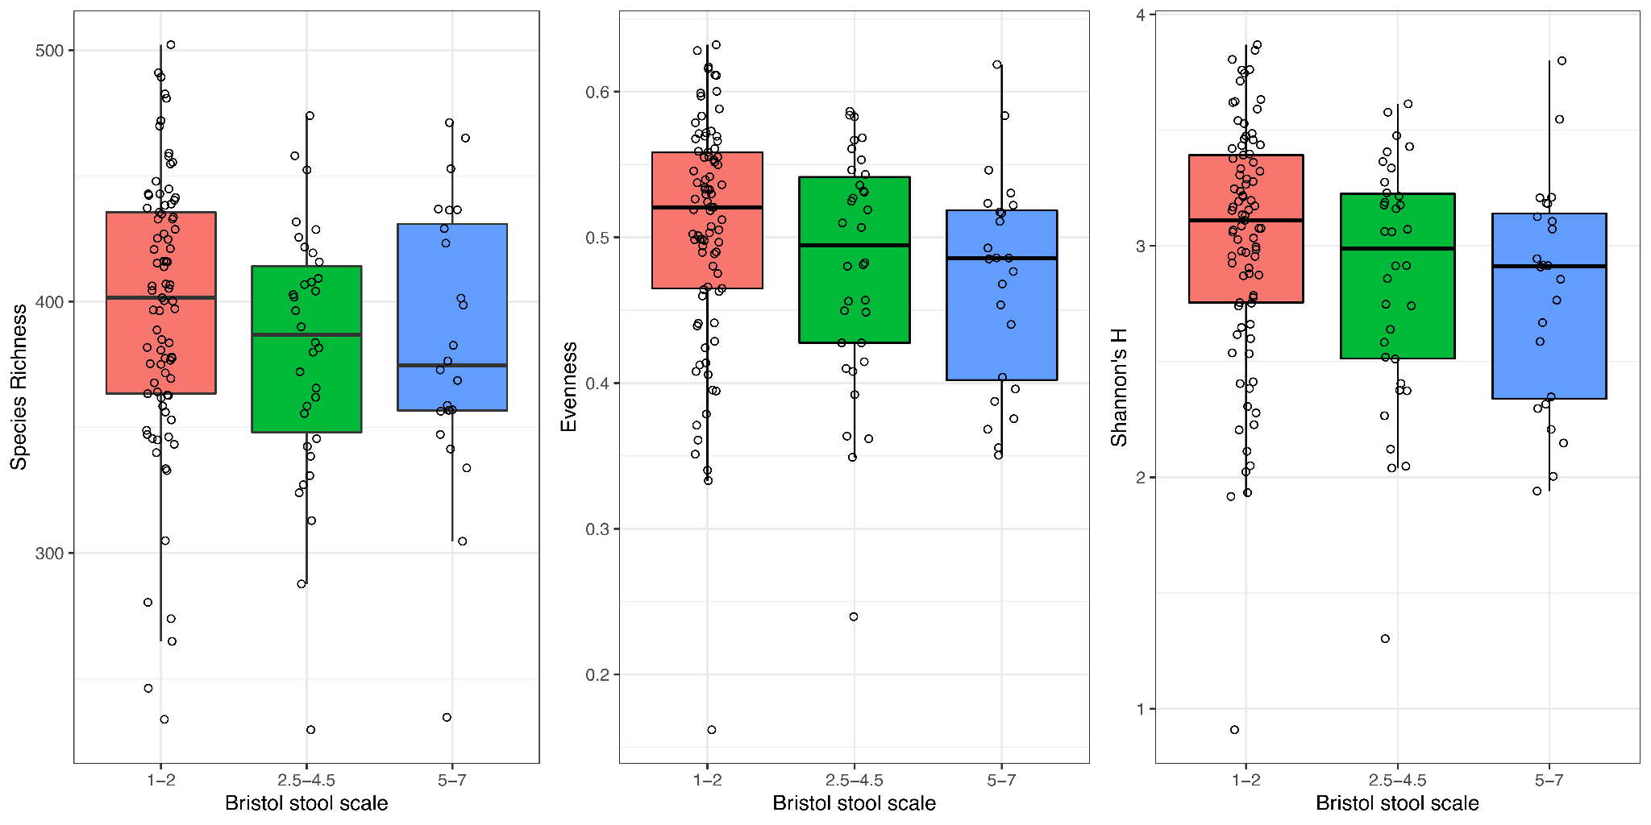
Supplementary Figure 16. α-Diversity metrics at read depth 220,000 in the three stool consistency groups (dense/constipation n=85, normal consistency n=34, loose/watery n=24).

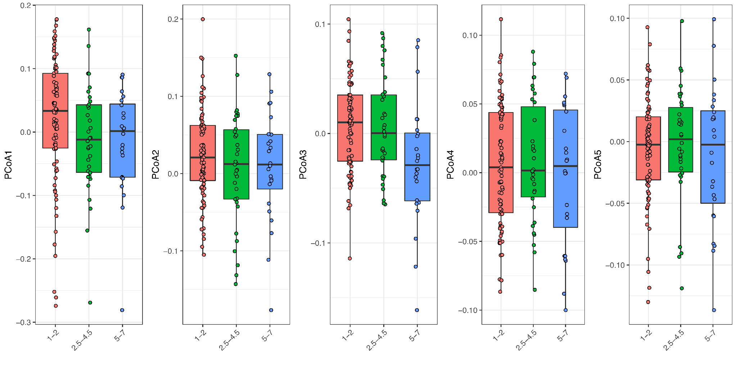
Supplementary Figure 17. Scores of the first five PCoA axes (species) in the three Bristol stool scale groups (dense/constipation n=85, normal consistency n=34, loose/watery n=24)

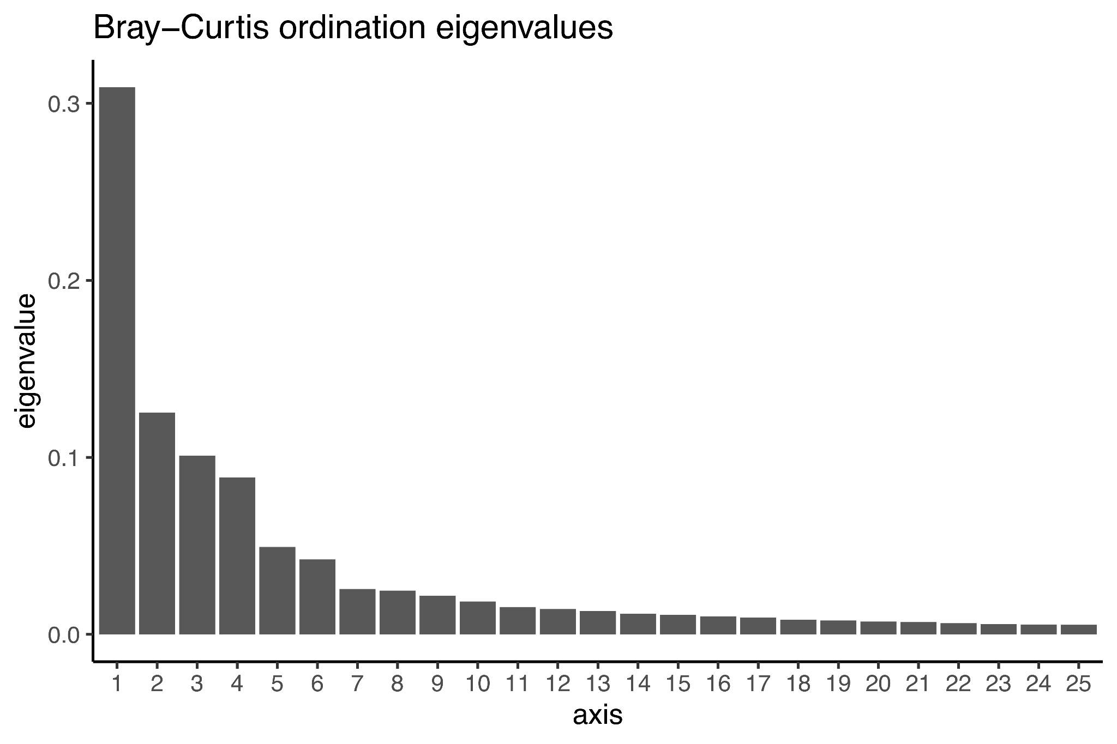
Supplementary Figure 18. Scree plot of the KO terms showing the first 25 PCoA axes with the highest variances (n=288).

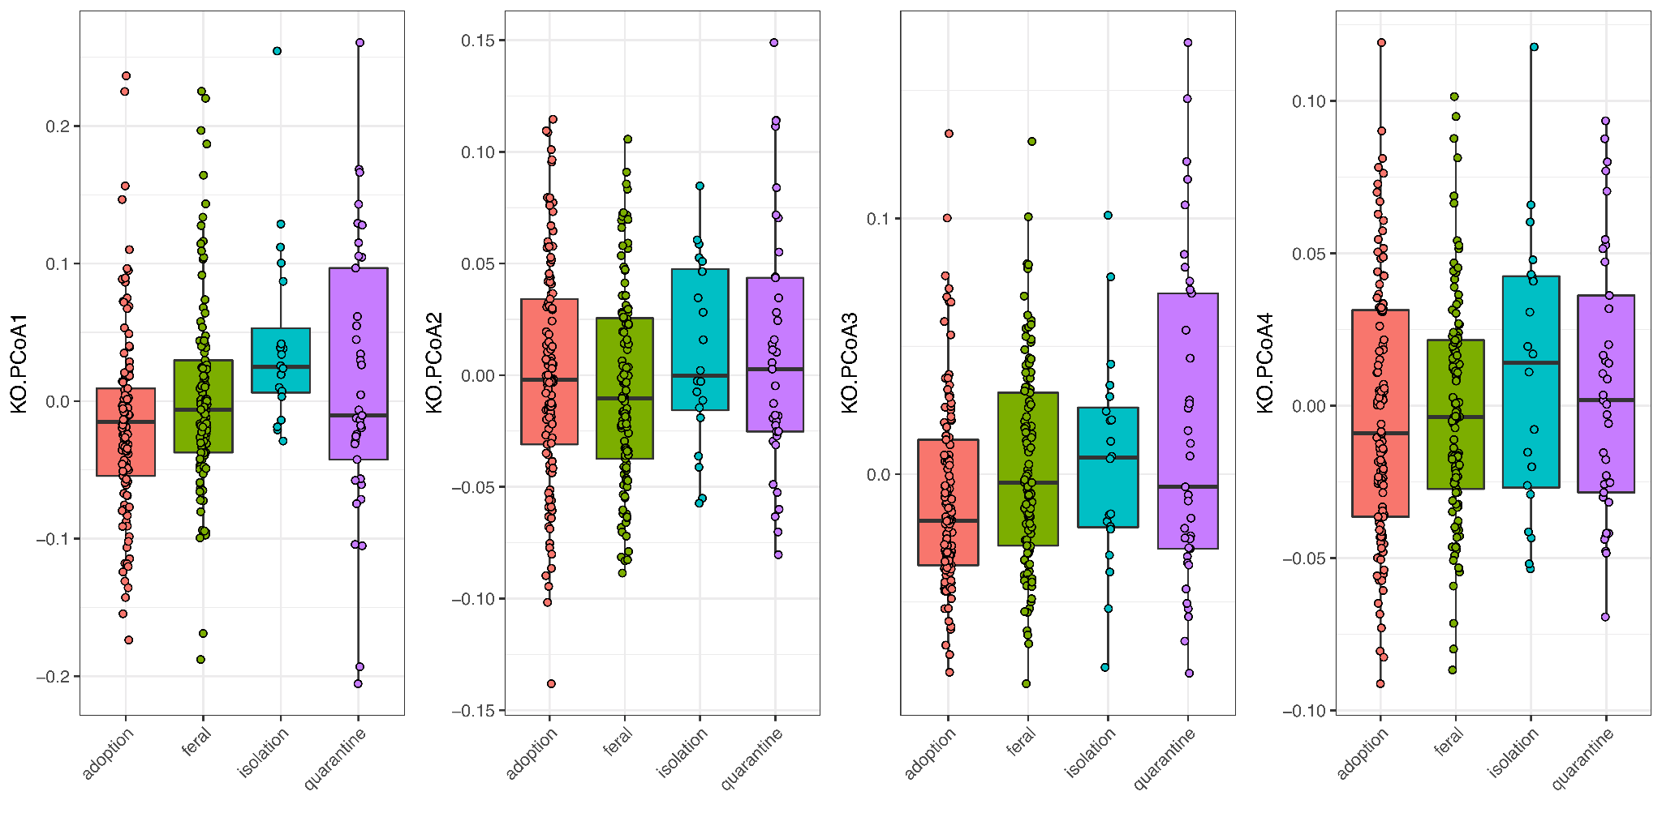
Supplementary Figure 19. Scores of the first five PCoA axes (KO terms) in the four rooms at the shelter (adoption n=117, feral n=113, isolation n=20, quarantine n=37).

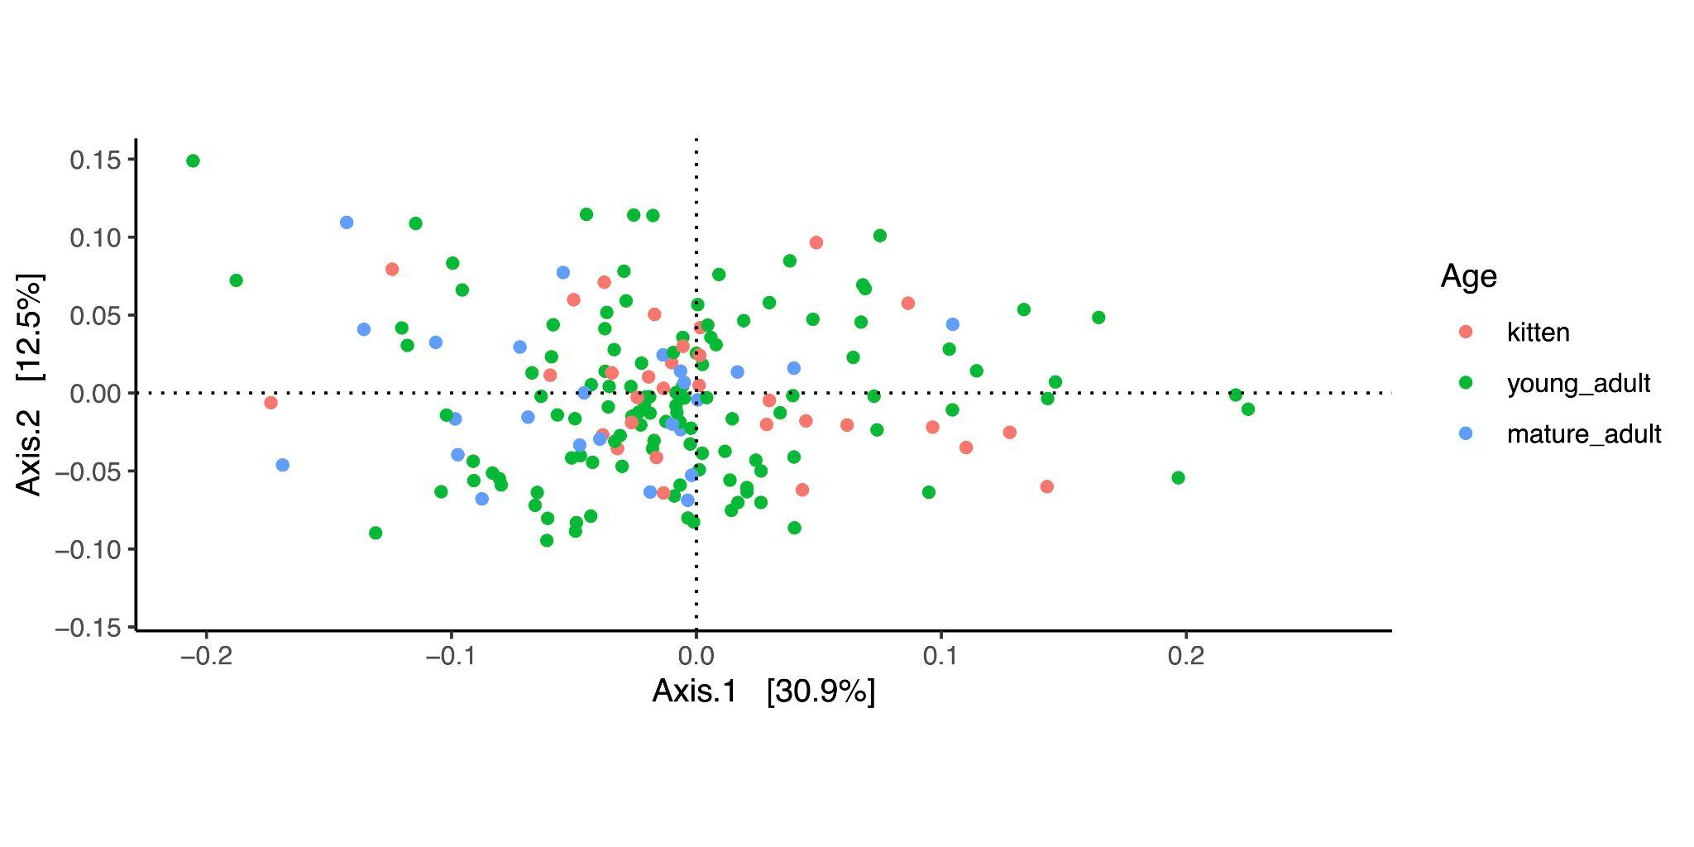
Supplementary Figure 20. PCoA plot of the first two axes (KO terms) in the three age groups using (kitten n=31, young adult n=118, mature adult n=25)

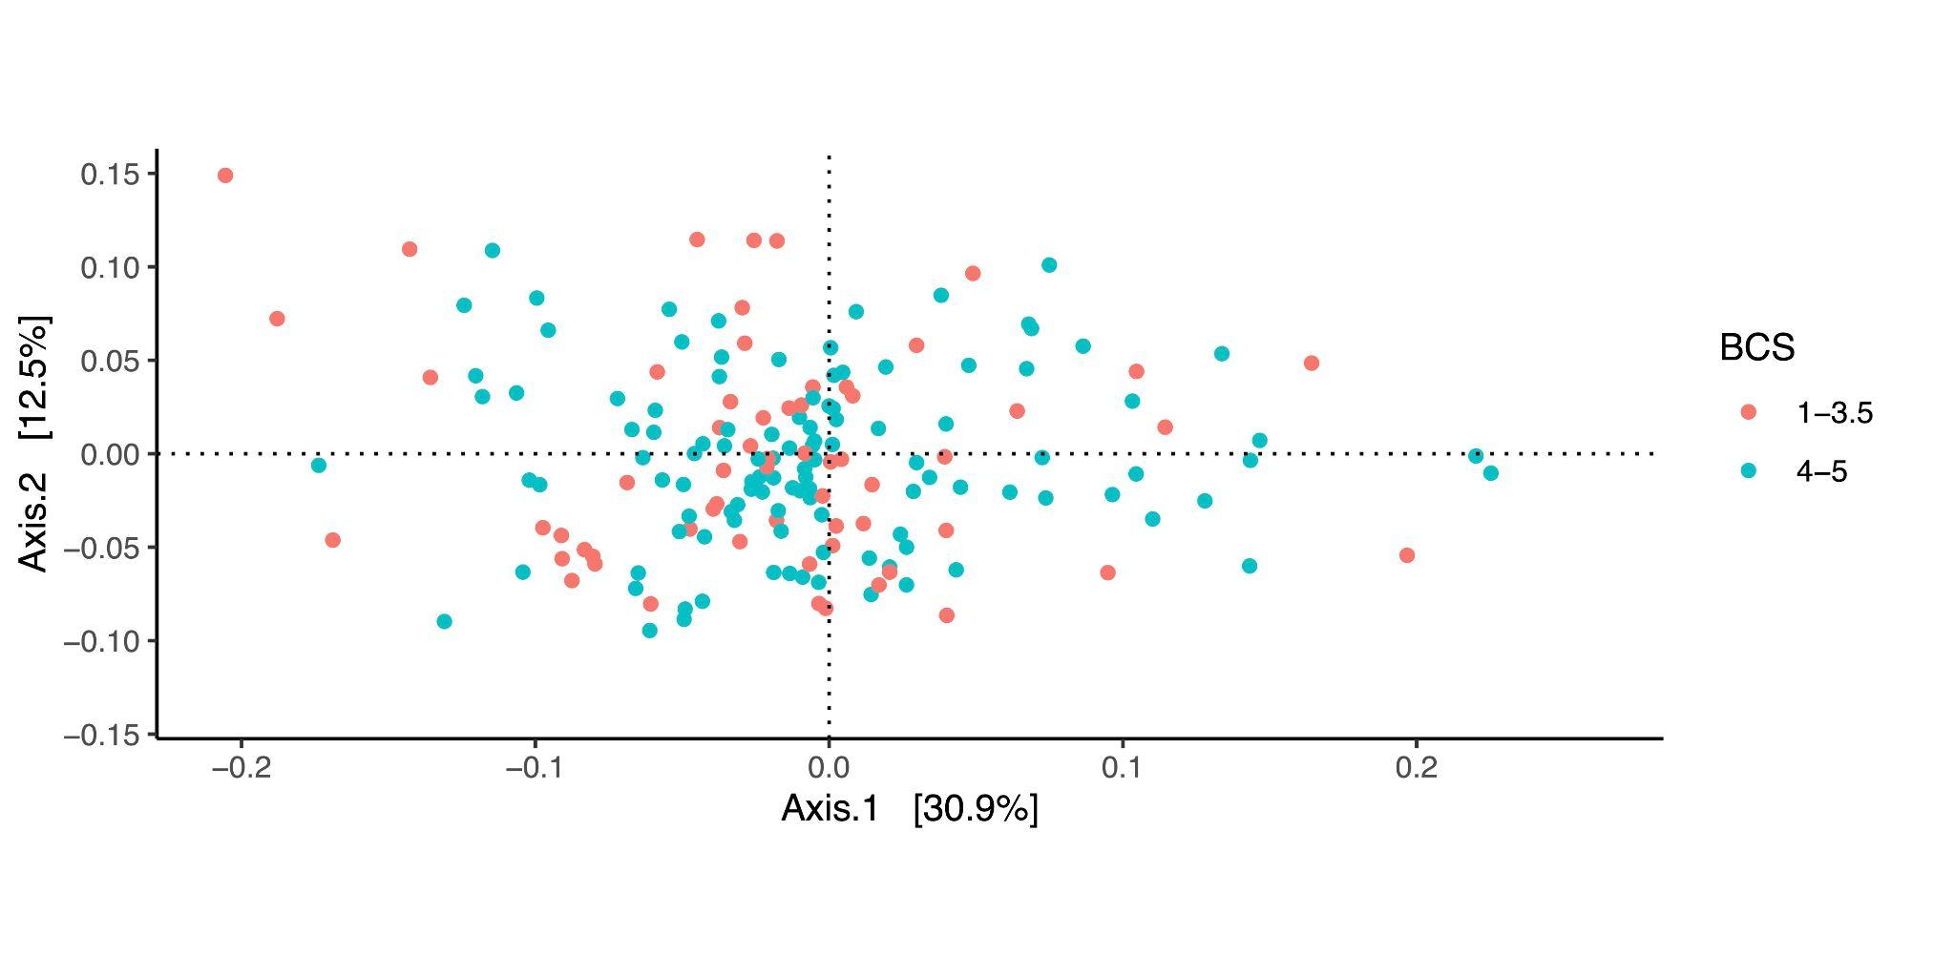Supplementary Figure 21. PCoA plot of the first two axes (KO terms) in the two body condition score (BCS) groups (BCS 1-3.5 n=61, BCS 4-5 n=113)

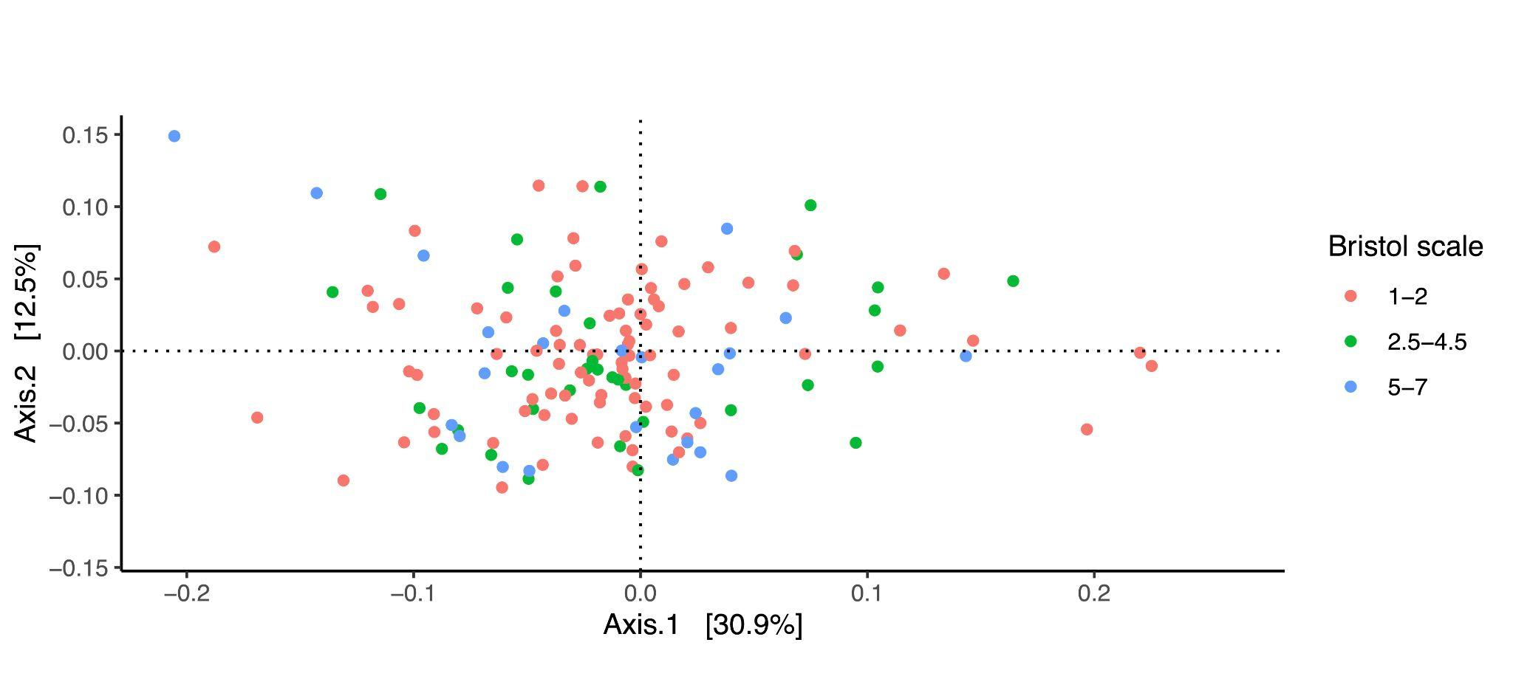
Supplementary Figure 22. PCoA plot of the first two axes (KO terms) in the three Bristol stool scale groups (dense/constipation n=85, normal consistency n=34, loose/watery n=24)

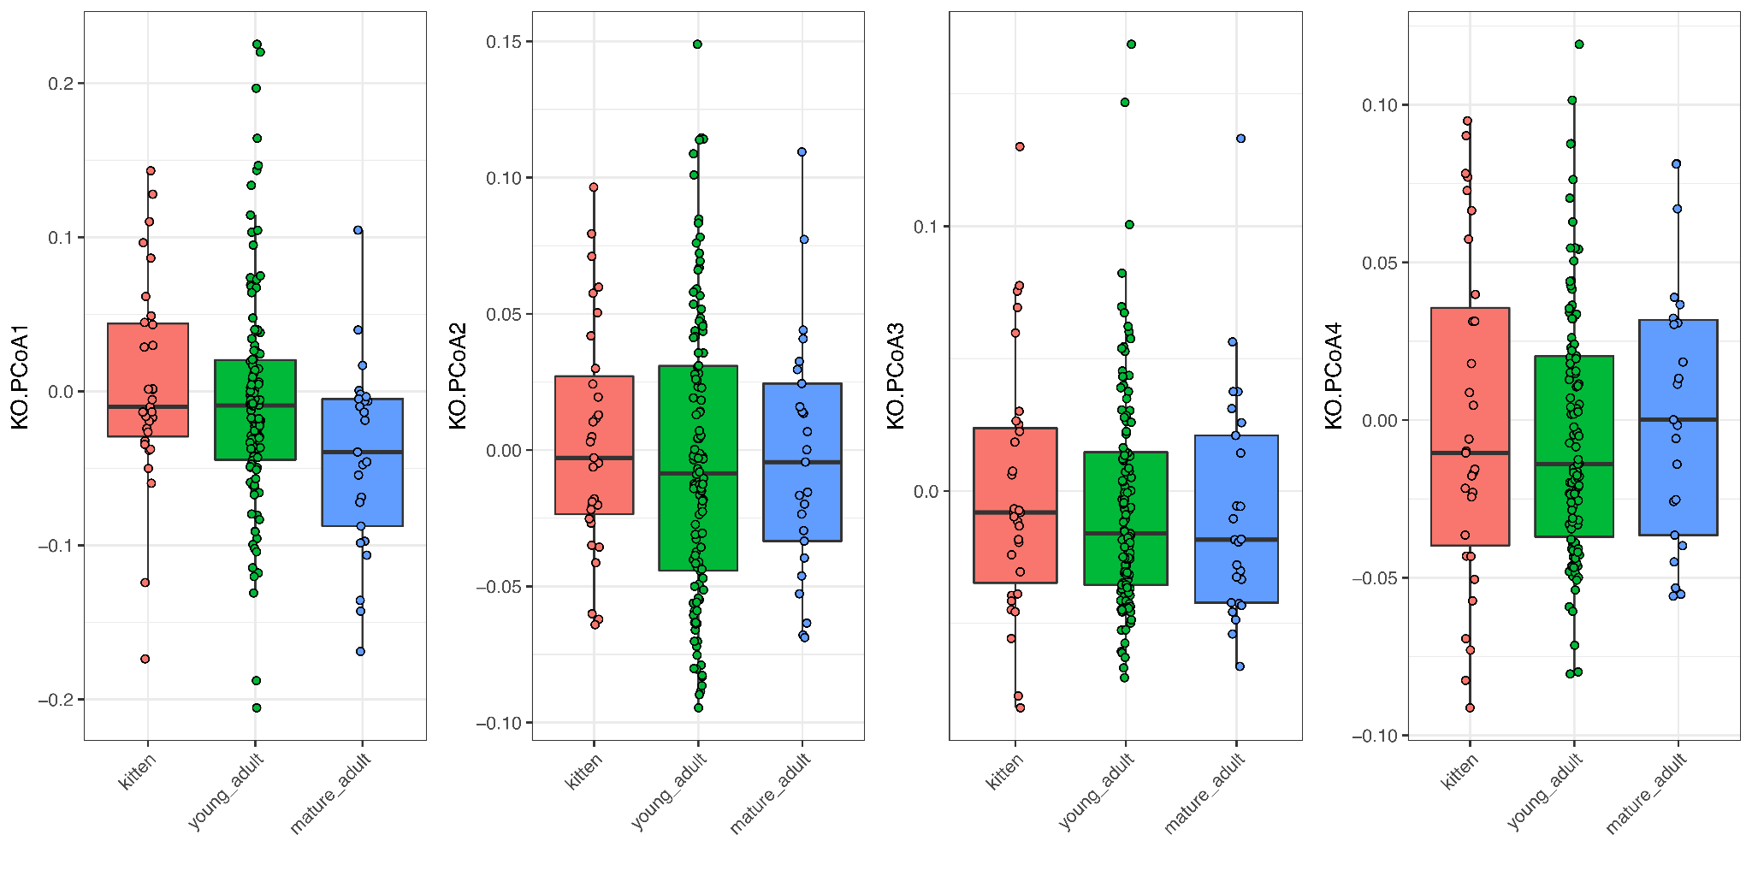
Supplementary Figure 23. Scores of the first four PCoA axes (KO terms) in the three age groups (kitten n=31, young adult n=118, mature adult n=25)

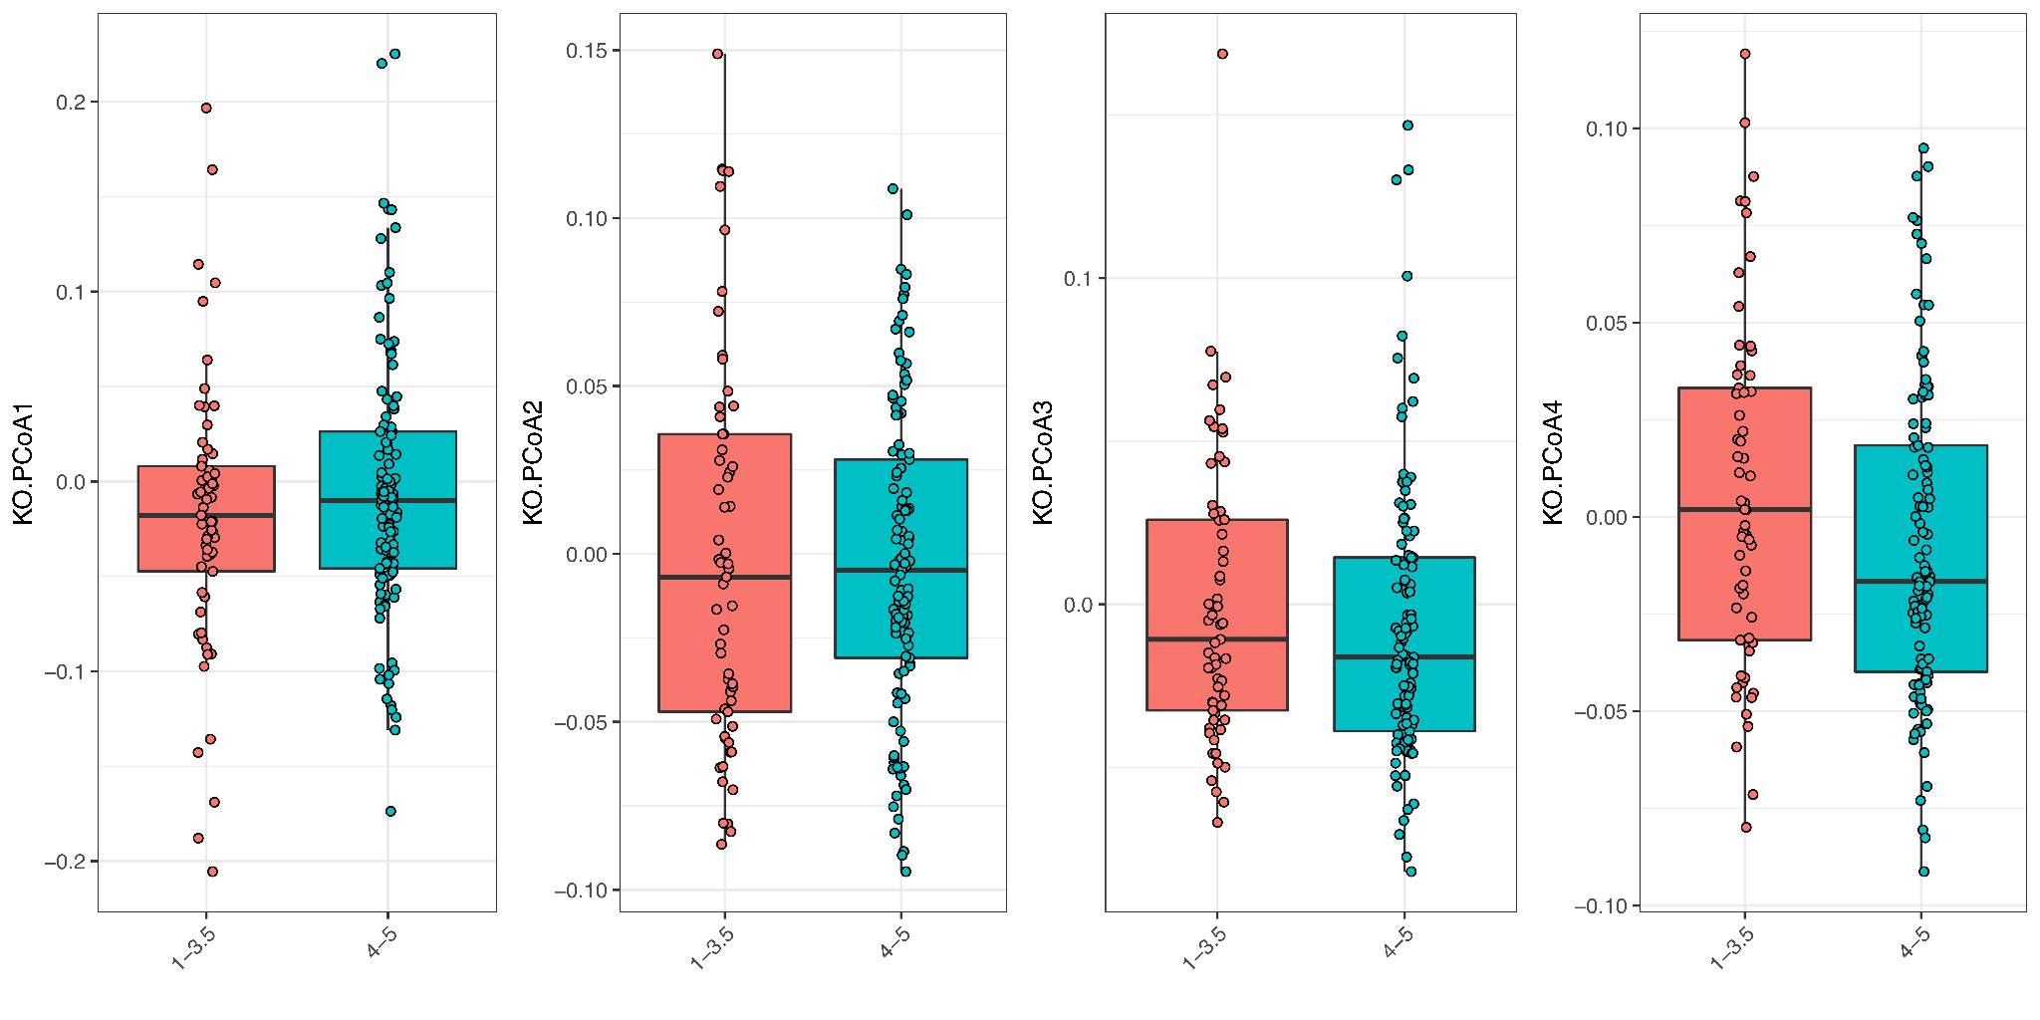
Supplementary Figure 24. Scores of the first four PCoA axes (KO terms) in the two body condition score (BCS) groups (BCS 1-3.5 n=61, BCS 4-5 n=113)

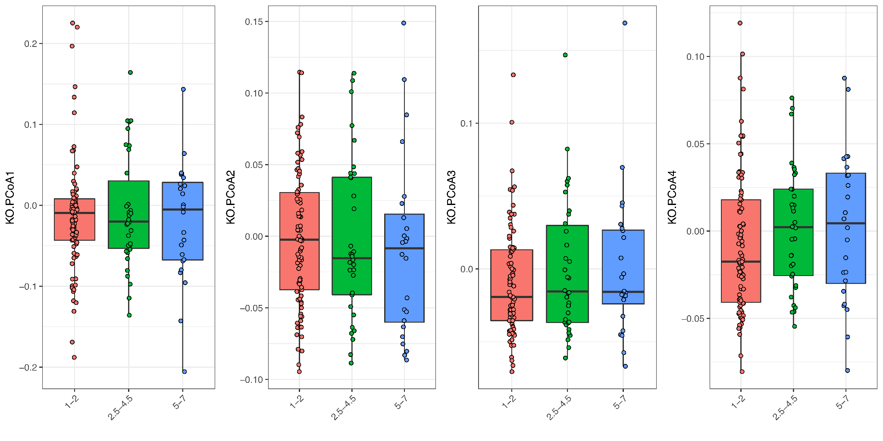
Supplementary Figure 25. Scores of the first four PCoA axes (KO terms) in the three Bristol stool scale groups (dense/constipation n=85, normal consistency n=34, loose/watery n=24)

