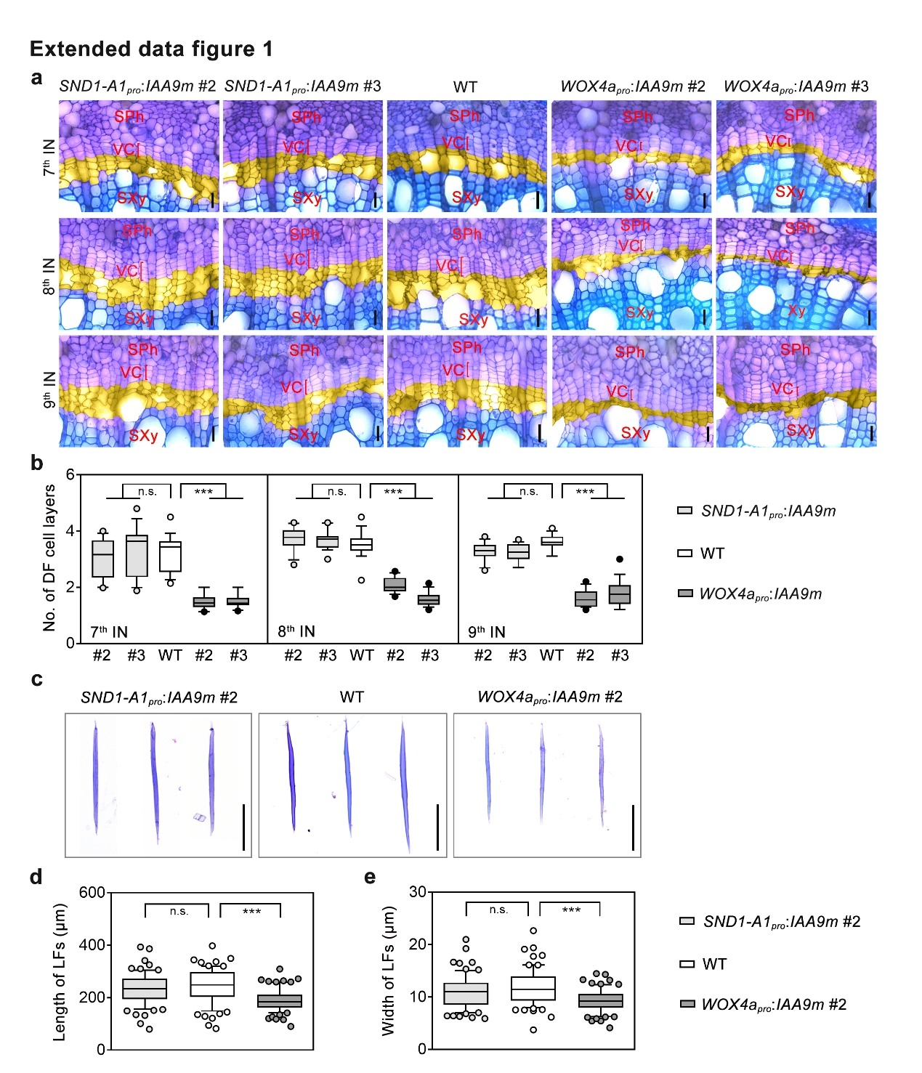
Extended data figure 1. The cell layers of developing fibres and the length and width of lignified fibres of WT and SND1-A1_{pro}:IAA9m and WOX4a_{pro}:IAA9m transgenics.
a, Anatomical sections of the 7th, 8th and 9th internodes of 3-month-old WT and SND1-A1_{pro}:IAA9m and WOX4a_{pro}:IAA9m transgenics. The developing fibre cell layers are in yellow. Scale bars, 30 μm. b, Number of developing fibre cell layers in the 7th, 8th and 9th internodes of 3-month-old WT and SND1-A1_{pro}:IAA9m and WOX4a_{pro}:IAA9m transgenics. c, Cellular morphology of lignified fibres isolated from the 10th internodes of 3-month-old WT and SND1-A1_{pro}:IAA9m #2 and WOX4a_{pro}:IAA9m #2 transgenics. d and e, The length (d) and width (e) of lignified fibres isolated from the 10th internodes of 3-month-old WT and SND1-A1_{pro}:IAA9m #2 and WOX4a_{pro}:IAA9m #2 transgenics. In a and c, the cross-sections (a) and fibre cells (c) were stained with toluidine blue. In b, the average value was calculated using the number of developing fibre cell layers of 10 radial cell files from one cross-section. Eighteen cross-sections from three biological replicates were analyzed (n=18). In d and e, 24 lignified fibre cells were quantified for each biological replicate. Three biological replicates were analyzed. n=72 for d and e. The boxes show the median and 10-90 percentile, and the whiskers represent the data range excluding outliers. In b, d and e, one-way ANOVA analysis followed by Dunnett test for pairwise comparison was performed to test significant differences among WT and transgenic lines. ***, P<0.001; n.s., not significant. DF, developing fibre; LF, lignified fibre; SXy, secondary xylem; VC, vascular cambium; Ve: vessel.

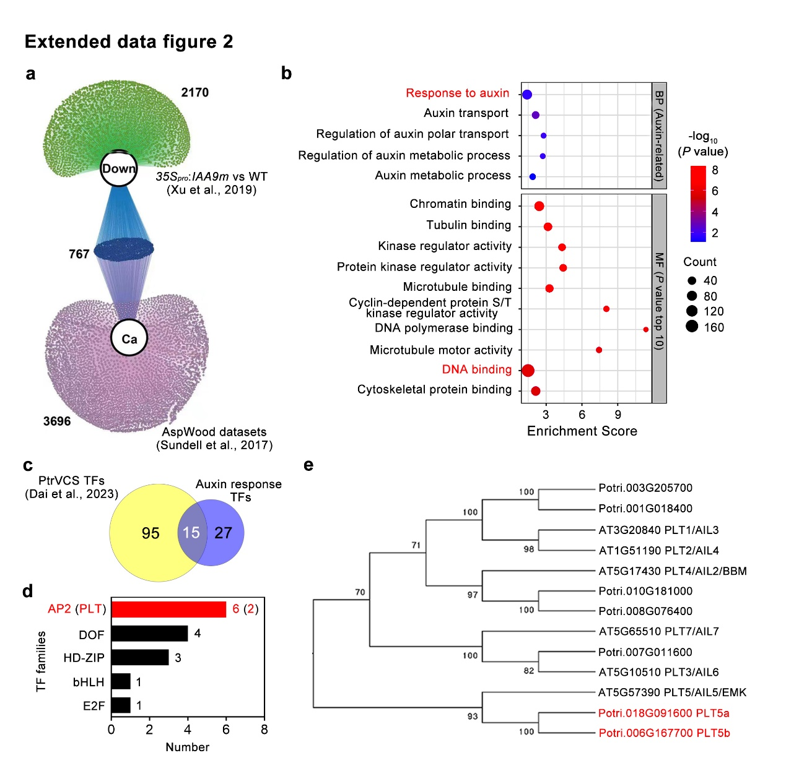
Extended data figure 2. Identification of PLT5a and PLT5b from the transcriptome datasets of IAA9m-overexpressing poplar lines.
a, Network diagram of the genes that are repressed by IAA9m overexpression and specifically expressed in vascular cambium. The transcriptome data of 35S_{pro}:IAA9m are from our previous study (Xu et al., 2019, New Phytologist). The data of genes specifically expressed in vascular cambium are from AspWood database (Sundell et al., 2017, Plant Cell). The network is constructed with Gephi software. Ca, cambium; Down, down-regulated genes by IAA9m overexpression. The numbers in the diagram represent the number of genes in different clusters. b, Enrichment of GO terms of the genes that are down-regulated by IAA9m overexpression and specifically expressed in vascular cambium. c, Venn diagram of the transcription factors (TFs) that are down-regulated by IAA9m overexpression and specifically expressed in vascular cambium versus those identified as vascular cambium-specific (VCS) TFs by Dai et al.(2023). d, The families of 15 identified vascular cambium specific TFs that are responsive to auxin. The number of identified members from each family is indicated. e, The phylogenetic analysis of PLT proteins from Arabidopsis and poplar. The PLT5 homologs are indicated in red.
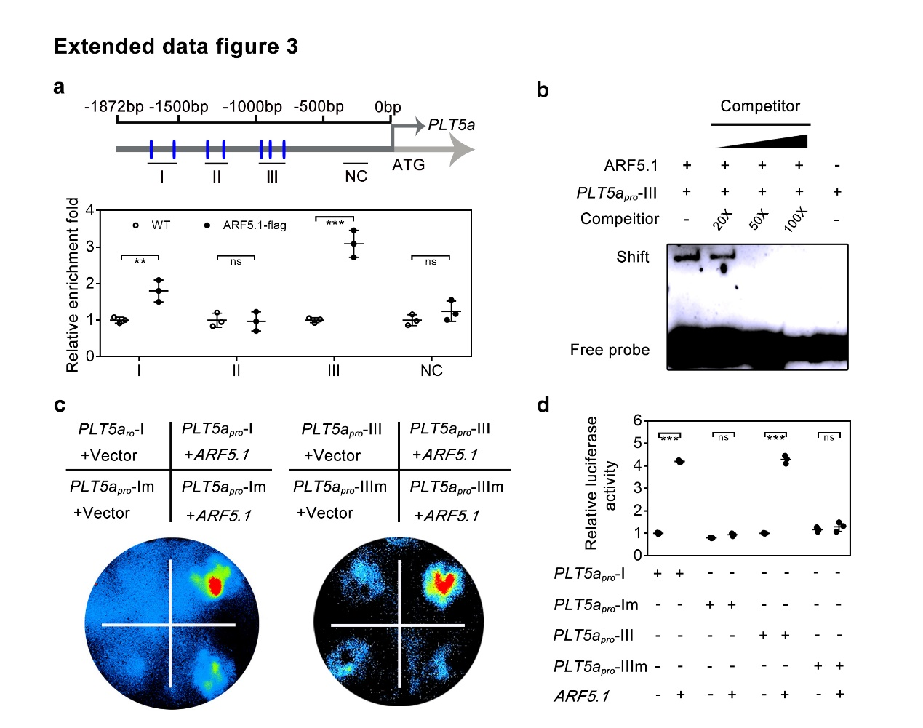
Extended data figure 3. Auxin Response Factor (ARF) 5.1 directly targets PLT5a to activate its expression.
a, Distribution of predicted ARF5.1-binding sites within the promoter of PLT5a and ChIP-qPCR analysis. b, The binding capacity of ARF5.1 proteins to the PLT5a promoter fragment examined by EMSA. c, Luciferase-based effector-reporter assays of ARF5.1-activated PLT5a expression in transiently transfected tobacco leaf cells. d, Quantification of luciferase activities. In c to d, PLT5a_{pro}-IVm indicates the promoter regions of SND1-A2, SND1-B1 and SND1-B2 with impaired binding sites of ARF5.1 proteins generated by site-directed mutagenesis. The data are shown as mean ± s.d.; n = 3. One-way ANOVA analysis followed by Dunnett test for pairwise comparison was performed to evaluated significant differences. ***, P<0.001; **, P<0.01; *, P<0.05; n.s., not significant.

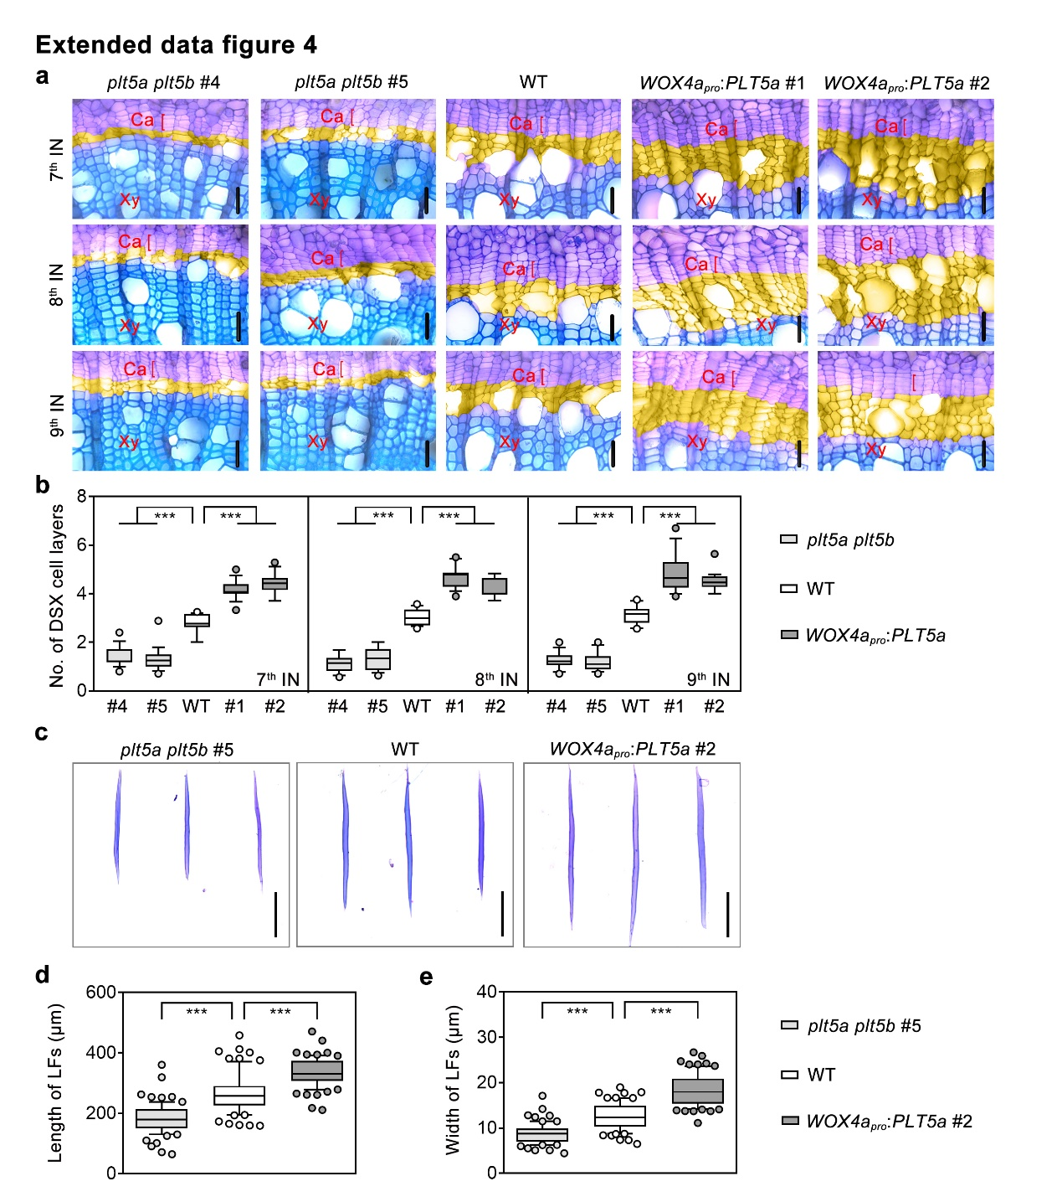
Extended data figure 4. The cell layers of developing fibres and the length and width of lignified fibres of WT, plt5a plt5b double mutants and WOX4a_{pro}:PLT5a transgenics.
a, Anatomical sections of the 7th, 8th and 9th internodes of 3-month-old WT, plt5a plt5b mutants and WOX4a_{pro}:PLT5a transgenics. The developing fibre cell layers are in yellow. Scale bars, 30 μm. b, Number of developing fibre cell layers in the 7th, 8th and 9th internodes of 3-month-old WT, plt5a plt5b mutants and WOX4a_{pro}:PLT5a transgenics. c, Cellular morphology of lignified fibres isolated from the 10th internodes of 3-month-old WT, plt5a plt5b #5 mutants and WOX4a_{pro}:PLT5a #2 transgenics. d and e, The length (d) and width (e) of lignified fibres isolated from the 10th internodes of 3-month-old WT, plt5a plt5b #5 mutants and WOX4a_{pro}:PLT5a #2 transgenics. In a and c, the cross-sections (a) and fibre cells (c) were stained with toluidine blue. In b, the average value was calculated using the number of developing fibre cell layers of 10 radial cell files from one cross-section. Eighteen cross-sections from three biological replicates were analyzed (n=18). In d and e, 24 lignified fibre cells were quantified for each biological replicate. Three biological replicates were analyzed. n=72 for d and e. The boxes show the median and 10-90 percentile, and the whiskers represent the data range excluding outliers. In b, d and e, one-way ANOVA analysis followed by Dunnett test for pairwise comparison was performed to test significant differences among WT and transgenic lines. ***, P<0.001; n.s., not significant. DF, developing fibre; LF, lignified fibre; SXy, secondary xylem; VC, vascular cambium; Ve: vessel.

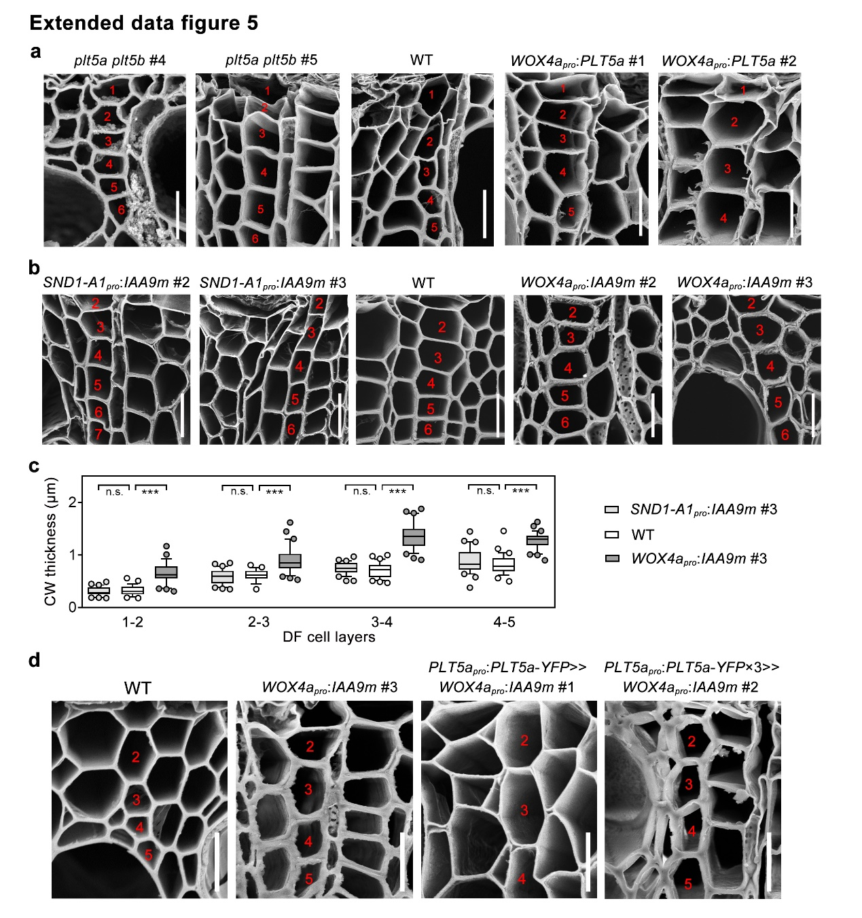
Extended data figure 5. The cell wall thickness of fibres across radial cells files of WT and IAA9m- and PLT5a-associated transgenics.
a, SEM analyses of developing fibre cells in the 8th internodes of 3-month-old WT, plt5a plt5b double mutants and WOX4a_{pro}:PLT5a transgenics. Scale bars: 15 μm. b, SEM analyses of developing fibre cells in the 8th internodes of 3-month-old WT and SND1-A1_{pro}:IAA9m and WOX4a_{pro}:IAA9m transgenics. Scale bars: 15 μm. c, Quantification of cell wall thickness at the 1st to 5th developing fibre cell layers of WT and SND1-A1_{pro}:IAA9m #3 and WOX4a_{pro}:IAA9m #3 transgenics. d, SEM analyses of developing fibre cells in the 8th internodes of 3-month-old WT and WOX4a_{pro}:IAA9m #3, PLT5a_{pro}:PLT5a-YFP>> WOX4a_{pro}:IAA9m #1 and PLT5a_{pro}:PLT5a-YFP×3>>WOX4a_{pro}:IAA9m #2 transgenics. In c, the cell wall thickness between neighboring developing fibre cell layers was measured from 30 radial cell files representing three biological replicates. n=30 for c. The boxes show the median and 10-90 percentile, and the whiskers represent the data range excluding outliers. One-way ANOVA analysis followed by Dunnett test for pairwise comparison was performed to evaluate significant differences among WT and transgenic lines. ***, P<0.001; n.s., not significant. In a, b and d, the numbers in red indicate the developing fibre cell layers. CW, cell wall.

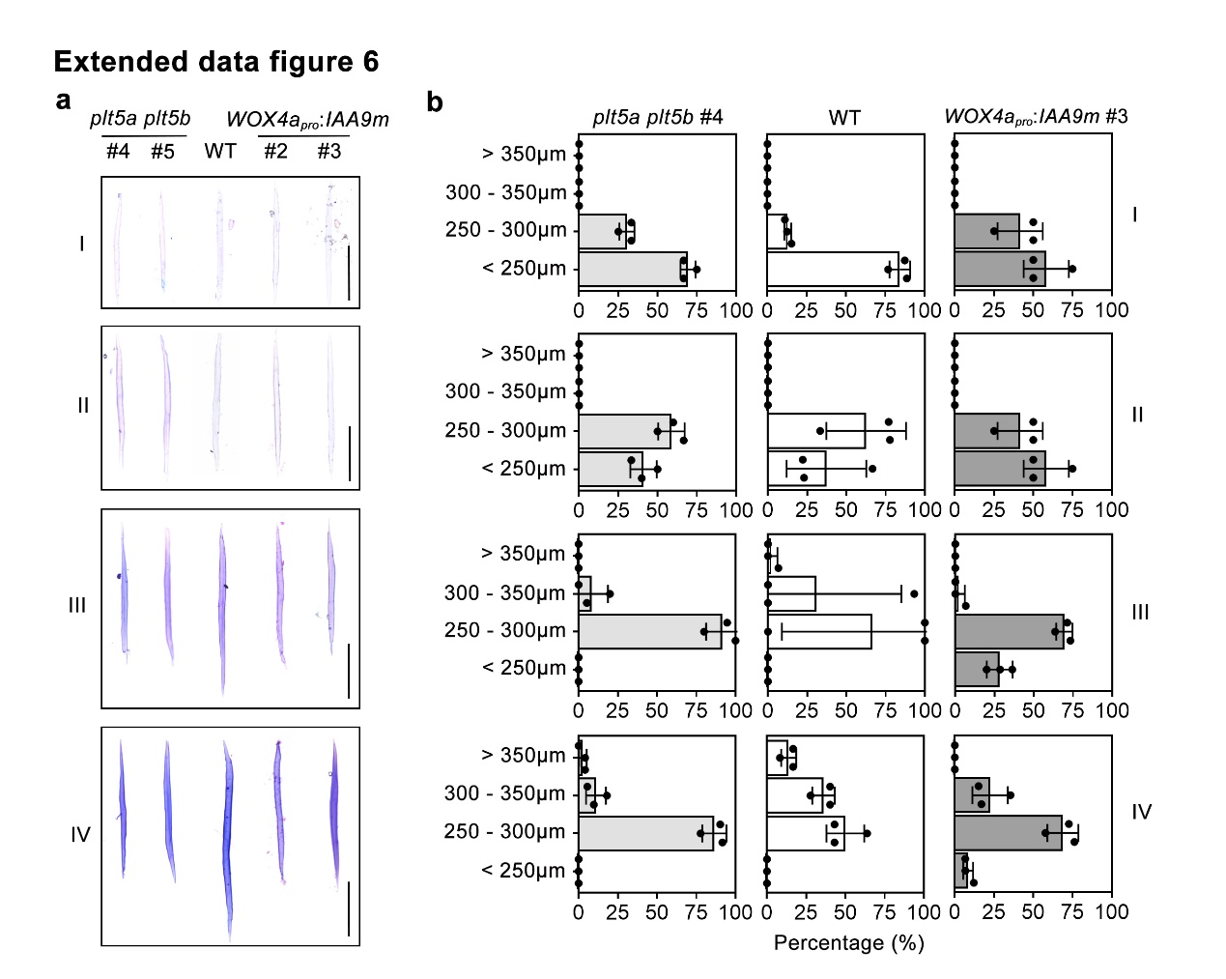
Extended data figure 6. The morphology and length distribution of fibre cell belonging to different developmental classes in plt5a plt5b double mutants and WOX4a_{pro}:IAA9m transgenics.
a and b, cellular morphology (a) and length quantification (b) of fibre cells isolated from the 10th internodes of 3-month-old WT, plt5a plt5b mutants and WOX4a_{pro}:IAA9m transgenics classified into four categories. In a, the fibres were stained with toluidine blue. In b, the isolated fibres were photographed and their length and width measured by ImageJ software. A total of 72 fibre cells from three plants representing independent biological replicates were measured. The data are shown as mean ± s.d. (n = 3).

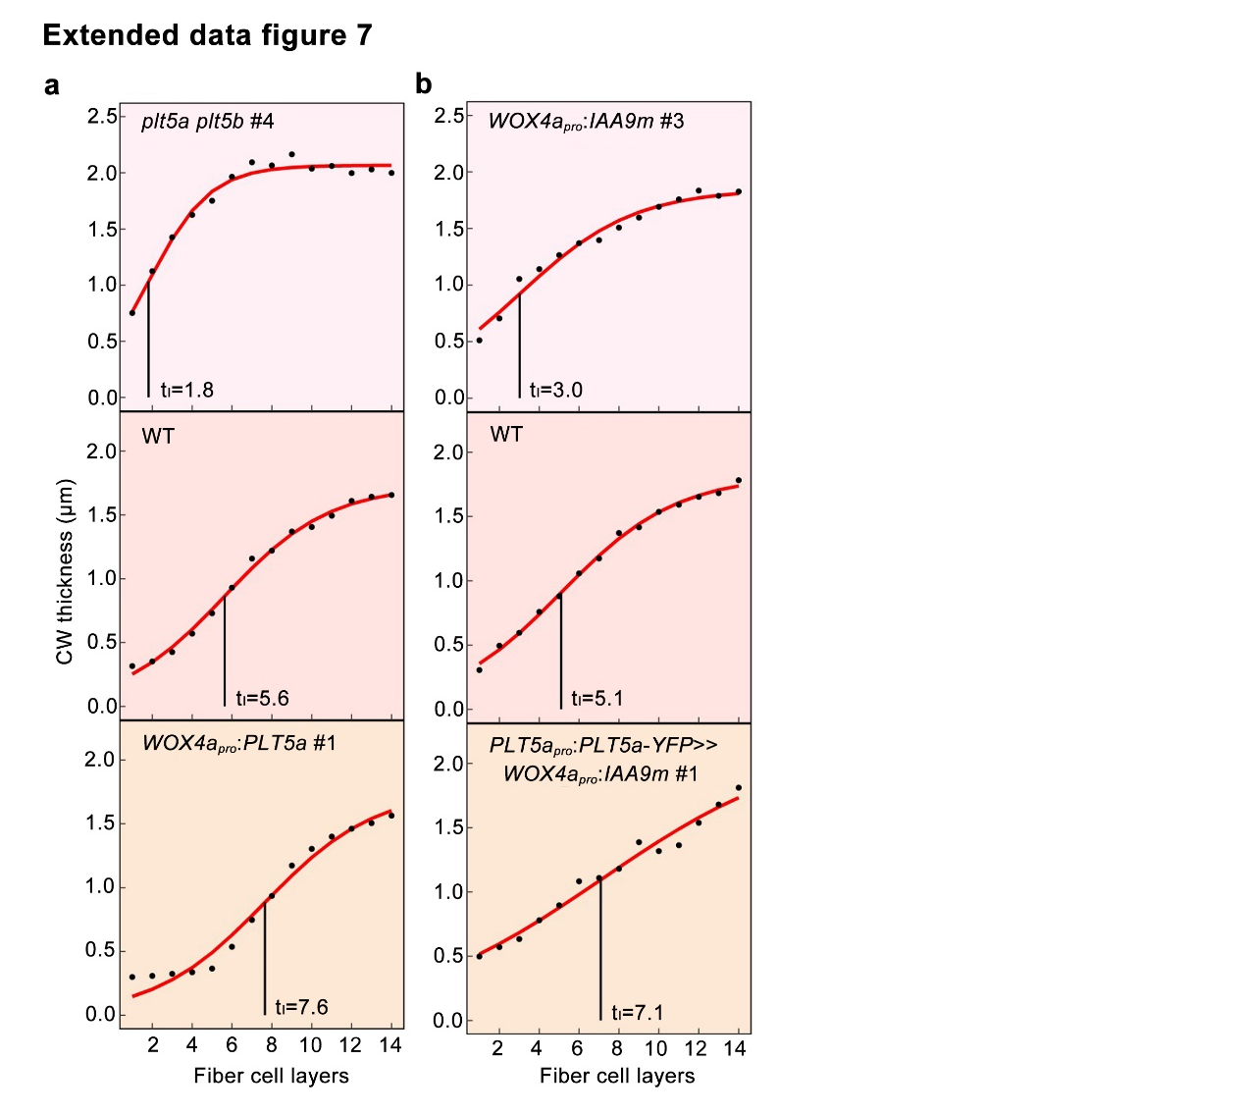
Extended data figure 7. The fitness of growth equation to the cell wall thickness that changes with increasing fibre cell layers.
a and b, The fitness of growth equation to the cell wall thickness that changes with increasing fibre cell layers in the 8th internodes of plt5a plt5b #4 mutants and WOX4a_{pro}:PLT5a #1 transgenics (a) and WOX4a_{pro}:IAA9m #3 and PLT5a_{pro}:PLT5a-YFP >>WOX4a_{pro}:IAA9m #1 transgenics (b). Dots denote observations of cell wall thickness at different layers. The timing of inflection point t_{I} is indicated in each case.

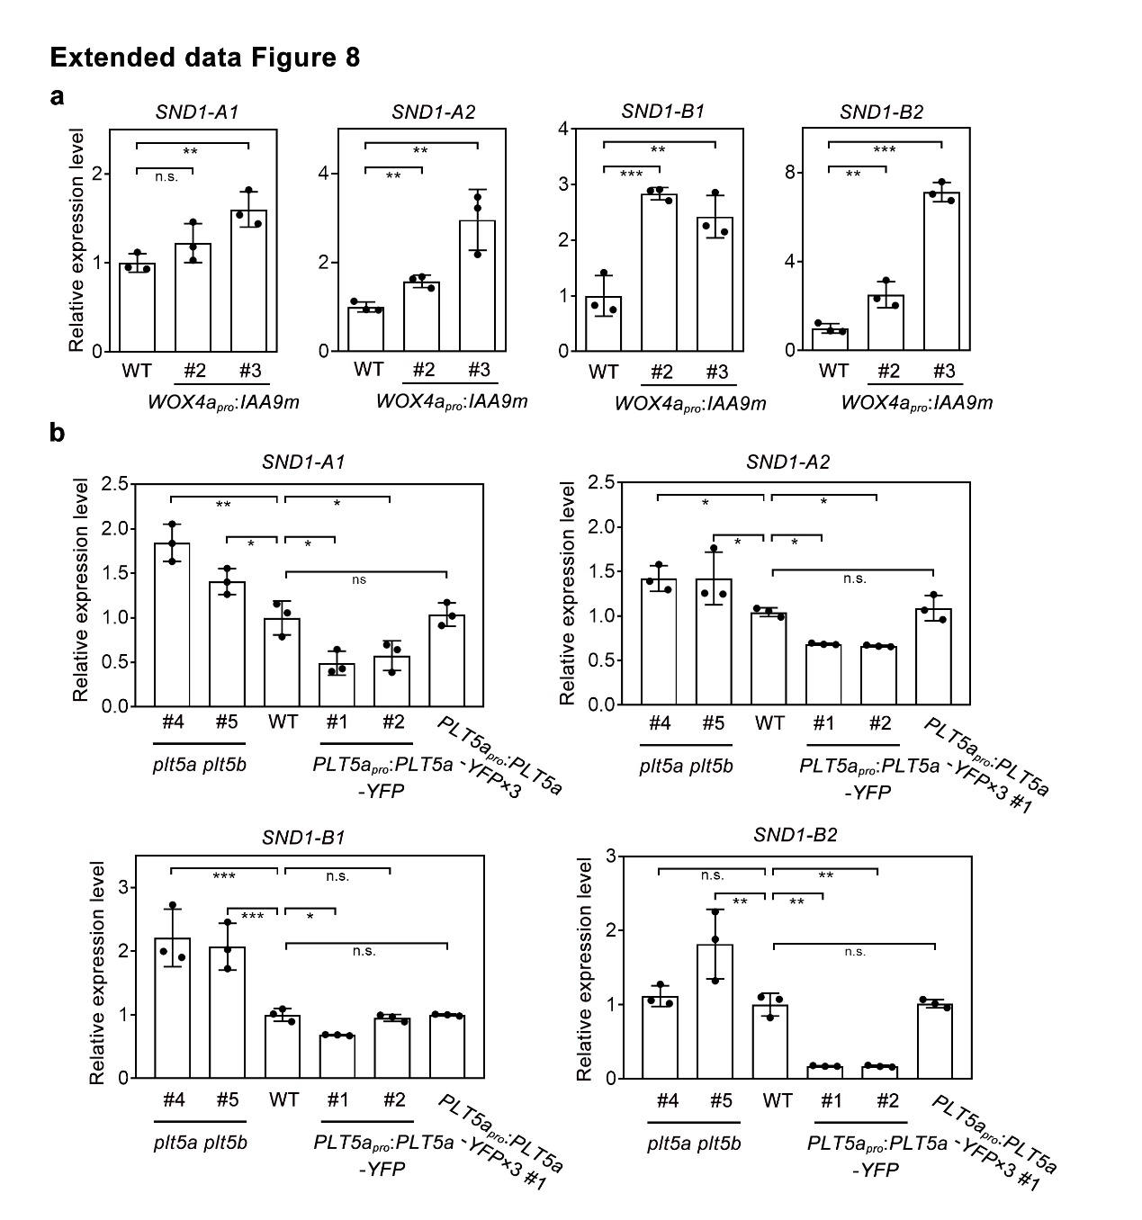
Extended data figure 8. Expression levels of SND1 genes in IAA9m- and PLT5-associated transgenic lines assayed by qRT-PCR.
a and b, Expression levels of poplar SND1-A1, SND1-A2, SND1-B1 and SND1-B2 in stem of WOX4_{pro}:IAA9m transgenics (a), plt5a plt5b mutants, PLT5a_{pro}:PLT5a-YFP and PLT5a_{pro}:PLT5a-YFP×3 transgenics (b). Three biological replicates were analyzed. The data are shown as mean ± s.d. (n = 3). One-way ANOVA analysis followed by Dunnett test for pairwise comparison was performed to test significant differences among WT and transgenic lines. ***, P<0.001; **, P<0.01; *, P<0.05; n.s., not significant.

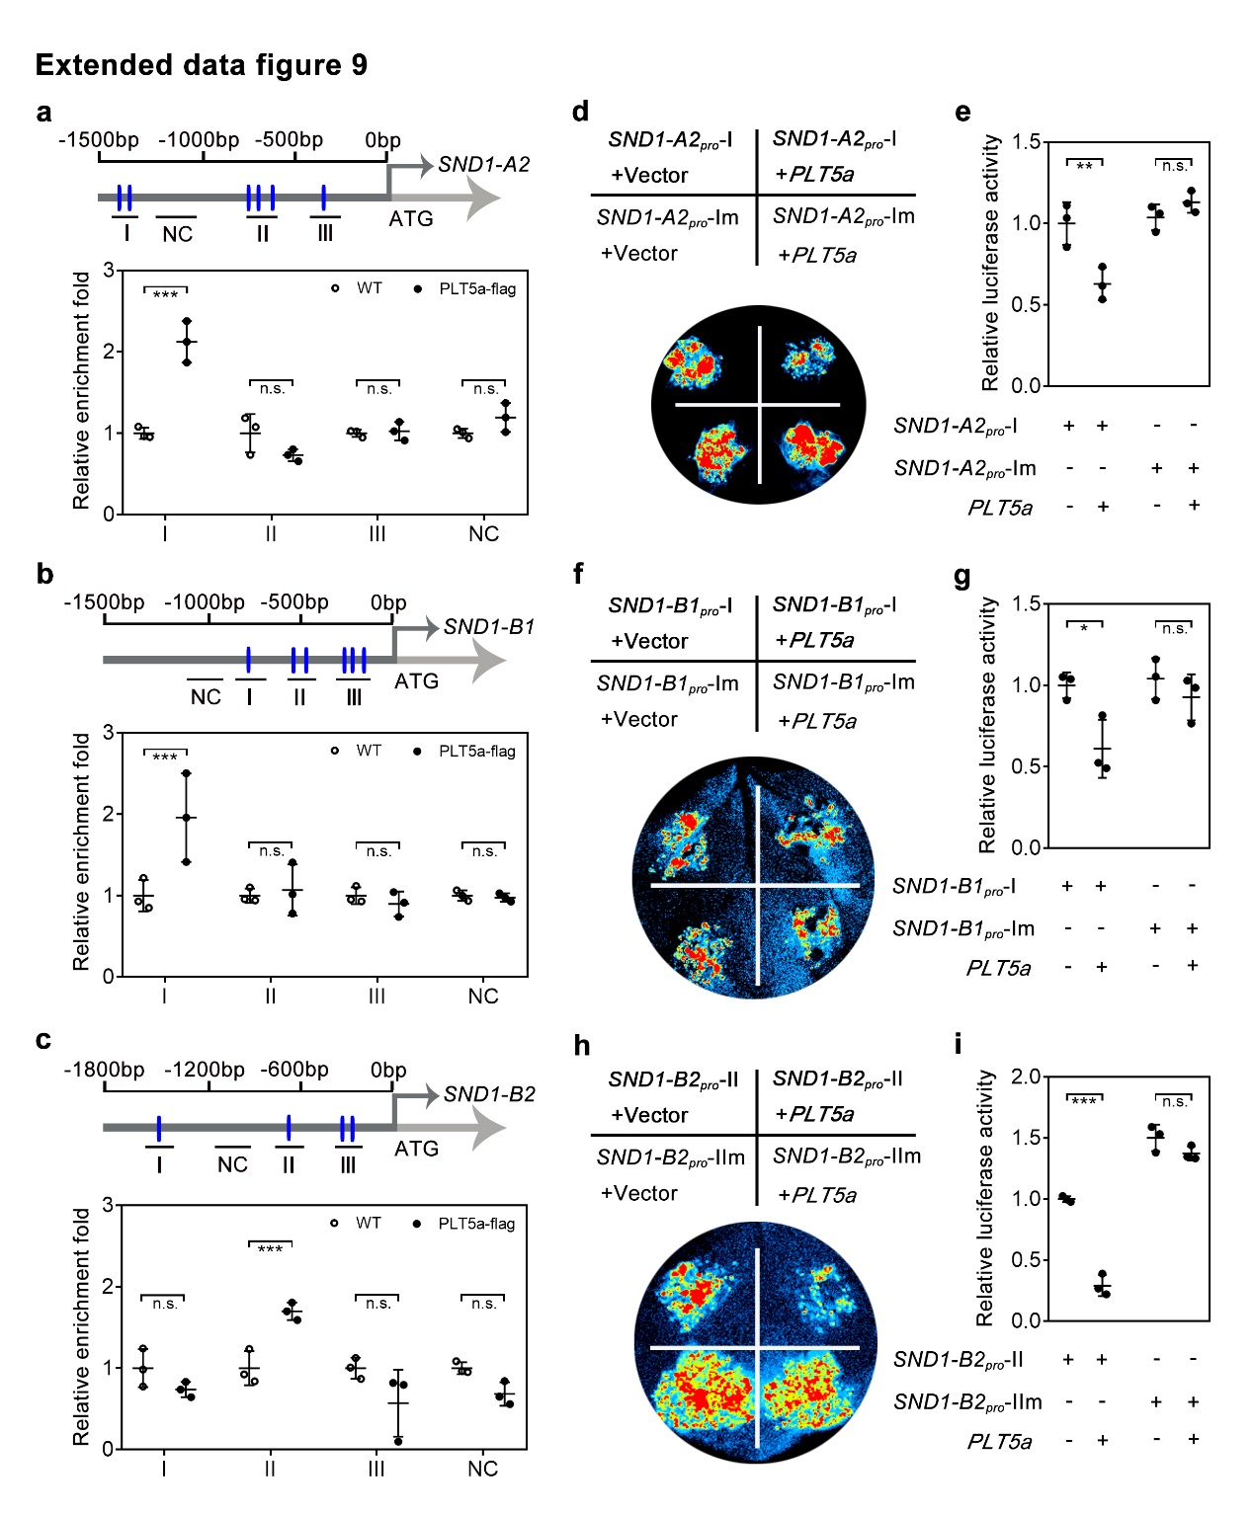
Extended data figure 9. ChIP-qPCR and effector-reporter assays of PLT5-bindiing capacity to SND1-A2/B1/B2 promoters.
a, b and c, Distribution of predicted PLT5-binding sites within the promoter of SND1-A2 (a), SND1-B1 (b) and SND1-B1 (c) and ChIP-qPCR analysis for the promoter of SND1-A2 (a), SND1-B1 (b) and SND1-B1 (c). d, f and h, Luciferase-based effector-reporter assays of PLT5-suppressed SND1-A2 (d), SND1-B1 (f) and SND1-B2 (h) expression in transiently transfected tobacco leaf cells. e, g and i, Quantification of luciferase activity of PLT5-suppressed SND1-A2 (e), SND1-B1 (g) and SND1-B2 (i) expression in transiently transfected tobacco leaf cells. In d to i, SND1-A2_{pro}-Im, SND1-B1_{pro}-Im and SND1-B1_{pro}-IIm indicate the promoter regions of SND1-A2, SND1-B1 and SND1-B2 with impaired binding sites of PLT5 proteins generated by site-directed mutagenesis. The data are shown as mean ± s.d.; n = 3. One-way ANOVA analysis followed by Dunnett test for pairwise comparison was performed to test significant differences. ***, P<0.001; **, P<0.01; *, P<0.05; n.s., not significant.

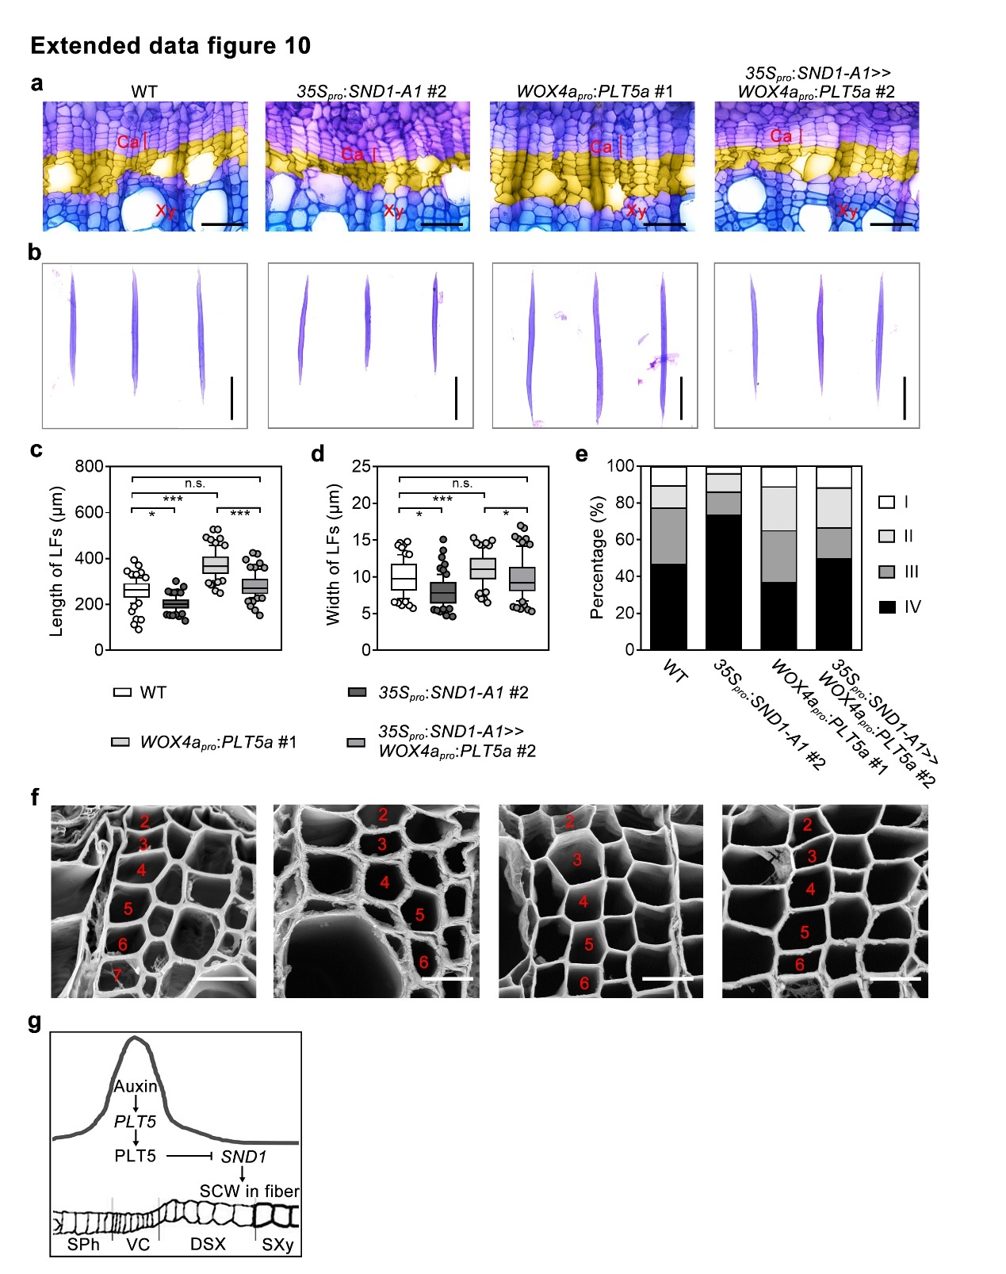
Extended data figure 10. The cell layers, cell wall thickness, length and width of WT and 35S_{pro}:SND1-A1 #2, WOX4a_{pro}:PLT5a #1 and 35S_{pro}:SND1-A1>>WOX4a_{pro}:PLT5a #2 transgenics.
a, Anatomical sections of the 8th internodes of 3-month-old WT and 35S_{pro}:SND1-A1 #2, WOX4a_{pro}:PLT5a #1 and 35S_{pro}:SND1-A1>> WOX4a_{pro}:PLT5a #2 transgenics. The developing fibre cell layers are in yellow. Scale bars, 30 μm. b, Cellular morphology of lignified fibres isolated from the 10th internodes of 3-month-old WT and 35S_{pro}:SND1-A1 #2, WOX4a_{pro}:PLT5a #1 and 35S_{pro}:SND1-A1>> WOX4a_{pro}:PLT5a #2 transgenics. Scale bars, 100 μm. c, d, The length (c) and width (d) of lignified fibres isolated from the 10th internodes of 3-month-old WT and 35S_{pro}:SND1-A1 #2, WOX4a_{pro}:PLT5a #1 and 35S_{pro}:SND1-A1>> WOX4a_{pro}:PLT5a #2 transgenics. e, The percentages of four classes of fibres cells isolated from the 10th internodes of 3-month-old WT and 35S_{pro}:SND1-A1 #2, WOX4a_{pro}:PLT5a #1 and 35S_{pro}:SND1-A1>> WOX4a_{pro}:PLT5a #2 transgenics. f, SEM analyses of developing fibre cells in the 8th internodes of 3-month-old WT and 35S_{pro}:SND1-A1 #2, WOX4a_{pro}:PLT5a #1 and 35S_{pro}:SND1-A1>> WOX4a_{pro}:PLT5a #2 transgenics. The numbers in red indicate the developing fibre cell layers. Scale bars, 15 μm. g, Model of auxin-PLT5 signalling-regulated wood fibre development in poplar stem. Arrowheads represent a positive regulatory action of one component on another. Lines ending with a trait represents a negative regulatory action. DSX, developing secondary xylem; SPh, secondary phloem; SXy, secondary xylem; VC, vascular cambium. In a and b, the cross-sections (a) and isolated fibre cells (b) were stained with toluidine blue. In c and d, 24 lignified fibre cells were quantified for each biological replicate. Three biological replicates were analyzed. n=72 for d and e.

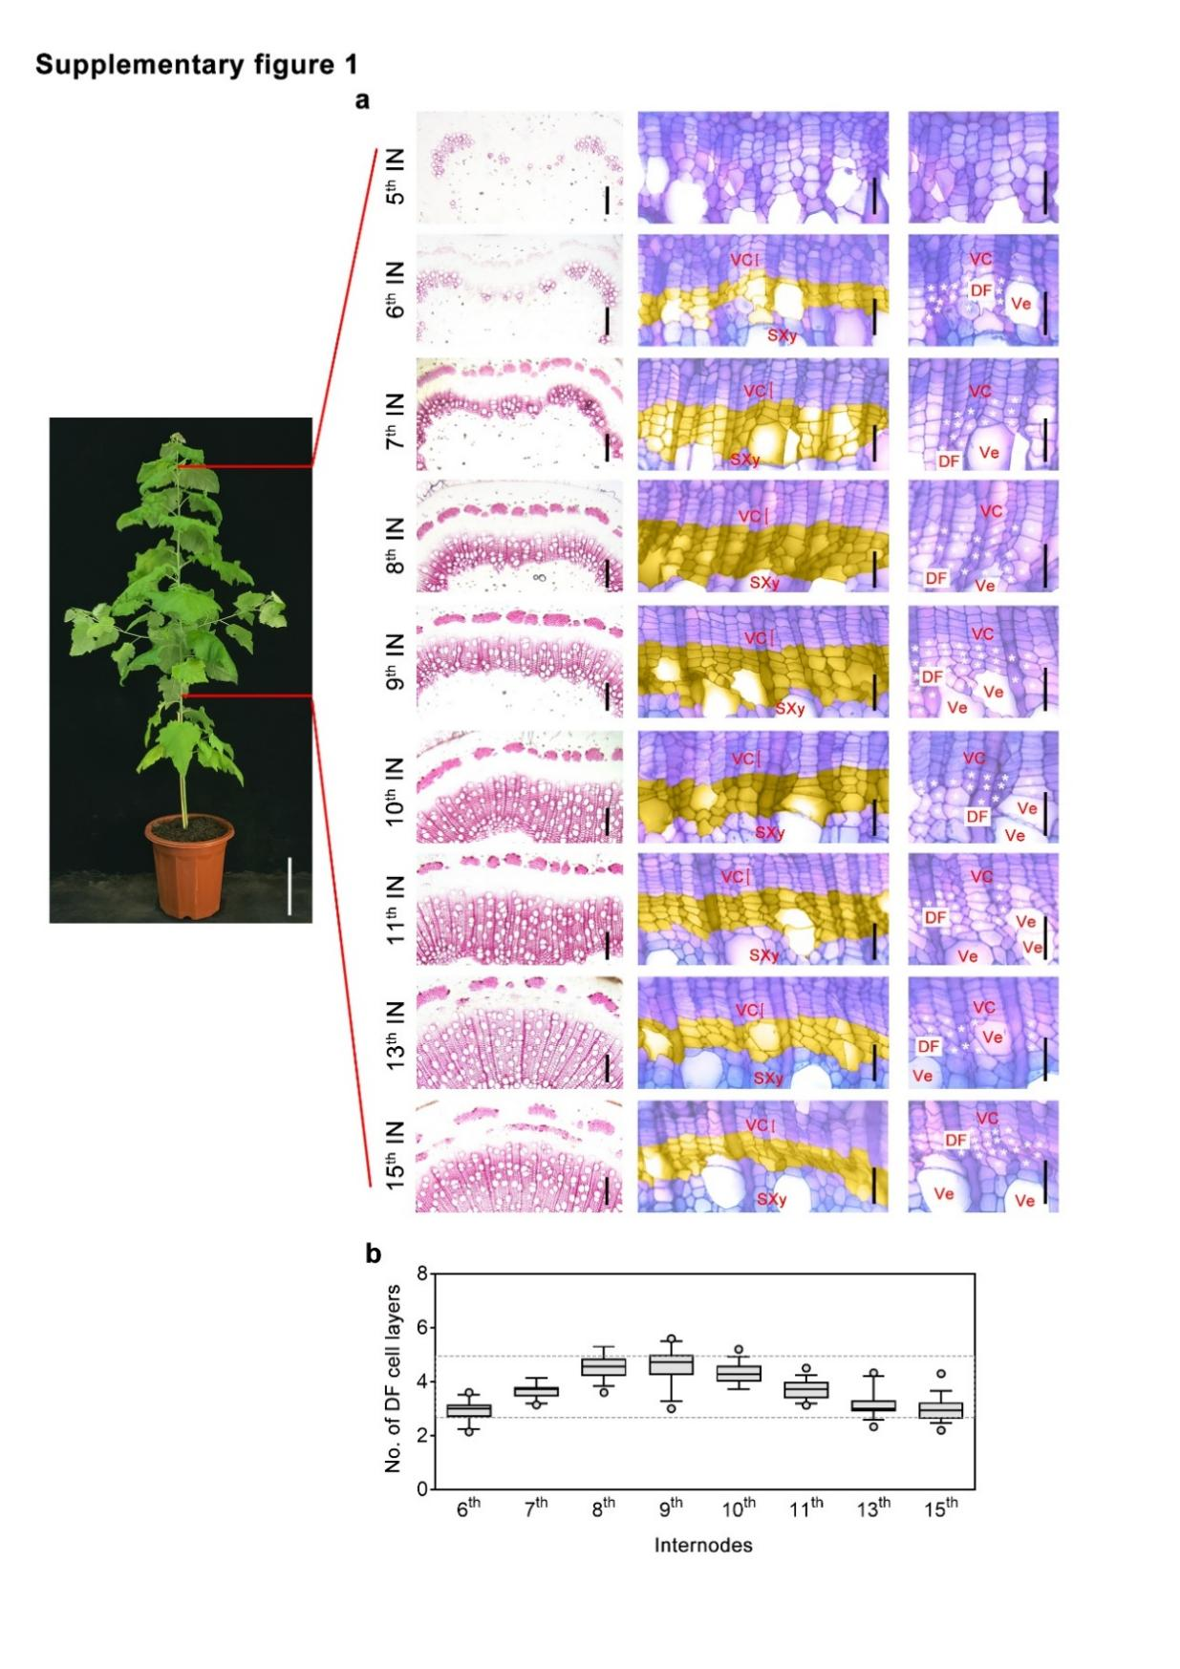
Supplementary figure 1. The cell layers of developing fibres in the DSX region.
a, Cross-sections of the 5th to 15th internodes of 3-month-old P. tomentosa plants stained with phloroglucinol-HCl (the left panel) or toluidine blue (the middle and right panels). The developing fibre cells are marked in yellow (the middle panel) or by white asterisks (the right panel). DF: developing fibre; IN: internode; SXy: secondary xylem; VC: vascular cambium; Ve: vessel. Scale bars, 15 cm for the photo of the poplar plant, 70 μm (the left panel), 40 μm (the middle and right panels). b, The number of developing fibre cell layers in stem internodes of 3-month-old P. tomentosa. The average value was calculated using the numbers of developing fibre cell layers of 10 radial cell files from one cross-section. Eighteen cross-sections representing three biological replicates were analyzed (n=18). The boxes show the median and 10-90 percentile, and the whiskers represent the data range excluding outliers.

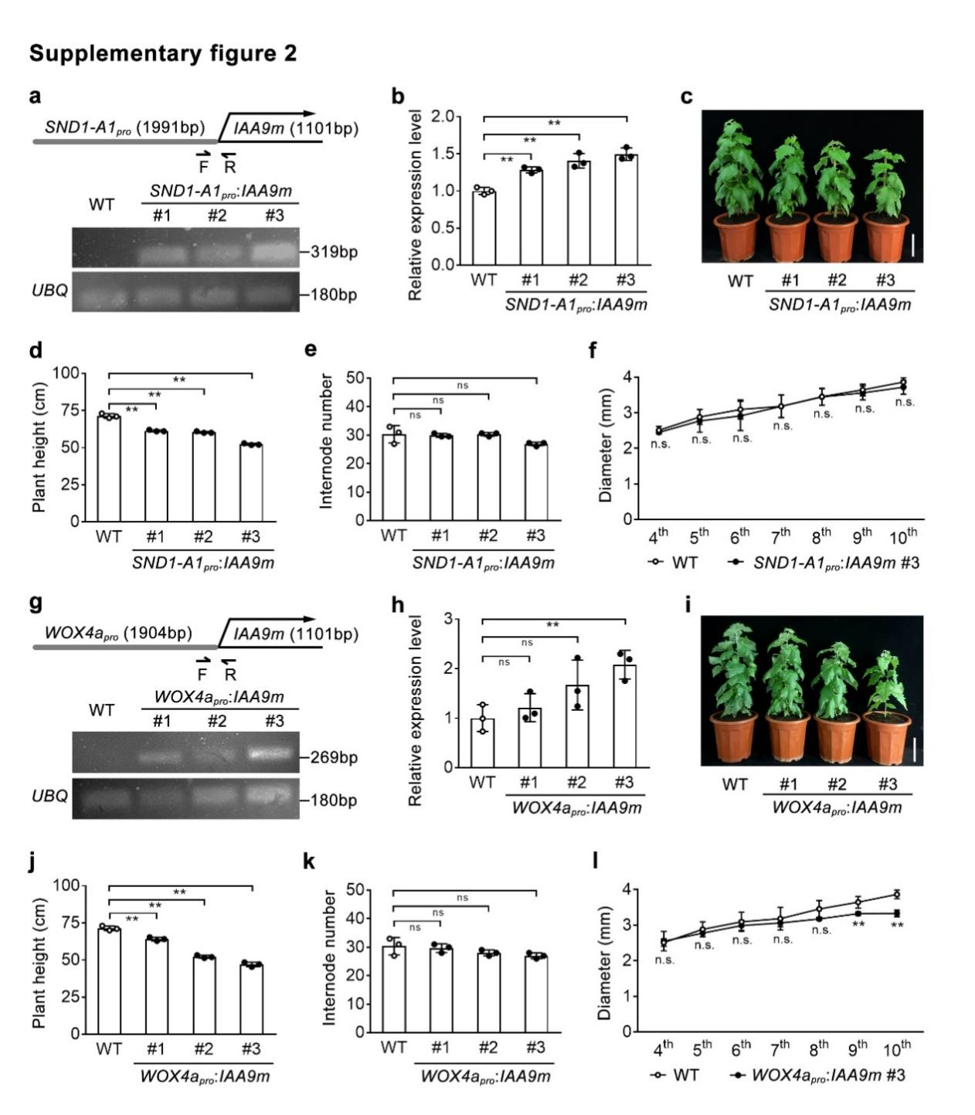
Supplementary figure 2. Generation and plant phenotypes of SND1-A1_{pro}:IAA9m and WOX4a_{pro}:IAA9m transgenics.
a, g, Construction of SND1-A1_{pro}:IAA9m (a) and WOX4a_{pro}:IAA9m (g) and genotyping of transgenic lines by semi-quantitative RT-PCR. A 319-bp or 269-bp DNA fragment was amplified from the positive lines of SND1-A1_{pro}:IAA9m and WOX4a_{pro}:IAA9m, respectively, using specific primers. UBIQUITIN (UBQ) gene of P. tomentosa was used as the reference. F, forward primer; R, reverse primer. b, h, Expression levels of IAA9 gene in the stems of SND1-A1_{pro}:IAA9m (b) and WOX4a_{pro}:IAA9m (h) transgenics assayed by qRT-PCR. The values of WT were normalized to 1. c, i, The 3-month-old plants of SND1-A1_{pro}:IAA9m (c) and WOX4a_{pro}:IAA9m (i) transgenics. Scale bars, 10 cm. d, j, Plant height of SND1-A1_{pro}:IAA9m (d) and WOX4a_{pro}:IAA9m (j) transgenics. e, k, Internode number of SND1-A1_{pro}:IAA9m (e) and WOX4a_{pro}:IAA9m (k) transgenics. f, l, Diameters of the 4th to 10th internodes of SND1-A1_{pro}:IAA9m #3 (f) and WOX4a_{pro}:IAA9m #3 (l) transgenics. In b, d, e, f, h, j, k and l, three biological replicates were analyzed. The data are shown as mean ± s.d. (n = 3). In b, d, e, h, j and k, one-way ANOVA analysis followed by Dunnett test for pairwise comparison was performed to test significant differences among WT and transgenic lines. **, P<0.01; *, P<0.05; n.s., not significant. In f and l, student t test was performed to test significant differences for each internode between WT and transgenic lines.

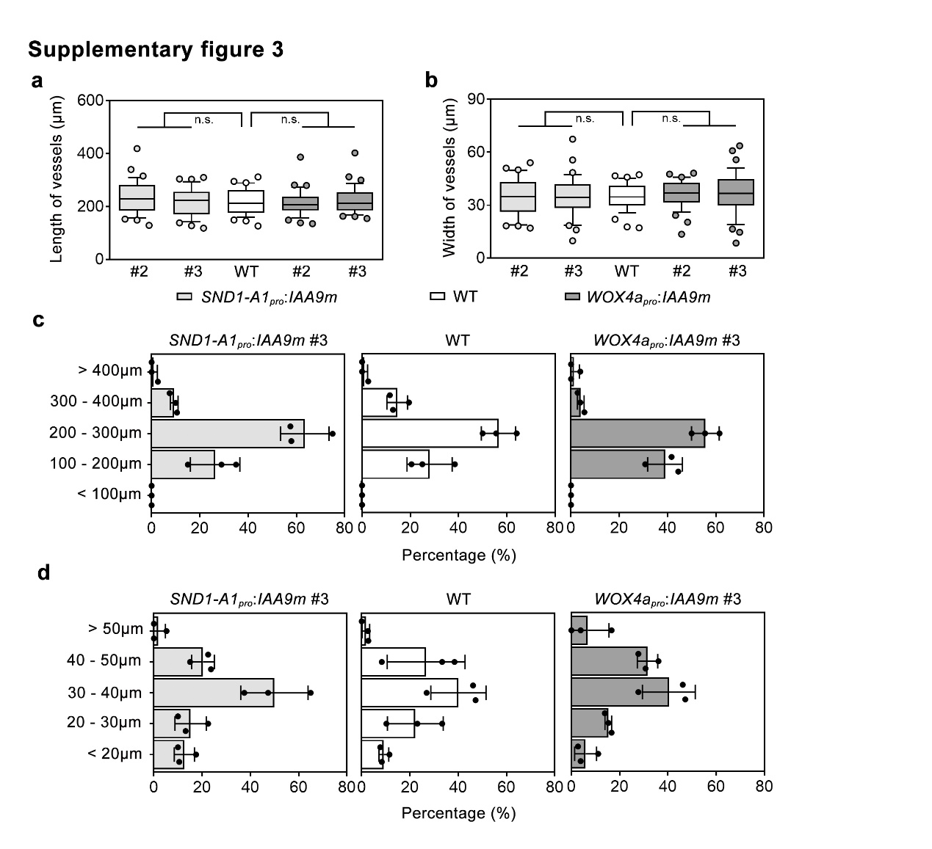
Supplementary figure 3. Quantification of vessel cell length and width in SND1-A1_{pro}:IAA9m and WOX4a_{pro}:IAA9m transgenics.
a, b, The length (a) and width (b) of mature vessels isolated from the 10th internodes of WT and SND1-A1_{pro}:IAA9m and WOX4a_{pro}:IAA9m transgenic lines. c, d, Frequency distribution of vessel length (c) and width (d) of mature vessels isolated from the 10th internodes of WT and SND1-A1_{pro}:IAA9m and WOX4a_{pro}:IAA9m transgenic lines. The isolated vessels were photographed and their length and width measured by ImageJ software. A total of 36 vessels from three plants representing independent biological replicates were measured. In a and b, the boxes show the median and 10-90 percentile, and the whiskers represent the data range excluding outliers. One-way ANOVA analysis followed by Dunnett test for pairwise comparison was performed to evaluate significant differences between WT and transgenic lines. n.s., not significant. In c and d, the data are shown as mean ± s.d. (n = 3).

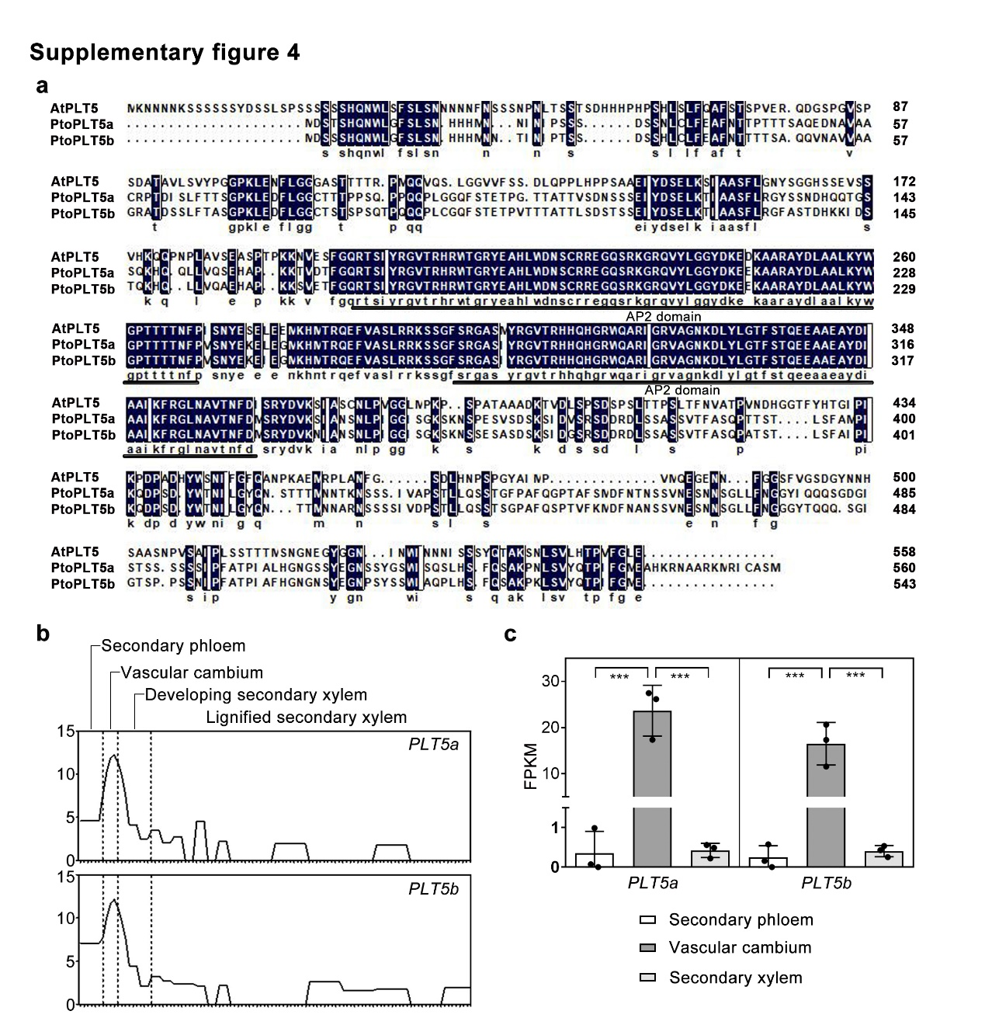
Supplementary figure 4. Sequence identity and cambium-specific expression of P. tomentosa PLT5a and PLT5b.
a, Sequence alignment of Arabidopsis PLT5, P. tomentosa PLT5a and PLT5b proteins. The AP2 domain is underlined. Identical and similar amino acid residues are shaded with blue. b, Expression patterns of poplar PLT5a and PLT5b genes across secondary vascular tissues of stem based on the RNA-seq datasets from the AspWood database (Sundell et al., 2017, Plant Cell). c, Expression level of PLT5a and PLT5b genes in vascular cambium and neighboring secondary vascular tissues based on cell-type transcriptome datasets of P. trichocarpa stems (Dai et al., 2023, Nature Plants). Both PLT5s belong to the gene set encoding vascular-cambium-specific (VCS) transcription factors identified by Dai et al. (2023). PLT5a and PLT5b were nominated as PtrVCS11 and PtrVCS20, respectively, in their datasets.

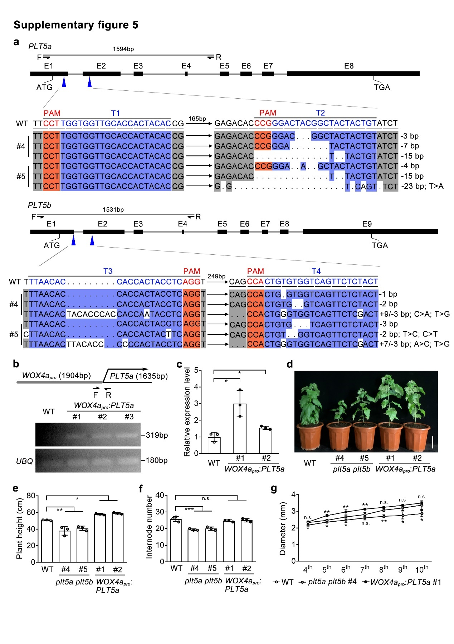
Supplementary figure 5. Generation and plant phenotypes of plt5a plt5b double mutants and WOX4a_{pro}:PLT5a transgenic lines.
a, Identification of the mutations in the coding regions of PLT5a and PLT5b generated by CRISPR/Cas9-based genome editing system. T1, T2, T3 and T4 indicate the positions of sgRNA-targeted sites. F and R indicate the binding positions of forward and reverse primers used for PCR genotyping. The sequences of the sgRNA-targeted sites are in blue. The PAM sequences are in red. The text on the right summarizes mutation details in two independent CRISPR/Cas9-generated lines. b, Construction of WOX4a_{pro}:IAA9m and genotyping of transgenic lines by semi-quantitative RT-PCR. A 319-bp DNA fragment was amplified from the positive lines of WOX4a_{pro}:PLT5a, using specific primers. UBIQUITIN (UBQ) gene of P. tomentosa was used as the reference. F, forward primer; R, reverse primer. c, Expression levels of IAA9 gene in the stems of WOX4a_{pro}:PLT5a transgenics assayed by qRT-PCR. The values of WT were normalized to 1. d, The 3-month-old plants of WT, plt5a plt5b mutants and WOX4a_{pro}:PLT5a transgenics. Scale bars, 10 cm. e and f, Plant height (e) and internode number (f) of WT, plt5a plt5b mutants and WOX4a_{pro}:PLT5a transgenics. g, Diameters of the 4th to 10th internodes of WT, plt5a plt5b mutants and WOX4a_{pro}:PLT5a transgenics. In c, e, f and g, three biological replicates were analyzed. The data are shown as mean ± s.d. (n = 3). In c, e and f, one-way ANOVA analysis followed by Dunnett test for pairwise comparison was performed to test significant differences among WT and transgenic lines. ***, P<0.001; **, P<0.01; *, P<0.01; n.s., not significant. In g, student t test was performed to test significant differences for each internode between WT and transgenic lines.

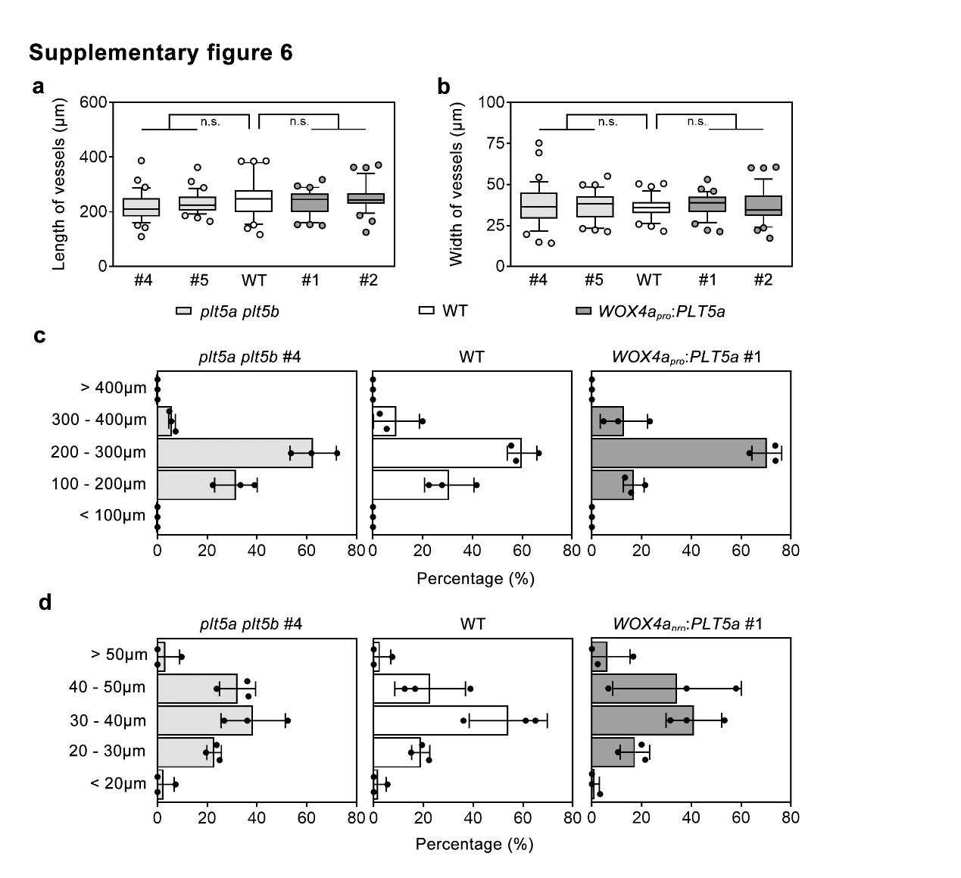
Supplementary figure 6. Quantification of vessel cell length and width in plt5a plt5b double mutants and WOX4a_{pro}:PLT5a transgenics.
a, b, The length (a) and width (b) of mature vessels isolated from the 10th internodes of WT and plt5a plt5b and WOX4a_{pro}:IAA9m transgenics. c, d, Frequency distribution of vessel length (c) and width (d) of mature vessels isolated from the 10th internodes of WT, plt5a plt5b mutants and WOX4a_{pro}:IAA9m transgenic lines. The isolated vessels were photographed and their length and width measured by ImageJ software. A total of 36 vessels from three plants representing independent biological replicates were measured. In a and b, the boxes show the median and 10-90 percentile, and the whiskers represent the data range excluding outliers. One-way ANOVA analysis followed by Dunnett test for pairwise comparison was performed to evaluate significant differences between WT and transgenic lines. n.s., not significant. In c and d, the data are shown as mean ± s.d. (n = 3).

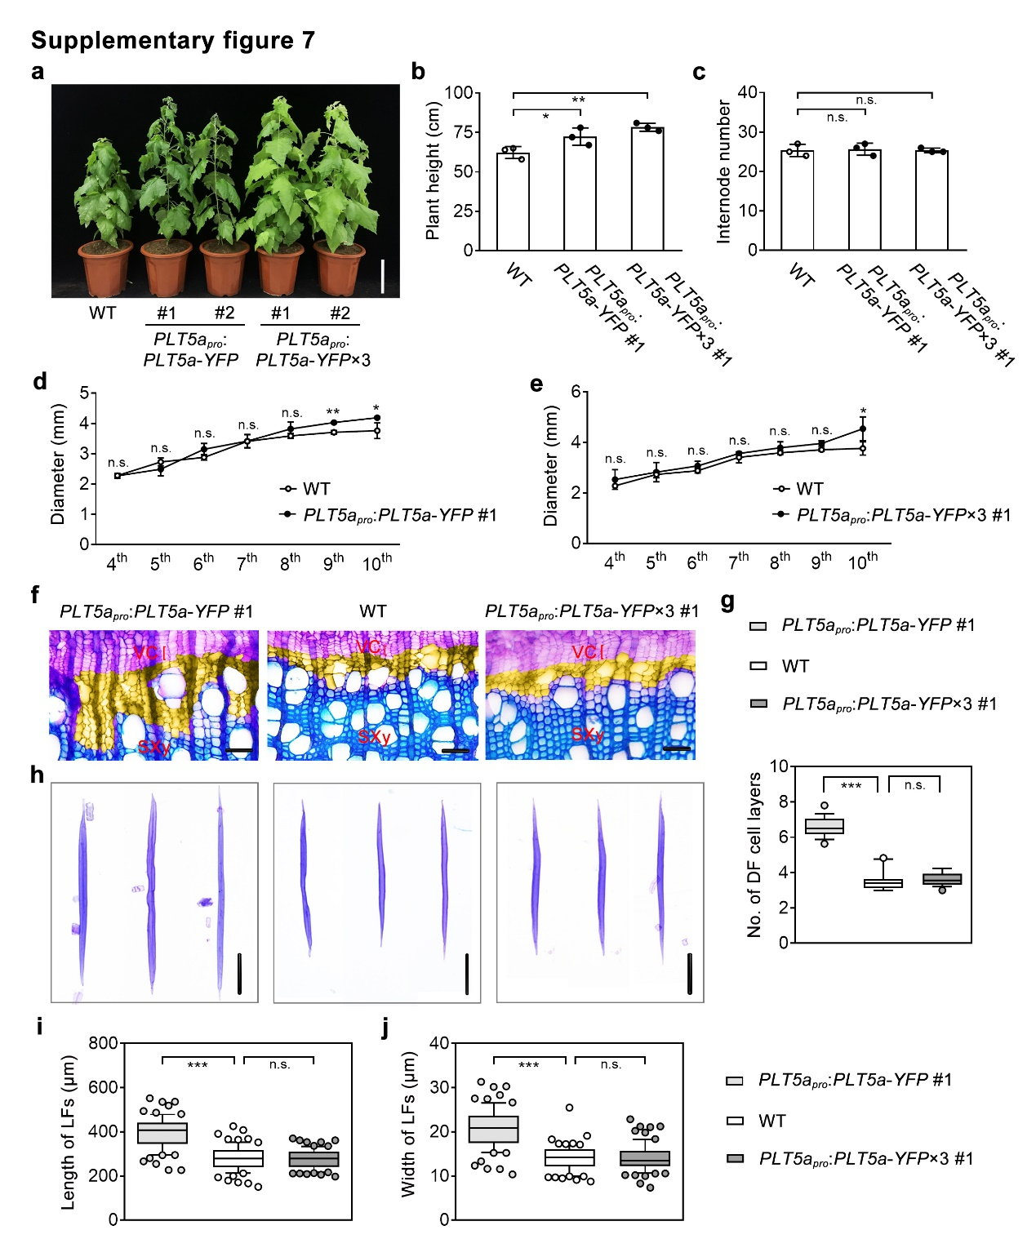
Supplementary figure 7. Generation and phenotypes of PLT5a_{pro}:PLT5a-YFP #1 and PLT5a_{pro}:PLT5a-YFP×3 #1 transgenic lines.
a, The 3-month-old plants of WT and PLT5a_{pro}:PLT5a-YFP and PLT5a_{pro}:PLT5a-YFP×3 transgenics. Scale bars, 20 cm. b and c, Plant height (b) and internode number (c) of WT and PLT5a_{pro}:PLT5a-YFP and PLT5a_{pro}:PLT5a-YFP×3 transgenics. d and e, Diameters of the 4th to 10th internodes of WT and PLT5a_{pro}:PLT5a-YFP (d) and PLT5a_{pro}:PLT5a-YFP×3 (e) transgenics. f, Anatomical sections of the 8th internodes of 3-month-old WT and PLT5a_{pro}:PLT5a-YFP #1 and PLT5a_{pro}:PLT5a-YFP×3 #1 transgenics. The developing fibre cell layers are in yellow. Scale bars, 30 μm. g, Number of developing fibre cell layers in the 8th internodes of 3-month-old WT and PLT5a_{pro}:PLT5a-YFP #1 and PLT5a_{pro}:PLT5a-YFP×3 #1 transgenics. h, Cellular morphology of lignified fibres isolated from the 10th internodes of 3-month-old WT and PLT5a_{pro}:PLT5a-YFP #1 and PLT5a_{pro}:PLT5a-YFP×3 #1 transgenics. Scale bars, 100 μm. i and j, The length (i) and width (j) of lignified fibres isolated from the 10th internodes of 3-month-old WT and PLT5a_{pro}:PLT5a-YFP #1 and PLT5a_{pro}:PLT5a-YFP×3 #1 transgenics. In f and h, the cross-sections (f) and fibre cells (h) were stained with toluidine blue. In b, c, d and e, three biological replicates were analyzed. The data are shown as mean ± s.d. (n = 3). In g, the average value was calculated using the number of developing fibre cell layers of 10 radial cell files from one cross-section. Eighteen cross-sections from three biological replicates were analyzed (n=18). In i and j, 24 lignified fibre cells were quantified for each biological replicate. Three biological replicates were analyzed. n=72 for i and j. The boxes show the median and 10-90 percentile, and the whiskers represent the data range excluding outliers. In b, c, g, i and l, one-way ANOVA analysis followed by Dunnett test for pairwise comparison was performed to test significant differences among WT and transgenic lines. ***, P<0.001; **, P<0.01; *, P<0.05; n.s., not significant. In d and e, student t test was performed to test significant differences for each internode between WT and transgenic lines. **, P<0.01; *, P<0.05; n.s., not significant. DF, developing fibre; LF, lignified fibre; SXy, secondary xylem; VC, vascular cambium.

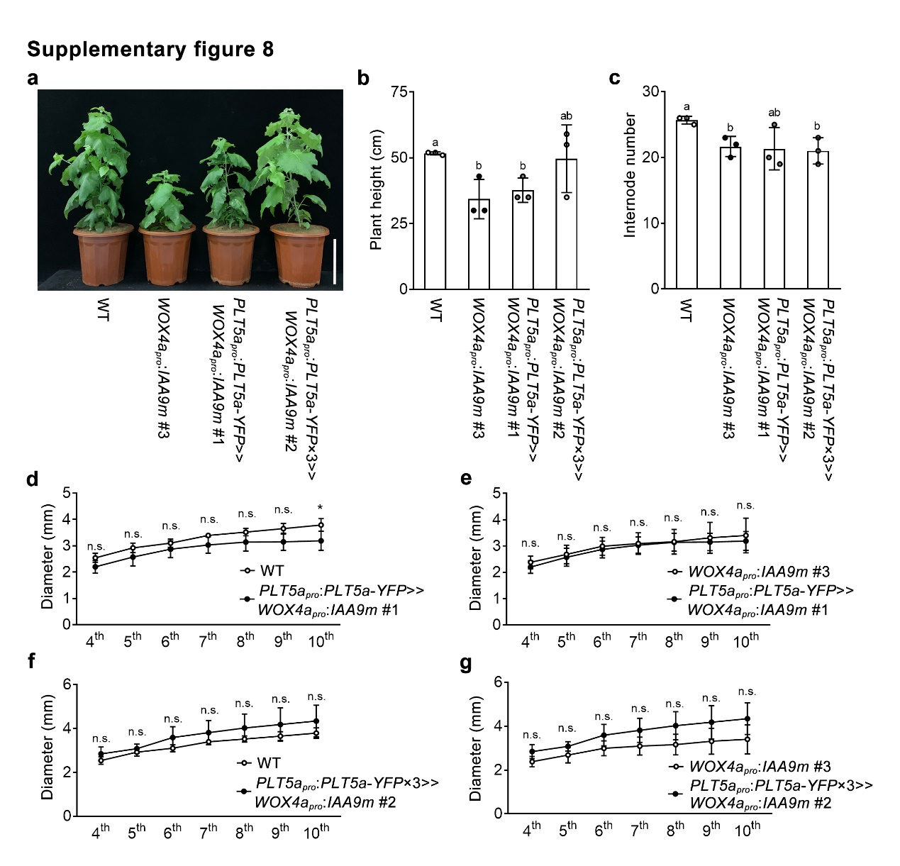
Supplementary figure 8. Generation and phenotypes of PLT5a_{pro}:PLT5a-YFP>>WOX4a_{pro}:IAA9m and PLT5a_{pro}:PLT5a-YFP×3>>WOX4a_{pro}:IAA9m transgenic lines.
a, The 3-month-old plants of WT and WOX4_{pro}:IAA9m #3, PLT5a_{pro}:PLT5a-YFP>>WOX4a_{pro}:IAA9m #1 and PLT5a_{pro}:PLT5a-YFP×3>>WOX4a_{pro}:IAA9m #2 transgenics. Scale bars, 20 cm. b and c, Plant height (b) and internode number (c) of WT and WOX4_{pro}:IAA9m #3, PLT5a_{pro}:PLT5a-YFP>>WOX4a_{pro}:IAA9m #1 and PLT5a_{pro}:PLT5a-YFP×3>>WOX4a_{pro}:IAA9m #2 transgenics. d, e, f and g, Diameters of the 4th to 10th internodes of PLT5a_{pro}:PLT5a-YFP>>WOX4a_{pro}:IAA9m #1 compared with WT (d) or WOX4_{pro}:IAA9m #3 (e) and PLT5a_{pro}:PLT5a-YFP×3>>WOX4a_{pro}:IAA9m #2 compared with WT (f) or WOX4_{pro}:IAA9m #3 (g). In b, c, d, e f and g, three biological replicates were analyzed. The data are shown as mean ± s.d. (n = 3). In b and c, one-way ANOVA analysis followed by Dunnett test for pairwise comparison was performed to test significant differences among WT and transgenic lines. Different letters above bars indicate significant difference (P < 0.05). In d, e, f and g, student t test was performed to evaluate significant differences for each internode. *, P<0.05; n.s., not significant.

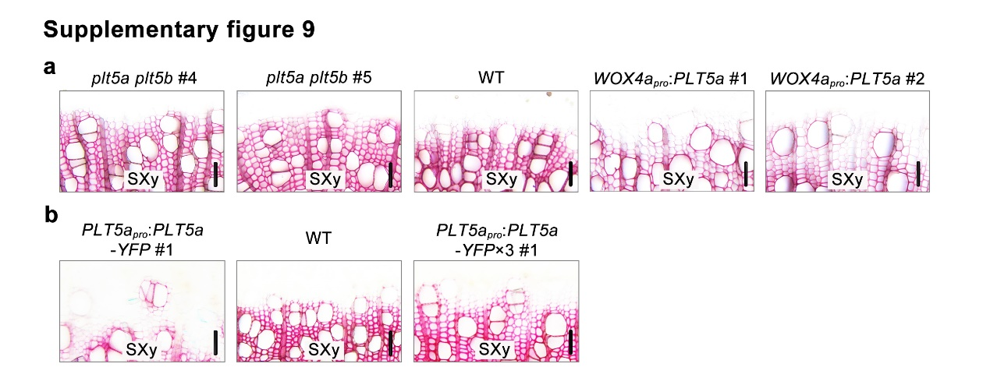
Supplementary figure 9. Phloroglucinol-HCl staining of cross-sections from the 8th internodes of PLT5a-associated transgenic lines.
a, Phloroglucinol-stained sections of the 8th internodes of 3-month-old WT, plt5a plt5b mutants and WOX4a_{pro}:PLT5a transgenics. b, Phloroglucinol-stained sections of the 8th internodes of 3-month-old WT and PLT5a_{pro}:PLT5a-YFP #1 and PLT5a_{pro}:PLT5a-YFP×3 #1 transgenics. Scale bars, 25 μm. SXy, secondary xylem.

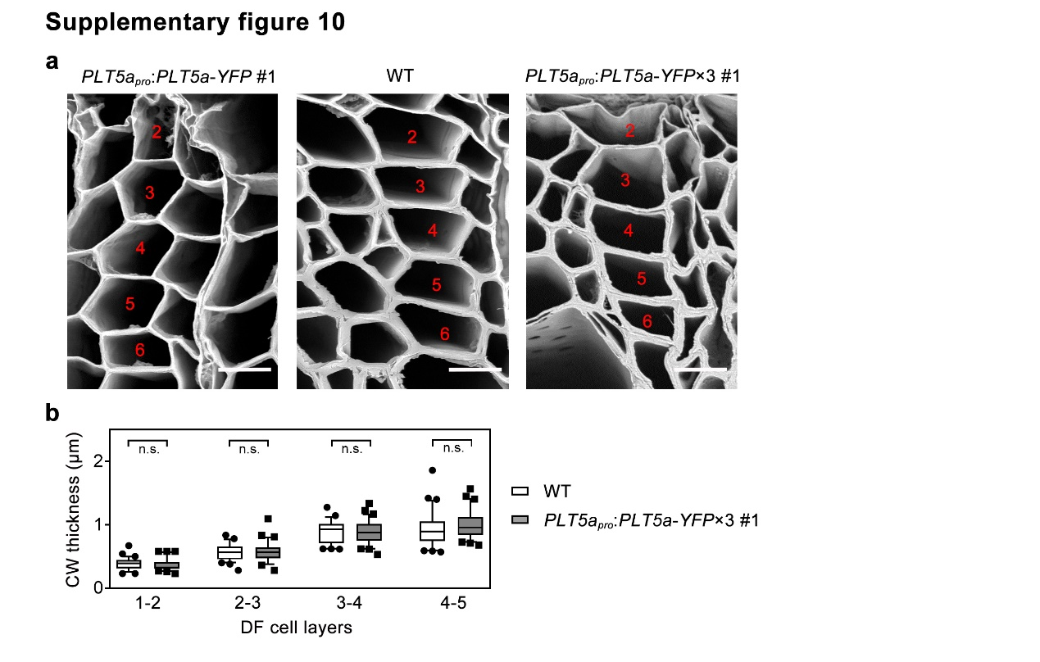
Supplementary figure 10. Cell wall thickness of fibres across radial cells files of PLT5a_{pro}:PLT5a-YFP #1 and PLT5a_{pro}:PLT5a-YFP×3 #1 transgenic lines
a, Scanning electron microscopy (SEM) analyses of developing fibre cells in the 8th internodes of WT and PLT5a_{pro}:PLT5a-YFP #1 and PLT5a_{pro}:PLT5a-YFP×3 #1 transgenics. Scale bars, 15 μm. b, Quantification of cell wall thickness at the 1st to 5th developing fibre cell layers of WT and PLT5a_{pro}:PLT5a-YFP×3 #1 transgenics. The cell wall thickness between neighboring developing fibre cell layers was measured from 30 radial cell files representing three biological replicates. n=30. The boxes show the median and 10-90 percentile, and the whiskers represent the data range excluding outliers. One-way ANOVA analysis followed by Dunnett test for pairwise comparison was performed to evaluate significant differences between WT and PLT5a_{pro}:PLT5a-YFP×3 #1. n.s., not significant. The numbers in red indicate the developing fibre cell layers. CW, cell wall; DF, developing fibre.

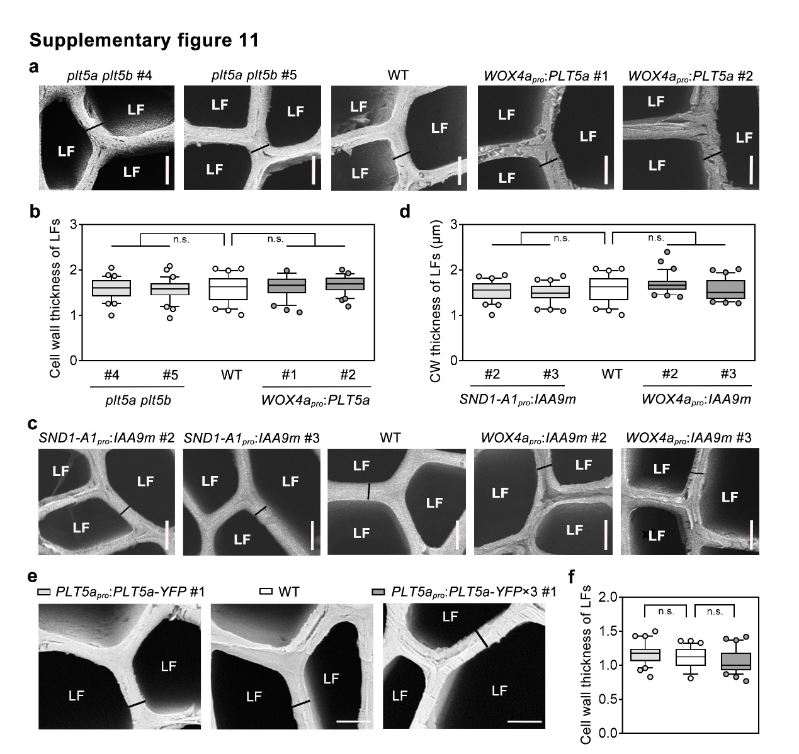
Supplementary figure 11. Cell wall thickness of lignified fibres of in PLT5- and IAA9m-associated transgenic lines.
a, c and e, SEM analyses of lignified fibre cells in the 8th internodes of plt5a plt5b mutants and WOX4a_{pro}:PLT5a transgenics (a), SND1-A1_{pro}:IAA9m and WOX4a_{pro}:IAA9m transgenics (c) and PLT5a_{pro}:PLT5a-YFP and PLT5a_{pro}:PLT5a-YFP×3 transgenics (e). Scale bars, 3.5 μm. LF, lignified fibres. b, d and f, Quantification of the cell wall thickness of lignified fibre cells in the 10th internodes of plt5a plt5b mutants and WOX4a_{pro}:PLT5a transgenics (b), SND1-A1_{pro}:IAA9m and WOX4a_{pro}:IAA9m transgenics (d) and PLT5a_{pro}:PLT5a-YFP and PLT5a_{pro}:PLT5a-YFP×3 transgenics (f). The cell wall thickness was measured from 30 lignified fibre cell representing three biological replicates. n=30. The boxes show the median and 10-90 percentile, and the whiskers represent the data range excluding outliers. One-way ANOVA analysis followed by Dunnett test for pairwise comparison was performed to evaluate significant differences between WT and transgenic lines. n.s., not significant.

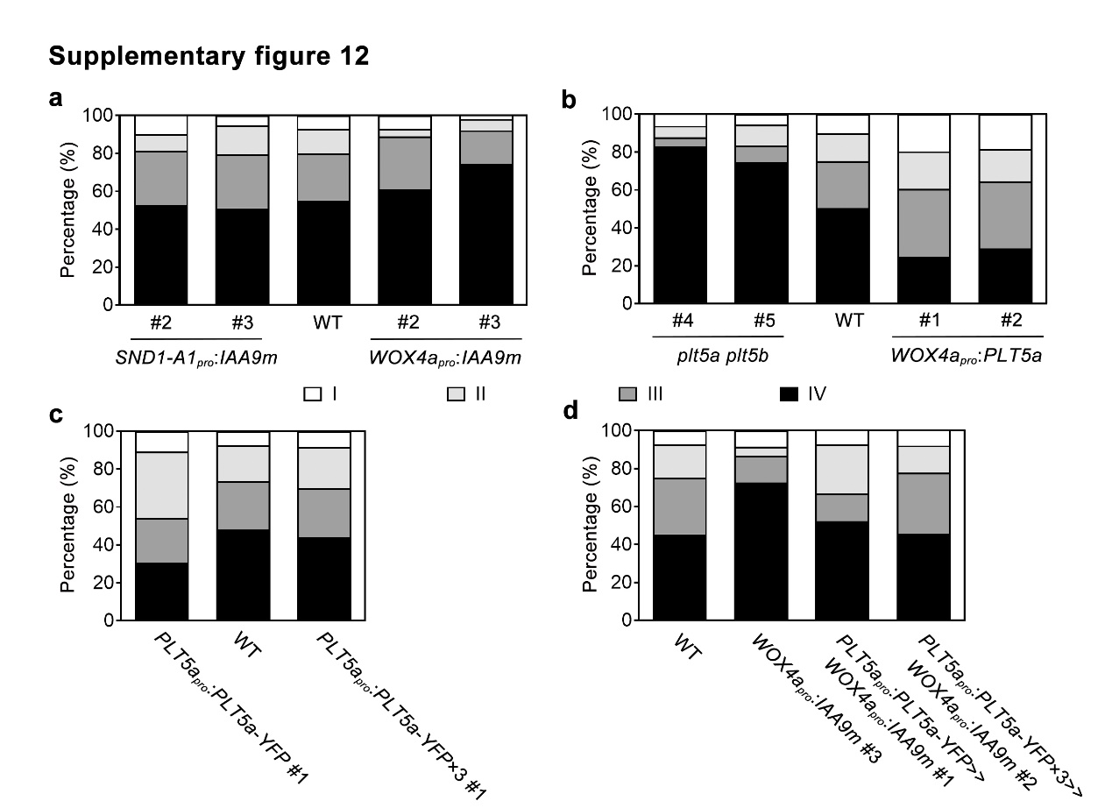
Supplementary figure 12. Percentage of different fibre classes in IAA9m- and PLT5-associated transgenic lines.
a, b, c and d, The percentages of four classes of fibres cells isolated from the 10th internodes of 3-month-old IAA9m- (a), PLT5- (b and c) and PLT5-complementing (d) transgenic lines.

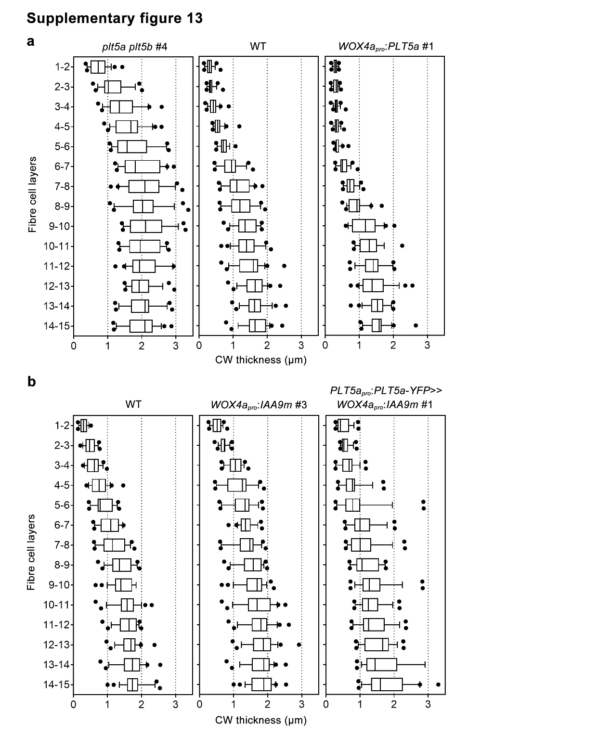
Supplementary figure 13. Quantification of cell wall thickness of developing fibre cells across radial cell files of PLT5a- and IAA9m-associated transgenic lines.
a and b, Quantification of cell wall thickness of developing fibre cells in the 8th internodes of plt5a plt5b #4 mutants and WOX4a_{pro}:PLT5a #1 transgenics (a) and WOX4a_{pro}:IAA9m #3 and PLT5a_{pro}:PLT5a-YFP >>WOX4a_{pro}:IAA9m #1 transgenics (b). The cell wall thickness between neighboring developing fibre cell layers was measured from 24 radial cell files representing three biological replicates. n=24. The boxes show the median and 10-90 percentile, and the whiskers represent the data range excluding outliers. CW, cell wall.

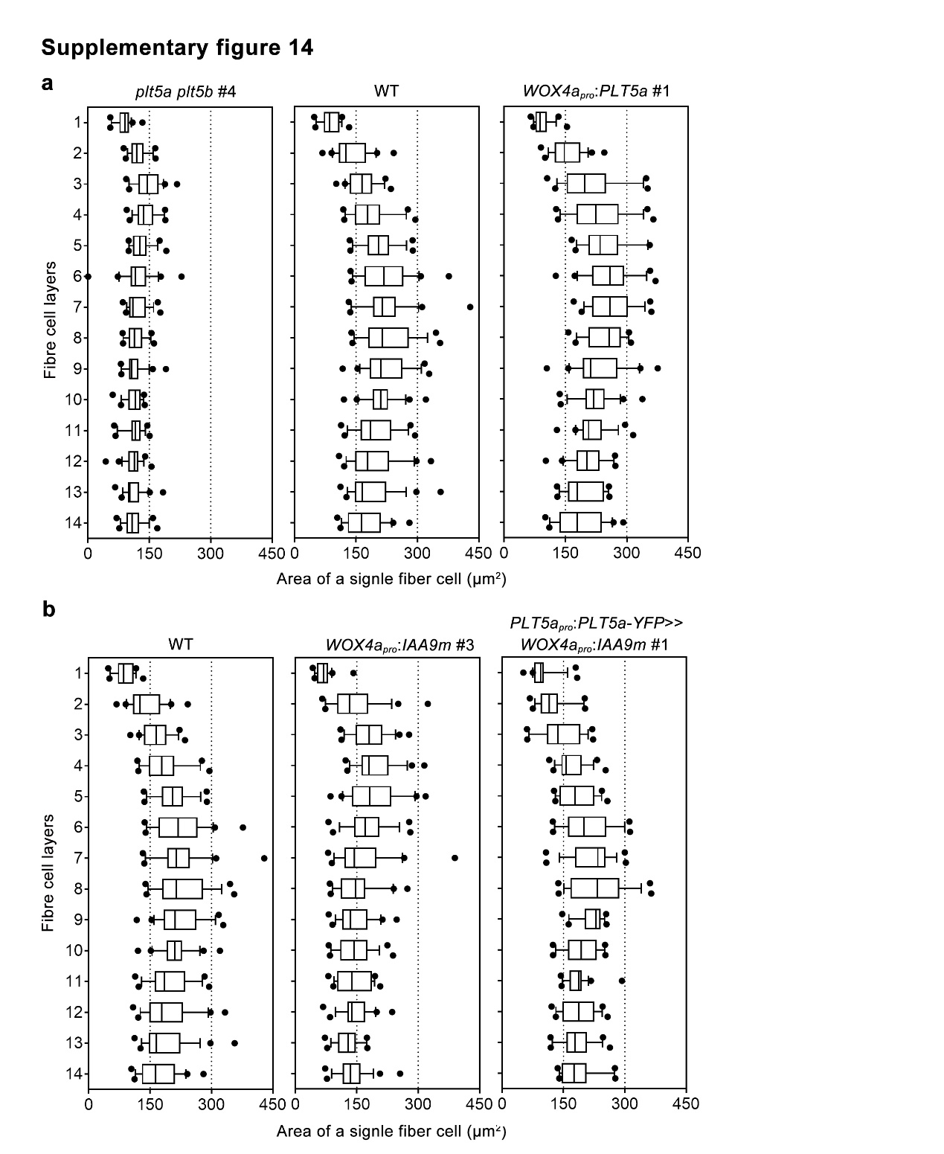
Supplementary figure 14. Quantification of lumen area of a single fibre cell across radial cell files of PLT5a- and IAA9m-associated transgenic lines.
a and b, Quantification of lumen area of a single fibre cell across radial cell files in the 8th internodes of plt5a plt5b #4 mutants and WOX4a_{pro}:PLT5a #1 transgenics (a) and WOX4a_{pro}:IAA9m #3 and PLT5a_{pro}:PLT5a-YFP >>WOX4a_{pro}:IAA9m #1 transgenics (b). The lumen area of a single fibre cell was measured from 24 radial cell files representing three biological replicates. n=24. The boxes show the median and 10-90 percentile, and the whiskers represent the data range excluding outliers.

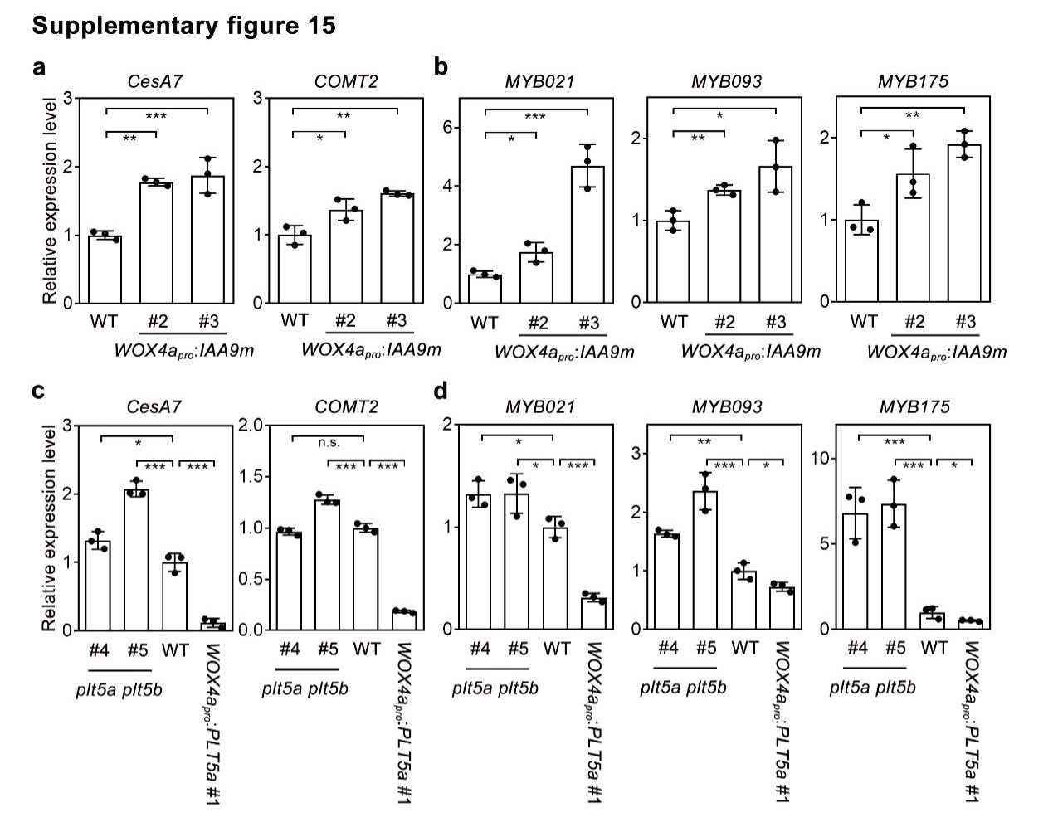
Supplementary figure 15. Expression levels of genes encoding SCW biosynthetic enzymes and MYB transcription factors in IAA9m- and PLT5-associated transgenic lines.
a and c, Expression levels of CesA7 and COMT2 genes assayed by qRT-PCR in WOX4a_{pro}:IAA9m transgenics (a) and plt5a plt5b mutants and WOX4a_{pro}:PLT5a (c) transgenics. b and d, Expression levels of MYB021, MYB093 and MYB175 genes assayed by qRT-PCR in WOX4a_{pro}:IAA9m transgenics (b) and plt5a plt5b mutants and WOX4a_{pro}:PLT5a (d) transgenics. Three biological replicates were analyzed. The data are shown as mean ± s.d. (n = 3). One-way ANOVA analysis followed by Dunnett test for pairwise comparison was performed to test significant differences among WT and transgenic lines. ***, P<0.001; **, P<0.01; *, P<0.05; n.s., not significant.

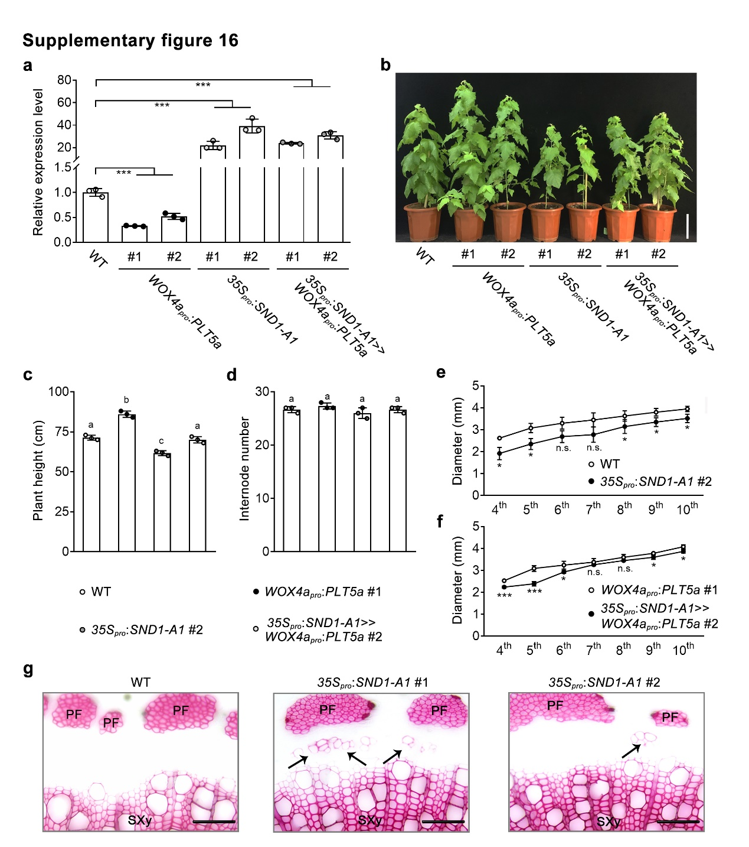
Supplementary figure 16. Generation and phenotypes of 35S_{pro}:SND1-A1 and 35S_{pro}:SND1-A1>>WOX4a_{pro}:PLT5a transgenics.
a, Expression levels of SND1-A1 gene in the stems of WT and WOX4a_{pro}:PLT5a, 35S_{pro}:SND1-A1 and 35S_{pro}:SND1-A1>>WOX4a_{pro}:PLT5a transgenics assayed by qRT-PCR. The values of WT were normalized to 1. b, The 3-month-old plants of WT and WOX4a_{pro}:PLT5a, 35S_{pro}:SND1-A1 and 35S_{pro}:SND1-A1>>WOX4a_{pro}:PLT5a transgenics. Scale bars, 15 cm. c and d, Plant height (c) and internode number (d) of WT and WOX4a_{pro}:PLT5a #1, 35S_{pro}:SND1-A1 #2 and 35S_{pro}:SND1-A1>>WOX4a_{pro}:PLT5a #2 transgenics. e and f, Diameters of the 4th to 10th internodes of WT and 35S_{pro}:SND1-A1 #2 transgenics (e) and WOX4a_{pro}:PLT5a #1 and 35S_{pro}:SND1-A1>>WOX4a_{pro}:PLT5a #2 transgenics (f). g, Phloroglucinol-stained sections of the 8th internodes of 3-month-old WT and 35S_{pro}:SND1-A1 transgenics. Scale bars, 50 μm. PF, phloem fibre; SXy, secondary xylem. The black arrowheads indicate ectopic SCW deposition. In a, c, d, e and f, three biological replicates were analyzed. The data are shown as mean ± s.d. (n = 3). In a, c and d, one-way ANOVA analysis followed by Dunnett test for pairwise comparison was performed to test significant differences. **, P<0.01; *, P<0.05; n.s., not significant. In c and d, different letters above bars indicate significant difference (P<0.05). In e and f, student t test was performed to test significant differences for each internode. ***, P<0.001; *, P<0.05; n.s., not significant.

