Achievement of therapeutic antibiotic exposures using Bayesian dosing software in critically unwell children and adults with sepsis.

Supplementary materials

Supplementary Fig. 2 Time taken to achieve target concentrations above the MIC/clinical breakpoint for all adult patients (2A) and all paediatric patients (2B) as well as time taken to achieve target concentrations above the MIC/clinical breakpoint in patients who failed to achieve target concentrations within the first 24 hours of antibiotic commencement for adult patients (2C) and paediatric patients (2D).

Supplementary Fig. 3 Time taken to achieve target concentrations above the MIC/clinical breakpoint in patients who failed to achieve target concentrations within the first 24 hours of antibiotic commencement for adult patients (A) and paediatric patients (B).

Supplementary Fig. 4 Kaplan-Meier plot estimates of subtherapeutic concentrations in patients who do not achieve target concentrations within 24 hours of antibiotic commencement for adult patients (A) and paediatric patients (B).

Supplementary Table 1 Full inclusion and exclusion criteria for the DIRECT study.

Supplementary Table 2: In-hospital mortality for all patients and patients with subtherapeutic concentrations at 24 hours.

Supplementary Table 3: Cost of the DIRECT Intervention

Supplementary Fig. 2 Time taken to achieve target concentrations above the MIC/clinical breakpoint for all adult patients (2A, n=97; 72 in Phase 1 and 25 in Phase 2) and all paediatric patients (2B, n=78; 51 in Phase 1 and 27 in Phase 2) as well as time taken to achieve target concentrations above the MIC/clinical breakpoint in patients who failed to achieve target concentrations within the first 24 hours of antibiotic commencement for adult patients (2C, n=25; 19 in Phase 1 and 6 in Phase 2) and paediatric patients (2D, n=36; 22 in Phase 1 and 14 in Phase 2).

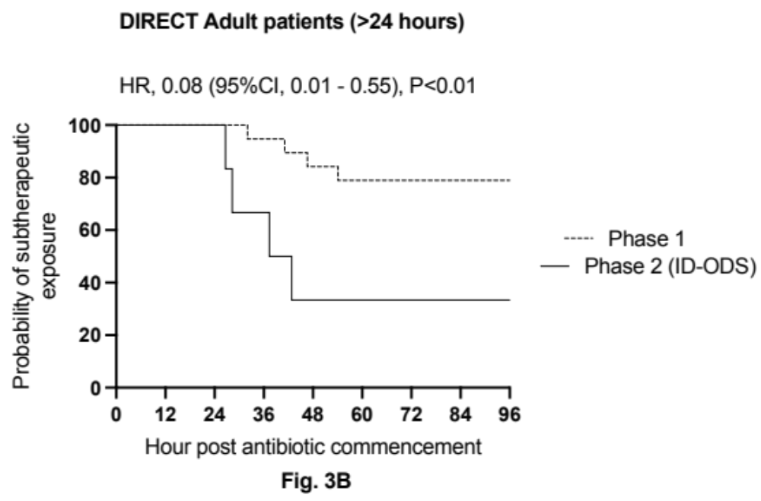
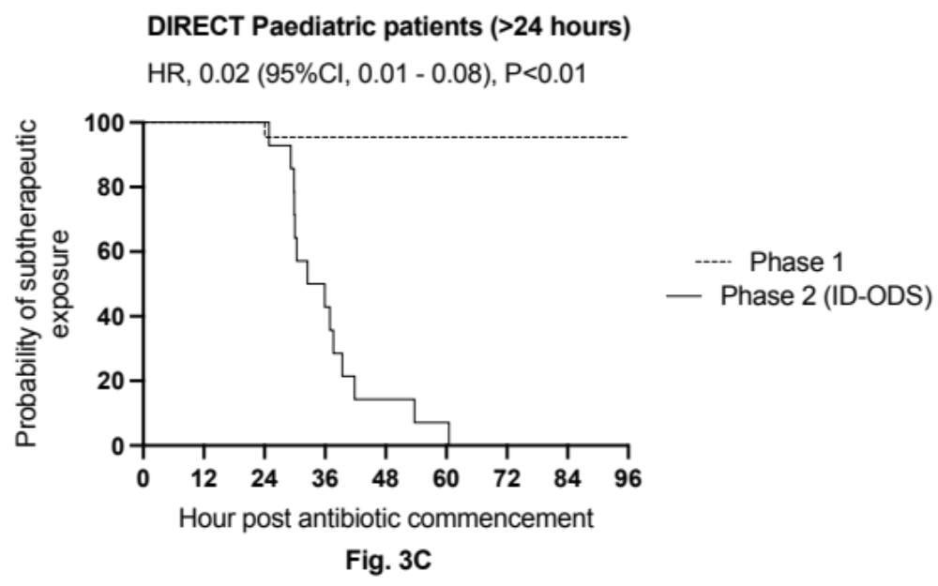
Supplementary Fig. 3 Kaplan-Meier plot estimates of subtherapeutic concentrations in patients who do not achieve target concentrations within 24 hours of antibiotic commencement for adult patients (Fig. 3B) and paediatric patients (Fig. 3C).

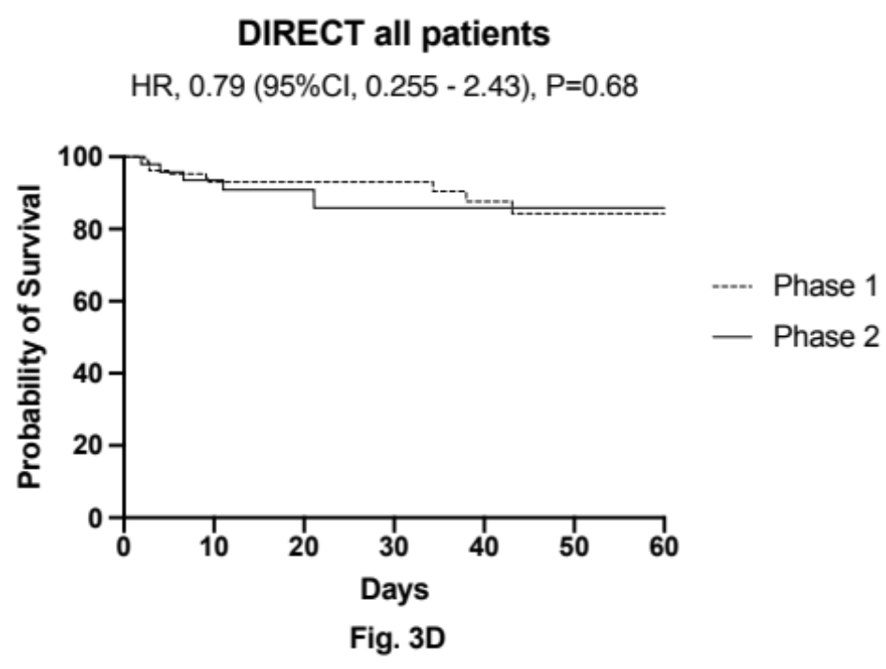

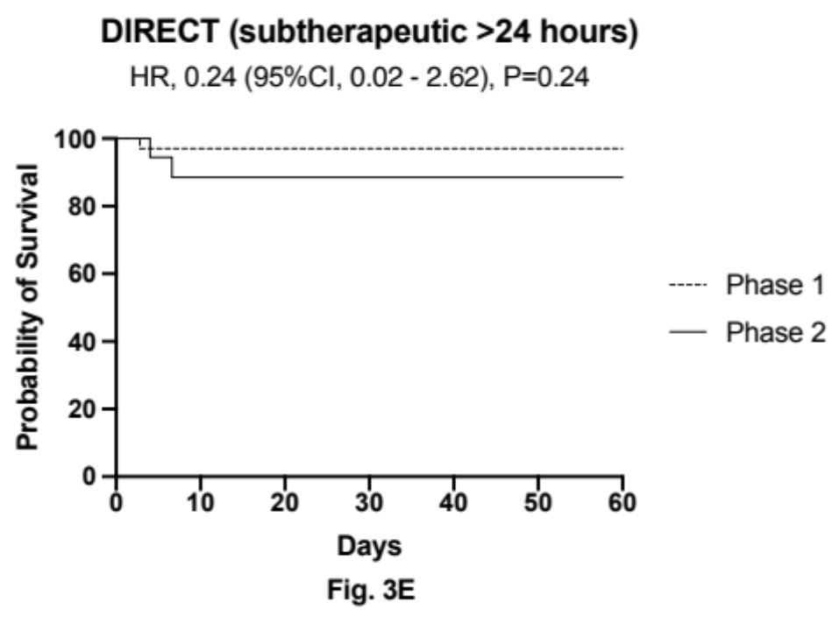

Supplementary Fig. 4 Kaplan-Meier plot estimates of survival for all patients (Top) and patients who failed to achieve target concentrations within 24 hours (Bottom).

Inclusion criteria
• Age >1month
• Admitted to paediatric or adult ICU at one of the participating centres
• Decision to treat for suspected sepsis, defined as suspected or proven infection with or without confirmed organ dysfunction.
• Commenced within 24h on intravenous broad-spectrum antibiotics, or within 24h of a change to new antibiotics consistent with treatment for a new episode of
suspected sepsis.
• Blood cultures are being obtained or were obtained within the past 12 hours
Exclusion Criteria
• Inability to gain informed consent during the study period
• Neonates
• Death is likely imminent
• Palliative care patient
• Renal replacement therapy
• Extra-corporeal membrane oxygenation
Supplementary Table 1: Full inclusion and exclusion criteria for the DIRECT study.

 | All patients  N (%) |  | Kaplan-Meier Log-rank test, P-value | Patients with subtherapeutic concentrations at 24 hours  N (%) |  | Kaplan-Meier Log-rank test, P-value
 | Alive | Deceased | Kaplan-Meier Log-rank test, P-value | Alive | Deceased | Kaplan-Meier Log-rank test, P-value
Phase 1 | 97 (89.8) | 11 (10.1) | 0.676 | 35 (97.2) | 1 (2.8) | 0.244
Phase 2 | 43 (89.6) | 5 (10.4) | 0.676 | 16 (88.9) | 2 (11.1) | 0.244
Supplementary Table 2: In-hospital mortality for all patients and patients with subtherapeutic concentrations at 24 hours.

Item | Phase 1 (n = 108) | Phase 2 (n = 48)
Cost of intervention (AU$)
Antibiotic assay of blood sample | -- | 30.00
Clinical service of pharmacist to run simulation | -- | 41.00
Dosing simulation run | -- | 0.05
Cost of server line for simulation | -- | 0.07
Average total cost per patient | -- | 71.13
Benefits of the interventionª
Time spent in ICU (days) | 12.89 (95%CI: 7.92 – 17.87) | 10.76 (95%CI: 7.72 – 13.80)
Time saved due to intervention (days) | -- | 2.134 (95%CI: 1.65 – 2.62)
Total cost of ICU stay per patient (AU$) | $62,135.41 (95%CI: $42,125.5 – $82,144.88) | $74,459.69 (95%CI: $45,726.73 – $103,192.65)
Average benefit of the intervention (AU$) |  | $12,324.28 (95% CI: $9,520.93 – $15,127.62)
Benfit-cost ratio of the intervention |  | 173.27 (95%CI: 133.86 – 212.69)
Supplementary Table 3: Cost of the DIRECT Intervention; ªBenefits estimated are potential benefits and not necessarily actual given the sample size and heterogeneity of the participants. ICU = Intensive care unit

