eFigure 1. Histograms of 7 autoimmune related disease PRSs in NEER and PCAWG.
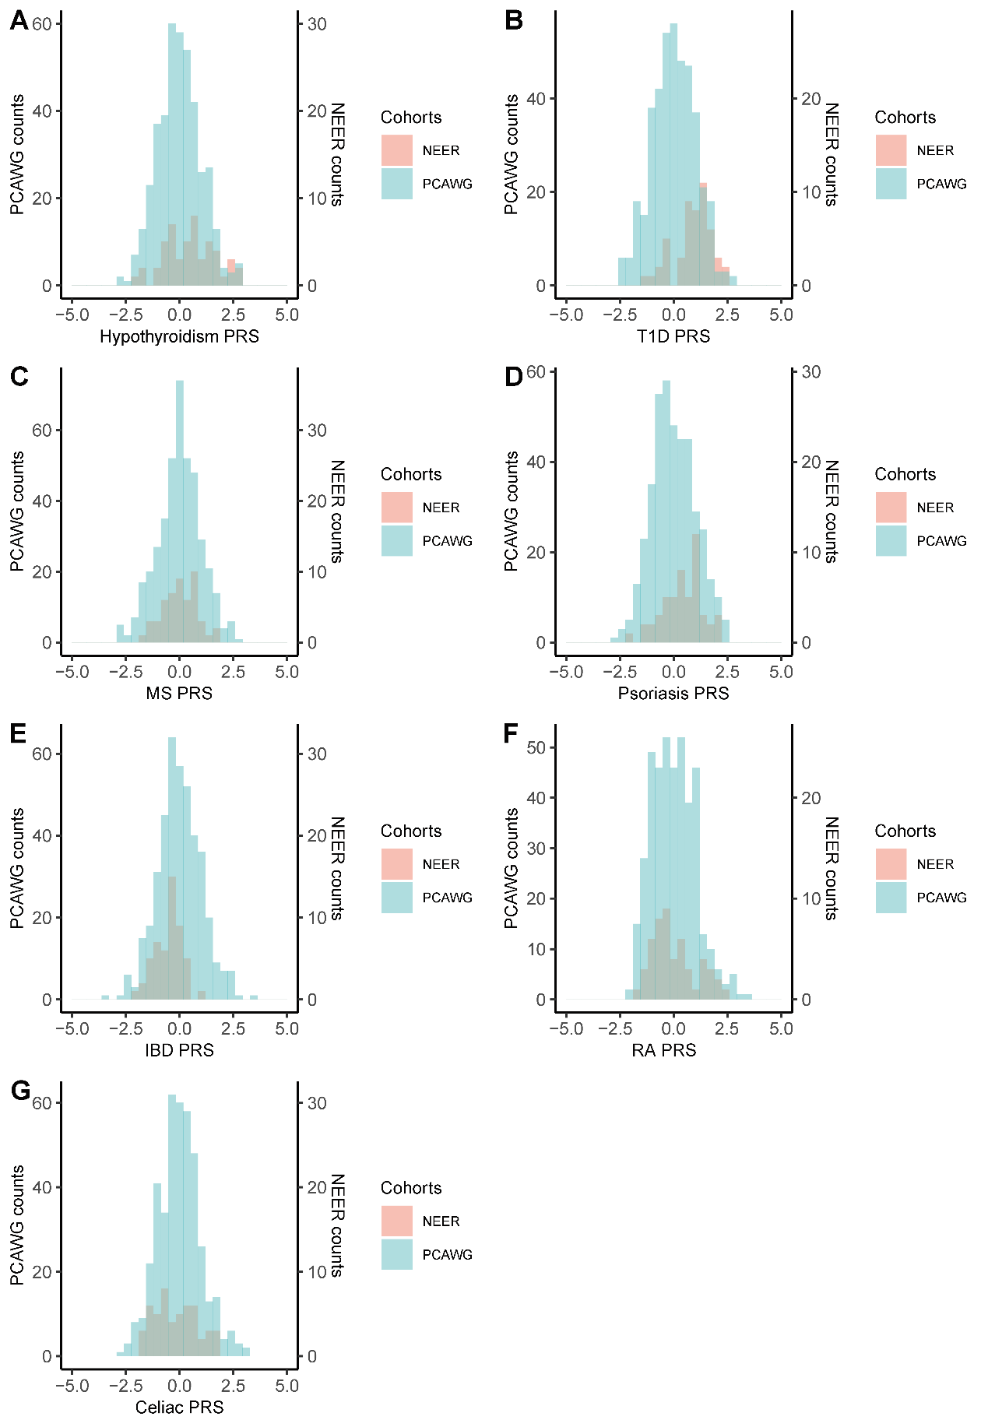
The histograms show the distribution of PRSs without being smoothed. The main y axis (left) shows counts of PCAWG typical patients with the given binned PRS, while the second y axis (right) shows the counts of NEER ERs.

eFigure 2. Survival curves of PCAWG patients stratified by high vs low PRSs
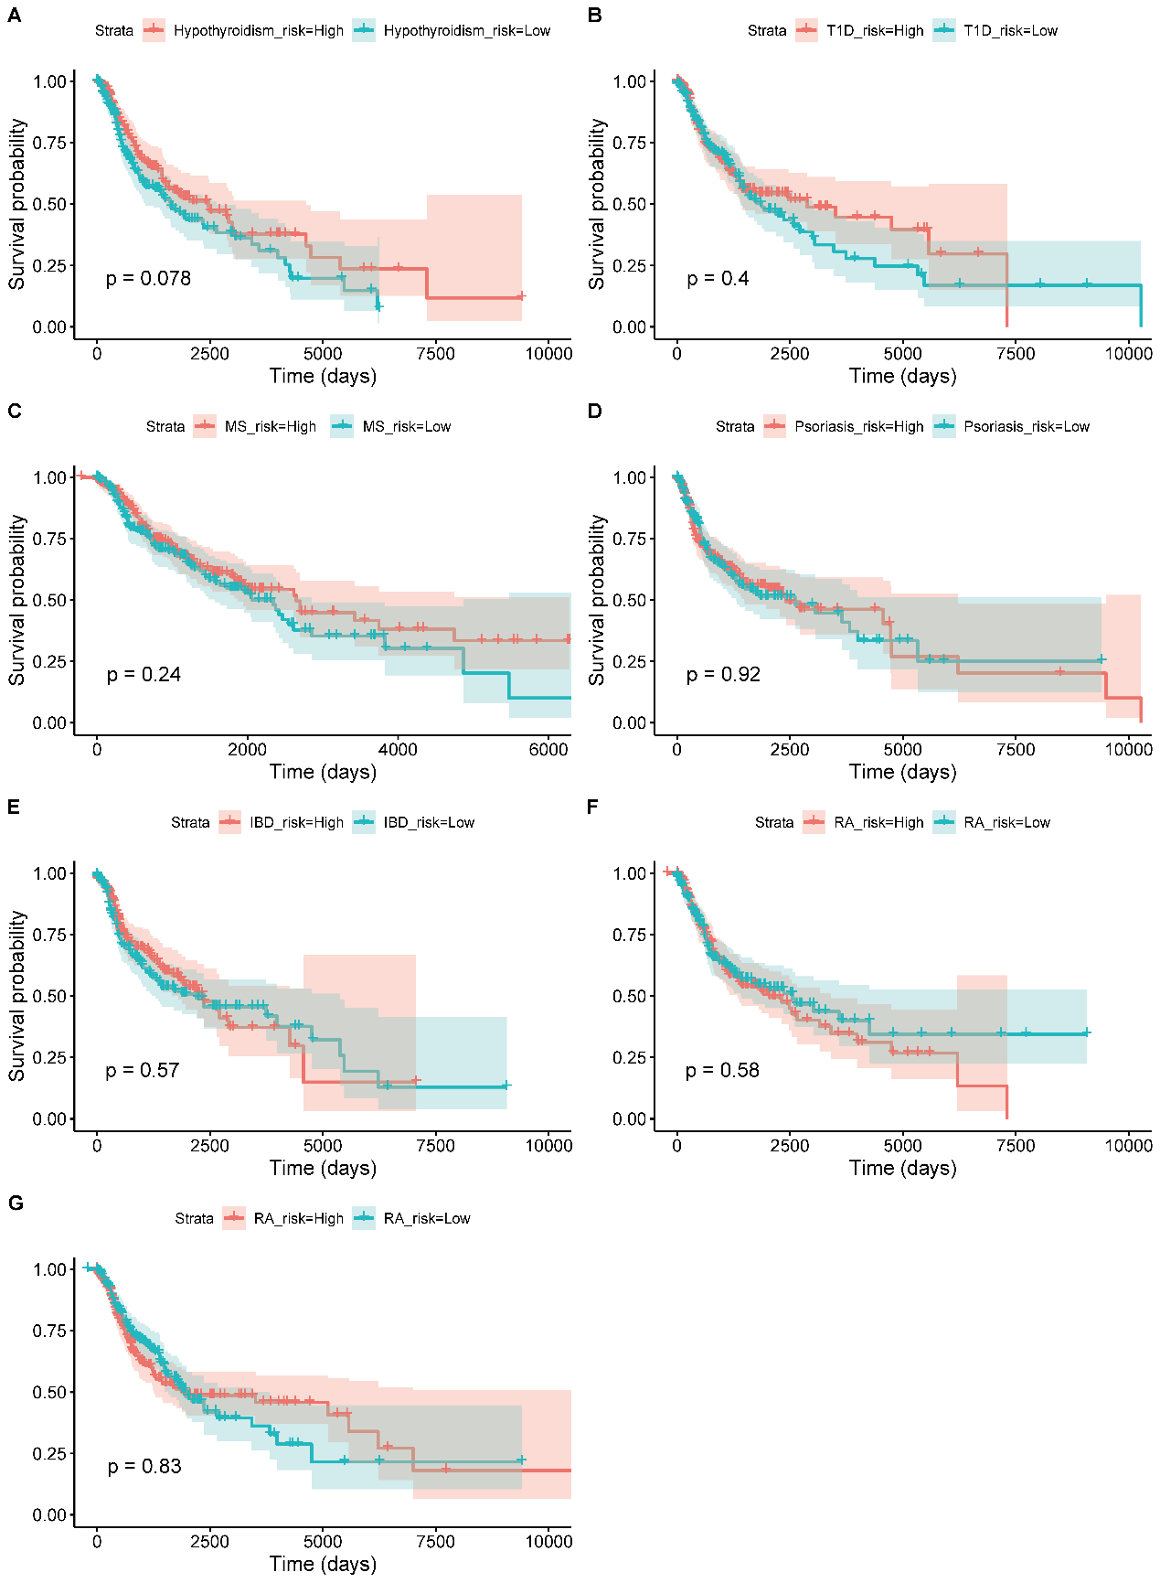
Survival curves in PCAWG typical cancer patients, stratified by PRSs in 7 autoimmune diseases. The red curve refers to those patients with high PRSs and high risk of diseases, while the blue curve refers to those with low risks. The number of individuals followed up for each time interval is shown in the table.

eFigure 3. 2-D PCA plot of all NEER and PCAWG patients.
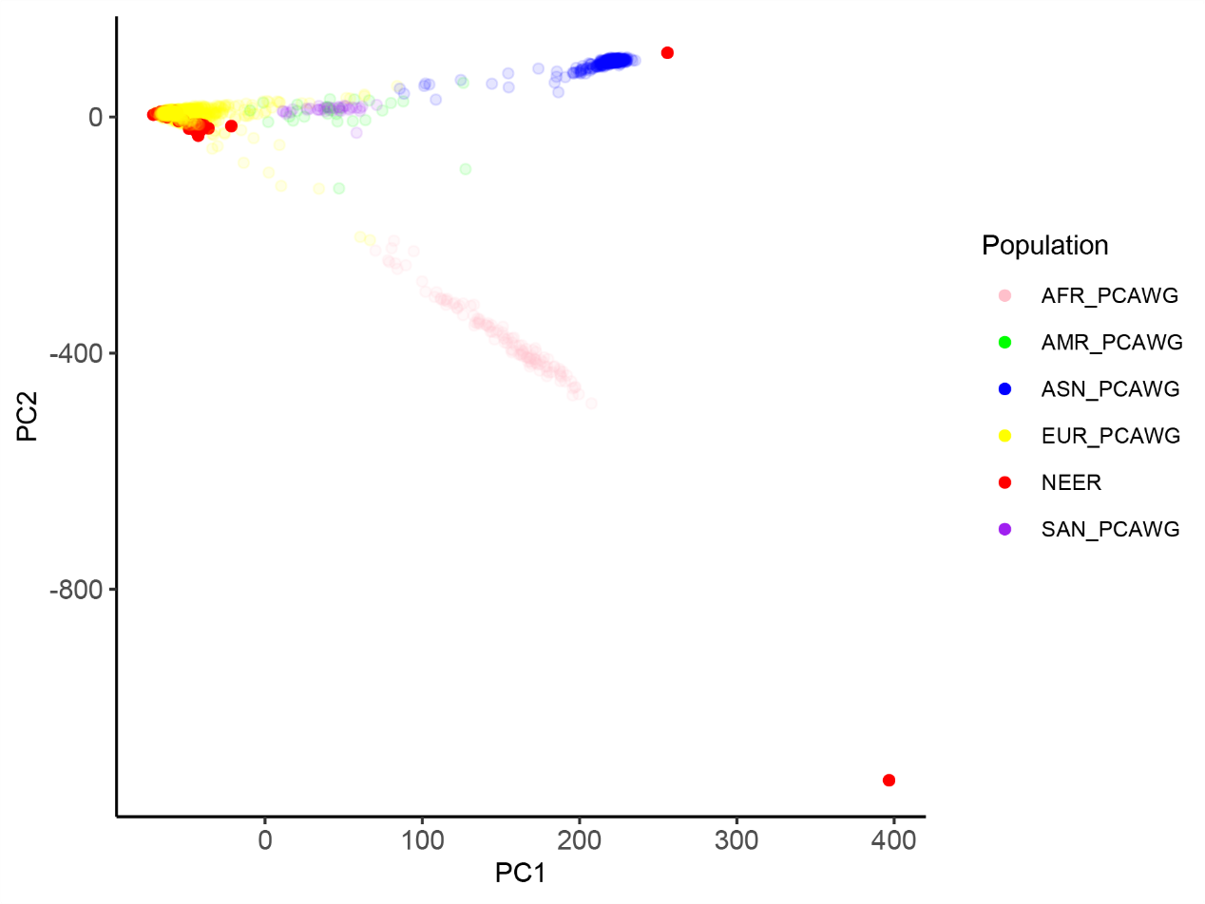
PCA was conducted among all NEER and PCAWG patients and PCAWG patients were colored by previously reported ancestry populations.

