Table (1). 2D interaction diagram and interactions of best 10 compounds along with co-crystallized standard drug, donepezil
Ligands | 2D interaction diagram | Interactions
NPC  109925 | 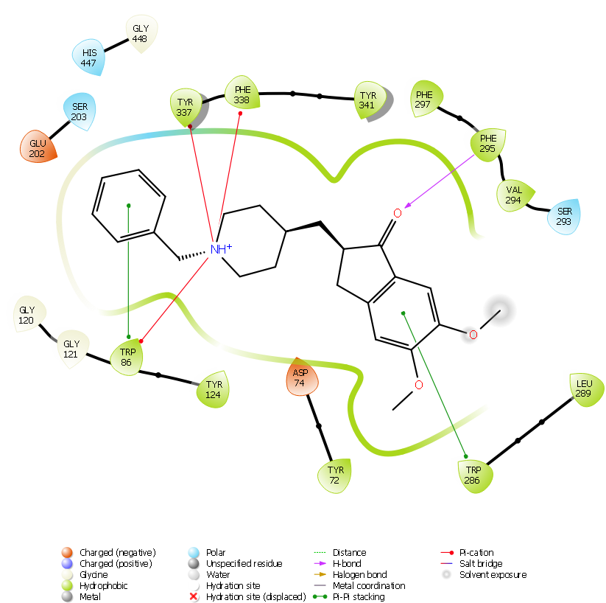 | 2H bond- SER 293, PHE 295  2Pi cation- TRP 286  Pi-Pi stacking- TRP86  Hydrophobic- TYR72, TYR 124, TYR 341, VAL 294, PHE 338, PHE 295, PHE 297, LEU 76, LEU 28  Polar- HIS 287, GLN 291  Charged positive- ASP 74, GLU 202  Charged negative- ARG 296  GLY-342
NPC  107602 | 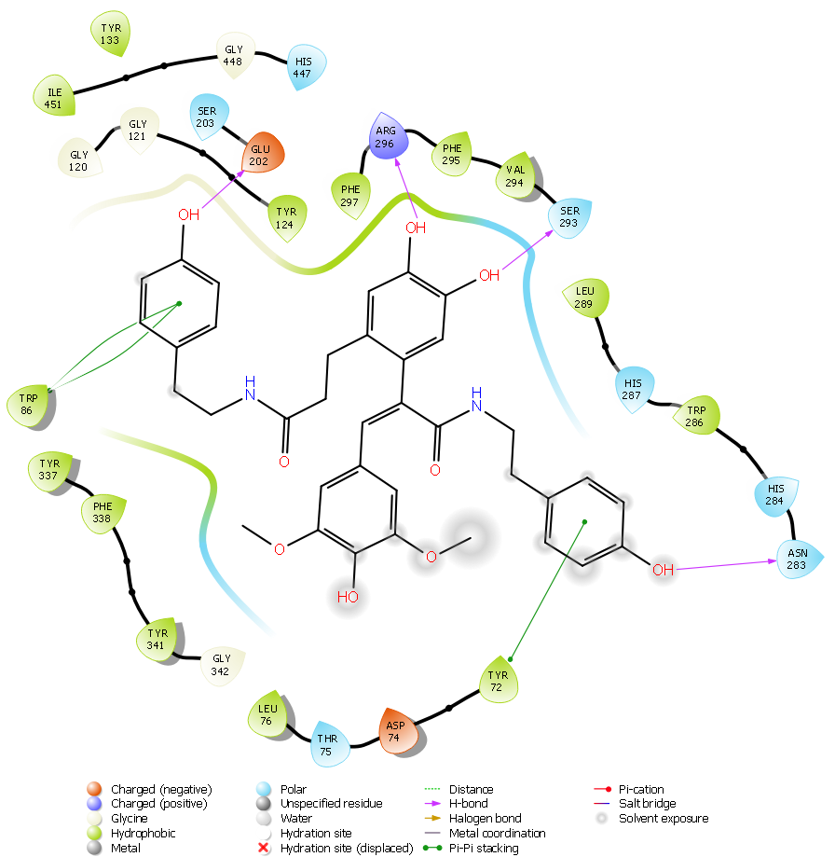 | Hydrogen bond- ASN 283, GLU 202, SER 293, ARG 296  Pi-Pi stacking- TYR 72, TRP86  Hydrophobic- TYR 72, TYR 124, TYR 133, TYR 337, TYR 341, LEU 76, LEU 289, PHE 295, PHE 297, TRP 286, PHE 338, VAL 294  Polar- THR 75, SER 203, ASN 283, HIS 284, HIS 287, GLN 291, SER 293, HIS 447  Charged positive- ASP 74, GLU 292  Charged negative- ARG 296  GLY- 120,121,342,448
NPC101543 | 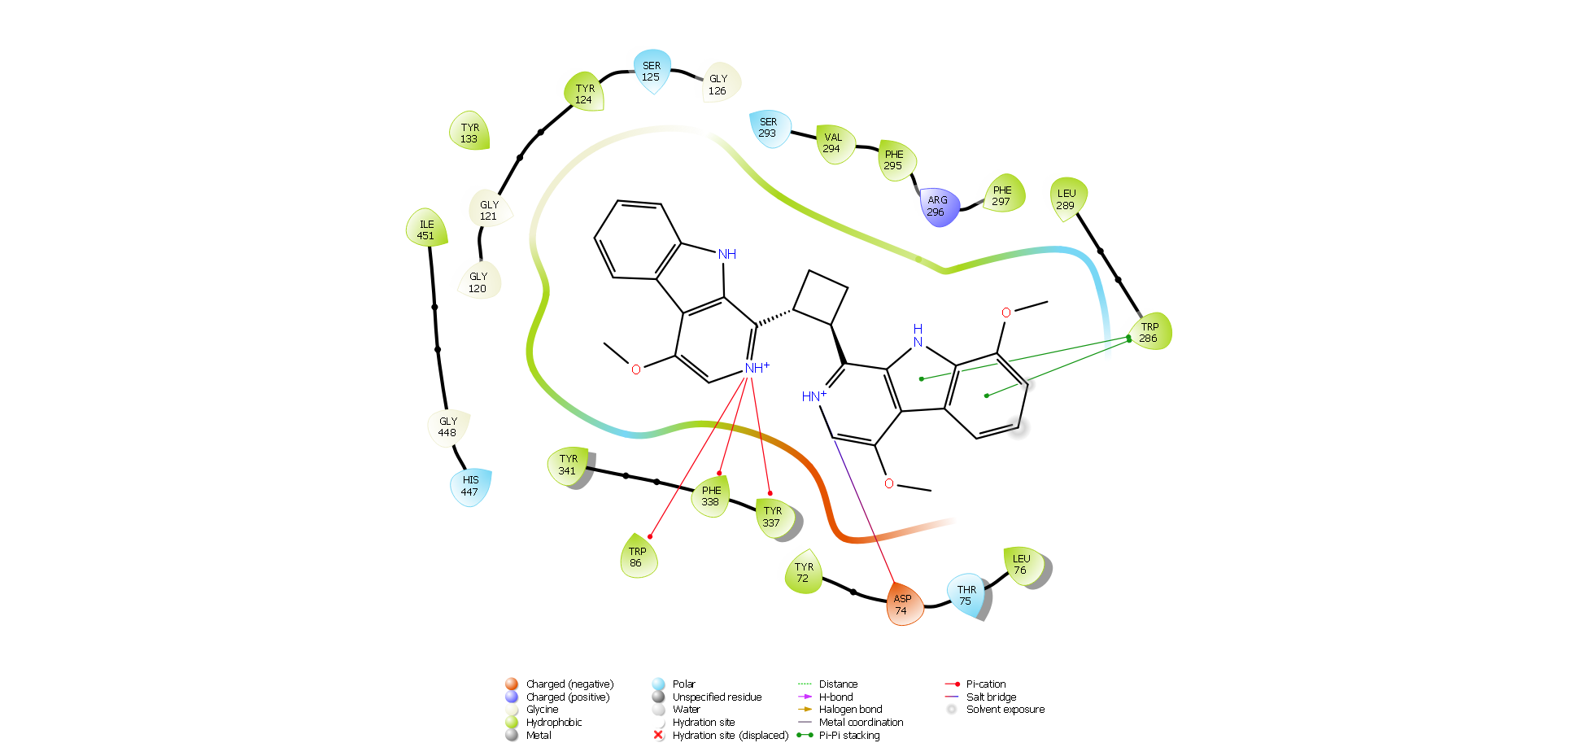 | Pi-cation- TRP 86, TYR 337, TYR 338  2Pi-Pi stacking- TRP 286  Salt bridge- ASP 74  Hydrophobic- TYR 72, TYR 124, TYR 133, TYR 337, TYR 341, TYR 449, PHE 297, LEU 76, LEU 289, VAL 294, PHE 295, ILE 451, PHE 338  Polar- THR 75, SER 125, SER 293, HIS 447  Charged negative- ARG 296  Charged positive- ASP 74  GLY- 120,121,126,448
NPC43065 | 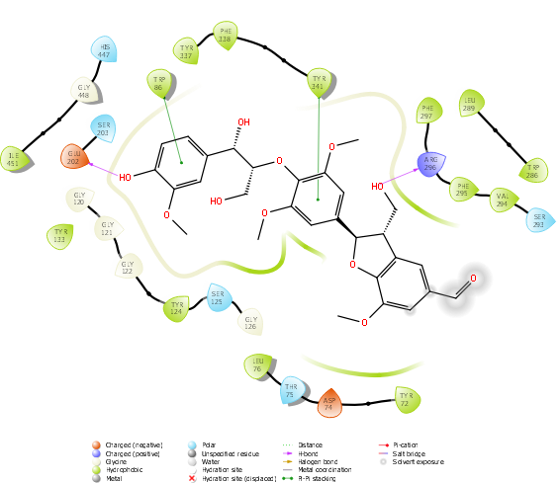 | Hydrogen bond- ARG 296, GLU 202, PHE 295, ASP 74  Pi-pi stacking-TRP 86, TYR 341  Hydrophobic-TYR72, TYR 124, TYR 133, TYR 337, LEU 76, PHE 338, VAL 294, PHE 297, ILE 451  Polar-THR 75, SER 125, SER 203, SER 293, HIS 447  Charged negative- ARG 296  Charged positive- ASP 74  GLY- 120,121,126,448
NPC86198 | 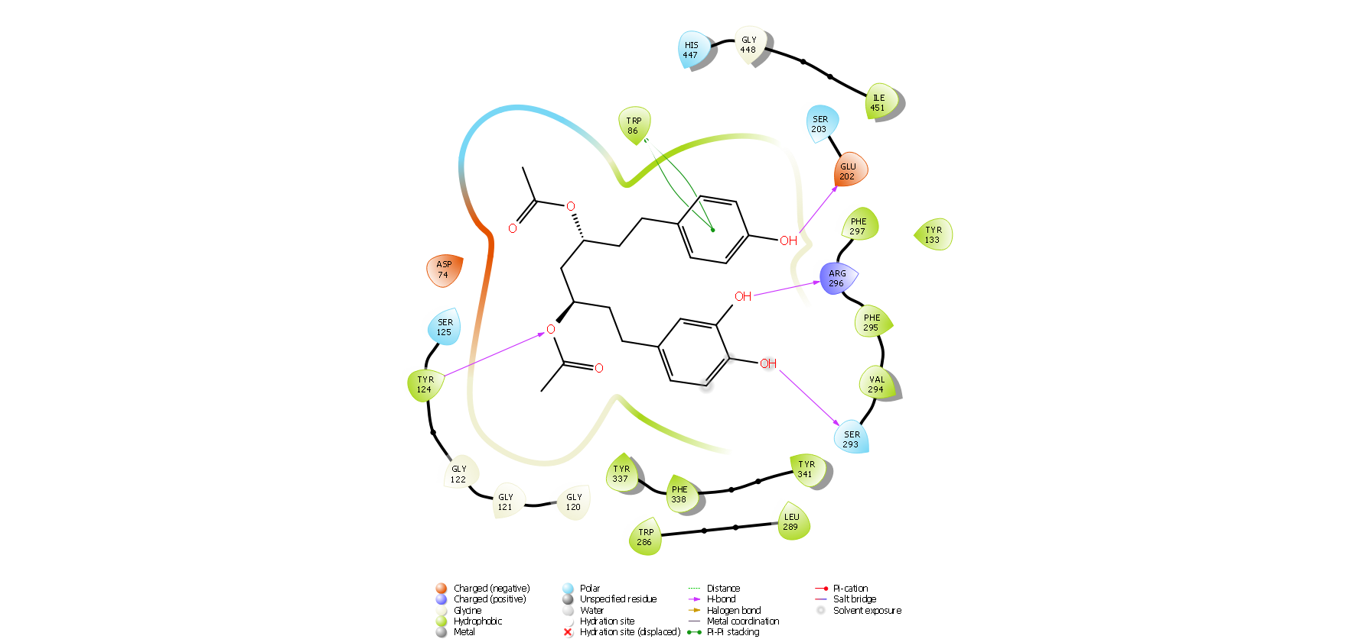 | Hydrogen bond-ASP 24, TYR 124, GLU 202, SER 293, ARG 296, TYR 337  Pi-pi stacking-TRP 86  Hydrophobic-TYR 124, TYR 133, TYR 337, PHE 338, TYR 341, TRP 286, VAL 294, PHE 297, ILE 451, LEU 289  Polar-SER 125, SER 203, SER 293, HIS 447  Charged negative- ARG 296  Charged positive- ASP 74, GLU 202  GLY- 120,121,126,448
NPC59692 | 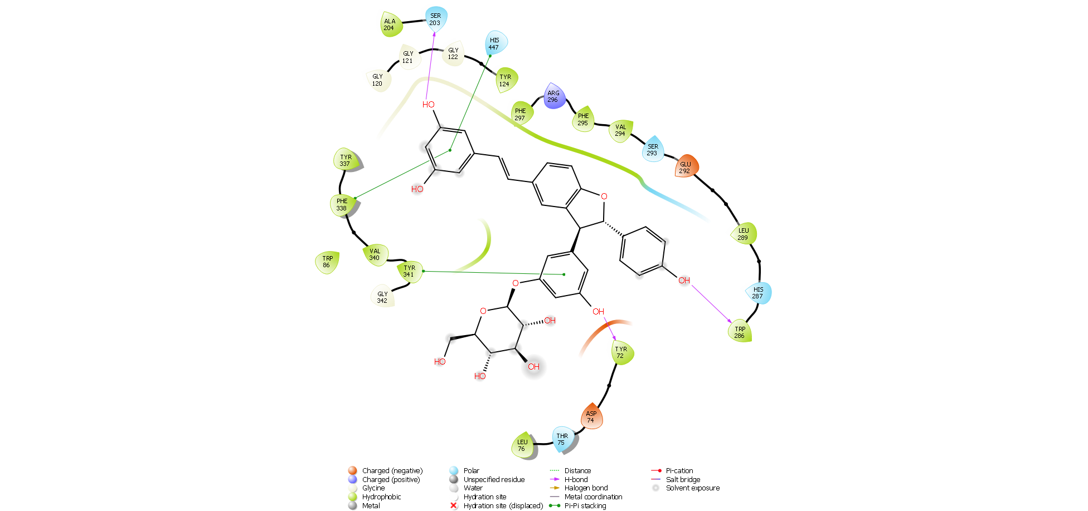 | Hydrogen bond- TYR 72, ASP 74, TYR 337, TRP 286  Pi-pi stacking-TYR 341  Hydrophobic- LEU 76, TRP 86, TYR 124, TYR 337, TYR 341, TRP 286, LEU 289, PHE 295, PHE 338, PHE 297, VAL 340, ILE 451, VAL 294  Polar-THR 75, SER 203, HIS 287, GLN 291, SER 293, HIS 447  Charged negative- ARG 296  Charged positive- ASP 74, GLU 292  GLN-121,122,342
NPC324492 | 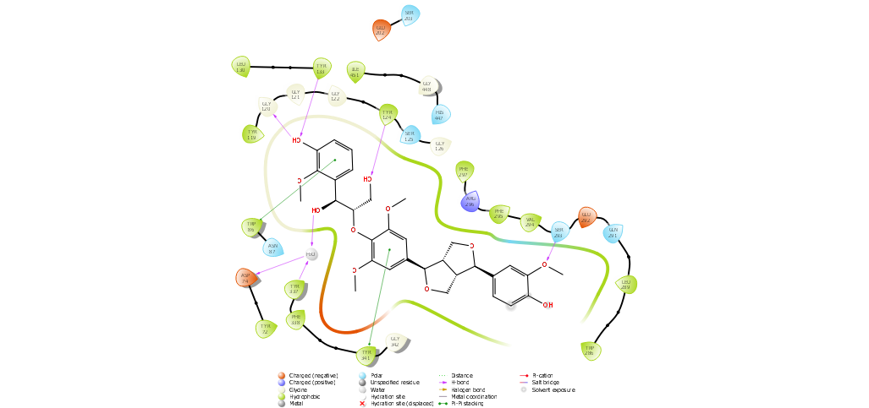 | Hydrogen bond- TYR 124, SER 293, ASP 74, TYR 337  Pi-pi stacking-TYR 341  Hydrophobic- TYR 72, TYR 124, VAL 294, TYR 133, TYR 337, PHE 338, TYR 341, TRP 286, TRP 86, LEU 130, LEU 289, PHE 295, PHE 297, ILE 451  Polar-SER 125, SER 203, GLN 291, SER 293, HIS 447  Charged negative-ARG 296  Charged positive- ASP 74, GLU 202, GLU 292  GLN-121,122,342
NPC471415 | 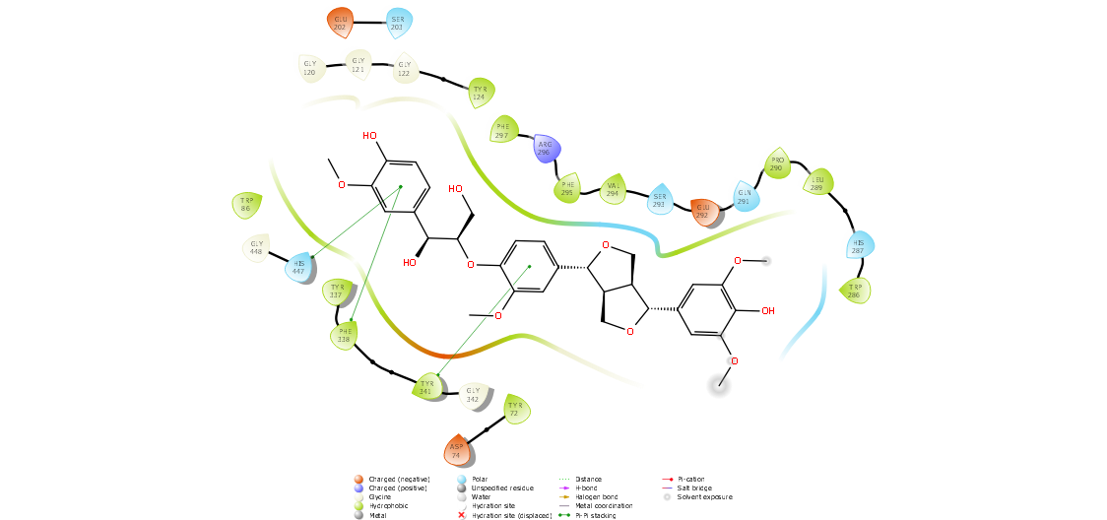 | Pi-pi stacking- PHE 338, TYR 341, HIS 441  Hydrophobic- TYR 72, LEU 289, TYR 124, PHE 295, TYR 337, PHE 338, TYR 341, ALA 204, TRP 86, TRP 286, PRO 290, VAL 294, PHE 297, ILE 451  Polar-SER 203, HIS 287, GLN 291, SER 293, HIS 447  Charged negative-ARG 296  Charged positive- ASP 74, GLU 202, GLU 292  GLN-120,121, 122, 342, 448
NPC9218 | 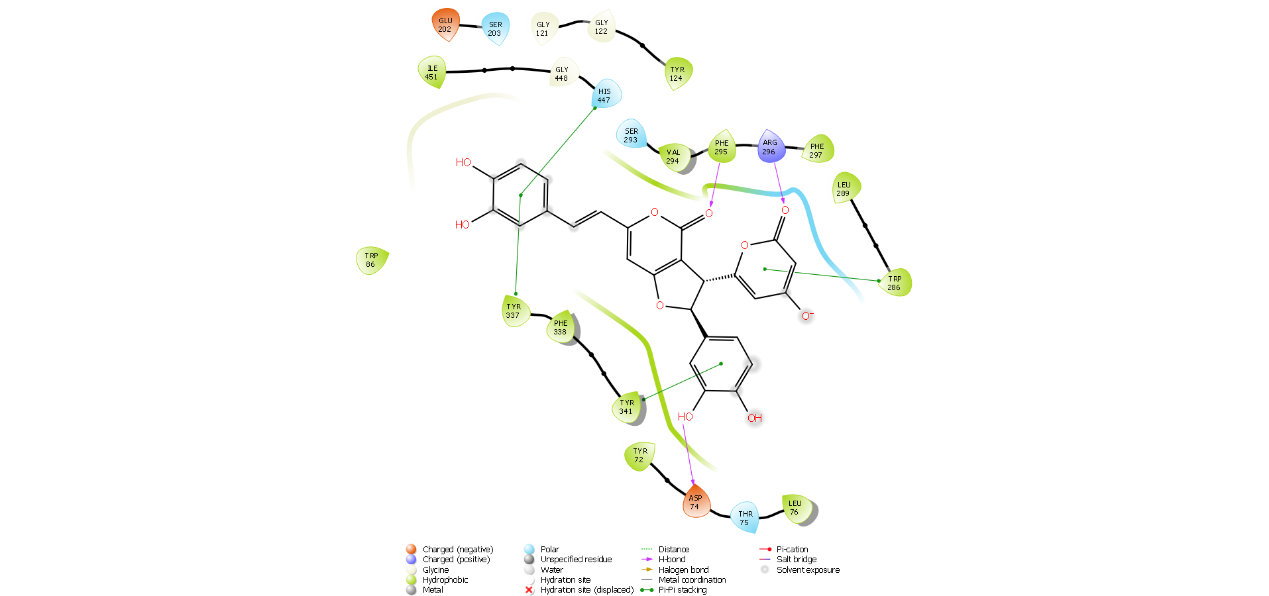 | Hydrogen bond-ASP 74, PHE 295, GLU 202, ARG 296,  Pi-pi stacking- TRP 286, TYR 341, HIS 447  Hydrophobic-TYR 72, LEU 289, TYR 124, PHE 338  TYR 337, TYR 341, LEU 76, PHE 297,  Polar-THR 75, SER 203, SER 293, HIS 447  Charged negative- ARG 296.  Charged positive- ASP 74, GLU 202  GLY- 120,121,122,126, 342,448
NPC472087 | 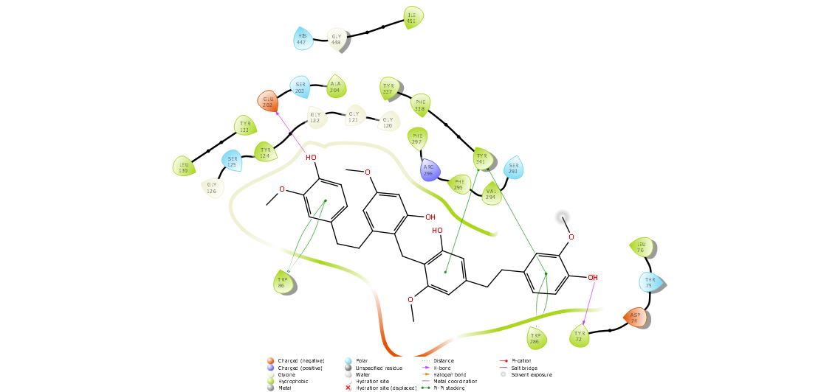 | Hydrogen bond-TYR 72, GLU 202  Pi-pi stacking-TRP 86, PHE 338, TRP 286, TYR 341  Hydrophobic- TYR 124, PHE 297, LEU 76, TYR 133, PHE 338, TYR 337, TYR 341, ALA 202, VAL 294, ILE 451  Polar-THR 75, SER 125, SER 203, HIS 447, SER 293  Charged negative- ARG 296.  Charged positive- ASP 74, GLU 202  GLY- 120,121,122,126, 342,448
Donepezil | 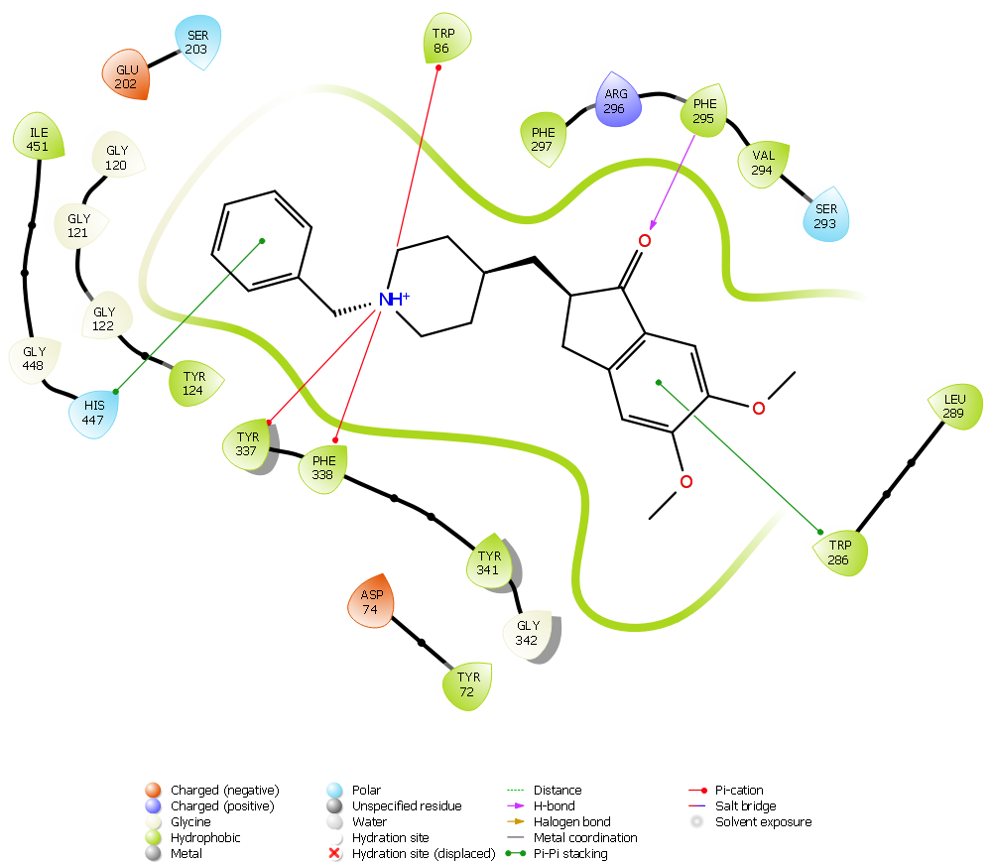 | Hydrogen bond-PHE 295  Pi-pi stacking-TRP 286, HIS 447  Pi-cation - TRP 86, TYR 337, TYR 338  Hydrophobic-TYR 72, ILE 451, TYR 124, LEU 289, VAL 294, PHE 297, TYR 341,  Polar-SER 203, SER 293, HIS 447  Charged negative- ARG 296.  Charged positive- ASP 74, GLU 202  GLY- 120,121,122,342, 448

