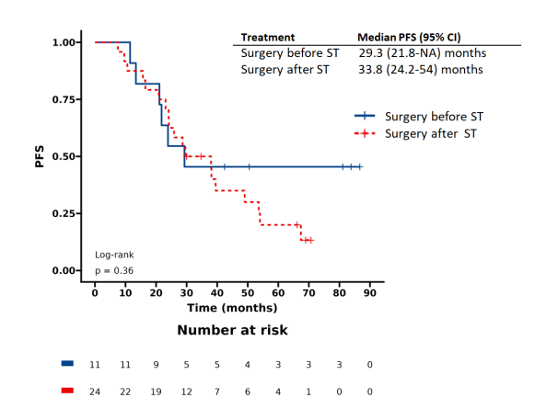
Supplementary Figure 1 PFS in patients undergoing surgery before/after systemic therapy (ST)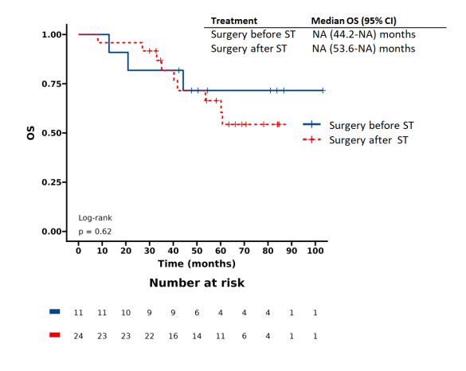
Supplementary Figure 2 OS in patients undergoing surgery before/after systemic therapy (ST)

