Additional file 1: Figure S1−8

“Spatial variations in seismicity characteristics in and around the source region of the 2019 Yamagata-Oki Earthquake” by Taku Ueda et al.
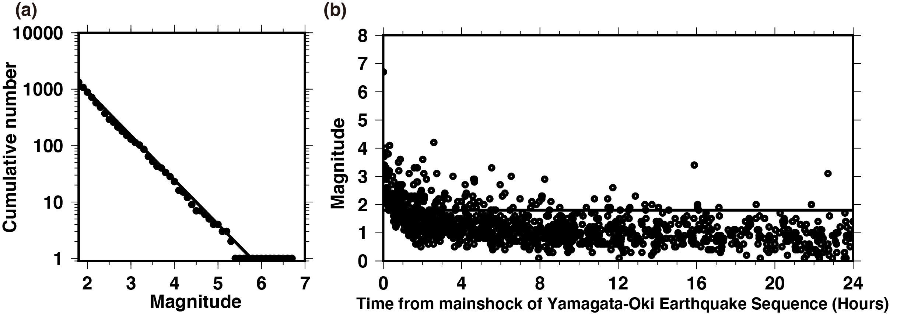
Additional Figure S1 (a) Cumulative frequency-magnitude distributions of the earthquakes that were recorded from 1998 and which occurred within the blue rectangular box in Fig. 1c. (b) Magnitude-time plot of the aftershocks (${\text{M}}_{\text{j}}≥0.0$) that occurred within 24 h following the 2019 Yamagata-Oki earthquake.
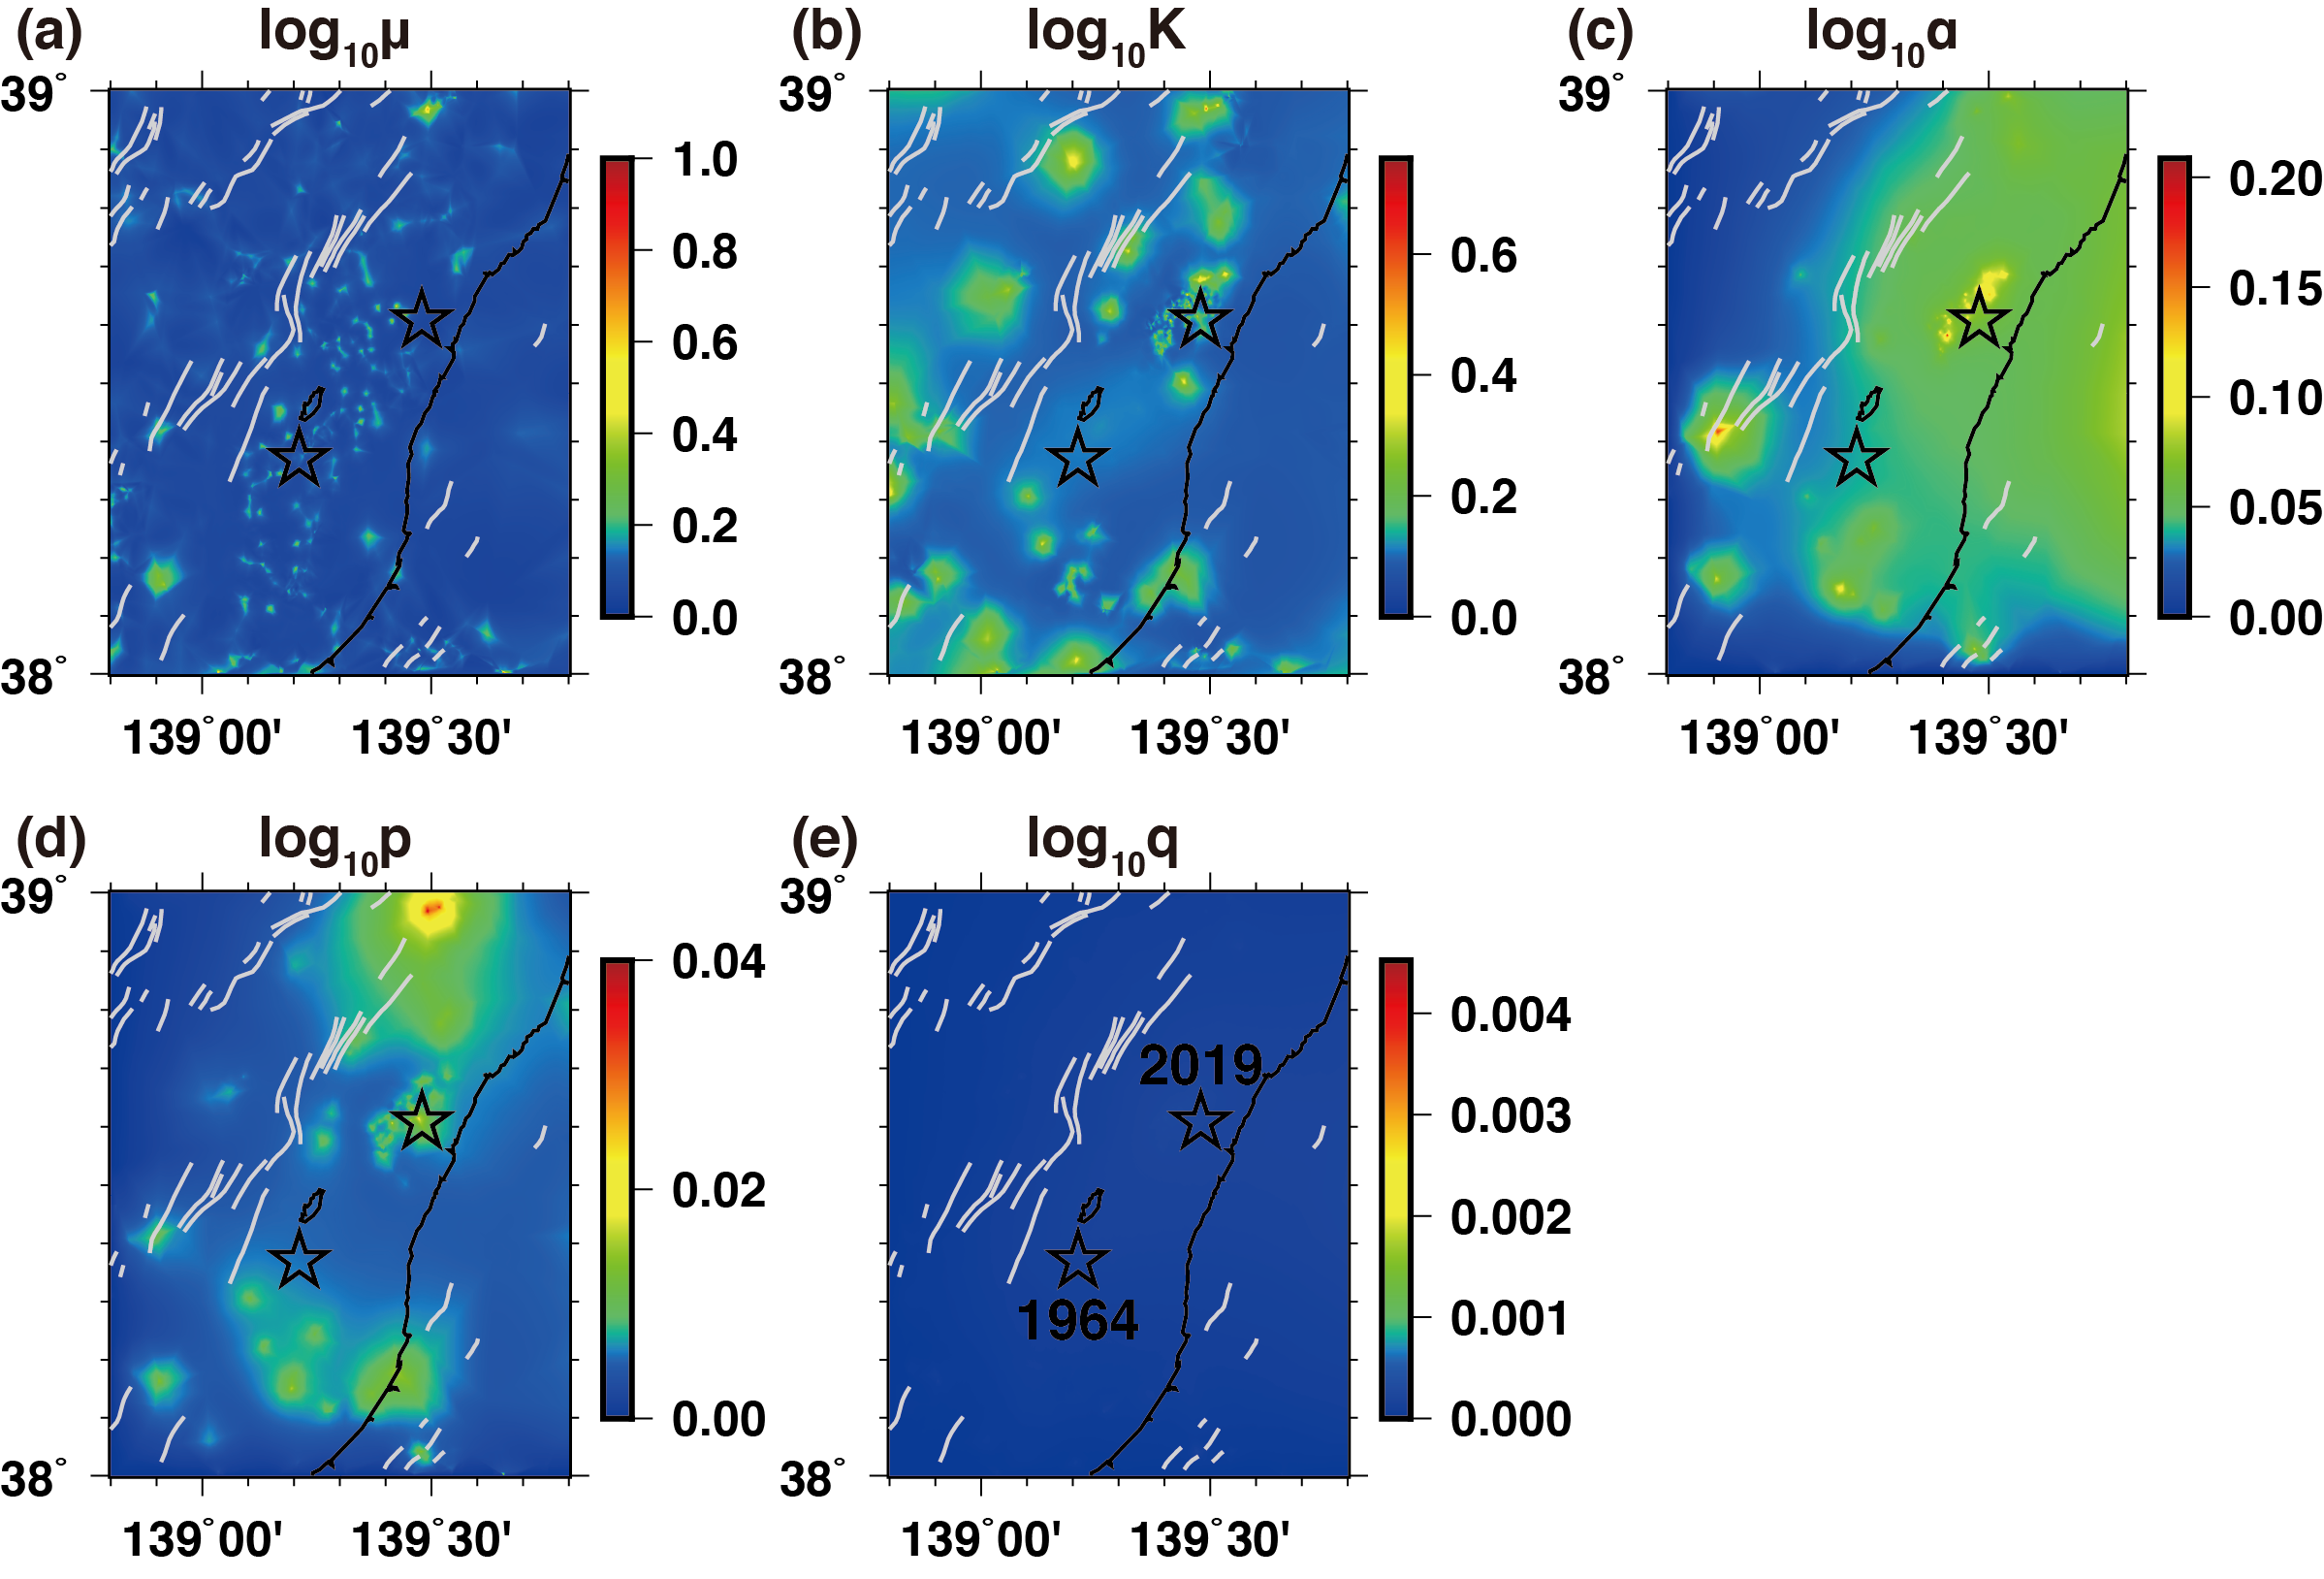
Additional Figure S2 Spatial distributions of the standard deviations of the relative HIST-ETAS parameters calculated by using resampled data set extracting 90% of the earthquake data used in the analysis. Standard deviations of (a) $ϑ_{μ}(x,y)/\ln{10}$, (b) $ϑ_{K}(x,y)/\ln{10}$, (c) $ϑ_{α}(x,y)/\ln{10}$, (d) $ϑ_{p}(x,y)/\ln{10}$, and (e) $ϑ_{q}(x,y)/\ln{10}$. The two stars denote the epicenters of the 1964 Niigata (lower) and 2019 Yamagata-Oki (upper) earthquakes. Gray lines are the surface traces of active Quaternary faults.

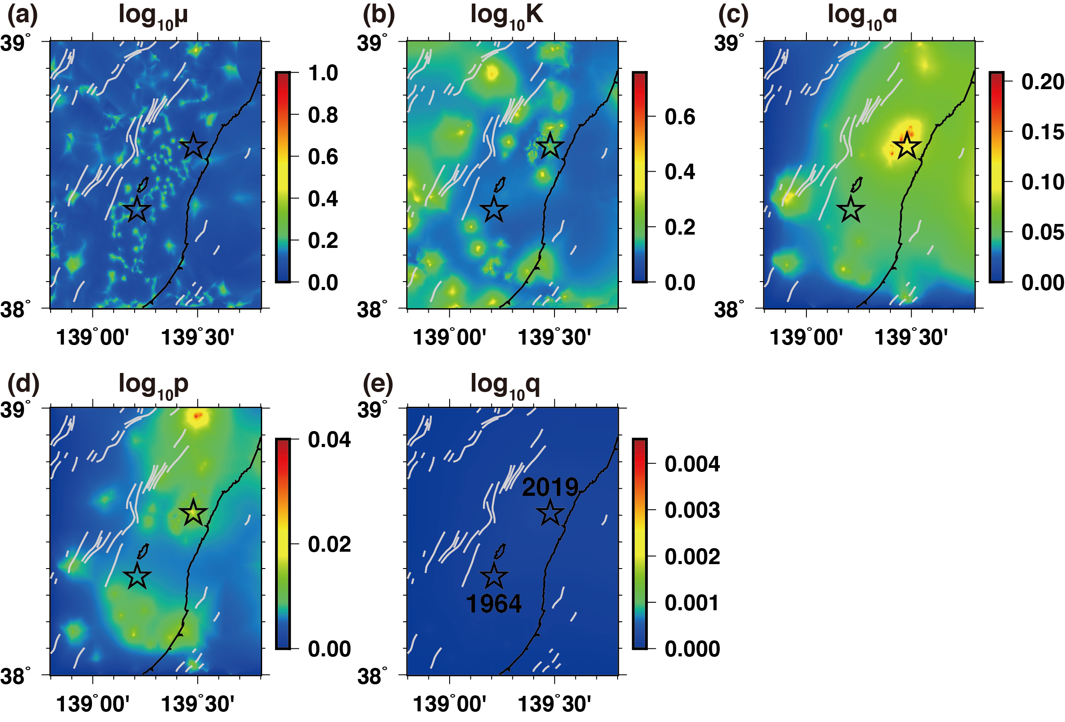
Additional Figure S3 Spatial distributions of the standard deviations of the relative HIST-ETAS parameters calculated by using resampled data set extracting 80% of the earthquake data used in the analysis. Standard deviations of (a) $ϑ_{μ}(x,y)/\ln{10}$, (b) $ϑ_{K}(x,y)/\ln{10}$, (c) $ϑ_{α}(x,y)/\ln{10}$, (d) $ϑ_{p}(x,y)/\ln{10}$, and (e) $ϑ_{q}(x,y)/\ln{10}$. The two stars denote the epicenters of the 1964 Niigata (lower) and 2019 Yamagata-Oki (upper) earthquakes. Gray lines are the surface traces of active Quaternary faults.

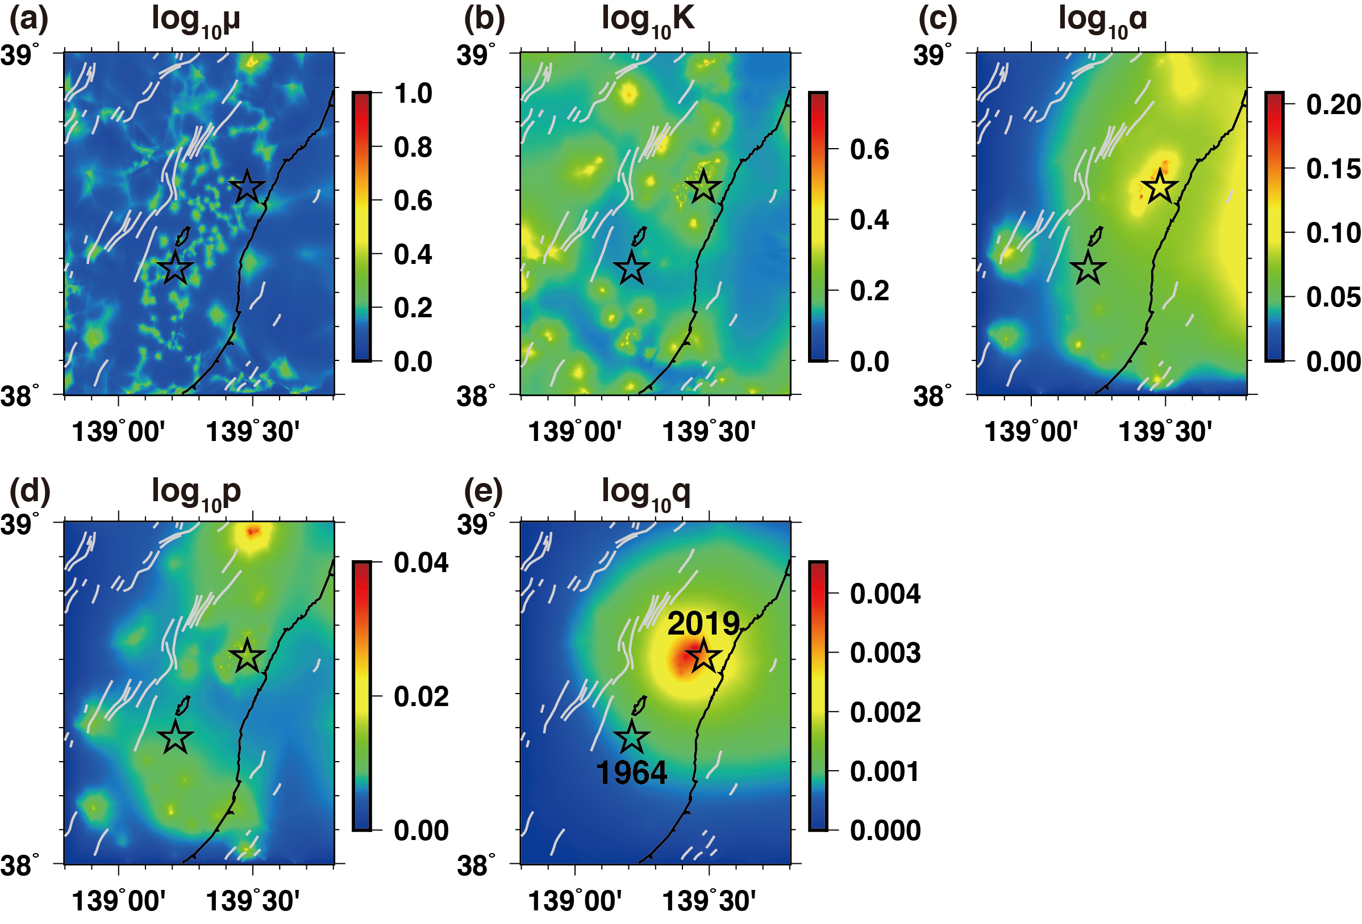
Additional Figure S4 Spatial distributions of the standard deviations of the relative HIST-ETAS parameters calculated by using resampled data set extracting 70% of the earthquake data used in the analysis. Standard deviations of (a) $ϑ_{μ}(x,y)/\ln{10}$, (b) $ϑ_{K}(x,y)/\ln{10}$, (c) $ϑ_{α}(x,y)/\ln{10}$, (d) $ϑ_{p}(x,y)/\ln{10}$, and (e) $ϑ_{q}(x,y)/\ln{10}$. The two stars denote the epicenters of the 1964 Niigata (lower) and 2019 Yamagata-Oki (upper) earthquakes. Gray lines are the surface traces of active Quaternary faults.

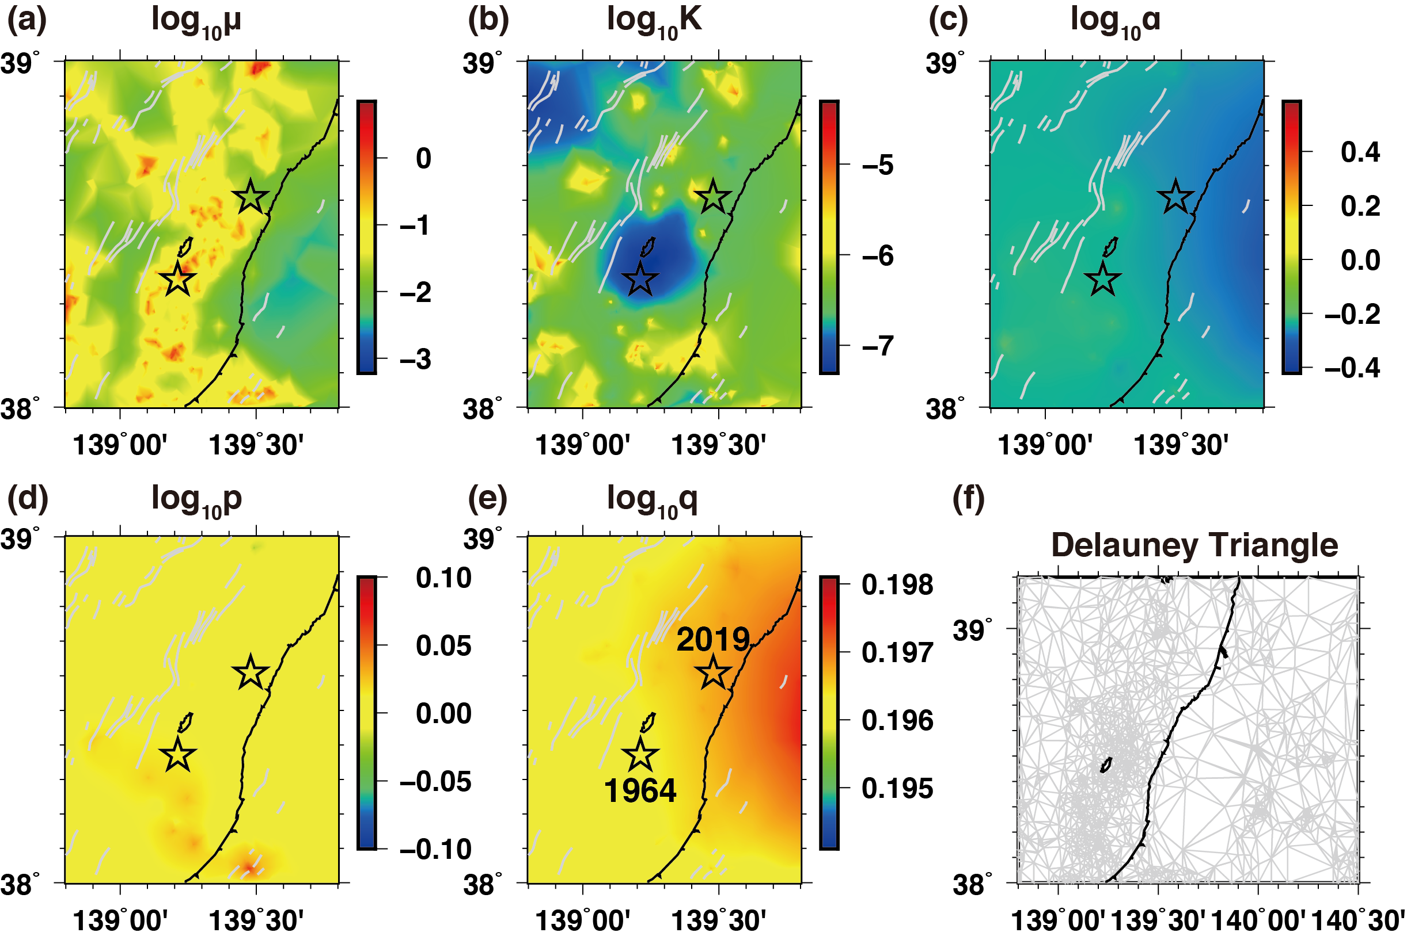
Additional Figure S5 Spatial distributions of the optimal maximum posterior estimates for the respective HIST-ETAS parameter functions estimated using earthquake data before the 2019 Yamagata-Oki earthquake. Common logarithm of (a) $μ$-values, (b) $K$-values, (c) $α$-values, (d) $p$-values, and (e) $q$-values. The two stars denote the epicenters of the 1964 Niigata (lower) and 2019 Yamagata-Oki (upper) earthquakes. Gray lines are the surface traces of active Quaternary faults. (f) The Delaunay tessellation used for the smoothing penalties via the HIST-ETAS model. The Delaunay tessellation encompassed the entire study region shown in Fig. 1a and b.

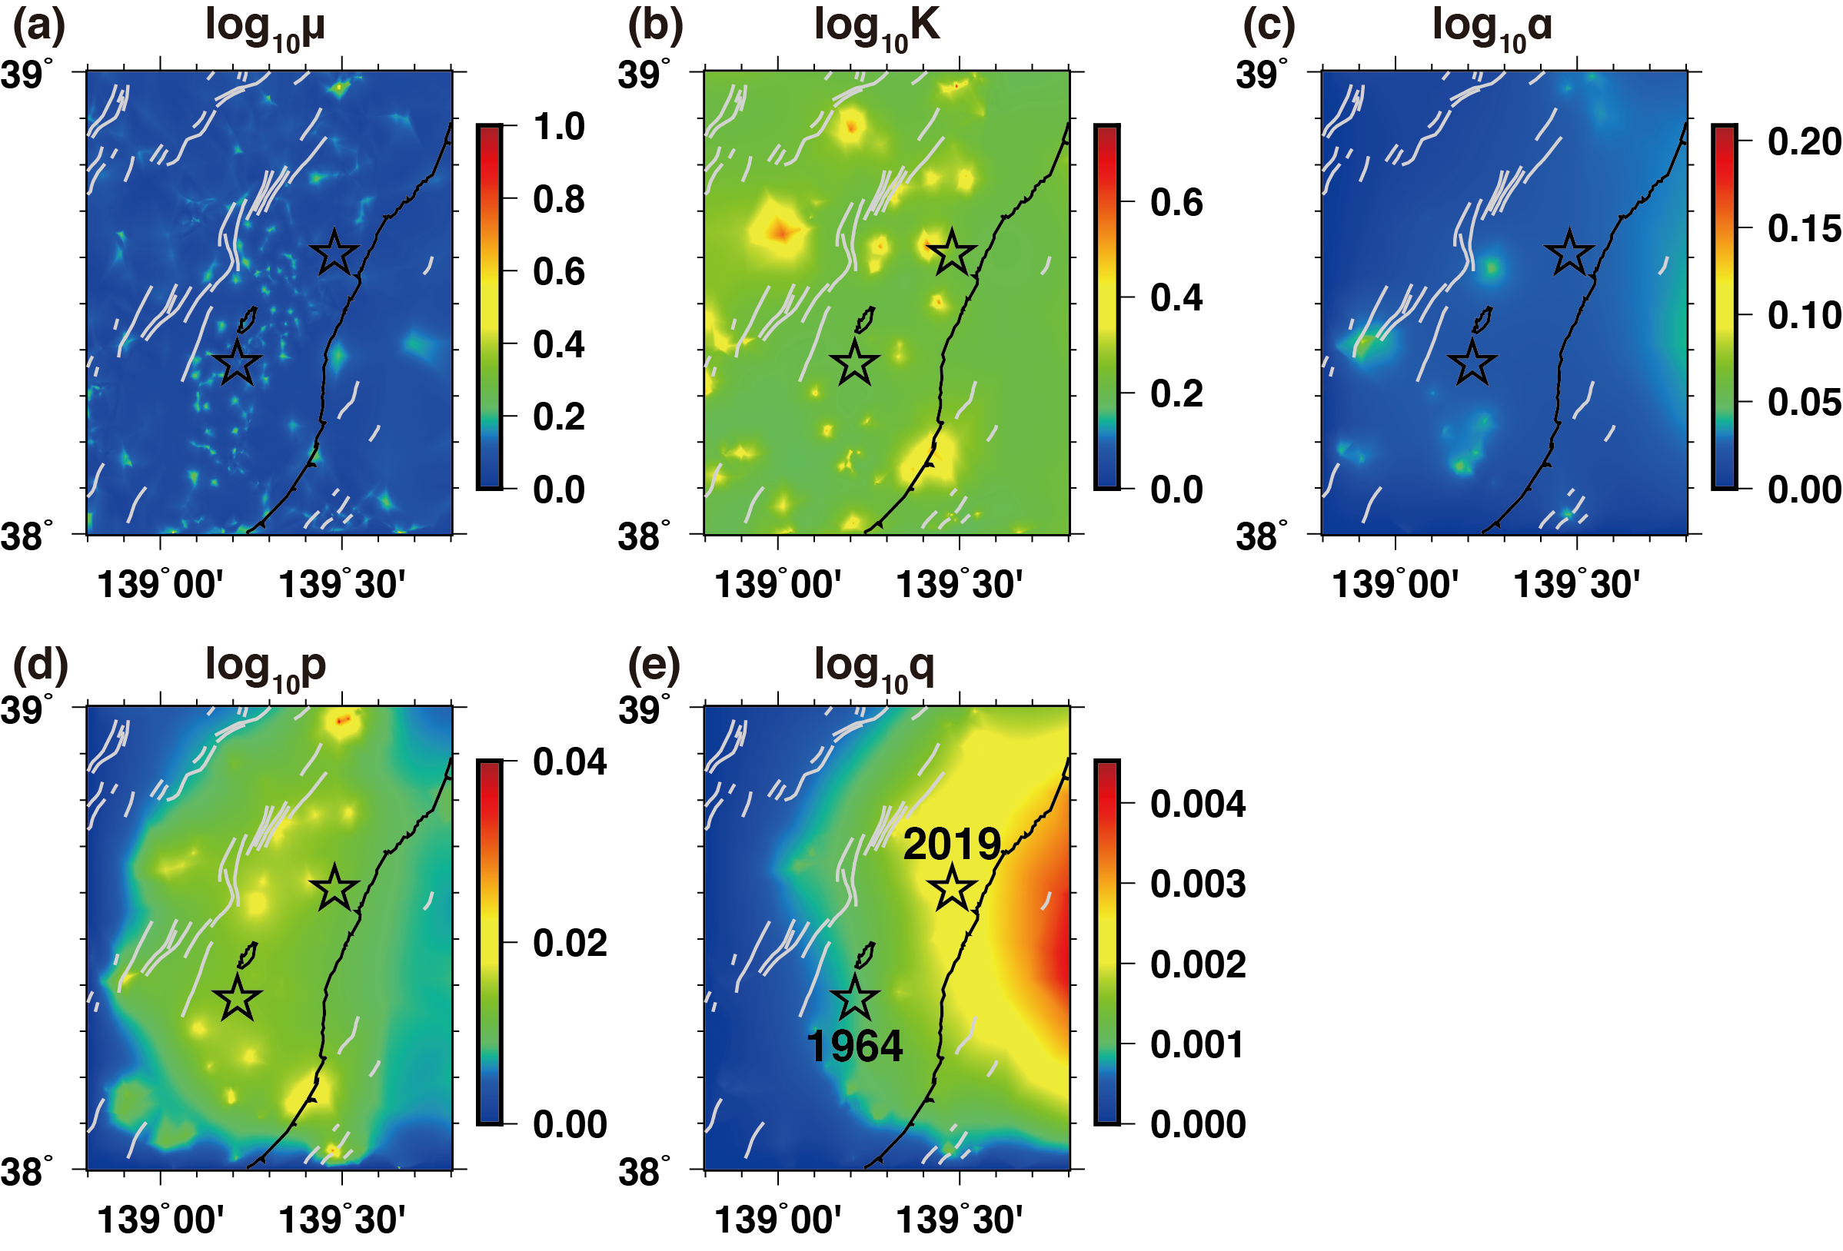
Additional Figure S6 Spatial distributions of the standard deviations of the relative HIST-ETAS parameters calculated by using resampled data set extracting 90% of the earthquake data before the 2019 Yamagata-Oki earthquake. Standard deviations of (a) $ϑ_{μ}(x,y)/\ln{10}$, (b) $ϑ_{K}(x,y)/\ln{10}$, (c) $ϑ_{α}(x,y)/\ln{10}$, (d) $ϑ_{p}(x,y)/\ln{10}$, and (e) $ϑ_{q}(x,y)/\ln{10}$. The two stars denote the epicenters of the 1964 Niigata (lower) and 2019 Yamagata-Oki (upper) earthquakes. Gray lines are the surface traces of active Quaternary faults.

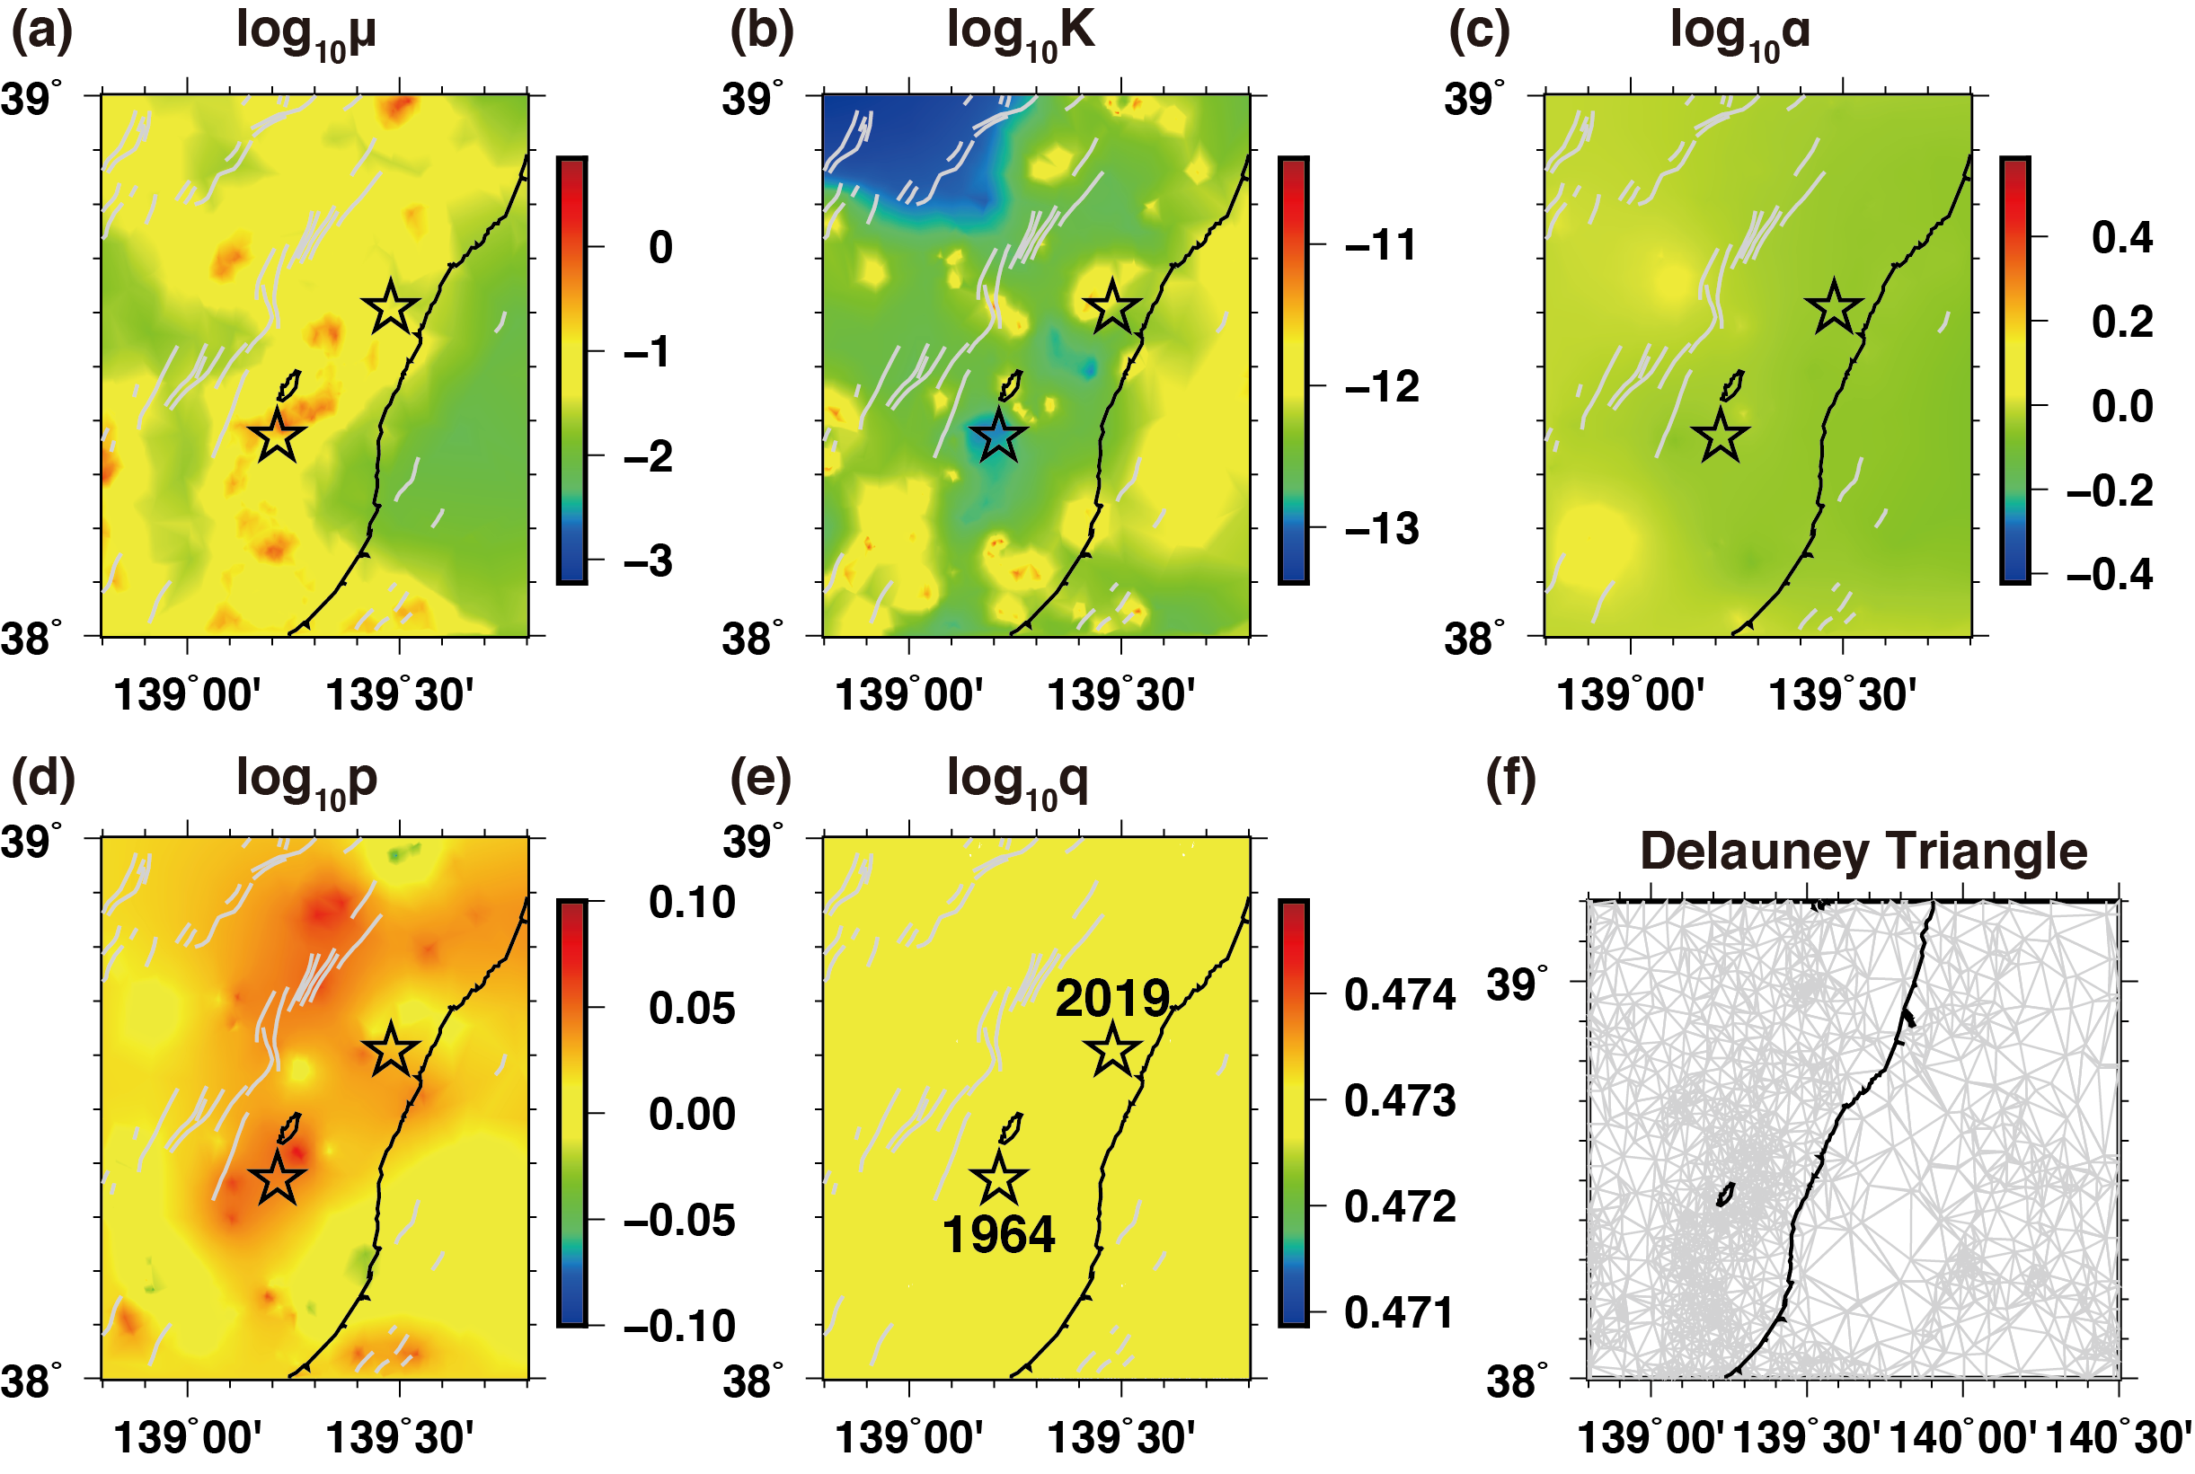
Additional Figure S7 Spatial distributions of the optimal maximum posterior estimates for the respective HIST-ETAS parameter functions estimated using synthetic data made by HIST-ETAS model (Input parameters are shown in Fig. 2). Common logarithm of (a) $μ$-values, (b) $K$-values, (c) $α$-values, (d) $p$-values, and (e) $q$-values. The two stars denote the epicenters of the 1964 Niigata (lower) and 2019 Yamagata-Oki (upper) earthquakes. Gray lines are the surface traces of active Quaternary faults. (f) The Delaunay tessellation used for the smoothing penalties via the HIST-ETAS model. The Delaunay tessellation encompassed the entire study region shown in Fig. 1a and b.

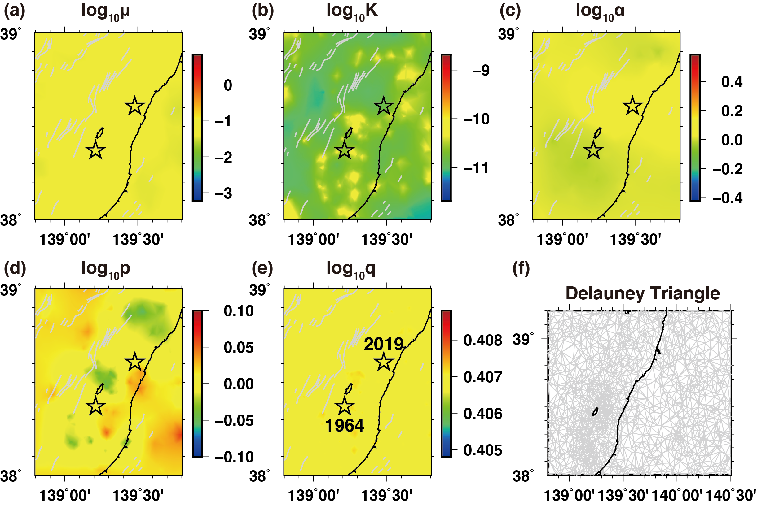
Additional Figure S8 Spatial distributions of the optimal maximum posterior estimates for the respective HIST-ETAS parameter functions estimated using synthetic data made by Space-time ETAS model (each input parameter is spatially uniform). Common logarithm of (a) $μ$-values, (b) $K$-values, (c) $α$-values, (d) $p$-values, and (e) $q$-values. The two stars denote the epicenters of the 1964 Niigata (lower) and 2019 Yamagata-Oki (upper) earthquakes. Gray lines are the surface traces of active Quaternary faults. (f) The Delaunay tessellation used for the smoothing penalties via the HIST-ETAS model. The Delaunay tessellation encompassed the entire study region shown in Fig. 1a and b.

