Additional file 1: Figure S1

“Spatial variations in seismicity characteristics in and around the source region of the 2019 Yamagata-Oki Earthquake” by Taku Ueda et al.

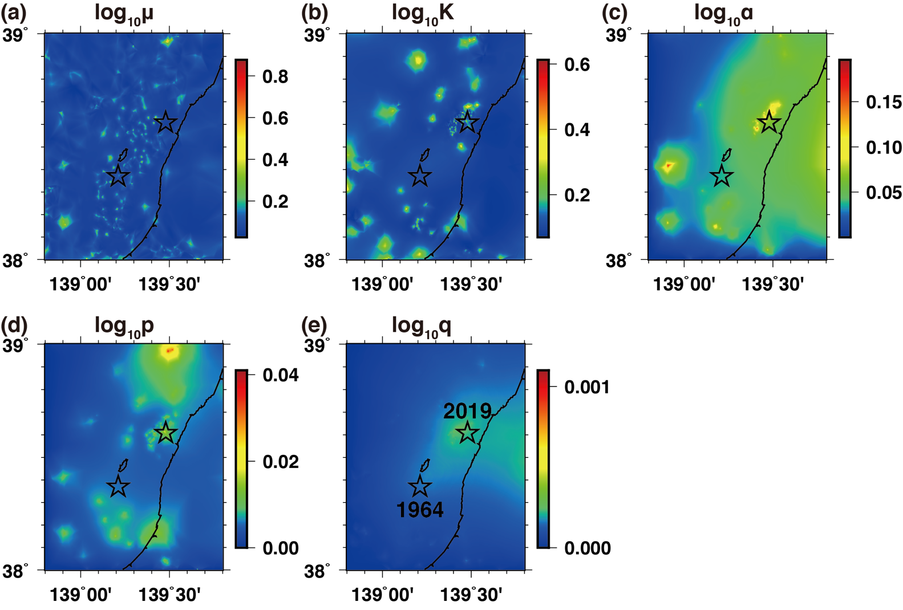
Additional Figure S1 Spatial distributions of the standard deviations of the relative HIST-ETAS parameters. Standard deviations of the common logarithm of (a) $ϑ_{μ}(x,y)$, (b) $ϑ_{K}(x,y)$, (c) $ϑ_{α}(x,y)$, (d) $ϑ_{p}(x,y)$, and (e) $ϑ_{q}(x,y)$. The two stars denote the epicenters of the 1964 Niigata (lower) and 2019 Yamagata-Oki (upper) earthquakes.

