Techno-economical evaluation of three methods for stripping gas recovery in gas dehydration by unit of Khark petrochemical complex

Arman Mohammadi Abdehvandª, Mahdi Haghi^{a,b,*}, Ebrahim Hoseiniradª

ª Research and Development department, Khark Petrochemical Company, Khark Island, Bushehr, Iran

^{b} Department of Chemical and Petroleum Engineering, Sharif University of Technology, Tehran, Iran

* Corresponding author: haghi_1321@yahoo.com

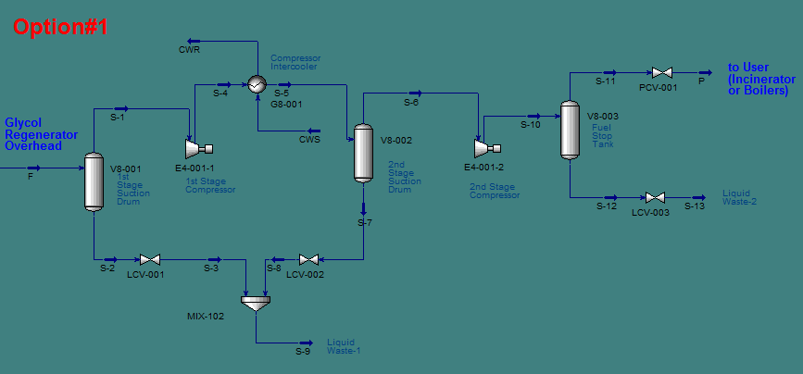

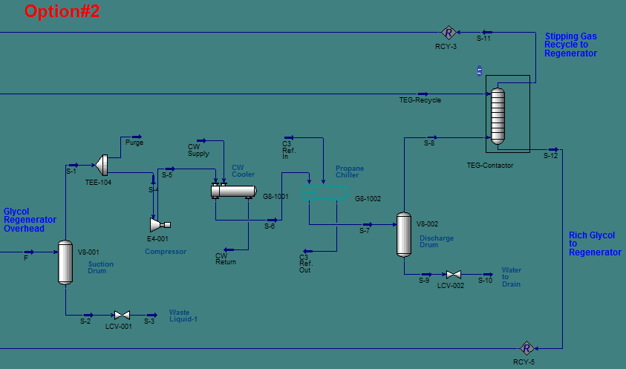

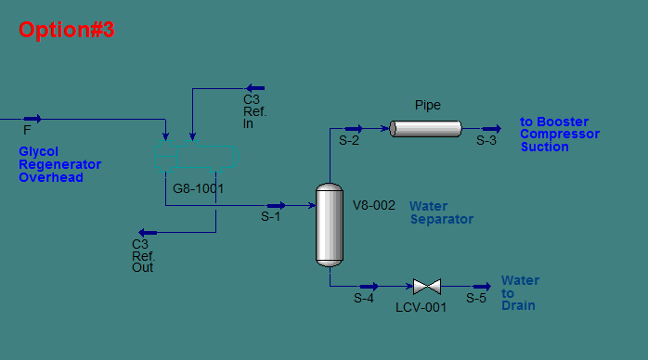

Fig. S1 Sketch of options proposed for the stripping gas recovery
Table S1 Specification of equipment required for each options
Equipment | Specification | Unit | Value
Option 1
Compressor | Power | kW | 74.58
Intercooler | Duty | kW | 175.3
Cooling Water | Flowrate | m3/h | 15.2
First Suction Drum | Diameter / Height | m | 0.5 /2.3
Second Suction Drum | Diameter / Height | m | 0.35 /2.2
Fuel Stop Tank | Diameter / Height | m | 0.5 /1.5
Option 2
Compressor | Power | kW | 22.4
After Cooler | Duty | kW | 146.2
Cooing Water | Volume Flowrate | m3/h | 12.6
Propane Chiller | Duty | kW | 41.1
Propane Refrigerant | Mass Flowrate | ton/h | 0.38
Compressor Suction Drum | Diameter / Height | m | 0.5 / 2.3
Compressor Discharge Drum | Diameter / Height | m | 0.4 / 2.2
New Glycol Regenerator | Diameter / Height | m | 0.3 / 5.0
New Reboiler | Duty | kW | 568
Option 3
New Reboiler | Duty | kw | 625
Propane Chiller | Duty | kW | 196.7
Propane Refrigerant | Mass Flowrate | ton/h | 1.83
Water Separator | Diameter / Height | m | 0.35 / 2.2

Table S2 Cost estimation coefficient for CAPEX
Row | Description | Cost Estimation Coefficient (F)
1 | Piping | 30%
2 | Electrical | 10%
3 | Instrument | 10%
4 | Insulation | 7%
5 | Construction and Installation | 30%
6 | Contingencies | 10%

Table S3 Utility prices used for the calculation of the operating cost
Utility | Price ( $C_{op,i}$) | Unit
Electricity | 0.04 | $/ kWh
Steam | 8.33 | $/ ton
Cooling Water | 0.034 | $/ ton
Propane for chilling | 2.94 | $ /ton

Table S4 Capital cost estimation for different options
CAPEX Item (1000 $) | Option 1 | Option 2 | Option 3
Compressor | 632.2 | 0.0 | 0.0
Heat Exchanger | 39.3 | 64.6 | 38.8
Drum | 4.4 | 4.3 | 2.5
Tower | - | 8.1 | -
Total Equipment Cost | 675.9 | 77.0 | 41.3
Piping | 202.8 | 23.1 | 12.4
Electrical | 67.6 | 7.7 | 4.1
Instrument | 67.6 | 7.7 | 4.1
Insulation | 47.3 | 5.4 | 2.9
Construction and Installation | 202.8 | 23.1 | 12.4
Contingencies | 67.6 | 7.7 | 4.1
Total CAPEX | 1331.6 | 151.8 | 81.4

Table S5 Utility consumption of for different options
Utility Consumption | Unit | Option 1 | Option 2 | Option 3
Power | kW | 74.58 | 22.4 | 0
Steam | ton/h | 0.1 | 0.1 | 0.3
Cooling Water | ton/h | 15.2 | 12.6 | 0
Propane Chilling | ton/h | 0 | 0.4 | 1.83

Table S6 Operating cost estimation for different options
Operating Cost | Option 1 | Option 2 | Option 3
Power | 26250 | 7884 | 0
Steam | 5428 | 5428 | 17732
Cooling Water | 4103 | 0 | 0
Propane Chilling | 0 | 8849 | 42497
Total Utility Price | 35780 | 22161 | 60229
Maintenance | 20278 | 2311 | 1239
Contingencies | 5605.9 | 2447.2 | 6146.7
Total Operating Cost | 61664 | 26919 | 67614

