Additional file
Table S1: Inhibitor concentration of straw saccharification liquid
Name | content （%）
Acetic acid | 0.992
Ferulic acid | 0.005
4-hydroxybenzaldehyde | 0.011
Syringaldehyde | 0.002
5-hydroxymethyl furaldehyde | 0.012
Phenol | 0.079
Furfuraldehyde | 0.006
Acetosyringone | 0.003

Table S2 Nutrient Utilization of BRM001
 | Nutritional ingredient | Whether it can be utilized
Carbon source | Glucose | +
Carbon source | Xylose | +
Carbon source | Fructose | +
Carbon source | Mannose | +
Carbon source | Starch | +
Carbon source | Galactose | +
Carbon source | Sugar | +
Carbon source | Cellobiose | +
Nitrogen source | Nitrogen | +
Nitrogen source | Hydrazine | -
Nitrogen source | Nitronitrogen | +
Nitrogen source | Hydroxylamine | +
Nitrogen source | Nitrite | +
Nitrogen source | Nitrate | +
Nitrogen source | Urea | -
Nitrogen source | Ammonia water | +
Nitrogen source | Nitrogen oxide | -
Sulphur source | Sulfate | +
Sulphur source | Sulfite | +
Sulphur source | Sulfides | +
Sulphur source | Thiosulfate | -
Sulphur source | Taurine | -
Note: ' + ' means can be used, ' - ' means can’t be used

Table S3 Analysis of KAAS synthesis ability of nutrients
 | Nutritional ingredient | Whether it can be synthesized
Amino acid | Valine | +
Amino acid | Leucine | +
Amino acid | Isoleucine | +
Amino acid | Lysine | +
Amino acid | Arginine | +
Amino acid | Phenylalanine | +
Amino acid | Tyrosine | +
Amino acid | Tryptophan | -
Amino acid | Glycine | +
Amino acid | Alanine | +
Amino acid | Methionine | +
Amino acid | Proline | +
Amino acid | Serine | +
Amino acid | Tyrosine | +
Amino acid | Cysteine | +
Amino acid | Aspartic acid | +
Amino acid | Threonine | +
Amino acid | Glutamic acid | +
Amino acid | Histidine | +
Amino acid | Asparagine | +
Amino acid | Glutamine | +
Vitamin | Thiamin | +
Vitamin | Riboflavin | +
Vitamin | Nicotinic acid | +
Vitamin | Pantothenic acid | +
Vitamin | Folic acid | +
Vitamin | Biotin | -
Note: ' + ' means it can be synthesized, ' - ' means it cannot be synthesized.

Table S4 Each step of the gene name corresponding to the local gene name, enzyme number
Symbol | Name | Enzyme
PTS | Phosphotransferase system | EC:2.7.1.-, EC:2.7.1.199, EC:2.7.3.9, EC:2.7.1.198,
pgi | glucose-6-phosphate isomerase | EC:5.3.1.9
pfk | ATP-dependent phosphofructokinase / diphosphate-dependent phosphofructokinase | EC:2.7.1.11;2.7.1.90
fbaA | fructose-bisphosphate aldolase, class II | EC:4.1.2.13
gapA | glyceraldehyde 3-phosphate dehydrogenase (phosphorylating) | EC:1.2.1.12
pgk | phosphoglycerate kinase | EC:2.7.2.3
gpmA | 2,3-bisphosphoglycerate-dependent phosphoglycerate mutase | EC:5.4.2.11
gpmI | 2,3-bisphosphoglycerate-independent phosphoglycerate mutase | EC:5.4.2.12
pyk | pyruvate kinase | EC:2.7.1.40
ldh | L-lactate dehydrogenase | EC:1.1.1.27
nifJ | pyruvate-ferredoxin/flavodoxin oxidoreductase | EC:1.2.7.1
atoB | acetyl-CoA C-acetyltransferase | EC:2.3.1.9
pta | phosphate acetyltransferase | EC:2.3.1.8
ackA | acetate kinase | EC:2.7.2.1
acyP | acylphosphatase | EC:3.6.1.7
paaH | 3-hydroxybutyryl-CoA dehydrogenase | EC:1.1.1.157
crt | enoyl-CoA hydratase | EC:4.2.1.17
atoA | acetate CoA/acetoacetate CoA-transferase beta subunit | EC:2.8.3.9;2.8.3.8
fabV | enoyl-[acyl-carrier protein] reductase / trans-2-enoyl-CoA reductase (NAD+) | EC:1.3.1.9;1.3.1.44
tktA | transketolase | EC:2.2.1.1
talA | transaldolase | EC:2.2.1.2
xylA | xylose isomerase | EC:5.3.1.5
xylB | xylulokinase | EC:2.7.1.17
wecB | UDP-N-acetylglucosamine 2-epimerase (non-hydrolysing) | EC:5.1.3.14
prsA | ribose-phosphate pyrophosphokinase | EC: 2.7.6.1

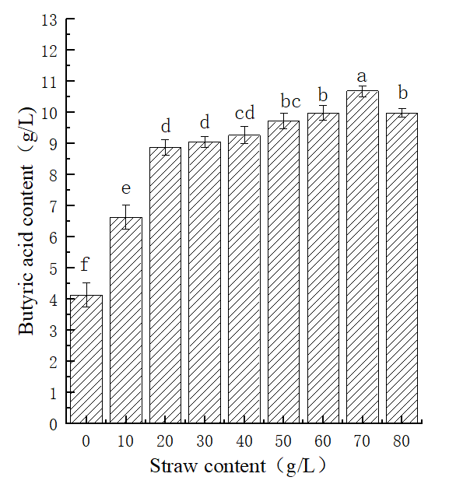
Fig. S1 Effect of straw addition on butyric acid yield

