Supporting Information

TITLE:

Sena Kıvrak¹, Yunus Emre Dilek², İrem Kara¹, Şeyma Çolakoğlu Özkaya³, Kerem Yiğit Abacar⁴, Can Erzik⁵, Mehmet Pamir Atagündüz⁴, Günseli Bayram Akçapınar^{2,*}
¹Department of Biostatistics and Bioinformatics, Institute of Health Sciences, Acibadem University, Istanbul, TURKEY
²Department of Medical Biotechnology, Institute of Health Sciences, Acibadem University, Istanbul, TURKEY
³Department of Medical Biology and Genetics, Institute of Health Sciences, Marmara University, Istanbul, TURKEY
⁴Department of Internal Medicine and Rheumatology, Faculty of Medicine, Marmara University, Istanbul, TURKEY
⁵ Department of Medical Biology, Faculty of Medicine, Marmara University, Istanbul, TURKEY

* Corresponding author
Email: gunseli.akcapinar@acibadem.edu.tr

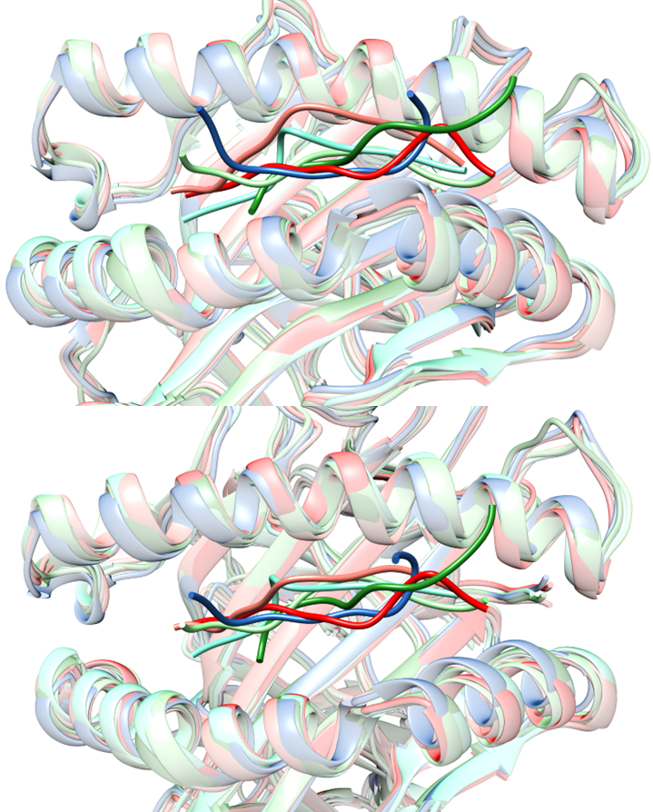
Figure S1. Both the side and top views illustrating the superimposition of six complexes involving HLA-B27 and peptides, with each complex color-coded as follows: HLA-B27:05/KK10 in salmon, HLA-B27:09/KK10 in red, HLA-B27:05/ARGQPGVMG in light green, HLA-B27:09/ARGQPGVMG in forest, HLA-B27:05/DRASFIKNL in aqua marine, and HLA-B27:05/DRASFIKNL in marine.
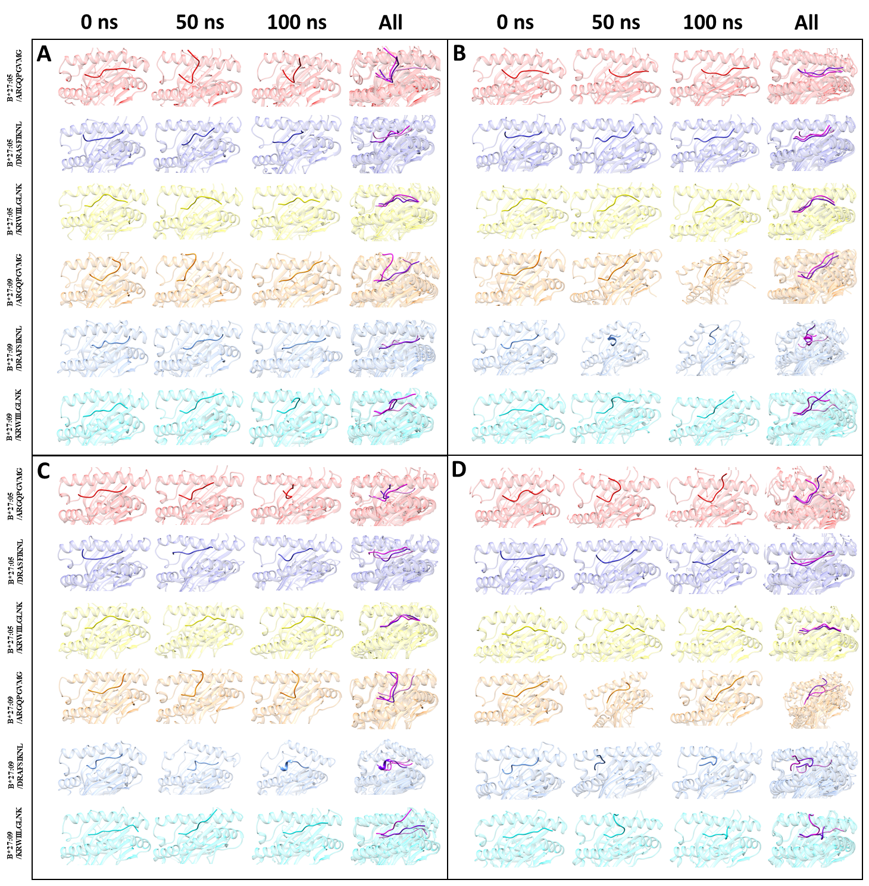
Figure S2. Snapshots of six complexes at 0, 50, and 100 ns of simulation 2(a), 3(b), 4(c), and 5(d). When showing the superimposed view for the three snapshots, the color scheme is as follows: light pink at 0 ns, light magenta at 50 ns, and deep purple at 100 ns.

Table S1. The lowest HADDOCK scores for HLA-B*27:05 and HLA-B*27:09 bound to three peptides.
Peptide Sequence | HLA-B*27:05 |  |  | HLA-B*27:09
Peptide Sequence | HADDOCK Score | Cluster Number | Cluster Size | HADDOCK Score | Cluster Number | Cluster Size
ARGQPGVMG | -96.772 | 1 | 84 | -94.718 | 11 | 4
DRASFIKNL | -130.172 | 1 | 126 | -115.344 | 1 | 84
KRWIILGLNK | -161.813 | 12 | 9 | -129.807 | 13 | 8

Table S2. Immunogenicity prediction of the peptides specified to HLA-B*27:05.
Peptide | Length | Score
DRASFIKNL | 9 | -0.11297
ARGQPGVMG | 9 | -0.16322
KRWIILGLNK | 10 | 0.27526

TableS3. The predictions of the MHC-I binding for HLA-B*27:05.
Peptide | Length | Score | Percentile Rank
DRASFIKNL | 9 | 0.30774 | 0.64
ARGQPGVMG | 9 | 0.02239 | 3
KRWIILGLNK | 10 | 0.79704 | 0.1

