Supplementary Material

Isolation, purification and identification of biological compounds from Beauveria sp. and their evaluation as insecticidal effectiveness against Bemisia tabaci

Ran An ¹, Maqsood Ahmed ^{1, 2} , Haiyan Li ¹, Yanbin Wang ¹ , Aimin Zhang ¹ , Yuhui Bi ¹ and Zhiguo Yu ^{1,}*

¹ College of Plant Protection, Shenyang Agricultural University , Shenyang 110866, China;
anan8u8@outlook.com (R.A.); maqsoodahmed200@hotmail.com (M.A.); lihaiyan98@163.com (H.L.); ybwang_yqh@163.com (Y.W.); zhangaimin99@126.com (A.Z.); biyuhui@syau.edu.cn (Y.B.)
² Department of Agriculture, Pest Warning & Quality Control of Pesticides, Gujrat 50700, Pakistan
* Correspondence: zyu@syau.edu.cn (Z.Y.); Tel.: +86-24-8848-7148 (Z.Y.)

Contents
Figure S1. ^{1H} NMR spectrum (MeOD, 600 MHz) of cerebroside F (1) 6
Figure S2. ^{13C} NMR spectrum (MeOD, 600 MHz) of cerebroside F (1) 7
Figure S3. ^{1H 13C} HMBC NMR spectrum (MeOD, 600 MHz) of cerebroside F (1) 8
Figure S4. ^{1H 13C} HSQC NMR spectrum (MeOD, 600 MHz) of cerebroside F (1) 9
Figure S5. ^{1H 1H} COSY NMR spectrum (MeOD, 600 MHz) of cerebroside F (1) 10
Figure S6. HR-ESI-MS data of cerebroside F (1) 11
Figure S7. HPLC signal of cerebroside F (1) 11
Figure S8. HR-ESI-MS fragments data of cerebroside F (1) 15
Table S1: Insecticidal activity of compound 1 16
Figure S9. ^{1H} NMR spectrum (DMSO, 600 MHz) of cerebroside B (2) 17
Figure S10. ^{13C} NMR spectrum (DMSO, 600 MHz) of cerebroside B (2) 18
Figure S11. HR-ESI-MS data of cerebroside B (2) 19
Figure S12. HPLC signal of cerebroside B (2) 19
Table S2. Insecticidal activity of compound 2 20
Figure S13. ^{1H} NMR spectrum (CDCl₃, 600 MHz) of bassiatin (3) 21
Figure S14. ^{13C} NMR spectrum (CDCl₃, 600 MHz) of bassiatin (3) 22
Figure S15 ESI-MS data of bassiatin (3) 23
Table S3. Insecticidal activity of compound 3 24
Figure S16. ^{1H} NMR spectrum (CDCl₃, 600 MHz) of methyl 1,4-dihydro-4-oxo-2-quinolinecarboxylate (4) 25
Figure S17. ^{13C} NMR spectrum (CDCl₃, 600 MHz) of methyl 1,4-dihydro-4-oxo-2-quinolinecarboxylate (4) 26
Figure S18. ESI-MS data of methyl 1,4-dihydro-4-oxo-2-quinolinecarboxylate (4) 27
Figure S19. HPLC signal of methyl 1,4-dihydro-4-oxo-2-quinolinecarboxylate (4) 27
Table S4. Insecticidal activity of compound 4 28
Figure S20. ^{1H} NMR spectrum (CDCl₃, 600 MHz) of cerevisterol (5) 29
Figure S21. ^{13C} NMR spectrum (CDCl₃, 600 MHz) of cerevisterol (5) 30
Figure S22. ESI-MS data of cerevisterol (5) 31
Table S5. Insecticidal activity of compound 5 32
Figure S23. ^{1H} NMR spectrum (MeOD, 600 MHz) of 9-hydroxycerevisterol (6) 33
Figure S24. ^{13C} NMR spectrum (MeOD, 600 MHz) of 9-hydroxycerevisterol (6) 34
Figure S25. HR-ESI-MS data of 9-hydroxycerevisterol (6) 35
Figure S26. HPLC signal of 9-hydroxycerevisterol (6) 35
Table S6. Insecticidal activity of compound 6 36
Figure S27. ^{1H} NMR spectrum (CDCl₃, 600 MHz) of 6-dehydrocerevisterol (7) 37
Figure S28. ^{13C} NMR spectrum (CDCl₃, 600 MHz) of 6-dehydrocerevisterol (7) 38
Figure S29. ESI-MS data of 6-dehydrocerevisterol (7) 39
Figure S30. HPLC signal of 6-dehydrocerevisterol (7) 40
Table S7: Insecticidal activity of compound 7 41
Figure S31. ^{1H} NMR spectrum (CDCl₃, 600 MHz) of (22E,24R)-ergosta-8(14),22-diene-3β,5α,6β,7α-tetrol (8) 42
Figure S32. ^{13C} NMR spectrum (CDCl₃, 600 MHz) of (22E,24R)-ergosta-8(14),22-diene-3β,5α,6β,7α-tetrol (8) 43
Figure S33. ESI-MS data of (22E,24R)-ergosta-8(14),22-diene-3β,5α,6β,7α-tetrol (8) 44
Figure S34. HPLC signal of (22E,24R)-ergosta-8(14),22-diene-3β,5α,6β,7α-tetrol (8) 45
Table S8. Insecticidal activity of compound 8 46
Figure S35. ^{1H} NMR spectrum (CDCl₃, 600 MHz) of melithasterol B (9) 47
Figure S36. ^{13C} NMR spectrum (CDCl₃, 600 MHz) of melithasterol B (9) 48
Figure S37. ESI-MS data of melithasterol B (9) 49
Table S9. Insecticidal activity of compound 9 50
Figure S38. ^{1H} NMR spectrum (CDCl₃, 600 MHz) of ergosterol peroxide (10) 51
Figure S39. ^{13C} NMR spectrum (CDCl₃, 600 MHz) of ergosterol peroxide (10) 52
Figure S40. ESI-MS data of ergosterol peroxide (10) 53
Table S10: Insecticidal activity of compound 10 54
Figure S41. Effects of active compounds on cotton at 100 µg/mL 55
Table S11. Effects of active compounds on cotton height at 100 µg/mL 56
Figure S42. Effects of active compounds on cucumber at 100 µg/mL 57
Table S12. Effects of active compounds on cucumber height at 100 µg/mL 58
Figure S43. Effects of active compounds on pepper at 100 µg/mL 59
Table S13. Effects of active compounds on pepper height at 100 µg/mL 60
Figure S44. Effects of active compounds on tomato at 100 µg/mL 61
Table S14. Effects of active compounds on tomato height at 100 µg/mL 62
Figure S45. The conidia of Beauveria sp. 63

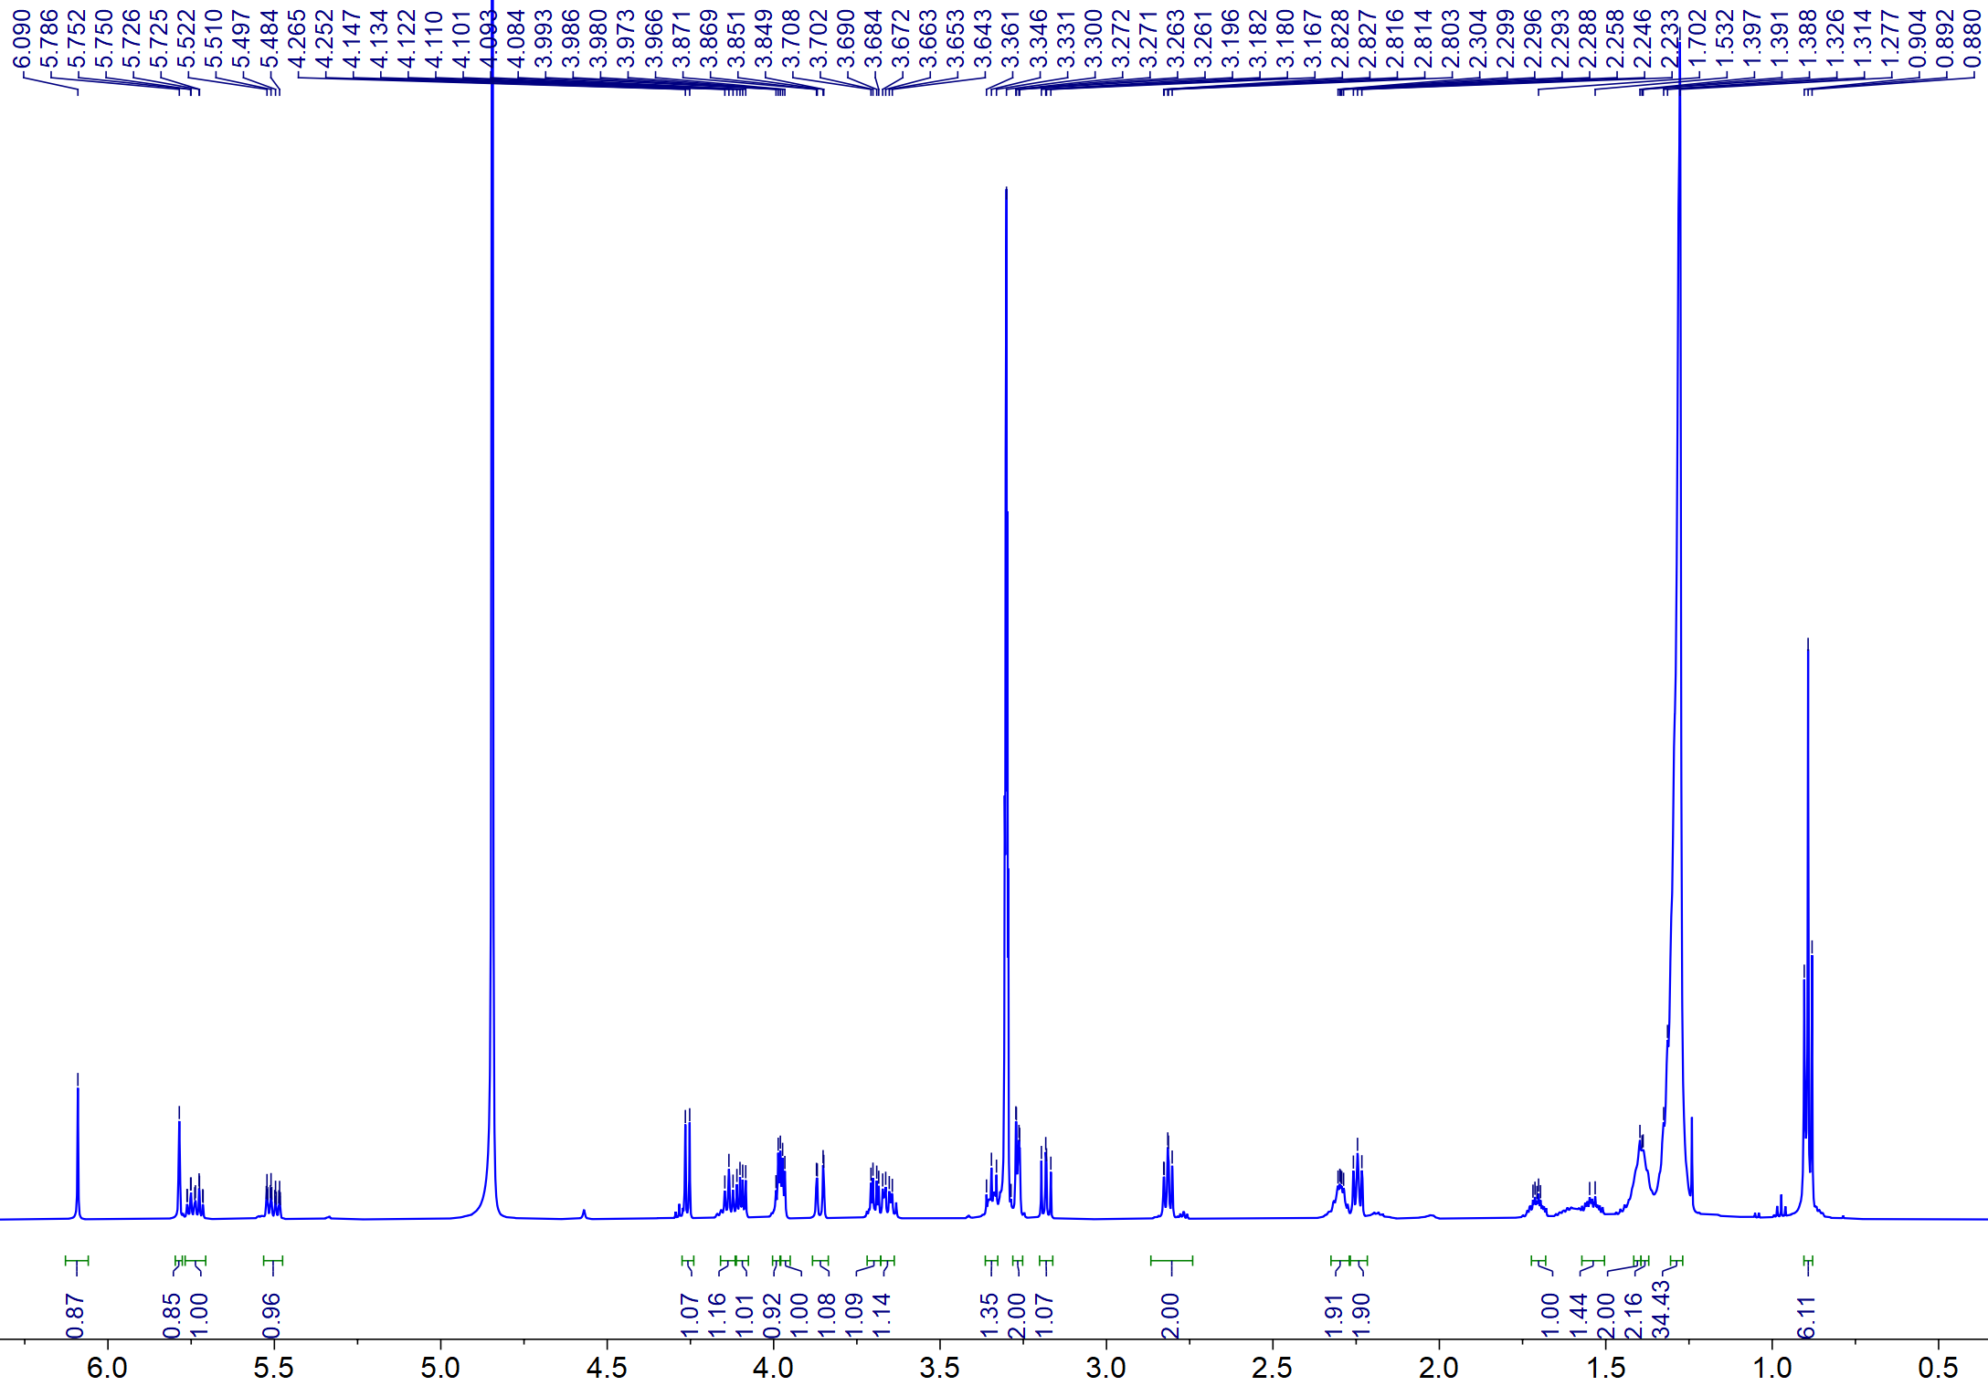

Figure S1. ¹H NMR spectrum (MeOD, 600 MHz) of cerebroside F (1)
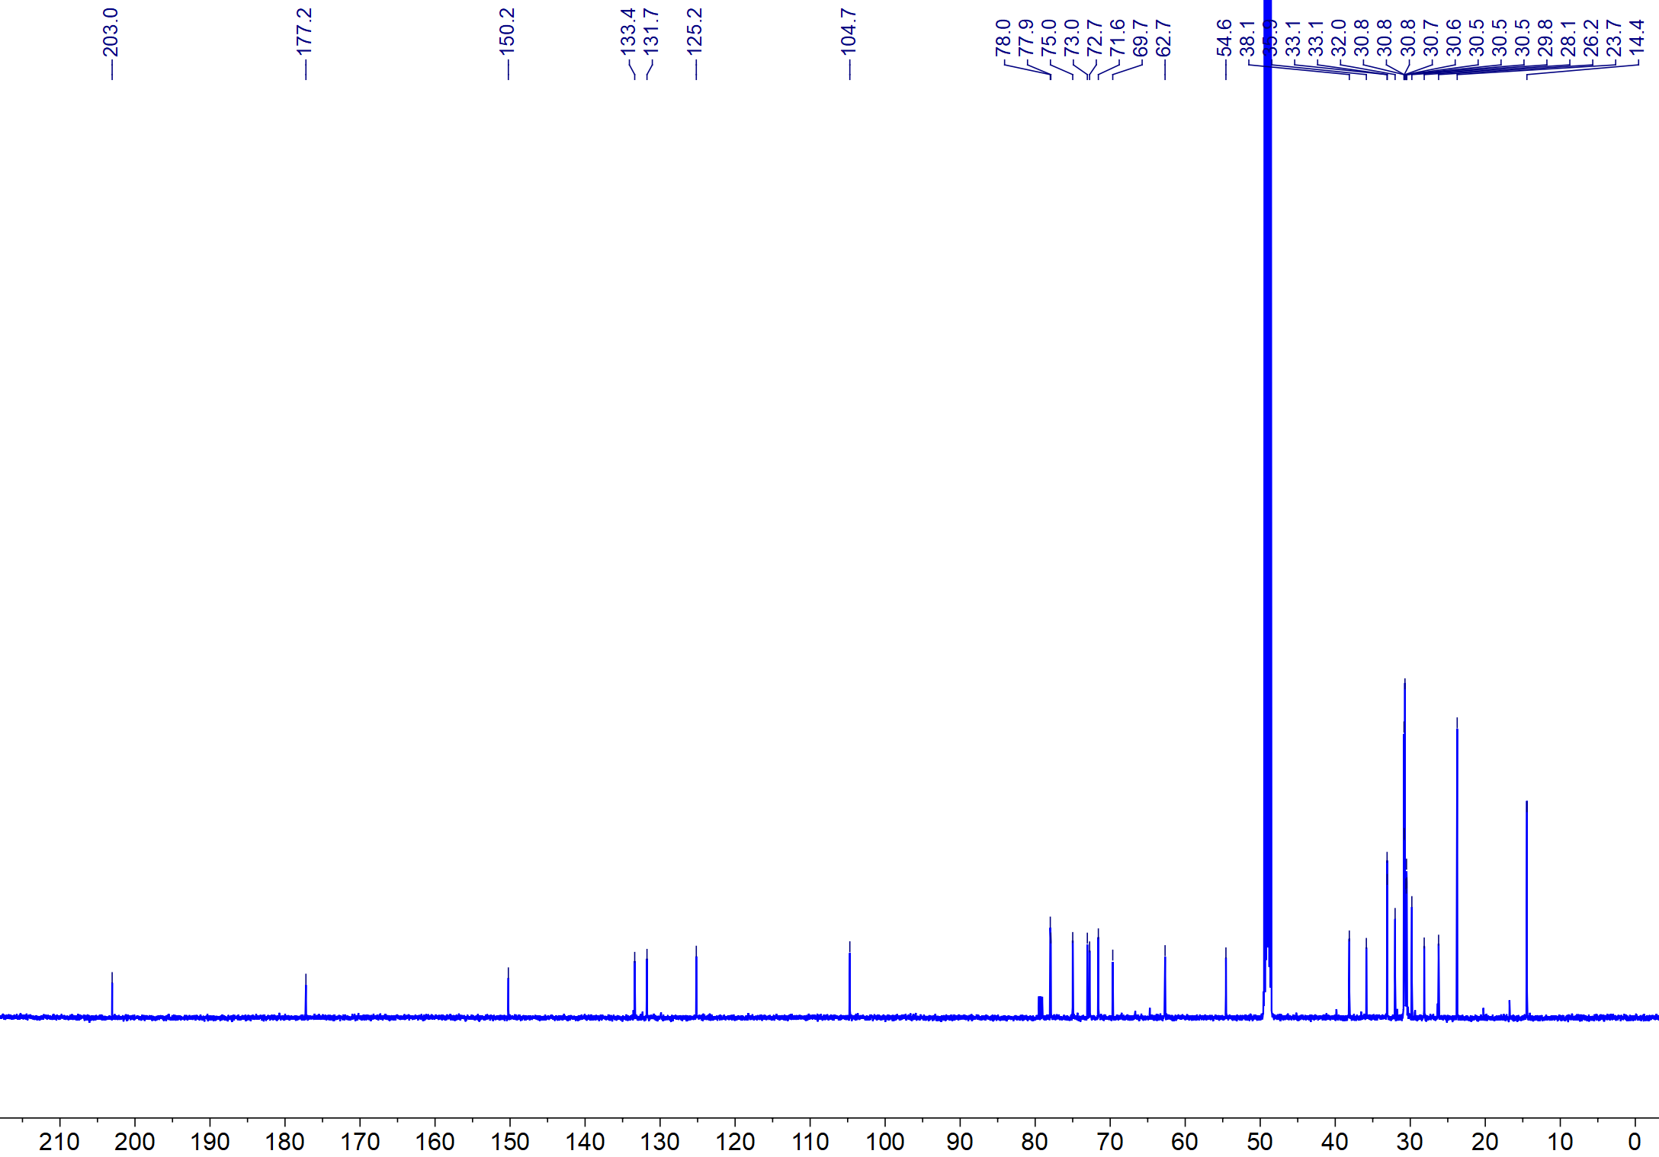

Figure S2. ¹³C NMR spectrum (MeOD, 600 MHz) of cerebroside F (1)
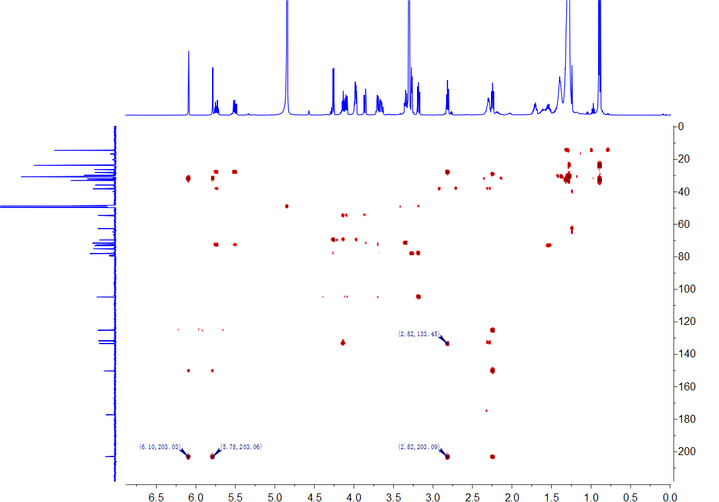

Figure S3. ¹H ¹³C HMBC NMR spectrum (MeOD, 600 MHz) of cerebroside F (1)
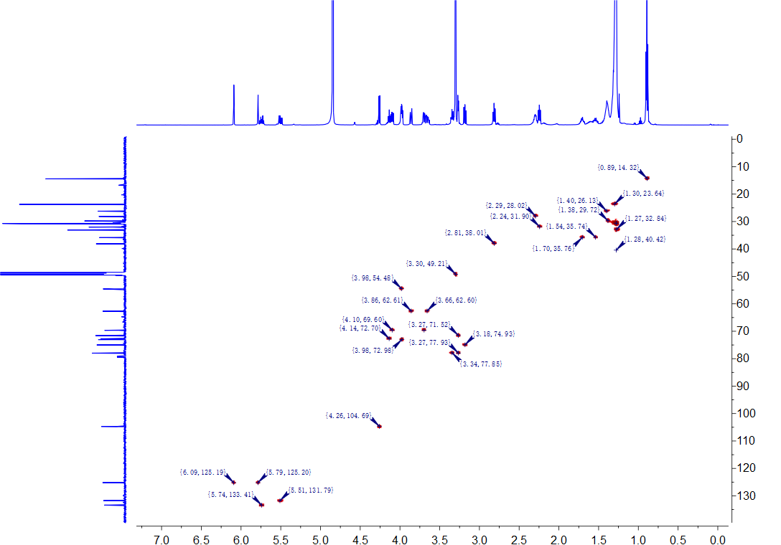

Figure S4. ¹H ¹³C HSQC NMR spectrum (MeOD, 600 MHz) of cerebroside F (1)
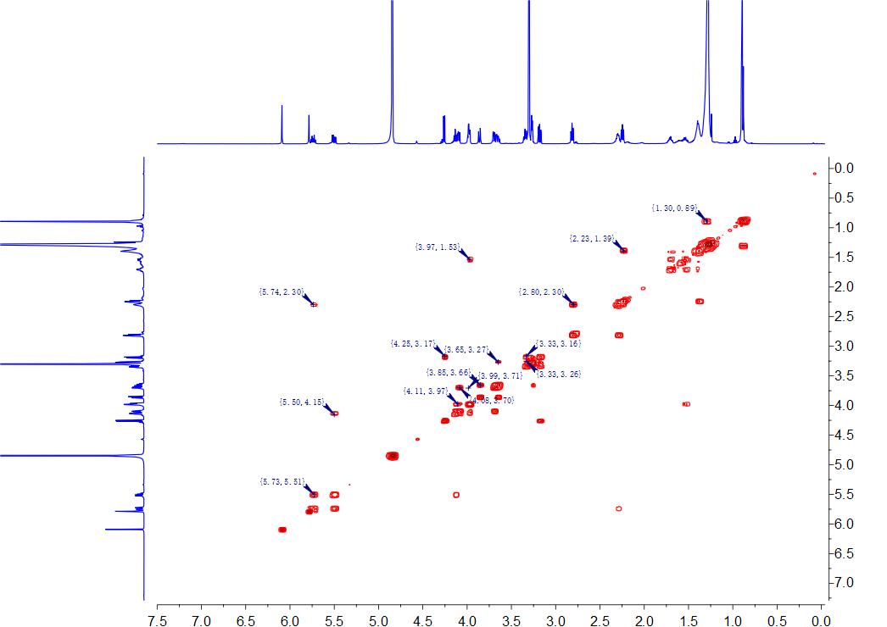

Figure S5. ¹H ¹H COSY NMR spectrum (MeOD, 600 MHz) of cerebroside F (1)

Figure S6. HR-ESI-MS data of cerebroside F (1)

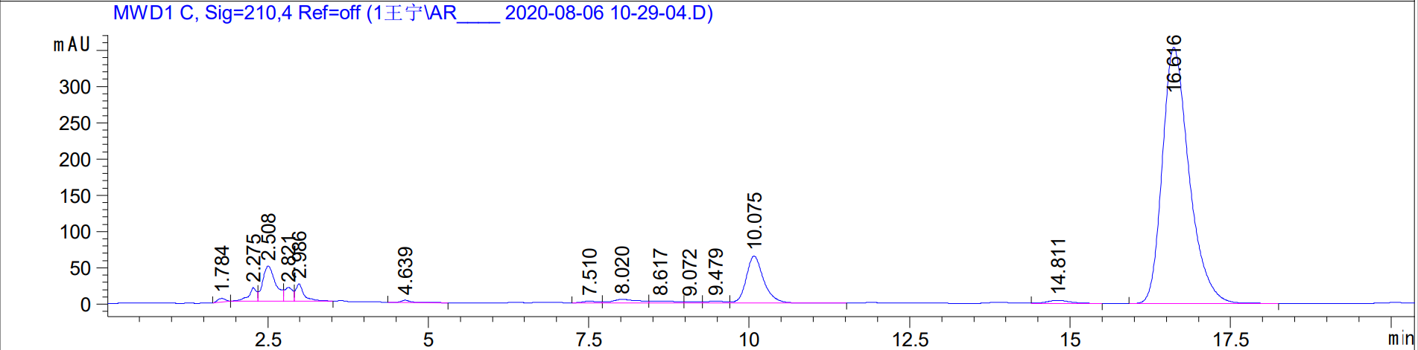

Figure S7. HPLC signal of cerebroside F (1)
MS

MS²

Figure S8. HR-ESI-MS fragments data of cerebroside F (1)

Table S1: Insecticidal activity of compound 1
Conc. (ppm) | Mean mortality (%) with exposure time (h)
Conc. (ppm) | Contact toxicity assay |  |  | Stomach toxicity assay
Conc. (ppm) | 24 | 48 | 72 | 24 | 48 | 72
50 | 13.33±6.67^{b} | 25.00±12.62^{b} | 41.67±11.05^{b} | 15.00±7.94^{b} | 22.50±13.7^{b} | 38.33±10.00^{b}
25 | 6.67±2.72^{b} | 10.83±4.19^{bc} | 25.83±6.84^{b} | 16.66±11.85^{b} | 15.83±9.56^{b} | 32.49±13.71^{bc}
12.5 | 5.83±5.00^{b} | 10.83±3.19^{bc} | 22.5±3.19^{c} | 10.83±11.98^{b} | 15.00±11.05^{b} | 30.83±10.67^{bc}
6.25 | 4.17±4.19^{b} | 8.33±6.38^{c} | 19.17±7.83^{c} | 7.50±6.87^{b} | 7.50±6.87^{b} | 22.50±8.76^{bc}
PC | 80.83±5.69ª | 97.50±3.19ª | 100.00±0.00ª | 88.33±4.30ª | 100.0±0.00ª | 100.0±0.00ª
CK | 3.33±2.72^{b} | 5.83±1.67^{c} | 13.33±0.00^{c} | 5.00±1.92^{b} | 8.33±1.92^{b} | 15.83±1.67^{c}
Statics summary
S.S | 18585 | 25164 | 20816 | 20319 | 25351 | 18533
M.S | 3717.12 | 5032.9 | 4163.1 | 4063.9 | 5070.3 | 3706.4
df | 5 | 5 | 5 | 5 | 5 | 5
f | 166.1*** | 125.5*** | 113.79*** | 58.5*** | 66.11*** | 46.18***
Data in the columns is described as mean values ± standard deviation with various superscripts is significantly
different according to DMRT” P> 0.05). S.S (Sum of square); Df (Degree of freedom); M.S (Mean square); F
(Significance); PC (Postive Control); CK (Check); *** (level of significance).

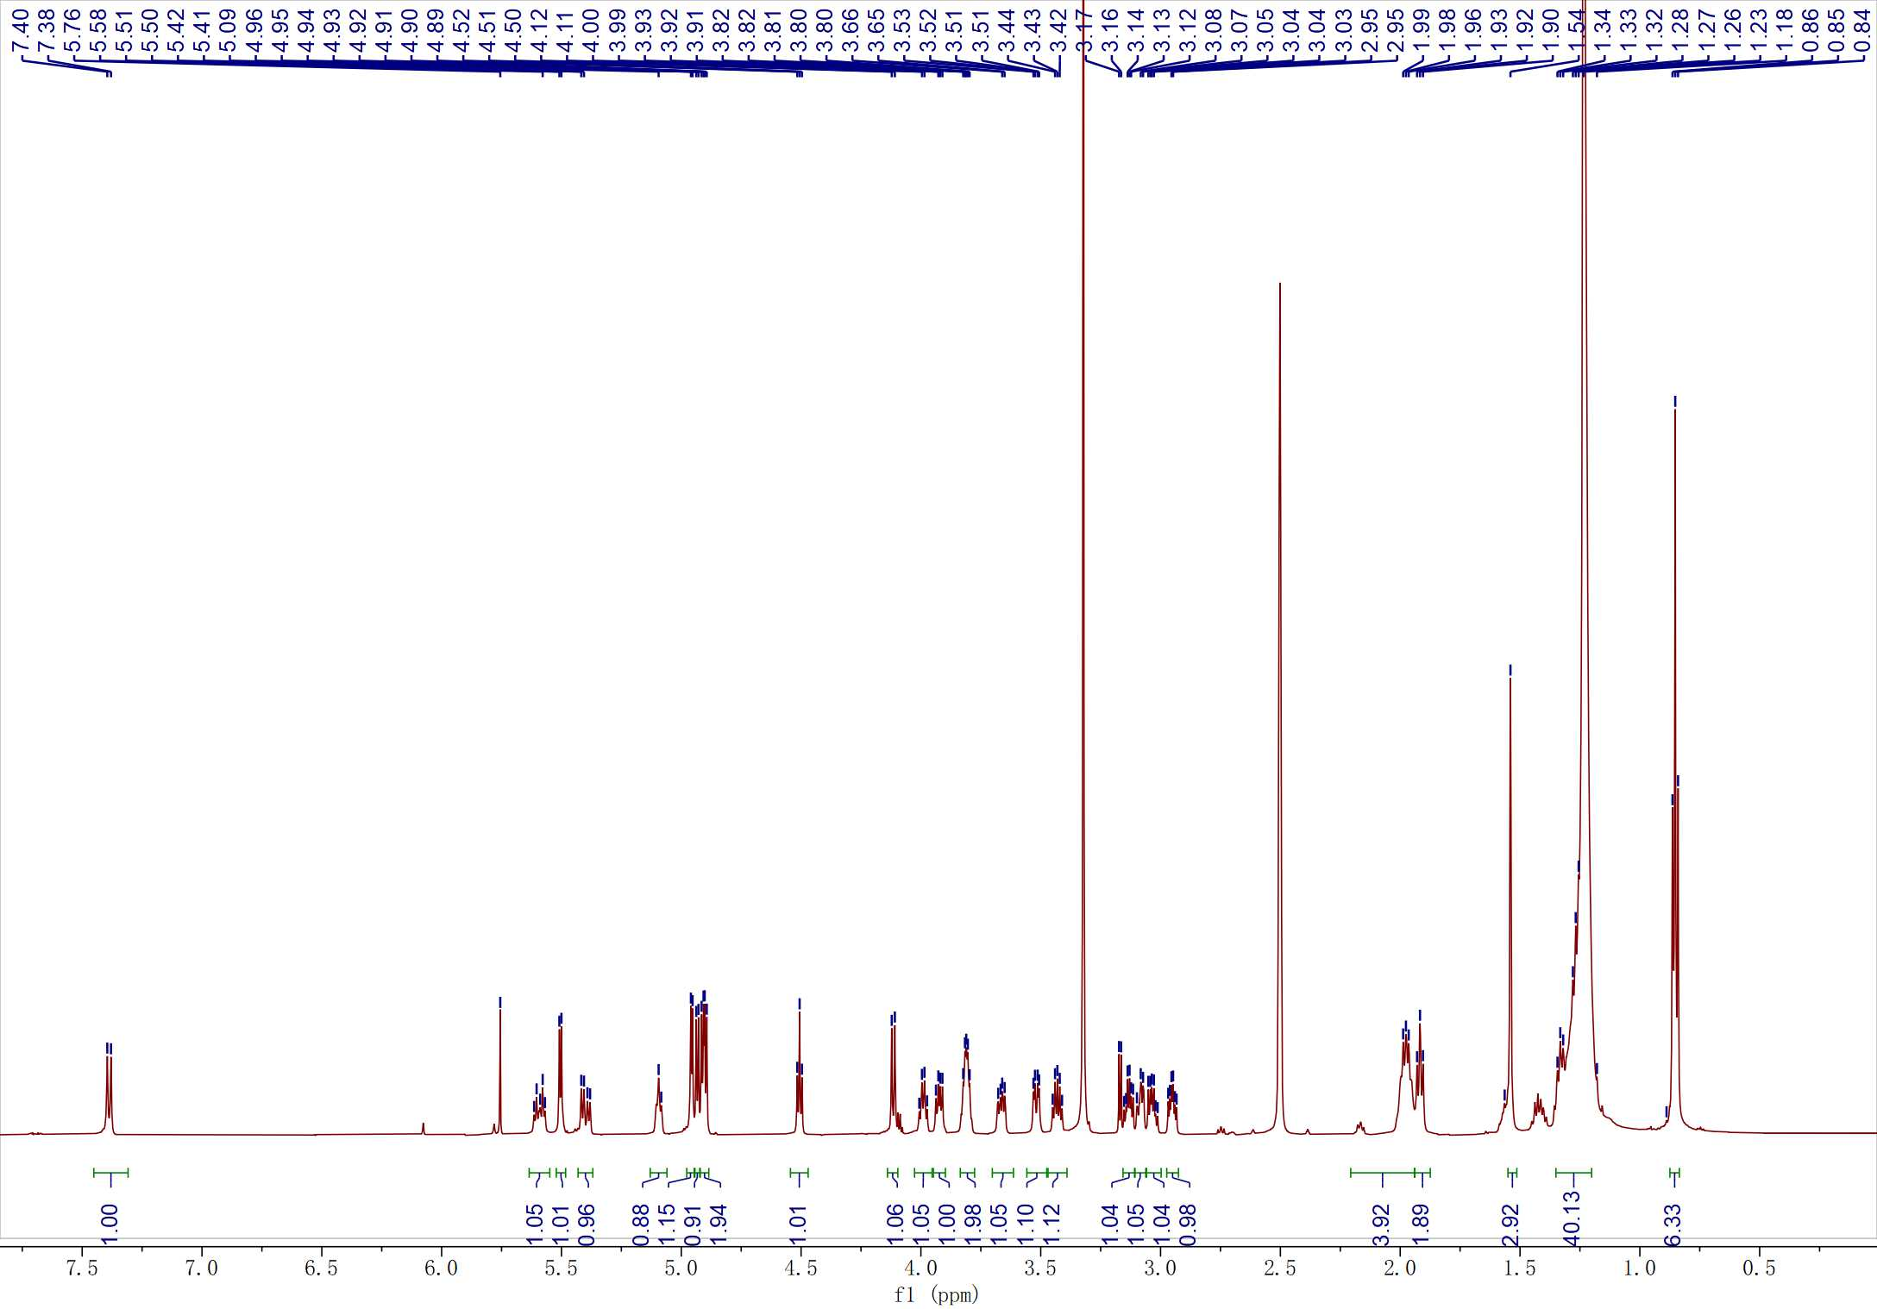

Figure S9. ¹H NMR spectrum (DMSO, 600 MHz) of cerebroside B (2)
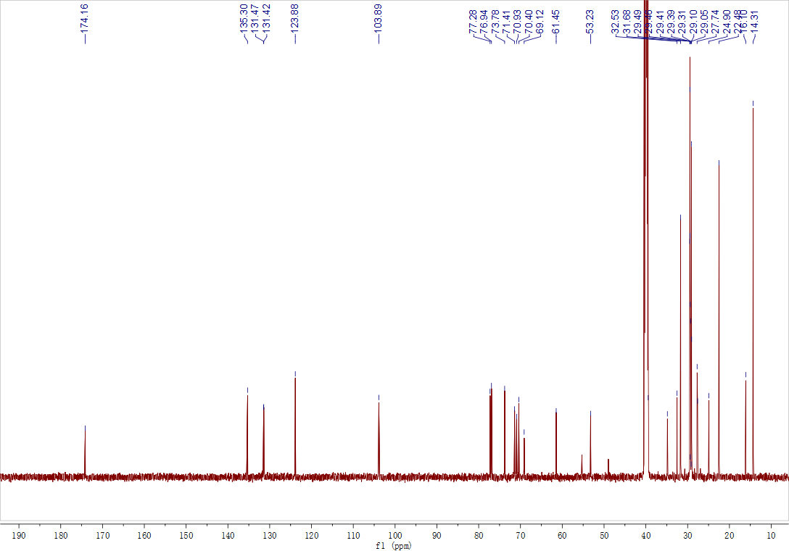

Figure S10. ¹³C NMR spectrum (DMSO, 600 MHz) of cerebroside B (2)

Figure S11. HR-ESI-MS data of cerebroside B (2)

Figure S12. HPLC signal of cerebroside B (2)

Table S2. Insecticidal activity of compound 2
Conc. (ppm) | Mean mortality (%) with exposure time (h)
Conc. (ppm) | Contact toxicity assay |  |  | Stomach toxicity assay
Conc. (ppm) | 24 | 48 | 72 | 24 | 48 | 72
50 | 20.83±1.67^{b} | 31.66±1.92^{b} | 44.17±3.19^{b} | 15.83±12.87^{b} | 19.99±14.14^{b} | 47.50±13.43^{b}
25 | 15.83±6.31^{b} | 20.00±3.84^{c} | 30.00±9.81^{c} | 9.17±5.00^{b} | 18.33±4.30^{b} | 40.83±13.97^{bc}
12.5 | 5.83±5.00^{c} | 13.33±3.85^{cd} | 21.67±4.30^{cd} | 7.50±3.19^{b} | 14.16±3.19^{b} | 24.16±5.69^{cd}
6.25 | 4.16±3.19^{c} | 11.67±4.30de | 15.83±5.00^{d} | 6.67±6.08^{b} | 13.33±6.08^{b} | 18.33±6.38^{d}
PC | 80.83±5.69ª | 97.50±3.19ª | 100.00±0.00ª | 88.33±4.30ª | 100.0±0.00ª | 100.0±0.00ª
CK | 3.33±2.72^{c} | 5.83±1.67e | 13.33±0.00^{d} | 5.00±2.72^{b} | 8.33±1.92^{b} | 15.83±1.67^{d}
Statics summary
S.S | 17713 | 23427 | 21245 | 21348 | 24513 | 19814
M.S | 3542.6 | 4685.4 | 4269.03 | 4269.6 | 4902.7 | 3962.9
df | 5 | 5 | 5 | 5 | 5 | 5
f | 180.72*** | 433.7*** | 169.91*** | 98.5*** | 109.2*** | 52.6***
Data in the columns is described as mean values ± standard deviation with various superscripts is significantly
different according to DMRT” P> 0.05). S.S (Sum of square); Df (Degree of freedom); M.S (Mean square); F
(Significance); PC (Postive Control); CK (Check); *** (level of significance).

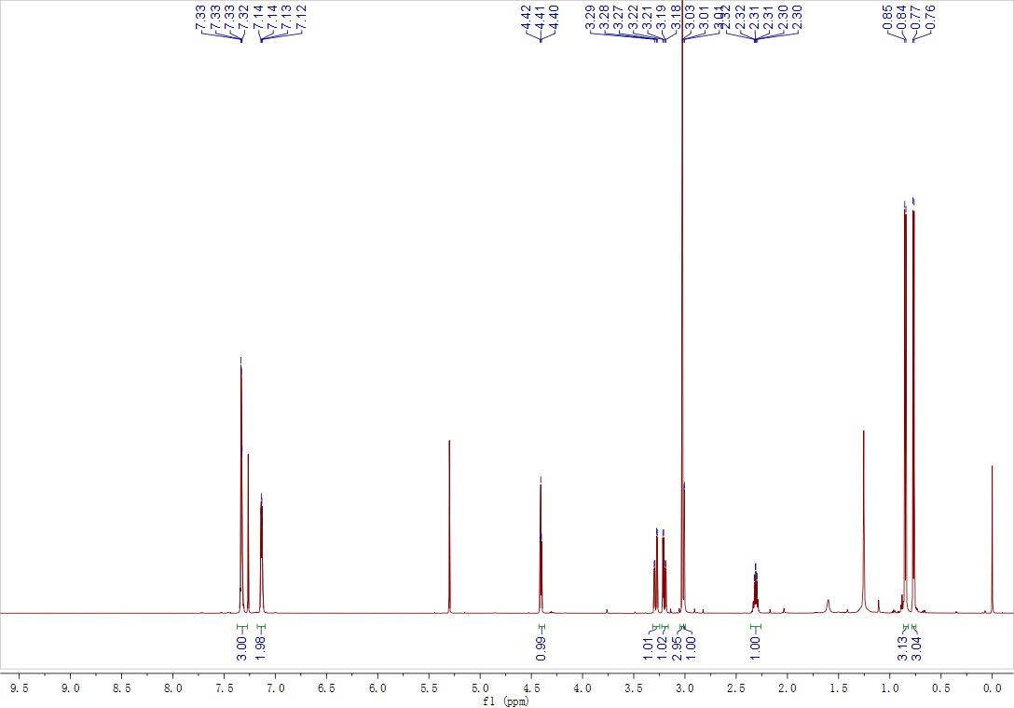

Figure S13. ¹H NMR spectrum (CDCl3, 600 MHz) of bassiatin (3)

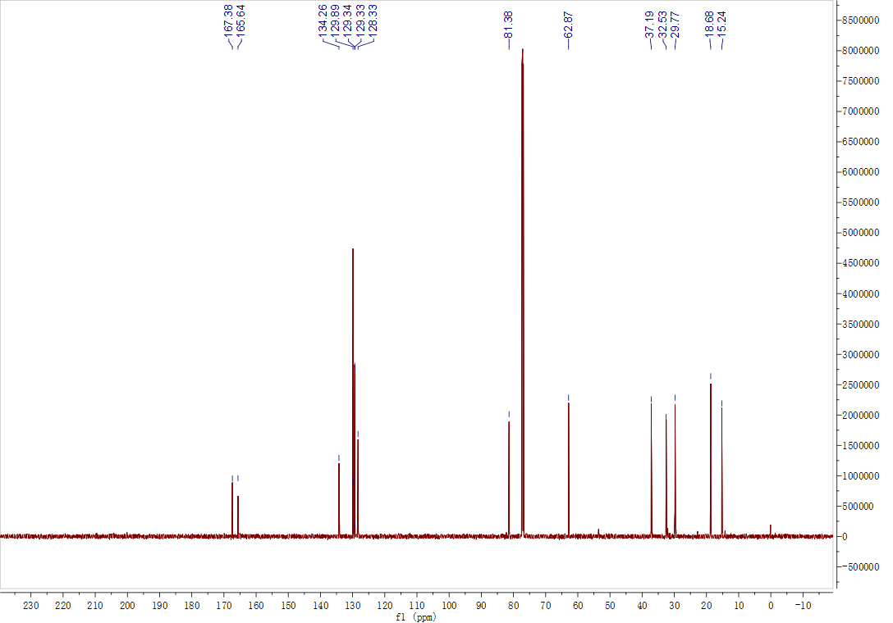

Figure S14. ¹³C NMR spectrum (CDCl3, 600 MHz) of bassiatin (3)
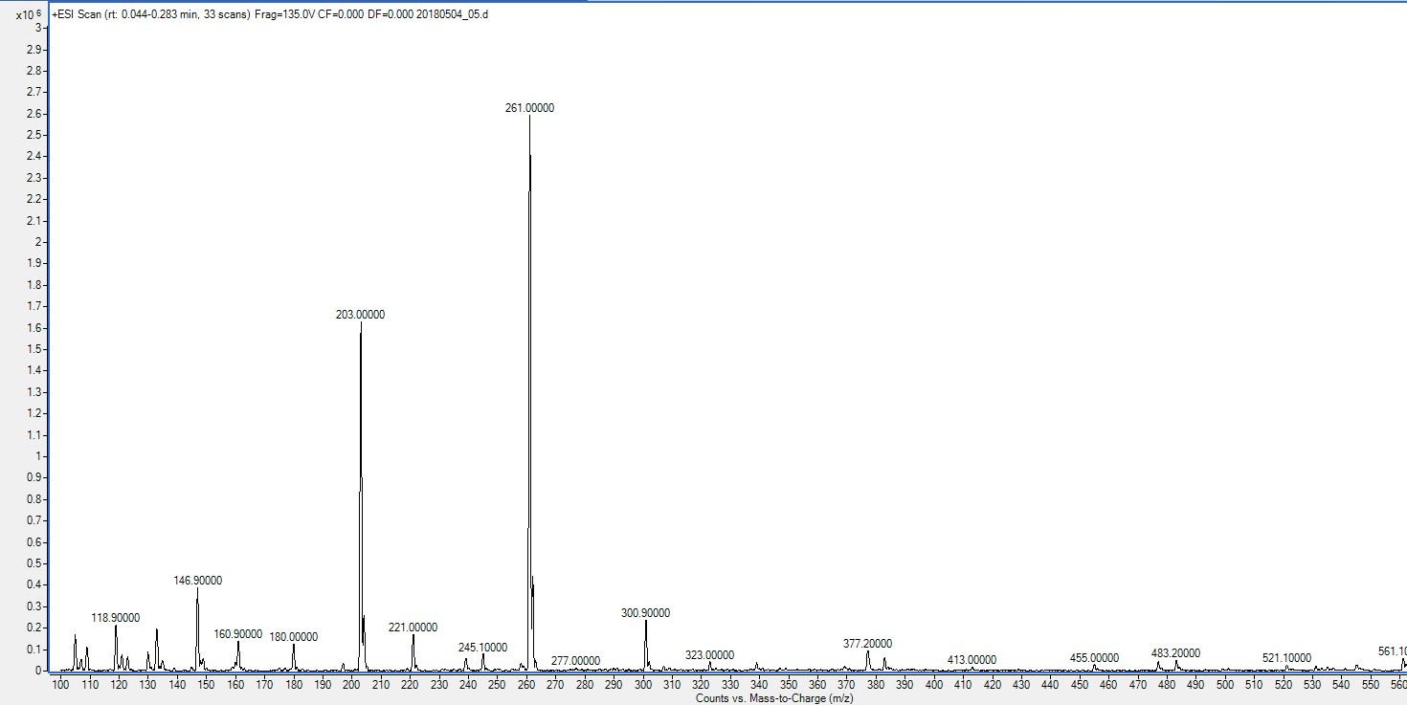

Figure S15 ESI-MS data of bassiatin (3)

Table S3. Insecticidal activity of compound 3
Conc. (ppm) | Mean mortality (%) with exposure time (h)
Conc. (ppm) | Contact toxicity assay |  |  | Stomach toxicity assay
Conc. (ppm) | 24 | 48 | 72 | 24 | 48 | 72
50 | 31.67±4.30^{b} | 54.17±7.39^{b} | 79.17±14.24^{b} | 46.67±5.44^{b} | 79.17±6.31^{b} | 97.50±3.19ª
25 | 23.33±0.00^{bc} | 46.67±2.72^{bc} | 66.67±7.20^{bc} | 45.00±6.94^{b} | 56.67±11.86^{c} | 80.83±9.95^{b}
12.5 | 18.33±4.30^{c} | 40.00±4.71^{cd} | 68.33±5.77^{bc} | 28.33±4.30^{c} | 33.33±2.72^{d} | 62.50±7.39^{c}
6.25 | 9.17±3.19^{d} | 35.00±6.93^{d} | 57.49±11.6^{c} | 25.00±4.30^{c} | 29.17±1.67^{d} | 51.67±8.82^{c}
PC | 80.83±5.69ª | 97.50±3.19ª | 100.00±0.00ª | 88.33±4.30ª | 100.0±0.00ª | 100.0±0.00ª
CK | 3.33±2.72^{d} | 5.84±1.67^{d} | 13.33±0.00^{d} | 5.00±1.92^{d} | 8.33±1.92e | 15.83±1.67^{d}
Statics summary
S.S | 15531 | 179851 | 16445.0 | 15964 | 23341 | 20308
M.S | 3106.3 | 3590.3 | 3329.1 | 3192.8 | 4668.3 | 4461.7
df | 5 | 5 | 5 | 5 | 5 | 5
f | 214.1*** | 148.2*** | 47.1*** | 139.8*** | 144.1*** | 99.7***
Data in the columns is described as mean values ± standard deviation with various superscripts is significantly
different according to DMRT” P> 0.05). S.S (Sum of square); Df (Degree of freedom); M.S (Mean square); F
(Significance); PC (Postive Control); CK (Check); *** (level of significance).

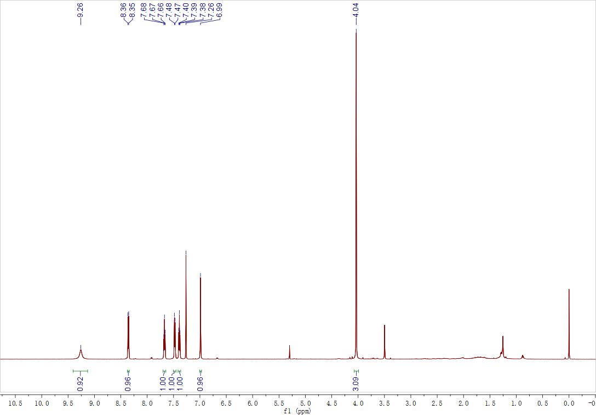

Figure S16. ¹H NMR spectrum (CDCl3, 600 MHz) of methyl 1,4-dihydro-4-oxo-2-quinolinecarboxylate (4)
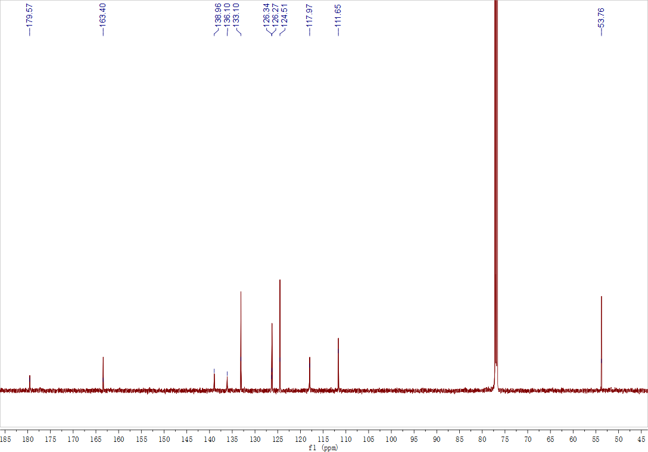

Figure S17. ¹³C NMR spectrum (CDCl3, 600 MHz) of methyl 1,4-dihydro-4-oxo-2-quinolinecarboxylate (4)

Figure S18. ESI-MS data of methyl 1,4-dihydro-4-oxo-2-quinolinecarboxylate (4)

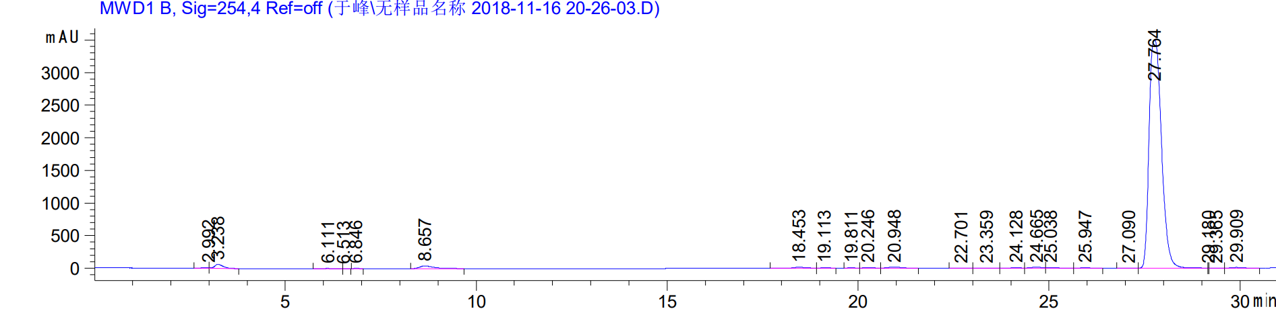

Figure S19. HPLC signal of methyl 1,4-dihydro-4-oxo-2-quinolinecarboxylate (4)

Table S4. Insecticidal activity of compound 4
Conc. (ppm) | Mean mortality (%) with exposure time (h)
Conc. (ppm) | Contact toxicity assay |  |  | Stomach toxicity assay
Conc. (ppm) | 24 | 48 | 72 | 24 | 48 | 72
50 | 25.00±1.93^{b} | 42.50±3.19^{b} | 87.50±7.87ª | 40.83±8.76^{b} | 85.00±6.93^{ab} | 100.00±0.00ª
25 | 19.17±5.00^{bc} | 30.00±4.71^{b} | 56.67±15.63^{b} | 38.33±5.77^{b} | 71.67±7.93^{c} | 92.50±5.69ª
12.5 | 15.83±3.19^{c} | 24.99±5.77^{cd} | 52.50±1287^{b} | 30.83±7.39^{b} | 44.17±8.76^{d} | 76.66±11.22^{b}
6.25 | 11.67±1.92^{c} | 18.33±3.33^{d} | 48.33±8.81^{b} | 29.17±14.2^{b} | 40.00±13.61^{d} | 66.67±5.44^{b}
PC | 80.83±5.69ª | 97.50±3.19ª | 100.00±0.00ª | 88.33±4.30ª | 100.0±0.00ª | 100.0±0.00ª
CK | 3.33±2.72^{d} | 5.83±1.67e | 13.33±0.00^{c} | 5.00±1.92^{c} | 8.33±1.92e | 15.83±1.67^{c}
Statics summary
S.S | 15507 | 20807 | 18949 | 15026 | 22646 | 20513
M.S | 3101.5 | 4161.7 | 3789.8 | 3005 | 4529.2 | 4102.7
df | 5 | 5 | 5 | 5 | 5 | 5
f | 225.7*** | 227.93*** | 41.35*** | 46.2*** | 72.1*** | 129.1***
Data in the columns is described as mean values ± standard deviation with various superscripts is significantly
different according to DMRT” P> 0.05). S.S (Sum of square); Df (Degree of freedom); M.S (Mean square); F
(Significance); PC (Postive Control); CK (Check); *** (level of significance).

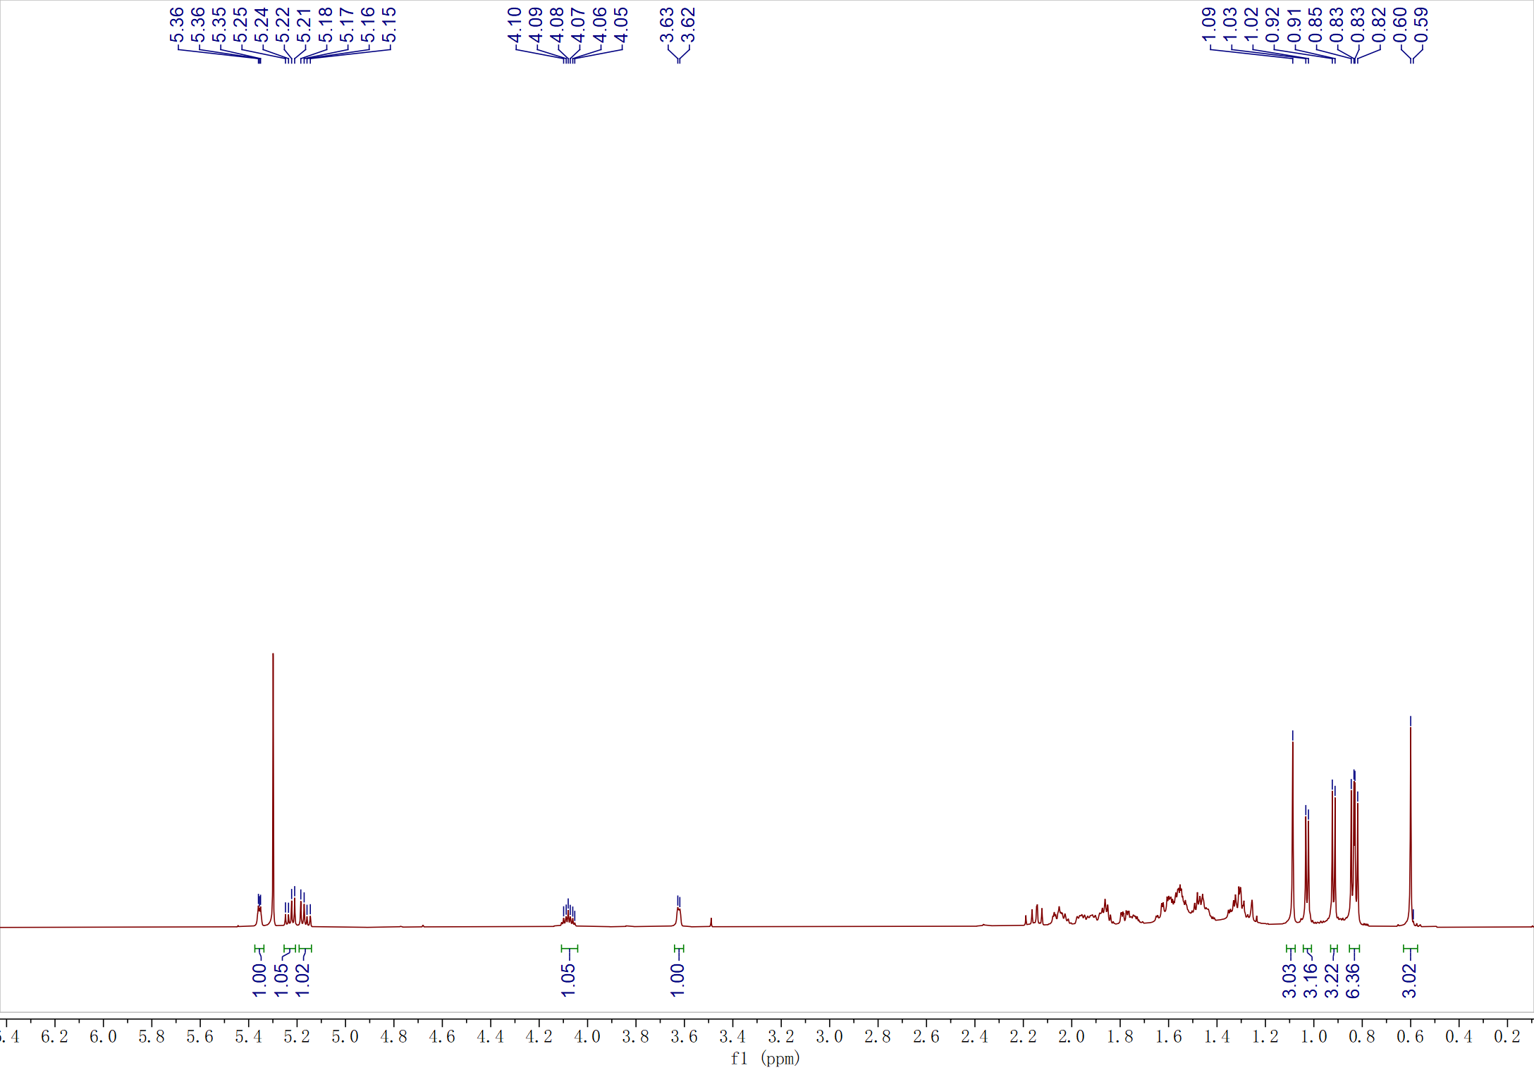

Figure S20. ¹H NMR spectrum (CDCl3, 600 MHz) of cerevisterol (5)
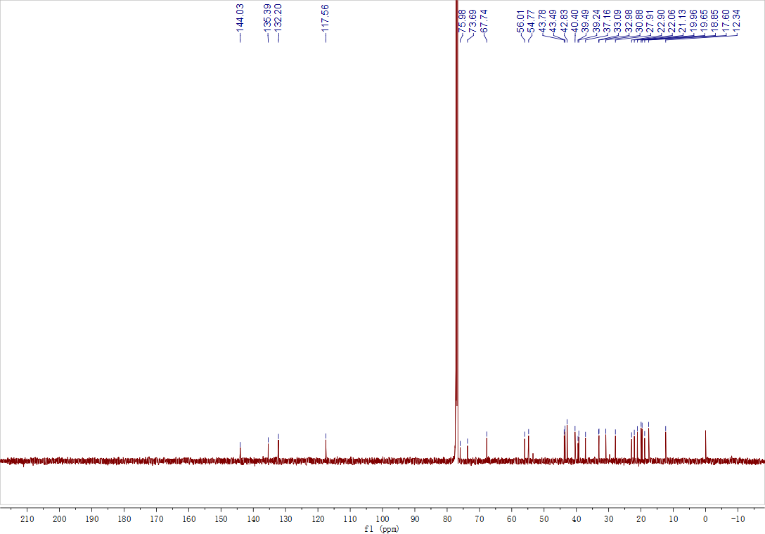

Figure S21. ¹³C NMR spectrum (CDCl3, 600 MHz) of cerevisterol (5)

Figure S22. ESI-MS data of cerevisterol (5)

Table S5. Insecticidal activity of compound 5
Conc. (ppm) | Mean mortality (%) with exposure time (h)
Conc. (ppm) | Contact toxicity assay |  |  | Stomach toxicity assay
Conc. (ppm) | 24 | 48 | 72 | 24 | 48 | 72
50 | 41.67±6.38^{b} | 44.17±7.39^{b} | 53.33±16.55^{b} | 30.83±18.53^{b} | 42.50±7.39^{b} | 70.83±11.01^{b}
25 | 30.83±7.39^{bc} | 36.67±7.20^{bc} | 50.83±8.76^{b} | 25.00±5.77^{bc} | 40.00±7.20^{b} | 66.67±6.08^{bc}
12.5 | 21.66±12.83^{c} | 25.00±15.52^{bcd} | 45.00±11.71^{bc} | 21.67±3.33^{bc} | 38.33±19.72^{b} | 56.67±11.85^{bc}
6.25 | 19.17±12.83^{cd} | 19.16±10.31^{cd} | 25.17±8.33^{cd} | 19.17±13.71^{bc} | 30.33±23.73^{bc} | 49.17±8.76^{c}
PC | 80.83±5.69ª | 97.50±3.19ª | 100.00±0.00ª | 88.33±4.30ª | 100.0±0.00ª | 100.0±0.00ª
CK | 3.33±2.72^{d} | 5.83±1.67^{d} | 13.33±0.00^{d} | 5.00±2.72^{c} | 8.33±1.92^{c} | 15.83±1.67^{d}
Statics summary
S.S | 14270 | 20553 | 17770 | 16893 | 18287 | 15362
M.S | 2854.1 | 4110.7 | 3554.19 | 3378.8 | 3657.4 | 3072.5
df | 5 | 5 | 5 | 5 | 5 | 5
f | 44.35*** | 52.25*** | 38.26*** | 33.9*** | 21.1*** | 46.68***
Data in the columns is described as mean values ± standard deviation with various superscripts is significantly
different according to DMRT” P> 0.05). S.S (Sum of square); Df (Degree of freedom); M.S (Mean square); F
(Significance); PC (Postive Control); CK (Check); *** (level of significance).

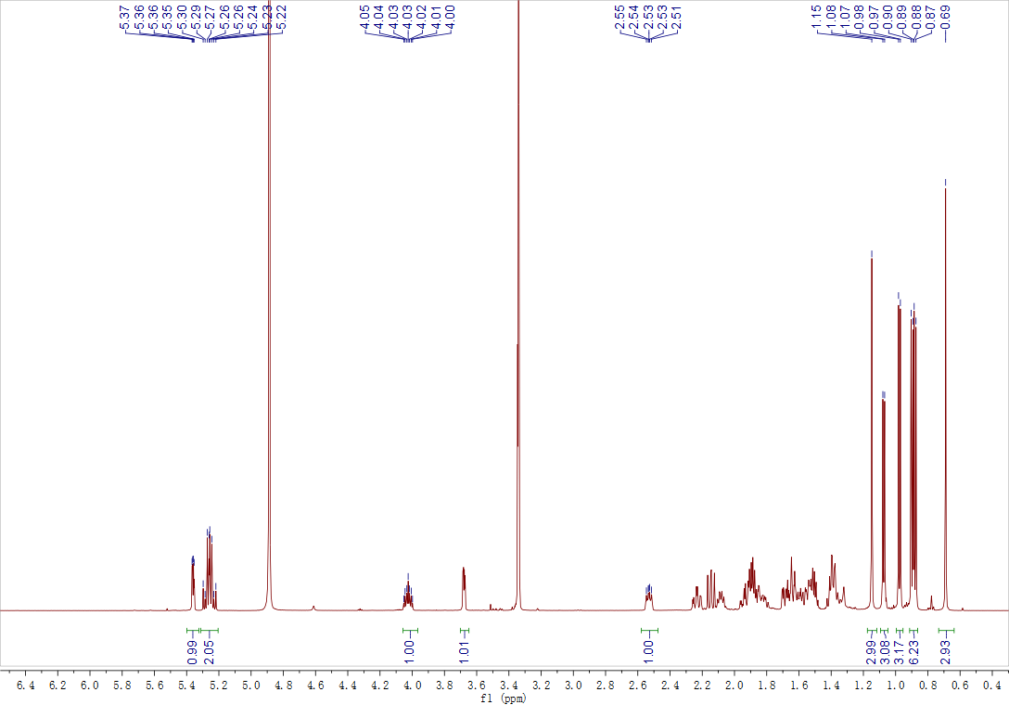

Figure S23. ¹H NMR spectrum (MeOD, 600 MHz) of 9-hydroxycerevisterol (6)
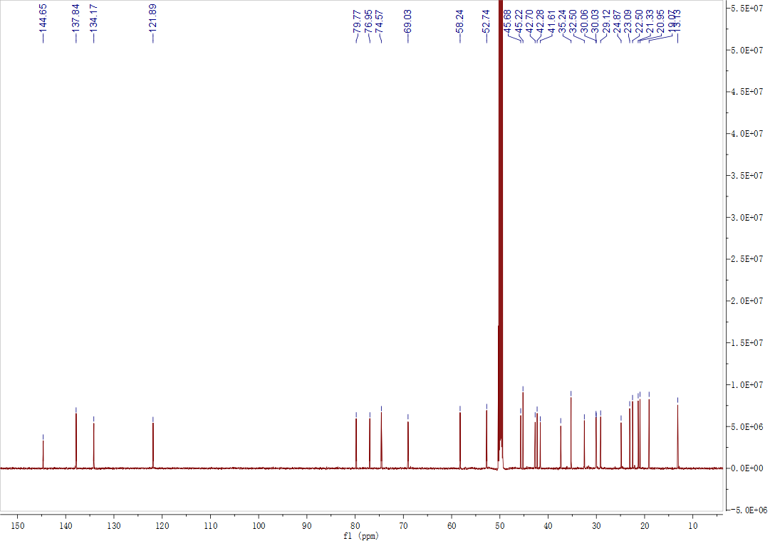

Figure S24. ¹³C NMR spectrum (MeOD, 600 MHz) of 9-hydroxycerevisterol (6)

Figure S25. HR-ESI-MS data of 9-hydroxycerevisterol (6)

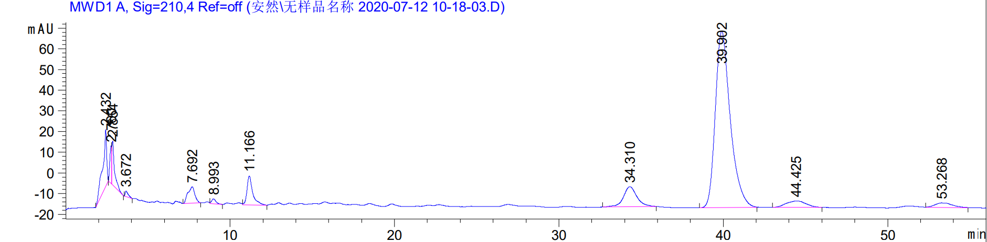

Figure S26. HPLC signal of 9-hydroxycerevisterol (6)

Table S6. Insecticidal activity of compound 6
Conc. (ppm) | Mean mortality (%) with exposure time (h)
Conc. (ppm) | Contact toxicity assay |  |  | Stomach toxicity assay
Conc. (ppm) | 24 | 48 | 72 | 24 | 48 | 72
50 | 19.17±8.33^{b} | 25.00±8.81^{b} | 36.67±4.71^{b} | 19.17±9.18^{b} | 25.00±4.30^{b} | 41.67±10.36^{b}
25 | 14.17±5.69^{bc} | 15.83±6.87^{bc} | 28.34±5.77^{bc} | 17.50±11.01^{b} | 23.33±6.08^{b} | 38.33±4.30^{b}
12.5 | 8.33±4.30^{bc} | 15.00±3.30^{bc} | 22.50±7.39^{cd} | 9.17±4.19^{b} | 18.33±7.93^{bc} | 28.33±4.30^{bc}
6.25 | 6.67±2.72^{c} | 11.67±1.92^{c} | 19.17±3.19^{cd} | 5.00±4.30^{b} | 9.99±8.16^{c} | 21.67±8.82^{c}
PC | 80.83±5.69ª | 97.50±3.19ª | 100.00±0.00ª | 88.33±4.30ª | 100.0±0.00ª | 100.0±0.00ª
CK | 3.33±2.72^{c} | 5.83±1.67^{c} | 13.33±0.00^{d} | 5.00±2.72^{b} | 8.33±1.92^{c} | 15.83±1.67^{c}
Statics summary
S.S | 17203 | 23651 | 20528 | 20585 | 23833 | 18264
M.S | 3440.7 | 4730.4 | 4105.6 | 4117.1 | 4776.7 | 3724.9
df | 5 | 5 | 5 | 5 | 5 | 5
f | 123.17*** | 177.19*** | 204.59*** | 93.6*** | 151.7*** | 99.35***
Data in the columns is described as mean values ± standard deviation with various superscripts is significantly
different according to DMRT” P> 0.05). S.S (Sum of square); Df (Degree of freedom); M.S (Mean square); F
(Significance); PC (Postive Control); CK (Check); *** (level of significance).

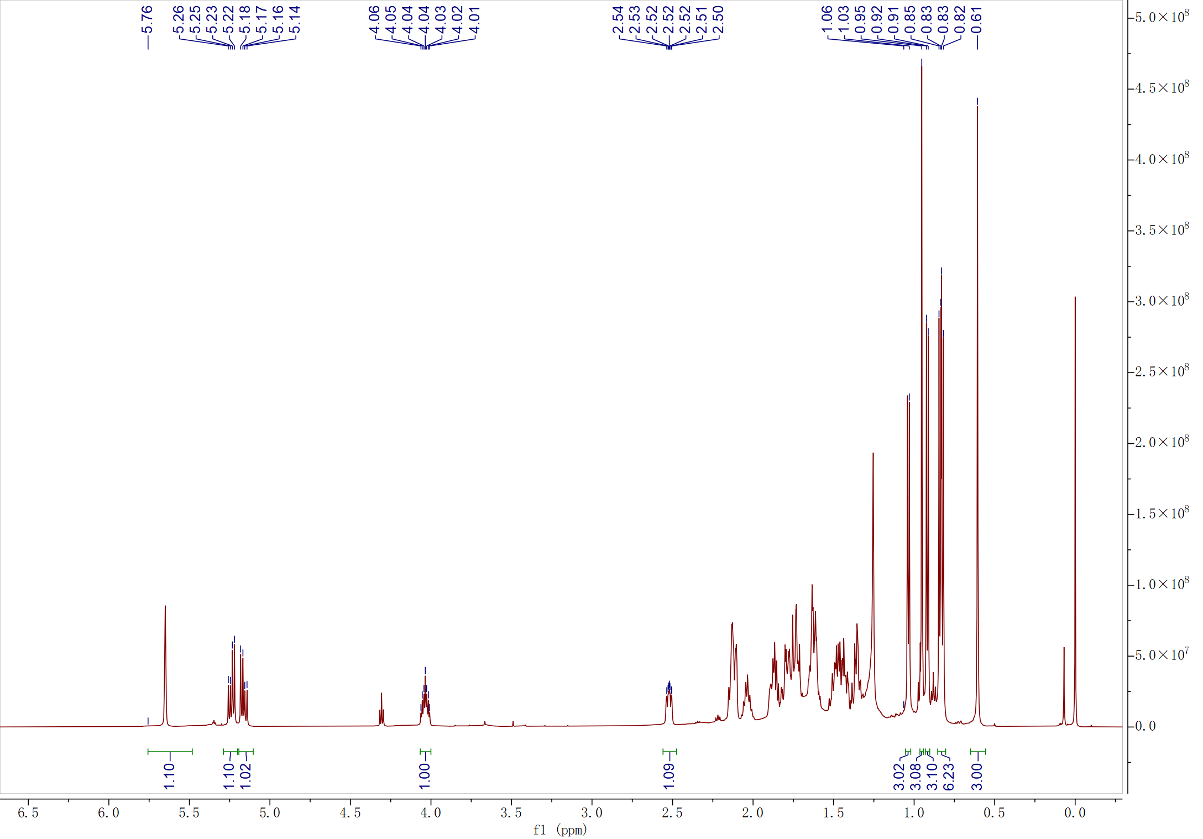

Figure S27. ¹H NMR spectrum (CDCl3, 600 MHz) of 6-dehydrocerevisterol (7)
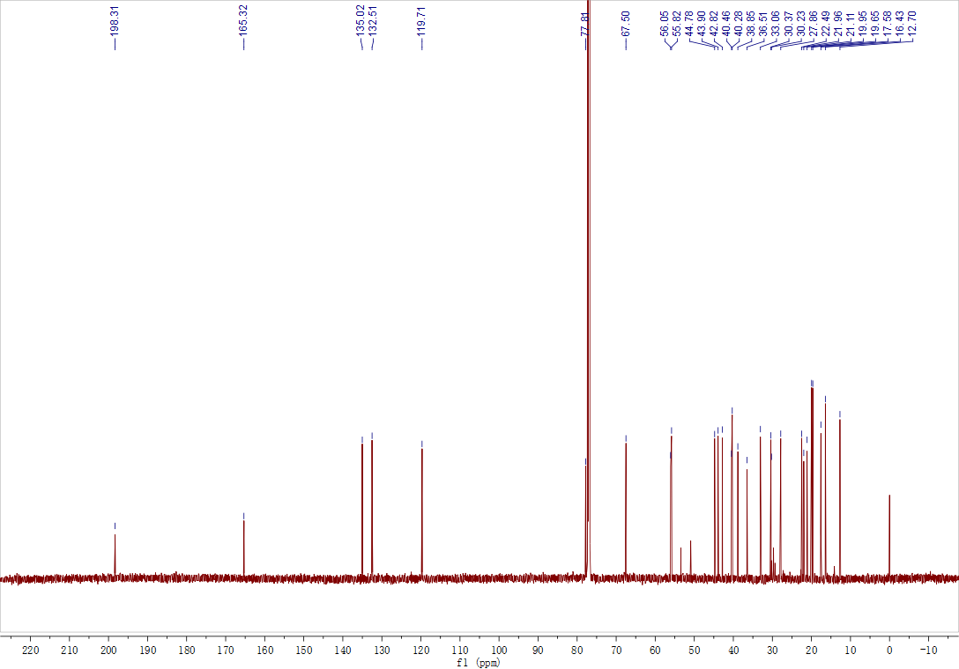

Figure S28. ¹³C NMR spectrum (CDCl3, 600 MHz) of 6-dehydrocerevisterol (7)

Figure S29. ESI-MS data of 6-dehydrocerevisterol (7)

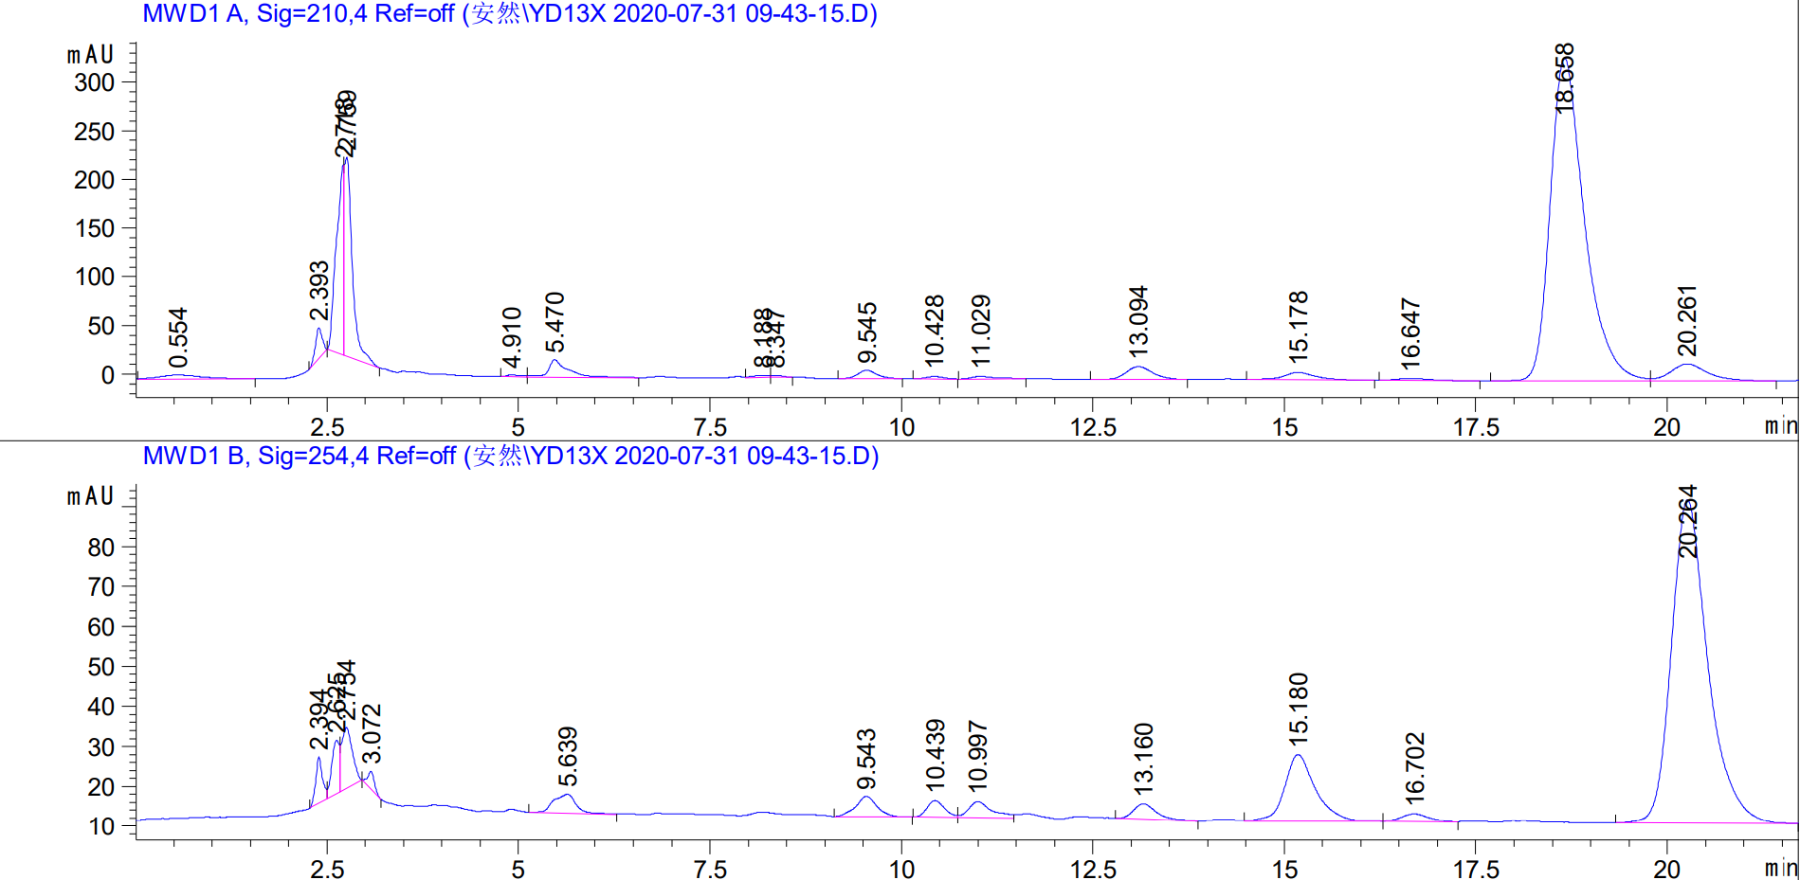

Figure S30. HPLC signal of 6-dehydrocerevisterol (7)

Table S7: Insecticidal activity of compound 7
Conc. (ppm) | Mean mortality (%) with exposure time (h)
Conc. (ppm) | Contact toxicity assay |  |  | Stomach toxicity assay
Conc. (ppm) | 24 | 48 | 72 | 24 | 48 | 72
50 | 26.67±5.44^{b} | 45.00±8.81^{b} | 71.67±4.71^{b} | 40.83±8.76^{b} | 85.00±6.94^{ab} | 100.00±0.00ª
25 | 19.99±10.53^{b} | 35.00±12.32^{b} | 65.83±5.77^{bc} | 38.33±5.77^{b} | 71.67±7.93^{c} | 92.50±5.69ª
12.5 | 18.33±5.77^{b} | 35.00±11.05^{b} | 47.50±7.39^{bc} | 30.83±7.39^{b} | 44.17±8.77^{d} | 76.67±11.22^{b}
6.25 | 15.00±4.30^{b} | 27.49±6.87^{b} | 44.17±3.19^{c} | 29.17±14.2^{b} | 40.00±13.61^{d} | 66.67±5.44^{b}
PC | 80.83±5.69ª | 97.50±3.19ª | 100.00±0.00ª | 88.33±4.30ª | 100.0±0.00ª | 100.0±0.00ª
CK | 3.33±2.72^{c} | 5.83±1.67^{c} | 13.33±0.00^{d} | 5.00±2.72^{c} | 8.33±1.92e | 15.83±1.67^{c}
Statics summary
S.S | 14902 | 18796 | 17216 | 15026 | 22646 | 20513
M.S | 2980.46 | 3759.3 | 3443.3 | 3005.2 | 4529.2 | 4102.7
df | 5 | 5 | 5 | 5 | 5 | 5
f | 76.95*** | 54.75*** | 25.67*** | 46.2*** | 72.1*** | 129.1***
Data in the columns is described as mean values ± standard deviation with various superscripts is significantly
different according to DMRT” P> 0.05). S.S (Sum of square); Df (Degree of freedom); M.S (Mean square); F
(Significance); PC (Postive Control); CK (Check); *** (level of significance).

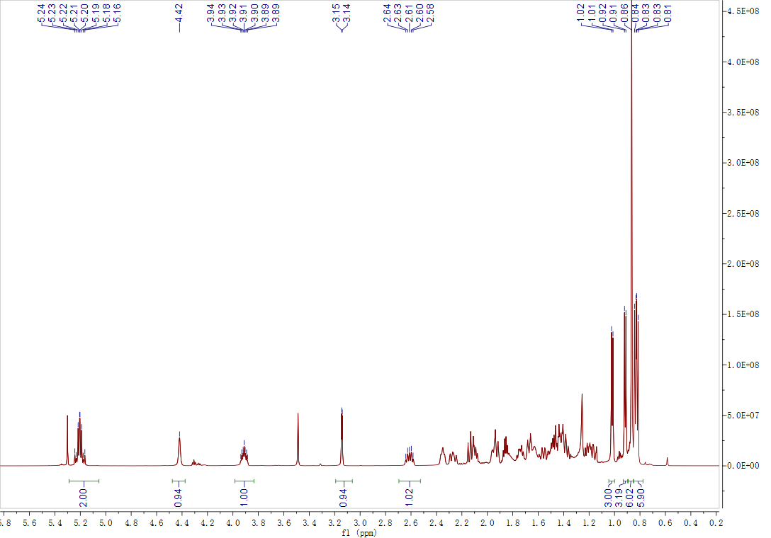

Figure S31. ¹H NMR spectrum (CDCl3, 600 MHz) of (22E,24R)-ergosta-8(14),22-diene-3β,5α,6β,7α-tetrol (8)
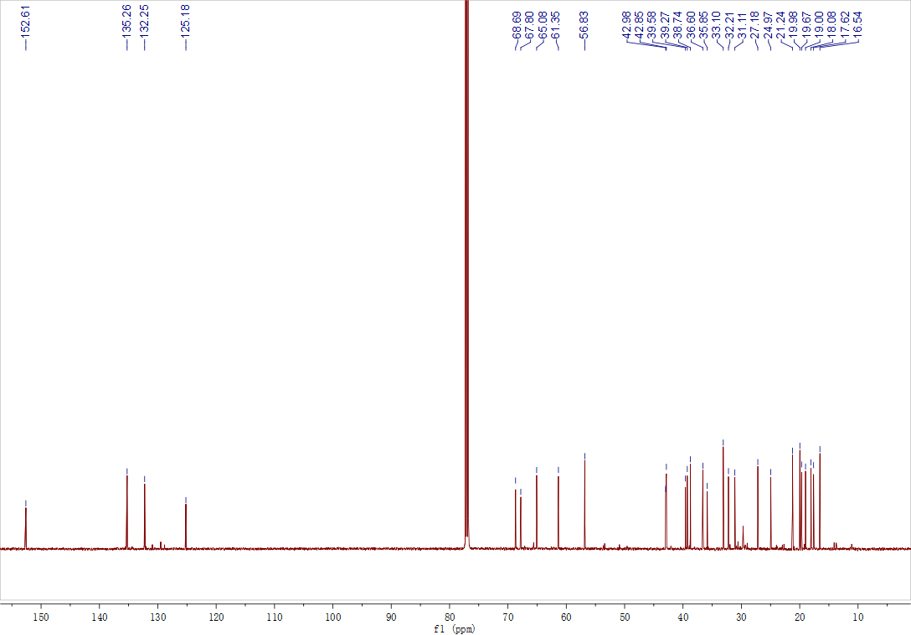

Figure S32. ¹³C NMR spectrum (CDCl3, 600 MHz) of (22E,24R)-ergosta-8(14),22-diene-3β,5α,6β,7α-tetrol (8)

Figure S33. ESI-MS data of (22E,24R)-ergosta-8(14),22-diene-3β,5α,6β,7α-tetrol (8)

Figure S34. HPLC signal of (22E,24R)-ergosta-8(14),22-diene-3β,5α,6β,7α-tetrol (8)

Table S8. Insecticidal activity of compound 8
Conc. (ppm) | Mean mortality (%) with exposure time (h)
Conc. (ppm) | Contact toxicity assay |  |  | Stomach toxicity assay
Conc. (ppm) | 24 | 48 | 72 | 24 | 48 | 72
50 | 43.33±13.33^{b} | 56.67±9.82^{b} | 61.67±10.37^{b} | 27.50±8.33^{b} | 45.83±8.76^{b} | 90.00±11.54^{ab}
25 | 41.67±14.53^{bc} | 49.17±11.35^{bc} | 57.50±15.24^{b} | 17.50±5.69^{bc} | 30.83±7.39^{bc} | 81.67±4.30^{b}
12.5 | 30.83±9.18^{bc} | 42.50±5.69^{bc} | 56.67±13.05^{b} | 16.67±9.02^{bc} | 25.83±6.30^{c} | 57.50±9.17^{c}
6.25 | 19.16±10.32^{cd} | 28.33±15.99^{c} | 49.17±3.7^{b} | 15.00±12.32^{bc} | 22.50±11.01^{cd} | 45.00±9.99^{C}
PC | 80.83±5.69ª | 97.50±3.19ª | 100.00±0.00ª | 88.33±4.30ª | 100.0±0.00ª | 100.0±0.0ª
CK | 3.33±2.72^{d} | 5.83±1.67^{d} | 13.33±0.00^{c} | 5.00±2.72^{c} | 8.33±1.92^{d} | 15.83±1.67^{d}
Statics summary
S.S | 13885 | 18843 | 15349 | 18305 | 20880 | 20004
M.S | 2777.15 | 3768.74 | 3069.85 | 3661.1 | 4176.2 | 4000.9
df | 5 | 5 | 5 | 5 | 5 | 5
f | 26.90*** | 42.98*** | 26.38*** | 61.5*** | 84.6*** | 70.9***
Data in the columns is described as mean values ± standard deviation with various superscripts is significantly
different according to DMRT” P> 0.05). S.S (Sum of square); Df (Degree of freedom); M.S (Mean square); F
(Significance); PC (Postive Control); CK (Check); *** (level of significance).

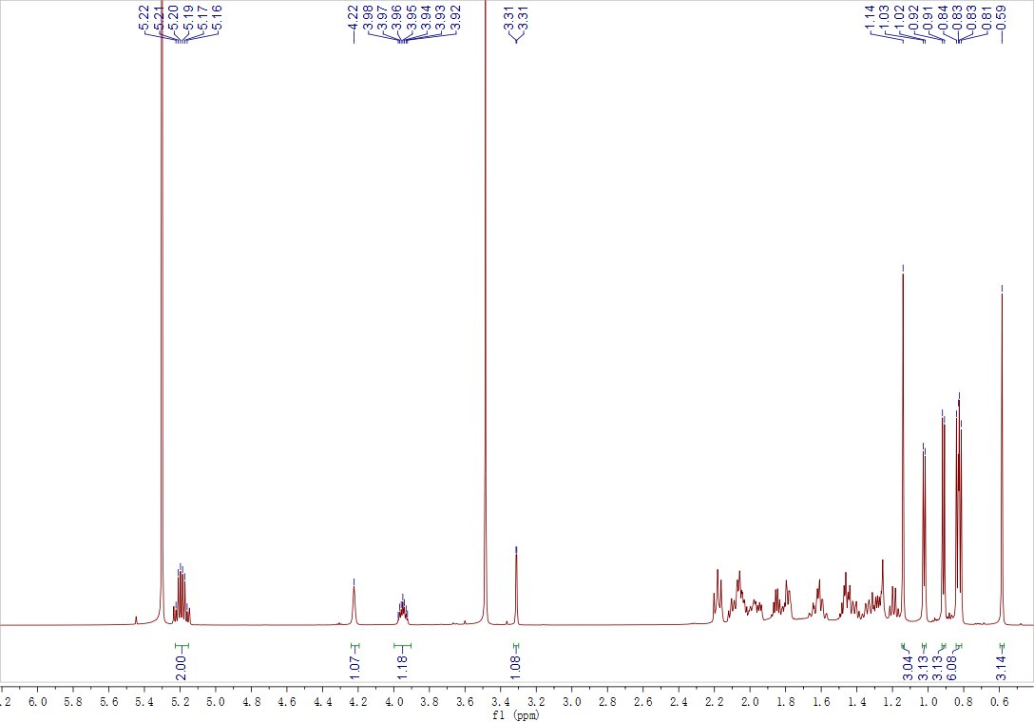

Figure S35. ¹H NMR spectrum (CDCl3, 600 MHz) of melithasterol B (9)
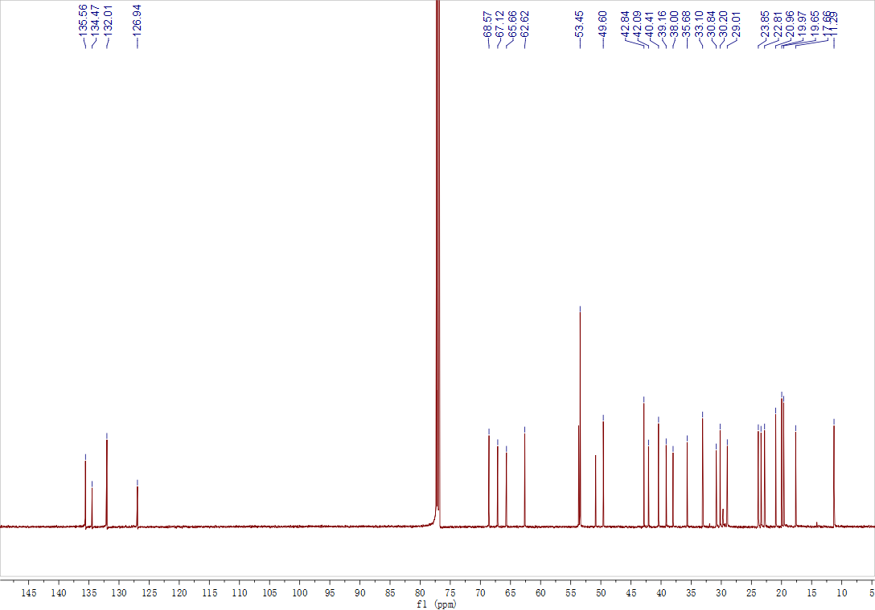

Figure S36. ¹³C NMR spectrum (CDCl3, 600 MHz) of melithasterol B (9)

Figure S37. ESI-MS data of melithasterol B (9)

Table S9. Insecticidal activity of compound 9
Conc. (ppm) | Mean mortality (%) with exposure time (h)
Conc. (ppm) | Contact toxicity assay |  |  | Stomach toxicity assay
Conc. (ppm) | 24 | 48 | 72 | 24 | 48 | 72
50 | 33.33±13.87^{b} | 51.67±16.87^{b} | 66.67±18.39^{b} | 22.50±4.19^{b} | 50.83±11.98^{b} | 64.17±23.62^{b}
25 | 30.00±6.08^{b} | 35.83±8.34^{bc} | 55.00±13.61^{bc} | 11.67±4.30^{c} | 25.83±12.87^{c} | 38.33±9.62^{bc}
12.5 | 21.67±4.30^{bc} | 24.17±5.69^{cd} | 48.33±6.93^{c} | 11.67±5.77^{c} | 21.67±4.73^{cd} | 36.67±11.22^{c}
6.25 | 7.49±5.00^{cd} | 18.33±11.87^{cd} | 40.83±4.30^{c} | 10.00±7.20^{c} | 20.00±4.30^{cd} | 36.67±8.17^{c}
PC | 80.83±5.69ª | 97.50±3.19ª | 100.00±0.00ª | 88.33±4.30ª | 100.0±0.00ª | 100.0±0.00ª
CK | 3.33±2.72^{d} | 5.84±1.67^{d} | 13.33±0.00^{d} | 5.00±1.92^{c} | 8.33±1.92^{d} | 15.83±1.67^{c}
Statics summary
S.S | 15520 | 21358 | 16548 | 19990 | 22508 | 17391
M.S | 3104.1 | 4271.8 | 3309.6 | 3898.1 | 4501.6 | 3478.4
df | 5 | 5 | 5 | 5 | 5 | 5
f | 59.51*** | 48.39*** | 64.79*** | 261.6*** | 76.4*** | 24.7***
Data in the columns is described as mean values ± standard deviation with various superscripts is significantly
different according to DMRT” P> 0.05). S.S (Sum of square); Df (Degree of freedom); M.S (Mean square); F
(Significance); PC (Postive Control); CK (Check); *** (level of significance).

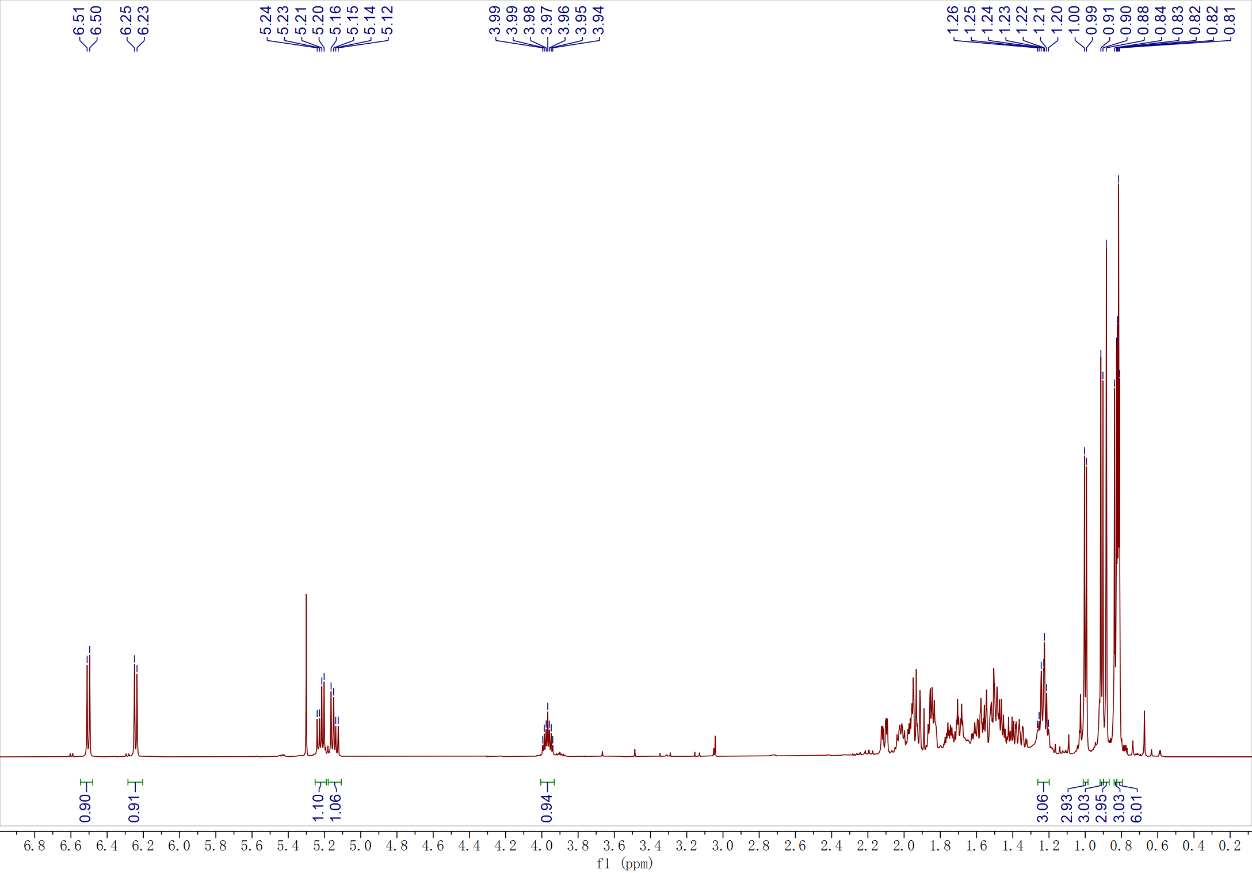

Figure S38. ¹H NMR spectrum (CDCl₃, 600 MHz) of ergosterol peroxide (10)
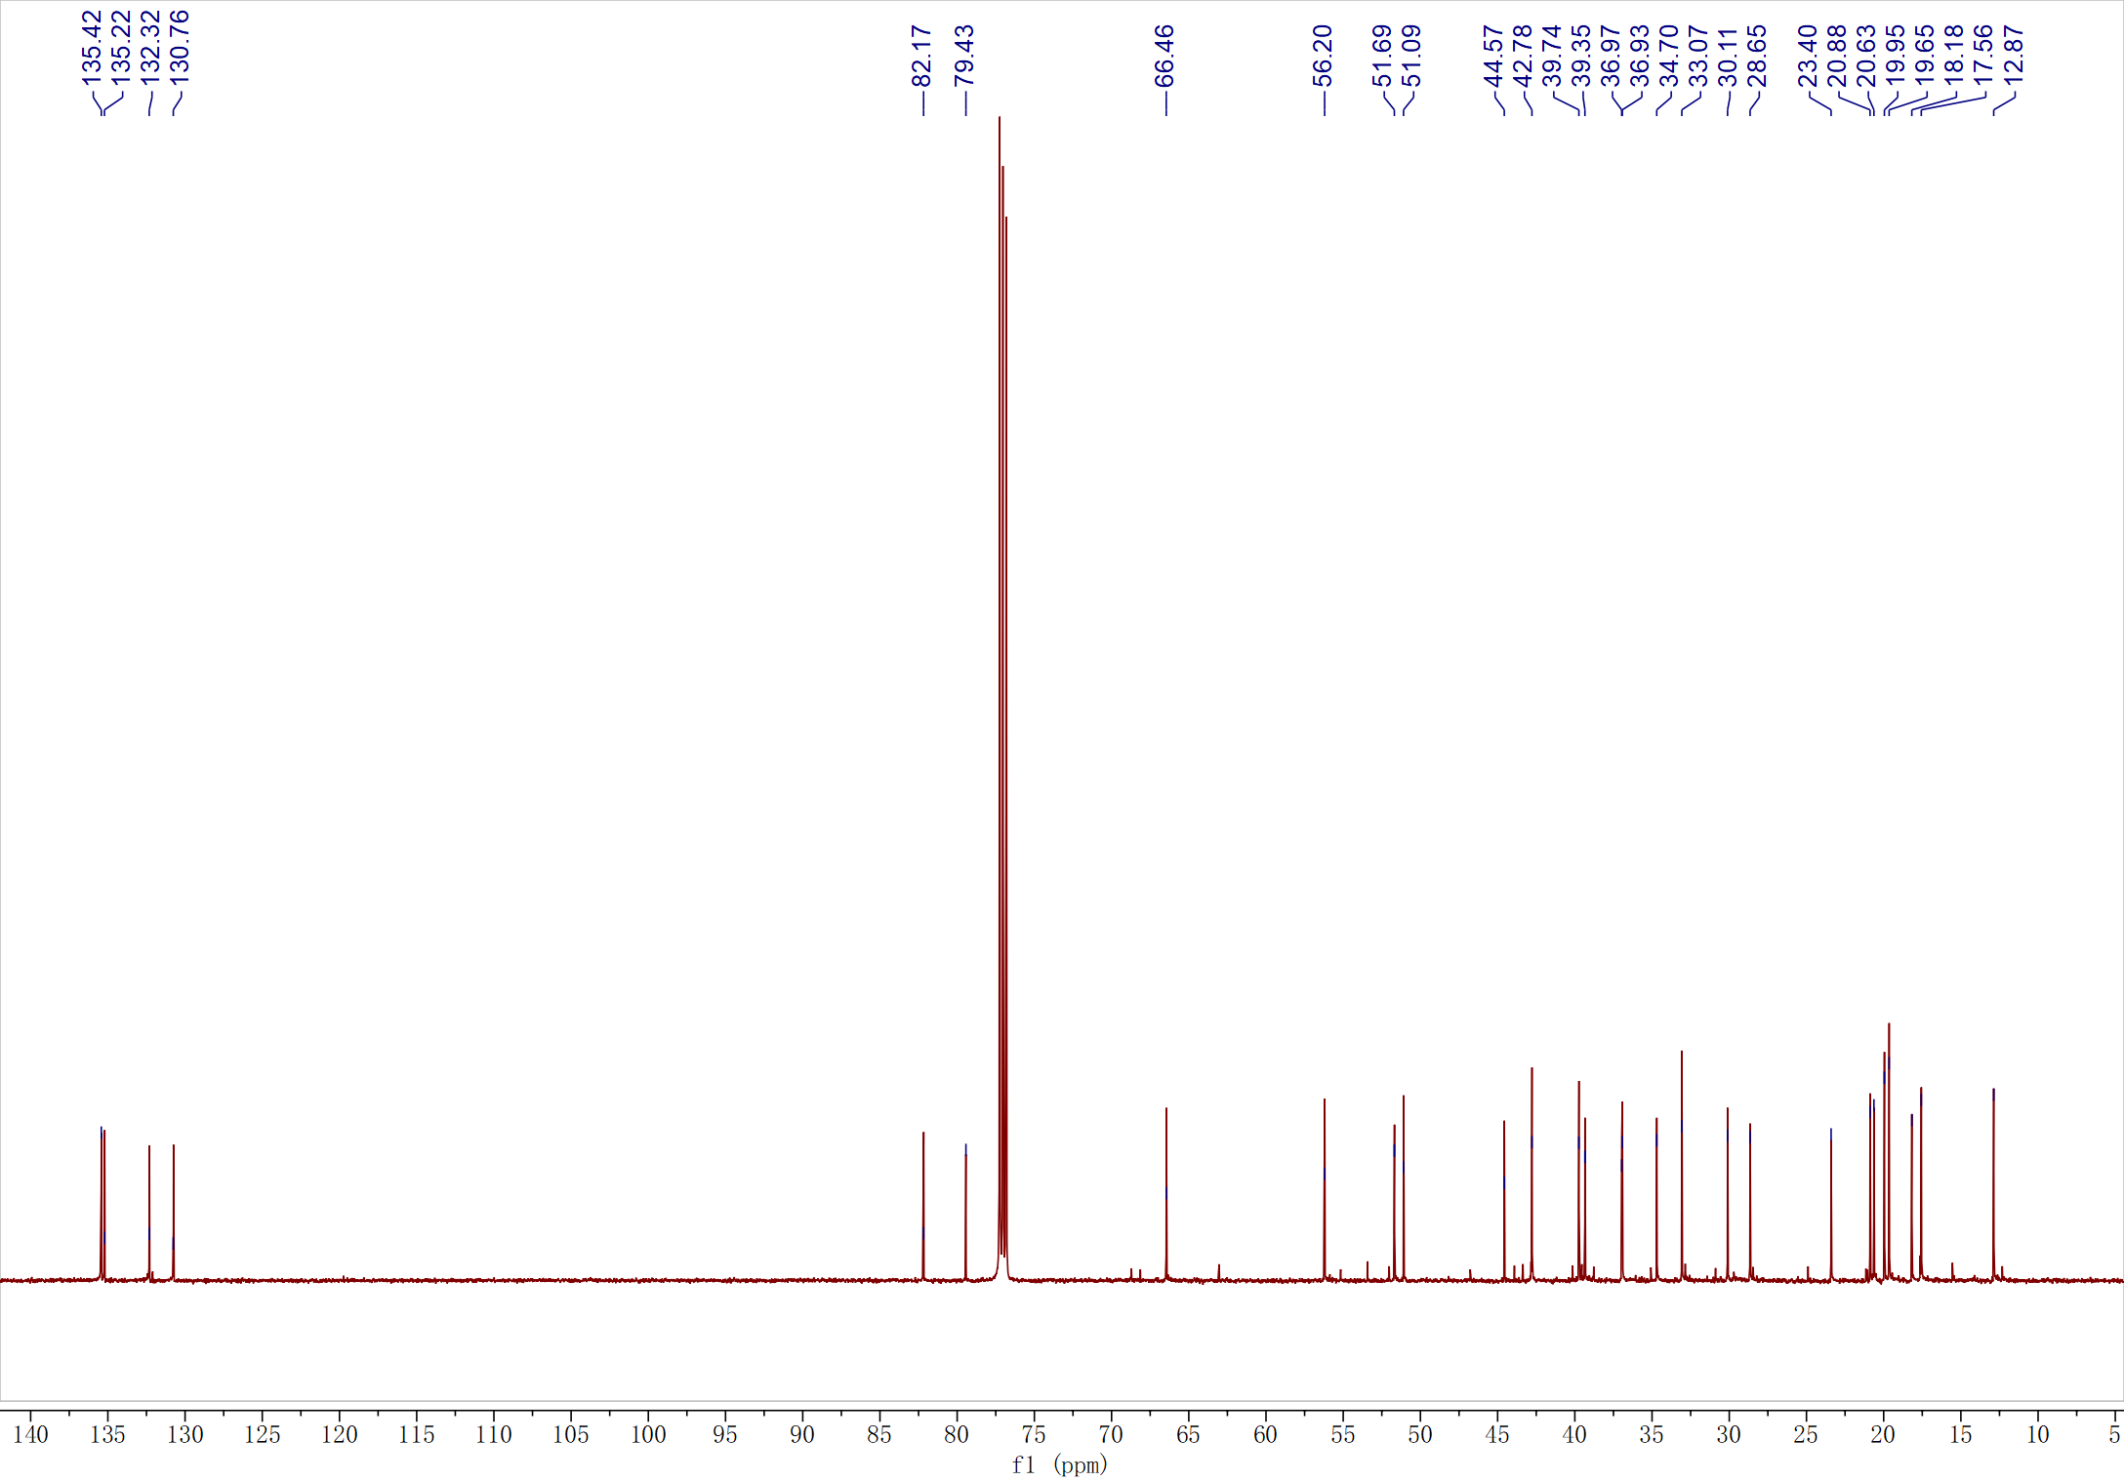

Figure S39. ¹³C NMR spectrum (CDCl₃, 600 MHz) of ergosterol peroxide (10)

Figure S40. ESI-MS data of ergosterol peroxide (10)

Table S10: Insecticidal activity of compound 10
Conc. (ppm) | Mean mortality (%) with exposure time (h)
Conc. (ppm) | Contact toxicity assay |  |  | Stomach toxicity assay
Conc. (ppm) | 24 | 48 | 72 | 24 | 48 | 72
50 | 15.00±8.92^{b} | 44.17±6.87^{b} | 56.67±15.15^{b} | 15.83±4.19^{b} | 45.00±10.36^{b} | 80.83±12.8^{ab}
25 | 9.17±10.32^{b} | 34.17±7.39^{bc} | 45.83±15.48^{b} | 15.00±4.30^{b} | 30.00±8.61^{bc} | 68.33±11.05^{b}
12.5 | 4.17±4.19^{b} | 23.33±3.85^{c} | 42.50±23.93^{bc} | 11.67±5.77^{b} | 23.33±3.85^{cd} | 44.17±9.57^{c}
6.25 | 3.33±2.72^{b} | 9.99±4.71^{d} | 40.84±8.76^{bc} | 10.00±7.20^{b} | 23.33±13.6^{cd} | 40.83±14.2^{c}
PC | 80.83±5.69ª | 97.50±3.19ª | 100.00±0.00ª | 88.33±4.30ª | 100.0±0.00ª | 100.0±0.00ª
CK | 3.33±2.72^{b} | 5.84±1.67^{d} | 13.33±0.00^{c} | 3.33±2.72^{b} | 5.83±1.67e | 15.33±0.00^{d}
Statics summary
S.S | 18481 | 22394 | 16186 | 19979 | 21066 | 18621
M.S | 3696.3 | 4478.8 | 3237.3 | 3995 | 4213.2 | 3724.2
df | 5 | 5 | 5 | 5 | 5 | 5
f | 88.04*** | 177.01*** | 17.35*** | 167.0*** | 65.6*** | 38.19***
Data in the columns is described as mean values ± standard deviation with various superscripts is significantly
different according to DMRT” P> 0.05). S.S (Sum of square); Df (Degree of freedom); M.S (Mean square); F
(Significance); PC (Postive Control); CK (Check); *** (level of significance).

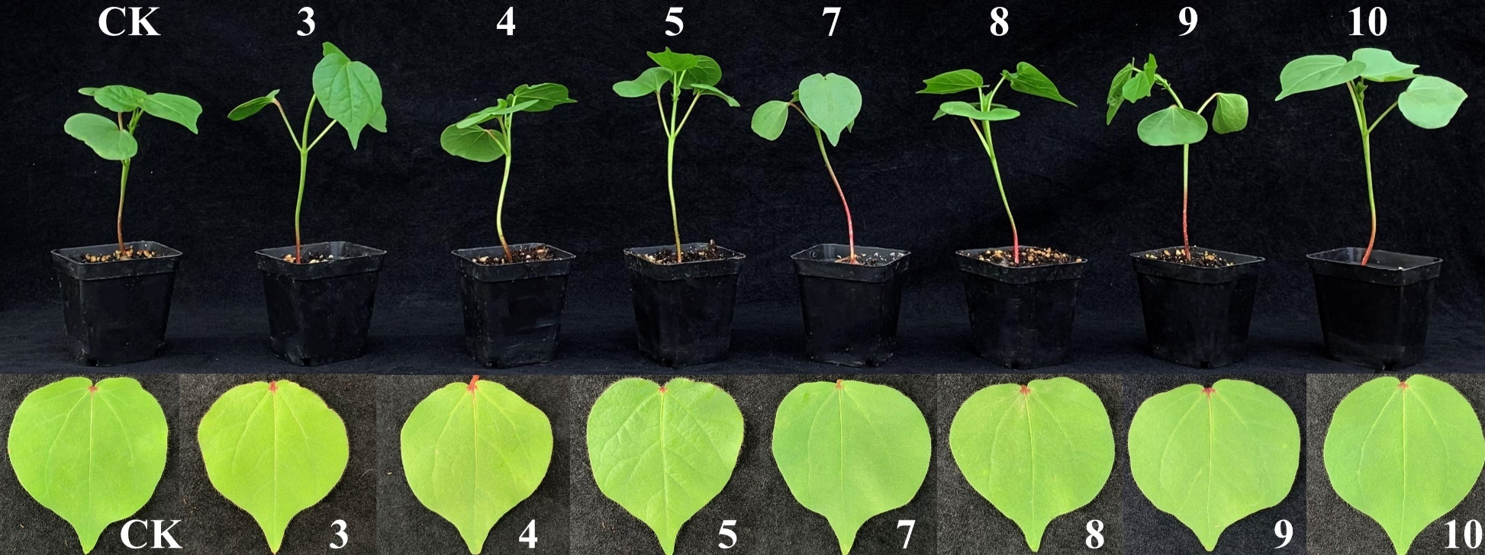

Figure S41. Effects of active compounds on cotton at 100 µg/mL

Table S11. Effects of active compounds on cotton height at 100 µg/mL

Day | Compound 3 | Compound 4 | Compound 5 | Compound 7 | Compound 8 | Compound 9 | Compound 10 | CK
0 | 12.97±0.3^{b} | 12.53±0.3^{b} | 12.36±0.3^{b} | 12.20±0.2^{c} | 12.63±0.3^{c} | 12.87±0.7ª | 12.13±0.3^{c} | 12.6±0.3^{b}
7 | 13.6±0.4^{ab} | 13.8±0.6^{ab} | 13.40±0.4^{ab} | 13.80±0.2^{b} | 13.4±0.3^{ab} | 13.63±0.6ª | 13.76±0.4^{b} | 13.4±0.4^{b}
14 | 14.60±0.3ª | 15.10±0.3ª | 14.43±0.2ª | 15.36±0.6ª | 14.37±0.3ª | 14.40±0.4ª | 15.13±0.4ª | 14.9±0.3ª
 | Statistical Summary
S.S | 4.069 | 9.882 | 6.407 | 15.042 | 4.542 | 3.527 | 13.536 | 7.829
M.S | 2.03 | 4.94 | 3.20 | 7.52 | 2.27 | 1.76 | 6.77 | 3.91
F | 6.67* | 9.36* | 9.74* | 14.91** | 7.92* | 1.63 NS | 14.71** | 10.33*
Df | 2 | 2 | 2 | 2 | 2 | 2 | 2 | 2
Data in the columns presented as mean values ± standard error with various superscripts are significantly different according to DMRT” at (P> 0.05). S.S (Sum of square); M.S (Mean square); Df (Degree of freedom); F (Significance); CK (Check); *, ** (level of significance).

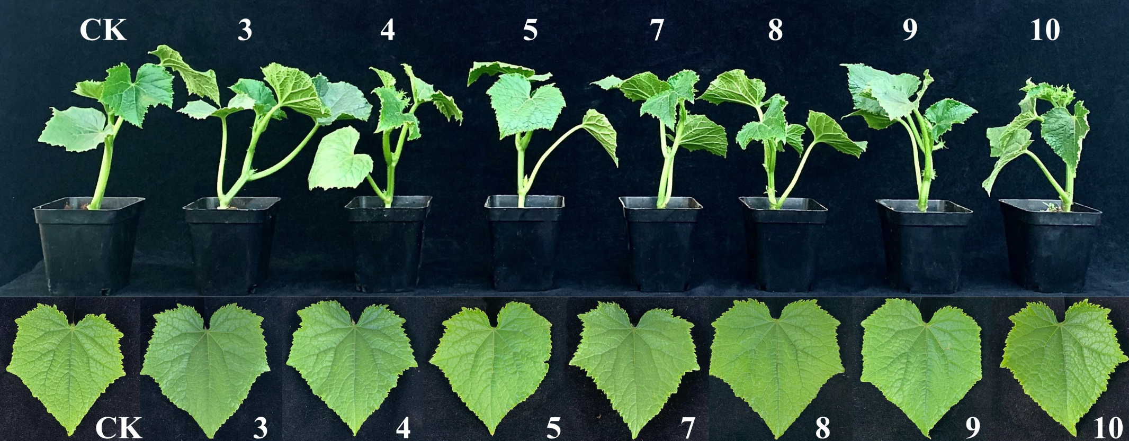

Figure S42. Effects of active compounds on cucumber at 100 µg/mL

Table S12. Effects of active compounds on cucumber height at 100 µg/mL

Day | Compound 3 | Compound 4 | Compound 5 | Compound 7 | Compound 8 | Compound 9 | Compound 10 | CK
0 | 7.23±0.3^{c} | 7.67±0.9^{c} | 7.40±0.3^{c} | 8.10±0.7^{c} | 7.80±0.4^{c} | 7.47±0.5^{b} | 8.40±0.6^{c} | 7.27±0.6^{c}
7 | 11.57±0.6^{b} | 12.27±0.4^{b} | 12.07±0.3^{b} | 11.87±1.1^{b} | 12.00±0.6^{b} | 13.00±1.0ª | 12.33±0.7^{b} | 11.33±0.3^{b}
14 | 15.17±0.5ª | 14.77±0.7ª | 15.13±0.6ª | 14.67±0.3ª | 15.23±0.8ª | 14.47±0.4ª | 14.60±0.3ª | 15.00±0.6ª
 | Statistical Summary
S.S | 94.676 | 77.820 | 90.987 | 65.149 | 83.349 | 81.769 | 59.049 | 89.787
M.S | 47.34 | 38.91 | 45.49 | 33.57 | 41.67 | 40.88 | 29.53 | 44.89
F | 66.673*** | 28.54*** | 82.88*** | 18.59*** | 38.77*** | 28.75*** | 32.53*** | 52.88***
Df | 2 | 2 | 2 | 2 | 2 | 2 | 2 | 2
Data in the columns presented as mean values ± standard error with various superscripts are significantly different according to DMRT” at (P> 0.05). S.S (Sum of square); M.S (Mean square); Df (Degree of freedom); F (Significance); CK (Check); *** (level of significance).

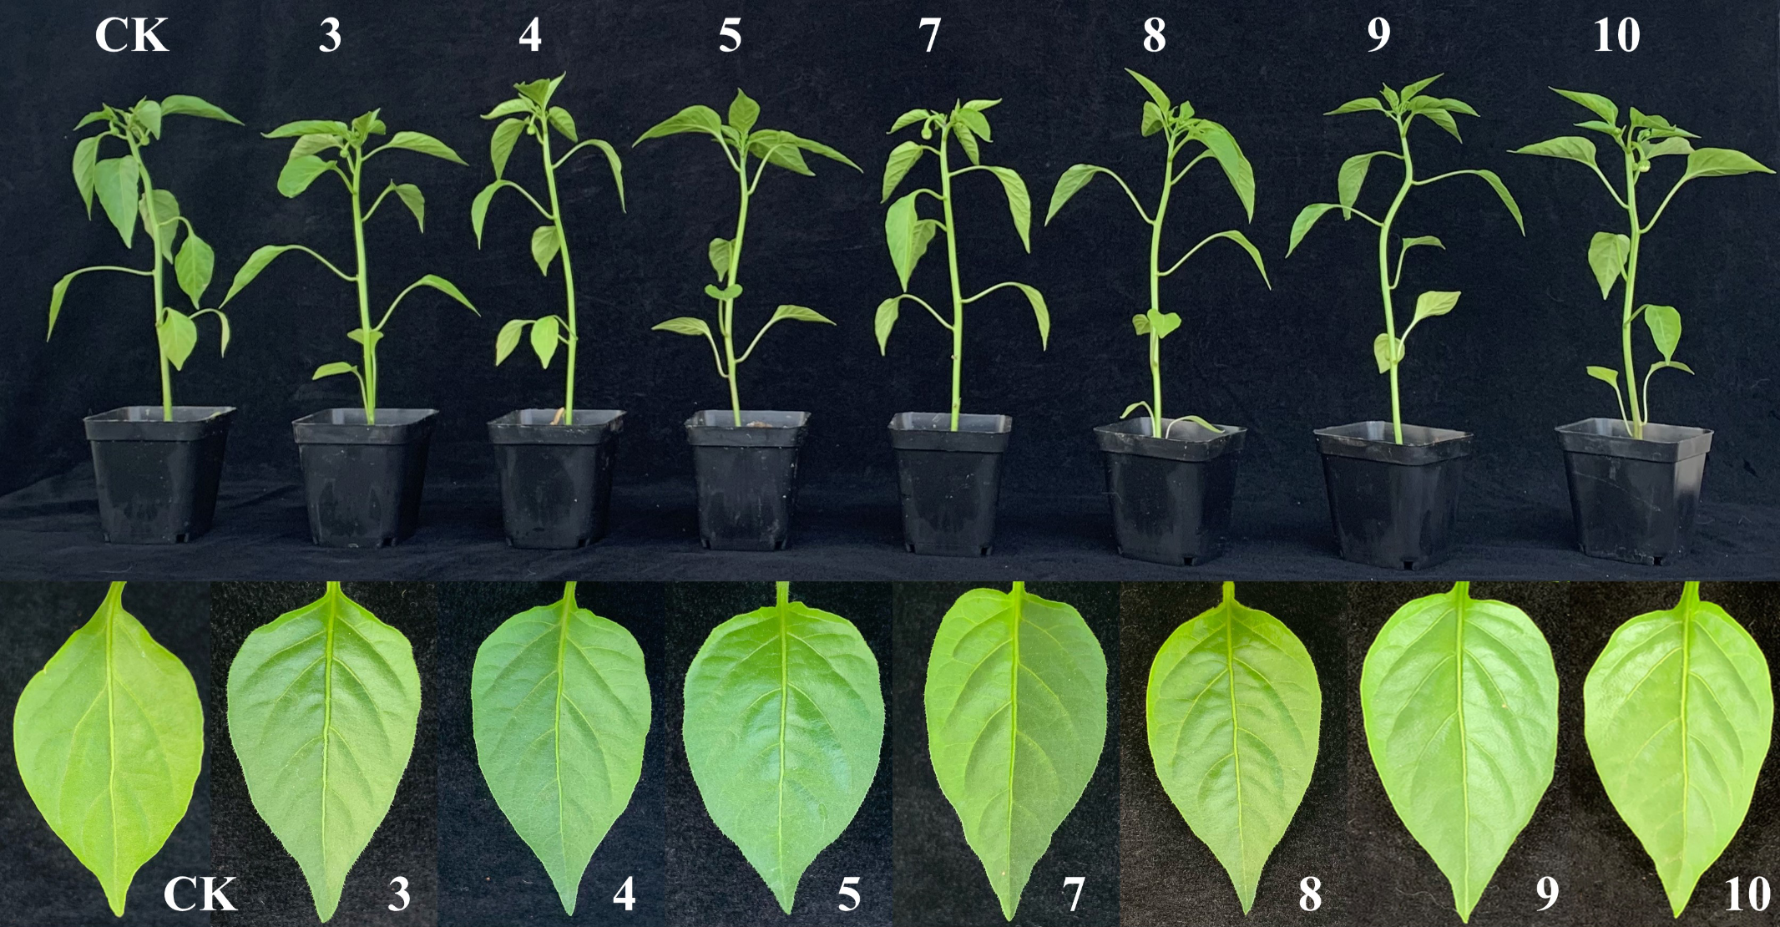

Figure S43. Effects of active compounds on pepper at 100 µg/mL

Table S13. Effects of active compounds on pepper height at 100 µg/mL

Day | Compound 3 | Compound 4 | Compound 5 | Compound 7 | Compound 8 | Compound 9 | Compound 10 | CK
0 | 16.53±0.98^{c} | 16.83±0.32^{c} | 16.40±0.53^{c} | 16.73±0.68^{c} | 17.03±0.56^{c} | 16.80±0.61^{c} | 16.86±0.84^{c} | 17.43±0.58^{c}
7 | 21.50±0.75^{b} | 22.13±1.35^{b} | 20.57±0.87^{b} | 21.37±0.55^{b} | 20.90±0.93^{b} | 21.67±0.97^{b} | 23.26±0.55^{b} | 22.86±0.35^{b}
14 | 27.50±0.61ª | 28.80±0.72ª | 28.20±0.78ª | 27.70±0.58ª | 28.23±0.59ª | 27.00±0.36ª | 28.60±0.36ª | 27.86±0.74ª
 | Statistical Summary
S.S | 180.9 | 215.7 | 179.7 | 181.8 | 194.2 | 156.2 | 207.1 | 163.4
M.S | 90.4 | 107.9 | 91.8 | 90.9 | 97.1 | 78.1 | 103.6 | 81.7
F | 47.3*** | 43.9*** | 1.2*** | 83.5*** | 64.5*** | 54.2*** | 90.4*** | 80.9***
Df | 2 | 2 | 2 | 2 | 2 | 2 | 2 | 2

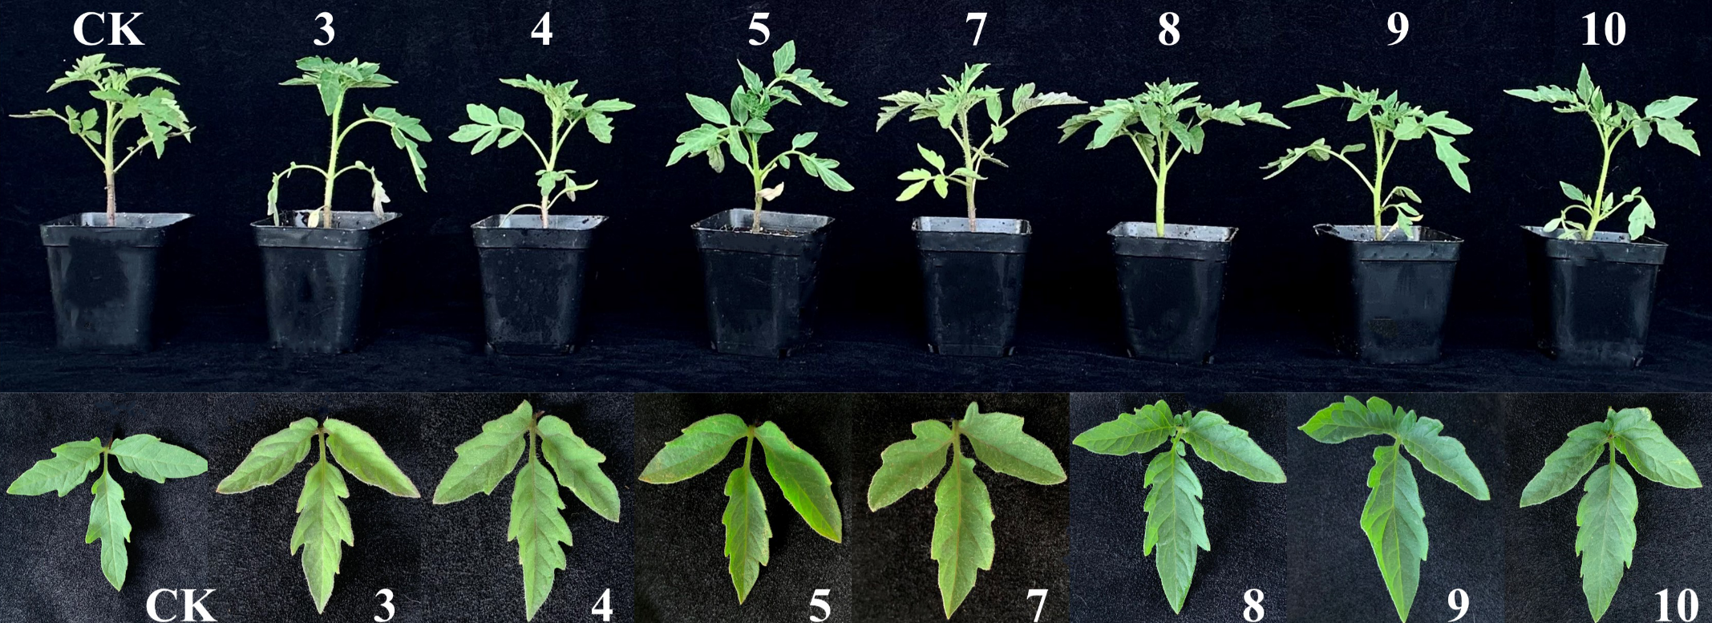

Figure S44. Effects of active compounds on tomato at 100 µg/mL

Table S14. Effects of active compounds on tomato height at 100 µg/mL

Day | Compound 3 | Compound 4 | Compound 5 | Compound 7 | Compound 8 | Compound 9 | Compound 10 | CK
0 | 10.47±04.^{c} | 10.36±0.6^{c} | 10.33±0.9^{b} | 9.3±0.6ª | 10.23±0.5^{c} | 10.13±0.2^{c} | 10.53±0.5^{b} | 10.5±0.6^{c}
7 | 13.17±0.2^{b} | 12.80±0.5^{b} | 12.00±0.2^{ab} | 12.60±0.5ª | 12.83±0.9^{b} | 13.23±0.9^{b} | 12.70±0.9^{b} | 13.3±0.7^{b}
14 | 15.83±0.6ª | 15.63±0.6ª | 15.20±1.4ª | 15.53±0.7ª | 16.13±0.8ª | 16.20±0.3ª | 15.80±0.9ª | 16.0±0.2ª
 | Statistical Summary
S.S | 43.202 | 41.687 | 36.702 | 43.762 | 52.460 | 55.816 | 42.042 | 45.402
M.S | 21.601 | 20.84 | 18.35 | 21.56 | 26.23 | 27.91 | 21.02 | 27.70
F | 31.16** | 22.12** | 6.51*** | 1.02 NS | 16.16*** | 28.75*** | 11.25** | 23.79***
Df | 2 | 2 | 2 | 2 | 2 | 2 | 2 | 2
Data in the columns presented as mean values ± standard error with various superscripts are significantly different according to DMRT” at (P> 0.05). S.S (Sum of square); M.S (Mean square); Df (Degree of freedom); F (Significance); CK (Check); **, *** (level of significance).

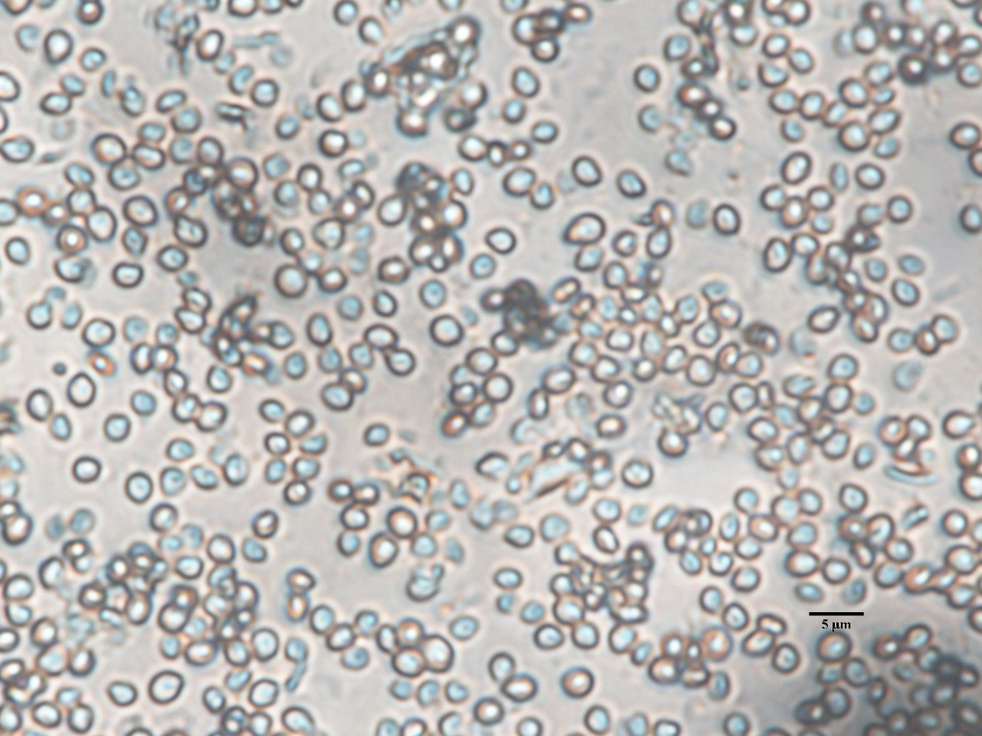

Figure S45. The conidia of Beauveria sp.
The conidia are spherical to nearly spherical, or oval-shaped, colorless and transparent, with thin walls. The size of the conidia is around 2. 41 (1.53- 3.26) μm × 2.62 (1.56-3.11) μm.

