Supplemental Materials
Stem cell membrane-cloaked biomimetic nanoparticles targeted delivery of Naringin to control cytokine storm in mouse pneumonia

Hua Jin^{1,2$}*, Yuezhao^{2$}, Suidong Ouyang¹, Yinlian Yao², Shilong Fan², Renxing Luo^{1,3}, Jiang Pi³, Yanyan Wang¹, Gonghua Huang¹*

¹Guangdong Provincial Key Laboratory of Medical Molecular Diagnostics, The First Dongguan Affiliated Hospital, Guangdong Medical University, Dongguan, Guangdong 523808, China
²School of Pharmacy, Guangdong Medical University, Dongguan, Guangdong 523808, China
³School of Medical Technology, Guangdong Medical University, Dongguan, Guangdong 523808, China

$Contributed equally to this paper.

*Correspondent authors:
Hua Jin: jinhua0413@gdmu.edu.cn
Gonghua Huang: gonghua.huang@gdmu.edu.cn

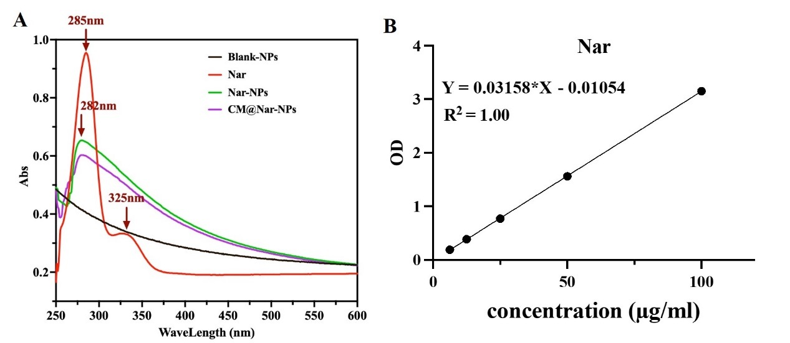
Fig. S1 The assay of Nar loading into NPs. (A) The UV-vis spectrum of free Nar, Nar-NPs and CM@Nar-NPs indicated that Nar was successfully encapsulated into the NPs, which were shown by the similar absorption peaks at around 285 nm. (B) The standard curve of Nar at 285 nm. According to this curve, the encapsulation of Nar in NPs was calculated using the absorption values of Nar-NPs and CM@Nar-NPs.

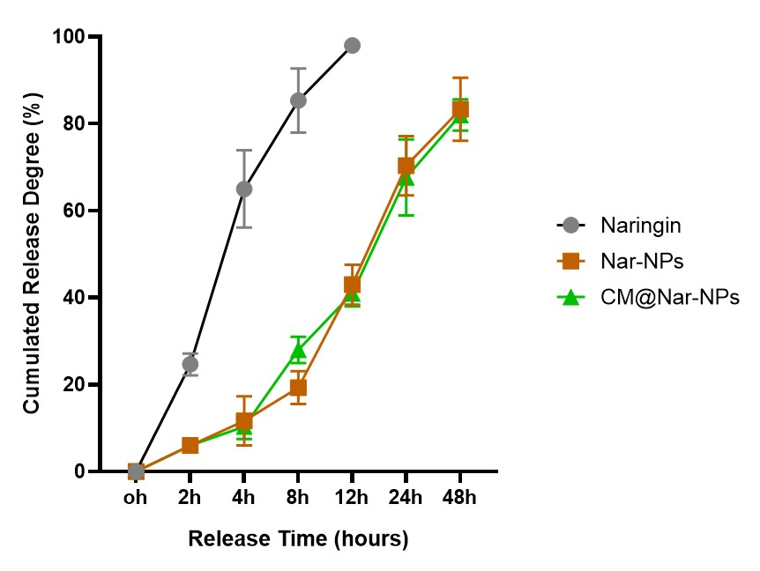
Fig. S2 In vitro release of Naringin from NPs in PBS (0.01 M, PH =7.4, n =3/group). Nar release from the nano-platform was tested in vitro using the dialysis method as previously described (PMID: 29052674). Briefly, dialysis bags with a molecular weight cut-off of 10,000 Da containing 10 mg of different formulations of Nar were immersed in 20 ml of PBS (pH 7.4) in a water bath 37 °C. At different time points, 1 ml of receiving buffer was withdrawn and replaced with 1 ml of PBS. Nar release from dialysis bag into the water bath was determined by ultraviolet spectrophotometry (Agilent 8,453, Agilent Technologies, USA) at 285 nm.

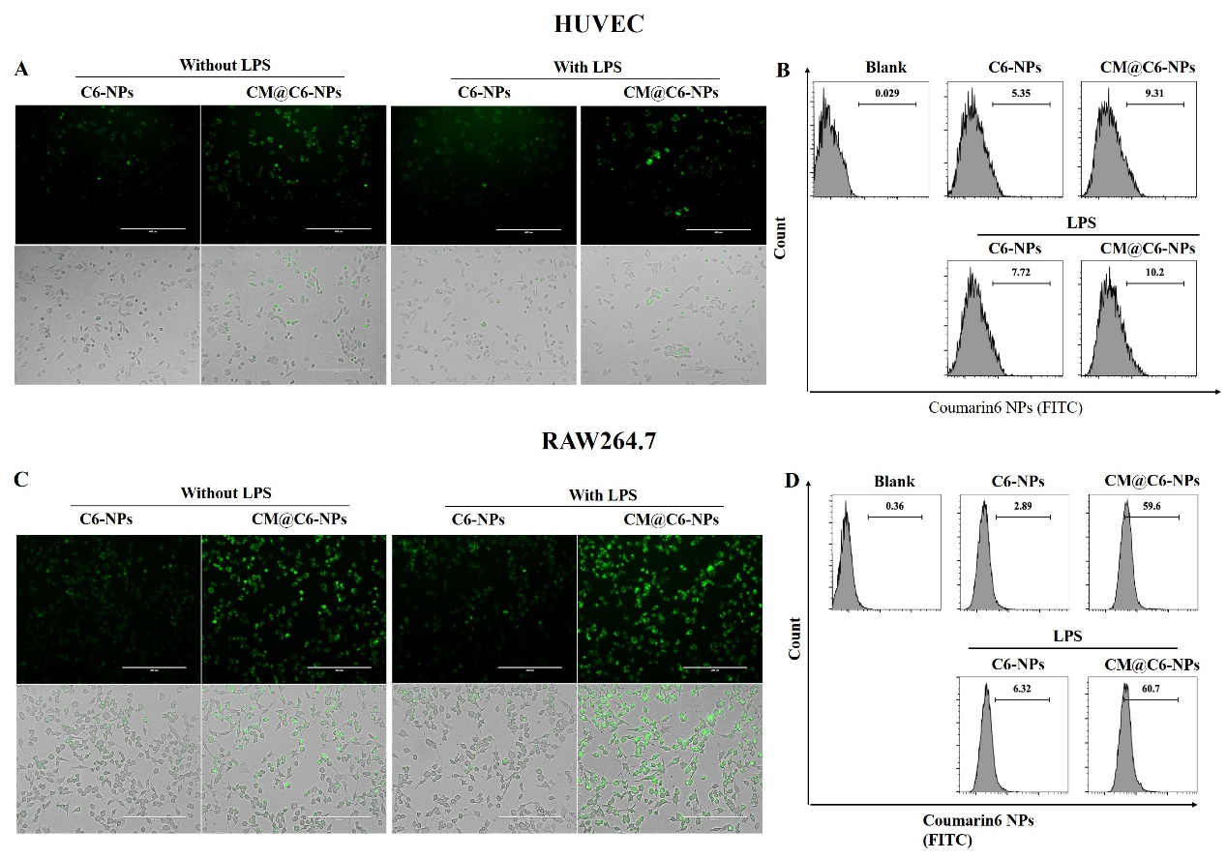
Fig. S3 Cellular uptake to assay the biocompatibility and targeting of the Nar-NPs.
(A, C) The typical images of Nar-NPs or CM@Nar-NPs in HUVECs and RAW264.7 cells, respectively. (B, D) The quantification analysis of mean fluorescence intensity of NPs in HUVECs and RAW264.7 cells assayed by flow cytometry, respectively.
Due to the weak autofluorescence of Nar, Cumarin 6 (C6) was also loaded into the PLGA NPs as a fluorescent marker. Flow cytometry analysis was employed to examine the cell uptake of coumarin 6-loaded Nar-NPs according to a published method [17]. RAW264.7 cells and Human umbilical vein endothelial cell (HUVEC) were provided by the Cell Library of Guangdong Provincial Key Laboratory of Medical Molecular Diagnostics, Guangdong Medical University. The cells were cultured in DMEM (Gibco, USA) with 10% fetal bovine serum (Gibco) containing 100 µg/mL streptomycin and 100 IU/mL penicillin at 5% CO₂ and 37 °C. The cells were cultured with C6-Nar-NPs for 4 hours, and then washed twice with PBS to remove unbound nanoparticles. For fluorescence imaging, the cells were added 1~2 mL phenol red-free medium and imaged under a live cell imaging system. For flow cytometry analysis, the cells were detached using trypsin and assayed at FITC channel. Results were expressed in terms of mean fluorescence intensity (MFI) of C6 in cells.

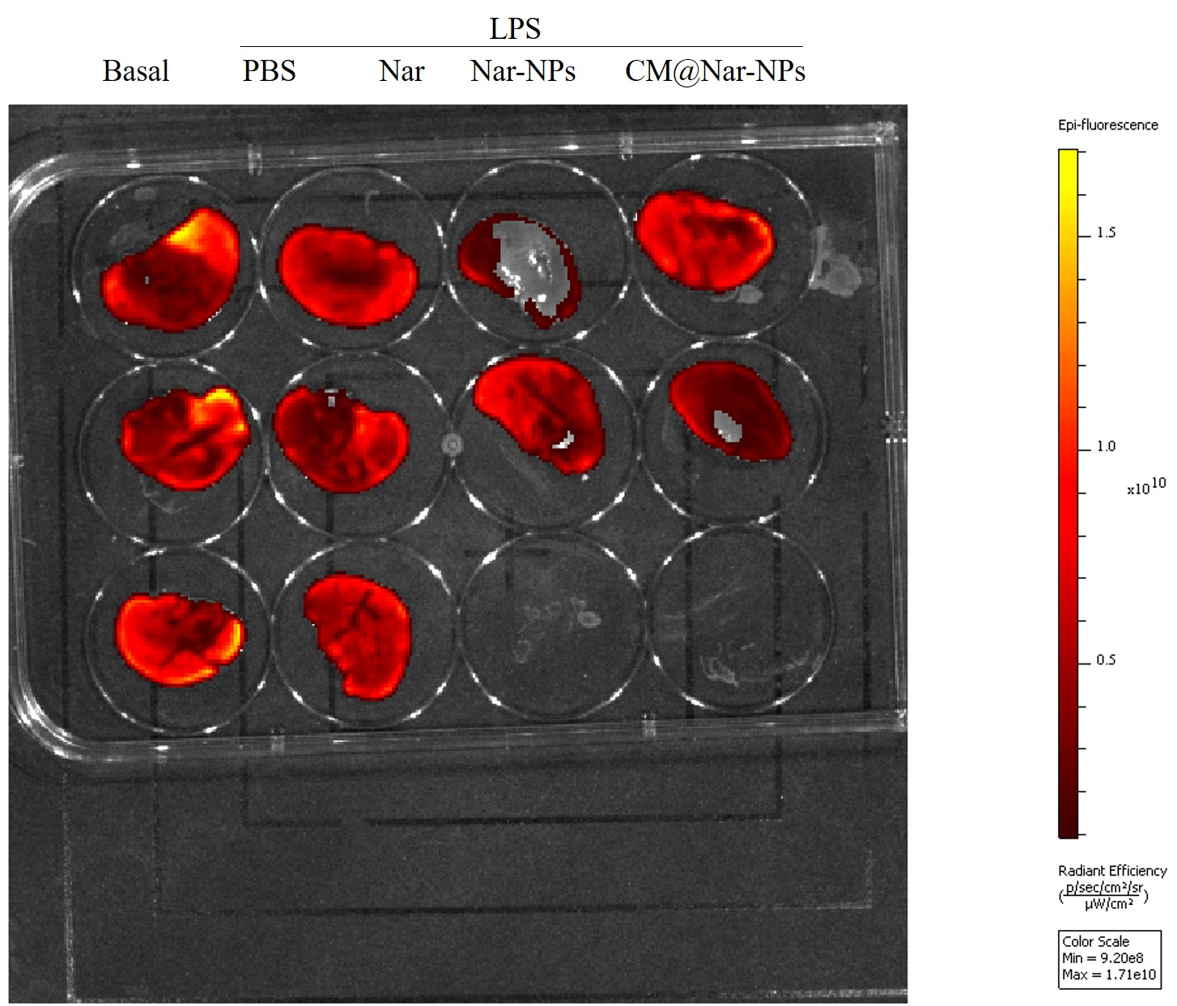

Fig. S4 ROS scavenging activity in livers originated from sepsis mice treated with different formulations of Nar. The data supposed that the Nar or Nar-NPs have not significant effects on ROS clearance in livers.

