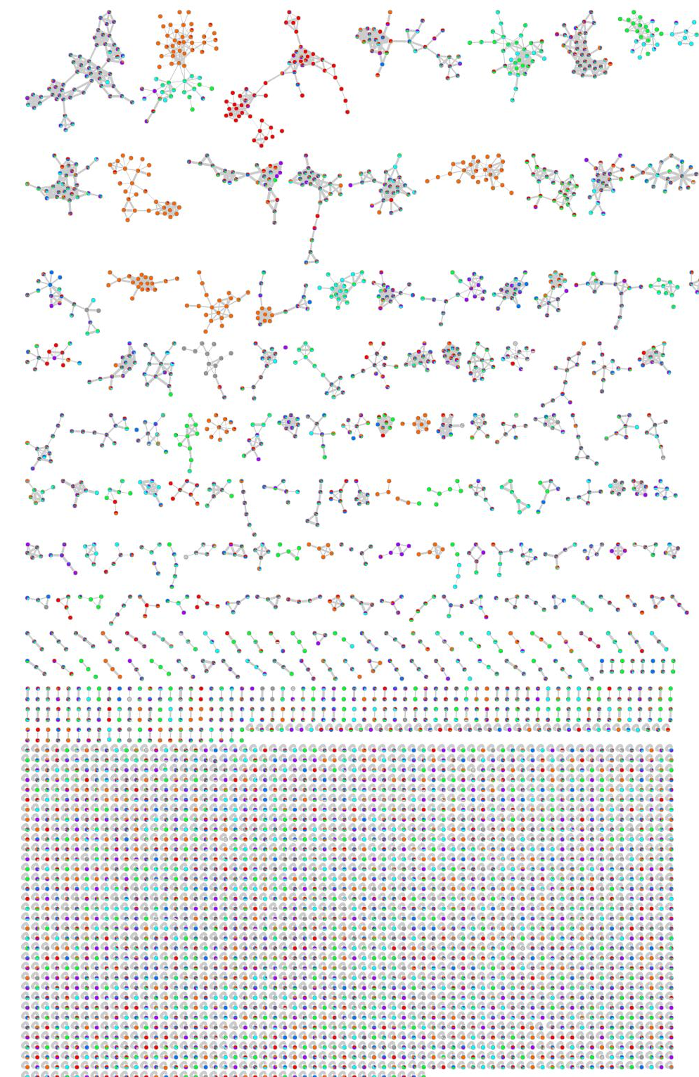
(b)
(c)
(a)
Fig. S1 The complete network of six Streptomyces isolates cultivated in three different media. Pie charts in nodes represent relative quantities of the ions produced by different Streptomyces isolates. Spiramycin (a), Actinomycin (b), and Lyngybatoxin (c).
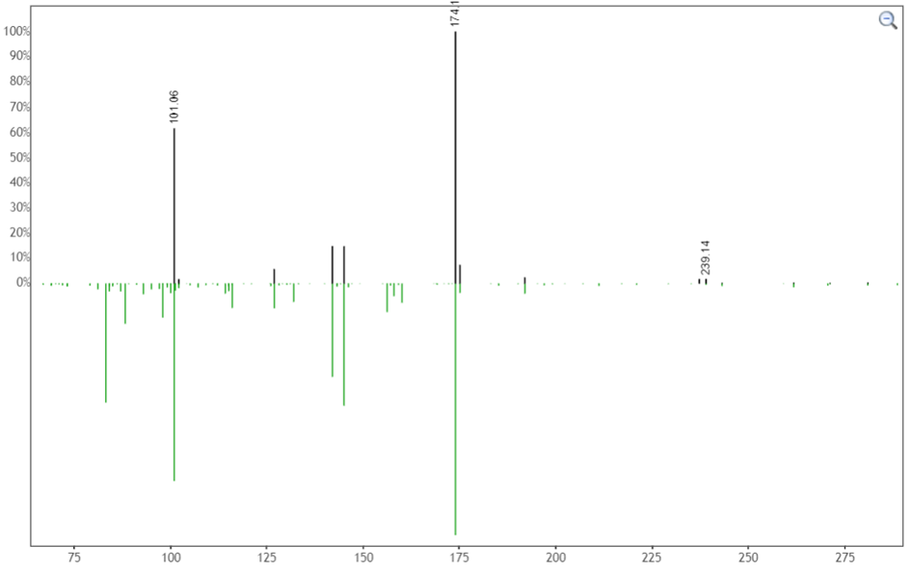
Fig. S2 The mirror plot of Spiramycin [422.26 ([M+2H]⁺) m/z] produced by Streptomyces sp AA50 and Streptomyces sp. AS41 (Shared peaks: 19, Cosine score: 0.78, and MZErrorPPM:0).
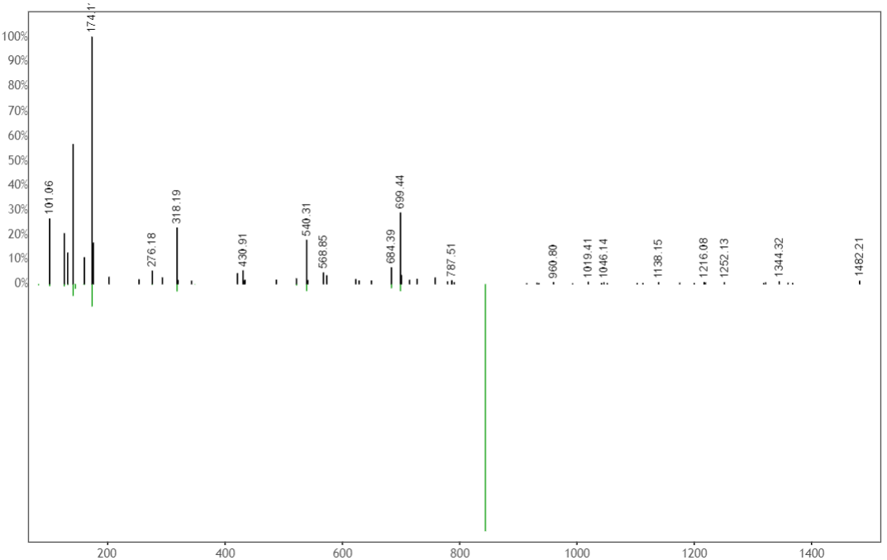
Fig. S3 The mirror plot of spiramycin [843.52 ([M+H]⁺) m/z] produced by Streptomyces sp AA50 (Shared peaks: 11, Cosine score: 0.80, and MZErrorPPM: 3).

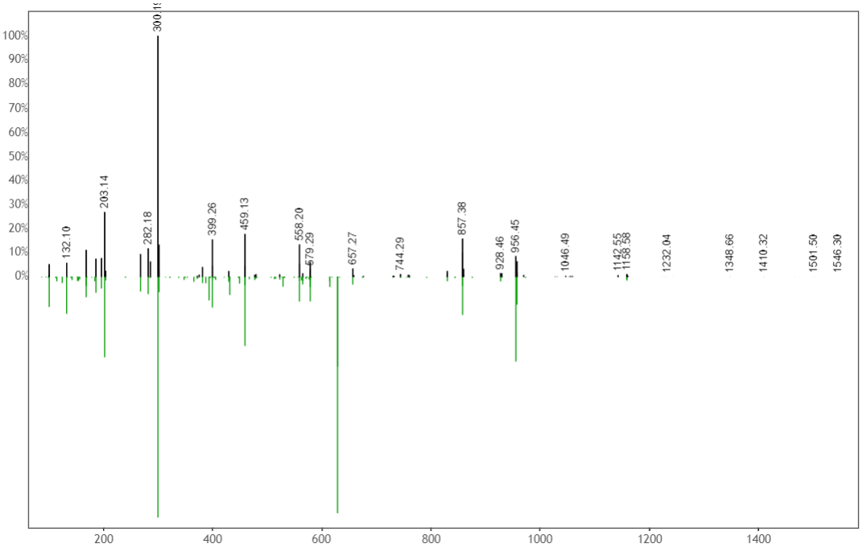
Fig. S4 The mirror plot of actinomycin D (627.31 m/z ([M+2H]⁺) m/z produced by Streptomyces sp. AA50, Streptomyces sp. BA2 and Streptomyces sp. CA17 (Shared peaks: 31, Cosine score: 0.86, and MZErrorPPM: 3).
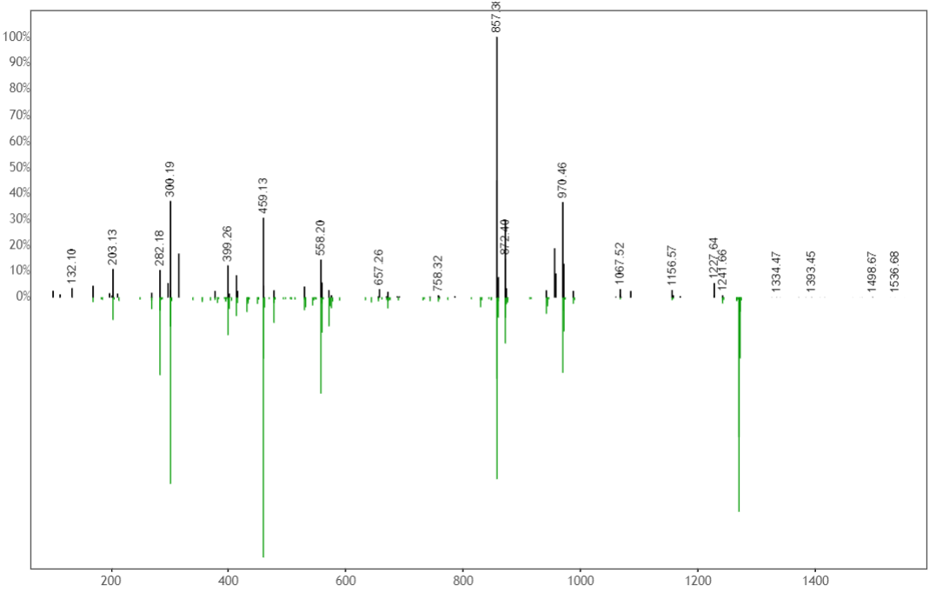
Fig. S5 The mirror plot of actinomycin K1c (1269.65 m/z ([M+H]⁺) m/z produced by Streptomyces sp. AA50 and Streptomyces sp. BA2 (Shared peaks: 36, Cosine score: 0.82, and MZErrorPPM: 2)
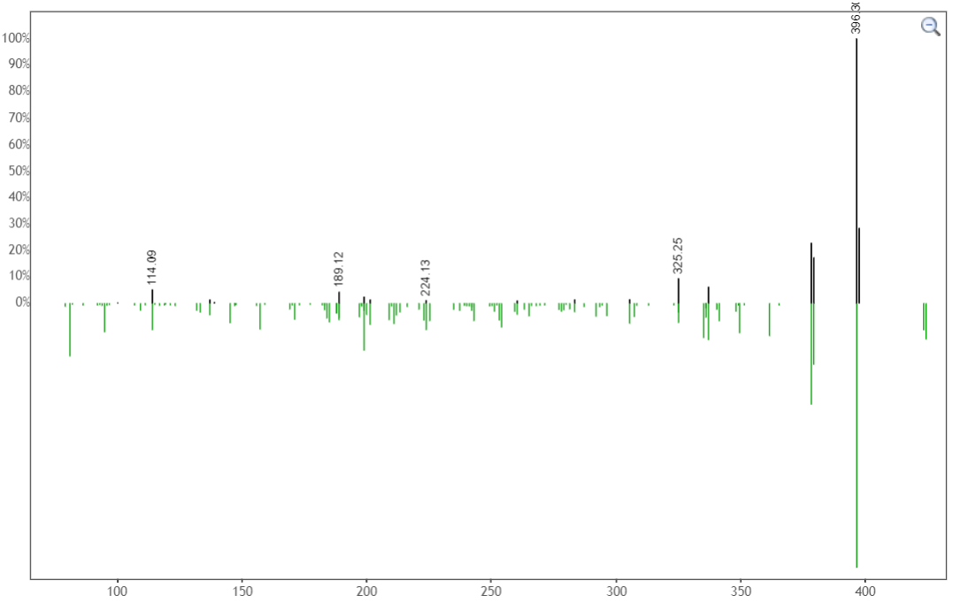
Fig. S6 The mirror plot of indolactam derivative related to lyngbyatoxin (424.293 m/z ([M+H]+) produced by Streptomyces sp. CA17 and produced by Streptomyces sp. CAH29 (Shared peaks: 10, Cosine score: 0.73 and MZErrorPPM: 7).
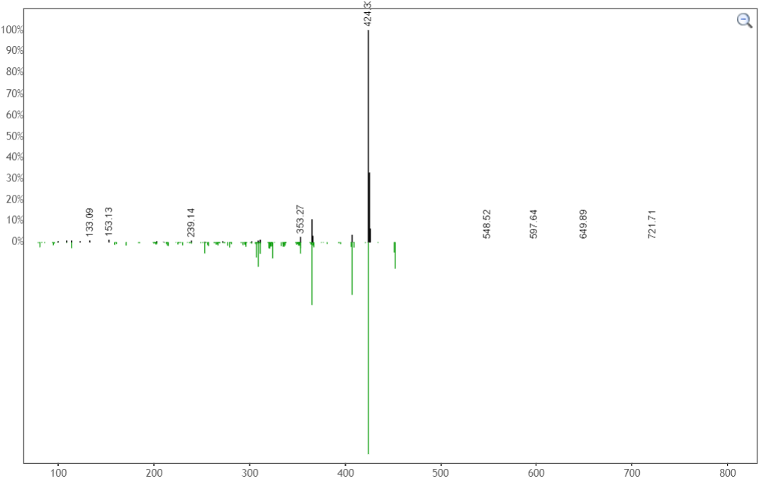
Fig.S7 The mirror plot of lyngbyatoxin putative isomer (Teleocidin B) (452.323 m/z ([M+H]+) (Shared peaks: 8, Cosine score: 0.72 and MZErrorPPM: 8).

