In vitro and in vivo comparative study of a novel ⁶⁸Ga-labeled PSMA-targeted inhibitor and ⁶⁸Ga -PSMA-11
Huanyu Chen ^{1,2,3}, Ping Cai ^{2,4}, Yue Feng ^{1,2,3}, Zhanliang Sun ^{1,2,3}, Yinwen Wang ^{2,4}, Yue Chen ^{1,2,3}, Wei Zhang^{1,2,3}, Nan Liu ^{1,2,3,}*, Zhijun Zhou^{1,2,3,4,}*
¹The Department of Nuclear Medicine, Affiliated Hospital of Southwest Medical University, Jiangyang District, Luzhou, Sichuan, China
²Nuclear Medicine and Molecular Imaging Key Laboratory of Sichuan Province, Jiangyang District, Luzhou, Sichuan, China
³Academician (Expert) Workstation of Sichuan Province, Jiangyang District, Luzhou, Sichuan, China
⁴Department of Pharmaceutics, School of Pharmacy, Southwest Medical University, Jiangyang District, Luzhou, Sichuan, China
Correspondence: zhouzjiang@gmail.com, everydayhappy815@163.com

Synthesis
- The synthesis of b-3
To a solution of b-1 (6.0 g, 20.3 mmol) and TEA (4.11 g, 40.7 mmol) in DCM (60 mL) was added Triphosgene (2.00 g, 6.71 mmol) at room temperature and stirred at 0°C. The mixture was stirred at room temperature for 1 h. b-2 (5.30 g, 14.2 mmol) and TEA (1.44 g, 14.2 mmol) was added the above solution at room temperature and stirred at room temperature for 16 h. The mixture was poured into ice water, extracted with EtOAc, washed with brine and dried over Na₂SO₄. The organic layer was concentrated in vacuo and purified by column chromatography (petroleum ether/EtOAc = 5/ 1) to give b-3 (7.5 g, 59.4% yield) as a yellow oil.
- The synthesis of b-4
A mixture of b-3 (4.0 g, 6.44 mmol) and Pd/C in EtOAc (100 mL) was stirred at 1atm of H₂ for 16 h. The mixture was concentrated in vacuo and purified by column chromatography (EtOAc = 1/ 1) to give b-4 (2.7 g, 86.1% yield) as a bark oil.
- The synthesis of b-6
A mixture of b-4 (2.5 g, 5.13 mmol), b-5 (1.32 g, 4.50 mmol) and K₂CO₃ (1.42 g, 10.3 mmol) in DMF (40 mL) was stirred at 60°C for 16 h. The mixture was poured into ice water, extracted with EtOAc, washed with brine and dried over Na₂SO₄. The organic layer was concentrated in vacuo and purified by column chromatography (petroleum ether/EtOAc = 1/ 1) to give b=6 (2. g, 77.7% yield) as a yellow solid.
- The synthesis of b-8
To a solution of b-7 (0.9 g, 3.63 mmol) in DMF (20 mL) was added HATU (1.65 g, 4.35 mmol) and stirred at room temperature for 0.5 h. b-6 (2.70 g, 4.0 mmol) and DIPEA (0.94 g, 7.26 mmol) was added the above solution and stirred at room temperature for 16 h. The mixture was poured into ice water and extracted with DCM, washed with brine and dried over Na₂SO₄. The organic layer was concentrated in vacuo and purified by column chromatography (DCM /MeOH= 30/ 1) to give b-8 (2.2 g, 73.2% yield) as a yellow oil.
- The synthesis of b
A mixture of b-8 (2.0 g, 2.15 mmol) and N₂H₄.H₂O (1 mL) in EtOH (50 mL) was stirred at 90°C for 8 h. The mixture was concentrated in vacuo and purified by column chromatography (DCM /MeOH= 10/ 1) to give b (0.89 g, 51.7% yield) as a yellow solid.
- The synthesis of TM-1
To a solution of a (0.5 g, 0.71 mmol) in DMF (20 mL) was added HATU (0.41 g, 1.07 mmol) and stirred at room temperature for 0.5 h. b (0.60 g, 0.75 mmol) and DIPEA (185 mg, 1.43 mmol) was added the above solution and stirred at room temperature for 16 h. The mixture was poured into ice water and extracted with DCM, washed with brine and dried over Na₂SO₄. The organic layer was concentrated in vacuo and purified by column chromatography (DCM /MeOH= 20/ 1) to give TM-1 (0.50 g, 47.2% yield) as a yellow solid.
- The synthesis of SC691
A mixture of TM-1 (0.4 g, 0.27 mmol) and HCl (gas)/ 1,4-dioxane (20 mL) was stirred at room temperature for 16 h. The mixture was concentrated in vacuo and purified by Prep-HPLC to give SC691 (115 mg, 39.1% yield) as a yellow solid. MS (ESI) : [M+H]⁺=1093.2, ¹H NMR (CD₃OD, 400 MHz), δ 7.860 (d, 2H), δ 7.184 (q, 2H), δ 4.329 (m, 2H), δ 3.983 (t, 1H), δ 3.800 (m, 6H), δ 3.542 (m, 7H), δ 3.252 (m, 15H), δ 2.584 (m, 4H), δ 2.216 (m, 1H), δ 2.216 (m, 3H), δ 1.755 (t, 3H), δ 1.591 (m, 7H), δ 1.499 (m, 2H).
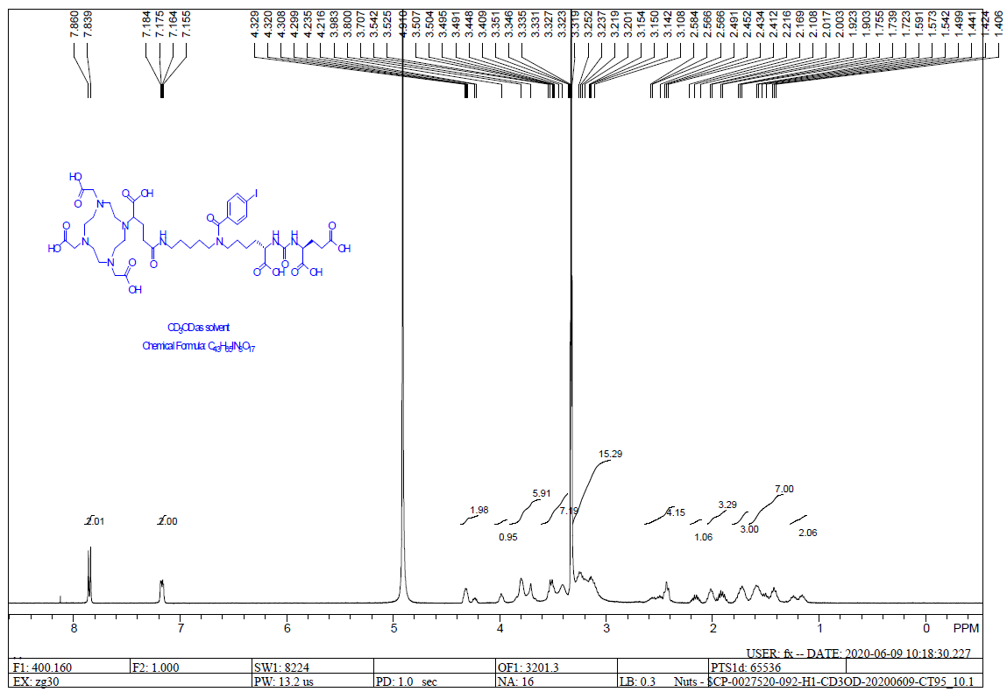
Figure S1. ¹H NMR of SC691 (400 MHz).
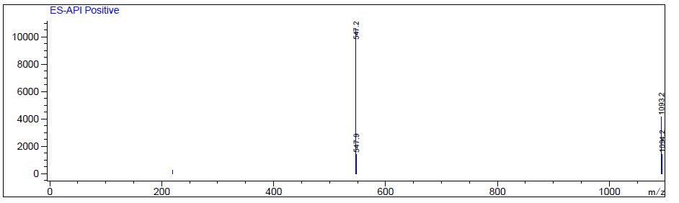
Figure S2. Mass Spectroscopy of SC691 (ESI) at retention time 1.33 min.

Micro-PET/CT Imaging
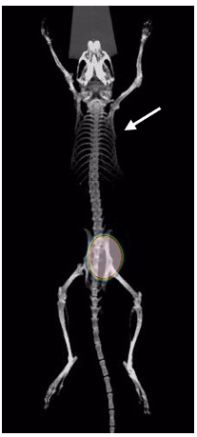

Figure S3. Blocking experiment for ⁶⁸Ga-SC691 in LNCaP inoculated NOD/SCID xenografts. Whole-body coronal micro-PET/CT images of an NOD/SCID male mouse bearing LNCaP tumor xenografts (white arrow).
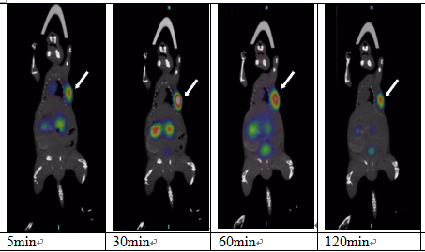
Figure S4. Whole-body coronal micro-PET/CT image of an NOD/SCSID male mice bearing LNCaP tumor xenografts (white arrow). The tumor targeting efficacy of ⁶⁸Ga-SC691 was demonstrated by time-dependent static scan at 5 min, 30 min, 60 min, 120 min post injection of ⁶⁸Ga-SC691. Approximately 1.9 MBq/ mouse was injected.

