Table of Contents
Data Item Page
Supplemental Table 1 2
Supplemental Table 2 3
Supplemental Figure 1 3
Supplemental Table 3 Separate File
Supplemental Table 4 Separate File
Supplemental Table 5 Separate File
Supplemental Table 6 Separate File
Supplemental Figure 2 4
Supplemental Table 7 Separate File
Supplemental Table 8 5
Supplemental Table 9 Separate File
Supplemental Table 10 6
Supplemental Table 11 6
Supplemental Table 12 6

 | Cell type | Dose (kGy) | Total expected colonies | Total observed colonies | Plating efficiency
α | WT | 0.000 | 1350 | 911 | 0.675
 |  | 0.125 | 2700 | 674 | 0.250
 |  | 0.250 | 2700 | 604 | 0.224
 |  | 0.500 | 2700 | 436 | 0.161
 | PKS | 0.000 | 1350 | 492 | 0.364
 |  | 0.125 | 2700 | 560 | 0.207
 |  | 0.250 | 2700 | 881 | 0.326
 |  | 0.500 | 2700 | 493 | 0.183
Proton | WT | 0.000 | 1350 | 911 | 0.675
 |  | 0.420 | 2700 | 625 | 0.231
 |  | 0.840 | 2700 | 307 | 0.114
 |  | 1.600 | 2700 | 249 | 0.092
 | PKS | 0.000 | 1350 | 492 | 0.364
 |  | 0.420 | 2700 | 586 | 0.217
 |  | 0.840 | 2700 | 195 | 0.072
 |  | 1.600 | 2700 | 229 | 0.085
Deuteron | WT | 0.000 | 1350 | 773 | 0.573
 |  | 0.250 | 2700 | 708 | 0.262
 |  | 0.500 | 2700 | 222 | 0.082
 |  | 1.000 | 2700 | 128 | 0.047
 | PKS | 0.000 | 1350 | 324 | 0.240
 |  | 0.250 | 2700 | 536 | 0.199
 |  | 0.500 | 2700 | 299 | 0.111
 |  | 1.000 | 2700 | 195 | 0.072
Supplemental Table 1: Colony forming unit and plating efficiency measurements for melanized (WT and non-melanized (PKS) strains upon irradiation by each particle type.
Cell type, radiation | α_{min} | 95% CIs (kGy⁻¹) |  | α_{max} | 95% CIs (kGy⁻¹) |  | δ | 95% CIs (kGy⁻¹) |  | RBE | 95% CIs
WT, particle | 1.23 | 1.11 | 1.32 | 4.25 | 3.60 | 5.23 | 2.28 | 1.73 | 3.01 | 2.03 | 1.88 | 111.49
PKS, particle | 1.08 | 1.01 | 1.16 | 50.00* | 32.28 | 50.00 | 22.01 | 19.17 | 23.59 | 1.30 | 1.21 | 1.39
Supplemental Table 2: Best-fit models for each strain detailing parameters for particle irradiation survival curves.
A

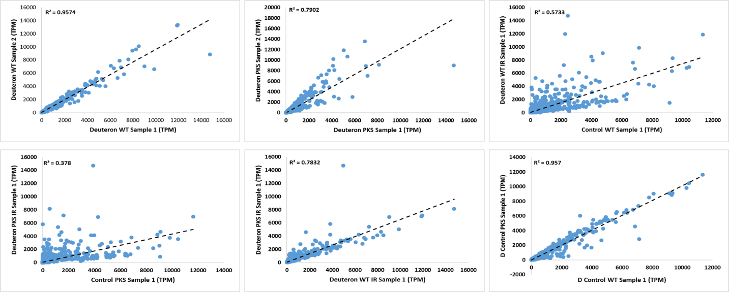
B

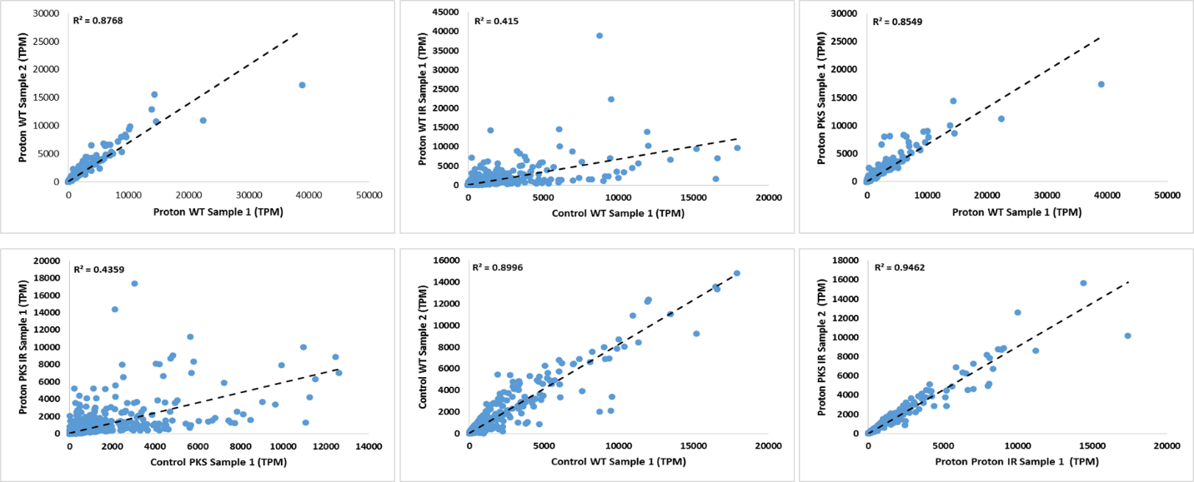
Supplemental Figure 1. A. TPM correlation plots within Deuteron- and B. Proton-irradiated cultures, within biological replicates and between samples.

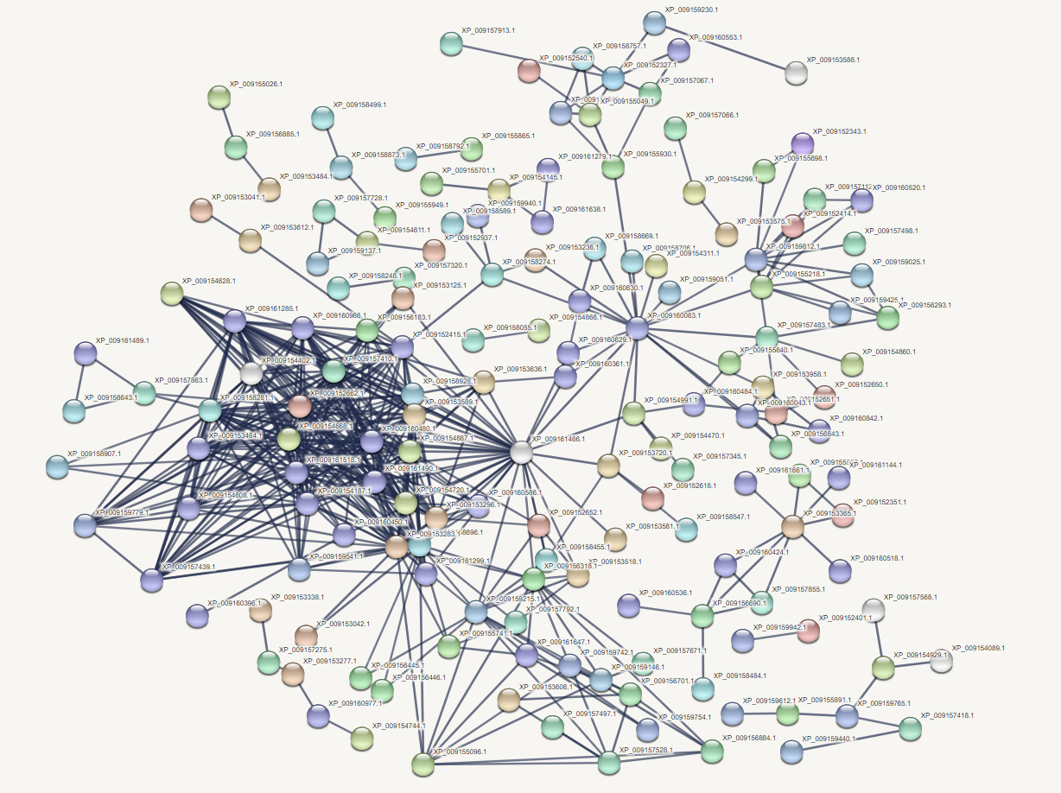
Supplemental Figure 2.

STRING network output showing highly confident connections between upregulated genes within the particle dataset.

Identified Nodes in Upregulated Gene Set
Gene | Uniprot Annotation | Links
HMPREF1120_08945 | Proliferating cell nuclear antigen | 34
HMPREF1120_06247 | Replication protein A subunit | 29
HMPREF1120_05844 | Minichromosome maintenance protein 2 | 29
HMPREF1120_00416 | Minichromosome maintenance protein 7 | 27
HMPREF1120_01029 | Replication factor A2 | 27
HMPREF1120_08997 | DNA helicase | 26
HMPREF1120_05011 | Minichromosome maintenance protein 6 | 25
HMPREF1120_08969 | DNA polymerase epsilon subunit 2 | 23
HMPREF1120_08768 | Minichromosome maintenance protein 3 | 23
HMPREF1120_00177 | Cell division control protein 6 | 23
HMPREF1120_07994 | DNA polymerase alpha subunit A | 20
HMPREF1120_08481 | DNA primase large subunit | 20
HMPREF1120_01328 | DNA polymerase alpha subunit B | 19
HMPREF1120_06477 | DNA primase small subunit | 18
HMPREF1120_01910 | Cell division control protein 45 | 18
HMPREF1120_02379 | Minichromosome maintenance protein 5 | 18
HMPREF1120_01204 | Origin recognition complex subunit 4 | 16
HMPREF1120_01042 | DNA polymerase delta subunit 1 | 15
HMPREF1120_07587 | Polyubiquitin | 15
Supplemental Table 8. The most highly connected, confident nodes identified in the particle-upregulated STRING analysis.

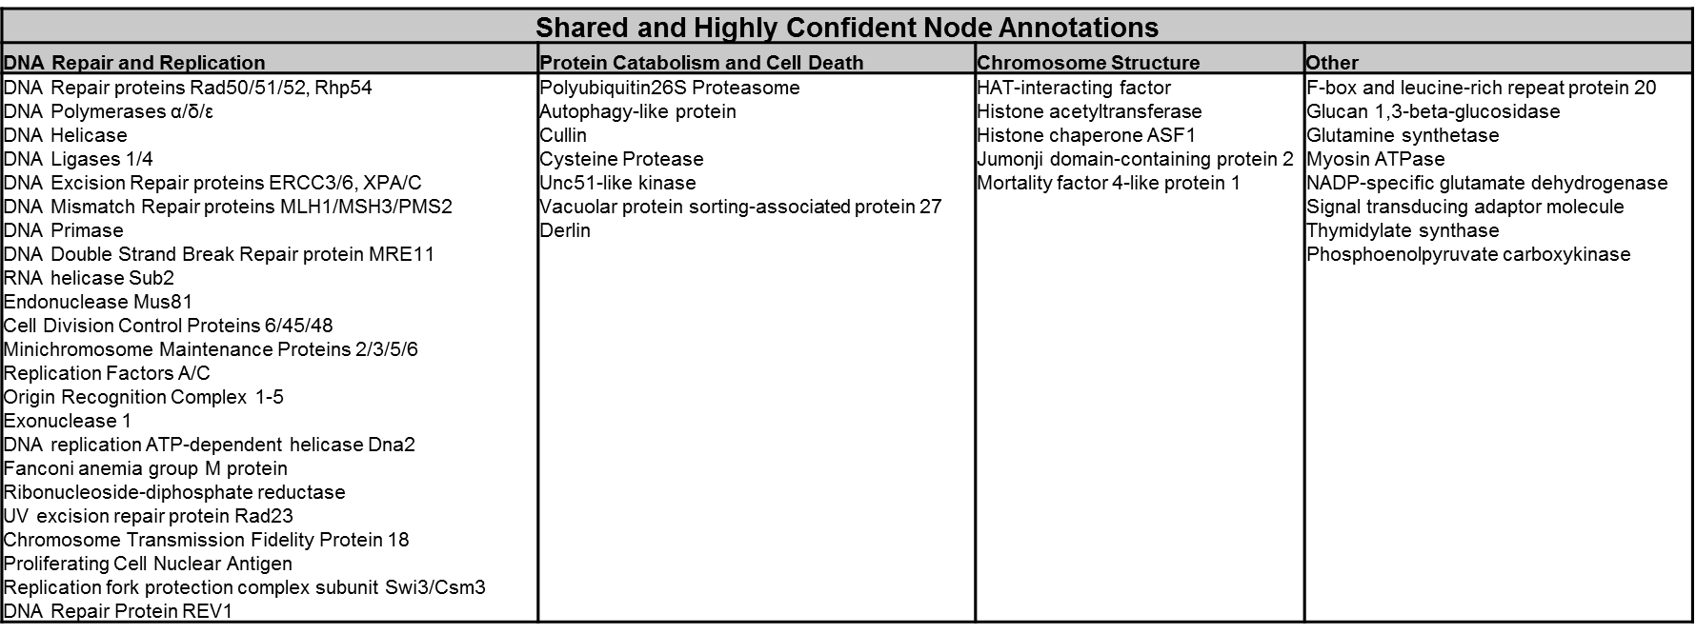Supplemental Table 10. STRING output of highly confident node connection annotations present in all WT particle irradiation-responsive datasets.
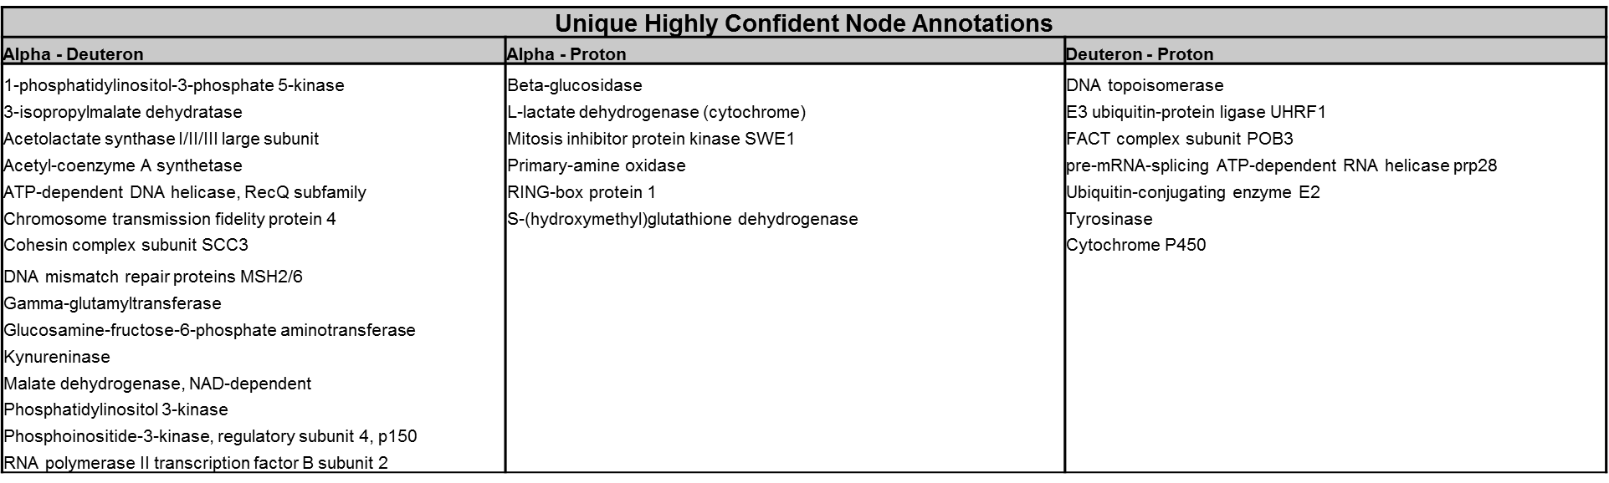Supplemental Table 11. STRING output of highly confident node connection annotations present in only two WT particle irradiation-responsive datasets.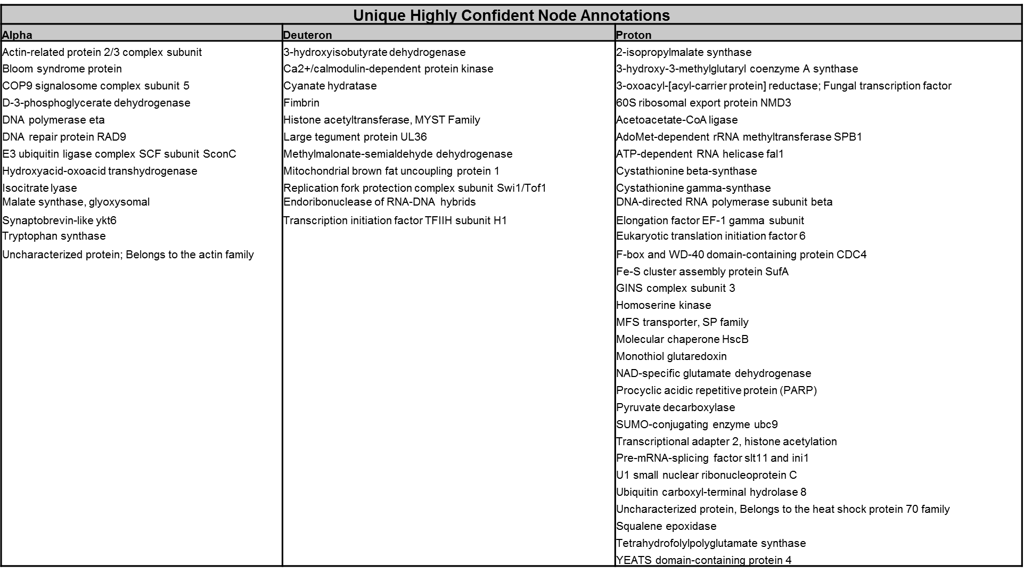Supplemental Table 12. STRING output of highly confident node connection annotations present in only one WT particle irradiation-responsive dataset.

