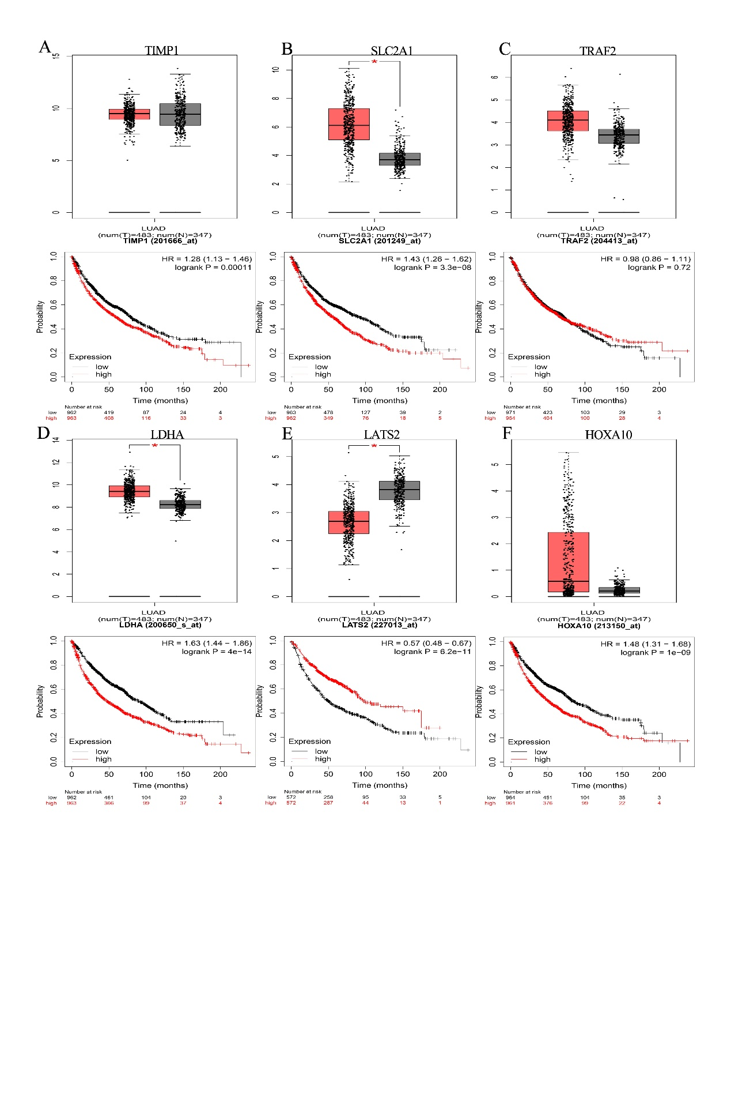
Supplementary Figure 1| (A-F) Validation of TIMP1, SLC2A1, TRAF2, LDHA, LATS2, HOXA10 expression levels in TCGA and GTEx using GEPIA and Kaplan-Meier survival analysis using Kaplan–Meier plotter

