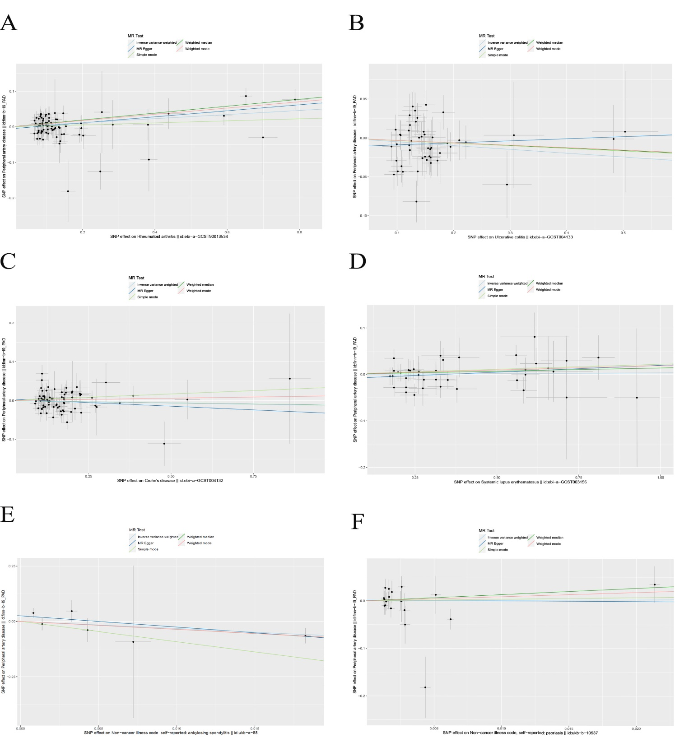
Supplementary Material
Supplementary Figure 1. Funnel plots of SNPs for causal effects of six IMIDs on PAD. (A) Funnel plot of RA on PAD. (B) Funnel plot of UC on PAD. (B) Funnel plot of CD on PAD. (D) Funnel plot of SLE on PAD. (E) Funnel plot of AS on PAD. (F) Funnel plot of PSO on PAD.
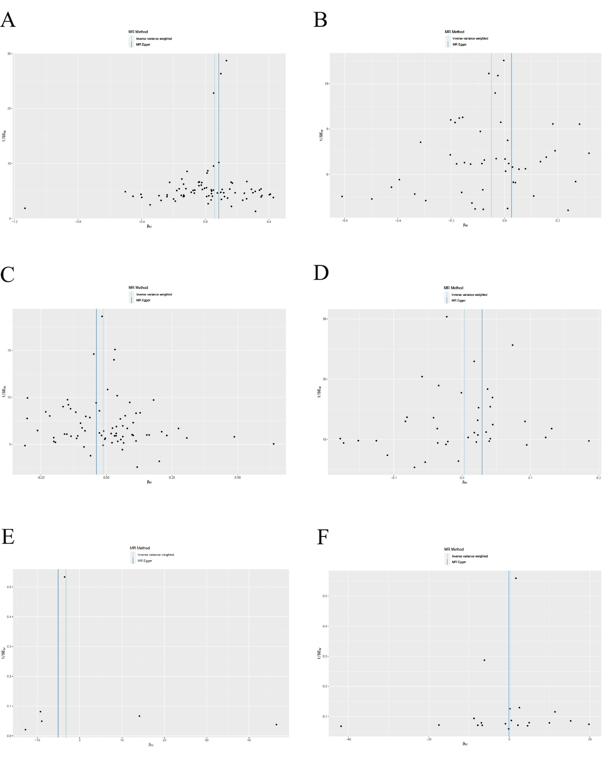
Supplementary Figure 2. Scatter plots of SNPs for causal effects of six IMIDs on PAD. (A) Scatter plot of RA on PAD. (B) Scatter plot of UC on PAD. (C) Scatter plot of CD on PAD. (D) Scatter plot of SLE on PAD. (E) Scatter plot of AS on PAD. (F) Scatter plot of PSO on PAD.
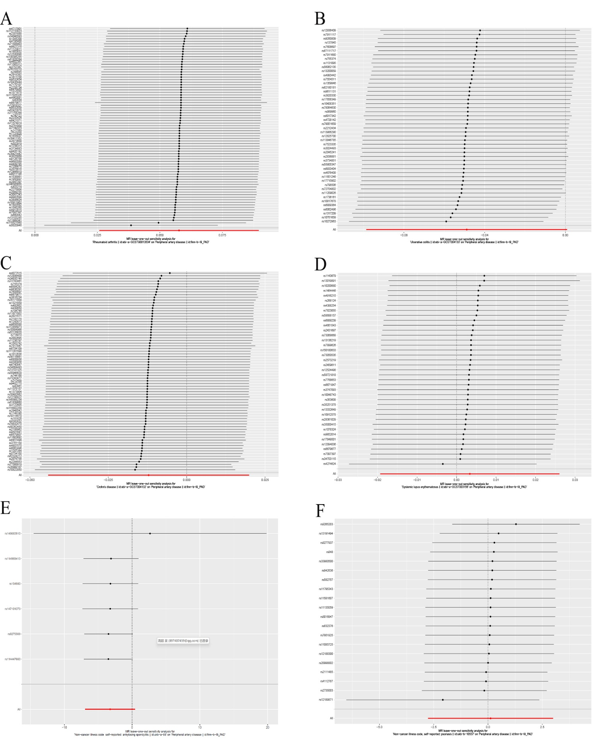
Supplementary Figure 3. Leave-one-out analysis of SNPs for six IMIDs on PAD. (A) Leave-one-out analysis for RA on PAD. (B) Leave-one-out analysis for UC on PAD. (C) Leave-one-out analysis for CD on PAD. (D) Leave-one-out analysis for SLE on PAD. (E) Leave-one-out analysis for AS on PAD. (F) Leave-one-out analysis for PSO on PAD.

