A Proposal for the Classification and Nomenclature of Hand, Foot and Mouth Disease-Related Enteroviruses

Supplementary materials

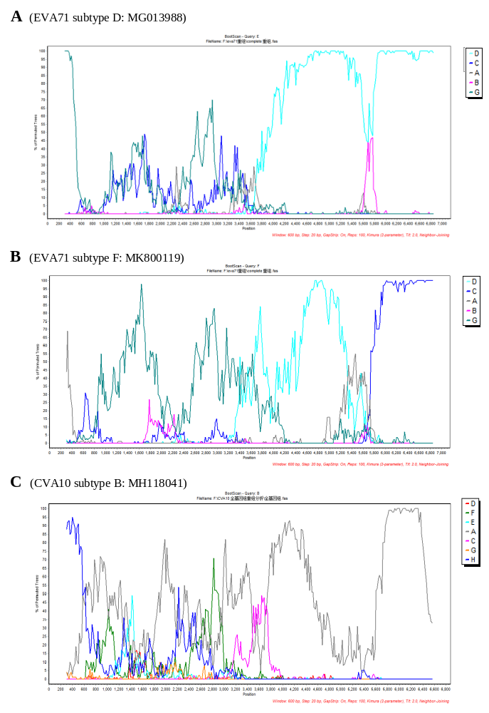
Supplementary Figure S1. Bootscan analysis of EVA71 subtypes D (A) and F (B), and CVA10 subtype B (C). The used reference strains of EVA71 were genotypes A (U22521), B (JF738001), C (JQ742002), D (MG672478) and G (HQ647172). The used reference strains of CVA10 were genotypes A (AY421767), C (HQ728262), D (MF678312), G (MH118054) and H (MH118051). The analyses were performed using a sliding 600-bp window with 20-bp steps.

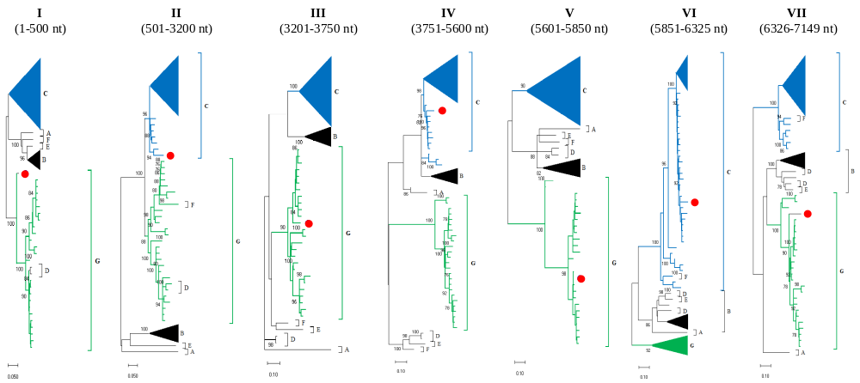
Supplementary Figure S2. Separate phylogenetic analyses of EVA71 RF01_CG. According to the plausible recombination breakpoints identified in bootscan analyses (Figure 2A), the EVA71 genomic sequences were divided into seven segments (I-VII). Each segment was then subjected to separate ML tree analysis to confirm its subtype origin. The RF01_CG sequence is highlighted by a red circle.

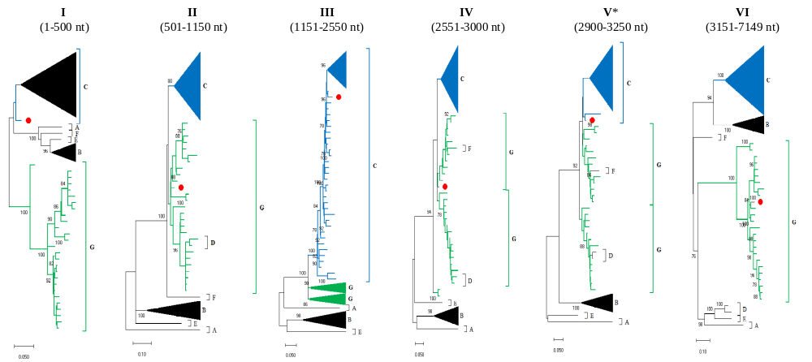
Supplementary Figure S3. Separate phylogenetic analyses of EVA71 RF02_CG. According to the plausible recombination breakpoints identified in bootscan analyses (Figure 2B), the EVA71 genomic sequences were divided into seven segments (I-VI). Each segment was then subjected to separate ML tree analysis to confirm its subtype origin. The RF02_CG sequence is highlighted by a red circle.
