Supplemental Figure 1
B
A
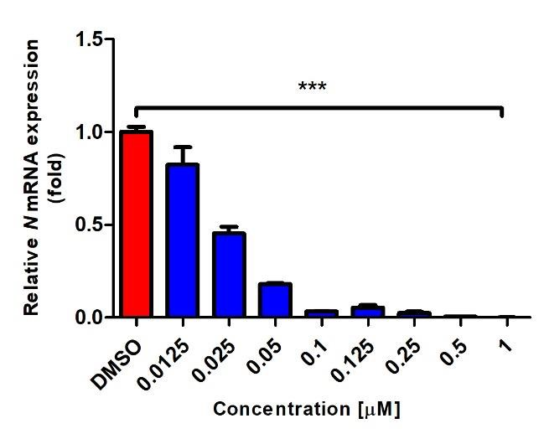
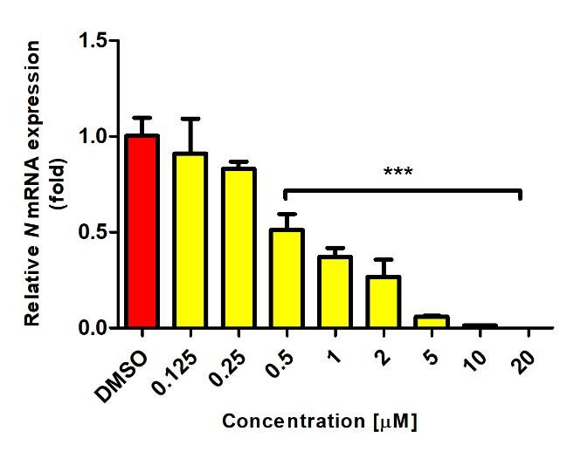
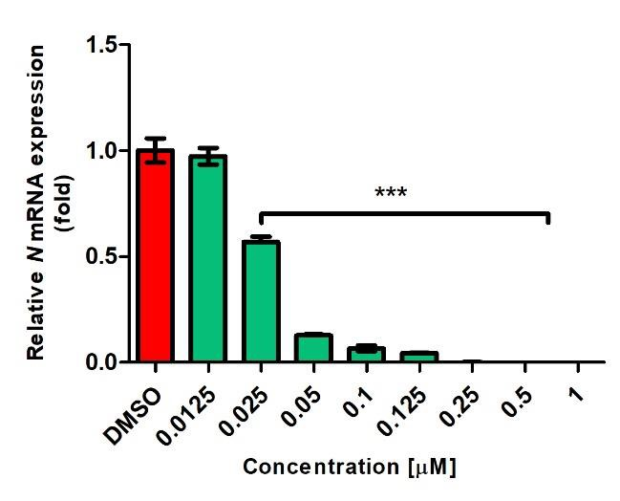
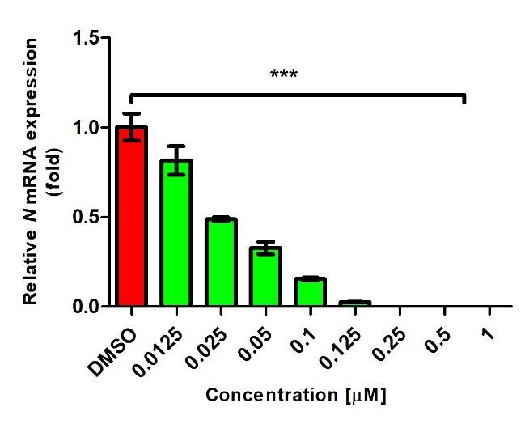
D
C
Supplemental Figure 2
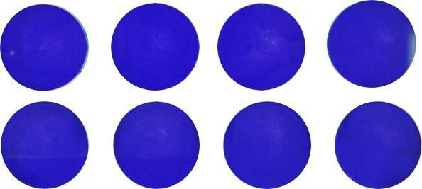
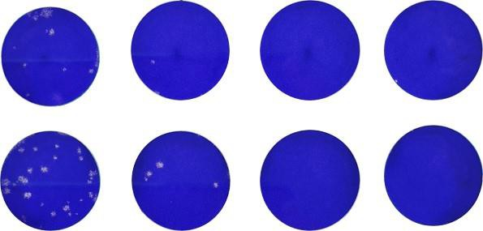
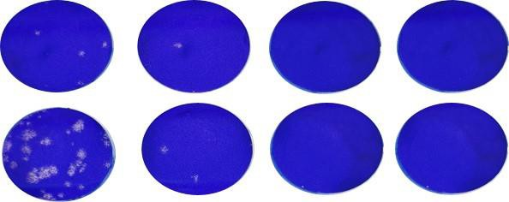
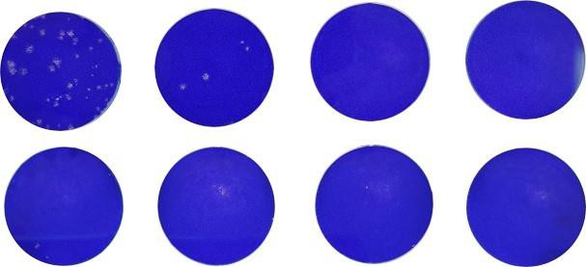
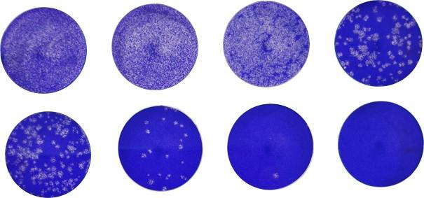
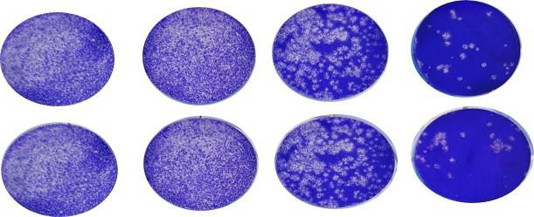
8 hpi
24 hpi
48 hpi

Dilution;
10⁻¹
10⁻²
10⁻³
10⁻⁴
Ouabain
(100 nM)
Digoxin
(100 nM)
Ouabain
(100 nM)
Digoxin
(100 nM)
Ouabain
(100 nM)
Digoxin
(100 nM)

Dilution;
10⁻¹
10⁻²
10⁻³
10⁻⁴
8 hpi
DMSO
Chloroquine
(10 μM)
24 hpi
DMSO
Chloroquine
(10 μM)
48 hpi
DMSO
Chloroquine
(10 μM)

Supplemental Figure 3
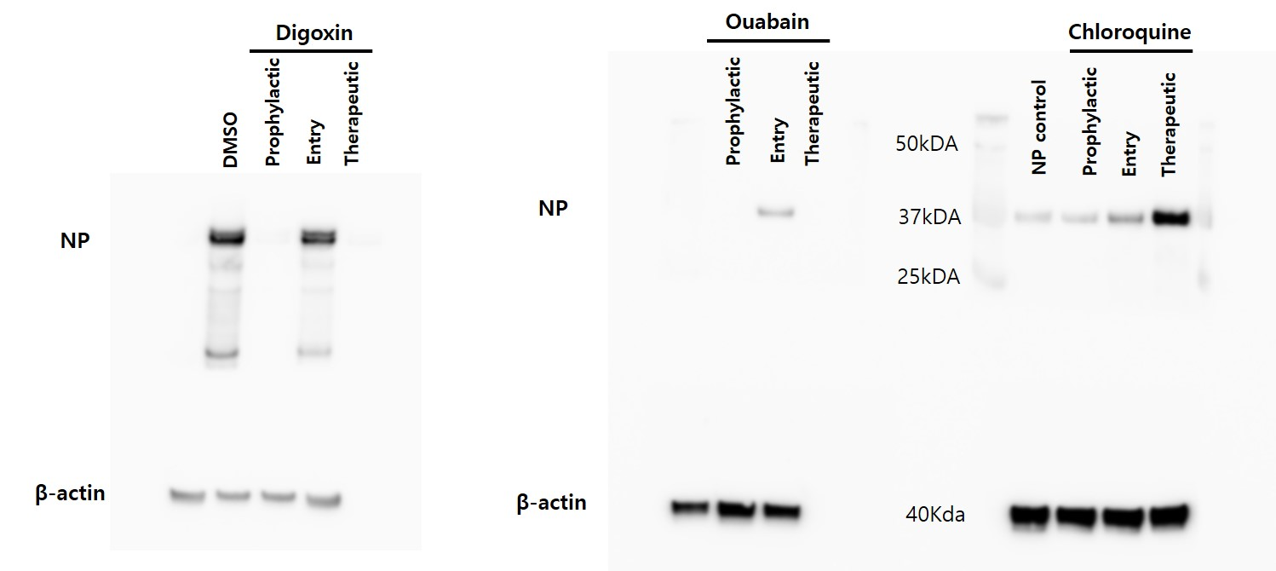

Supplemental Figure legend

Figure S1. Dose response of SARS-CoV-2 mRNA expression by the drug treatment
Vero cells were infected with BetaCoV/Korea/KCDC03/2020 at a multiplicity of infection of 0.01 in the presence of designated concentrations of the (A) digoxin (Sigma-Aldrich), (B) digoxin tablet (inno. N.), (C) ouabain, and (D) chloroquine, and incubated for 24 h. After incubation, total RNA was extracted from the cells and cDNA was synthesized from 1 μg of total RNA. Viral N mRNA of SARS-CoV-2 was amplified by qRT-PCR and normalized to the DMSO control. The data were plotted according to the relative value of the DMSO control. Statistically significantly differences between DMSO and drug treatment are represented as ***P<0.001 determined using the one way ANOVA with Dunnett’s multiple comparisons test by GraphPad Prism. Data are presented as mean ± SD (n=3/group).

Figure S2. Progeny virus titer measurement by plaque assay
Progeny virus titers of the cell supernatant treated with indicated treatments at 8, 24, and 48 hpi (Figure 2C) were determined by the plaque assay. Plaque assay was carried out by inoculation of the Vero cells treated with the indicated drug concentrations with 10-fold serial-diluted culture supernatant, followed by incubation at 37 °C for 1 h. Medium was removed and cells were washed with phosphate buffered saline. Each well was overlaid with minimal essential medium/agarose (Gibco) and maintained at room temperature until the overlay turned solid. The plates were incubated at 37 °C for 3 days. Then, the cells were fixed with 2% paraformaldehyde and stained with 1% crystal violet overnight. After staining, the cells were washed, and plaque were counted.

Figure S3. Full image of western blotting
Uncropped image of western blotting displayed in figure 3C. Vero cells were lysed in RIPA buffer and 20 μg of protein was separated using Bolt™ 4-12% Bis-Tris Plus. Proteins were detected by probing the membranes with 1:1,000 anti-SARS-CoV-2 nucleocapsid and 1:2,000 anti-β-actin antibodies. Protein transfer was performed using iBlot 2 and iBlot 2 PVDF Regular Stacks. Membranes were incubated with goat anti-rabbit antibody conjugated with horseradish peroxidase for 1 h, then membranes were washed five times with tris-buffered saline including 5% Tween 20. Blots were detected using Super Signal™. Anti-β-actin was used as a loading control.

