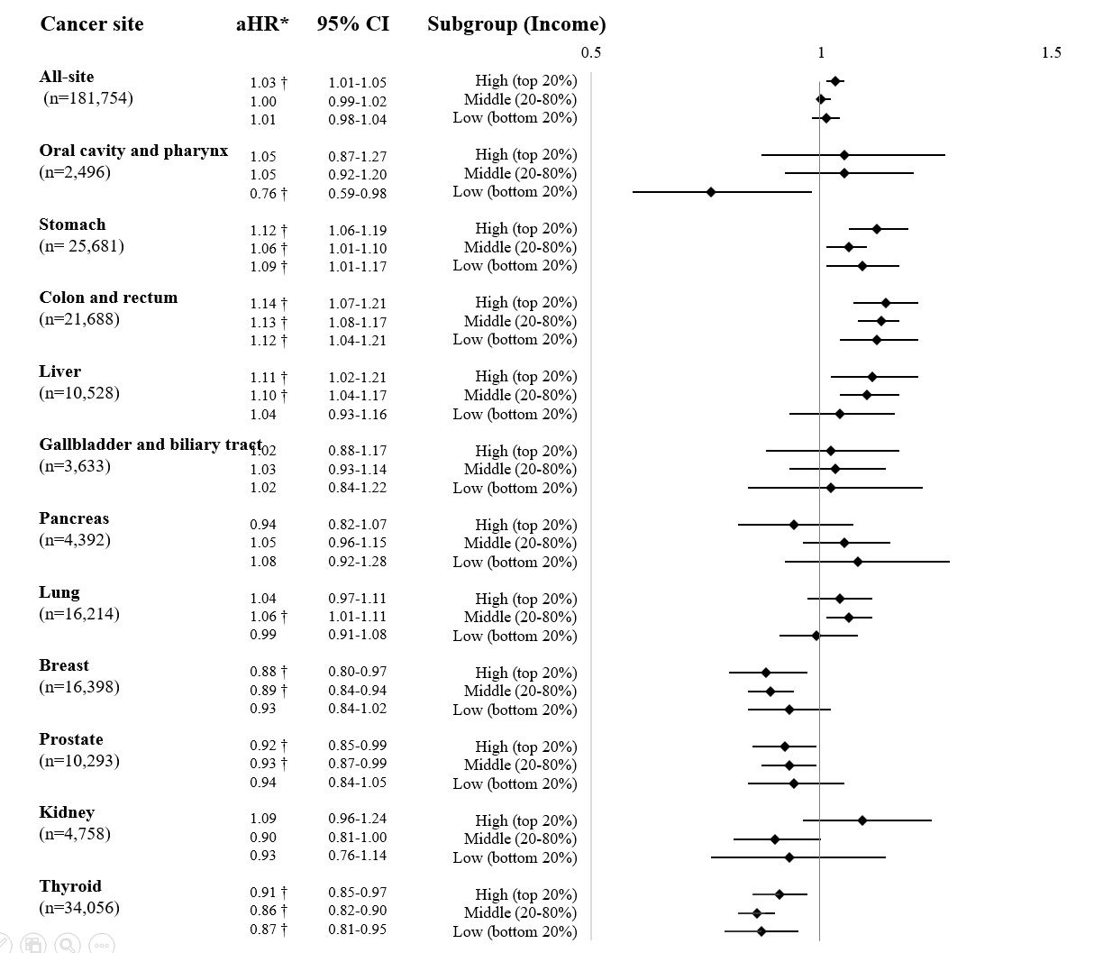
(Supplementary1) Sub-group analysis: Association between tooth loss and total and site-specific cancer incidence according to income level
* aHR, adjusted for age, sex, BMI, FBS, CCI, smoking, alcohol and physical activity Reference: No-tooth loss
†p-value<0.05

