Supporting Information
Facilely prepared carbon dots as effective anode modifier for enhanced performance of microbial fuel cells
Hui-Xu Wei, Rui Qiu, Ai-Yi Li, Liu-Jie Liang, Yan-Nan Feng, Shu-Hua Li, Nan Li*
School of Chemistry and Chemical Engineering/Guangzhou Key Laboratory for Clean Energy and Materials, Guangzhou University, Guangzhou 510006, China.
Corresponding author E-mail: nanli@gzhu.edu.cn

Figures:
(a)
Fig. S1 (a) Particle size distribution and (b) photoluminescence diagram of the prepared carbon dots
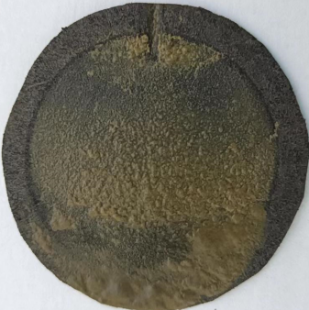
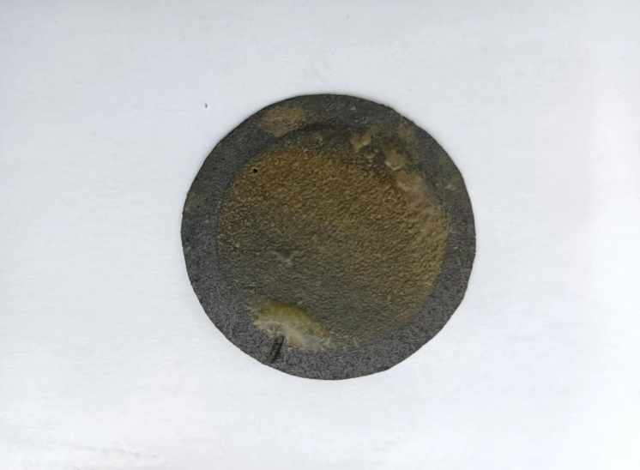
Fig. S2 (a) XRD pattern of the carbon points. (b) Zeta potential of the carbon points
CDs modified MFC
Blank group MFC
(a)
(b)

Fig. S3 (a) and (b) Surface photographs of the MFC anode for the CDs-modified group and the blank group, respectively
Tables
Table S1 Average relative abundance (%) of dominant populations in the test group and the blank group at genus level
Genus | Blank group | CDs modified group
Kluyvera | 18.001 | 21.457
Dysgonomonascc | 20.894 | 15.302
Klebsiellacc | 16.396 | 7.173
Saccharimonadales | 2.805 | 8.624
Propionicicella | 7.537 | 2.212
Christensenellaceae_R-7_group | 2.396 | 5.007
Citrobactercc | 2.443 | 3.790
Saccharimonadaceaecc | 3.687 | 1.558
Pleomorphomonascc | 1.062 | 1.603
Petrimonas | 0.848 | 1.731
Propionicimonas | 1.045 | 1.366
Allorhizobium-Neorhizobium-Pararhizobium-Rhizobiumcc | 1.358 | 0.923
Propionivibriocc | 0.560 | 1.681
Flavobacterium | 0.778 | 0.788
Sporomusacc | 0.428 | 0.829
Anaerovoraxcc | 0.446 | 0.698
Geobacter | 0.398 | 0.685
Cellulomonas | 0.380 | 0.703
Oscillibacter | 0.691 | 0.321
Telmatospirillum | 0.343 | 0.663
WPS-2 | 0.285 | 0.685
Ruminococcaceae_UCG-013 | 0.231 | 0.615
Others | 16.988 | 21.286

Table S2 At the genus level, the average relative abundance (%) of electric bacteria in the test group and the blank group
Genus | Blank group | CDs modified group
Kluyvera | 18.001 | 21.457
Klebsiella | 16.396 | 7.173
Christensenellaceae_R-7_group | 2.396 | 5.007
Citrobacter | 2.443 | 3.790
Petrimonas  Geobacter  Total | 0.848  0.398  40.482 | 1.731  0.685  39.843

