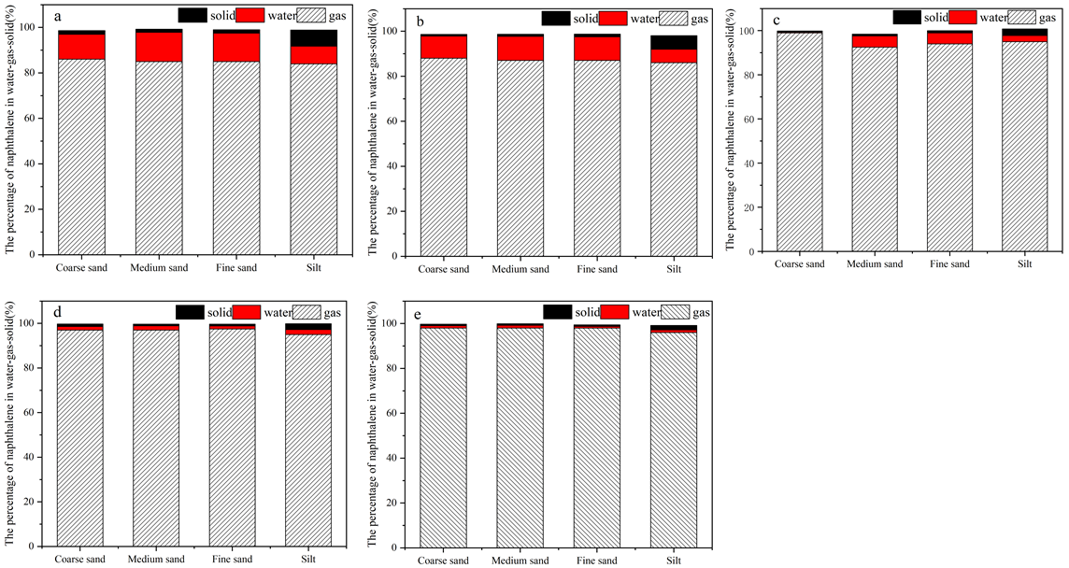
Fig. S1. Percentage of naphthalene as a solid/liquid/gas in (a)10, (b)30, (c) 50 (d) 70 and (e)90℃
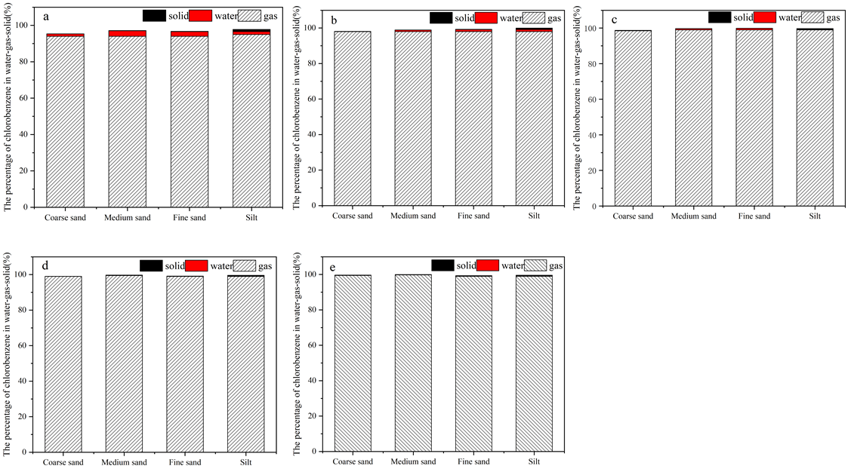
Fig. S2. Percentage of chlorobenzene as a solid/liquid/gas in (a)10, (b)30, (c) 50 (d) 70 and (e)90℃

