Exploring the impact of PEGylation on pharmacokinetics: a size-dependent effect of polyethylene glycol on prostate specific membrane antigen inhibitors

Yang Liu ^{1,2,3}, Li Xia ^{1,2,4}, Haiyang Li^{1,2,4}, Ping Cai ^{1,2,4}, Sufan Tang^{1,2,4}, Yue Feng ^{1,2,3}, Guangfu Liu ^{1,3}, Yue Chen ^{1,2,3,}*, Nan liu⁵*, Zhijun Zhou ^{1,2,3,4,}*
¹ Department of Nuclear Medicine, Afliated Hospital of Southwest Medical University, Jiangyang District, Luzhou, Sichuan, China
² Nuclear Medicine and Molecular Imaging Key Laboratory of Sichuan Province, Jiangyang District, Luzhou, Sichuan, China
³ Institute of Nuclear Medicine, Southwest Medical University, Jiangyang District, Luzhou, Sichuan, China
⁴ Department of Pharmaceutics, School of Pharmacy, Southwest Medical University, Jiangyang District, Luzhou, Sichuan, China
⁵ Department of Nuclear Medicine, Sichuan Provincial People’s Hospital, University of Electronic Science and Technology of China, Sichuan, Chengdu, China
*Correspondence: zhouzjiang@gmail.com, liunan_815@163.com, chenyue5523@126.com
Precursor Synthesis
1. The synthesis of s3
To a solution of s1(1.15g,2.358mmol), s2(250mg,2.83mmol) in MeOH(10ml) and CH₃COOH was added by drops and stirred at room temperature for 2h. NaBH₄ (134mg, 3.537mmol) was added the above solution at 0℃, then moved to room temperature and stirred for 6 h. The mixture was poured in to NaHCO₃ and extracted with EtOAc, dried over Na₂SO₄. The organic layer was concentrated in vacuo and purified by column chromatography (DCM/MeOH = 40/ 1) to give s3 (877mg, 66.7% yield) as a colorless oil.
2. The synthesis of s5
s4(250mg, mmol) was dissolved in SoCl₂(1ml) and stirred at room temperature for 24h. Solvent was evaporated under reduced pressure and the residue was redissolved in DCM(4ml). s3(430mg,0.768mmol) and Et₃N (94mg,0.922mmol) was added to above solution and stirred at room temperature for 6h. The mixture was poured into ice water and extracted with DCM, washed with brine and dried over Na₂SO_{4.} The organic layer was concentrated in vacuo and purified by column chromatography (PE/EA= 3/1) to give s5 (420mg, 72.7% yield) as a yellow oil.
3. The synthesis of s6
s5(300mg,0.399mmol) was dissolved in MeOH(5ml), then a solution of LiOH (20mg/ml,5ml) was added and the mixture was stirred at room temperature for 12h. The organic layer was concentrated in vacuo and the remaining mixture was diluted with water, 1M HCl was adjusted the PH to 5-6, then extracted with EA and dried over Na₂SO_{4.} The organic layer was concentrated under vacuo to provide the crude product s6(187mg, white solid), which was used in the next step without further purification.
- The synthesis of s9
To a solution of s7(45mg, 0.0785mmol) in DMF (3mL) was added HATU (35.8mg, 0.0942mmol) and stirred at room temperature for 1 h. s8 (54.8mg, 0.086mmol) and Et3N (2.8mg,0.027mmol) was added the above solution and stirred at room temperature for 9h. The mixture was poured into ice water and extracted with EA, washed with brine and dried over Na₂SO₄.The organic layer was concentrated in vacuo and purified by column chromatography (PE/EA= 5/1) to give the intermediate products (32mg, 45.5% yield). Then the intermediate product was dissolved in THF(2ml), 25%DEA was added at room temperature, the reaction was monitored by ESI-MS. When the reaction is over, the mixture was poured into ice water and extracted with DCM, washed with brine and dried over Na₂SO_{4.} The organic phase was concentrated under vacuo to provide the crude product s9, which was used in the next step without further purification.
5. The synthesis of s10
s6(20mg, 0.027mmol) and HATU (11.4mg, 0.03mmol) was dissolved in DMF(1.5ml) and stirred at room temperature for 1h. Followed by the addition of DIPEA (5.3mg, 0.041mmol) and s9(27.5mg, 0.03mmol), the mixture was stirred overnight at room temperature. When the reaction is over, the mixture was poured into ice water and extracted with EA, washed with brine and dried over Na₂SO_{4.} The organic phase was concentrated under vacuo to provide the intermediate product. Then, intermediate product was dissolved in 2mL 50% TFA/DCM solvent mixture and the reaction solution was stirred at room temperature overnight. The organic solvent and trifluoroacetic acid were removed by spin evaporation under reduced pressure, and the product was re-dissolved with acetonitrile and purified by preparative HPLC to obtain the product s10.
PP4-WD is synthesized in the same way as PP8-WD.

Mass Spectral Analysis of the key compounds
1.PP4-WD
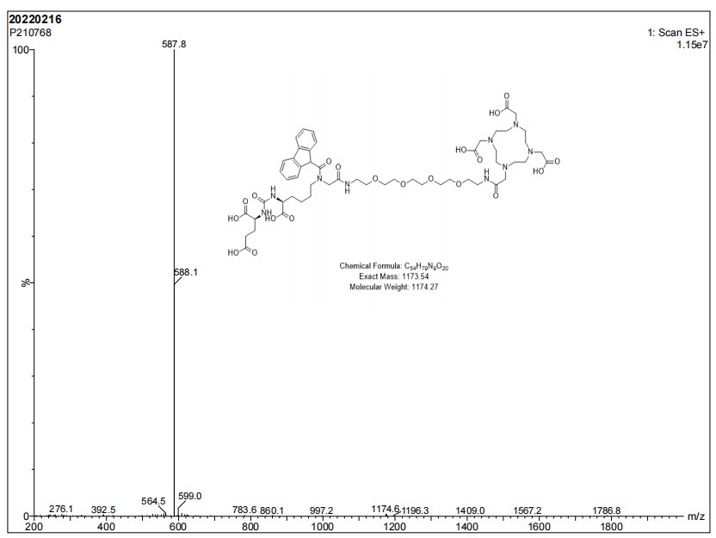
Figure S1. Mass Spectroscopy of PP4-WD (ESI+). Spectral data for PP4-WD: ESI-MS: calculated [M+H] ⁺ for C₅₄H₈₀N₉O₂₀ 1175.2765; found 1/2[M+H] ⁺ 587.8.

2.PP8-WD
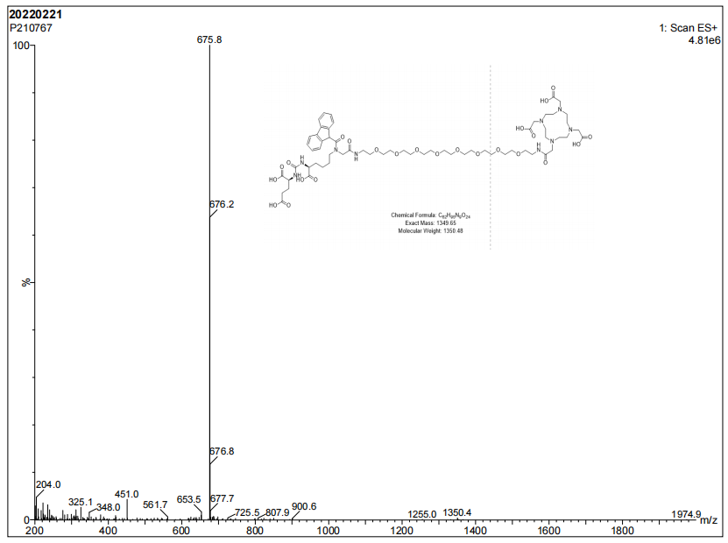
Figure S2. Mass Spectroscopy of PP8-WD (ESI+). Spectral data for PP8-WD: ESI-MS: calculated [M+H] ⁺ for C₆₂H₉₆N₉O₂₄ 1351.4885; found 1/2[M+H] ⁺ 675.8.

Cell Affinity Studies
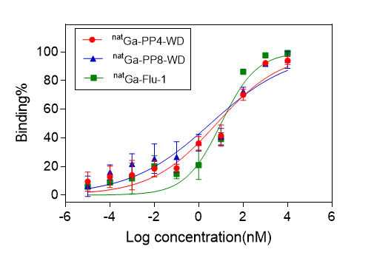
Figure S3. Representative inhibition curves of ^{nat}Ga-PP4-WD ，^{nat}Ga-PP8-WD and ^{nat}Ga-Flu-1.

Biodistribution
Table S1. Organ biodistribution of [⁶⁸Ga]Ga-PP4-WD as %ID/g tissue at 30 min, 60min, 120min post-injection. Data are expressed as mean ± SD (n=5).
Tissue | 30min | 60min | 120min
Heart | 1.07±0.12 | 0.42±0.22 | 0.13±0.03
Liver | 0.95±0.05 | 0.66±0.29 | 0.30±0.05
Spleen | 2.45±0.20 | 0.82±0.54 | 0.32±0.05
Lung | 3.49±0.27 | 1.14±0.16 | 0.42±0.11
Kidney | 47.24±3.68 | 21.63±4.03 | 2.23±0.58
Stomach | 1.38±0.58 | 0.39±0.20 | 0.13±0.01
Small int | 2.23±0.23 | 0.43±0.17 | 0.15±0.07
Muscle | 0.76±0.06 | 0.28±0.00 | 0.12±0.04
Bone | 0.36±0.09 | 0.39±0.22 | 0.26±0.06
Salivary | 3.72±0.67 | 1.40±0.22 | 0.44±0.06
Brain | 0.12±0.04 | 0.06±0.03 | 0.03±0.01
Blood | 3.30±0.22 | 0.84±0.11 | 0.28±0.08
Tumor | 33.45±3.40 | 39.28±3.25 | 25.75±2.43

Table S2. Organ biodistribution of [⁶⁸Ga]Ga-PP8-WD as %ID/g tissue at 30 min, 60min, 120min post-injection. Data are expressed as mean ± SD (n=5).
Tissue | 30min | 60min | 120min
Heart | 1.31±0.23 | 0.59±0.31 | 0.23±0.01
Liver | 1.53±0.77 | 0.79±0.44 | 0.41±0.09
Spleen | 1.34±0.34 | 0.97±0.38 | 0.30±0.07
Lung | 3.32±1.07 | 2.1±0.76 | 0.59±0.15
Kidney | 25.63±3.46 | 15.25±2.59 | 6.39±1.56
Stomach | 1.32±0.15 | 0.68±0.20 | 0.19±0.06
Small int | 1.33±0.32 | 0.78±0.02 | 0.26±0.15
Muscle | 1.06±0.12 | 0.58±0.24 | 0.21±0.14
Bone | 0.24±0.12 | 0.37±0.13 | 0.01±0.00
Salivary | 2.45±0.33 | 1.62±0.51 | 0.1±0.02
Brain | 0.20±0.13 | 0.12±0.12 | 0.05±0.02
Blood | 3.46±0.68 | 2.82±0.12 | 0.55±0.10
Tumor | 16.18±2.53 | 18.64±2.2 | 17.12±2.57

Tissue | 30min | 60min | 120min
Heart | 1.88±0.46 | 1.18±0.36 | 0.58±0.28
Liver | 2.11±0.52 | 1.57±0.60 | 1.08±0.71
Spleen | 9.45±5.92 | 7.25±3.39 | 2.38±1.75
Lung | 5.77±2.01 | 3.27±0.84 | 1.23±0.47
Kidney | 240.00±34.68 | 240.01±31.08 | 127.83±27.94
Stomach | 1.84±0.31 | 0.86±0.11 | 0.42±0.17
Small int | 2.52±0.60 | 1.89±1.10 | 0.46±0.25
Muscle | 0.93±0.34 | 0.44±0.25 | 0.19±0.08
Bone | 0.66±0.22 | 0.29±0.18 | 0.34±0.21
Salivary | 5.84±3.65 | 3.02±1.27 | 1.46±1.05
Brain | 0.18±0.10 | 0.11±0.10 | 0.06±0.04
Blood | 5.53±2.11 | 4.69±2.33 | 3.07±2.7
Tumor | 32.86±12.02 | 52.07±14.83 | 40.11±9.24
Table S3. Organ biodistribution of [⁶⁸Ga]Ga-Flu-1 as %ID/g tissue at 30 min, 60min, 120min post-injection. Data are expressed as mean ± SD (n=5).
Table S4. The tumor-to-heart (T/H), tumor-to-liver (T/L), tumor-to-kidney (T/K), tumor-to-salivary (T/Sl) and tumor-to-blood (T/Bl) ratios were obtained from the biodistribution data of [⁶⁸Ga]Ga-PP4-WD.
T/NT | 30min | 60min | 120min
Tumor/Heart | 31.16±2.11 | 94.26±3.65 | 127.21±4.22
Tumor/Liver | 35.03±3.31 | 59.23±2.56 | 84.59±3.21
Tumor/Kidney | 0.71±0.12 | 1.50±0.20 | 11.54±2.32
Tumor/Salivary | 11.00±0.99 | 28.0±1.45 | 58.00±2.45
Tumor/Blood | 7.49±1.20 | 20.6±1.98 | 90.61±3.12

Table S5. The tumor-to-heart (T/H), tumor-to-liver (T/L), tumor-to-kidney (T/K), tumor-to-salivary (T/Sl) and tumor-to-blood (T/Bl) ratios were obtained from the biodistribution data of [⁶⁸Ga]Ga-PP8-WD.

T/NT | 30min | 60min | 120min
Tumor/Heart | 12.31±0.58 | 31.66±2.2 | 75.85±3.6
Tumor/Liver | 10.58±0.32 | 23.74±1.90 | 41.69±2.9
Tumor/Kidney | 0.63±0.11 | 1.22±0.35 | 2.68±0.22
Tumor/Salivary | 5.23±0.24 | 11.50±1.19 | 45.05±2.56
Tumor/Blood | 4.67±0.32 | 5.31±0.54 | 30.88±1.36

Table S6. The tumor-to-heart (T/H), tumor-to-liver (T/L), tumor-to-kidney (T/K), tumor-to-salivary (T/Sl) and tumor-to-blood (T/Bl) ratios were obtained from the biodistribution data of [⁶⁸Ga]Ga-Flu-1.
T/NT | 30min | 60min | 120min
Tumor/Heart | 17.48±3.23 | 44.13±4.22 | 69.16±5.69
Tumor/Liver | 15.57±2.89 | 33.17±3.09 | 37.14±3.65
Tumor/Kidney | 0.14±0.12 | 0.22±0.21 | 0.31±0.21
Tumor/Salivary | 5.63±1.11 | 17.24±3.54 | 27.47±4.33
Tumor/Blood | 5.94±1.41 | 11.1±1.97 | 13.07±2.56

Micro-PET/CT imaging
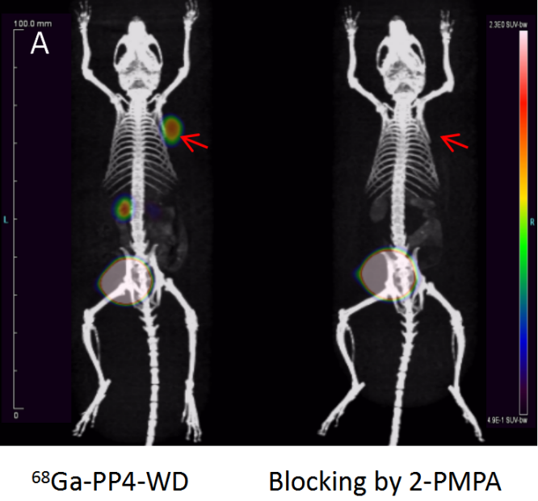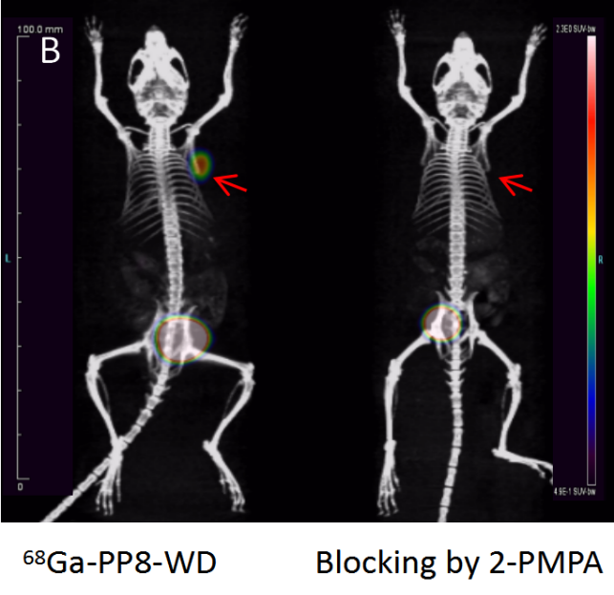
Figure S4. Micro-PET/CT images of [⁶⁸Ga]Ga-PP4-WD (A) and [⁶⁸Ga]Ga-PP8-WD (B) at 1 h post-injection using NOD/SCID male mouse bearing LNCaP tumor xenograft. Left is static scans at 1h, approximately 2.6 MBq was injected into each mouse, right is blocking scan, 40 nmol 2-PMPA was injected into each mouse before the radiolabeled drug was injected.
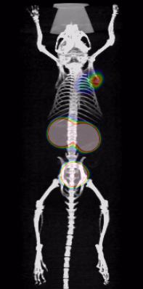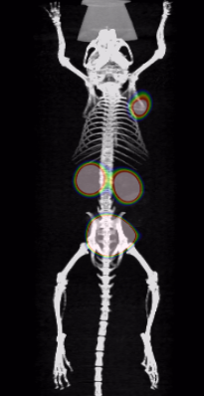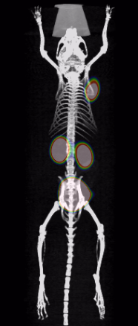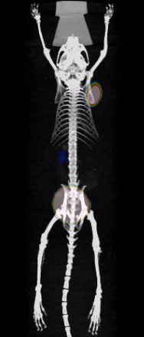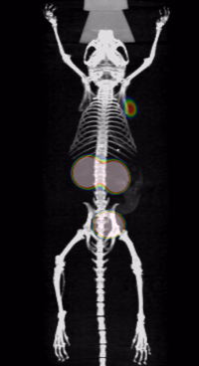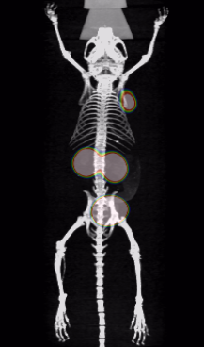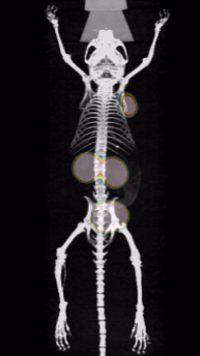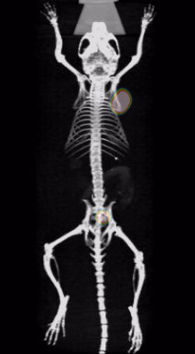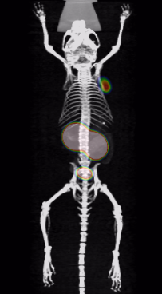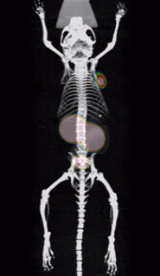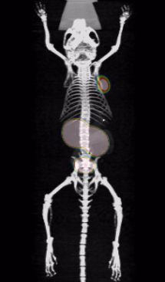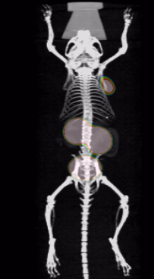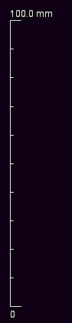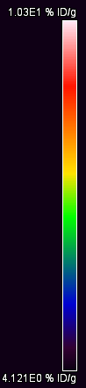
A
B
C
Figure S5. Maximum intensity projections of whole-body coronal micro-PET/CT images of a NOD/SCID male mouse bearing an LNCaP tumor xenograft (red arrow for the tumor, white arrow for the kidney). The tumor-targeting efficacy of [⁶⁸Ga]Ga-PP4-WD, [⁶⁸Ga]Ga-PP8-WD and [⁶⁸Ga]Ga-Flu-1 was demonstrated by time-dependent static scans at 10, 30, 60, and 120 min (from left to right) post-injection of [⁶⁸Ga]Ga-PP4-WD (A), [⁶⁸Ga]Ga-PP8-WD (B) and [⁶⁸Ga]Ga-Flu-1 (C). Approximately 2.6 MBq was injected into each mouse.

