Supplementary Information on

Microwave plasmonic frequency diverse array for high-resolution far-field target localization using a single physical channel

This supplementary information includes
Supplementary Note: Detailed proof of identifiability of the FDA scheme
Supplementary Figures 1-4

Supplementary Note: Detailed Proof of Identifiability of the FDA Scheme
In this note, we demonstrate the identifiability issue for both UFDA and NFDA to reveal the joint angular-range estimation ability of the NFDA scheme. We assume that K targets are randomly distributed at K DoA-range pairs $T$ = {(θ_{k}, r_{k}), 1 ≤ k ≤ K} with K ≤ P. The identifiability of the FDA is provided by the following theorem.

Theorem: Let the K DoA-range pairs $T$={(θ_{k}, r_{k}), 1≤k≤K} satisfy that θ_{k}∈[−90◦, 90◦] and r_{k}∈[0, c/∆f]. Then, the spatial spectrum will exhibit a peak if and only if the following conditions are satisfied:

- C1: The integers set $C$={0, c₂, · · ·, c_{P} } is non-uniform.
- C2: The steering vector a(θ, r) corresponds to one of the K sources in $T$ = {(θ_{k}, r_{k}), 1 ≤ k ≤ K}.

Proof: The K targets in $T$ give rise to the K columns of the array manifold in the form
$$A=\left[\begin{matrix}\begin{matrix}1 \\ e^{-jπsinθ_{1}} \\ \begin{matrix}⋮ \\ e^{-j(P-1)πsinθ_{1}}\end{matrix}\end{matrix} & \begin{matrix}… \\ … \\ \begin{matrix}⋮ \\ …\end{matrix}\end{matrix} & \begin{matrix}1 \\ e^{-jπsinθ_{K}} \\ \begin{matrix}⋮ \\ e^{-j(P-1)πsinθ_{K}}\end{matrix}\end{matrix}\end{matrix}\right]∘\left[\begin{matrix}\begin{matrix}1 \\ e^{\frac{j2πc_{2}∆fr_{1}}{c}} \\ \begin{matrix}⋮ \\ e^{\frac{j2πc_{P}∆fr_{1}}{c}}\end{matrix}\end{matrix} & \begin{matrix}… \\ … \\ \begin{matrix}⋮ \\ …\end{matrix}\end{matrix} & \begin{matrix}1 \\ e^{\frac{j2πc_{2}∆fr_{K}}{c}} \\ \begin{matrix}⋮ \\ e^{\frac{j2πc_{P}∆fr_{K}}{c}}\end{matrix}\end{matrix}\end{matrix}\right]=\underset{C^{P×K}}{\underbrace{\left[\begin{matrix}\begin{matrix}1 \\ e^{-jπ[sinθ_{1}-\frac{2c_{2}∆fr_{1}}{c}]} \\ \begin{matrix}⋮ \\ e^{-jπ[(P-1)sinθ_{1}-\frac{2c_{P}∆fr_{1}}{c}]}\end{matrix}\end{matrix} & \begin{matrix}… \\ … \\ \begin{matrix}⋮ \\ …\end{matrix}\end{matrix} & \begin{matrix}1 \\ e^{-jπ[sinθ_{K}-\frac{2c_{2}∆fr_{K}}{c}]} \\ \begin{matrix}⋮ \\ e^{-jπ[(P-1)sinθ_{K}-\frac{2c_{P}∆fr_{K}}{c}]}\end{matrix}\end{matrix}\end{matrix}\right]}}$$

Assuming that there exist two DoA-range pairs (θ_{k1}, r_{k1}) and (θ_{k2}, r_{k2}) which yield same steering vector. Then, the steering vector corresponding to (θ_{k1}, r_{k1}) is equal to that of (θ_{k2} , r_{k2}), i.e.,
$r_{k2}=r_{k1}+\frac{(sinθ_{k2}-sinθ_{k1})(p-1)c}{2c_{p}∆f}, p=1,…,P.$ (S-1)
This equation holds if and only if c_{p} = S(p − 1), S ∈ $N$⁺ for p = 1, · · · , P , which means $C$ is a uniform integers set, and the condition C1 is not met. Thus, UFDA scheme fails to provide identifiability for joint DoA-range estimation. For NFDA scheme, all columns in A are linear-independent when C1 and C2 are met, and thus, the array manifold A is full-rank. As such, the null-space U_{N} is spanned by (P − K)-dimensional orthogonal components of the range space of A. Each DoA-range pair in $T$ yields a^{H}U_{N} = 0^{T}. Now, we consider a DoA-range pair (θ_{k3}, r_{k3}) $∉$ $T$ and assume that a^{H}(θ_{k3}, r_{k3})U_{N} =0^{T}. We express the orthogonality between the steering vectors and the null space as
$\left[\begin{matrix}a_{p,f}^{H}(θ_{1},r_{1}) \\ \begin{matrix}a_{p,f}^{H}(θ_{2},r_{2}) \\ ⋮ \\ a_{p,f}^{H}(θ_{k3},r_{k3})\end{matrix}\end{matrix}\right]U_{N}=\left[\begin{matrix}0^{T} \\ \begin{matrix}0^{T} \\ ⋮ \\ 0^{T}\end{matrix}\end{matrix}\right]$. (S-2)
We firstly assume that a^{H}(θ_{k3}, r_{k3}) is linearly independent on the other steering vectors. Combing the assumption with (11) yields to an (P −K−1) dimensional null-space, which is contradict to U_{N} ∈ $C$^{P×(P−K)}. On the other hand, if a^{H}(θ_{k3}, r_{k3}) is linearly dependent on the other steering vectors, the condition C2 is not met. Hence a^{H}(θ_{k3}, r_{k3})U_{N}≠0^{T} holds for any DoA-range pair fall outside$T$. Eventually, it’s confirmed that the utilization of non-uniform frequency increment can suppress the coupling angle and range phenomenon and provide identifiability of target localization.

Based on the NFDA scheme, determined maximum likelihood (DML) algorithm is utilized to calculate the spatial spectrum with enhanced resolution. The spatial-spectral function of DML is expressed as
$f_{DML}\left(θ,r\right)=tr\left[A\left(θ,r\right)A^{†}\left(θ,r\right)\hat{R}\right]$, (S-3)
where $tr\left[⋅\right]$ denotes the trace function, ${\left[⋅\right]}^{†}$ represents the Moore-Penrose pseudoinverse, and $\hat{R}$ is the sampled covariance matrix of receive signal. Then, the location can be uniquely estimated by searching the peak of $f_{DML}\left(θ,r\right)$.

Supplementary Fig. 1. System composition of the proposed microwave plasmonic frequency diverse array. The FDA transmitter consists of a crystal oscillator, a power divider, phase frequency detectors, filters, voltage-controlled oscillators, and plasmonic antennas. The 100 MHz sinusoidal signal generated by the crystal oscillator is input to the phase-locked loop modules through the power divider, which is used as the common reference of the RF signals in eight channels. The phase-locked loop is composed of the phase-frequency detectors, voltage-controlled oscillators (VCO), and frequency dividers, which is the key to generate the customized high-precision frequency signals. The frequency dividing ratio of the frequency dividers can be changed in real time by writing the command signal, which guarantees the programmable frequency adjustment capability. The RF signals with different frequencies are radiated into free space through eight plasmonic antennas. The receiver comprises of a spoof plasmonic antenna, a low noise amplifier, and a band pass filter. The signals with different frequencies are captured by a single receiving antenna and processed by the amplifier and filter, and finally input to the signal processing module. Considering the convenience of application, we integrate and package all components except the antennas.

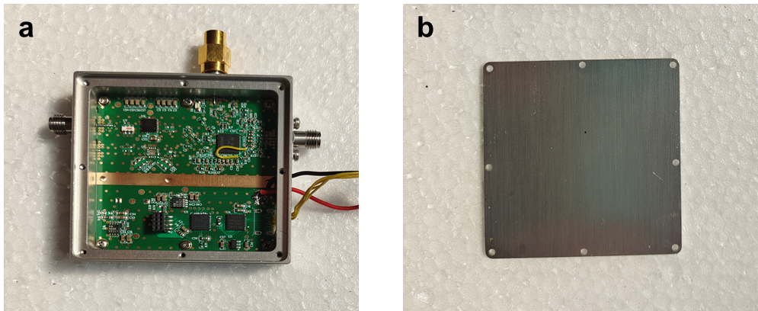
Supplementary Fig. 2. Photograph of the proposed high-precision frequency sources. a, The circuit diagram of the proposed frequency sources. b, Photograph of the shielded enclosure.
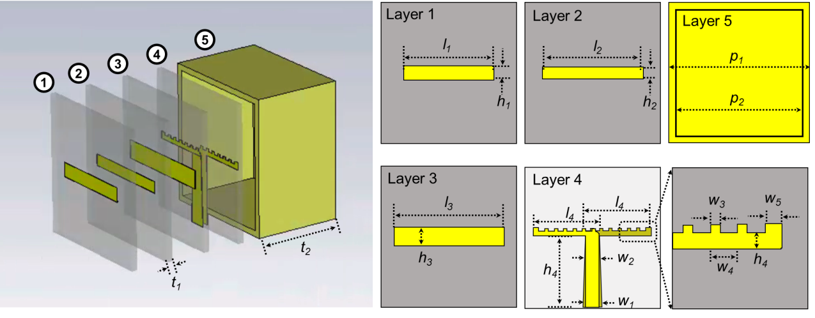
Supplementary Fig. 3. Schematic diagram of the proposed plasmonic antenna. The plasmonic antenna consists of five layers. Except for the fifth layer, which is of all-metal construction, the remaining four layers are made of copper-etched PCB dielectric boards. The values of structural parameters marked in the figure are as follows: l₁=7.30mm, h₁=1.20mm, l₂=7.96mm, h₂=0.96mm, l₃=8.91mm, h₃=1.56mm, l₄=5.43mm, h₄=5.89mm, w₁=1.52mm, w₂=1.18mm, w₃=0.31mm, w₄=0.76mm, w₅=0.47mm, h₄=0.38mm, p₁=11.62mm, p₂=10.62mm, t₁=0.50mm, t₂=7.50mm,

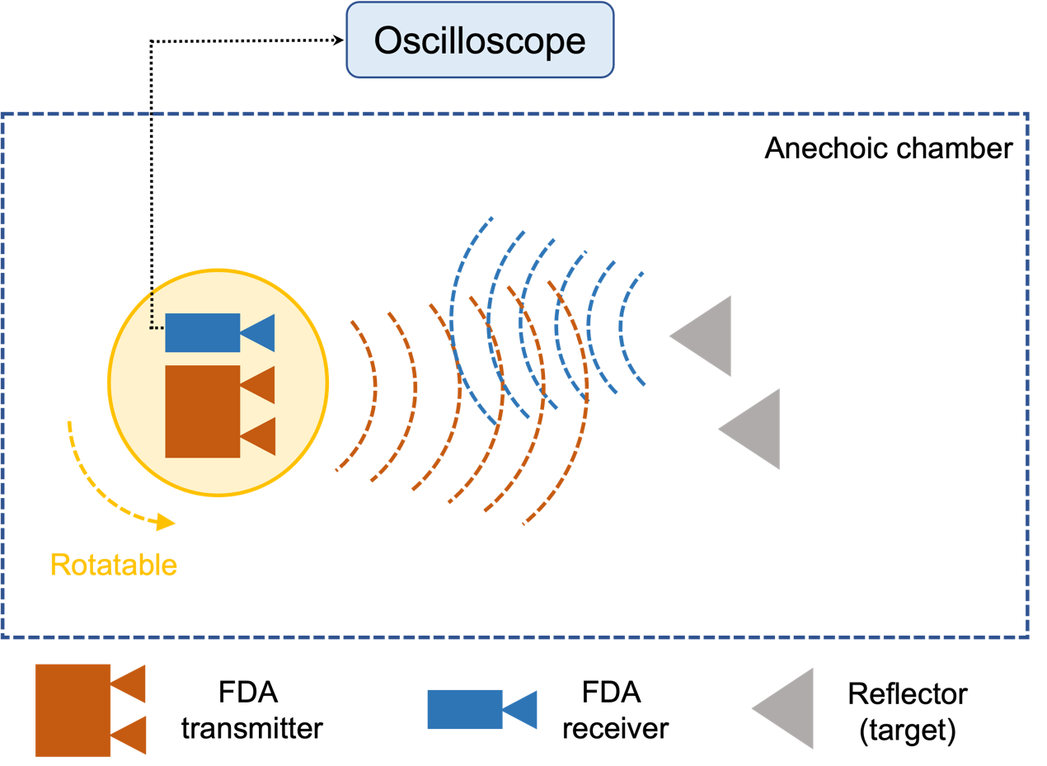

Supplementary Fig. 4. Experimental setup of the target localization.

