Supporting Information

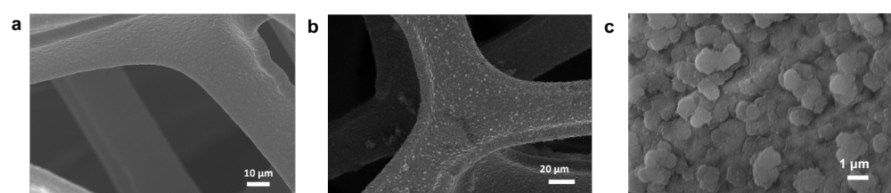

Figure S1. The morphology of PDA layer: a. s-PDA, b. r-PDA, c. The PDA cluster on r-PDA layer.
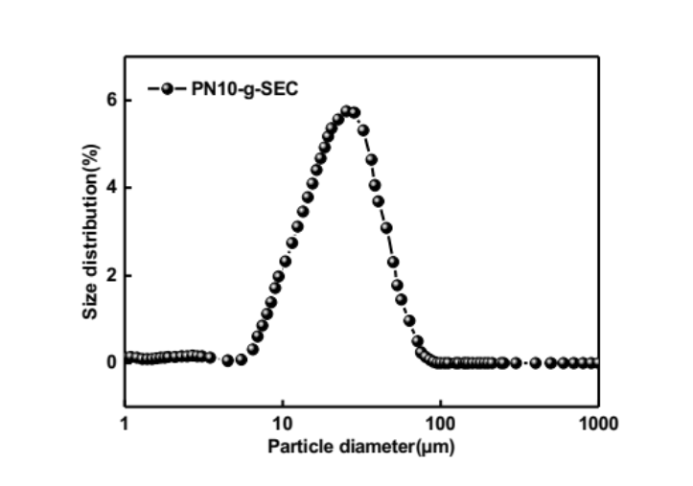

Figure S2. Particle Size of PN10-g-SEC
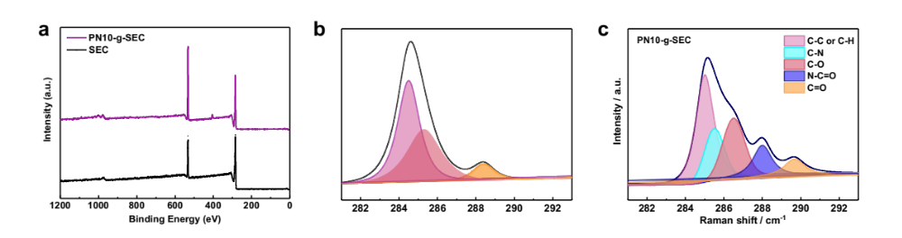

Figure S3. XPS spectrum of PN10-g-SEC: a. XPS characterization of PN10-g-SEC and SEC, b. C1s fitting spectra of SEC, c. C1s fitting spectra of PN10-g-SEC

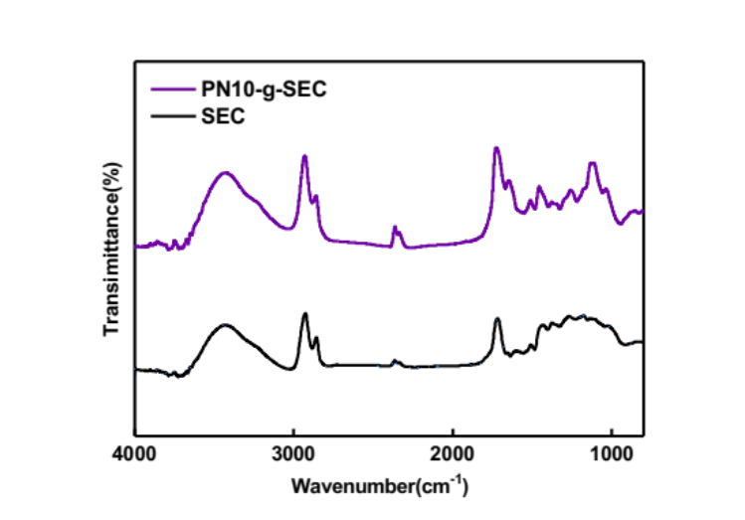
Figure S4. FT-IR spectrum of SEC and PN10-g-SEC
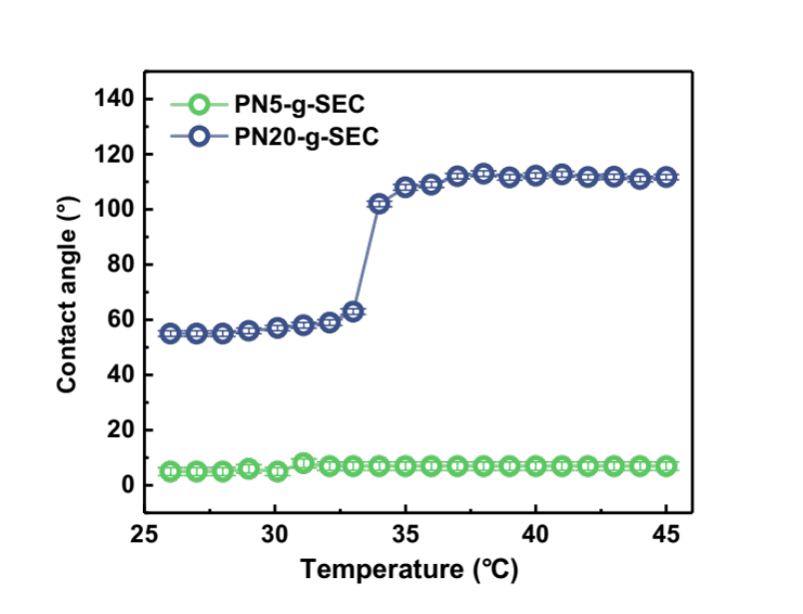
Figure S5. Contact angle variation of PN5-g-SEC and PN20-g-SEC under different temperature
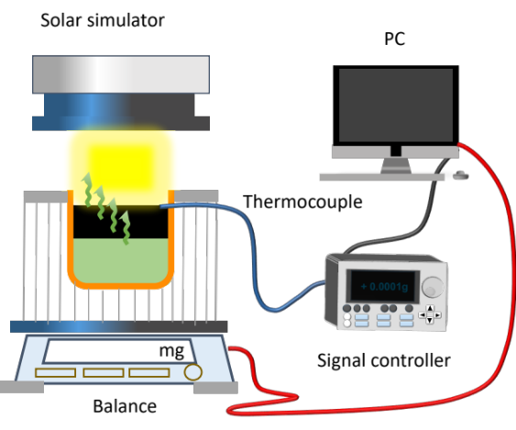
Figure S6. The set-up for measuring the solar evaporation performance
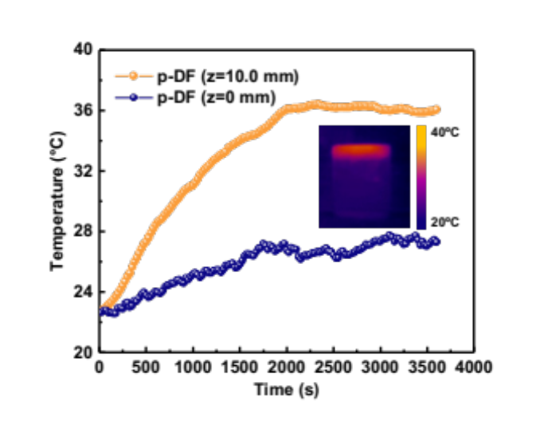
Figure S7. The surface temperature and ambient water temperature of p-DF (p-PDA coated nickel foam without bottom SEC layer)
Figure S8. a. Illustration of the water transport rate and evaporation rate varying the thickness of PDA layer, b. The thickness of p-PDA layer on PN10-g-SEC

Surface free energy ($\text{γ}$) was composed of various inter-molecular attractive forces, including polar components (${\text{γ}}_{\text{s}}^{\text{p}}$) and dispersive components (${\text{γ}}_{\text{s}}^{\text{d}}$) at the interface. Based on the contact angle data and fittings according to the Owens, Wendt, Rabel and Kaelble (OWRK) method, the surface free energies were calculated using Equation (1):
$\text{1+}\text{cos}{\text{θ}}\text{=2}\sqrt{{\text{γ}}_{\text{s}}^{\text{d}}}\left(\frac{\sqrt{{\text{γ}}_{\text{l}}^{\text{d}}}}{{\text{γ}}_{\text{lv}}}\right)\text{+2}\sqrt{{\text{γ}}_{\text{s}}^{\text{p}}}\left(\frac{\sqrt{{\text{γ}}_{\text{l}}^{\text{p}}}}{{\text{γ}}_{\text{lv}}}\right)$ (1)
where $\text{θ}$ was the contact angle of liquid, the superscripts p and d corresponding to the polar and dispersion force components, respectively. ${\text{γ}}_{\text{lv}}$was the free energy between liquid and solid against their saturated vapor, while ${\text{γ}}_{\text{l}}^{\text{d}} and {\text{γ}}_{\text{l}}^{\text{p}}$referred to the free energies of liquids as reported in several references (pls cite references).

Figure S9. a. Ilustration of water affinity and its corresponding contact angles of PDA layer varying the structure, b. Contact angle and interfacial free energy of s-PDA, r-PDA and p-PDA layer, c. The phase of water pumping using different p-SE and p-SDWE

Figure S10 a. Thin water layer characterization conducted by Micro-CT, b. Water thickness within s-SDWE, r-SDWE and p-SDWE, c. Cross view of water layer observed in p-SDWE

DSC Measurements of Vaporization Enthalpies
We measured the evaporation enthalpy of water in SDWEs using differential scanning calorimetric (DSC) measurements. The vaporization enthalpy measurements were carried out by placing the saturated foam in an open aluminum crucible and subjecting it to a linear heating rate of 5 K/min under a nitrogen flow rate of 20 mL/min, within a temperature range of 20 to 180 °C. The effective specific heat capacity was calculated by comparing the heat flow of the measured samples with that of the standard sample. As shown in Figure S11, a sharp peak is observed in pure water, followed by a significant decrease in the heat flow signal, indicating immediate water evaporation. However, the heat flow signals were differed in all the tested SDWE samples, the peaks were much broader and lower than that of pure water.
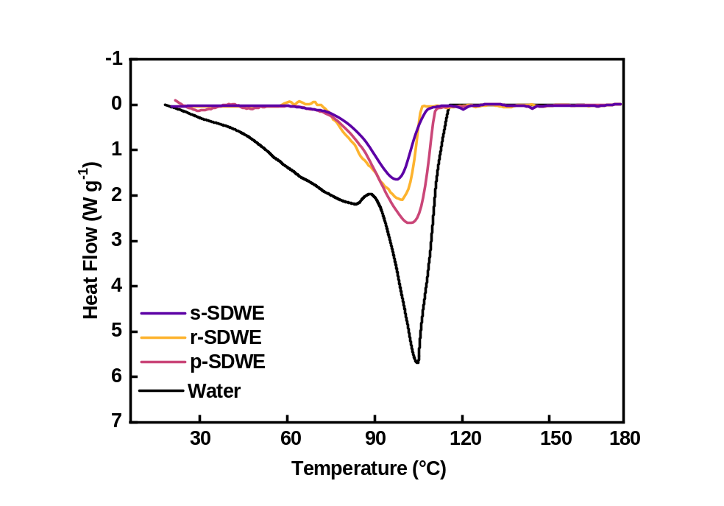
Figure S11 Thermograms of pure water and SDWEs.

Supplementary Table 1 summarizes the total mass, mass of water, and calculated vaporization enthalpy of bulk water and our as-prepared samples. The measured enthalpy of water is 2420 J/g, which closely to the theoretical value of 2450 J/g, indicating the accuracy of our measurements. The vaporization enthalpy of water within the p-DSF was significantly lower than that of pure water.

To determine the vaporization enthalpy, the evaporation enthalpy of water within SDWE was measured. Specifically, water and SDWE samples with the same surface area were placed together in a closed container along with a supersaturated potassium carbonate solution, creating a stabilized relative humidity (RH) under room temperature. The equivalent evaporation enthalpy (h_{eq}) of water in SDWEs could be estimated by vaporizing water with the same power input (U_{in}), using Equation (2):
U_{in}= h_{eq} m₀= h_{vap}m_{g} (2)
where h_{vap} was the evaporation enthalpy and m₀ was the mass change of bulk water, while m_{g} referred to the mass change of the HNG (??) sample. The evaporation rate of water and the corresponding calculated h_{eq} were shown in Figure S11, where h_{eq} was 1930 J g⁻¹ for p-SDWE, was found to be significantly reduced compared to bulk water.

Table S1 Equivalent evaporation Enthalpy of Water and SDWEs
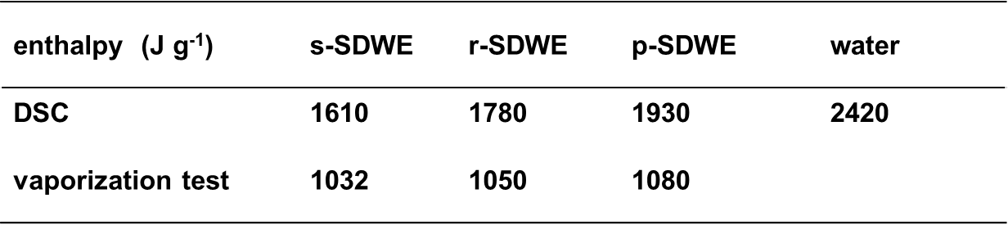

Energy conversion efficiency
The solar energy conversion efficiency (η) wass calculated using Equation (3):
η = mh_{v}/C_{opt}P₀ (3)
where m represents the net evaporation rate calculated by subtracting evaporation rate under dark condition from evaporation rate under one sun irradiation, h_{v} refers to the equivalent evaporation enthalpy of water in SDWEs. P₀ is the solar irradiation power of one sun (1 kW m⁻²). C_{opt} refers to the optical concentration on evaporator surface.
For p-SDWE, m = 3.58 – 0.45 = 3.13 kg m⁻² h⁻¹, E_{eq} = 1080 J g⁻¹. Therefore, the solar energy conversion efficiency is 93.9% under one sun illumination.
Energy loss analysis
The energy loss during the entire process can be attributed to four main factors: conduction, radiation, convection, and reflection. Each heat loss parameters were calculated as follows:
(1) Conduction
Q_{conduction}= CmΔT (4)
where Q_{conduction} referred to the heat energy transfer from the evaporator to bulk water, C was the specific heat capacity of pure water (4.2 kJ kg⁻¹ K⁻¹), m was the weight of water and ΔT is the temperature change of bulk water under one sun irradiation within 3600 s. Therefore, the conduction heat loss of the evaporator was ~1.86% under 1 sun irradiation.
(2) Radiation
Q_{radiation}= εAσ(T_{s}⁴ – T₀⁴) (5)
where ε corresponding to the emissivity (assumed to be 1), A was the evaporator area (5.0 x 5.0 cm²), and σ was the Stefan-Boltzmann constant (5.669 × 10⁻⁸ W · m⁻² · K⁻⁴ ), T_{s} was associated to the temperature of evaporator surface, T₀ was the ambient water temperature. The surface radiation heat loss accounts for ~2.84% of the total received energy.
(3) Convection
Q_{convection}= hA (T_{s} – T₀) (6)
where h was the convection heat transfer coefficient (5 W m⁻² K⁻¹). The convection heat loss made up for 1.9% of the total received energy.
(4) Reflection
The measured average reflection loss of p-SDWE over the broad solar spectrum (200‒2000 nm) was ~6.4%.
Therefore, the sum of calculated energy losses is 13.0% under 1 sun illumination.

