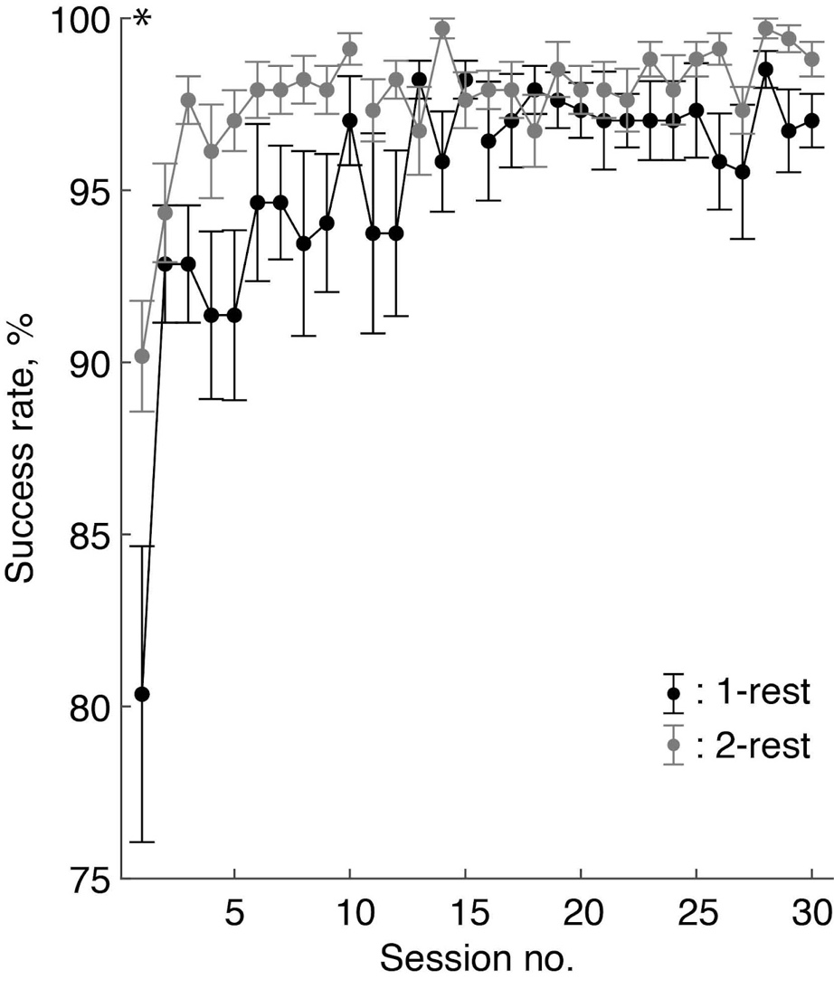
Supplementary figure 1. Task success rate across the training sessions. The filled dots and error bars represent the mean and standard error of the mean, respectively. *: p < 0.05 by post-hoc pairwise comparisons.

