Supplementary Information

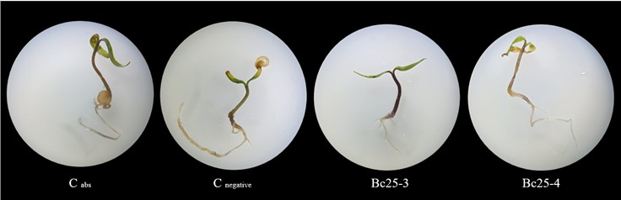

Supplementary Figure S1. C. annum var. glabriusculum seedlings treated with Bacillus spp. on day 7 after induction of water stress with polyethylene glycol (30%).

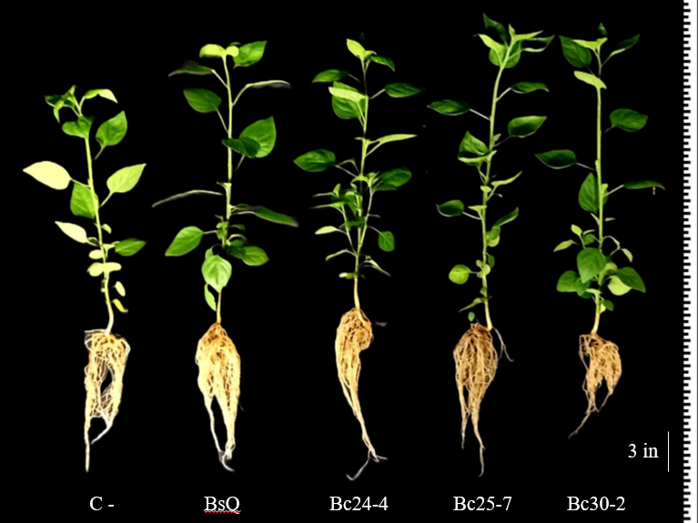

Supplementary Figure S2. Growth promotion in C. annuum var. glabriusculum seedlings treated with Bacillus spp. and developed in greenhouse conditions on day 42 DAT.

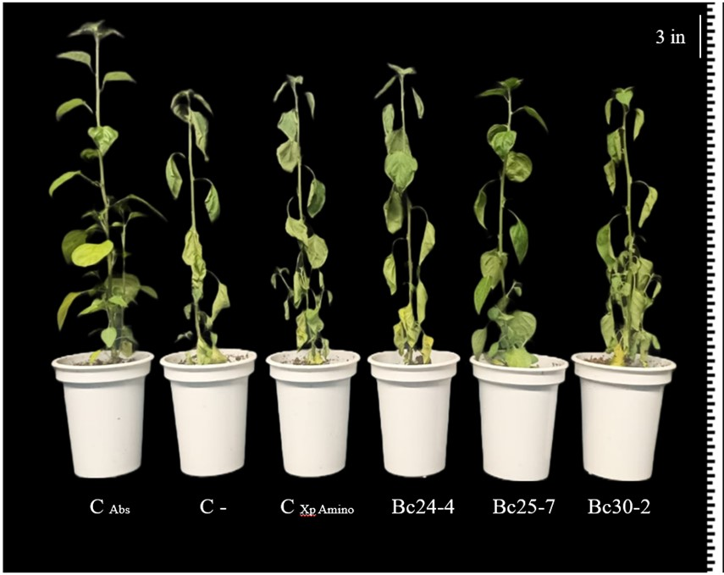

Supplementary Figure S3. C. anuum var. glabriusculum seedlings treated with Bacillus spp. under drought stress conditions in vivo.

