1. Chill Hour/Chill Portion Calculation Methods
The first “Simple Method” measures chill hours based on hourly temperatures, with values between 0 and 7.2°C receiving one chill hour and temperatures outside of this range receiving no hours (Weinberger, 1950). The Simple Method is only additive and therefore anomalously high or low winter temperatures do not subtract from the cumulative total from the previous days.
The second method is a weighted temperature model known as the “Utah Method” (Richardson et al. 1974; Linvill, 1990), which accounts for both the decreased efficacy of chill accumulation outside of an ideal temperature range and the potential deteriorative effects of anomalously high temperatures to chill accumulation. The Utah Method assigns 1 chill hour to an hourly temperature between 2.5 and 9.1°C, 0.5 chill hour to temperatures between 1.5-2.4°C or between 9.2-12.4°C, and 0 hours to temperatures either less than 1.4°C or between 12.5-15.9°C. We use the modified Utah Method of Linvill (1990), which removes previously accumulated chill hours when hourly air temperature exceeds 16°C, specifically removing 0.5 chill hours when temperatures are between 16-18°C, and 1 chill hour when temperatures exceed 18°C.
The third chill hour model is the “Dynamic Method”, (Erez and Fishman, 1997), which accumulates chill portions instead of hours in a two-step process. The method assumes the creation of an intermediate product by cold temperatures, and the product can either be destroyed by subsequent warmer temperatures or deposited as a chill portion if a certain amount of the product has been created. The Dynamic Method is sensitive to parameter selection, including the threshold temperature at which product is created or destroyed, and the time over which product accumulates before it is deposited as a chill portion (Darbyshire et al. 2011). We adopt the Dynamic Method parameter values from Luedling et al. (2009) to calculate the number of chill portions at time $t$ such that:
$$x_{i}=\frac{e^{slp∙tetmlt∙\left({\left(T_{K}-tetmlt\right)}/{T_{K}}\right)}}{1+e^{slp∙tetmlt∙\left({\left(T_{K}-tetmlt\right)}/{T_{K}}\right)}}$$
$$x_{s}=\frac{a_{0}}{a_{1}}∙e^{\left(e_{1}-e_{0}\right)/T_{K}}$$
$${ak}_{1}=a_{1}∙e^{-\left({e_{1}}/{T_{K}}\right)}$$
$${inter}_{E}=x_{s}-\left(x_{s}-{inter}_{S}\right)×e^{-{ak}_{1}}$$
$${inter}_{St}=\left\{if \begin{aligned} t=t_{0}, 0 \\ t>t_{0}& ∧{ inter}_{E}<1, {inter}_{Et-1} \\ t>t_{0}& ∧{inter}_{E}≥1, {inter}_{Et-1}∙\left(1-x_{i}\right)\end{aligned}\right.$$
$$delt=\left\{if \begin{aligned} t=t_{0}, 0 \\ t>t_{0}& ∧{ inter}_{E}<1, 0 \\ t>t_{0}& ∧{inter}_{E}≥1, x_{i} ∙ {inter}_{E}\end{aligned}\right.$$
chill portions = $\left\{if \begin{aligned}t=t_{0}, delt \\ t≥t_{0}, delt+{chill portions}_{t-1}\end{aligned}\right.$
The derived constants took the following values:
$slp=1.6$, $tetmlt$ = 277, $a_{0}=139500$, $a_{1}=2.567×{10}^{18}$, $e_{0}=12888.8$, $e_{1}=$4153.5, and $T_{K}$ is the hourly temperature (Kelvin), and $t$ is the time during the season in hours with $t_{0}$ representing the start of the chill accumulation in the season.
2. NEX-GDDP-CMIP6 Projections
The NEX-GDDP-CMIP6 dataset is a collection of global, high-resolution (~25 km) statistically downscaled climate scenarios derived from global climate simulations in the Coupled Model Intercomparison Project Phase 6 (CMIP6, O’Neill et al. 2016; Thrasher et al. 2022). Studies have used the NEX-GDDP-CMIP6 datasets to quantify projected changes in temperature and temperature impacts in various global regions (Tang et al. 2022; Murali et al. 2023; Colelli et al. 2023). In this study, we use daily surface air temperature from historical simulations (1951-2014) and future projections (2015-2100) based on 24 climate models that are part of the NEX-GDDP-CMIP6 dataset. The SSP245 and SSP585 future scenarios are used to represent moderate and high emissions pathways, respectively, which produce 4.5 and 8.5 Wm⁻² of radiative forcing by 2100.
2. Chill Hour Time Series Comparison
We use the idealized temperature curve from Linvill (1990) to estimate an hourly temperature time series from daily maximum and minimum values. The method uses a sine curve for daytime temperatures and a logarithmic decline curve for nighttime temperatures. We followed the method of Darbyshire et al. (2011) to set the daily high temperature two hours after solar noon and the daily minimum temperature set to occur at sunrise each day. This method has shown good results when applied to chill hour studies (e.g., Luedeling and Brown, 2011; Ghrab et al. 2014). To test the method’s performance in the Midwest, we calculated season-total chill hours using the Modified Utah Method between 1951 and 2022. Chill hours were calculated using both daily maximum and minimum temperatures and hourly temperatures from the same Automated Surface Observing System (ASOS) stations in three Midwest locations: (1) Columbus, Ohio, (2) Chicago, Illinois, and (3) Fargo, North Dakota. We then compared the distributions of season-total chill hours at each station based on the hourly observed and hourly estimated temperature series (Figure S2). The 10th percentile, median, and 90th percentile of each distribution are shown in Figure S2 as well. Chill hours derived from the estimated hourly temperature time series match well with those derived from direct hourly observations. The largest differences are in the extreme high chill hour seasons, for which the estimated hourly series tends to underestimate the season total chill hours in Chicago and Fargo and overestimate total chill hours in Columbus. The maximum difference of season total chill hours between estimated and observed hourly temperature series was 15% in Fargo, 11% in Chicago, and 8% in Columbus, with no systematic bias.
3. Sequential Model for Spring Freeze Risk
Chill hour accumulation is only one component of the risk of spring freeze injury to perennial crops. Spring freeze risk is also dependent on the air temperature following the fulfillment of the plant’s chill requirement and the likelihood of temperatures that can cause injury at various phenological stages. Following the methods of DeGaetano (2018), chill hours were first accumulated using the Utah Method until the requisite 800 chill hours were accumulated. The threshold of 800 hours was selected to represent the best estimate of chill hour requirements for both Gala and Fuji apple varieties, based on Illinois Extension and Illinois apple grower input. Once the 800-hour threshold was reached, we used accumulated base 6.1°C development growth units to estimate spring phenology. Specifically, the first day that development growth units exceeded 235.6 was marked as the full bloom stage in apple. Spring freeze injury can occur in earlier phenological stages than full bloom; however, we focus solely on full bloom in this study to reduce the potentially compounding effects of uncertainty in (1) development growth units needed to advance to each phenological stage and (2) the air temperature at which injury occurs in each phenological stage. Potential spring freeze injury was noted in any year, historical or future, in which the daily low temperature fell below 3.9°C after the estimated date of full bloom. It is estimated that temperatures lower than the 3.9°C threshold often cause 90% or greater kill in many apple varieties (Michigan State University Extension, 2014).
4. CMIP6 Model Comparison with Observations
We compare CMIP6 estimated season-total chill hours to the nClimGrid observations over the mutual historical period 1984-2014 (Figure S3). The multi-model ensemble mean of season-total chill hour accumulation has a similar spatial pattern as the observations, with relative maxima in the eastern and central Midwest and relative minima in the far southern and northwest Midwest. More CMIP6 ensemble comparison details are in the Supplemental Material.
The model ensemble mean underestimates chill hour accumulation in the southern Midwest and slightly overestimates accumulation in parts of the upper Midwest. The Taylor Diagram in Figure S3 based on the 30-year average season-total chill hour accumulation shows most of the models cluster in error space, with no models substantially over- or under-performing relative to the others. The models have a spatial correlation with the observations ranging from 0.58 to 0.81, and a root mean square difference ranging from 110 to 175 hours (i.e., 8-13% difference, relative to the observation mean). The models generally span the standard deviation of season-total chill hour accumulation across the region, between 140 and 180 hours. As much as can be inferred from model performance during the historical period, we are confident using the entire 24-model ensemble to assess potential future changes in Midwest chill hour accumulation.

Figures
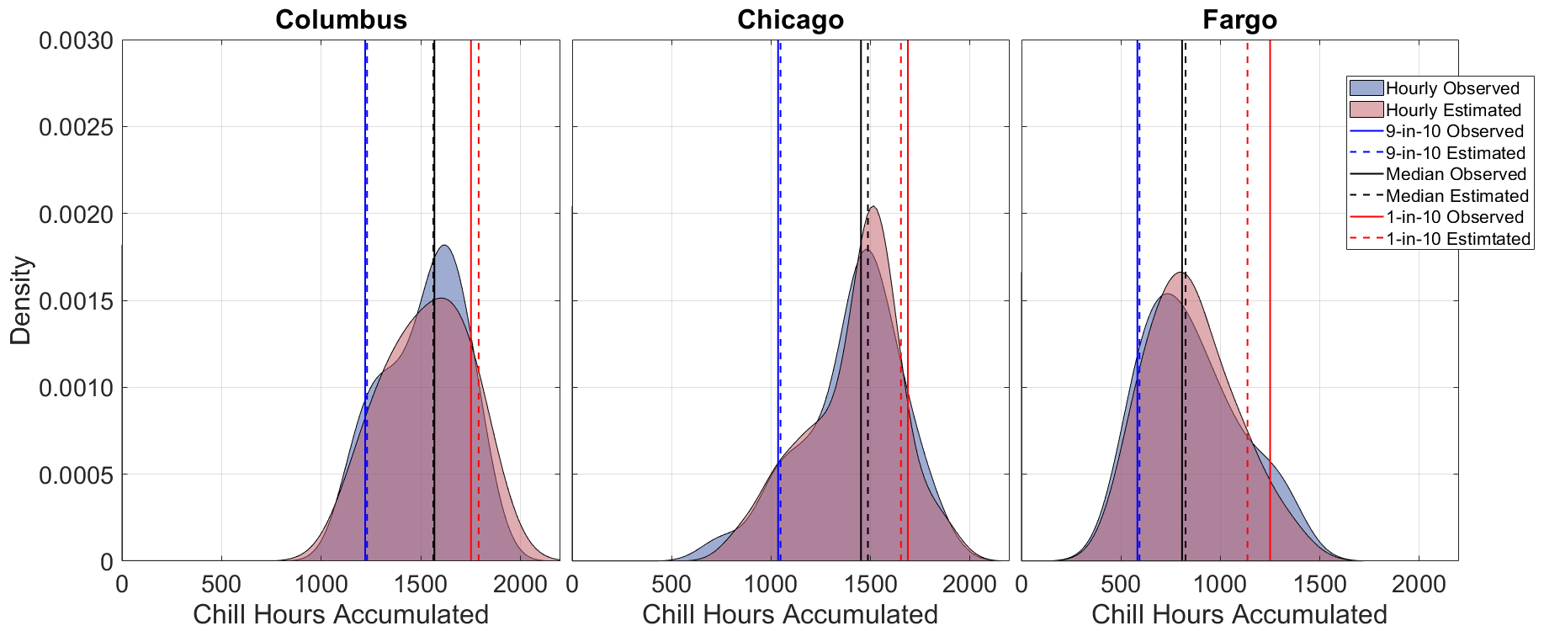
Figure S1. Distributions of season total chill hours in Columbus, Ohio, Chicago, Illinois, and Fargo, North Dakota. The red and blue distributions show winter chill hour totals from estimated and observed hourly temperature time series, respectively. The solid lines and dashed lines show the 10th percentile, 90th percentile, and median chill hour total values based on observed and estimated hourly temperature series, respectively.

a.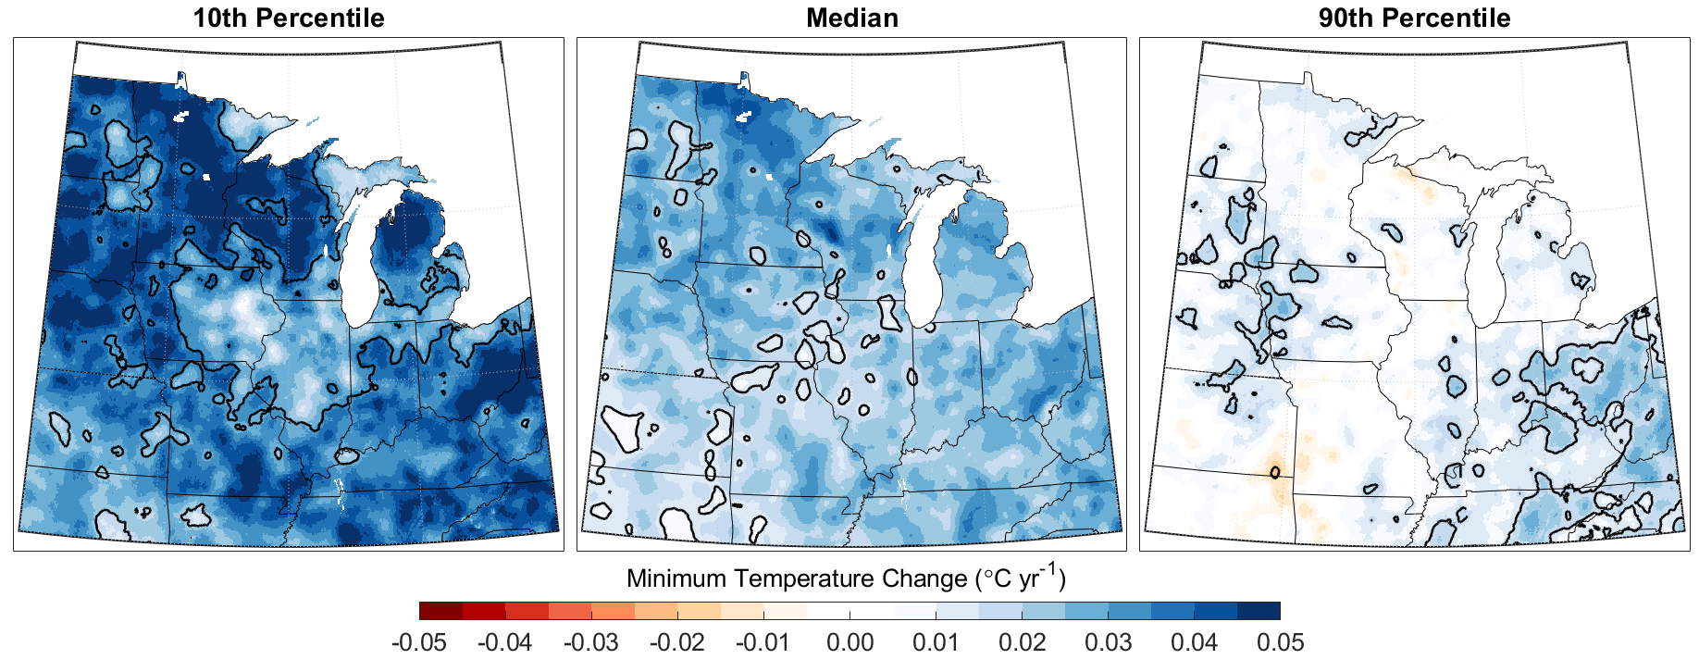 b.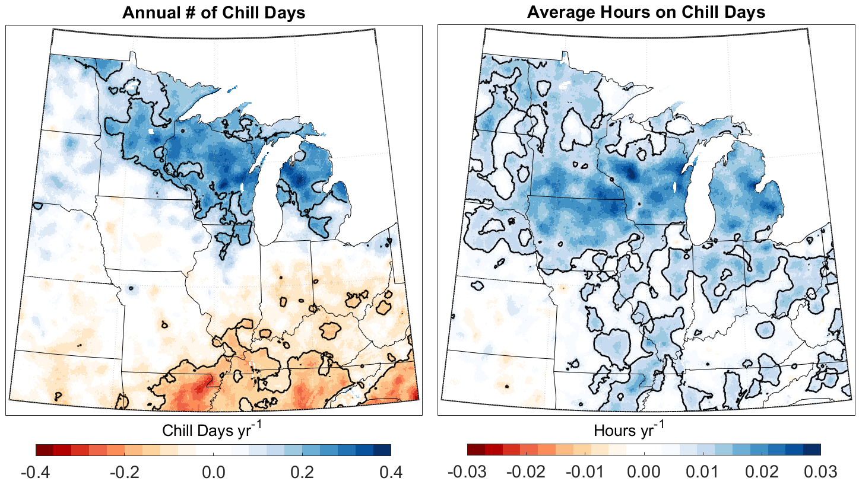
Figure S2. (a) Trends in the (left) 10th percentile, (middle) median, and (right) 90th percentile of daily average October-April minimum temperatures between 1951 and 2021. (b) trends in (left) annual number of days with positive chill accumulation and (right) average number of hours per day during the chill accumulation season, calculated between 1951 and 2021. The black contour in trend maps indicate statistical significance (p-value > 0.95).

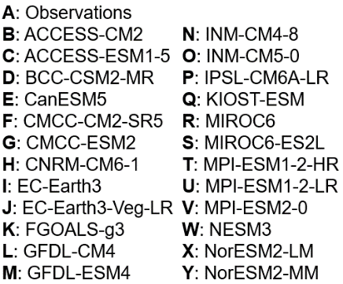
a.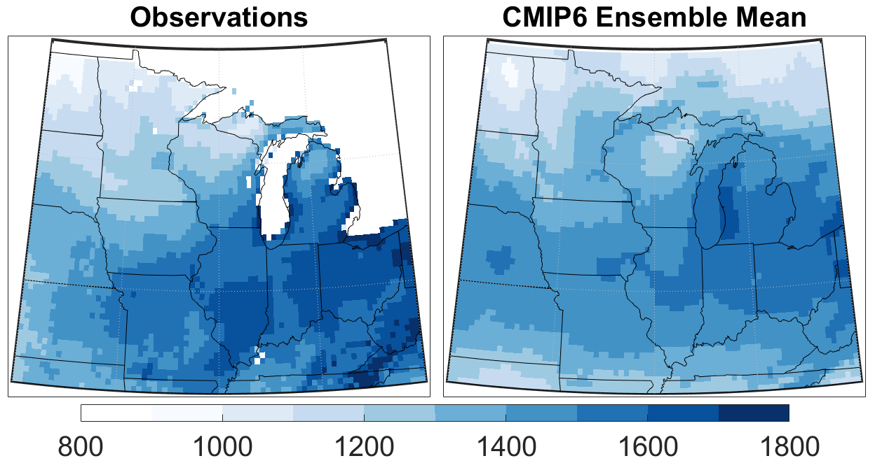 b. 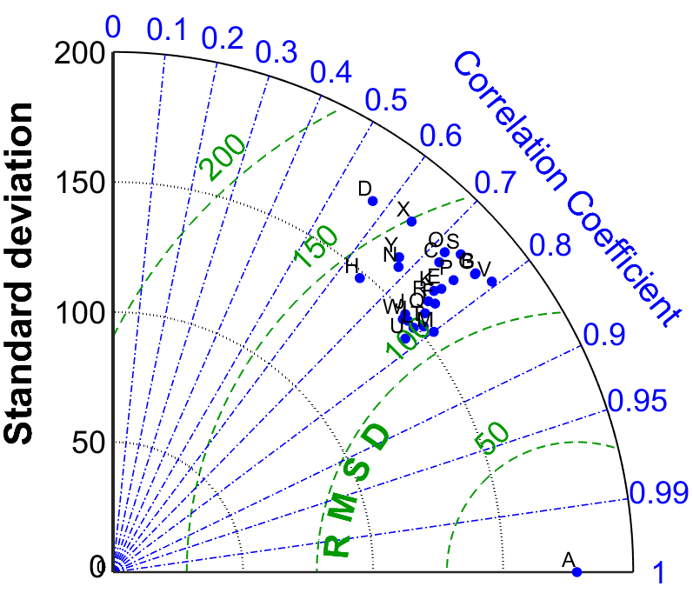
Figure S3. (Top) Average season-total chill hour accumulation from (left) observations and (right) the CMIP6 model ensemble mean, calculated over the period 1984-2014. (Bottom) Taylor Diagram from comparison of average season-total chill hour accumulation from each model with observations.

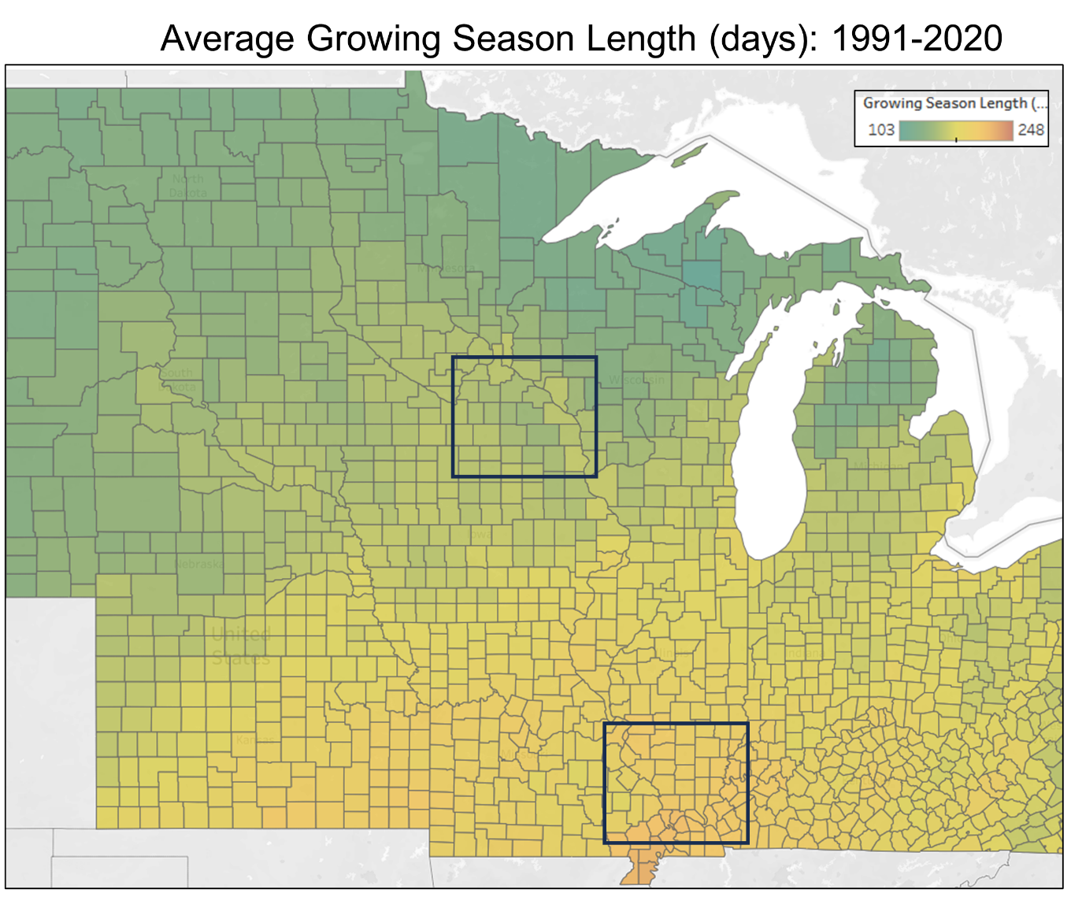
Figure S4. Map shows the 1991-2020 average growing season length (days) by county across the Midwest United States. Growing season length is the number of days elapsed between the first and last 0C freeze observed in each county. The growing season length graphic is taken from the Midwestern Regional Climate Center’s Freeze Date Tool: https://mrcc.purdue.edu/freeze/freezedatetool.

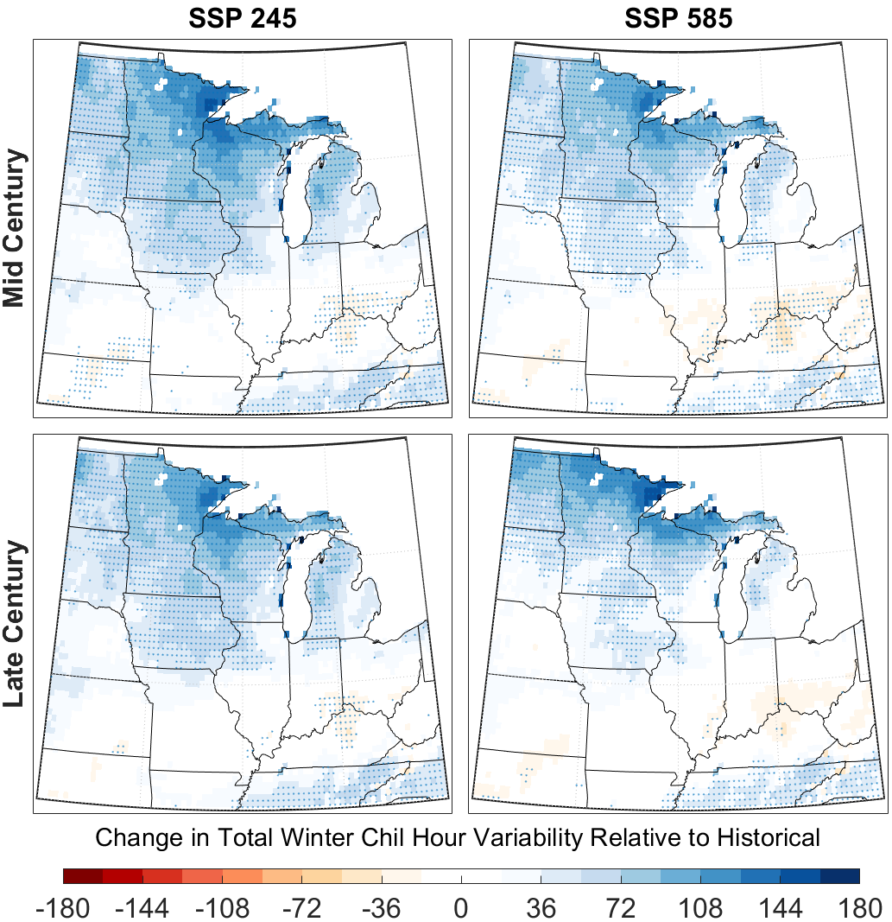
Figure S5. Maps show the projected change in total chill hour interannual variability, relative to the model historical period. Hatching indicates at least 75% of the models agree on the sign of projected change.

a.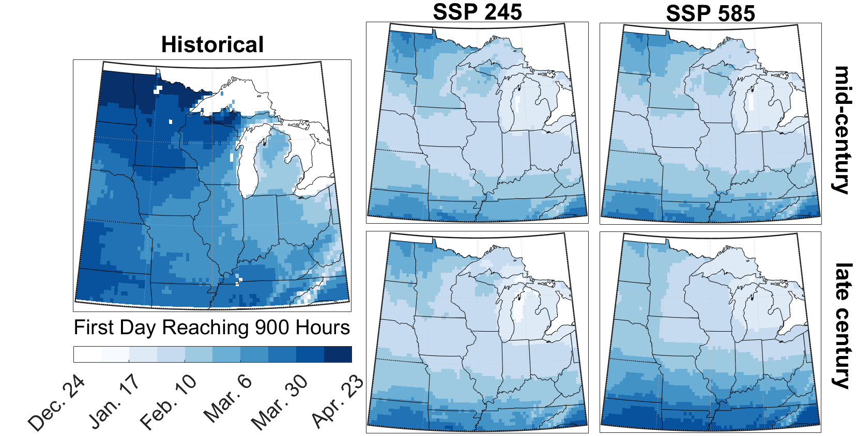
b.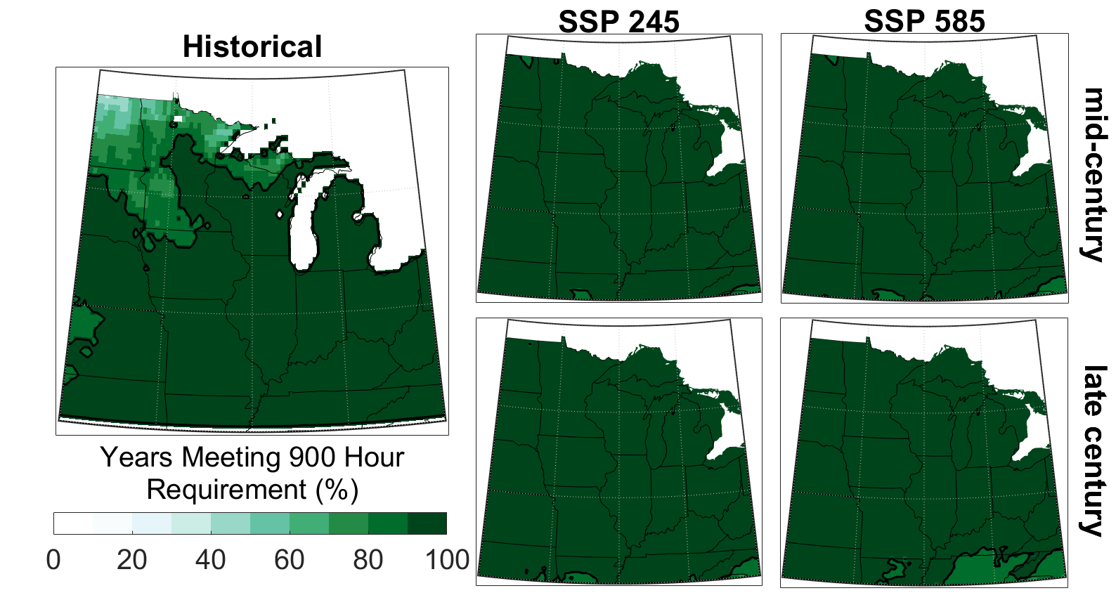
Figure S6. Maps in panel (a) show the historical and projected first day reaching the Gala Apple requirement of 900 chill hours. Maps show the 30-year average over the historical period and projected periods by mid- and late-century under SSP245 and SSP585 pathways. Maps in panel (b) show the historical and projected percent of years in the 30-year historical and projected periods that meet the Gala Apple requirement of 900 chill hours by May 1st. The black contour denotes areas meeting that requirement in at least 90% of years.

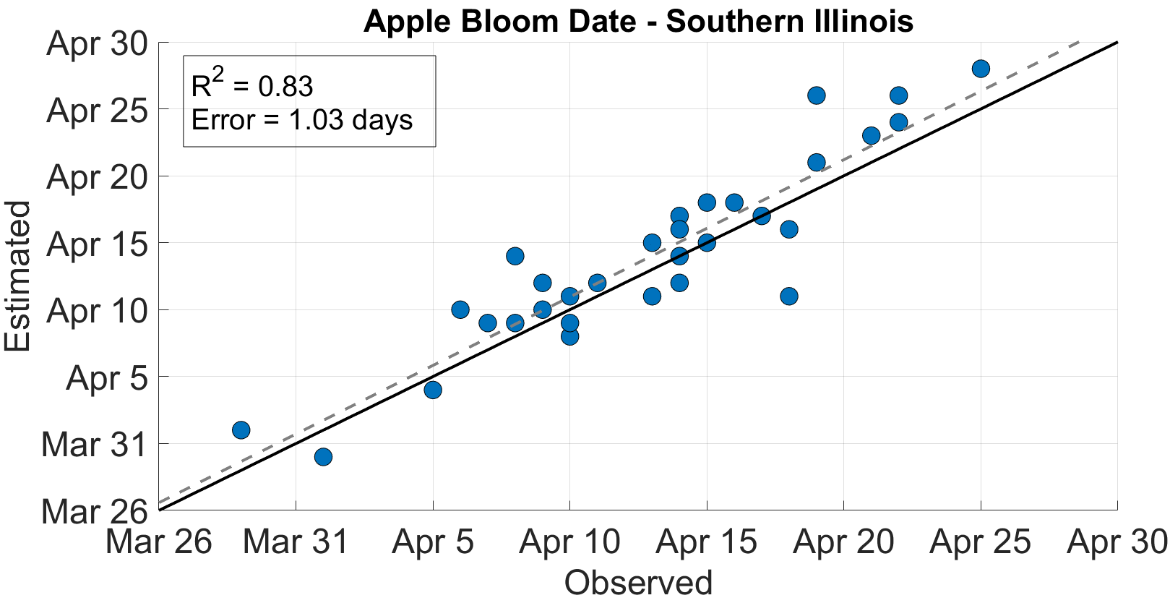
Figure S7. Scatter plot of observed and estimated date of apple full bloom in southern Illinois between 1991 and 2022. Bloom observations were made by a commercial grower in southern Illinois.

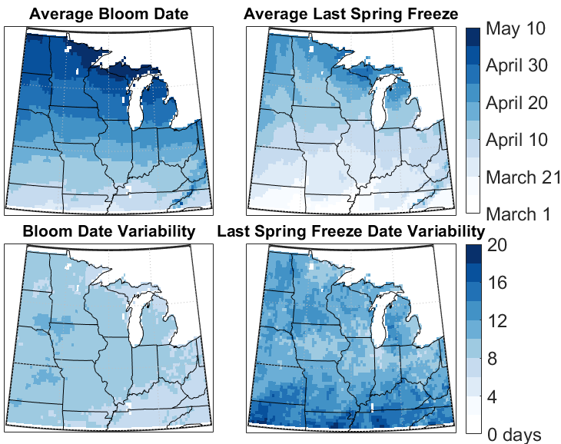
Figure S8. Left panels show the historical average and variability of estimated date of full bloom in Gala and Fuji apple varieties between 1951 and 2021. Right panels show the average and variability of the last spring (-3.9°C) freeze date over the same 1951-2021 period.
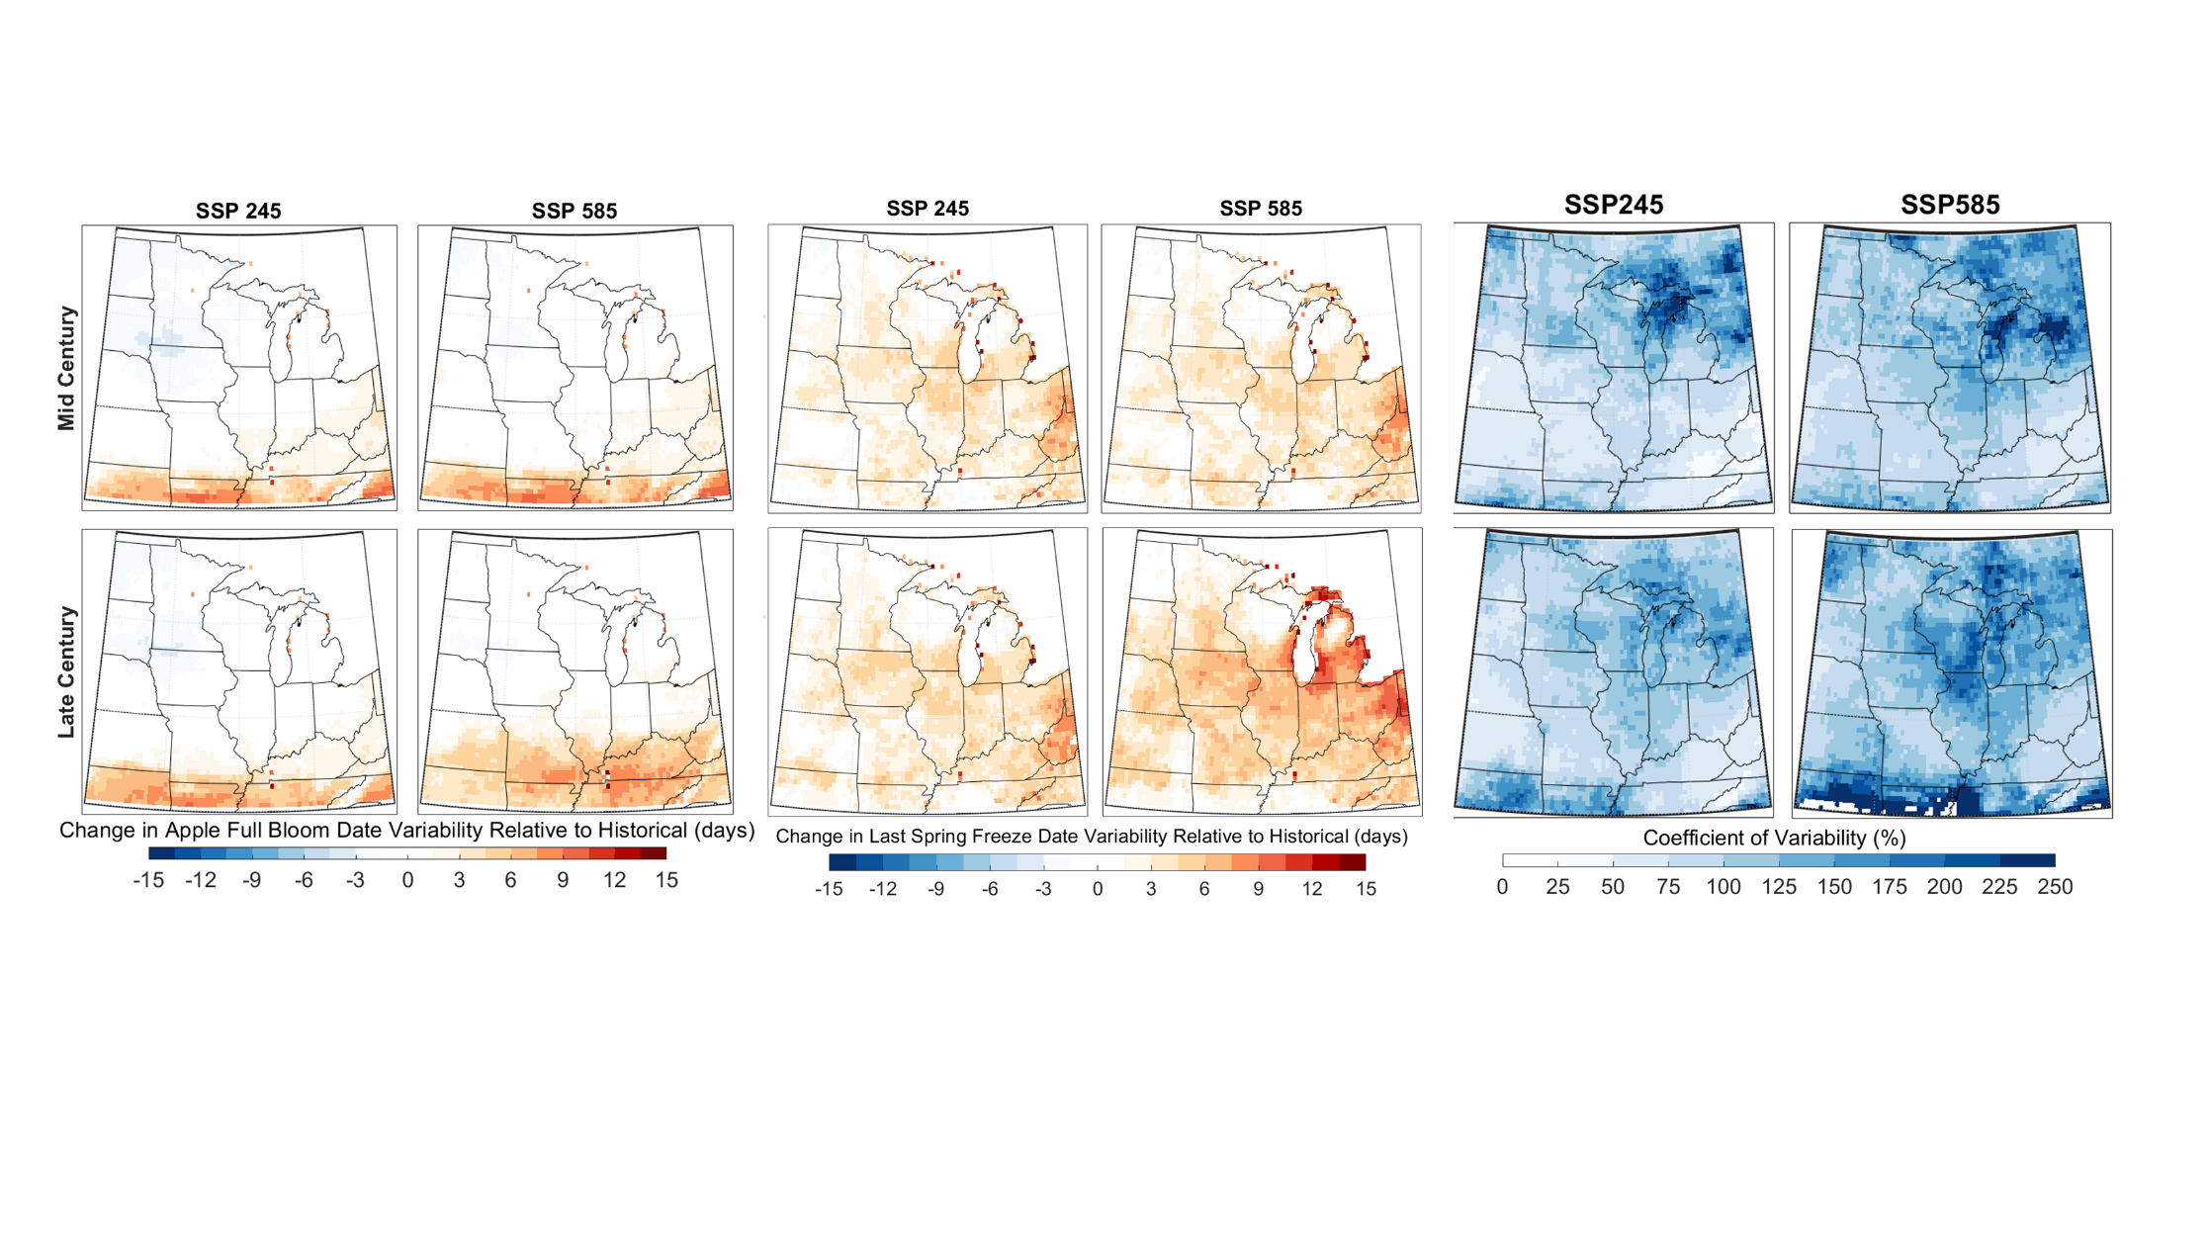
Figure S9. Top maps show the projected change in interannual variability in (left) apple full bloom dates and (right) last spring freeze dates, relative to historical. Bottom maps show the coefficient of variability of spring freeze injury risk between individual CMIP6 models relative to the multi-model ensemble mean.

References
Colelli, F.P., Wing, I.S., and Cian, E.D. 2023. Air-conditioning adoption and electricity demand highlight climate change mitigation – adaptation tradeoffs. Sci. Report., 13, 4413.
Darbyshire, R., Webb, L., Goodwin, I., et al. 2011. Winter chilling trends for deciduous fruit trees in Australia. Ag. Forest Meteorol., 151, 1074-1085.
DeGaetano, A.T. 2018. Regional influences of mean temperature and variance changes in freeze risk in apples. HortScience, 53, 90-96.
Erez, A., and Fishman, S. 1997. The dynamic model for chilling evaluation in peach buds. IV International Peach Symposium, 465.
Ghrab, M., Mimoun, M.B., Masmoudi, M.M., et al. 2014. Chilling trends in a warm production area and their impact on flowering and fruiting of peach trees. Sci. Hort., 178, 87-94.
Linvill, D.E. 1990. Calculating chilling hours and chill units from daily maximum and minimum temperature observations. HortSci., 25, 14-16.
Luedeling, E., Zhang, M., McGranahan, G., et al. 2009. Validation of winter chill models using historic records of walnut phenology. Ag. Forest Meteorol., 149, 1854-1864.
Luedeling, E., and Brown, P.H. 2011. A global analysis of the comparability of winter chill models for fruit and nut trees. Int. J. Biometeorol., 55, 411-421.
Michigan State University Extension, 2014. “Critical Spring Temperatures”, https://www.canr.msu.edu/apples/weather/critical-spring-temperatures, accessed August 1, 2022.
Murali, G., Iwamura, T., Meiri, S., et al. 2023. Future temperature extremes threaten land vertebrates. Nature, 615, 461-467.
O’Neill, B.C., Tebaldi, C., Van Vuuren, D.P., et al. 2016. The scenario model intercomparison project (ScenarioMIP) for CMIP6. Geosci. Mod. Develop., 9, 3461-3482.
Richardson, E.A., Seeley, S.D., and Walker, D.R. 1974. A model for estimating the completion of rest for ‘Redhaven’ and ‘Elberta’ peach trees. HortSci., 9, 331-332.
Tang, H., Wang, X., Kang, Y., et al. 2022. Long-term impacts of diurnal temperature range on mortality and cardiovascular disease: a nationwide prospective cohort study. Metabolites, 12, 1287.
Thrasher, B., Wang, W., Michaelis, A., et al. 2022. NASA global daily downscaled projections, CMIP6. Sci. data, 9, 262.
Weinberger, J.H. 1950. Chilling requirements of peach varieties. Proc. Amer. Soc. Hort. Sci., 56, 122-128.

