Supplementary Figures
Supplemental Figure 1: Distributions of genetic diversity (observed heterozygosity, allelic richness, and mean number of alleles) and genetic differentiation (fixation index, Fst) across microsatellite studies collated from 2010-2022 in our meta-analyses, classified by IUCN RedList rankings (Least Concern – Critically Endangered). Distributions are broken down by class of animals (Mammalia, Aves, Actinopterygii, Amphibia, and Reptilia). Note that data were clearly insufficiently available across Amphibia and Reptilia, indicating large gaps in conservation-related studies of these taxa.
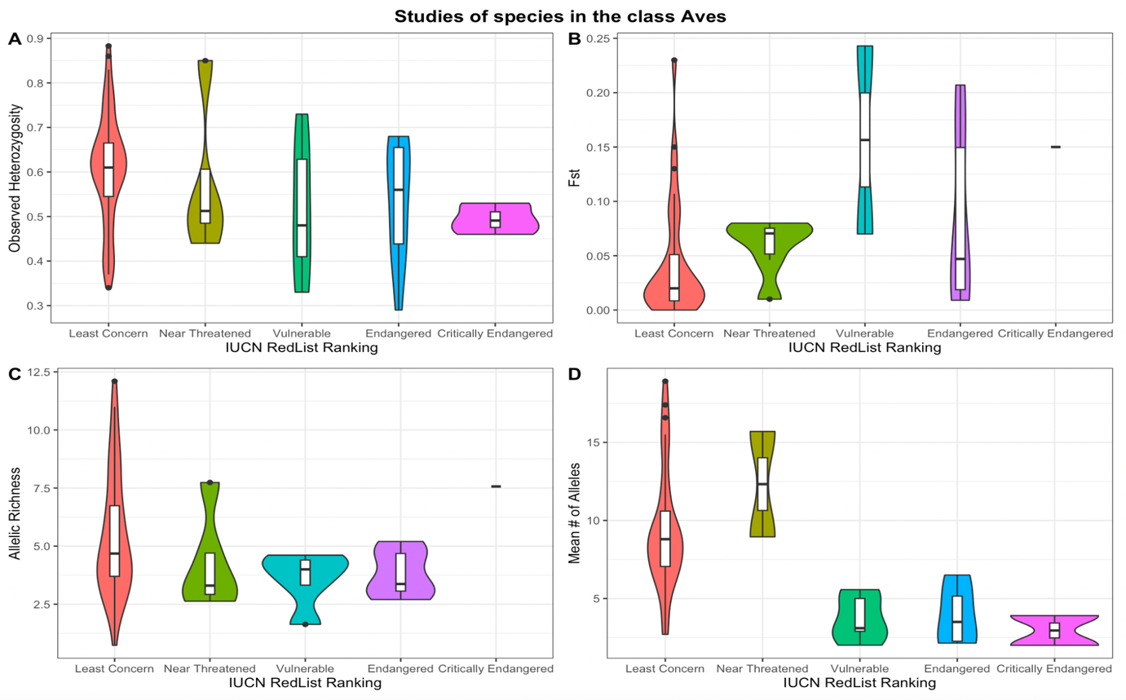
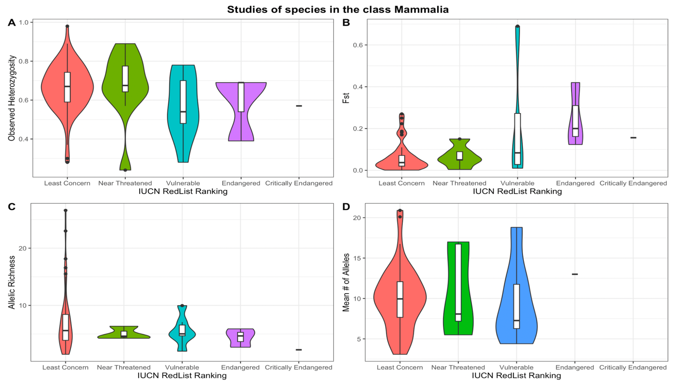
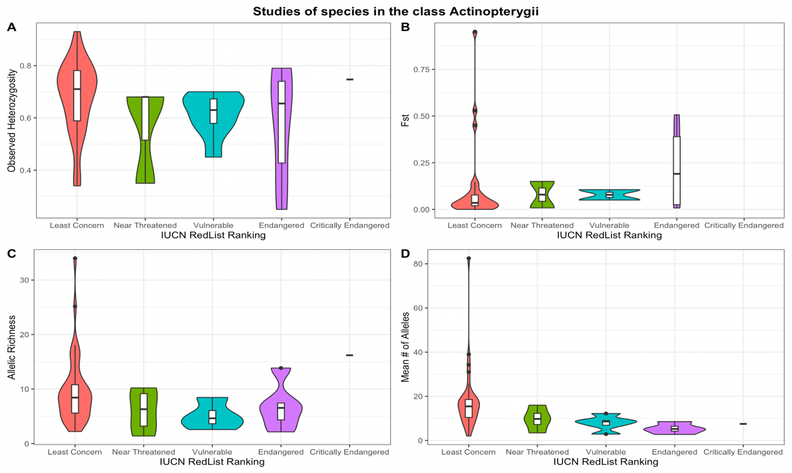

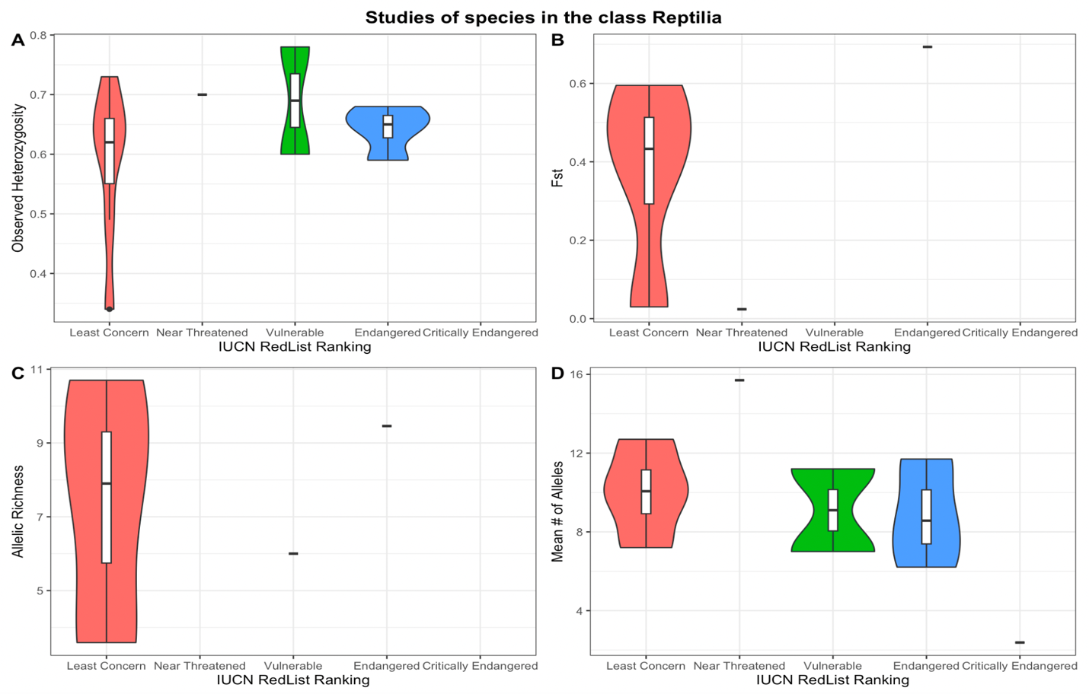
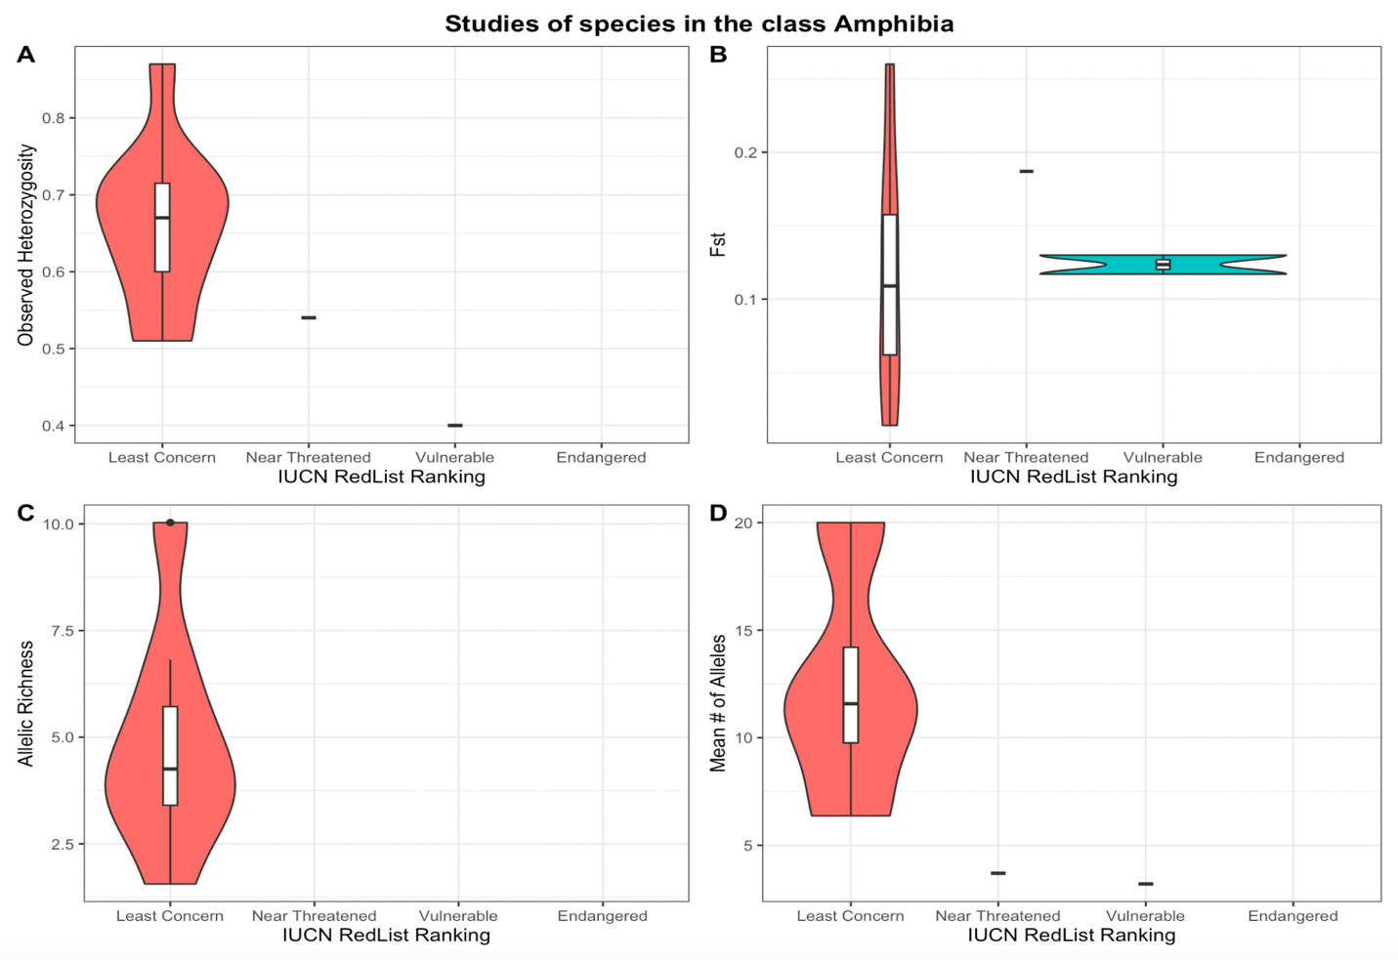
Supplemental Figure 2: Error rate of the out-of-bag estimator and response variables (threat level) of the random forest model for class Actinopterygii.
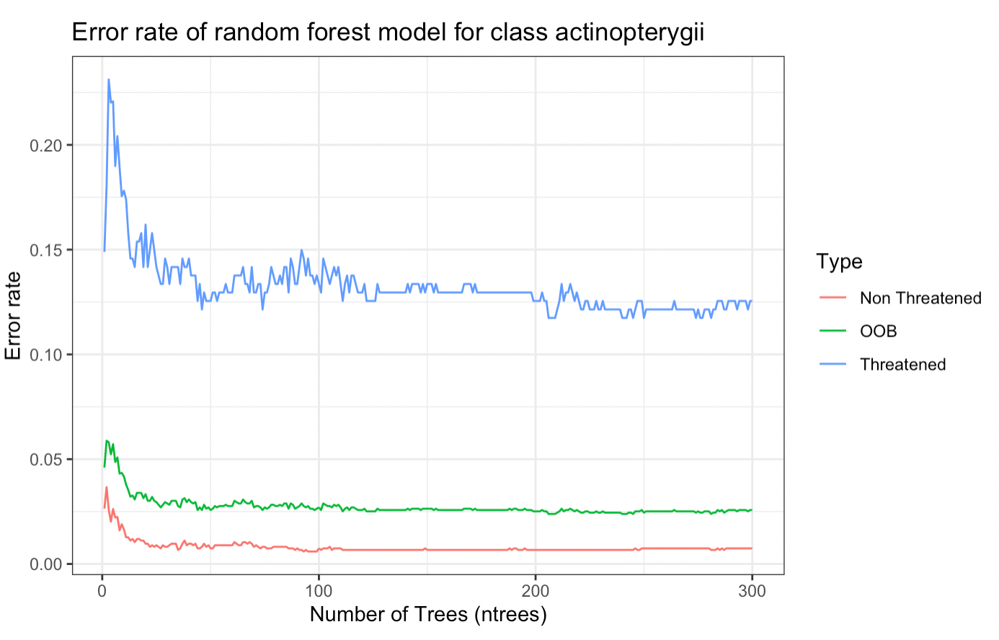

Supplemental Figure 3: Model attributes that contribute to the greatest mean decrease in accuracy in the random forest model of threat level for class Actinopterygii.
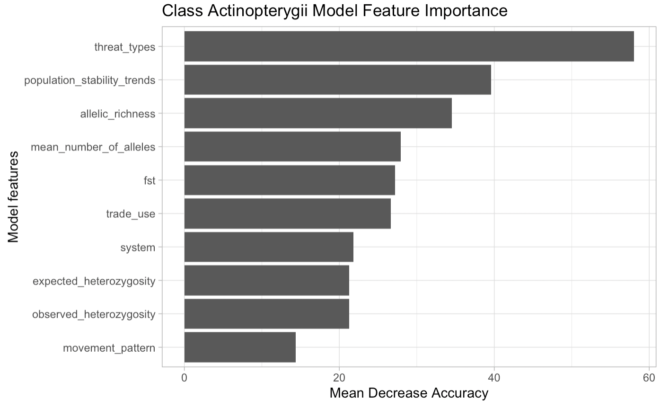
Supplemental Figure 5: Error rate of the out-of-bag estimator and response variables (threat level) of the random forest model for class Amphibia.
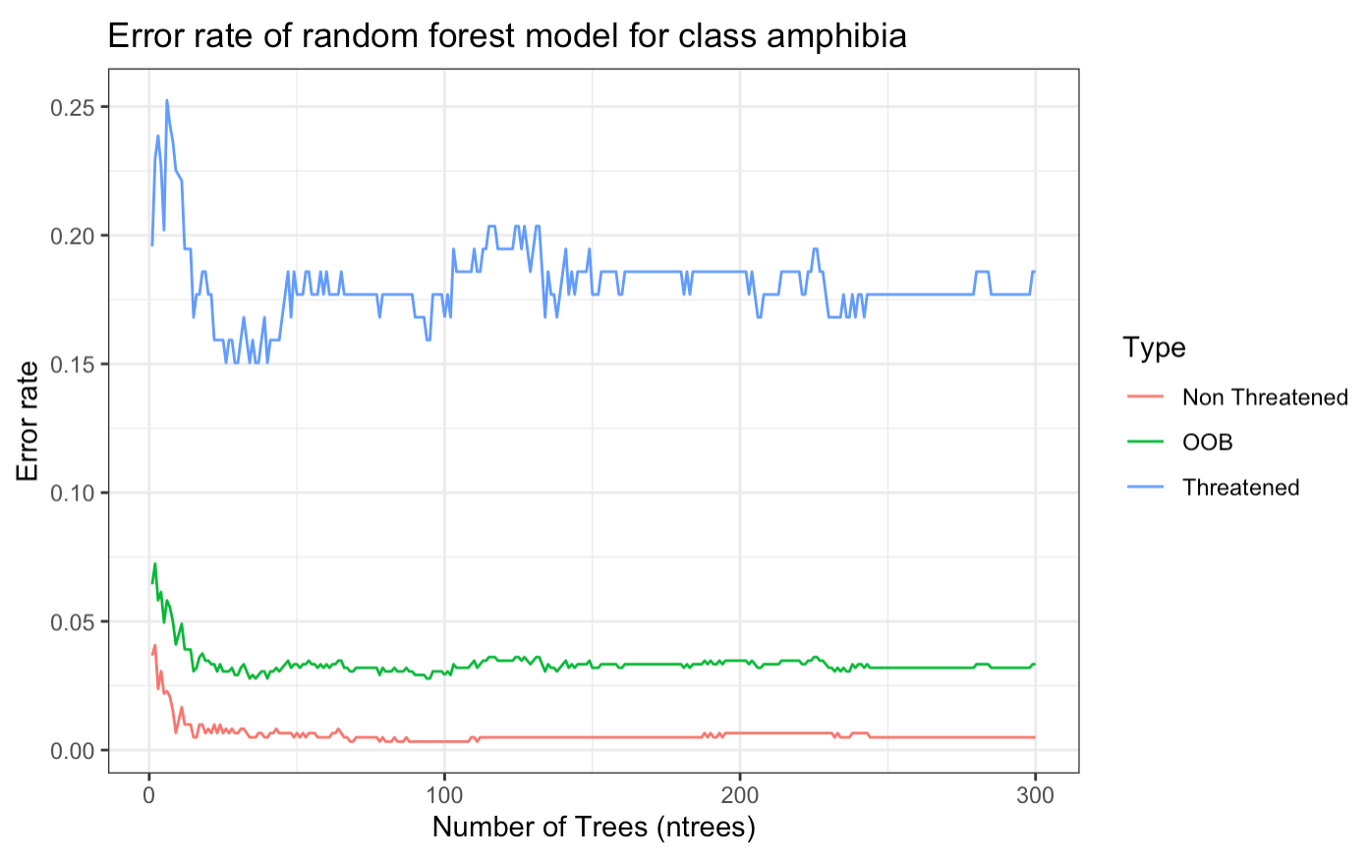

Supplemental Figure 6: Model attributes that contribute to the greatest mean decrease in accuracy in the random forest model of threat level for class Amphibia
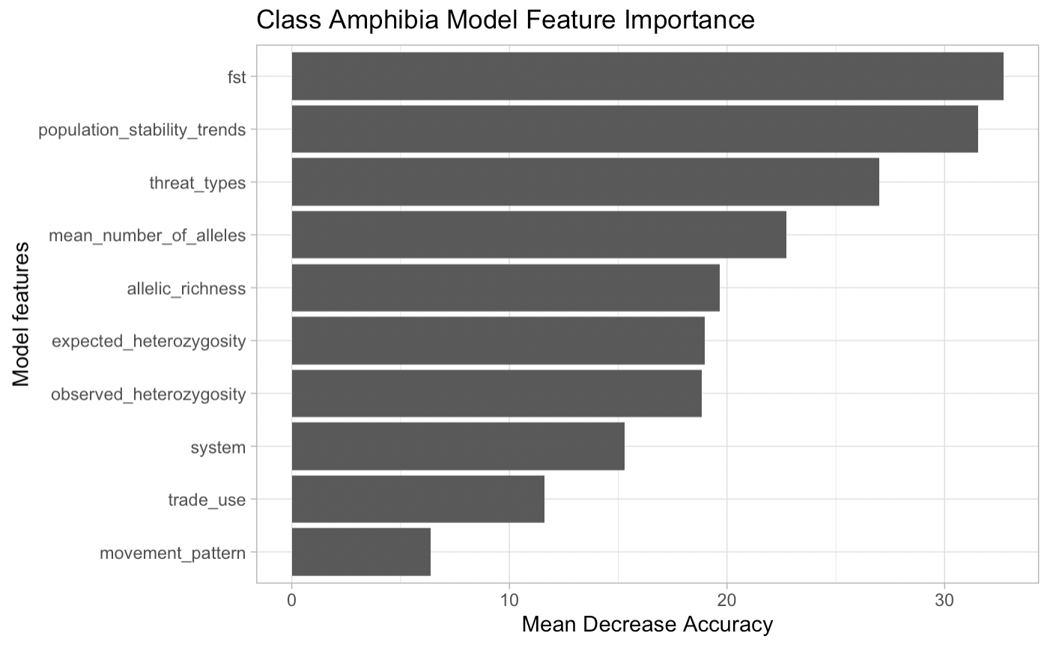
Supplemental Figure 7: Error rate of the out-of-bag estimator and response variables (threat level) of the random forest model for class Aves.
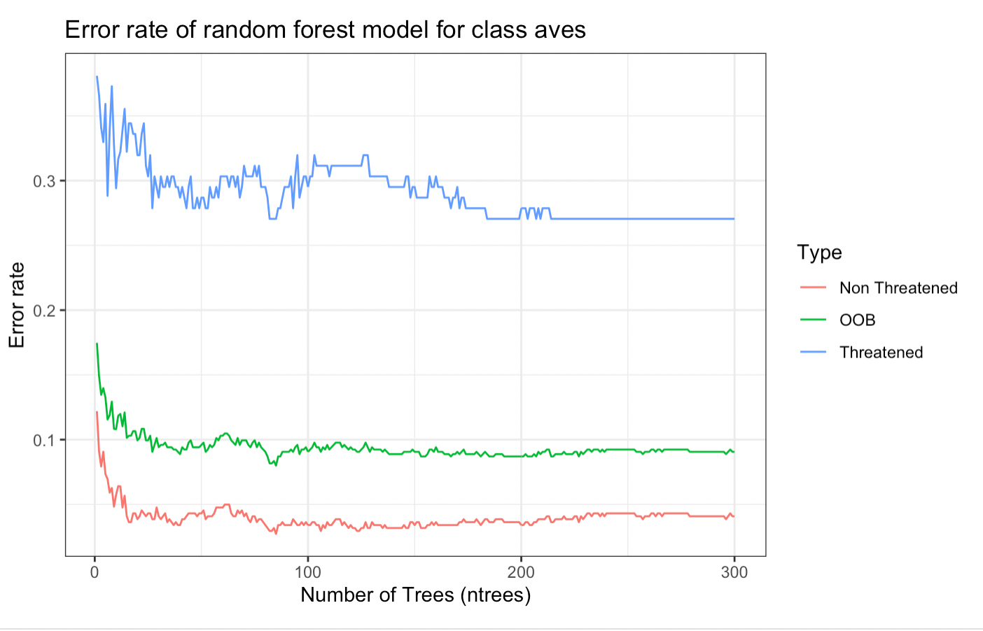

Supplemental Figure 8: Model attributes that contribute to the greatest mean decrease in accuracy in the random forest model of threat level for class Aves.
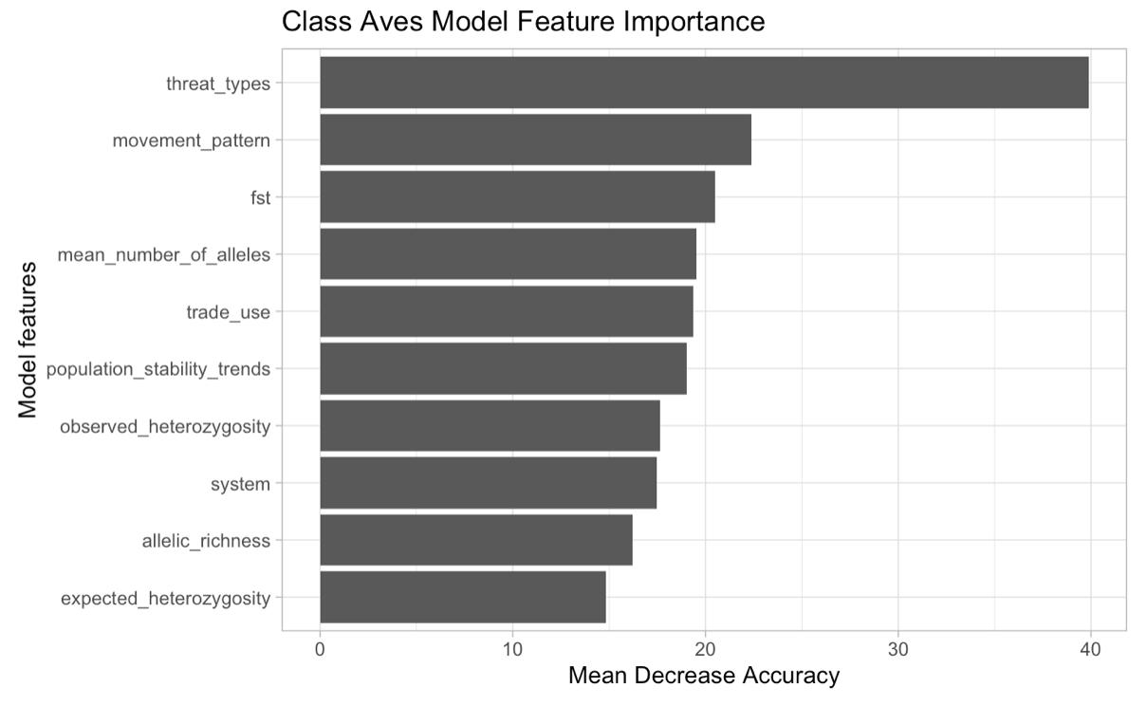
Supplemental Figure 9: Error rate of the out-of-bag estimator and response variables (threat level) of the random forest model for class Mammalia.
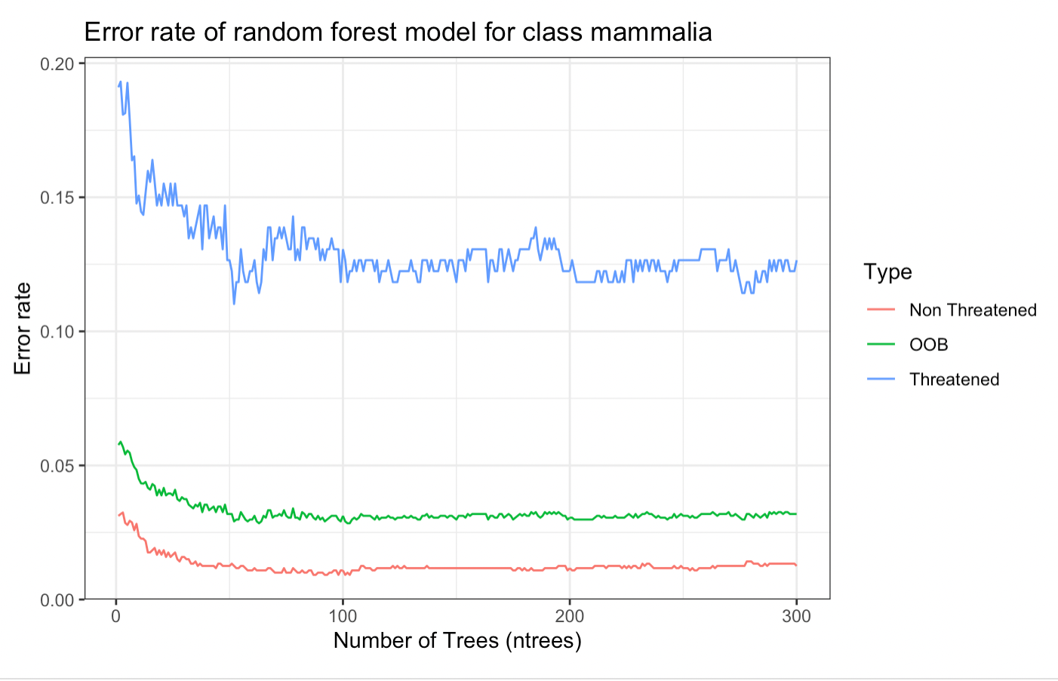

Supplemental Figure 10: Model attributes that contribute to the greatest mean decrease in accuracy in the random forest model of threat level for class Mammalia.
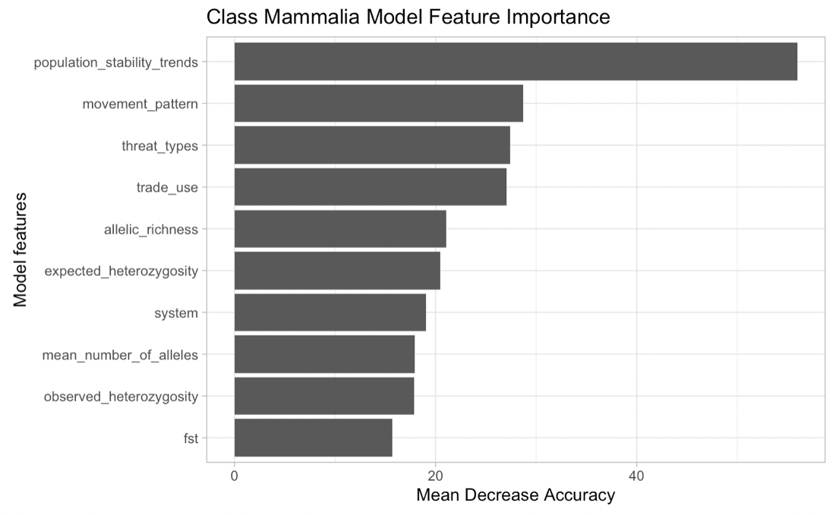
Supplemental Figure 11: Error rate of the out-of-bag estimator and response variables (threat level) of the random forest model for class Reptilia.
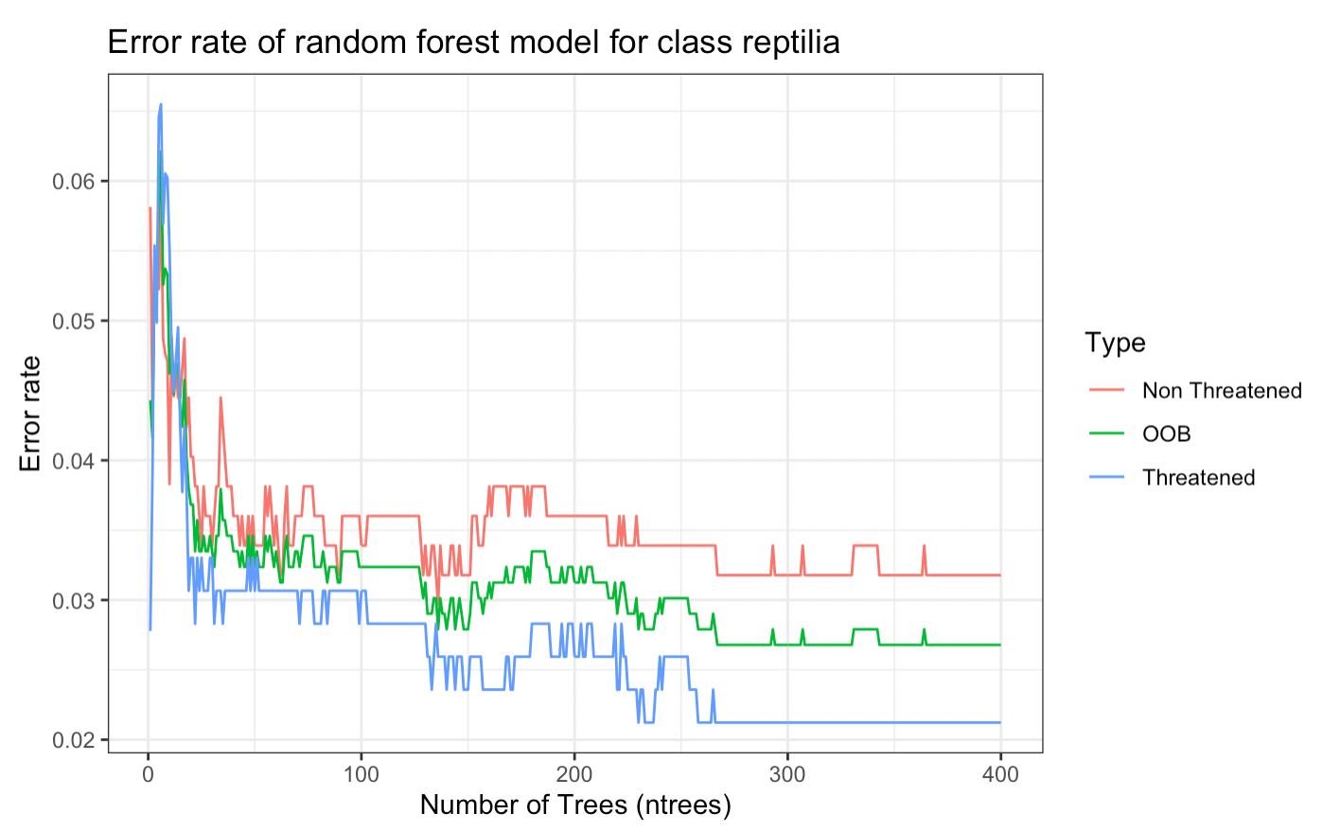

Supplemental Figure 12: Model attributes that contribute to the greatest mean decrease in accuracy in the random forest model of threat level for class Reptilia.
