Supplementary Information

Widespread link between DNA-packing density distribution and TAD boundary locations

Luming Meng,^{1,2,5*} Fu Kit Sheong,^{3*} and Qiong Luo^{4*}

¹Key Laboratory for Biobased Materials and Energy of Ministry of Education, College of Materials and Energy, South China Agricultural University, Guangzhou 510630, People’s Republic of China
²Guangdong Laboratory for Lingnan Modern Agriculture, Guangzhou 510630, People’s Republic of China
³Department of Chemistry, The Hong Kong University of Science and Technology, Clear Water Bay, Hong Kong, People’s Republic of China
⁴Center for Computational Quantum Chemistry, School of Chemistry, South China Normal University, Guangzhou 510631, People’s Republic of China
⁵Lead contact
*Correspondence: menglum@scau.edu.cn (L.M.), fksheong@connect.ust.hk (F.K.S.), luoqiong@scnu.edu.cn (Q. L.)

Supplementary Fig. 1 Plots of bead numbers, different sets of random independent Poisson variables (k₁, k₂,…k_{N}), and DNA-packing density in our models, resulted from population-based chromatin accessibility data
(A to C) Row 1: Population-averaged chromatin accessibility data for the 5-Mb chromatin region (Chr5: 109Mb-114 Mb) in K562 erythroleukemia cell type obtained from ATAC-seq experiment (A) or from DNase-seq experiment (B), and in IMR90 lung fibroblast cell type obtained from ATAC-seq experiment (C). Row 2: Ten sets of random independent Poisson variable vectors (k₁, k₂,…k_{N}) are derived from the data shown in Row 1 by the approach of developing heteropolymer models. Row 3: The mean vector across the ten vectors shown in Row 2, showing the mean value of bead number for each 10-kb segment in the region. Note that the profile of this plot is similar to that of population-averaged chromatin accessibility data shown in Row 1, consistent with our Poisson model of bead number generation. Row4: DNA-packing density, which is defined as the length of the segment (in kb) divided by the average number of beads (shown Row 3).

Supplementary Fig. 2 Plots of population-averaged chromatin accessibility data, averaged bead number distribution, and DNA-packing density for cells at eight developmental stages.
(A and B) Column 1: Population-averaged chromatin accessibility data for the genomic region (Chr11:18Mb-20Mb) (A) and the region (Chr12:107Mb-110Mb) (B) in cell types of eight developmental stages (HSPC, MPP, CLP, ETP, DN2, DN3, DN4, and DP) during the differentiation shown in Figure 4. Column 2: The mean value of bead number for each 10-kb segment in the region. Column 3: DNA-packing density, which is defined as the length of the segment (in kb) divided by the average number of beads shown in Column 2.

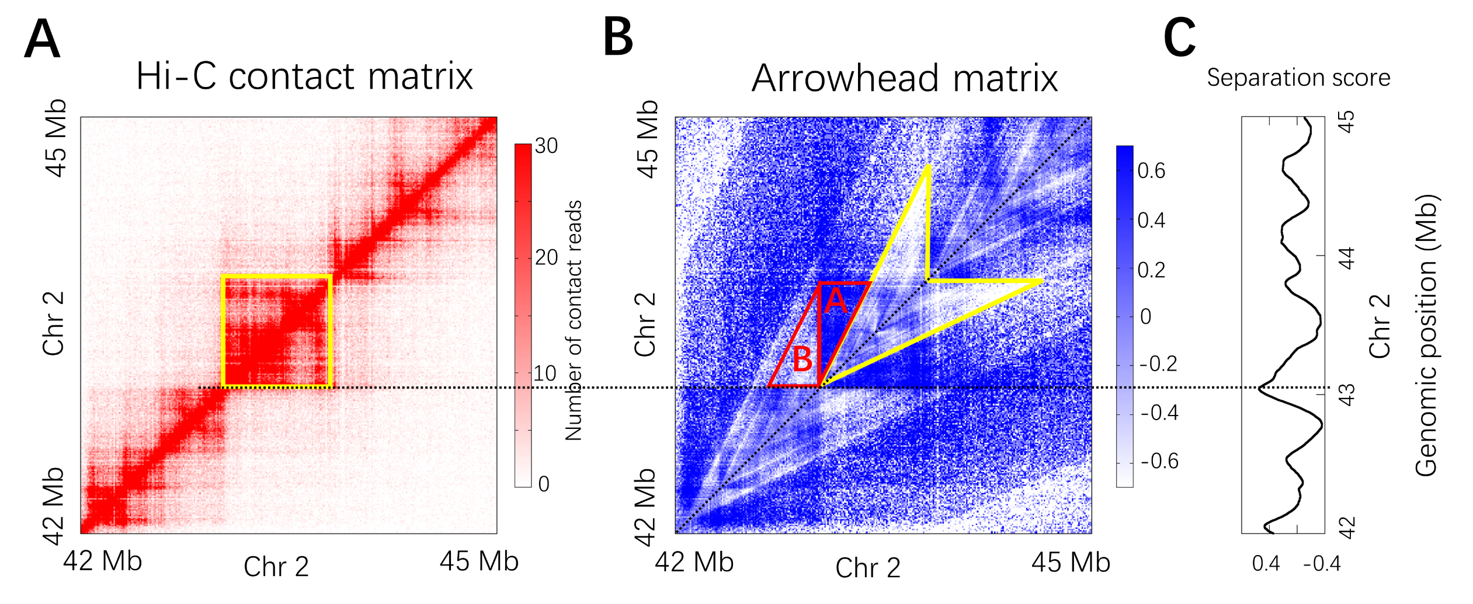
Supplementary Fig. 3 A scheme of the definition of separation score
(A)Population-average Hi-C contact frequency matrix for the 3-Mb region (Chr2:42Mb-45Mb) of K562 at 10-kb resolution.
(B)The arrowhead matrix M where the arrowhead-shaped motif highlighted by yellow corresponds to the yellow highlighted domain square in panel A.
(C) Separation score of a position along the diagonal of the arrowhead matrix is defined based on the two constructed edge-shared congruent right triangles at that position. As an example, such two edge-shared congruent right triangles of the position corresponding to a domain boundary are highlighted by red in panel B. The length of horizontal edge of the two congruent right triangles is 250-kb and the length of the vertical edge (or shared edge) is 500-kb.

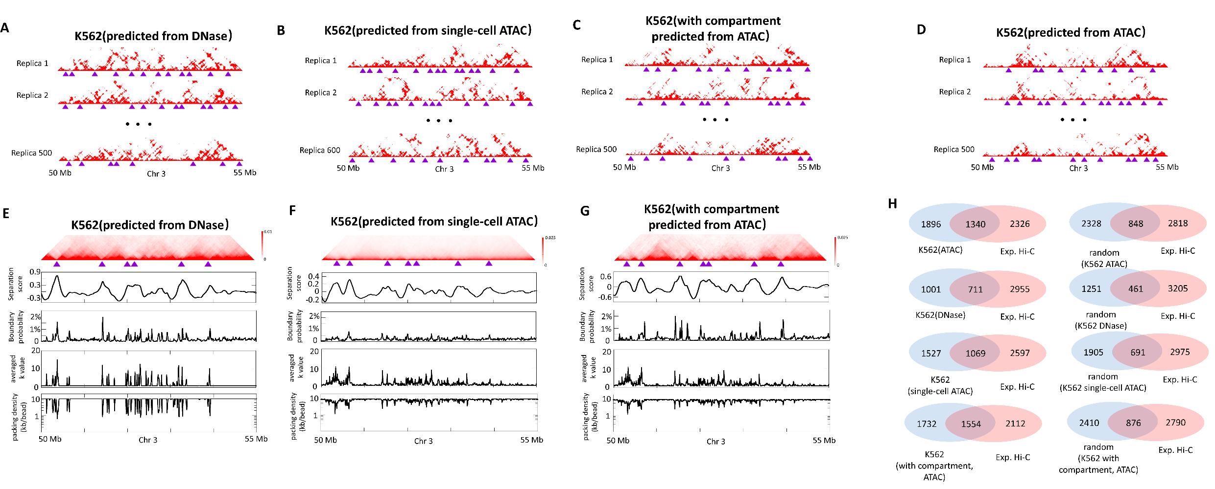
Supplementary Fig. 4 Prediction of domain boundary positions of K562 cell type by the our model and comparison against those obtained from experimental Hi-C data
(A to D)Individual contact matrices of the 5-Mb chromatin region (Chr3:50Mb-55 Mb) in K562, calculated from individual conformations in the conformation ensemble of K562 calculated from population-averaged DNase-seq data(A), single-cell ATAC-seq data(B), population-averaged ATAC-seq data with self-attractions between heterochromatin regions(C), population-averaged ATAC-seq data(D). Domain structures are identified for each individual conformations and their boundaries are shown as purple triangles.
(E to G) Row 1: Ensemble-averaged contact matrix across the all individual contact matrices of chromatin region (Chr3:50Mb-55 Mb) shown in pannel A and C. Row 2: Separation score plot for segments in this chromatin region. Row 3: Probability (fraction of the individual conformations) for each genomic segment to appear as a single-cell domain boundary. Row 4: Averaged k_{i} for each of the 10-kb segments. Row 5: DNA-packing density along the segment, defined by the length of the segment (in kb) divided by the average number of beads in the segment.
(H) Analysis of the overlapping TAD boundaries between the Hi-C contact matrix and the three ensemble-averaged contact matrices calculated from three ensembles of K562. As comparison, similar overlapping analysis are also shown between Hi-C derived TAD boundaries and random TAD boundaries (generated by circular shifting the genomic positions of domain boundaries determined from corresponding ensemble-averaged contact matrix along chromatin sequence).

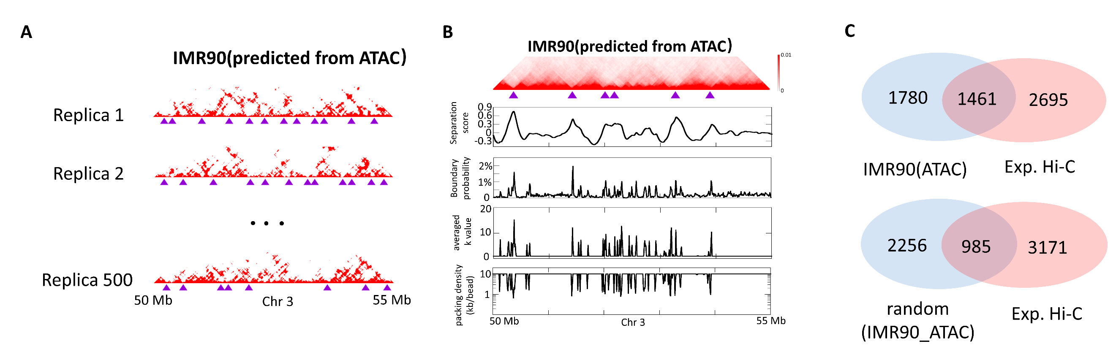
Supplementary Fig. 5 Prediction of domain boundary positions of IMR90 cell type by the our model and comparison against those obtained from experimental Hi-C data
(A)Individual contact matrices of the 5-Mb chromatin region (Chr3:50Mb-55 Mb) in IMR90, calculated from individual conformations in the conformation ensemble of IMR90 calculated from population-averaged DNase-seq data. Domain structures are identified for each individual conformations and their boundaries are shown as purple triangles.
(B) Row 1: Ensemble-averaged contact matrix across the all individual contact matrices of chromatin region (Chr3:50Mb-55 Mb) shown in pannel A. Row 2: Separation score plot for segments in this chromatin region. Row 3: Probability (fraction of the 500 individual conformations) for each genomic segment to appear as a single-cell domain boundary. Row 4: Averaged k_{i} for each of the 10-kb segments. Row 5: DNA-packing density along the segment, defined by the length of the segment (in kb) divided by the average number of beads in the segment.
(C) Analysis of the overlapping TAD boundaries between the Hi-C contact matrix and ensemble-averaged contact matrix calculated from three ensembles of IMR90. As comparison, similar overlapping analysis are also shown between Hi-C derived TAD boundaries and random TAD boundaries (generated by circular shifting the genomic positions of domain boundaries determined from corresponding ensemble-averaged contact matrix along chromatin sequence).

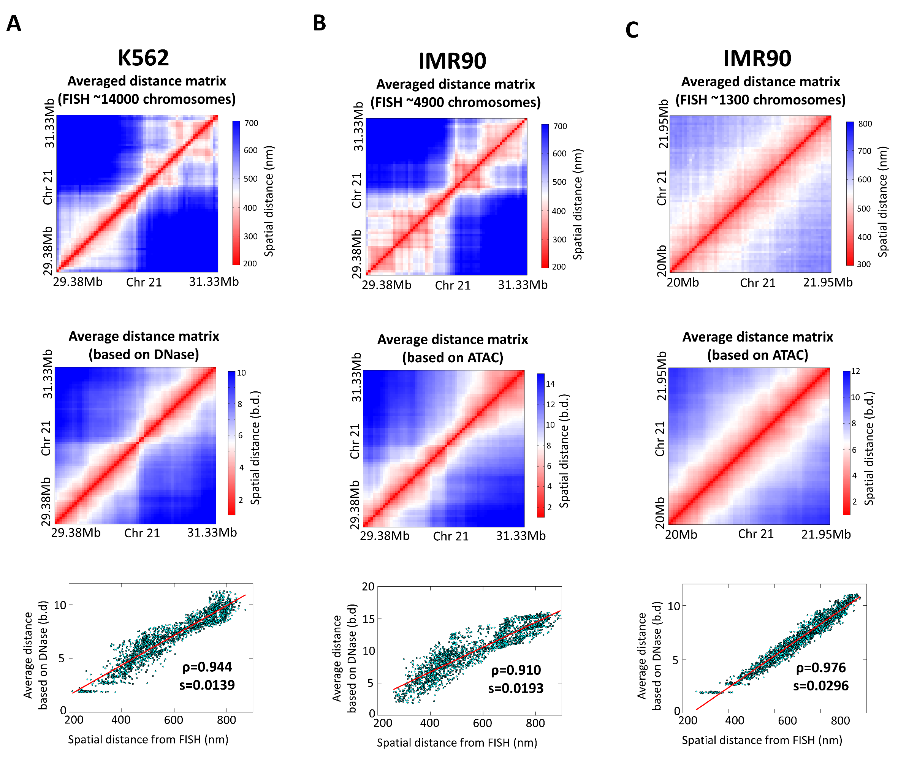
Supplementary Fig. 6 Predictions of chromatin organization by our model and comparison against experimental FISH data for three regions.
(A to C) Row 1: The experimental averaged distance matrices at 30-kb resolution across ~14,000 FISH images of the 2-Mb region (Chr21:29.38Mb-31.33Mb) in K562 cell type (A), across ~4900 FISH images of the 2-Mb region (Chr21:29.38Mb-31.33Mb) in IMR90 cell type (B), across~1300 FISH images of the 2-Mb region (20Mb-21.95Mb) in IMR90 cell type (C). Row 2: The 30-kb resolution ensemble-averaged distance matrix of the region shown in Row 1, calculated from the conformation ensemble of K562 predicted from DNase-seq data (A) or calculated from the conformation ensemble of IMR90 predicted from ATAC-seq data (B and C). Row 3: Correlation between the elements of the FISH distance matrix shown in Row 1 and the ensemble-averaged distance matrix shown in Row 2.
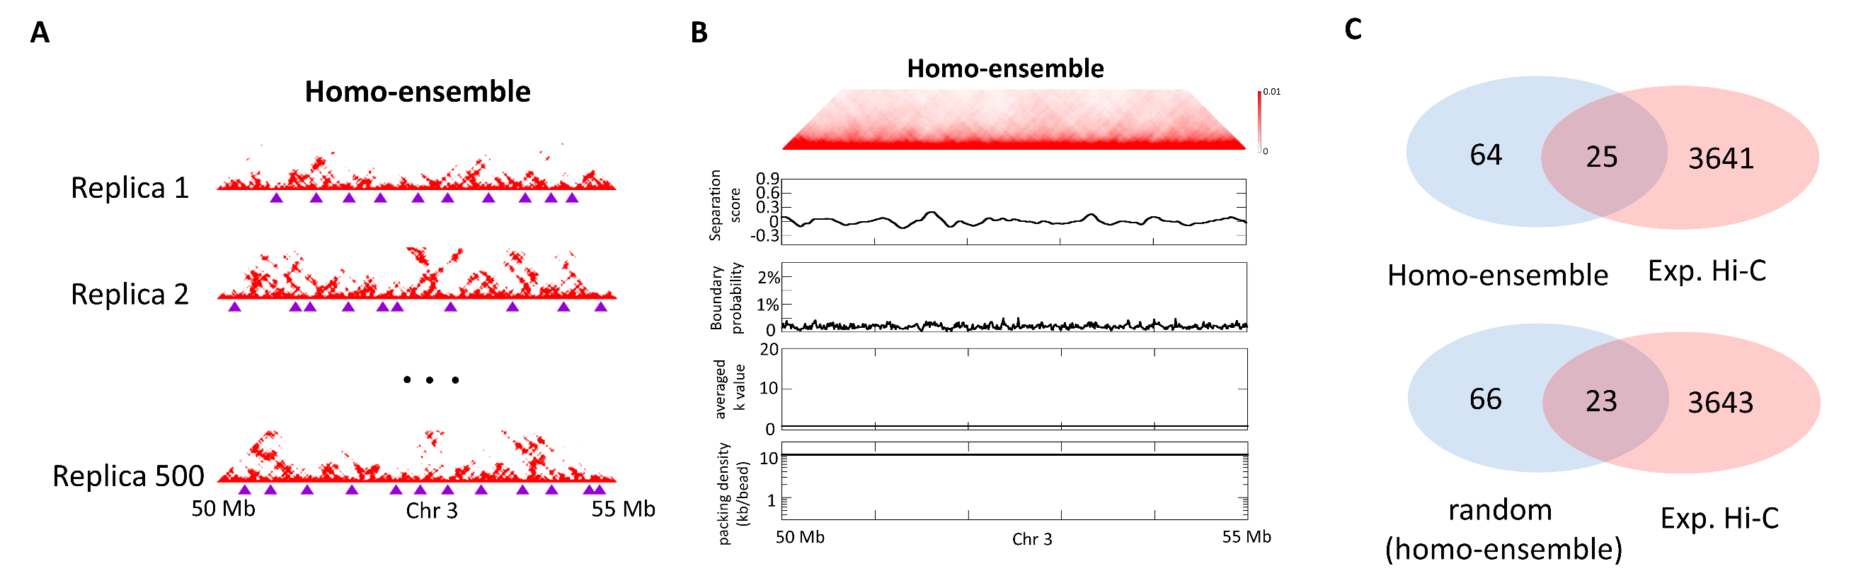
Supplementary Fig. 7 Domain boundaries in the conformation ensemble generated based on the polymer model that is homogeneous in DNA-packing density
(A)Individual contact matrices of the 5-Mb chromatin region (Chr3:50Mb-55 Mb), calculated from individual conformations in the conformation ensemble of homogeneous DNA-packing density model. Domain structures are widespread in individual conformations and their boundaries (indicated by purple triangles) show apparent variation among conformations.
(B)Row 1: Ensemble-averaged contact matrix across the 500 individual contact matrices shown in a. No discernable diagonal blocks appear in the 5-Mb region. Row 2: Separation sore for each genomic position. Row 3: Probability (fraction of the 500 individual conformations) for each genomic position to appear as a single-cell domain boundary. Row 4: Averaged k_{i} for each of the 10-kb segments. Row 5: DNA-packing density along the segment, defined by the length of the segment (in kb) divided by the average number of beads in the segment.
(C)Analysis of the overlap of TAD boundaries among Hi-C contact matrix (of K562 as an example) and the ensemble-averaged contact matrix calculated from conformation ensemble of homogeneous DNA-packing density model.

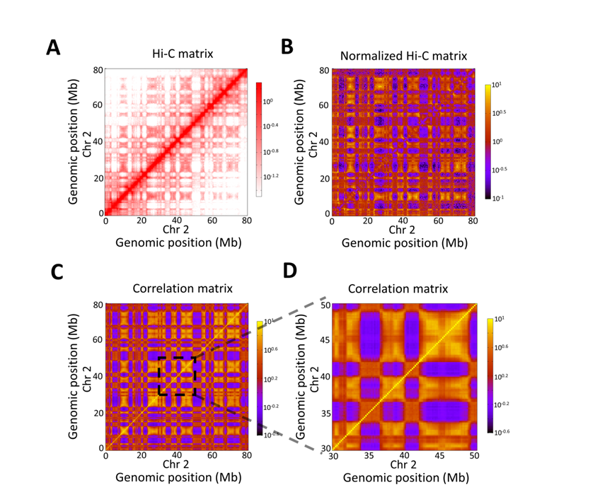
Supplementary Fig. 8 Identification of compartments from the Hi-C contact-frequency matrix. (A) Hi-C matrix of the region (Chr2: 0Mb -80Mb) of K562 at 200-kb resolution. (B) Normalized Hi-C contact frequency matrix at 200-kb resolution, calculated through dividing each matrix element in (A) by the genome-wide average contact frequency for bin pairs at the same genomic distance. (C) Correlation matrix calculated from (B) illustrates large blocks of enriched and depleted interactions. The plaid pattern indicates the presence of two compartments. (D) An expanded view of the region (Chr2: 30Mb -50Mb).

