Concordant and discordant polygenic scores and their association with time to MACE in primary and secondary prevention

Due to the greater contribution of the PRSs to prediction performance in individuals at higher risk that we observed in the analysis of primary MACE, we wanted to investigate whether the PRSs could also contribute to MACE prediction in individuals with established CVD. We first attempted to achieve this using data from biobank participants who had prior history of CVD (N=10,448). Compared to individuals without prior MACE, participants with prior MACE were older, had higher HbA1c and lower HDL and eGFR (Figure 1).

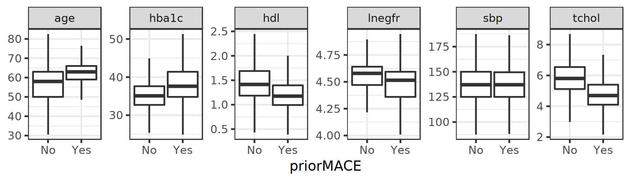
Figure 1. Distribution of SCORE2 predictors among UK Biobank participants with and without prior MACE at baseline.

To assess whether the effects of the PRSs change across prior MACE strata, we included individuals regardless of their MACE history and then refitted the Cox models adding interaction terms between each PRS and prior MACE. We found that the effect of both concordant and discordant PRSs on the incidence of secondary MACE in individuals with prior MACE were attenuated with respect to the effect on primary MACE. The concordant PRS coefficient was especially in males with prior MACE was particularly affected (Concordant PRS * prior MACE interaction estimate = -0.013, 95% CI: -0.018, -0.007, p = 7.04·10⁻⁶). This attenuation was also seen after adjustment by SCORE2-Diabetes covariates (Supplementary Table 17).

We also fitted Cox models only in individuals with prior MACE to test the added value of the PRSs in these subpopulations. Aside from encountering the same attenuation described in the interaction models, we found that adding the PRSs to SCORE2 did not improve the predictive ability in individuals with prior MACE (likelihood ratio test > 0.05).

Given that UK Biobank participants tend to be healthier, we further explore the association of the PRSs in populations at higher risk using data from ORIGIN, an international multicentre trial that included individuals with dysglycemia and evidence of established CVD (N = 4,147). A considerable proportion of participants already had prior history of MACE at baseline (~38%). We evaluated the association of the PRSs to prevalence of MACE using logistic regression, and to incidence of MACE using Cox regression adjusting for treatment allocation. We analysed each ancestry separately and then combined the estimates using fixed effects meta-analysis.

As expected, the concordant PRS was significantly associated with higher prevalence of MACE, while the discordant PRS tended to be associated with lower prevalence (OR_{C} = 1.003 per allele, 95% CI: 1.001, 1.006; OR_{D} = 0,996 per allele, 95% CI: 0.990, 1.003; p_{δ} = 0.06). Notably, in ancestry-specific analyses we found that the Native Latin subgroup of ORIGIN (N = 2,216), whose prevalence of MACE was much higher compared to individuals of European ancestry (42% vs. 34%, respectively), there was also a significant association of the concordant PRS with higher MACE prevalence (OR_{C} = 1.005 per allele, 95% CI: 1.001, 1.008; OR_{D} = 0.995 per allele, 95% CI: 0.986, 1.005; p_{δ} = 0.07, Supplementary Table 6).

In contrast to these cross-sectional associations, during follow-up the discordant PRS was significantly associated with higher MACE incidence, exceeding the estimated effect of the concordant PRS (HR_{C} = 1.003 per allele, 95% CI: 0.989, 1.017; HR_{D} = 1.040 per allele, 95% CI: 1.006, 1.075; p_{δ} = 0.04, Supplementary Table 18). Ancestry-specific analyses showed that in Native Latin population not only was there a significant association of the discordant PRS with higher incidence of MACE, but also a tendency of the concordant PRS to be associated with lower incidence (HR_{C} = 0.995 per allele, 95% CI: 0.976, 1.014; HR_{D} = 1.057 per allele, 95% CI: 1.010, 1.106; p_{δ} = 0.01). We noted that this finding was driven by individuals with prior history of MACE (HR_{C} = 0.993 per allele, 95% CI: 0.967, 1.019; HR_{D} = 1.094 per allele, 95% CI: 1.026, 1.167; p_{δ} = 0.006). Thus, the observed inverted effects could be a consequence of participant selection, where individuals with MACE and high discordant PRS offset their genetic protection, while individuals with high concordant PRS counteract their genetic risk through better lifestyles or environment, making them able to survive enough to be part of the study. Accordingly, the overall association of the discordant PRS with higher incidence was attenuated after adjusting for traditional risk factors (HR_{C} = 1.003 per allele, 95% CI: 0.989, 1.017; HR_{D} = 1.028 per allele, 95% CI: 0.994, 1.064; p_{δ} = 0.18). As observed in participants with prior MACE in UK Biobank, adding the PRSs did not improve prediction (likelihood ratio test > 0.05). Putting together the estimates found for primary and secondary MACE in UK Biobank, with those found in the ORIGIN trial, we observe a continuum of shift of concordant and discordant estimates to the opposite direction of what is found in healthier individuals as we move to individuals with higher risk (Figure 2).

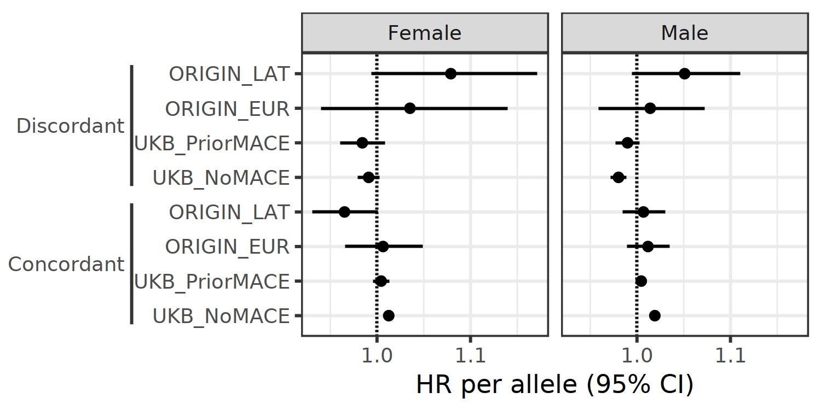
Figure 2. Shift in direction of effect of concordant and discordant PRSs from individuals without prior MACE in UK Biobank to individuals of Latin American ancestry in ORIGIN, who had the highest prior MACE rates.

