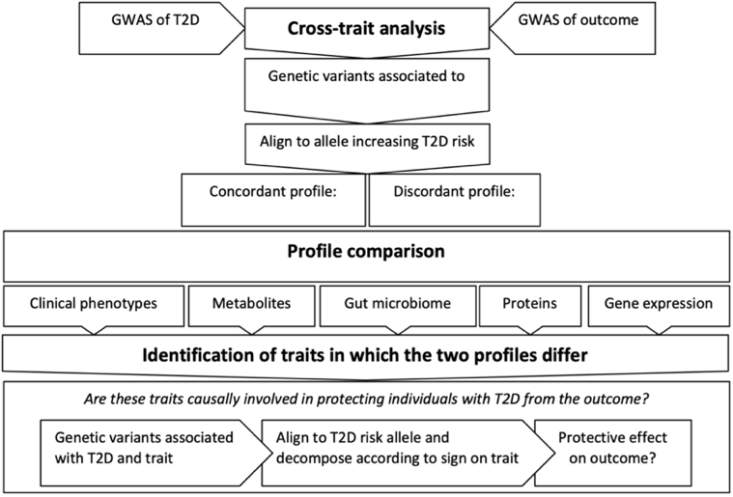
Supplementary Figure 1. Analysis flowchart for each outcome.

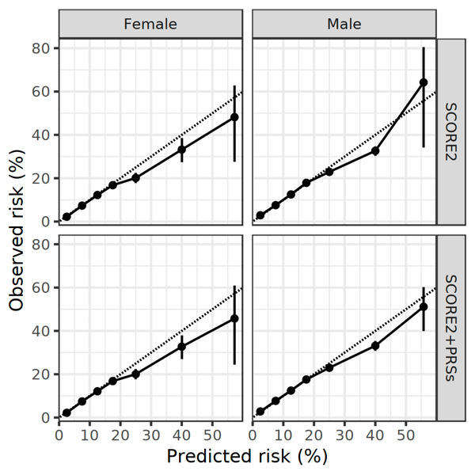
Supplementary Figure 2. Calibration of models with and without PRSs

