Supplementary Figure 1: CNV calling pipeline overview. BAM, binary sequence alignment map; VCF, variance call format; SNV, single nucleotide variant; VAF, variance allele frequency; WGD, whole genome duplication.

Supplementary Figure 2: Overview of stage 2 of the CNV calling pipeline. SNV, single nucleotide variant; VAF, variant allele frequency.
Supplementary Figure 3: Quantile-quantile plots of OncodriveFML analysis of non-coding elements. Red circles indicate non-coding elements with Q<0.01.
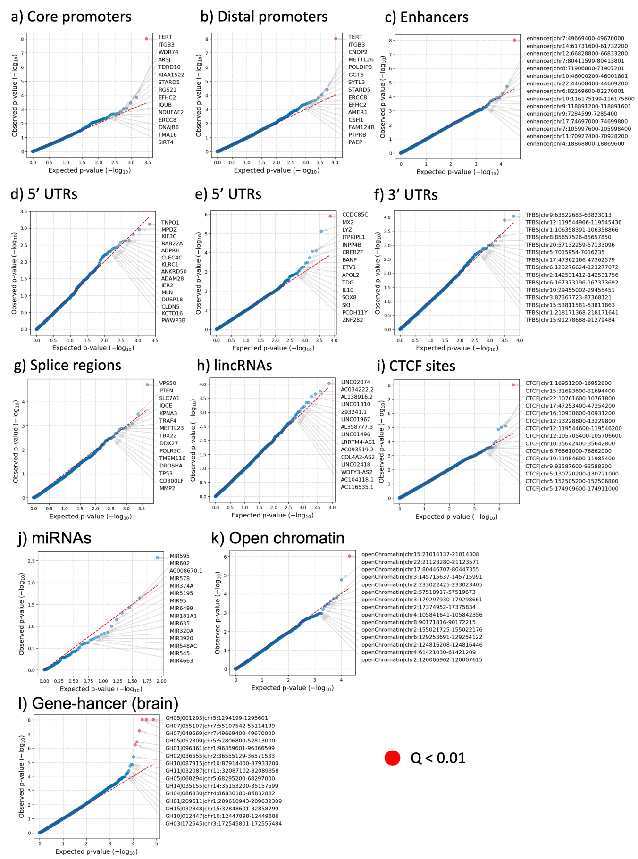
Supplementary Figure 4: Frequency of extrachromosomal DNA (ecDNA) by subtype and its contribution to oncogene amplification. (A) Counts of tumours carrying ≥ 1 ecDNA amplicon across tumour subtypes (e.g. tumour counted as “Circular” if ≥ 1 circularised amplicon detected, otherwise “BFB” if ≥ 1 BFB amplicon detected until “No amp” where no valid amplicon detected). (B-D) ecDNA classification of commonly amplified oncogenes in GBM, Astrocytoma and Oligodendroglioma tumours respectively. Classification restricted to gene amplifications with a total copy number ≥ 5 in diploid tumours and ≥ 10 in tetraploid tumours (i.e. “big gains”). Counts based on data from Supplementary Table 8.
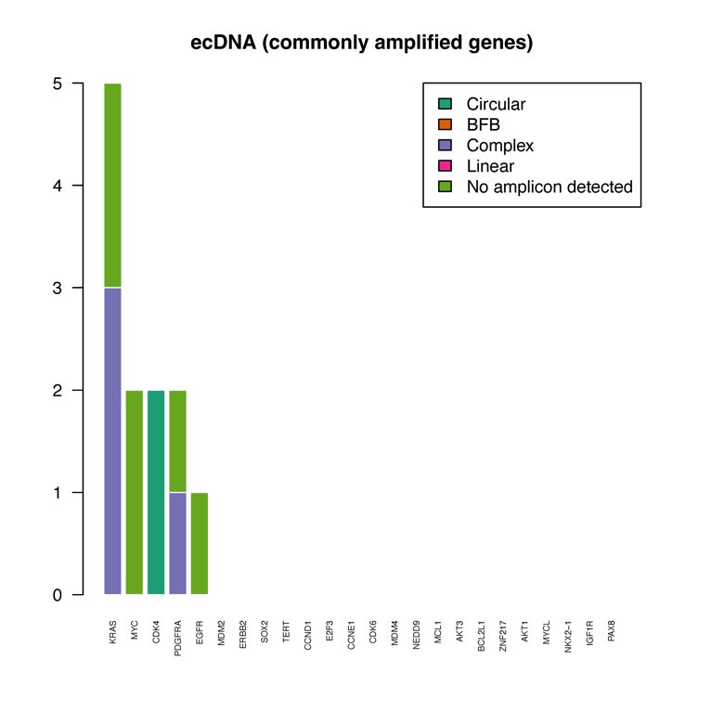
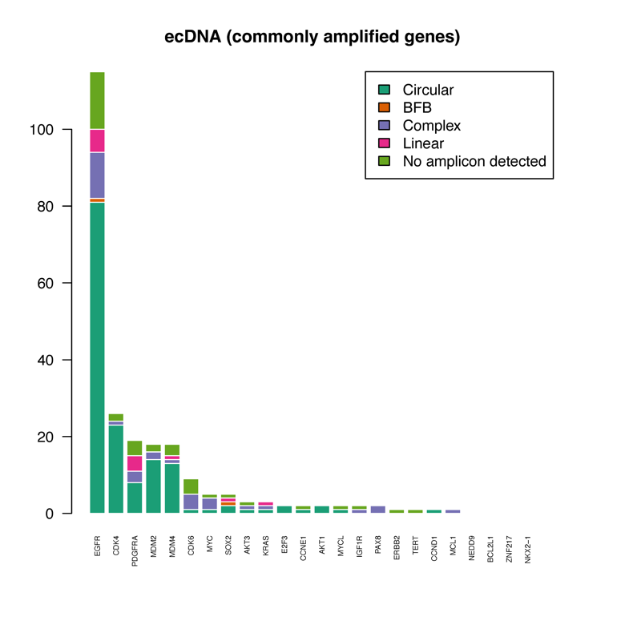
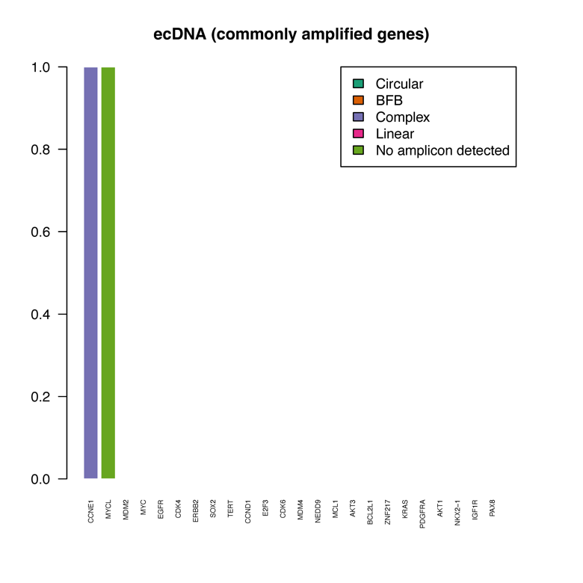
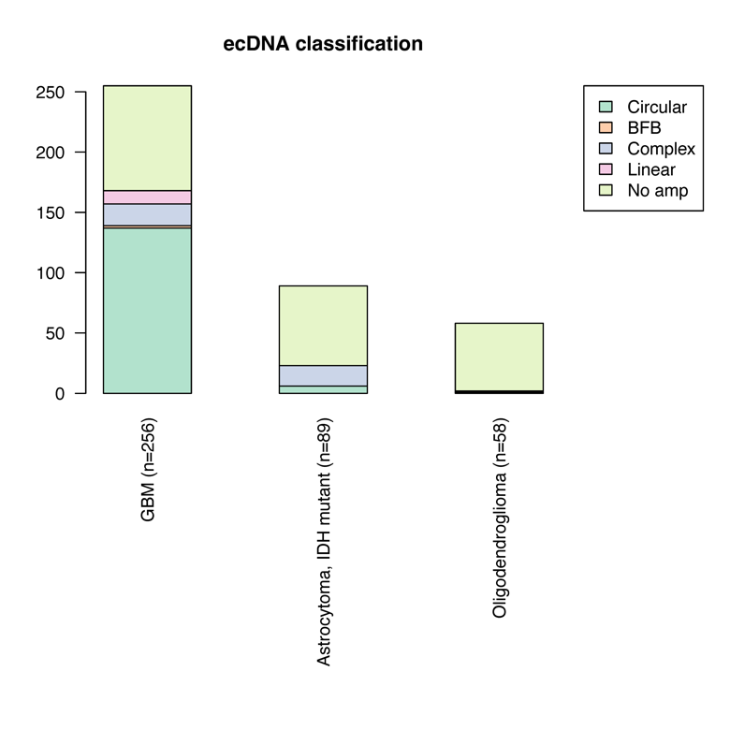
A
B
C
D
Extrachromsomal DNA (ecDNA) classification
GBM (n=256)
Astrocytoma (n=89)
Oligodendroglioma (n=58)

Supplementary Figure 5: Association between survival and EGFR amplification in extrachromosomal DNA. (A-B) Kaplan-Meier plots of mOS in all tumours (A) and primary glioblastoma (B). The table below depicts the number of patients at risk at each individual time point. (A) There is a statistically significant difference in mOS between tumours where EGFR amplified ecDNA is present (purple) compared to tumours without ecDNA (orange) in all tumours (LRT P<0.0001). (B) There is no statistically significant difference in mOS (LRT P>0.05) when comparing the presence EGFR amplification in ecDNA restricted to in primary glioblastoma; (C-D) Cox logistic regression (adjusted for age and gender in all tumours, and additionally MGMT methylation status in glioblastoma) analysis comparing predicted survival in patients with ecDNA EGFR amplification in all tumours (C) and in only primary glioblastoma (D). The table below each graph details the HR and associated CIs for each co-variate. (C) There was a statistically significant difference in predicted survival in all tumours comparing EGFR amplification in ecDNA (purple) to no EGFR amplification (P<0.01). (D) Cox logistic regression performed on primary glioblastoma shows no significant difference (P>0.05). There is a strong association of predicted survival with MGMT methylation status (independent of EGFR amplification in ecDNA, HR 0.51, CI 0.37-0.71).

Supplementary Figure 6: Per-tumour actionability across glioma subtypes
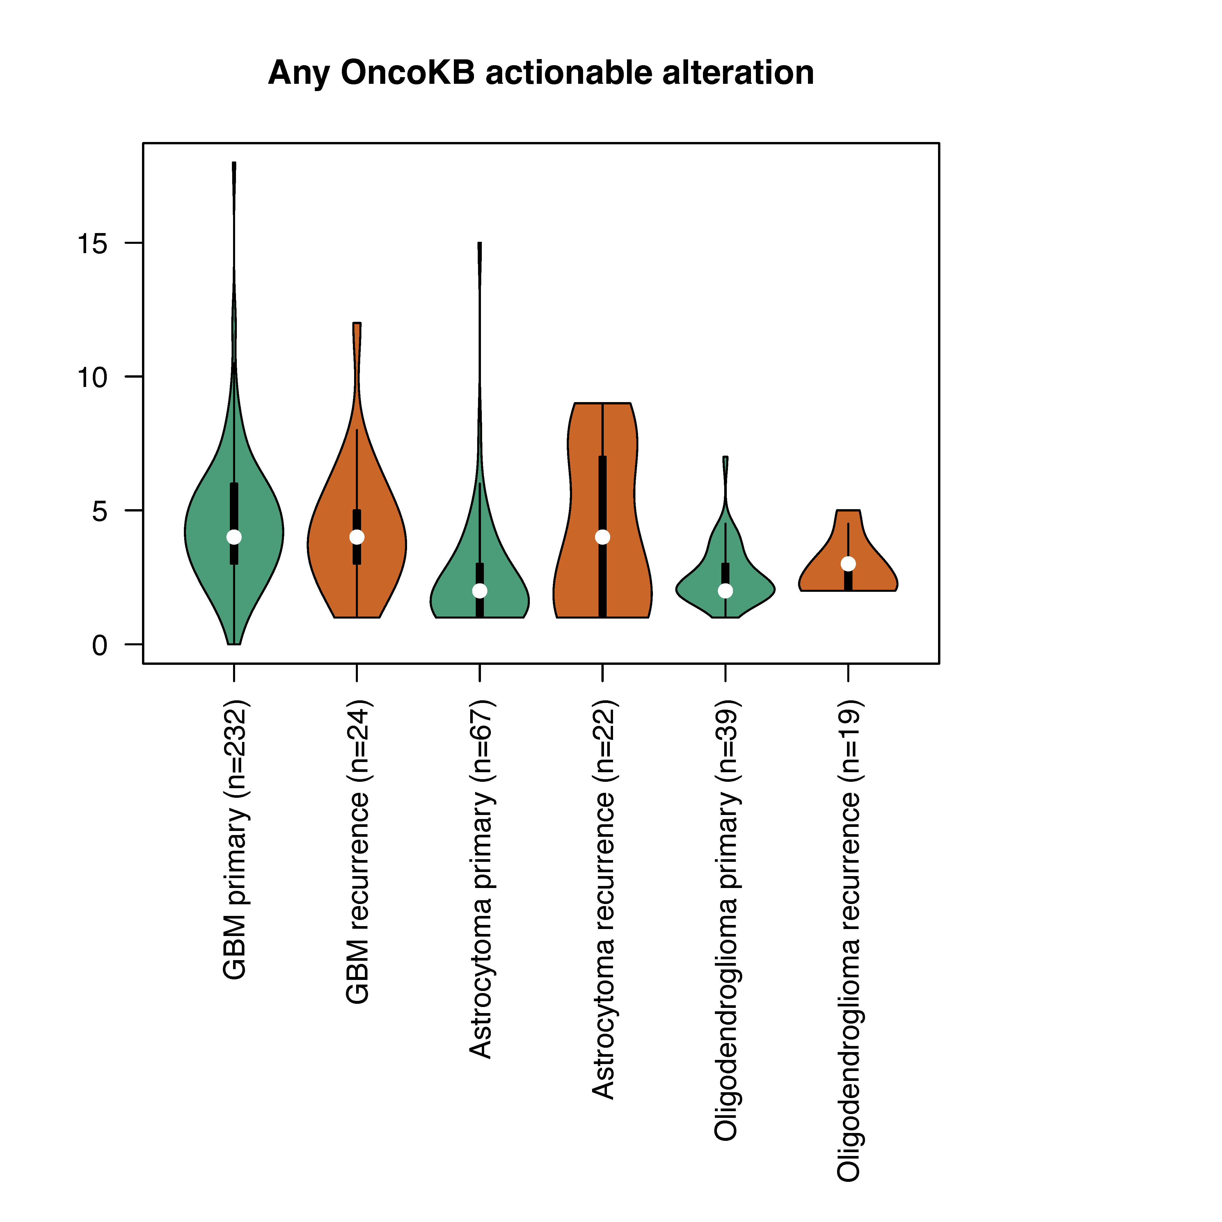
GBM
Astrocytoma
Oligodendroglioma
P
R
P
R
P
R
P=0.44
P=0.025
P=0.21

Supplementary Figure 7: SNV and indel mutation clonality across glioma subtypes.
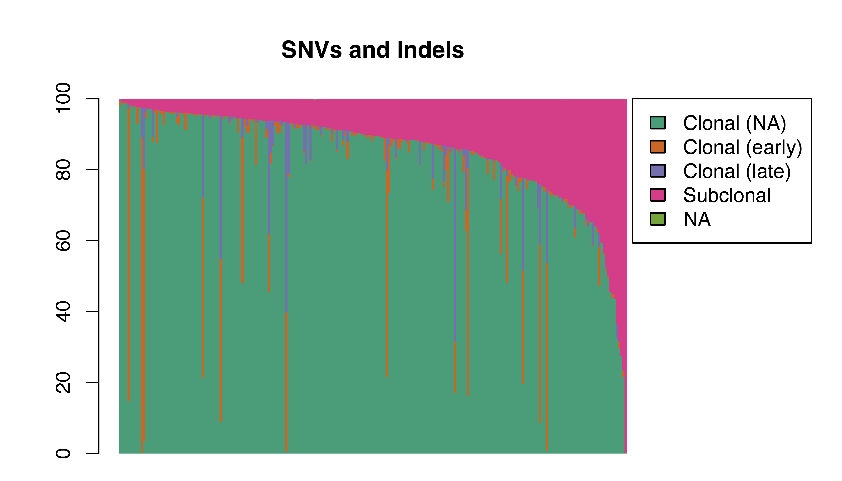
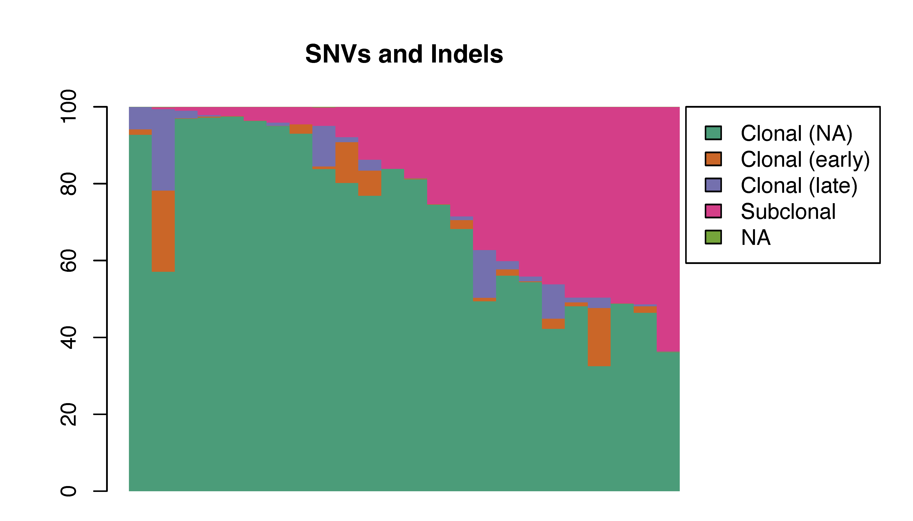
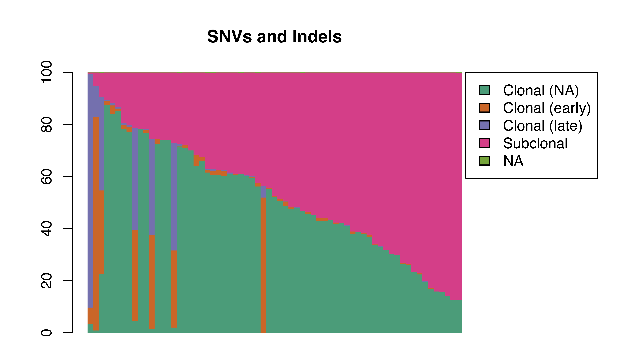
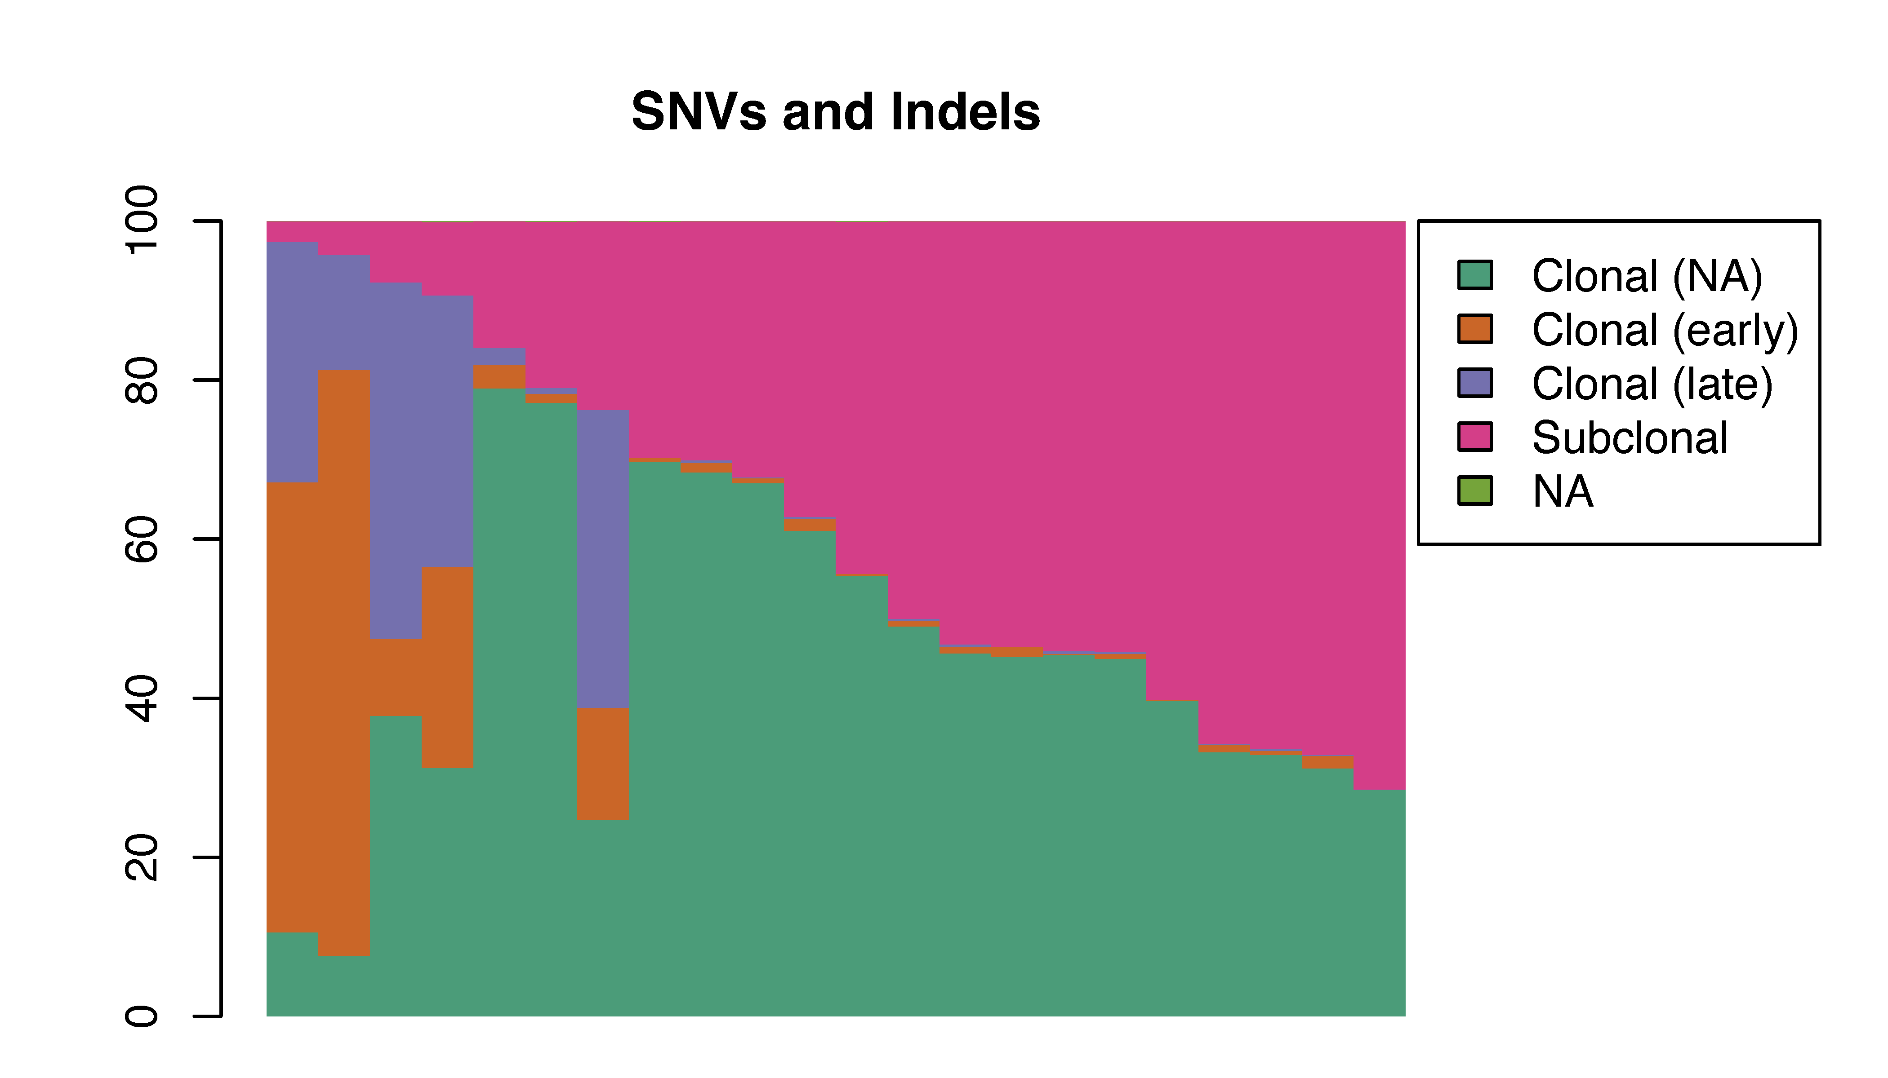
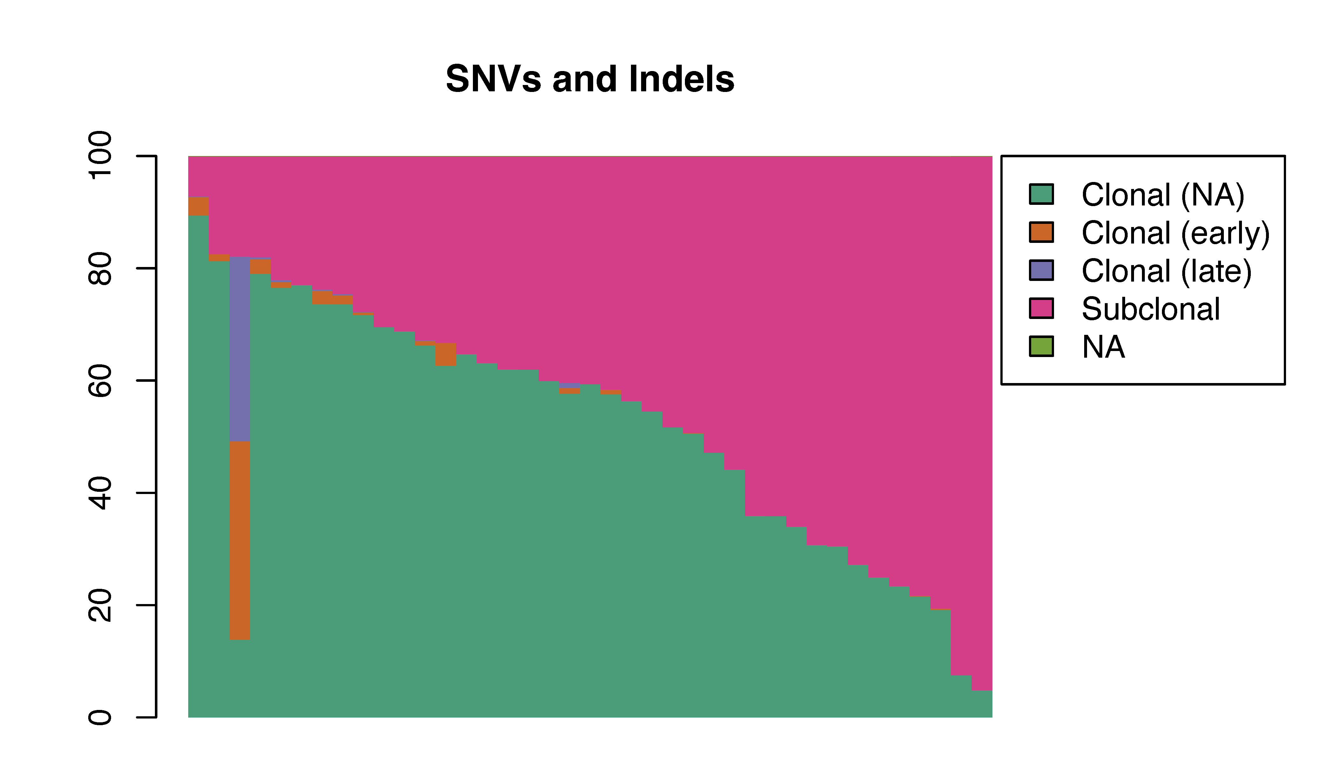
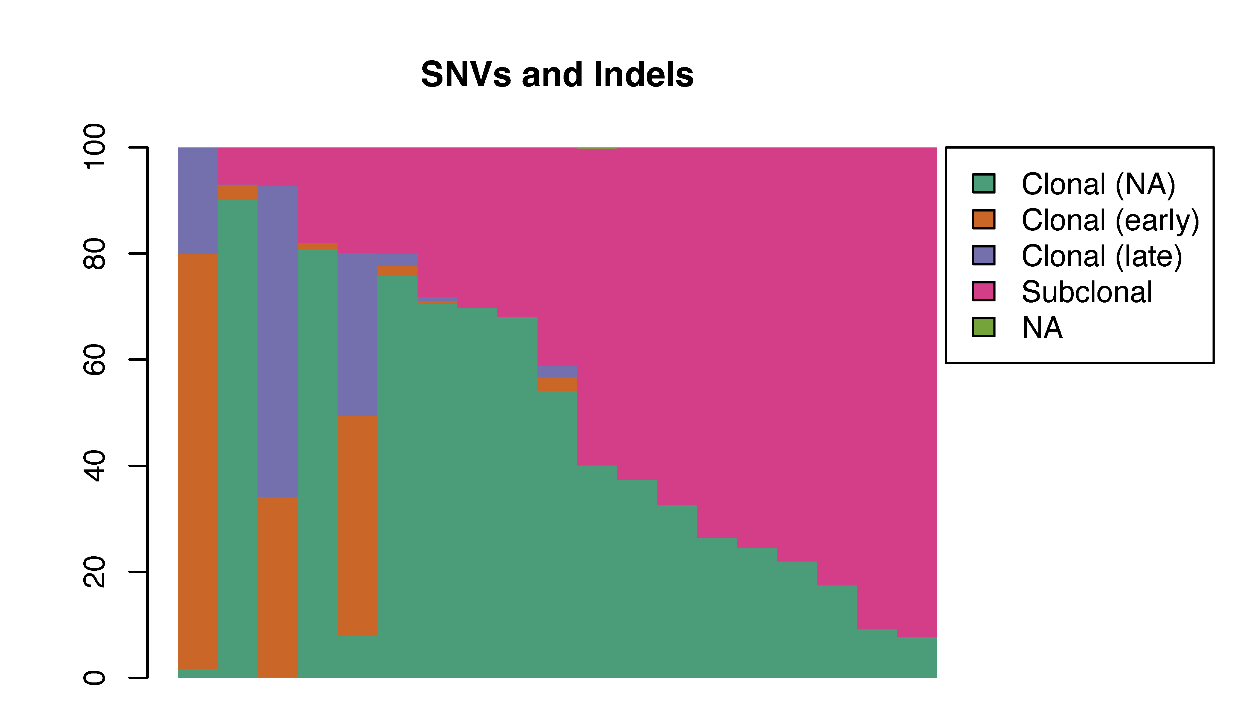
Primary GBM (n=232)
Recurrent GBM (n=24)
Primary Astrocytoma (n=67)
Recurrent Astrocytoma (n=22)
Primary Oligodendroglioma (n=39)
Recurrent Oligodendroglioma (n=19)
A
B
C
D
E
F
Tumour
Proportion of mutations
Tumour
Proportion of mutations
Tumour
Proportion of mutations
Tumour
Proportion of mutations
Tumour
Proportion of mutations
Tumour
Proportion of mutations

Supplementary Figure 8: Selection of SBS96, DBS78 and ID83 de novo signature solutions.
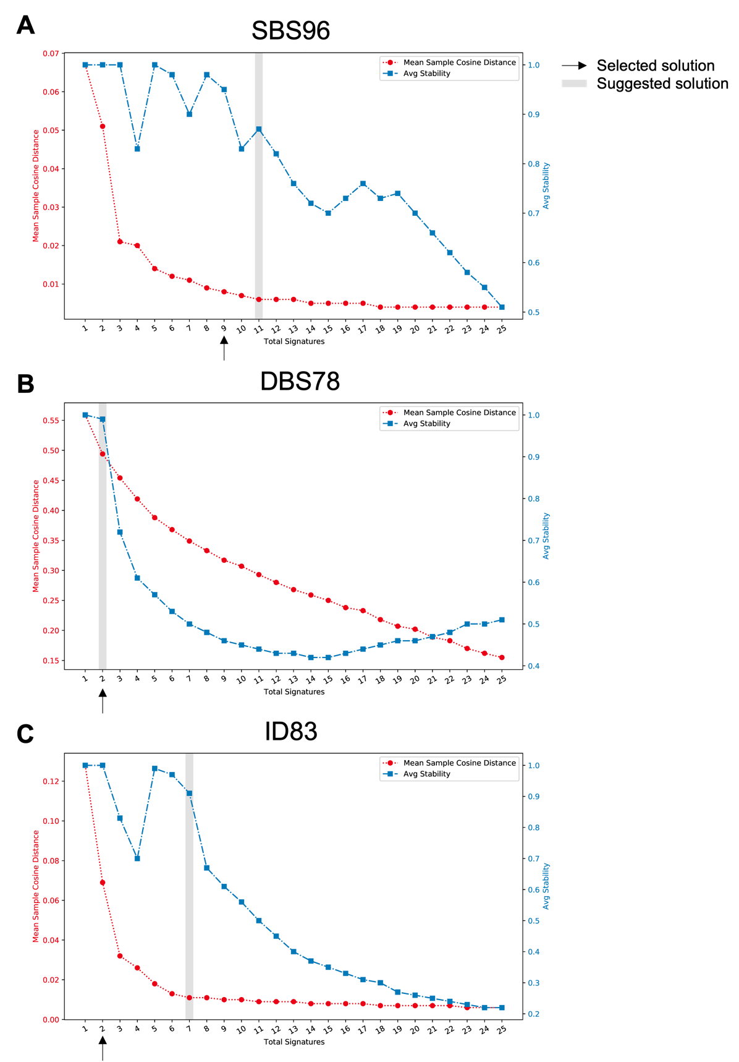

Supplementary Figure 9: SBS96, ID83 and DBS78 signatures by tumour mutational burden (TMB).
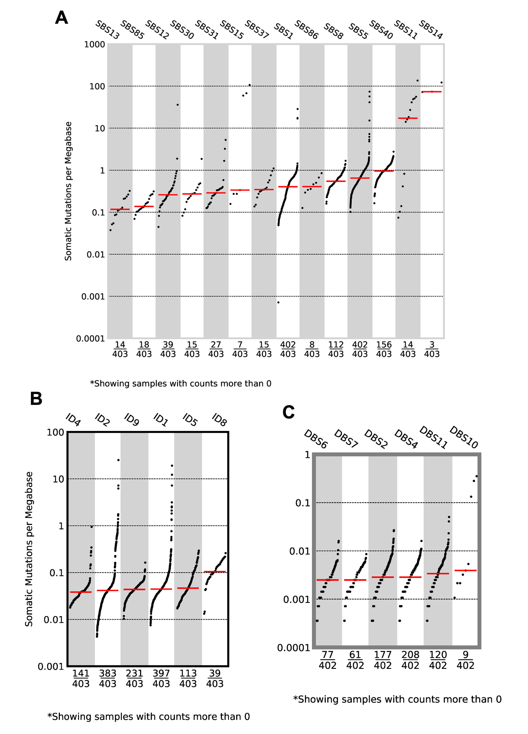
Supplementary Figure 10: SBS96 signature probabilities by mutational context
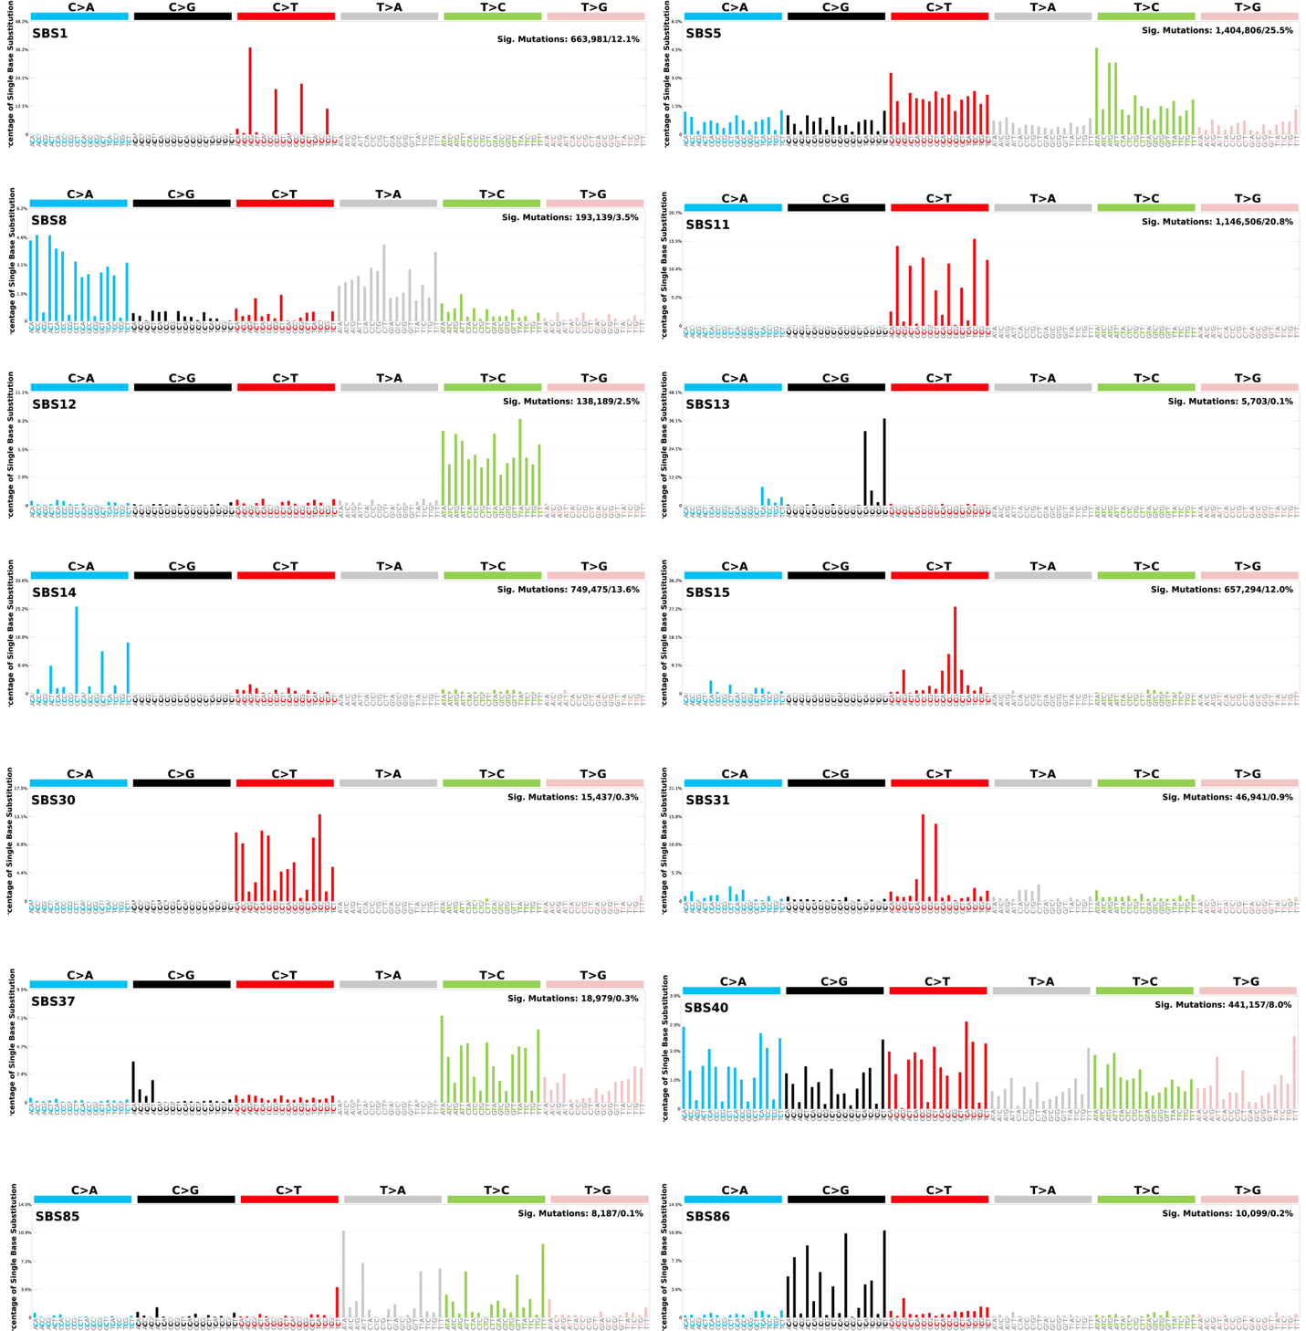
Supplementary Figure 11: ID83 signature probabilities by mutational context
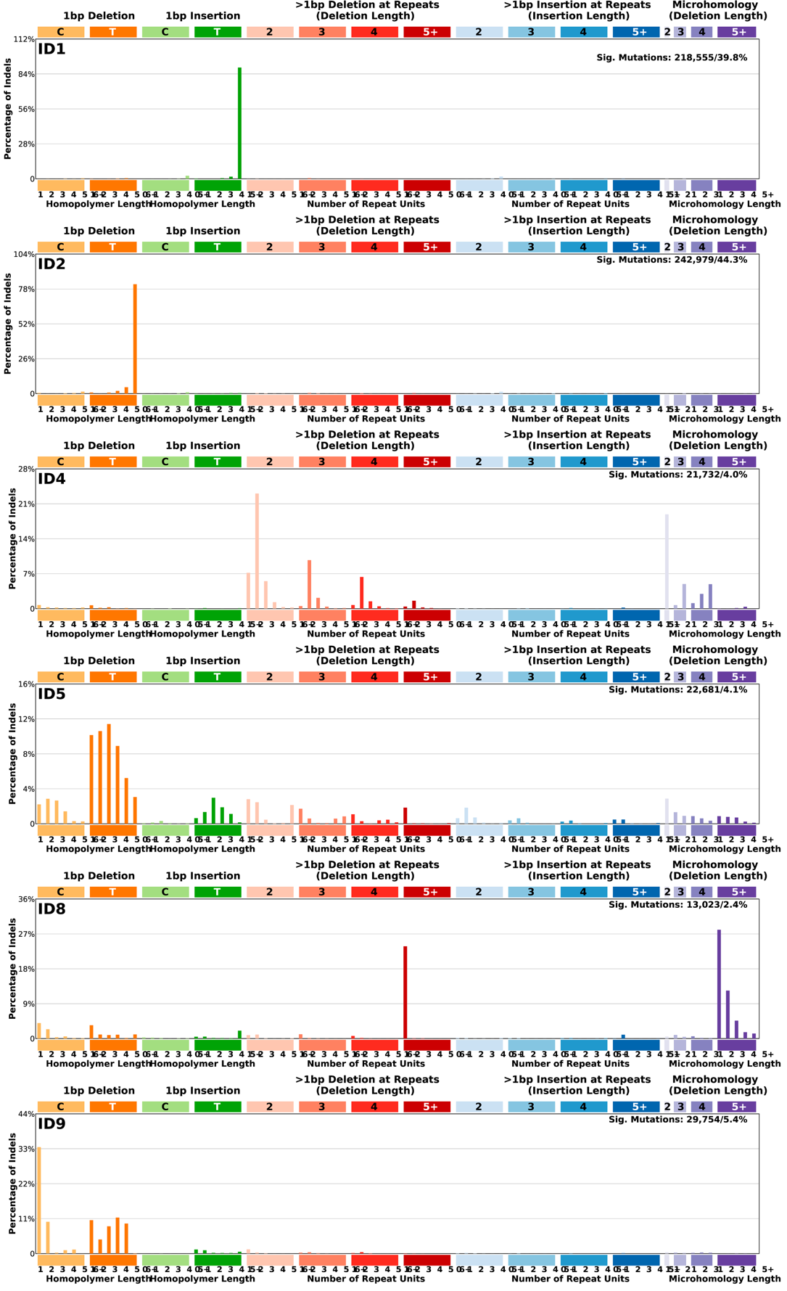
Supplementary Figure 12: DBS78 signature probabilities by mutational context
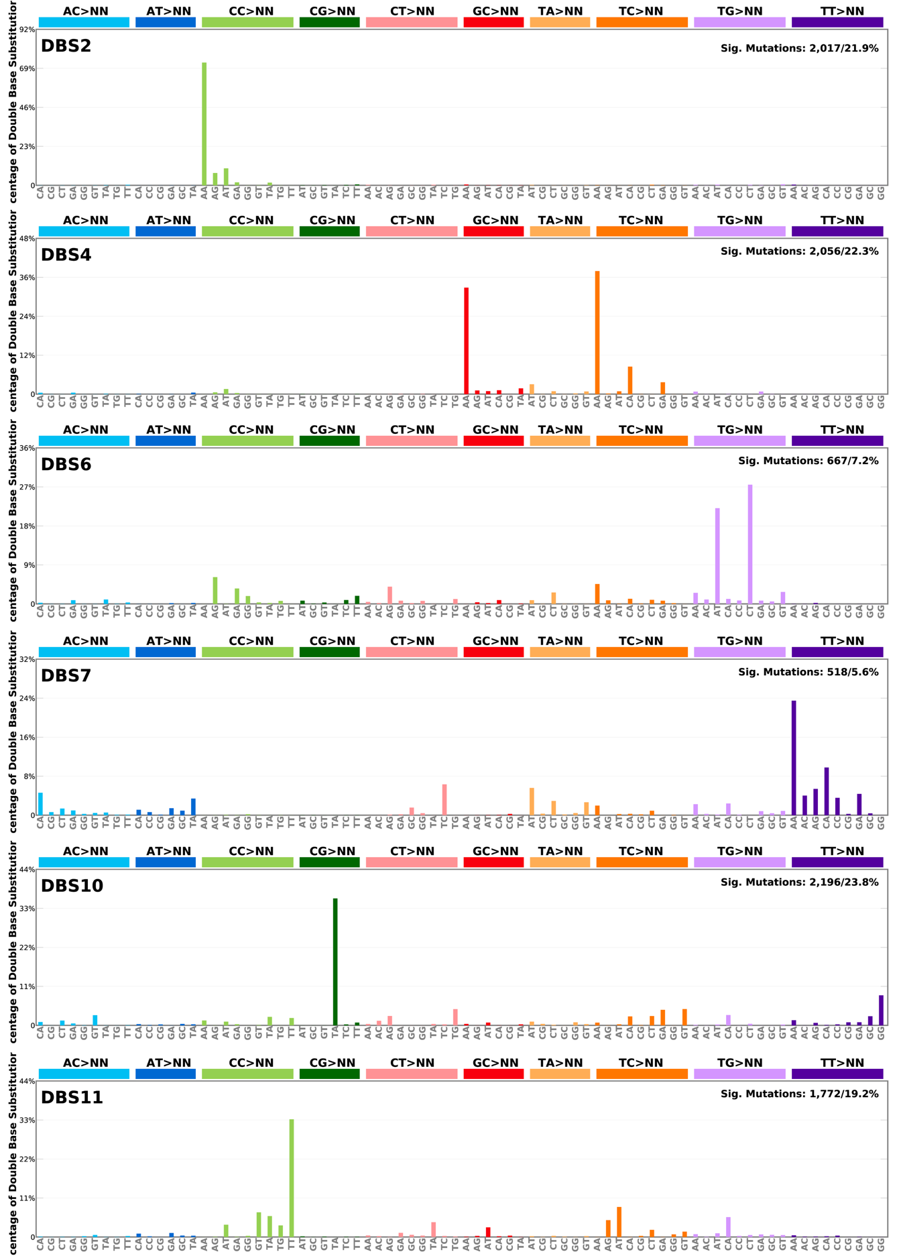
Supplementary Figure 13: Germline telomere content by age across glioma subtypes. Reported P-values are from Spearman’s correlation test.
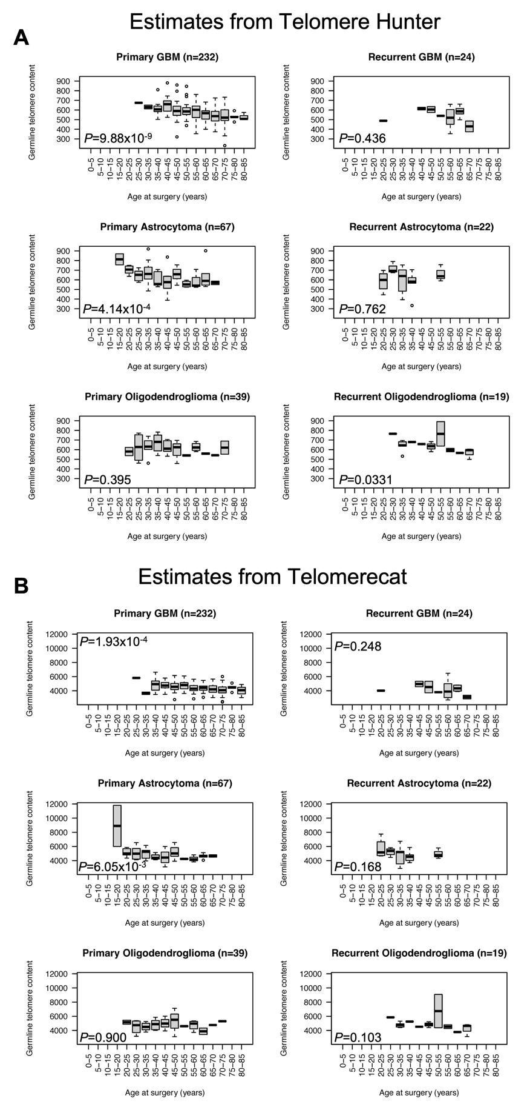
Supplementary Figure 14: Normalised telomere content by age across glioma subtypes. Telomere content normalized by log2(tumour/normal). P-values are from Spearman’s correlation test
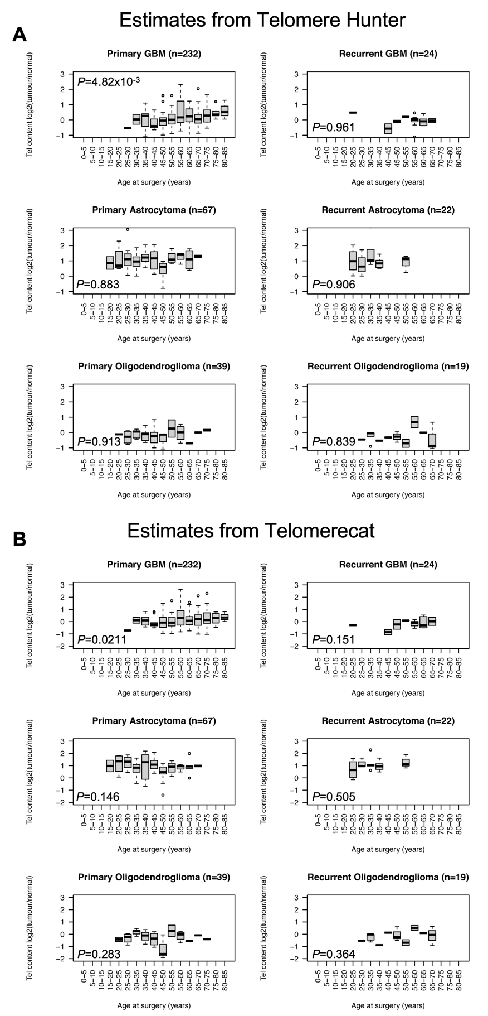
Supplementary Figure 15: Normalised telomere content by tumour purity across glioma subtypes. Telomere content normalized by log2(tumour/normal). P-values are from Spearman’s correlation test.
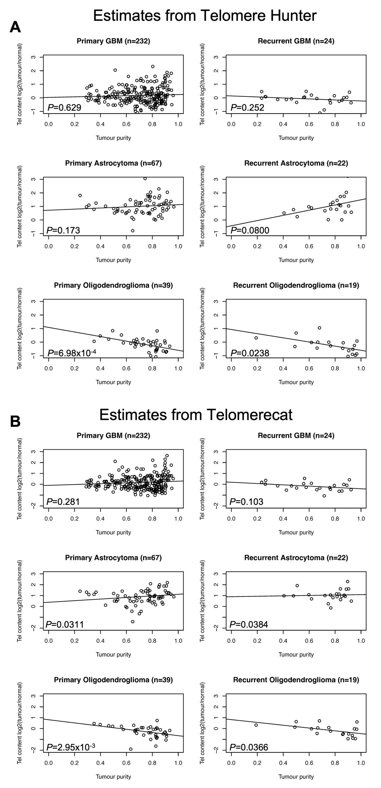
Supplementary Figure 16: Germline and tumour telomere content estimates by Telomere Hunter and Telomerecat. P-values are from Spearman’s correlation test between telomere content estimates.
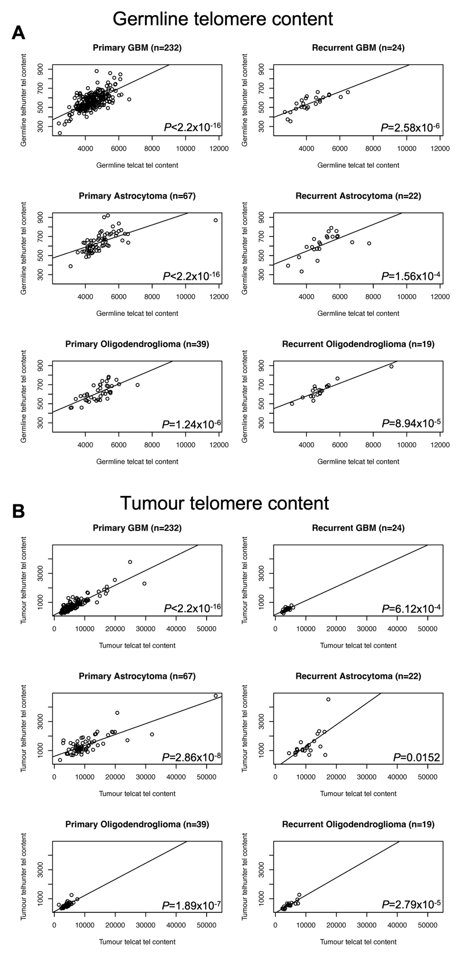
Supplementary Figure 17: Normalised telomere content by WGD status across glioma subtypes. Kruskal-Wallis P-values reported.
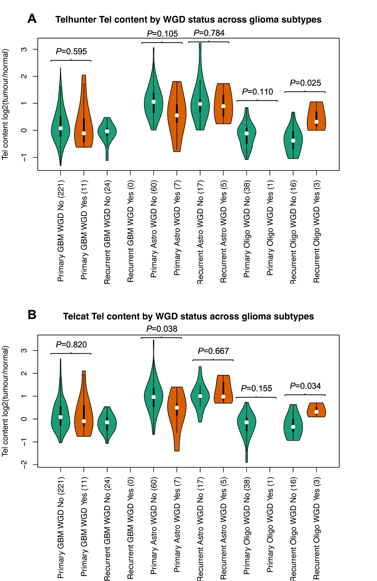
Supplementary Figure 18: Telomere content by glioma subtype and telomere maintenance mechanism. P-value are from Kruskal-Wallis test
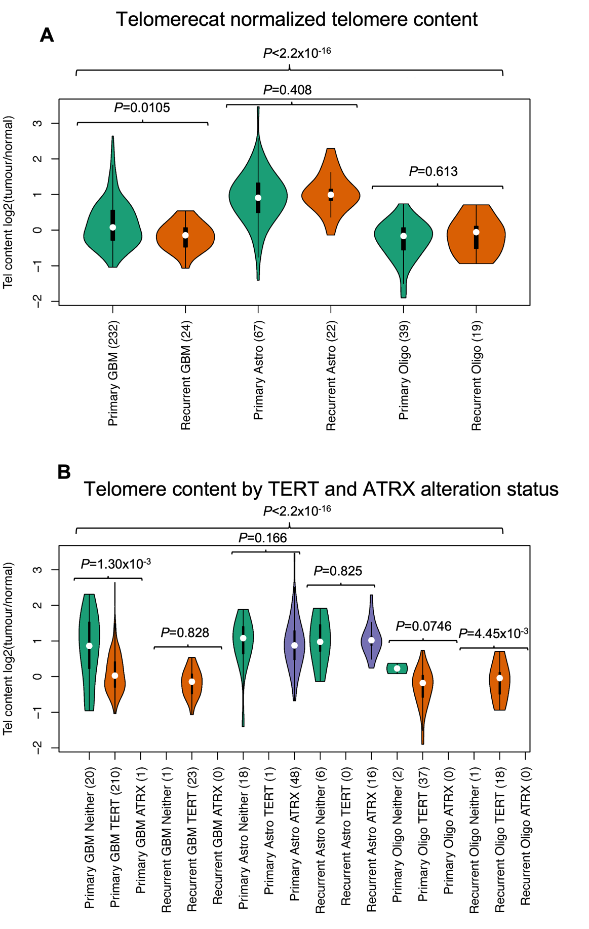
Supplementary Figure 19: Immune escape mechanisms by glioma subtype. IEG; immune escape gene.
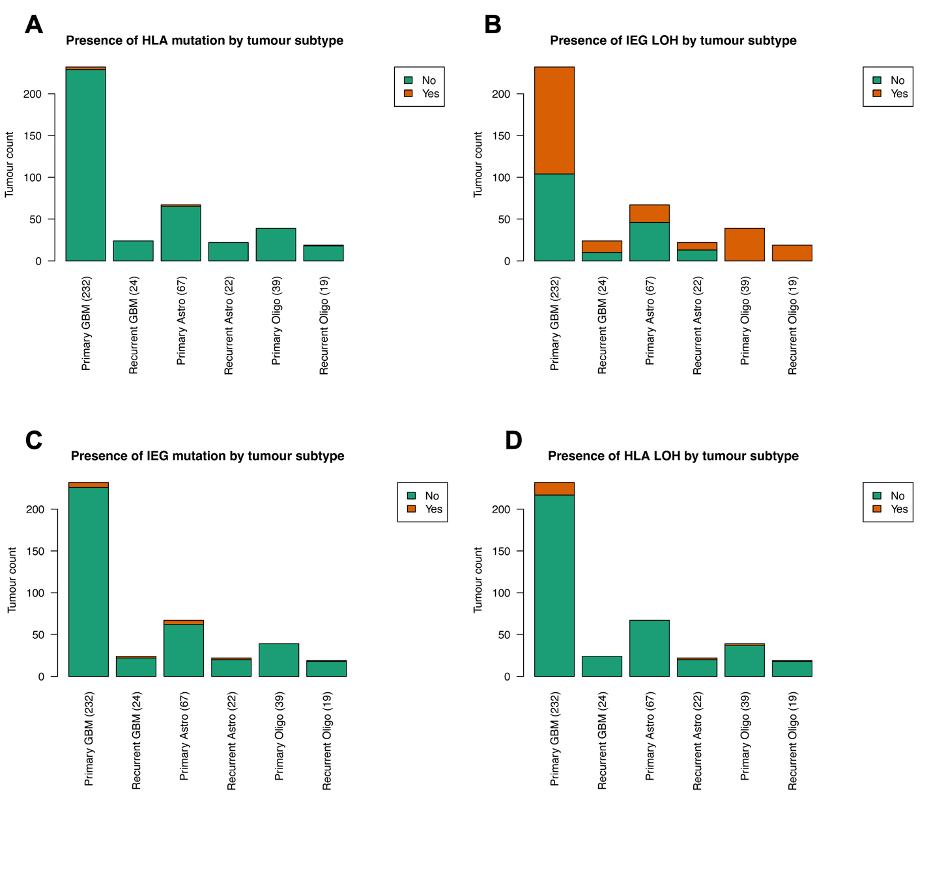
Supplementary Figure 20: Proportions of clonal/subclonal mutations and neoantigens by glioma subtype. P-value are from Kruskal-Wallis test
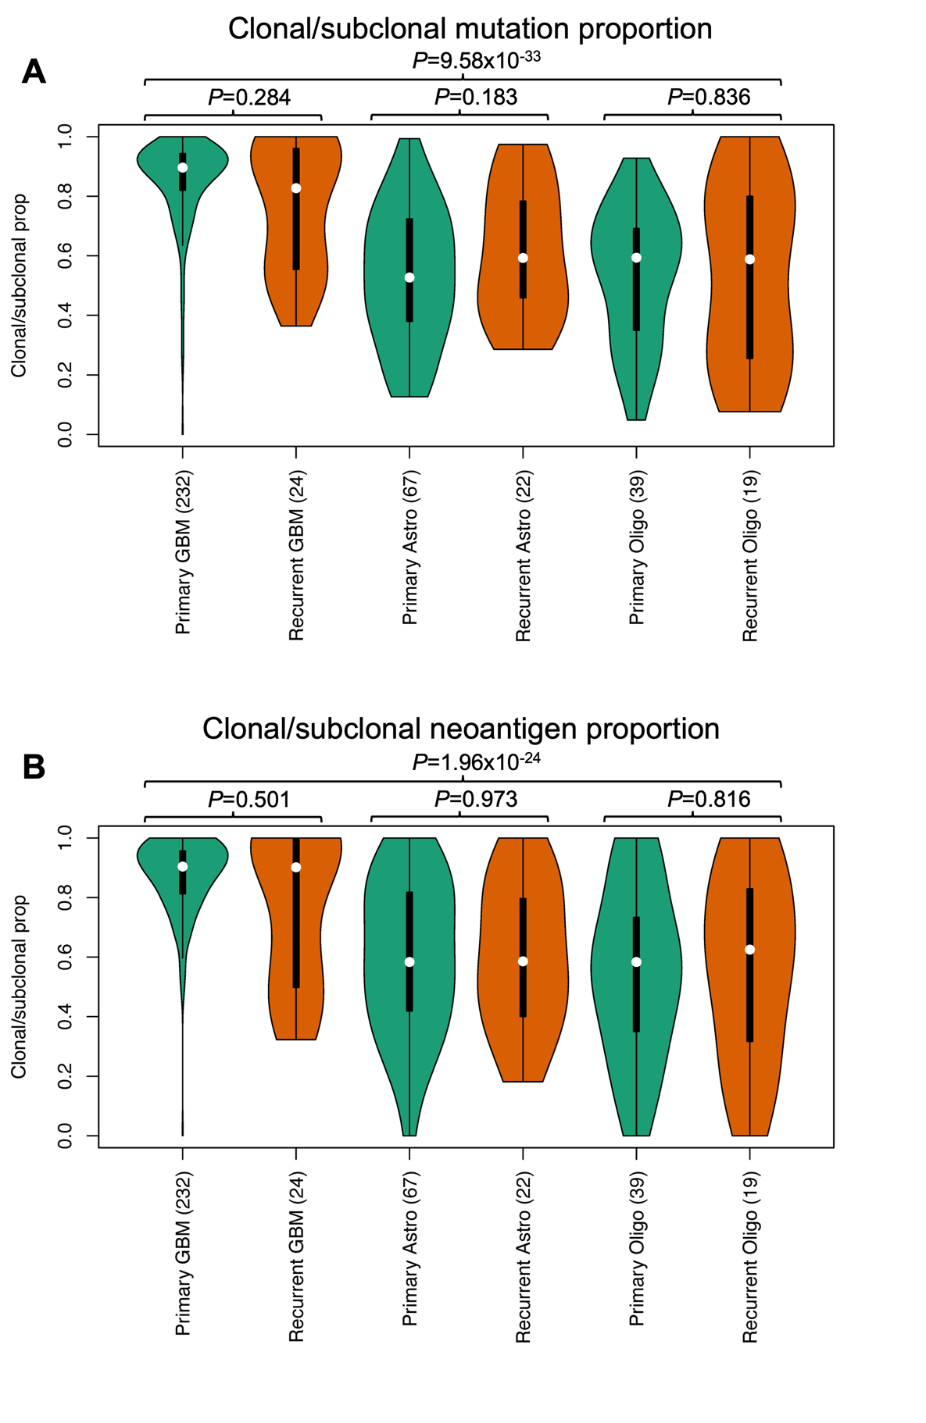
Supplementary Figure 21: Clonal and subclonal mutation counts by glioma subtype. P-value is from a Kruskal-Wallis test between mutation count estimates.
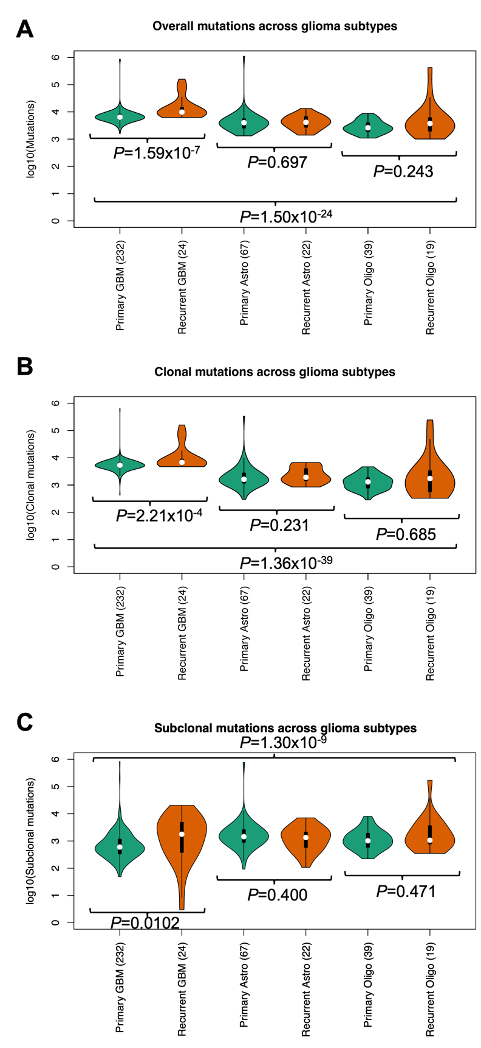
Supplementary Figure 22: Clonal and subclonal neoantigen counts by glioma subtype. P-value from Kruskal-Wallis test between neoantigen count estimates.
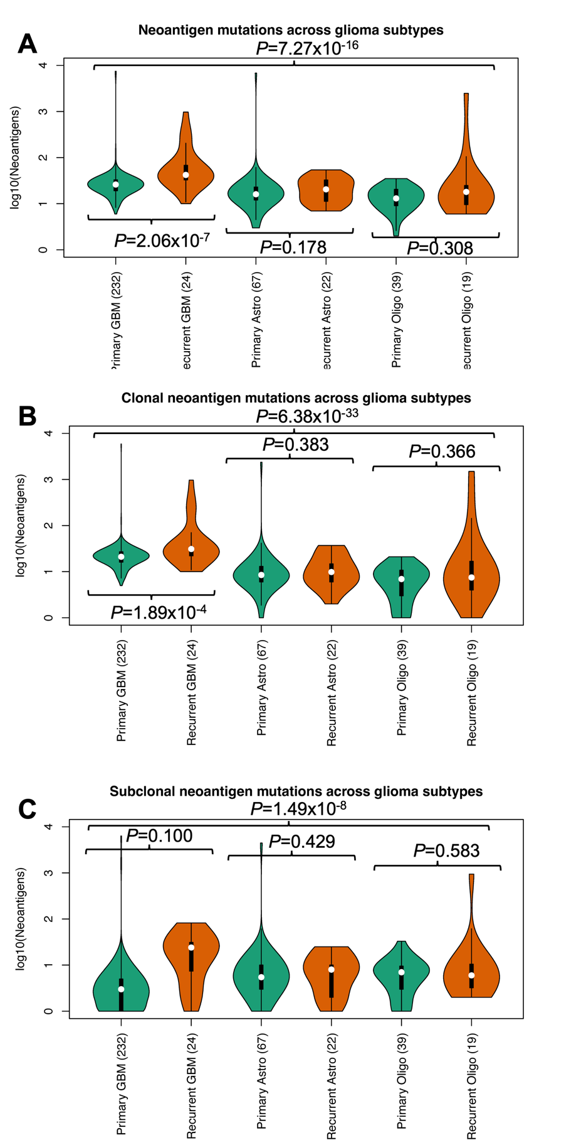
Supplementary Figure 23: Counts of mutations and neoantigens across glioma subtypes. (A) Total mutations and neoantigens; (B) Clonal and subclonal neoantigens. P-value is from a Spearman correlation test between counts.
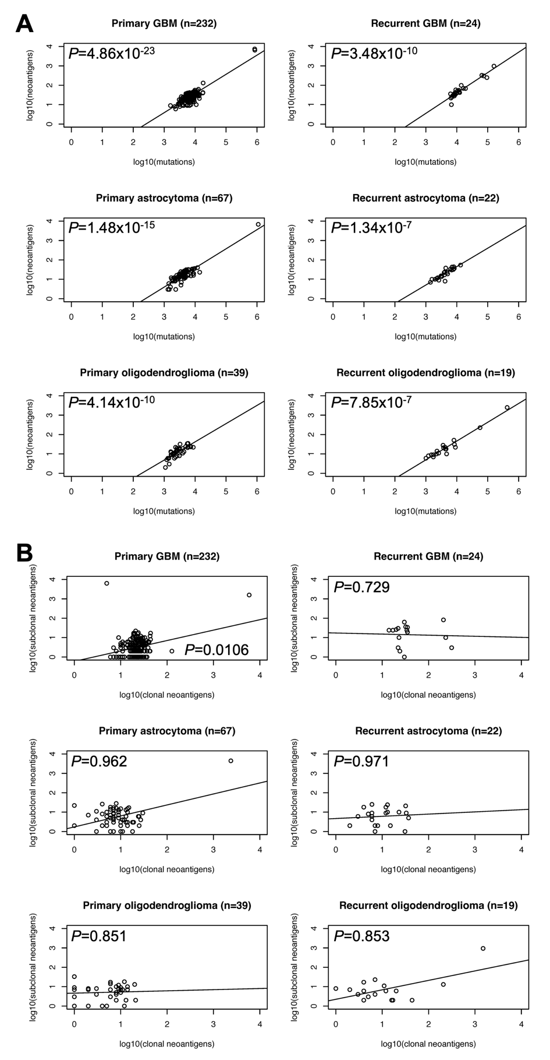
Supplementary Figure 24: Counts of total mutations and neoantigens across glioma subtypes. a) Clonal mutations and neoantigens; b) Subclonal mutations and neoantigens. Spearman P-values reported.
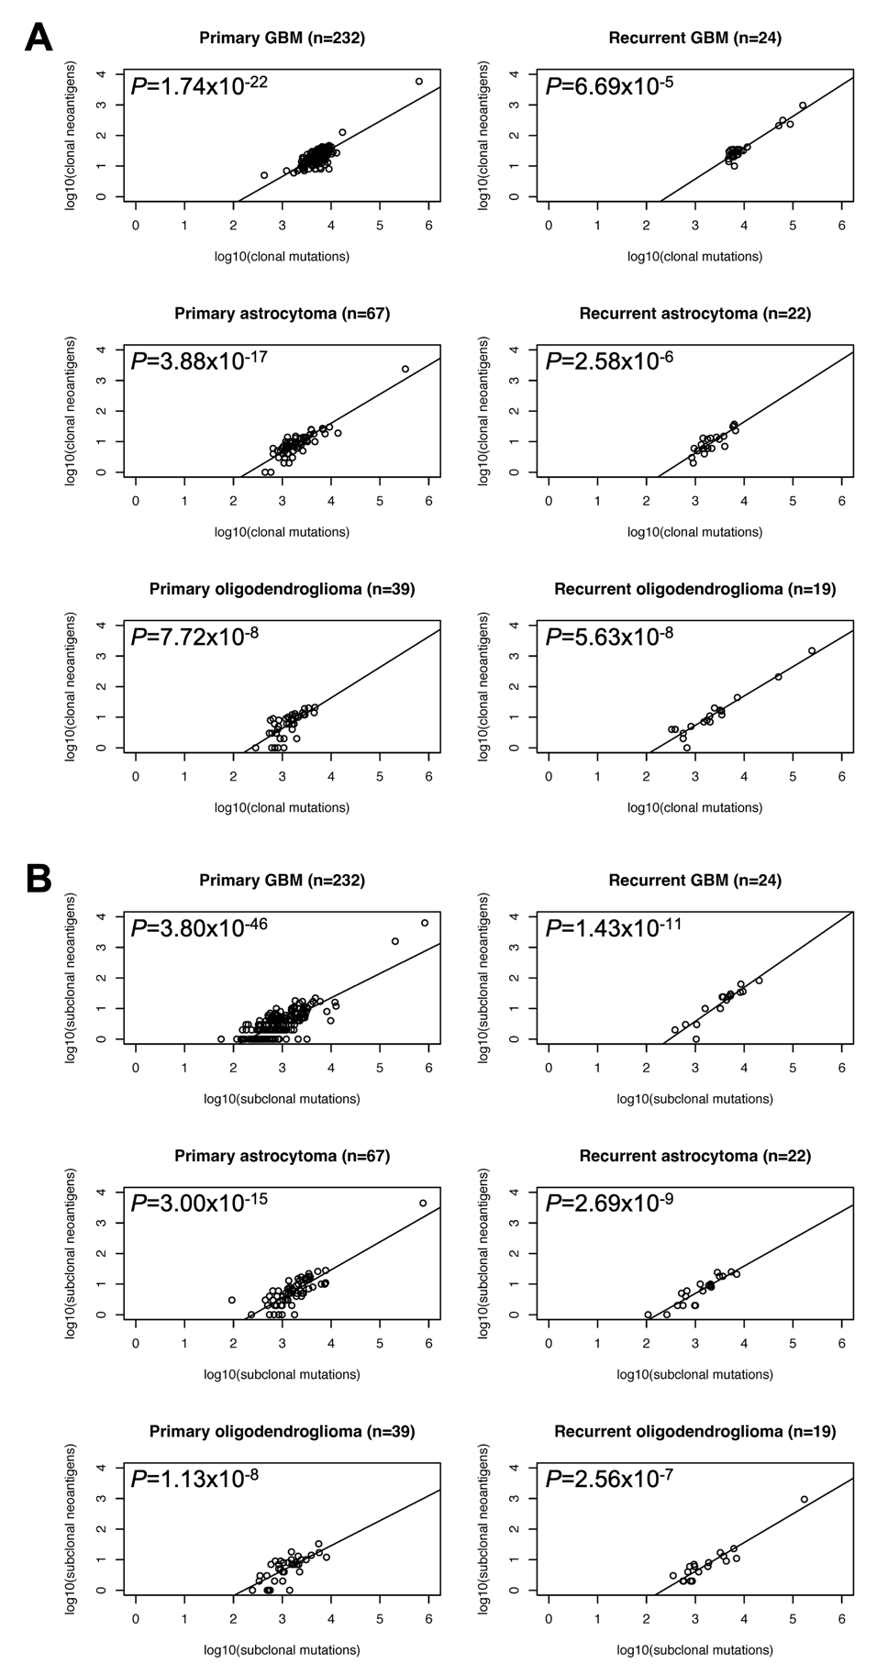
Supplementary Figure 25: Lollipop plots of candidate glioma driver genes. (A) CDC73; (B) COL3A1; (C) SALL3; (D) SFPQ; (E) TENM2; (F) TMEM132C.
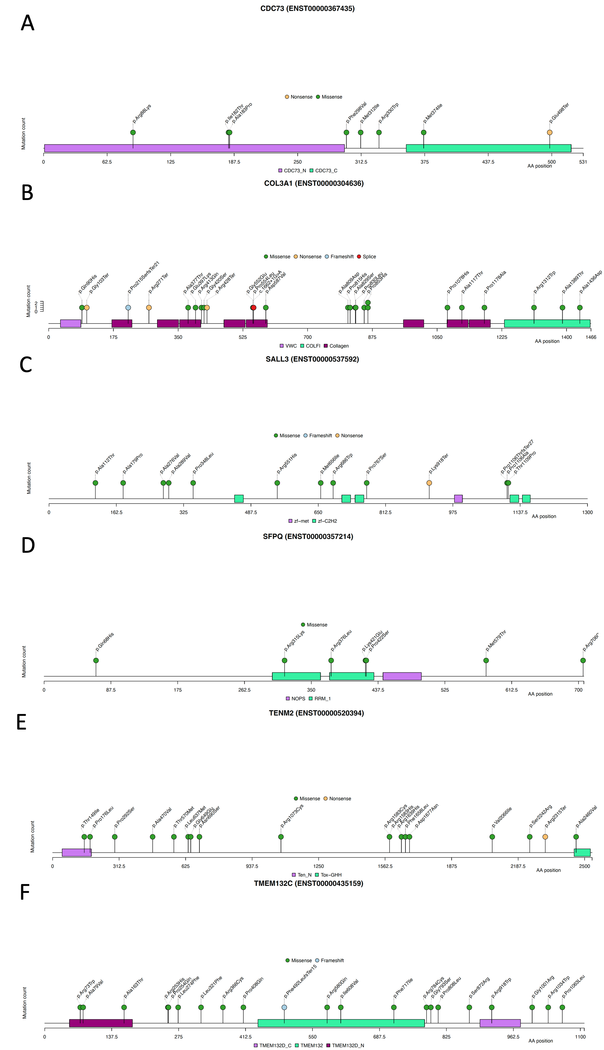
Supplementary Figure 26: Focal amplifications and deletions identified by GISTIC. (A-B) GBM amps and dels; (C-D) Astrocytoma amps and dels; (E-F) Oligodendroglioma amps and dels.
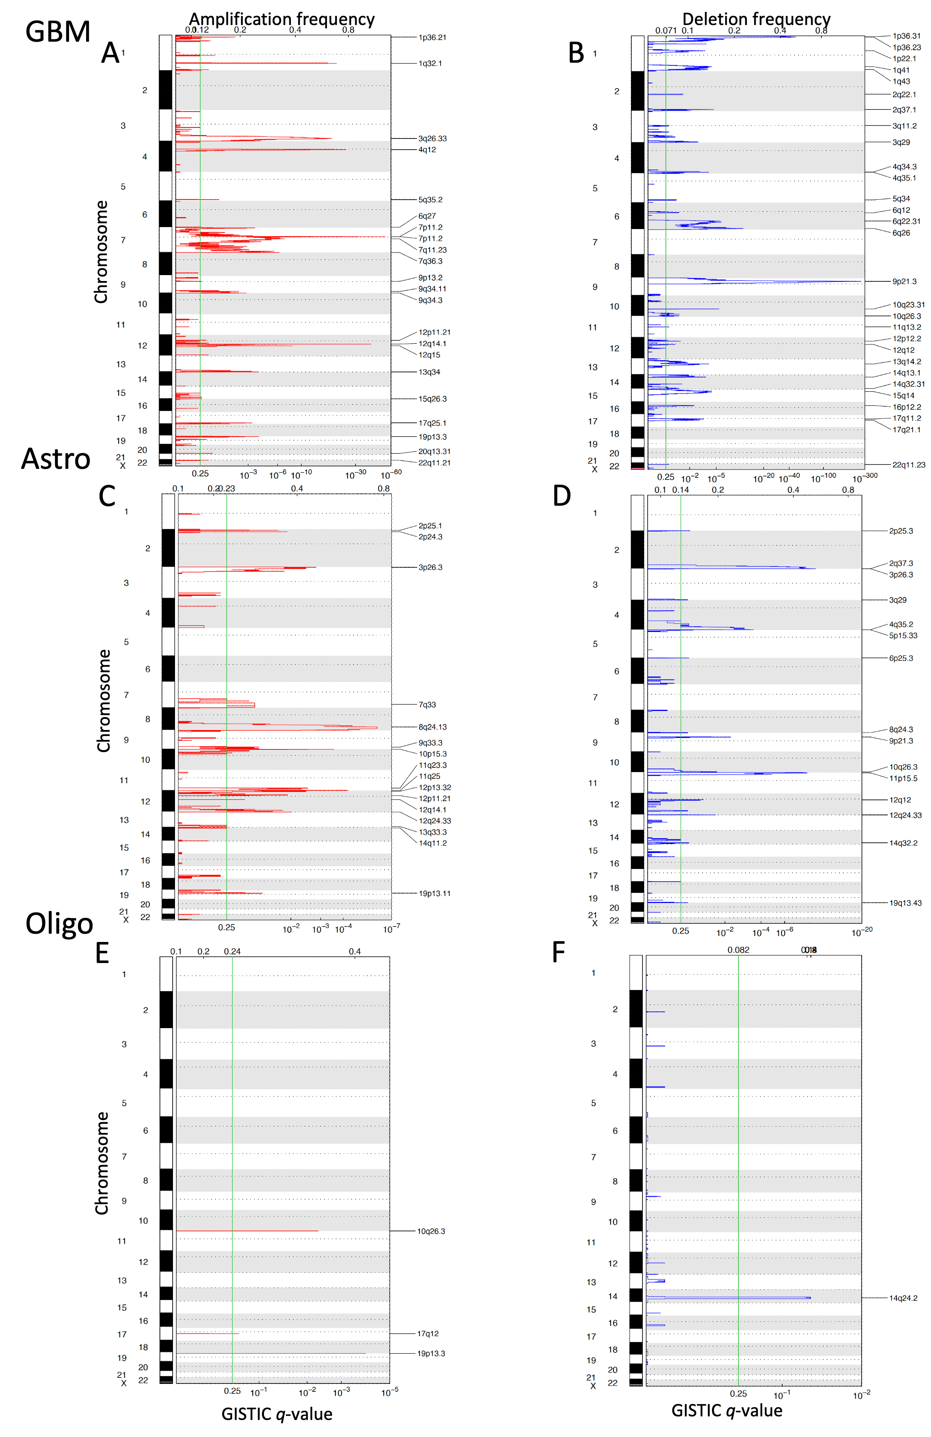

Supplementary Figure 27: Timing of mutational signatures across glioma subtypes. (A) primary GBM; (B) recurrent GBM; (C) primary astrocytoma; (D) recurrent astrocytoma; (E) primary oligodendroglioma; (F) recurrent oligodendroglioma.
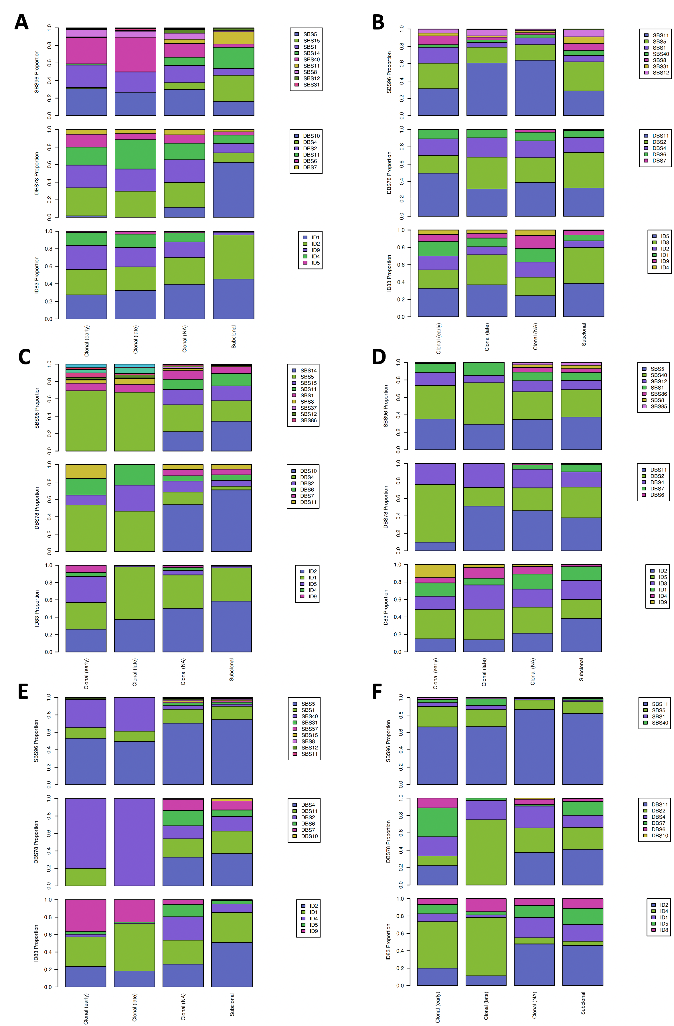
Supplementary Figure 28: Timing of mutational signatures across three hypermutated glioma tumours.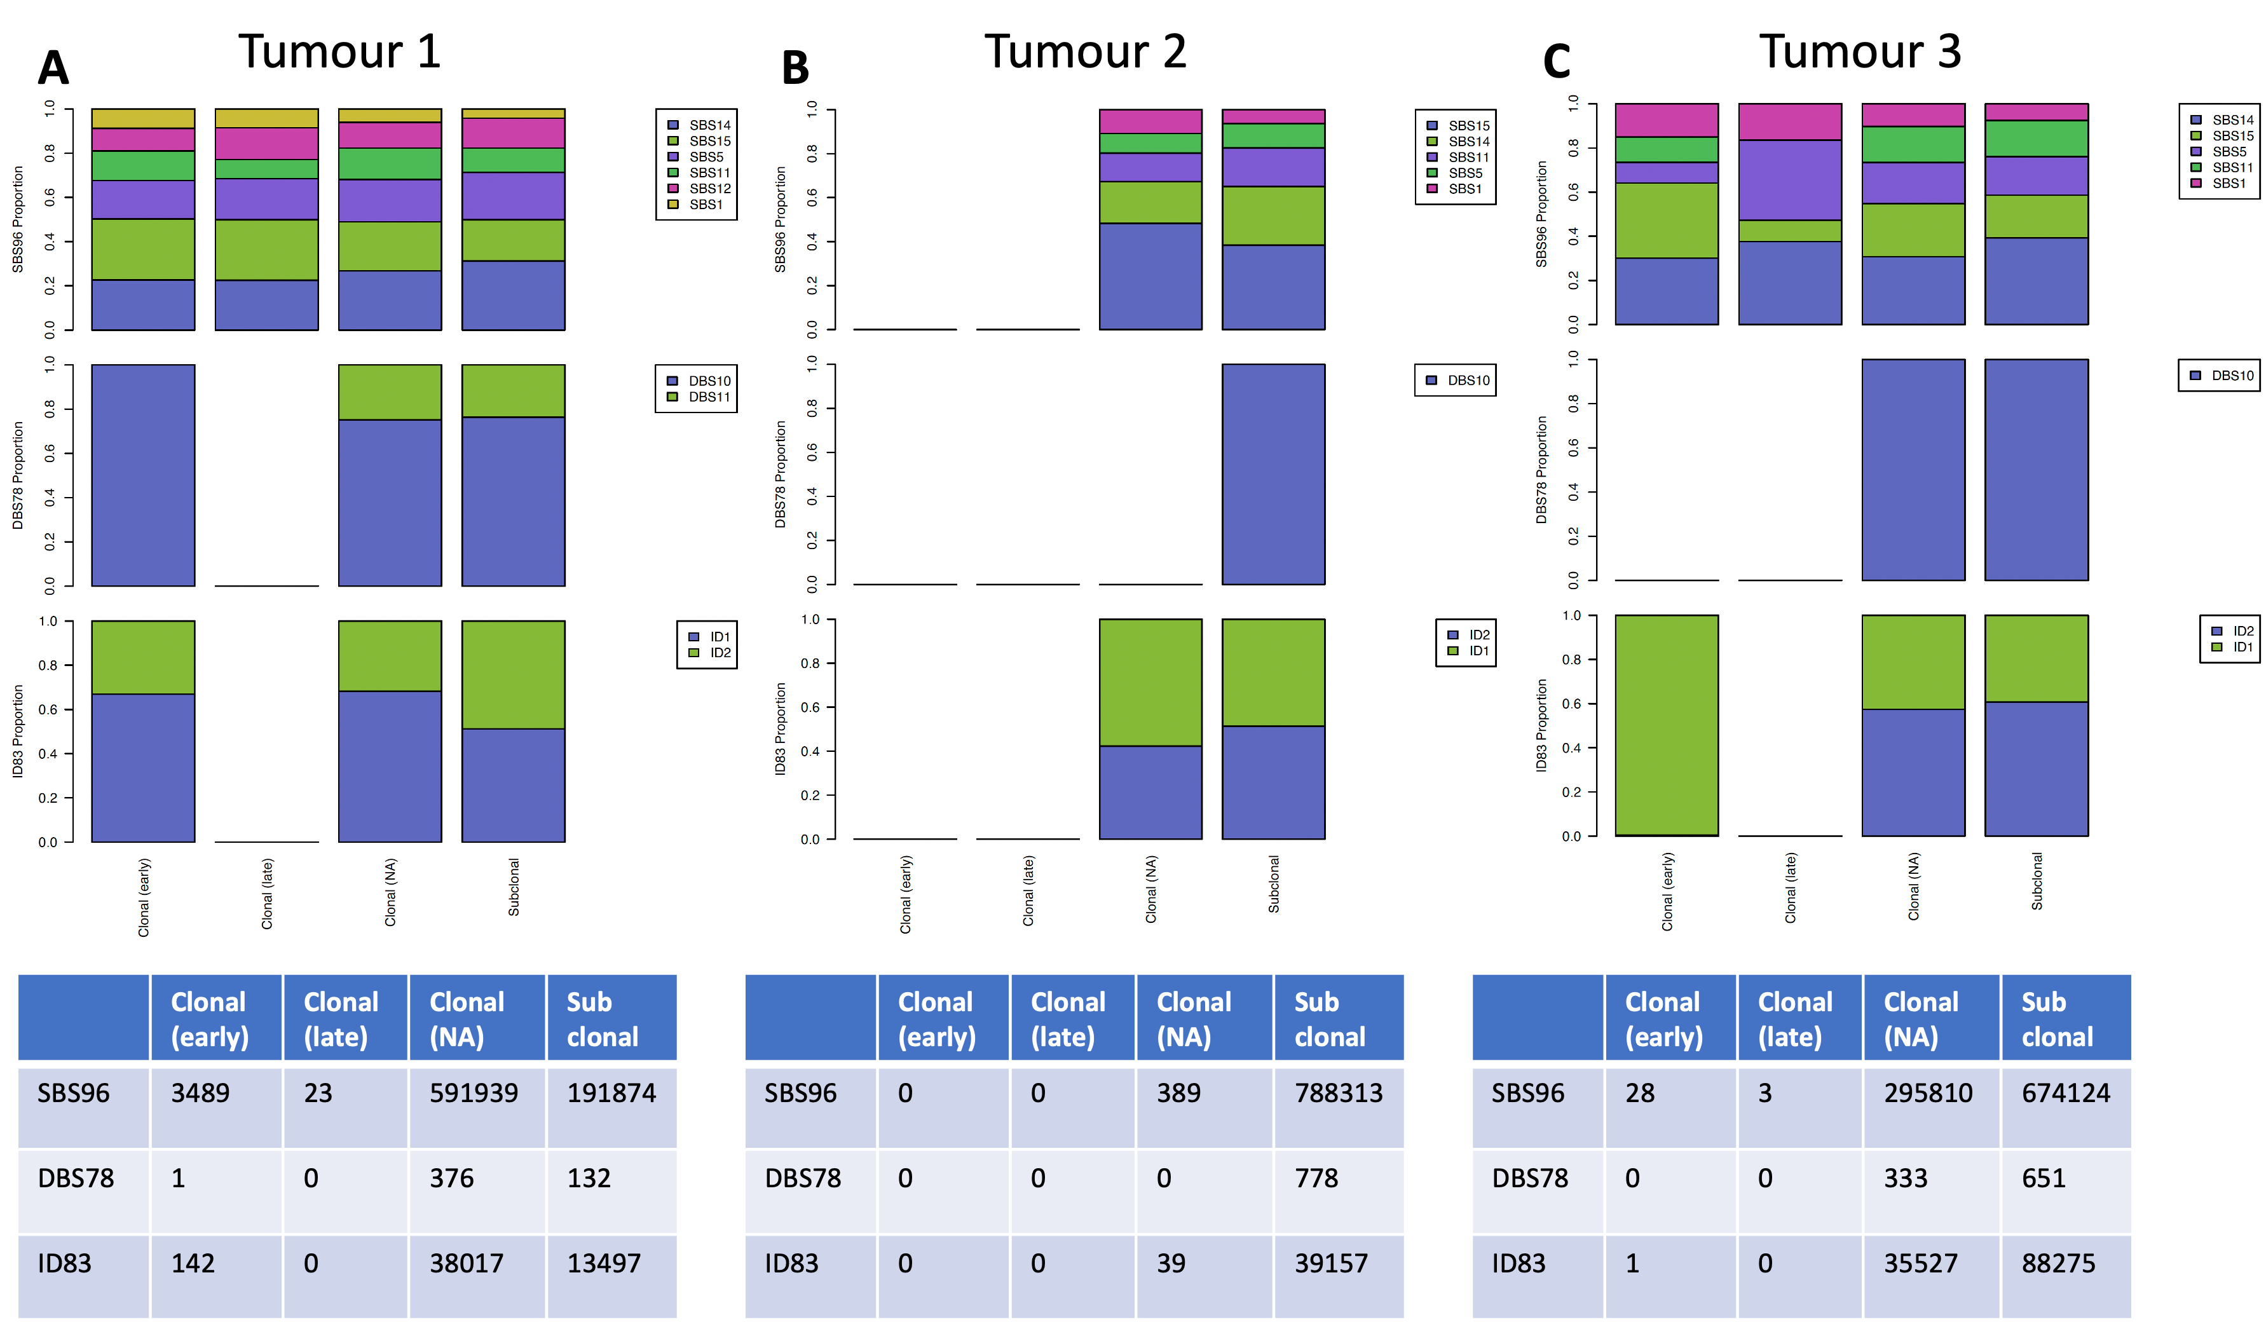

Supplementary Figure 29: Kaplan-meier survival curves. (A-C) Primary GBM TP53 mutations, CDKN2A LOH, 22q LOH; (D) Primary astrocytoma PIK3CA mutations; (E-F) Recurrent astrocytoma SBS40 activity and IEG LOH; (G) Recurrent oligodendroglioma BCOR mutation.
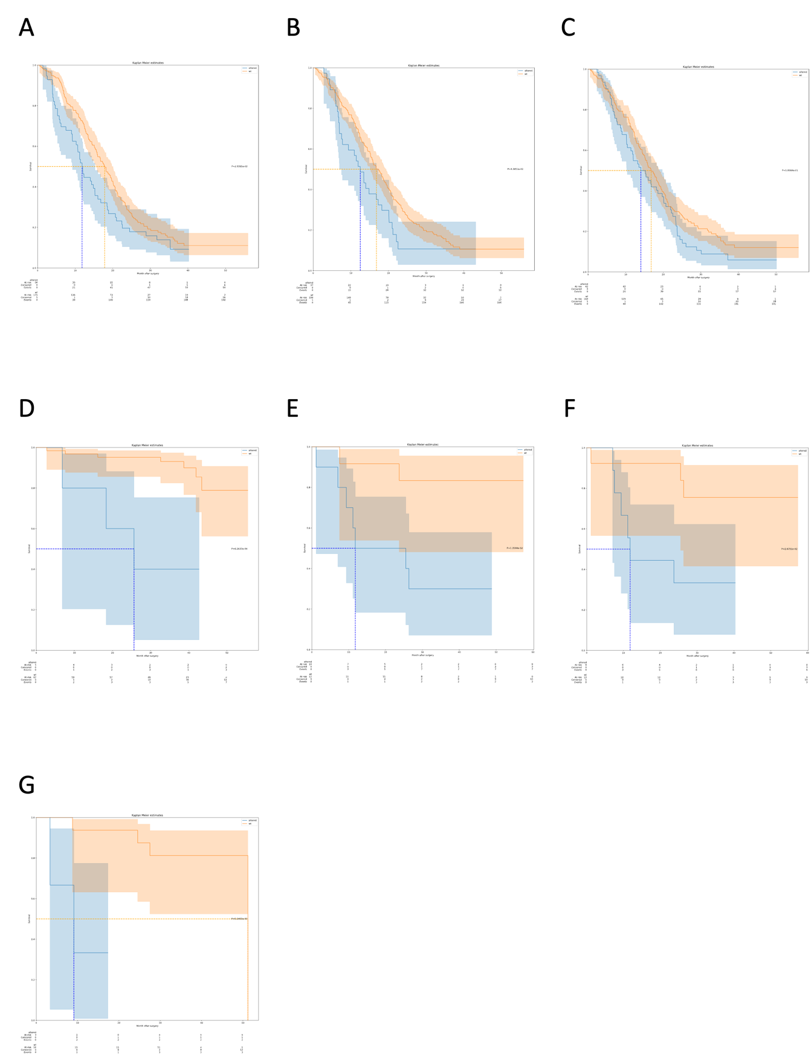

Supplementary Figure 30: Frequency of chromothripsis events across glioma subtypes. Regions enriched for chromothripsis at a 5% FDR greater than 5Mb are coloured blue. (a) primary GBM; (b) recurrent GBM; (c) primary astrocytoma; (d) recurrent astrocytoma; (e) primary oligodendroglioma; (f) recurrent oligodendroglioma.
