Supplementary Table 1. Statistically significant clusters in sensitivity-consistency analysis map
Cluster size | Threshold | MAX | MNI Coordinates |  |  | Center of Gravity |  |  | Brain Region
Voxels | t> | t | x | y | z | x | y | z | Brain Region
5503 | 7 | 11.9 | -32 | 2 | -8 | -0.498 | -0.878 | -5.77 | L insula
1044 | 7 | 9.63 | 0 | 22 | 18 | 0.55 | 26.7 | 17.6 | Anterior cingulate cortex
344 | 7 | 10.5 | -6 | -10 | 36 | -1.25 | -12.7 | 38.9 | L somatosensory cortex
117 | 7 | 9.94 | 24 | -40 | 2 | 24.1 | -38.6 | 0.787 | R hippocampus
111 | 7 | 9.72 | -22 | -40 | 0 | -21.7 | -40.6 | 0.452 | L hippocampus

Supplementary Table 2. Statistically significant clusters in specificity analysis map
Cluster size | Threshold | MAX | MNI Coordinates |  |  | Center of Gravity |  |  | Brain Region
Voxels | t> | t | x | y | z | x | y | z | Brain Region
2342 | 3.2 | 4 | -48 | -16 | 10 | -51.9 | -12.6 | 8.51 | L Superior temporal gyrus
2172 | 3.2 | 3.86 | 56 | -2 | 8 | 50.9 | -9.68 | 8.41 | R Somatosensory cortex
383 | 3.2 | 3.77 | -4 | -12 | 42 | -4.35 | -11.6 | 44.7 | L Anterior cingulate cortex
227 | 3.2 | 3.69 | 8 | -62 | -34 | 1.87 | -59.6 | -29.5 | R cerebellum
105 | 3.2 | 3.45 | 4 | 24 | 24 | 1.11 | 24.6 | 24.1 | R Anterior cingulate cortex

Supplementary Figure 1.
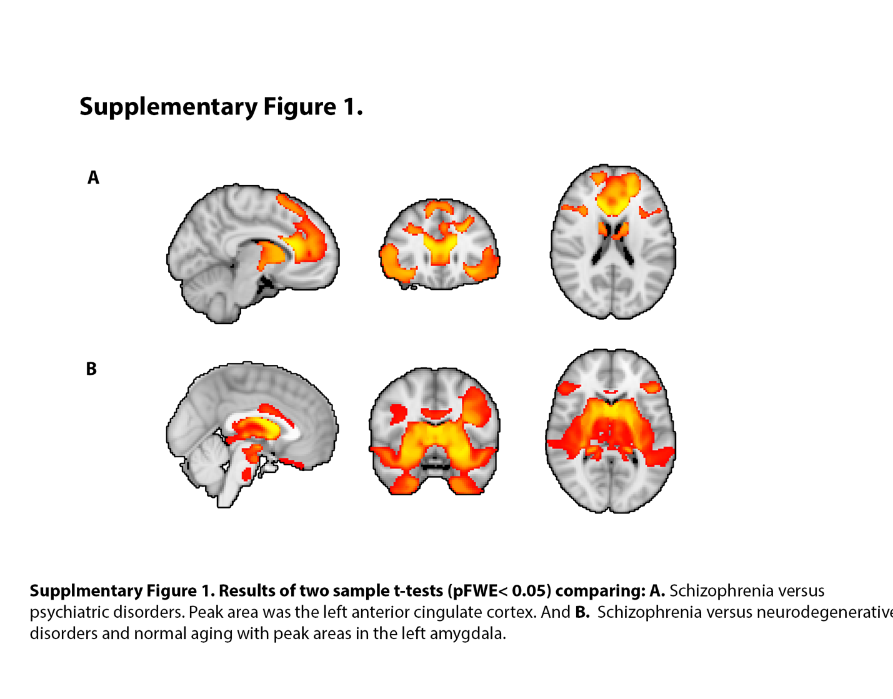
Supplementary Table 3. Specificity Analysis: Individual disorder comparisons
Two-sample t-test using TFCE | p value (pFWE) | Peak Coordinates |  |  | Brain Regions
Two-sample t-test using TFCE | p value (pFWE) | x | y | z | Brain Regions
Schizophrenia vs anxiety disorders | p< 0.05 | -28 | 6 | -14 | L amygdala
Schizophrenia vs bipolar disorder | p= 0.6 | N/A |  |  | N/A
Schizophrenia vs major depressive disorder | p= 0.17 | N/A |  |  | N/A
Schizophrenia vs obsessive-compulsive disorder | p< 0.05 | -22 | -4 | -12 | L amygdala
Schizophrenia vs substance use disorder | p< 0.05 | -28 | 6 | -14 | L amygdala
Schizophrenia vs Alzheimer’s disease | p< 0.05 | 30 | -50 | 30 | White matter in R parietal lobe
Schizophrenia vs Huntington’s disease | p< 0.05 | 46 | 0 | -34 | R temporal pole
Schizophrenia vs mild cognitive impairment | p< 0.05 | -26 | 38 | 18 | L dorsolateral prefrontal cortex
Schizophrenia vs normal aging | p< 0.05 | 10 | 70 | 32 | R medial prefrontal cortex
Schizophrenia vs Parkinson’s disease | p< 0.05 | -30 | 8 | -18 | L amygdala

