Response surface methodology as optimization approach for tetrabromobisphenol A (TBBPA) removal in aqueous media using activated carbon derived from puck (Afroxtyrax lepidophyllus) shell: isotherms and kinetics adsorption
Gédéon Nzetchuen Kouahou¹, Fredy Harcel Kamgang Djioko², Cyrille Donlifack Atemkeng¹, Cyrille Ghislain Fotsop^{1,3}, Liouna Adoum Amola¹, Aurelien Bopda¹, Serges Bruno Lemoupi Ngomadé^{1,4*}, Theophile Kamgaing¹*

¹Research unit of Noxious Chemistry and Environmental Engineering, Department of Chemistry, University of Dschang, Dschang, Cameroon.
²Africa Center of Excellence in Future Energies and Electrochemical Systems (ACE-FUELS), Federal University of Technology, Owerri, Imo State, Nigeria
³Institute of Chemistry, Faculty of Process and Systems Engineering, Universität Platz 2, 39106 Magdeburg, Germany.
⁴Biofuel division, CSIR-Indian institute of petroleum, Dehradum, India
*Corresponding author: Theophile Kamgaing, theokamgaing@yahoo.fr
Serges Bruno Lemoupi Ngomadé, sergesngomade848@gmail.com
Supporting information
Supplementary Table 1: Some characteristics of TBBPA
molecular formula
chemical structure | C₁₅H₁₂Br₄O₂
systematic name | 2,2-bis(3,5-dibromo-4-hydroxyphenyl)propane
λ_{max} (nm) | 293
pka | 7.5-8.5
molecular mass | 543.87

Supplementary table 2: absorbance obtained after spectrophotometer uv-vis analysis
order of experiments | pH | mass (g) | C (mol/L) | t (min) | Ce (mol/L) | Absorbance
1 | 8 | 125 | 8.5 | 90 | 3.968 | 0.041
2 | 8 | 125 | 8.5 | 90 | 4.057 | 0.042
3 | 8 | 125 | 8.5 | 90 | 4.199 | 0.043
4 | 8 | 200 | 2 | 90 | 1.337 | 0.015
5 | 11 | 50 | 8.5 | 90 | 6.554 | 0.066
6 | 5 | 50 | 8.5 | 90 | 6.022 | 0.061
7 | 8 | 125 | 15 | 160 | 2.865 | 0.030
8 | 5 | 125 | 15 | 90 | 7.0275 | 0.071
9 | 11 | 125 | 15 | 90 | 7.912 | 0.080
10 | 11 | 125 | 8.5 | 160 | 7.281 | 0.073
11 | 8 | 200 | 8.5 | 160 | 4.528 | 0.046
12 | 8 | 125 | 2 | 20 | 1.089 | 0.012
13 | 5 | 200 | 8.5 | 90 | 5.418 | 0.055
14 | 11 | 125 | 8.5 | 20 | 6.329 | 0.064
15 | 11 | 125 | 2 | 90 | 1.739 | 0.018
16 | 8 | 50 | 8.5 | 20 | 4.9283 | 0.050
17 | 8 | 200 | 15 | 90 | 2.055 | 0.022
18 | 8 | 50 | 8.5 | 160 | 4.5237 | 0.046
19 | 8 | 125 | 15 | 20 | 3.9285 | 0.040
20 | 5 | 125 | 8.5 | 20 | 6.21265 | 0.063
21 | 11 | 200 | 8.5 | 90 | 6.477 | 0.065
22 | 8 | 50 | 15 | 90 | 4.704 | 0.048
23 | 8 | 125 | 2 | 160 | 1.44 | 0.015
24 | 5 | 125 | 2 | 90 | 1.5922 | 0.017
25 | 8 | 200 | 8.5 | 20 | 3.6465 | 0.037
26 | 5 | 125 | 8.5 | 160 | 5.9976 | 0.061
27 | 8 | 50 | 2 | 90 | 1.051 | 0.012

Supplementary Table 3: Boehm titration of CRP
AC |  | Carboxylic | lactone | phenol | Total acid | Total base
CRP (meq/g) | 0.06 |  | 0.18 | 0.84 | 1.08 | 0.12
Supplementary Table 4: Validation of the experimental model
Activated carbons | Adsorption conditions | Adsorption Percentage (%)
Activated carbons | Adsorption conditions | Experimental value | Predicted value
CRP | A : 7.66  B (mg) : 200  C (mol/L) : 15  D (min) : 89 | 87.90 | 88.0647

293 nm
Supplementary Fig 1: UV-vis spectrum of TBBPA at 30 mg/L concentration and TBBPA calibration lines.

Supplementary Fig 2: structure of activated carbon used for computational simulations

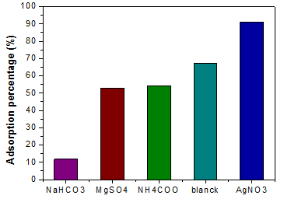
Supplementary Fig 3: effect of interfering ions on adsorption of TBBPA by CRP.
The desorption equation is given by supplementary equation 1
%Desorption =$\frac{C_{f-C_{r}}}{C_{r}}$*100 (S1)
Where Cf (mg/L) is the concentration of pollutant fixed on CRP and Cr the remaining concentration of pollutant on CRP after desorption.
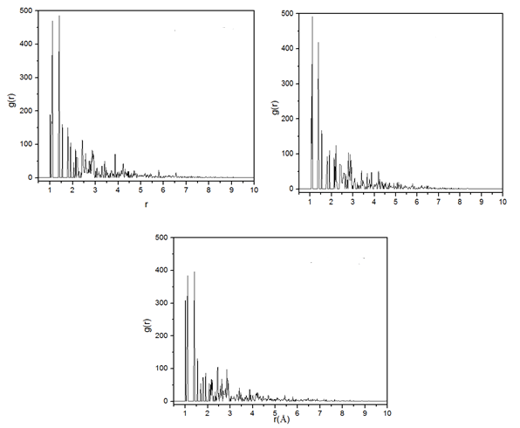
a)
b)
c)
Fig 10: RDF plots of the AC/TBBPA system as a function of the medium a) neutral, b) basic, c) acid

