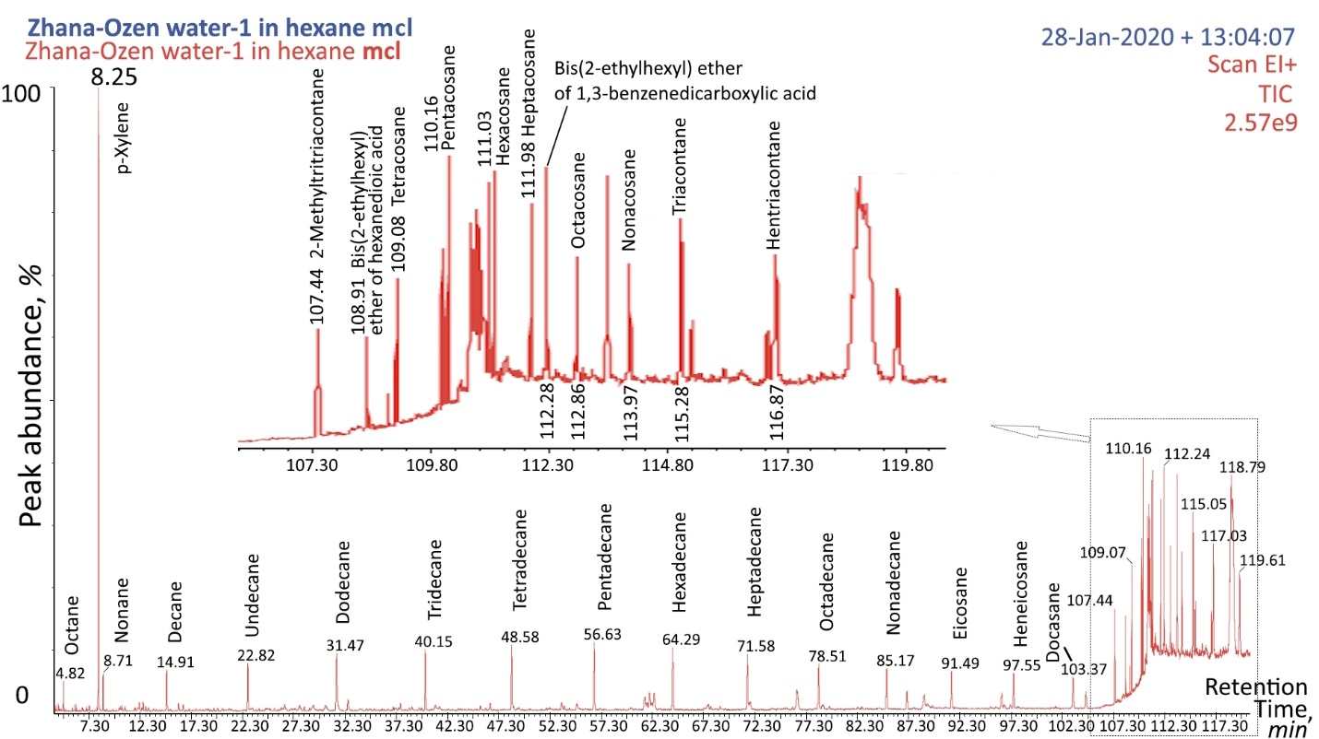
Figure S1. Chromatogram of the component composition of wastewater extract during hexane extraction.
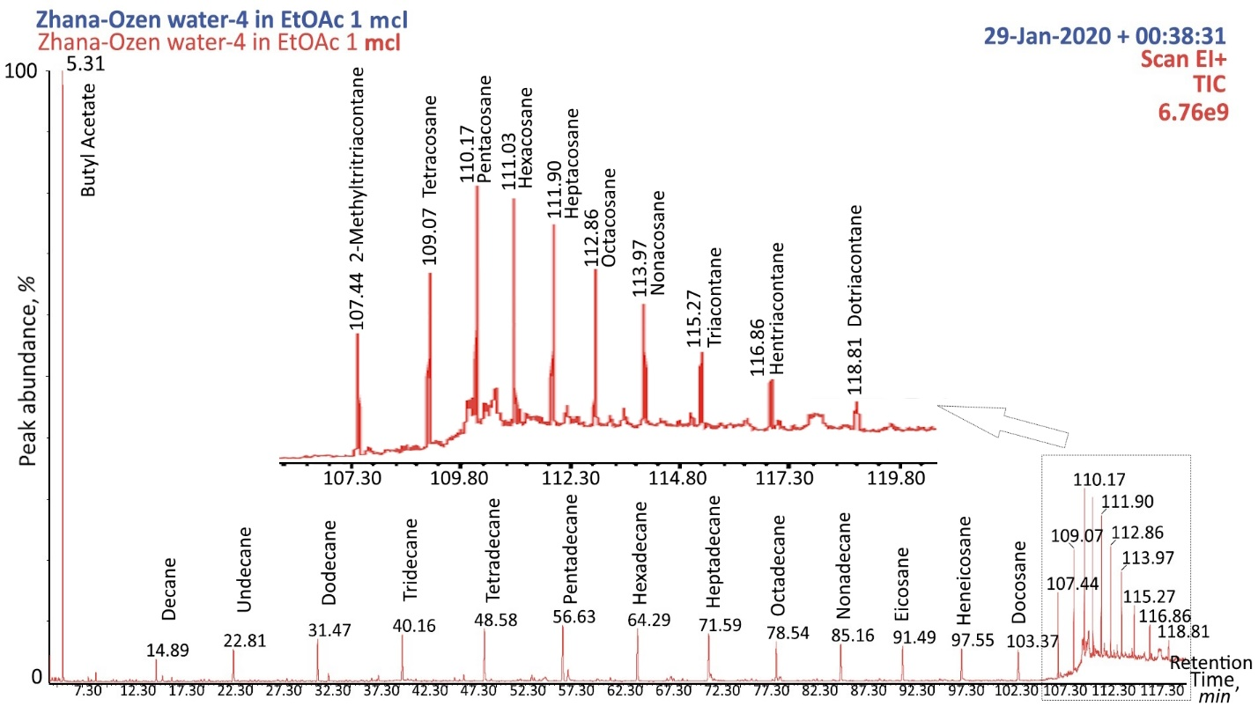
Figure S2. Chromatogram of the component composition of wastewater extract during ethyl acetate (EtOAc) extraction.

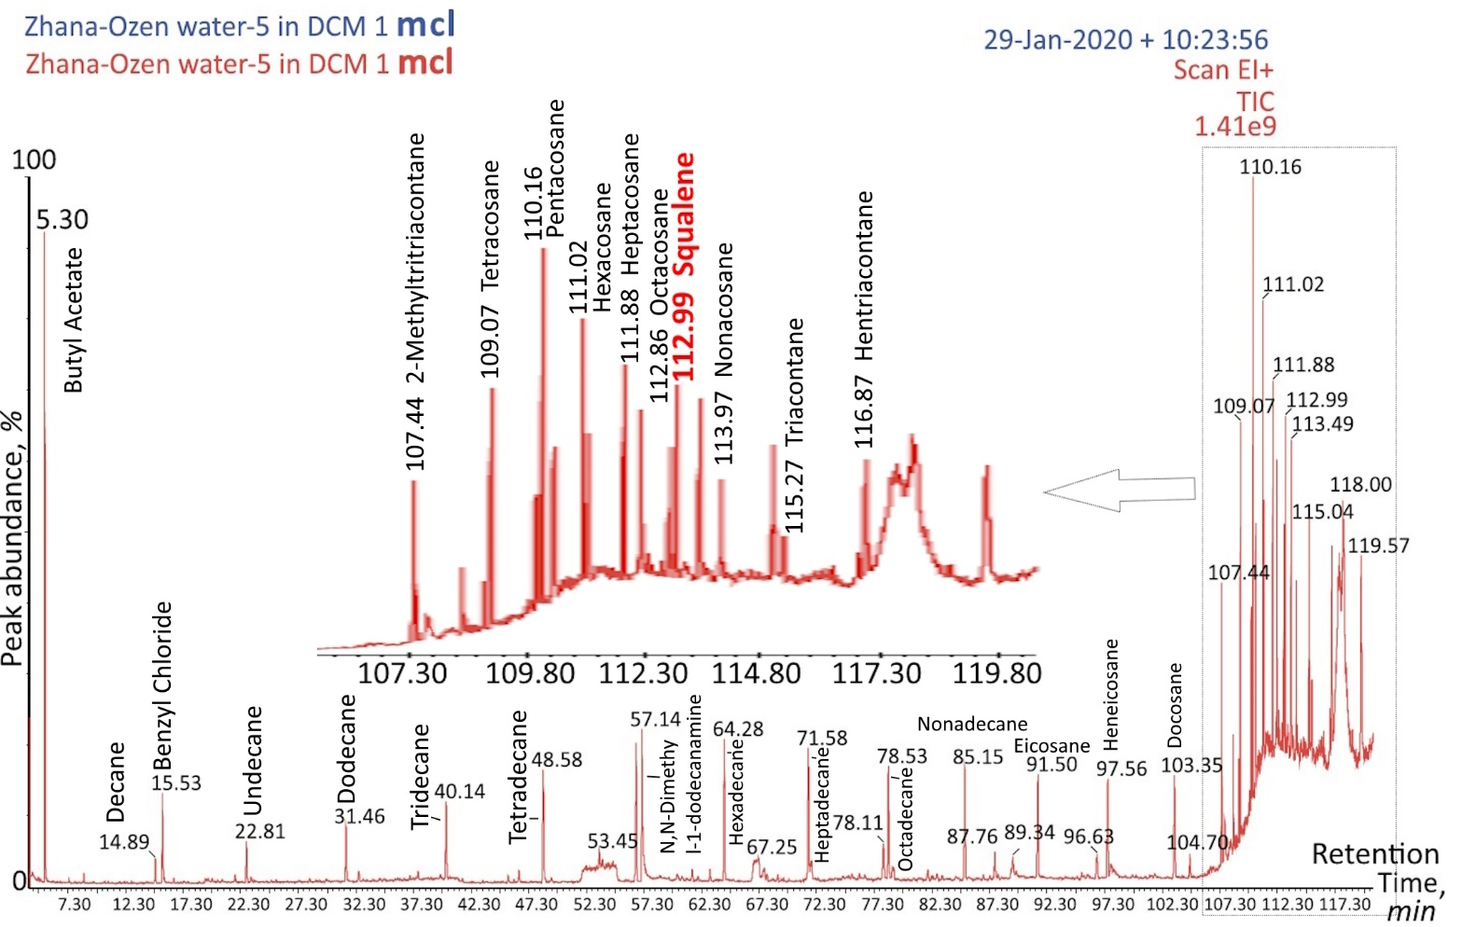
Figure S3. Chromatogram of the component composition of wastewater extract during dichloromethane (DCM) extraction.

RI_{calc} | RT | Components | Hexane, % | EtOAc, % | DCM, %
800 | 4.82 | Octane | 0.3
809 | 5.31 | Butyl Acetate* |  | 13.2 | 2.7
876 | 7.92 | n-Butyl Ether |  |  | 0.1
885 | 8.25 | p-Xylene** | 7.8
900 | 8.71 | Nonane | 0.5 | 0.3
958 | 12.58 | Mesitylene | 0.1
993 | 14.91 | Decane | 0.7 | 0.8 | 0.2
1009 | 16.07 | 1,2,3-Trimethylbenzene | 0.2
1010 | 15.53 | Benzyl Chloride*** |  | 0.3 | 1.0
1015 | 16.52 | 2,6-Dimethylnonane | 0.1 | 0.2
1059 | 19.86 | 2-Methyldecan |  |  | 0.1
1091 | 20.32 | 4-Methylundecene |  |  | 0.1
1100 | 22.82 | Undecane | 1.0 | 1.4 | 0.4
1103 | 23.27 | Decahydro-2-methylnaphthalene | 0.1
1158 | 28.32 | 2-Methylundecane |  |  | 0.1
1192 | 31.47 | Dodecane* | 1.7 | 2.0 | 0.6
1205 | 32.58 | 2,6-Dimethylundecane |  | 0.4 | 0.1
1259 | 37.01 | 2-Methyldodecane |  |  | 0.1
1267 | 37.71 | 2,6,11-Trimethyldodecane | 0.2 | 0.3 | 0.1
1281 | 38.86 | 3-Methyl-4-isopropylphenol | 0.1
1297 | 40.15 | Tridecane* | 1.4 | 2.4 | 1.0
1314 | 41.55 | 6-Methyltridecane |  |  | 0.1
1361 | 45.53 | 2-Methyltridecane | 0.1 | 0.2
1372 | 46.47 | 2,6,10-Trimethyldodecane | 0.2 | 0.3 | 0.2
1397 | 48.58 | Tetradecane* | 1.5 | 2.6 | 1.3
1399 | 48.74 | 4,8-Dimethyltridecane |  |  | 0.1
1399 | 48.76 | 2,6-Dimethylnaphthalene | 0.1
1405 | 49.28 | trans-Octahydro-2,2,4,4,7,7-hexamethyl-1H-indole | 0.1 | 0.1
1439 | 52.29 | Decahydro-1,1,4a,5,6-pentamethylnaphthalene |  | 0.1
1452 | 53.44 | 2,6,10-Trimethyltridecane | 0.2 | 0.4
1455 | 53.71 | 2-Methyltetradecane |  |  | 0.2
1488 | 56.63 | Pentadecane* | 1.6 | 2.9 | 1.7
1494 | 57.17 | N,N-Dimethyl-1-dodecanamine**** |  | 0.9 | 2.3
1537 | 60.19 | N,N-Dimethyl-1-tridecanamine**** | 0.1 | 0.2 | 0.1
1556 | 61.51 | 2-Methylpentadecane |  | 0.2 | 0.2
1578 | 63.05 | 2,2,4-Trimethyl-1,3-pentanediol diisobutyrate |  |  | 0.1
1597 | 64.29 | Hexadecane* | 1.5 | 2.7 | 1.7
1646 | 67.67 | 2,6,10-Trimethylpentadecane | 0.2 | 0.4 | 0.1
1651 | 67.98 | 1-Heptadecane |  |  | 0.1
1665 | 68.93 | 2-Methylhexadecane |  |  | 0.1
1703 | 71.58 | Heptadecane* | 1.4 | 2.5 | 1.7
1706 | 71.76 | 2,6,10,14-Tetramethylpentadecane | 0.2 | 0.4
1708 | 71.88 | 2,6,10-Trimethylhexadecane | 0.2 | 0.4 | 0.5
1759 | 75.36 | Undecylcyclohexane |  |  | 0.1
1768 | 76.01 | 2-Methylheptadecane |  |  | 0.1
1805 | 78.51 | Octadecane* | 1.1 | 2.1 | 1.4
1810 | 78.87 | 2,6,10,14-Tetramethylhexadecane | 0.4
1812 | 78.99 | 2-Methyloctadecane | 0.1 | 0.1 | 0.2
1855 | 81.95 | Bis(2-methylpropyl) ether of 1,2-benzenedicarboxylic acid |  |  | 0.2
1902 | 85.17 | Nonadecane* | 1.1 | 2.0 | 1.5
1956 | 88.83 | Palmitic Acid***** | 0.7 |  | 0.5
1961 | 89.13 | 2-Methylnonadecane | 0.3 | 0.1
1968 | 89.65 | Unidentified 1 |  |  | 0.2
1995 | 91.49 | Eicosane | 0.9 | 1.8 | 1.3
2091 | 97.24 | 2-Methyleicosane | 0.1 | 0.1
2096 | 97.55 | Heneicosane* |  | 2.0 | 1.2
2101 | 97.83 | Unidentified 2 |  |  | 0.2
2194 | 103.37 | Docosane | 0.9 | 1.7 | 1.3
2336 | 107.44 | 2-Methyltritriacontane | 1.4 | 1.9 | 1.5
2346 | 107.70 | Unidentified 3 |  | 0.3 | 0.6
2361 | 108.11 | Unidentified 4 |  | 0.2 | 0.2
2367 | 108.27 | Unidentified 5 |  |  | 0.2
2390 | 108.91 | Bis(2-ethylhexyl) ether of hexanedioic acid | 0.3 |  | 0.3
2396 | 109.08 | Tetracosane* | 1.0 | 2.0 | 1.5
2502 | 110.16 | Pentacosane* | 1.5 | 2.3 | 1.8
2527 | 110.41 | Dioctyl phthalate | 0.1 |  | 0.9
2590 | 111.03 | Hexacosane* | 1.0 | 2.2 | 1.4
2634 | 111.44 | Unidentified 5 | 0.2 |  | 0.2
2683 | 111.90 | Heptacosane* | 1.1 | 2.2 | 1.4
2724 | 112.28 | Bis(2-ethylhexyl) ether of 1,3-benzenedicarboxylic acid | 0.4
2738 | 112.41 | Eicosylheptyl ether |  |  | 0.2
2786 | 112.86 | Octacosane* | 1.0 | 2.0 | 1.0
2800 | 112.99 | Squalene****** |  |  | 1.4
2816 | 113.18 | Unidentified 6 | 0.2 | 0.3
2879 | 113.97 | Nonacosane | 1.1 | 1.9 | 0.9
2908 | 114.34 | Unidentified 7 |  | 0.2 | 0.2
2984 | 115.28 | Triacontane | 0.7 | 1.5 | 0.5
3026 | 115.96 | Unidentified 8 | 0.2
3046 | 116.32 | Unidentified 9 | 0.3 | 0.3 | 0.3
3076 | 116.87 | Hentriacontane | 0.6 | 1.1 | 0.3
3183 | 118.81 | Dotriacontane |  | 0.8 | 0.3

Table S1. Component Composition of Uzen Field Wastewater Extract.
RIcalc – Calculated Retention Index
RT – Retention Time (min)
* – Components with content exceeding 2%
** – Components representing typical emulsifier constituents
*** – Chloroorganic compound
**** – Components representing typical corrosion inhibitor constituents
***** – Compounds classified as organic acids
****** – Biomarker compound, valuable component

