Subcuticular and biofilm microbiomes in Holothuria tubulosa and its potential for denitrification

Journal: Microbial Ecology

Silke Martínez-Moreno^{1,2}, Elizabeth León-Palmero^{1*}, Héctor Pula², Ana María Cabello³, Isabel Ferrera³, Isabel Reche^{1,2,4**}

¹Departamento de Ecología e Instituto del Agua, Facultad de Ciencias, Universidad de Granada, 18071 Granada, Spain
²Aula del Mar, Facultad de Ciencias, Universidad de Granada, 18071 Granada, Spain
³Centro Oceanográfico de Málaga, Instituto Español de Oceanografía, IEO-CSIC, 29640 Fuengirola, Málaga, Spain
⁴Unidad de Excelencia Modeling Nature (MNat), Facultad de Ciencias, Universidad de Granada, 18071 Granada, Spain

** Corresponding author: ireche@ugr.es

Figure S1. Rarefaction curves of all sample. The X-axis represents the number of reads per sample and the Y-axis represents the number of ASVs per sample. All the samples reach a plateau. The vertical line indicates the minimum number of reads in the samples.
.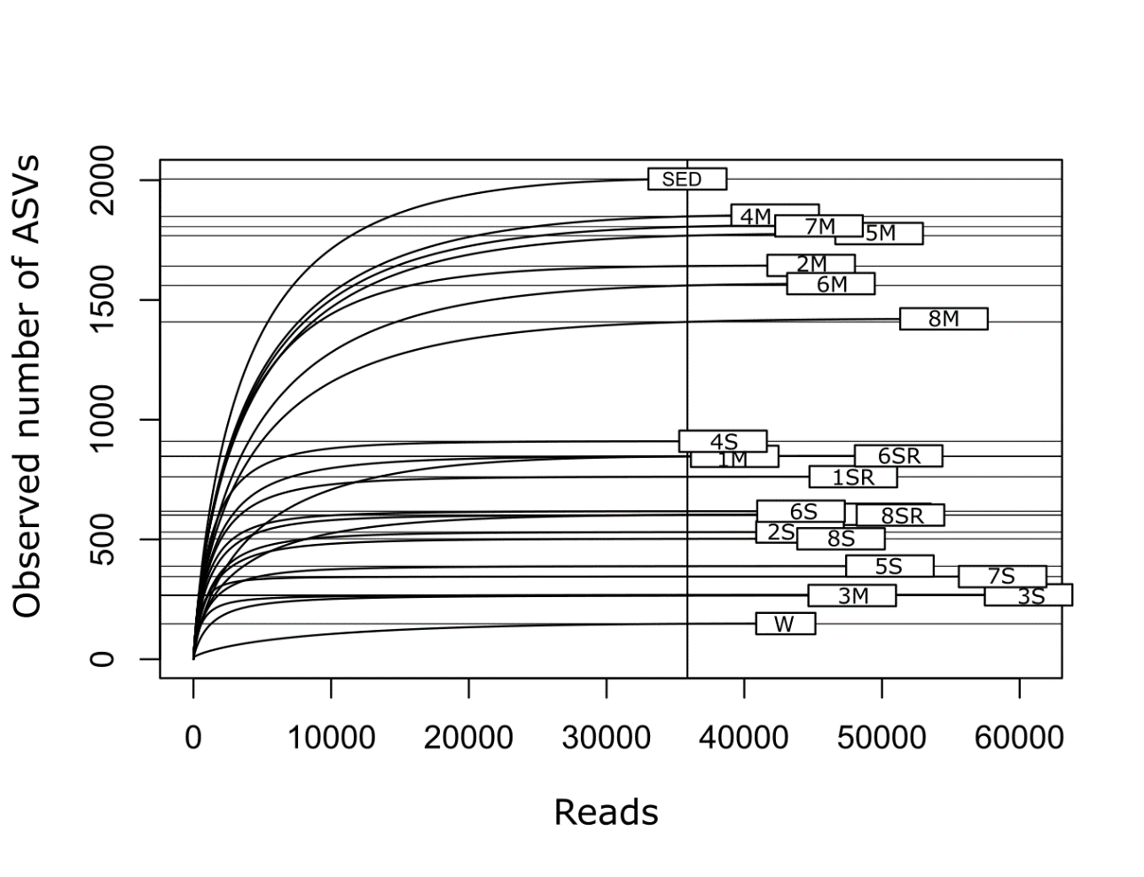

Table S1. Number of ASVs obtained per sample. Samples from #1 to 8 and R means replicate samples.
 | Number of ASVs
Sample | Subcuticle | Biofilm
1 | 605 | 847
1R | 762 | Not applicable
2 | 531 | 1,644
3 | 269 | 266
4 | 910 | 1,854
5 | 389 | 1,777
6 | 618 | 1,568
6R | 849 | Not applicable
7 | 345 | 1,813
8 | 503 | 1,421
8R | 602 | Not applicable
W | 149
SED | 205

