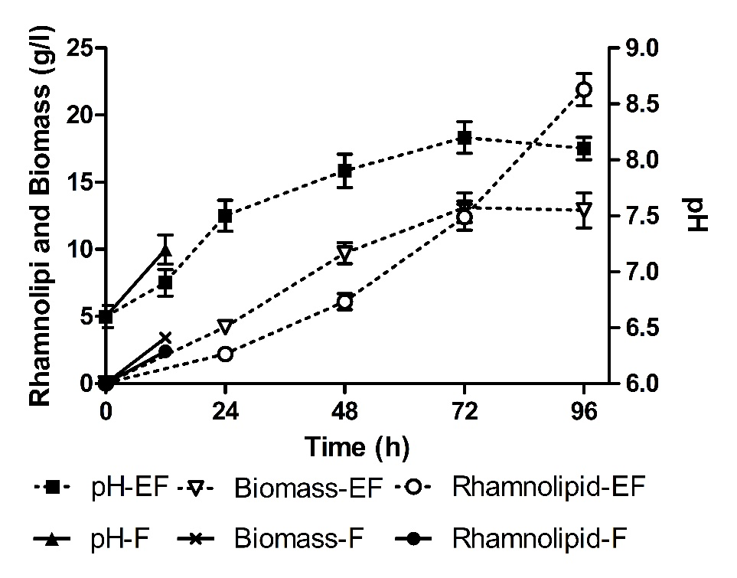
Fig. S1. Kinetics of the pH, biomass and rhamnolipid of rhamnolipid fermentation by Pseudomonas aeruginosa SG1 in 250 ml Erlenmeyer flask (EF) and 7.5 l fermenter (F) under no control pH condition. When fermentation was carried out in fermenter, excessive foam overflowed from the effluent gas outlet of the fermenter and the fermentation was forced to stop about 12 h.
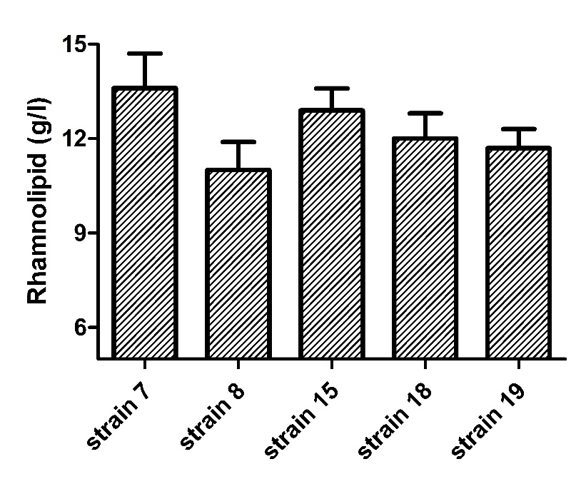
Fig. S2. The production of rhamnolipid of strain 7,8,15,18 and 19 at pH5.5.
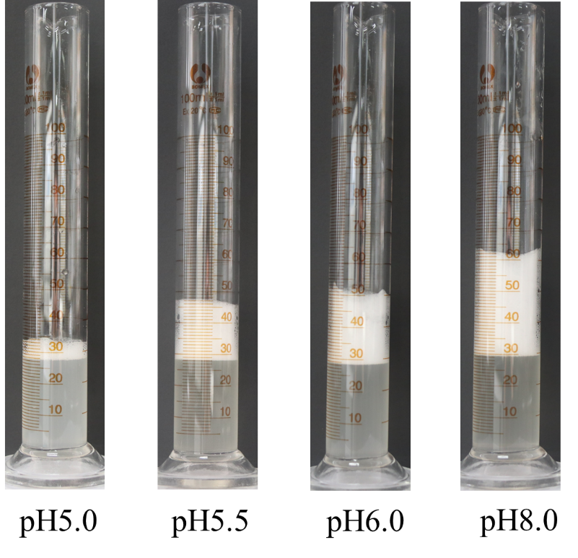
Fig. S3. The visual foam volume image of rhamnolipid solution after being stored for 1 min. There obvious turbidity at pH5.0 indicated the aggregation of rhamnolipid molecules.

