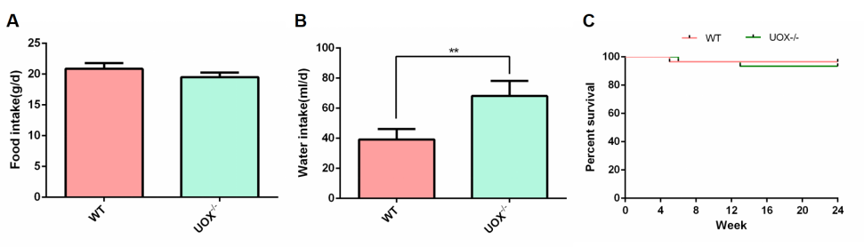
Fig.S1 The effects of HUA-induced by uricase knowout on food, water intake and survival of rats. A Food intake of 8 weeks old rats. B Water intake of 8 weeks old rats. C Survival of rats in a 24-week observation period. **p<0.01.

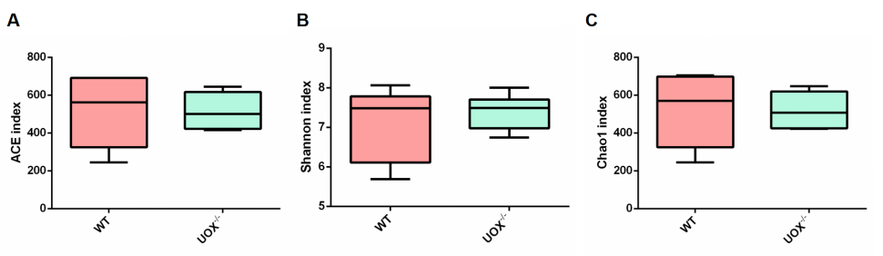
Fig.S2 The effects of HUA on microbial richness and evenness of rats. A ACE index. B Shannon index. C Chao1 index.

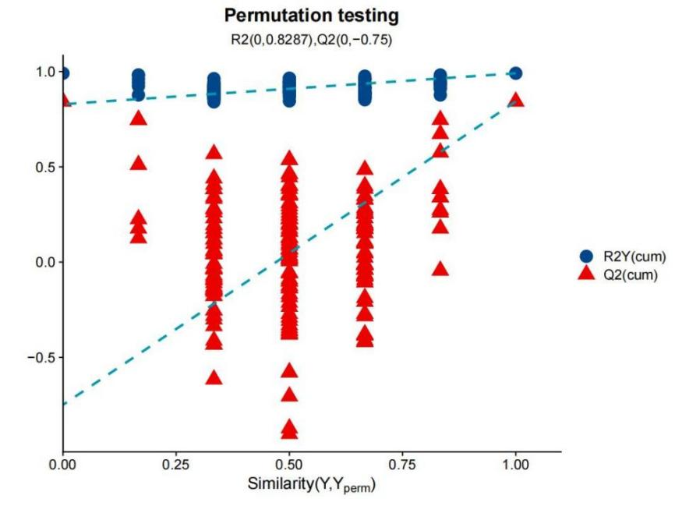
Fig.S3 Random permutation test with 200 permutations to evaluate the robustness of the OPLS-DA mode.
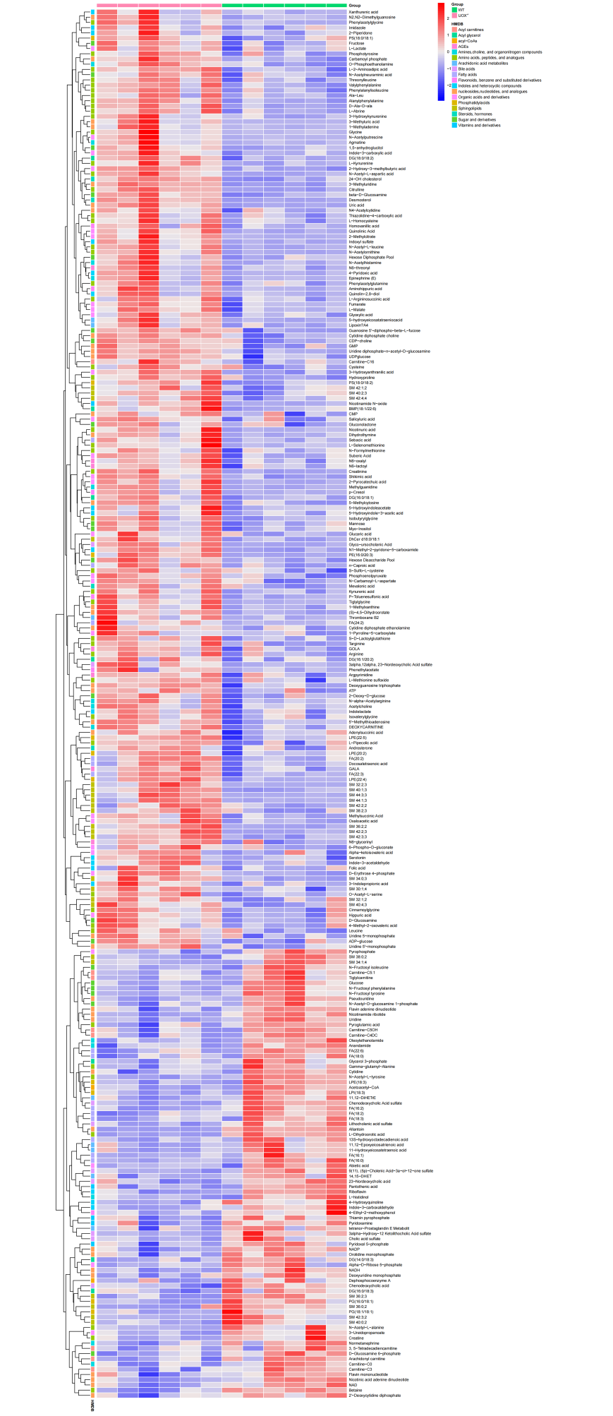
Fig.S4 Differential metabolites in kidneys of rats between WT and UOX^{-/-} group.

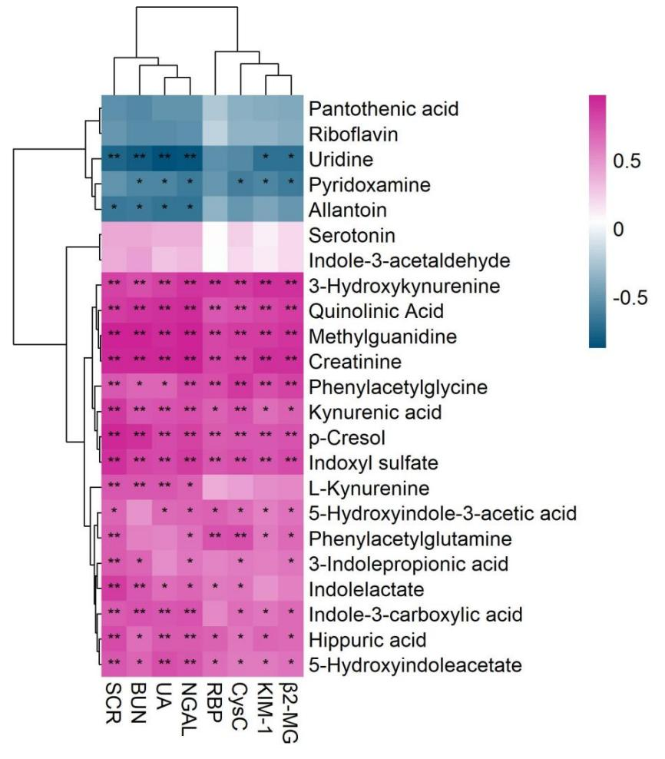
Fig.S5 Pearson correlation between several differential metabolites and renal function parameters. The red color means positive correlation while the blue color shows a negative correlation. *p<0.05; **p<0.01.
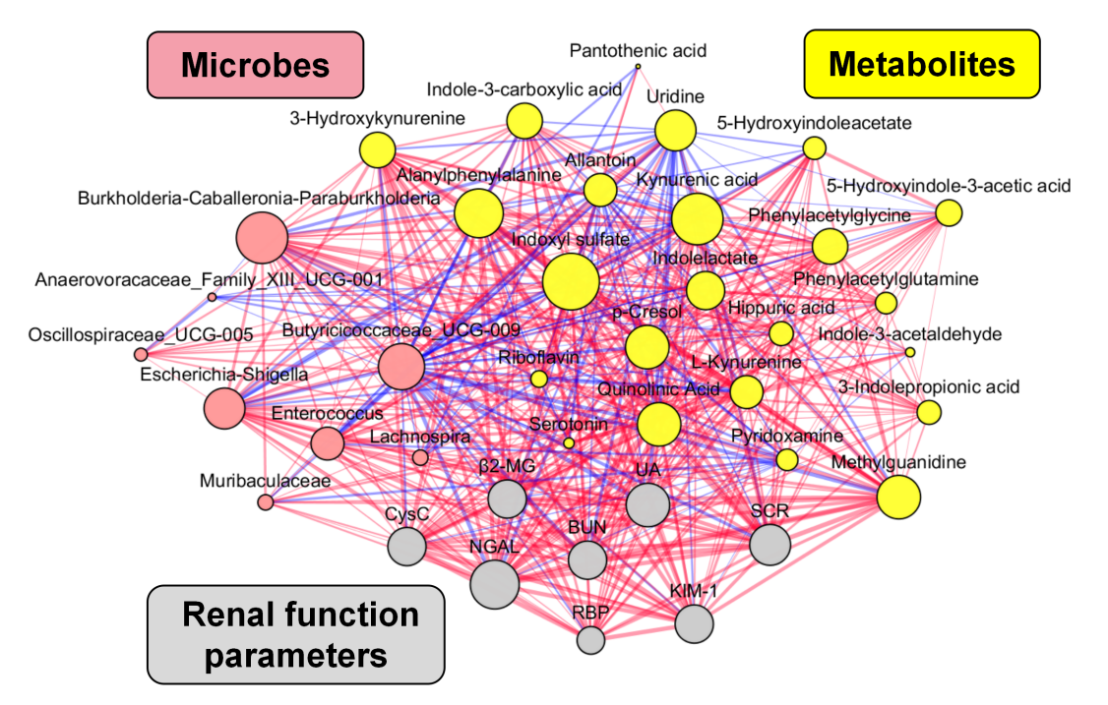
Fig.S6 Correlation network among microbes, metabolites and renal injury parameters (Pearson coefficient >0.5 and p<0.05). The red color means positive correlation while the blue color shows a negative correlation.

