Supplementary Material

Unraveling the effects of the Ebola experience on behaviour choices during COVID-19 in Liberia: A mixed methods study of ‘near misses’ and risk perception across successive outbreaks

Laura A. Skrip, Malcolm B. Weller, Sheikh Dukuly, Neima Candy, Wahdae-Mai Harmon-Gray, Adolphus Clarke, Bernice T. Dahn

Supplementary Figure 1. Proposed proportional sampling and difference between the proposed and actual sampling in terms of the proportion of the sample from each county.

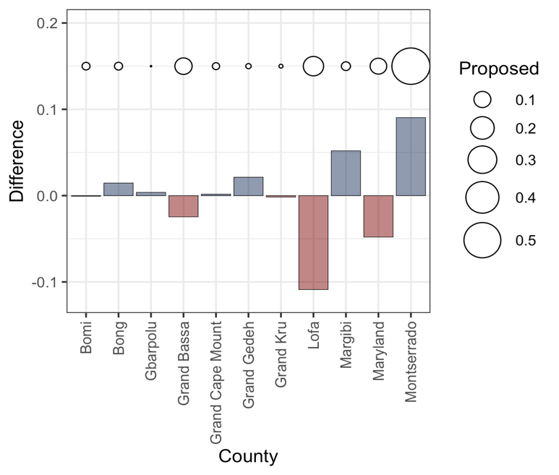

Supplementary Table 1. Results of GEE Model Selection
Precautionary Behavior | QIC | aOR (95% CI) | P-value
Less Frequent Visits to Places of Worship
Full Model* | 2757
Interaction Term Removed | 2757
Group Main Effect Removed | 2756
Outbreak Main Effect Removed | 2764
Both Group and Outbreak Main Effects Removed | 2764
Selected Model: Group Main Effect Removed
Group: EVD Near Miss **
Outbreak: COVID-19 ** |  | 0.76 (0.63, 0.90) | 0.002
Interaction: Group x Outbreak
Less Time Outside the Home (in Public Spaces)
Full Model* | 2704
Interaction Term Removed | 2703
Group Main Effect Removed | 2702
Outbreak Main Effect Removed | 2715
Both Group and Outbreak Main Effects Removed | 2714
Selected Model: Group Main Effect Removed
Group: EVD Near Miss
Outbreak: COVID-19 |  | 0.71 (0.59, 0.85) | <0.001
Interaction: Group x Outbreak
Less Frequent Use of Public Transport
Full Model* | 2716
Interaction Term Removed | 2714
Group Main Effect Removed | 2712
Outbreak Main Effect Removed | 2735
Both Group and Outbreak Main Effects Removed | 2733
Selected Model: Group Main Effect Removed
Group: EVD Near Miss
Outbreak: COVID-19 |  | 0.65 (0.54, 0.77) | <0.001
Interaction: Group x Outbreak
Less Frequent Visits to Health Facility
Full Model* | 2562
Interaction Term Removed | 2561
Group Main Effect Removed | 2570
Outbreak Main Effect Removed | 2572
Both Group and Outbreak Main Effects Removed | 2581
Selected Model: Interaction Term Removed
Group: EVD Near Miss |  | 2.02 (1.30, 3.12) | 0.002
Outbreak: COVID-19 |  | 0.71 (0.59, 0.86) | <0.001
Interaction: Group x Outbreak
More Frequent Handwashing
Full Model* | 2614
Interaction Term Removed | 2612
Group Main Effect Removed | 2615
Outbreak Main Effect Removed | 2611
Both Group and Outbreak Main Effects Removed | 2614
Selected Model: Outbreak Main Effect Removed
Group: EVD Near Miss |  | 0.66 (0.45, 0.95) | 0.027
Outbreak:
Interaction: Group x Outbreak
* Full Model: Behavior ~ (Outbreak*Group) + Outbreak + Group + Sex + Age + Education + Region
** For the Group variable, being an EVD near miss was compared to the reference level of not being an EVD near miss; for the Outbreak variable, the timepoint of the COVID-19 outbreak was compared to that of the EVD outbreak.

