Supporting Information

Anti-swelling and ROS scavenging nanofibers-hydrogel for preventing postoperative abdominal adhesion
Lin Jin^{1,2}, Congling Ren², Xing Chen³, Xiaolin Pan², Dan Rong¹, Xiaoli Liu¹, Zhe Yang^{4*}, Taoxia Wang¹, Guiying Li^{1*}, Xingcai Zhang^{3*}
¹Affiliated Hospital of Hebei Engineering University, The Key Laboratory of Basic Research on Blood Purification Application in Hebei Province, Handan, 056002, P. R. China
²International Joint Research Laboratory for Biomedical Nanomaterials of Henan, Zhoukou Normal University, Zhoukou 466001, P. R. China
³School of Engineering and Applied Sciences, Harvard University, Cambridge, Massachusetts, 02138, USA.
⁴ The Key Laboratory of Biomedical Information Engineering of Ministry of Education, School of Life Science and Technology, Xi’an Jiaotong University, Xi’an 710049, P. R. China

*Corresponding authors: fflgy@126.com (Guiying Li); jinlin_1982@126.com (Lin Jin); yangzhe@xjtu.edu.cn (Zhe Yang), xingcai@seas.harvard.edu (Xingcai Zhang)

Fig. S1 The adhesion images of NFs-H with various weight aqueous water.

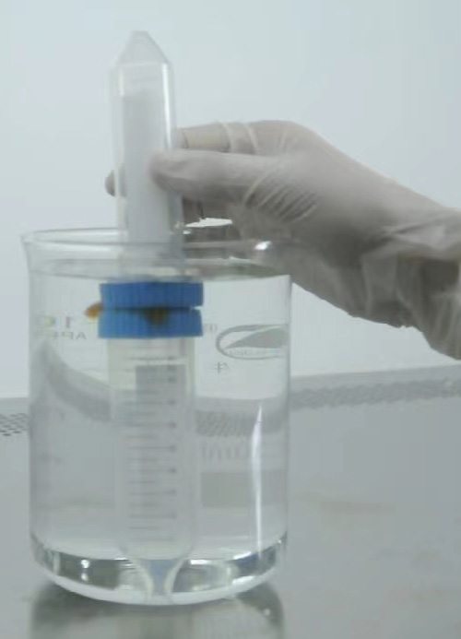
Fig. S2 The adhesion image of NFs-H in aqueous water (45mL).

Fig. S3 The HE staining of various organs.

